**TOPIC: GPS BASED TRACKING SYSTEM**

**Group Members:**

* Pruthviraj Patil
* Nikhilesh Prabakar
* Vignesh Mohan
* Nishanth T
* Ajith S

**Abstract:**

GPS based Mobile phone tracking is the establishing of the position or location of the lost cell mobile phone. Localization may occur either via multilateration of radio signals between (several) cell towers of the network and the phone, or simply via GPS. In this project we would aim at creating a useful application that can connect remotely to a desktop which can track the location of your phone at any point in time. Also, we will be trying to send the location from the application on the phone to the computer.

**Languages and Softwares Used:**

Java Development Kit  
PHP  
Android SDK  
Android Studio  
XAMPP

**E-R-Diagram of the Application**

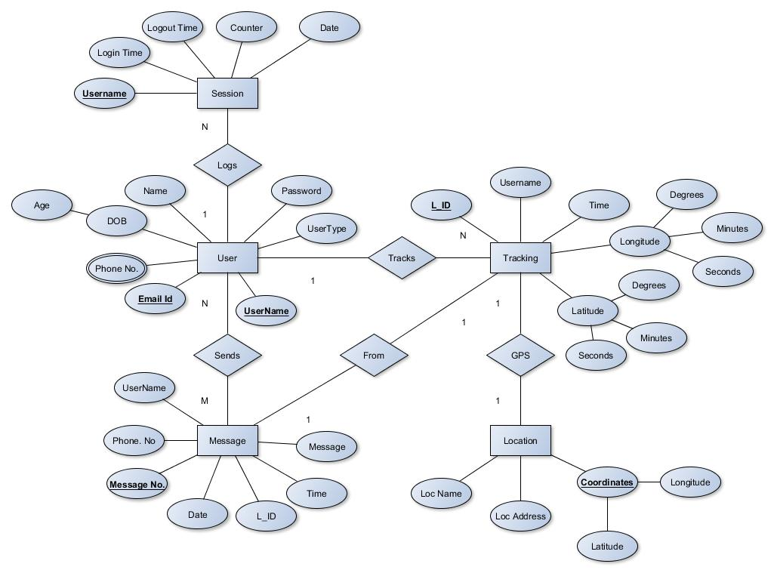

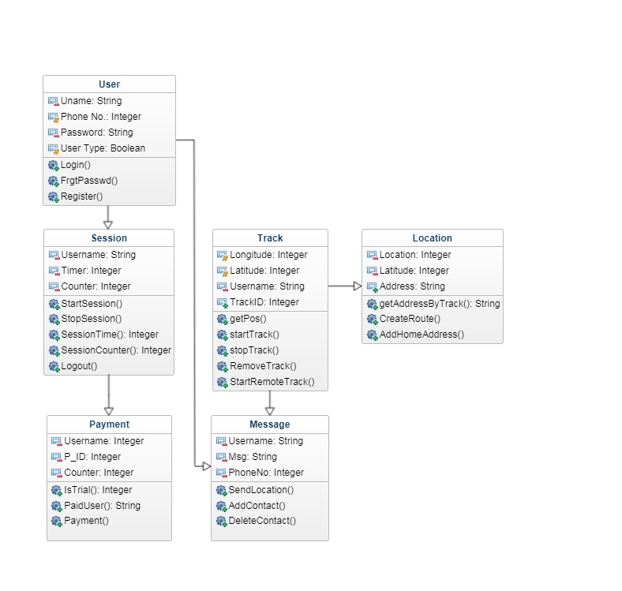**CLASS DIAGRAM OF THE SYSTEM**

Functional & Non Functional Requirements

**Functional Requirements**

1. **User**

* Email-ID
* Username
* Password
* Phone No.
* User Type

1. **Tracking**
   * L_ID
   * Username
   * Latitude
   * Longitude
2. **Session**

* Username
* CounterZ

1. **Location**
   * Latitude
   * Longitude
2. **Message**
   * Username
   * Message
   * L_ID
   * Phone No.

**Non - Functional Requirements**

**User**

* Security
* Ease-of-Access
* Adaptability
* User-Friendly
* Dependability

**Tracking**

* **Dependability**
* **Scalability**
* **Accessibility**
* **User-Friendly**

**Session**

* **Reusability**
* **Security**
* **Privacy**
* **Reliability**
* **Robustness**

**Location**

* **Accessibility**

**Message**

* **Readability**
* **Response Time**
* **Dependability**
* **Privacy**

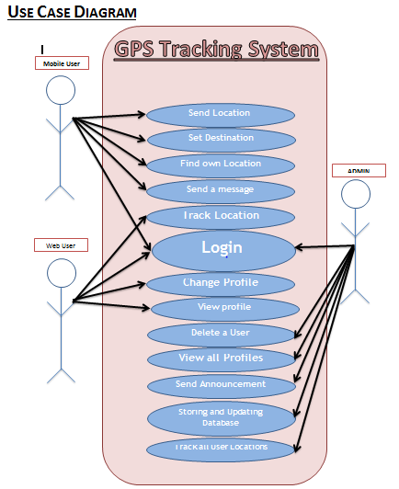

**The screen shots of the webpages**

**1.LOGIN PAGE:**

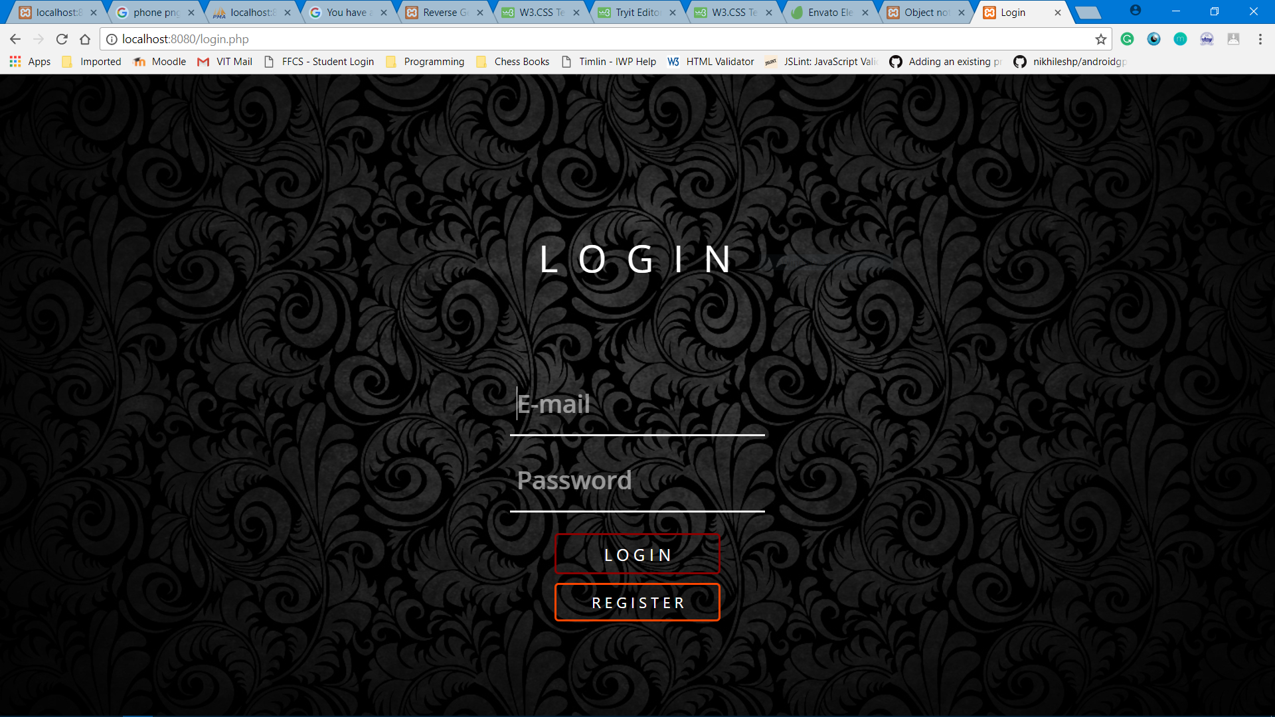

**2.Sign-up**

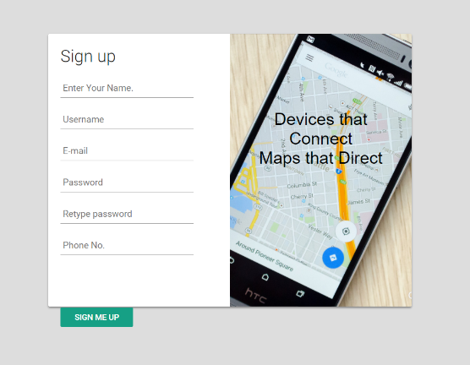

**3. Homepage**

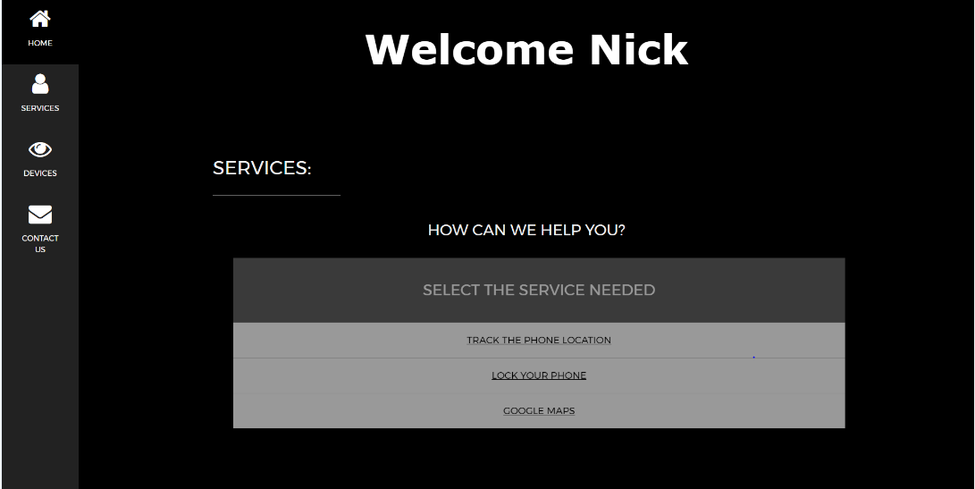

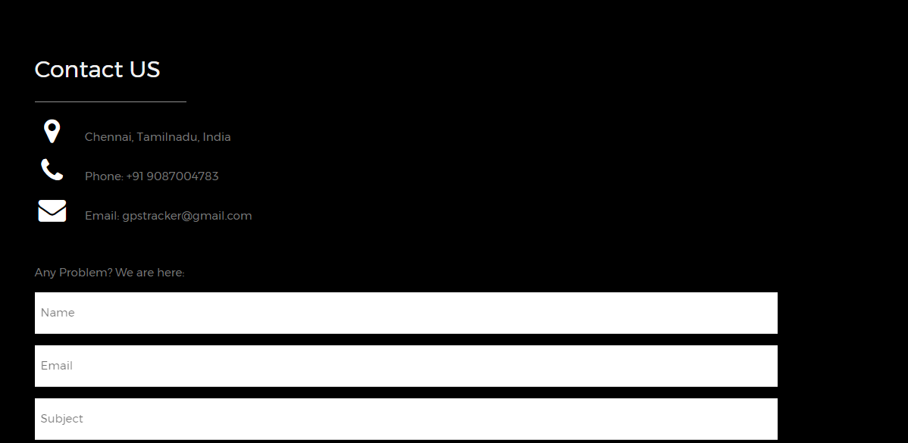

**4. Registered devices to track:**

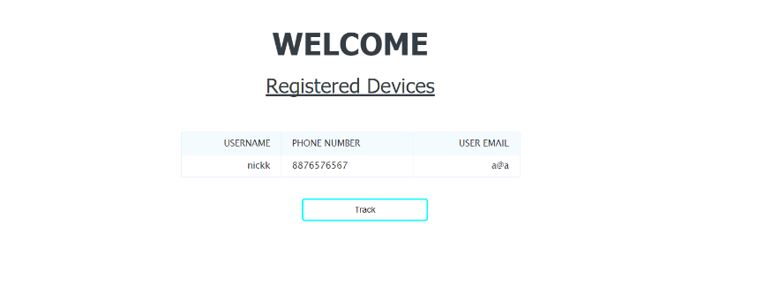

**5.Tracking :**

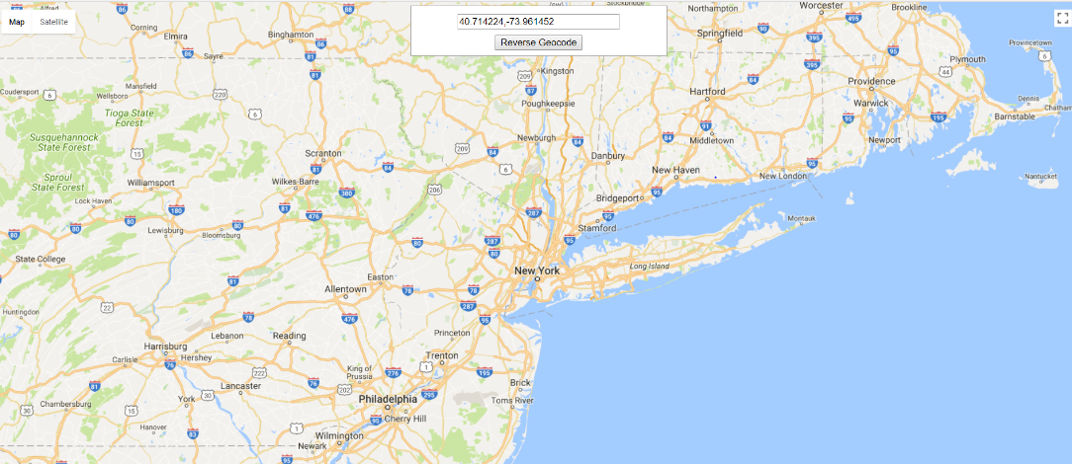

1. **Android Prototype:**

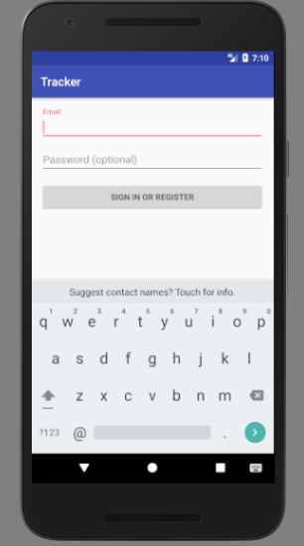

**Working of the site:**

Users login to the Website to approach for the help and registering himself/ herself in the website to ensure the protection for his/her cell phone. The Cell phone sends its External IP address in every predefined intervals of time to the server. The Server-side code finds the Latitude and longitude of the cell phone based on the IP address

The Latitude and the longitude found is used directly to find the location of the cell phone by using the google place Geo locator by using the Google maps’ API KEY. Thus the Location found is finally displayed on the Google Maps indicating the approximate location of the cell phone