**Report on**

**“**​**C Compiler in java for ‘While’ , ’ if else’ , ‘Ternary’ and ‘for’ constructs”**

*Submitted in complete fulfillment of the requirements for ​****Sem VI***

***Compiler Design Laboratory***

**Bachelor of Technology**

**in**

**Computer Science & Engineering**

**Submitted by:**

**Anush V Kini Pruthvish E Pradyumna YM**

**PES1201701646 PES1201701629 PES120170986**

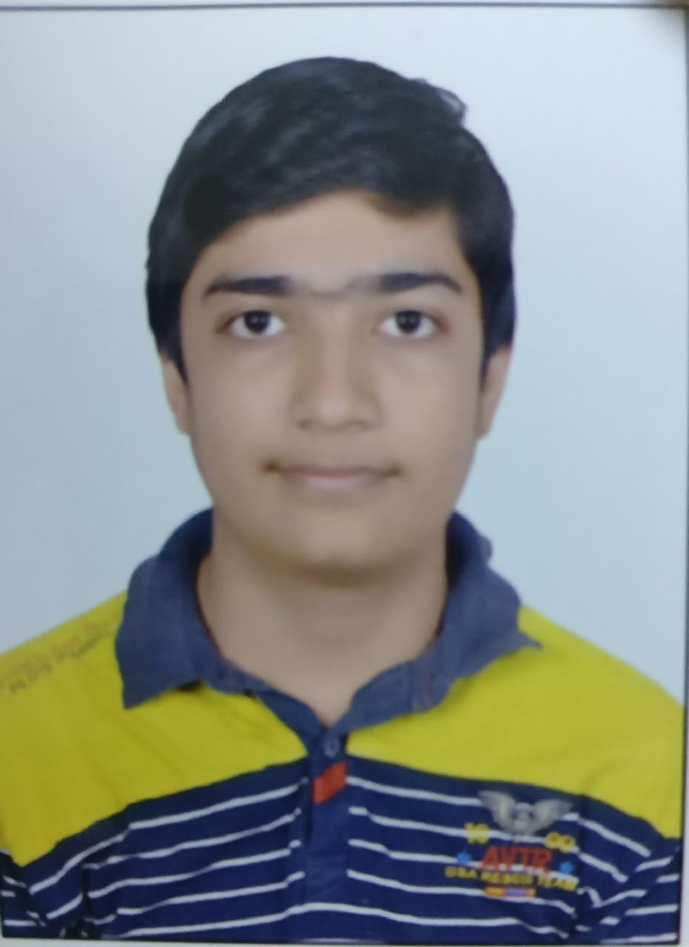

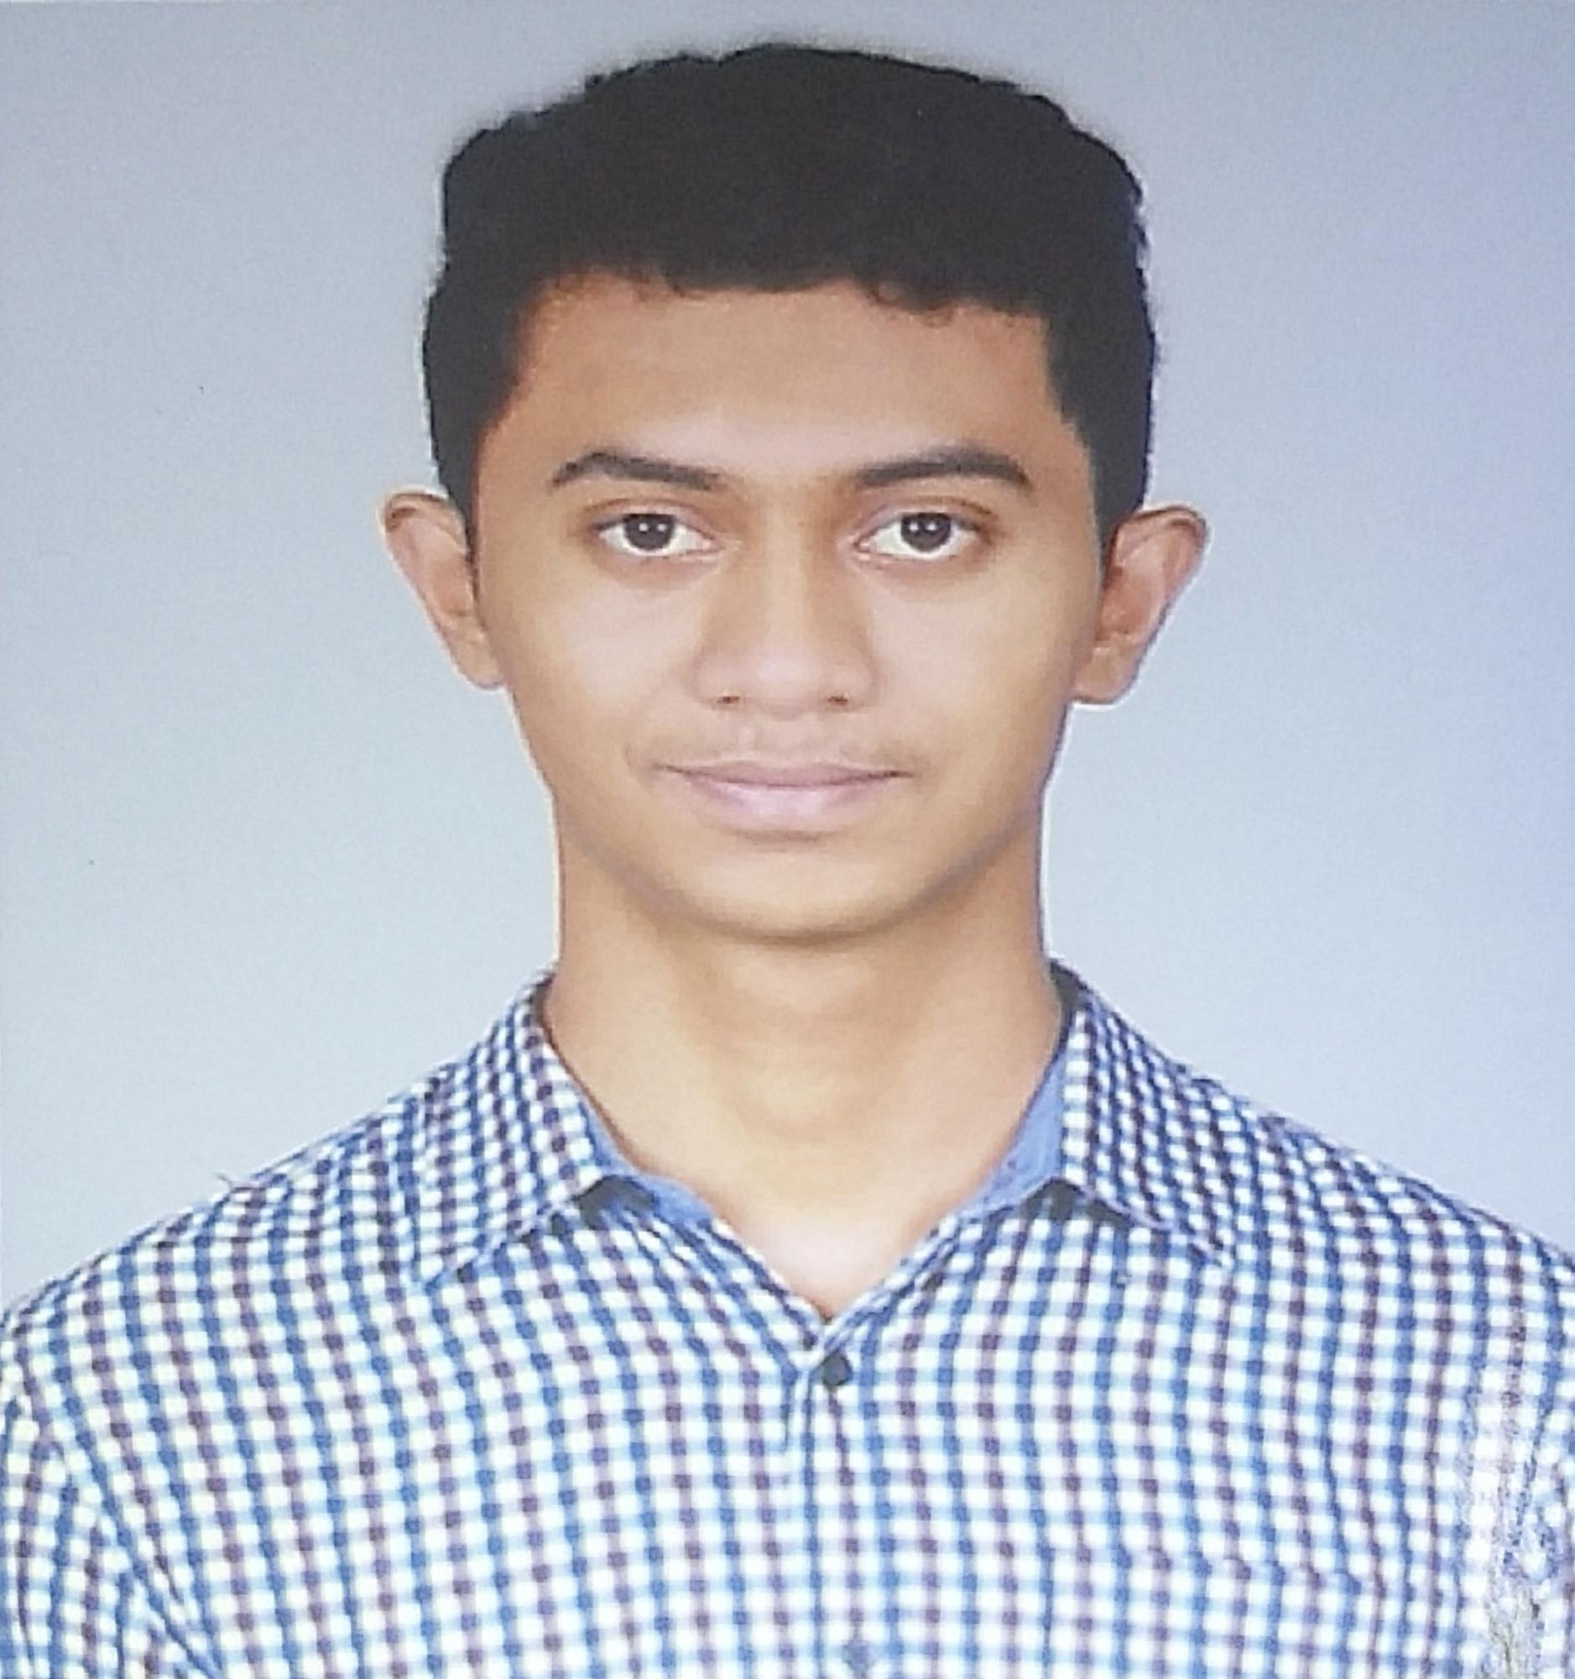

**January – May 2019**

**DEPARTMENT OF COMPUTER SCIENCE AND ENGINEERING**

FACULTY OF ENGINEERING

**PES UNIVERSITY**

(Established under Karnataka Act No. 16 of 2013)

100ft Ring Road, Bengaluru – 560 085, Karnataka, India

## Block Diagram