CX Reply Assistant — Architecture at Scale
Submitted by: Priyanshu Gupta
Date: 2 September 2026

1. Overview
Serverless, multi-tenant system for 500 brands, 5,000 agents, millions of messages across WhatsApp, Email, SMS, Web Chat.
Principle | How
Multi-tenancy | RLS on every table
Scalability | Edge Functions + BullMQ queues
Reliability | Idempotency, retries, DLQ
Security | JWT with brand_id
Cost | Redis caching, model selection

2. Architecture Diagram
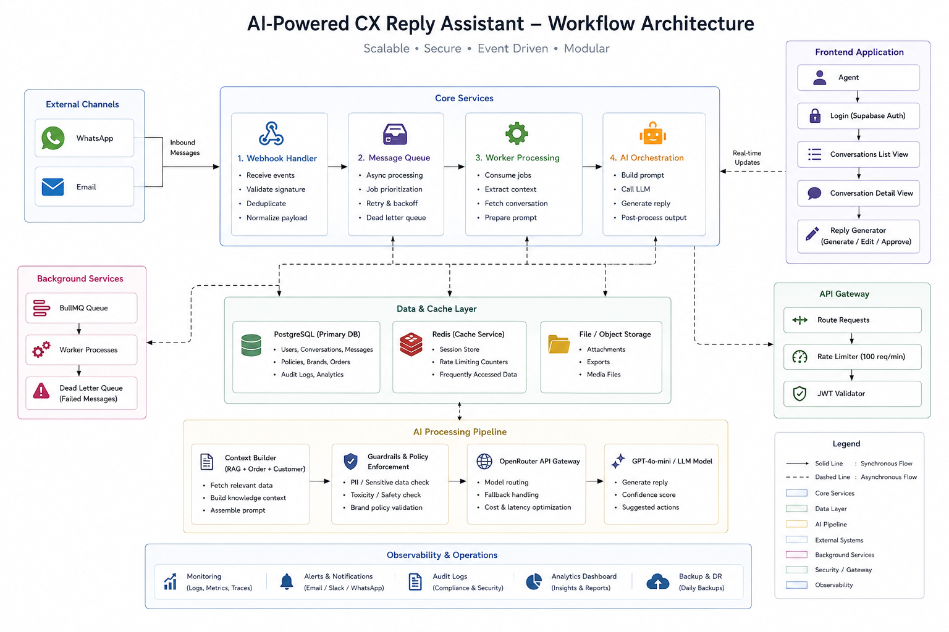

3. Frontend
- React + Vite + TailwindCSS (Vercel)
- Supabase Auth
- Pages: Login, Conversation List, Detail, Reply Generator
- Mobile-first, responsive

4. Backend
- Supabase Edge Functions (Deno)
- generate-reply → Context → KB → OpenRouter → Log
- webhook-handler → Validate → Deduplicate → Queue
- RESTful, JWT-auth, rate-limited (100/min), Redis cache (1hr)

5. Database
- PostgreSQL
- Tables: brands, customers, orders, conversations, messages, kb_articles, ai_logs
- RLS: brand_id = auth.jwt() ->> 'brand_id'
- Indexes on key columns

6. Auth & Integrations
Service | Protocol
WhatsApp | Webhook
Email | Webhook
Slack | Webhook
Datadog | REST API
Webhook Flow: External → Validate → Idempotency (Redis) → Queue → 200 OK

7. AI Layer
- OpenRouter (GPT-4o-mini)
- Guardrails: Answer ONLY from policies → No invention → Uncertain → "Specialist review"
- Confidence: 0-40% → Specialist | 41-70% → Clarify | 71-100% → Generate
- Evaluation: Automated checks + Human review + Metrics

8. Multi-Brand Isolation
Layer | How
Database | RLS: brand_id = auth.jwt() ->> 'brand_id'
API | JWT validation
Functions | Brand-scoped data only
UI | Shows user's brand only

9. Queues & Jobs
- BullMQ + Redis
Queue | Retries
Message Processing | 3 (5s backoff)
AI Generation | 3 (10s backoff)
Logging | 5 (1s backoff)
Notifications | 3 (15s backoff)
- DLQ: Failed messages → Manual review → Alert if >100

10. Scalability (20→500 Brands)
Bottleneck | Solution
Database | Partition, read replicas
KB Search | Qdrant vector search
AI Costs | Cache, batch, cheaper models
Concurrency | BullMQ queue
Rate Limits | Multiple API keys

11. Reliability
Issue | Fix
Duplicate Webhook | Idempotency key (Redis, 24h)
API Timeout | Circuit breaker → cached response
AI Failure | Retry (2s,10s,30s) → DLQ
Missed Response | Reconciliation job → Alert
Monitoring | Datadog: errors, queue, cost; Alerts on >5% errors, queue >1000

12. Summary
Component | 20 Brands | 500 Brands
Database | Single | Partitioned + replicas
KB Search | SQL | Qdrant
AI Calls/day | 1,000 | 100,000
Cost | $20k/mo | $1L/mo
Caching | None | Redis
Queues | None | BullMQ + DLQ
Monitoring | Manual | Automated

