**Final Year Project Synopsis, Online Examination System, PHP + MySQL**

**Introduction**  
  
Online Examination System is an  on-line test simulator is to take online examination, test in an efficient manner and no time wasting for manually checking of the test paper. The main objective of this web based online examination system is to efficiently evaluate the student thoroughly through a fully automated system that not only saves lot of time but also gives fast and accurate results. For students they give papers according to their convenience from any location by using internet and time and there is no need of using extra thing like paper, pen etc.

Online examination system helps students to offer a quick and easy way to appear for the test. It also provides the results immediately after the examination with 100% accuracy and security. Student can enter to perform exam only with their valid username and password. This examination contains multiple choice questions and appropriate number of options. There are no limitations on number of options and it can be randomized so same set of question will not appear to all student so it prevent manipulation. More than one option can be correct but the user can select only one option. This provides time limit. The user can see their results after completing the exam. This helps the students to write the exam from far distance and which can provide security and simplicity and other beneficial features to the user.

**Limitation of Existing System**

We have study ABC College and find existing system is manual entry of up keeping of the details of the student who are registered already. And it is very difficult for each student to come to the exam center. It is very difficult to the students from far distance to reach the exam center. This system is required to prepare registration\application form, question paper for the students and required to print a lot of number manually. To calculate how many students registered, and verification of details of these students in a month by hand is very difficult. This requires quite a lot of time and wastage of money as it requires quite lot of manpower to do that. Another factor that takes into account that is the possibility of errors. The limitation of existing system is that it is not all personalized. It cannot be used for personal and quick reference. Even the other staff members can make quick entries if the responsible person is not present.

|  |  |
| --- | --- |
| * Time Consuming for creating question paper * Time to check right and wrong answers * Calculation of Marks * Human error * Limitation of no of student can give examination at a time * Require teacher to monitor exam center * Student needs to come exam center for giving test |  |

**Proposed System**

The modern computerized system is developed with the aim to overcome the drawbacks of existing manual system. We have study manual examination system of ABC college and identify possible automation. The proposed system has got many advantages. People from different parts of the world can register very easily. The new system is more personalized. It is maze in such a manner that all the new users can understand all the options in it very easily. It is made in a quick and easy referential manner. Access to all important matters are not always locked and can be opened easily at the time of urgency. The advantages of proposed system are that security is maintained in the new system. Securities for all important data are maintained confidentially. As it is easily understandable and user friendly, quick entries can be made in this system

* Complete Automation, no manual intervention in whole process of examination
* No geographical boundary
* Student can give examination from anywhere of the world by 24X7
* 100% accuracy in result calculation
* Randomization of question set

**Software Requirement**

* PHP
* MySQL Server
* NetBeans / FrontPage / NotePad

**Hardware Requirement**

* Intel 3.0 ghz or higher processor
* 2 GB RAM
* 10 GB HDD Space

**ER Diagrams for Online Examination System**

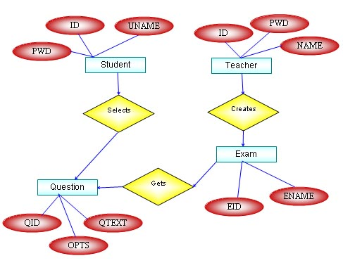

**DFD - Data Flow Diagram for Online Examination System**

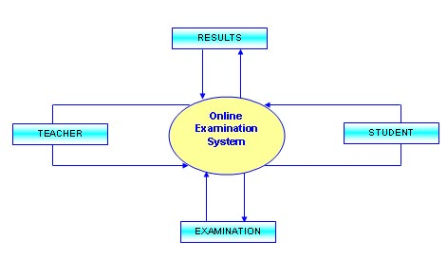  
**Future Improvements**

We have prepare new system after identify issue in existing manual examination system. Scope of this online examination system  is very broad in terms of other manually taking exams. However we can improve our system in next version like.

* Linking of other online site
* Include graphical and media file as question and answers
* Use of JQuery for more smooth interface

**Reference and Bibliography**

* Book : Php And Mysql In Easy by Mike Mcgrath
* Book : Beginning PHP and MySQL by Jason Gilmore
* [www.programmer2programmer.net](http://www.programmer2programmer.net/)
* [www.readymadeproject.coom](http://www.readymadeproject.coom/)
* <http://ajprofessionals.googlepages.com/>
* [www.wikipedia.org](http://www.wikipedia.org/)
* [www.php.net](http://www.php.net/)