Database Concepts Answer Sheet
  - Assignment 2, Semester 2, 2020

Student Information
Full Name | Maxwell Reid
Student Number | S3787033

Assignment Declaration
When you submit work for assessment, you’ll be asked to agree to the following declaration.
- I have not impersonated, or allowed myself to be impersonated by any person for the purposes of this assessment.
- This assessment is my/our original work and no part of it has been copied from any other source except where due acknowledgement is made.
- No part of this assessment has been written for me/us by any other person except where such collaboration has been authorised by the lecturer/teacher concerned.
- I have correctly acknowledged the re-use of any of my own previously submitted work within this submission.
- I give permission for my assessment response to be reproduced, communicated compared and archived for the purposes of detecting plagiarism.
- I give permission for a copy of my assessment to be retained by the university for review and comparison, including review by external examiners.

I understand that:
- Plagiarism is the presentation of the work, idea or creation of another person as though it is your own. It is a form of cheating and is a very serious academic offence that may lead to exclusion from the University. Plagiarised material can be drawn from, and presented in, written, graphic and visual form, including electronic data and oral presentations. Plagiarism occurs when the origin of the material used is not appropriately cited.
- Plagiarism includes the act of assisting or allowing another person to plagiarise or to copy my work.

I agree and acknowledge that:
1. I have read and understood the Declaration and Statement of Authorship above.
2. I accept that use of my RMIT account to electronically submit this assessment constitutes my agreement to the Declaration and Statement of Authorship
3. If I do not agree to the Declaration and Statement of Authorship in this context, the assessment outcome is not valid for assessment purposes and cannot be included in my aggregate score for this course.
You'll find more information about the penalties for plagiarism in the Student Conduct Policy.

Compulsory Worklog Snapshots
Place your snapshots below. One snapshot showing the tables in your account. One snapshot including the SQL history for each connection session that you work on the assignment. Your snapshot must be a full screenshot showing your account and connection and the timestamps of each entry your SQL history – only copy the SQL history is not sufficient.
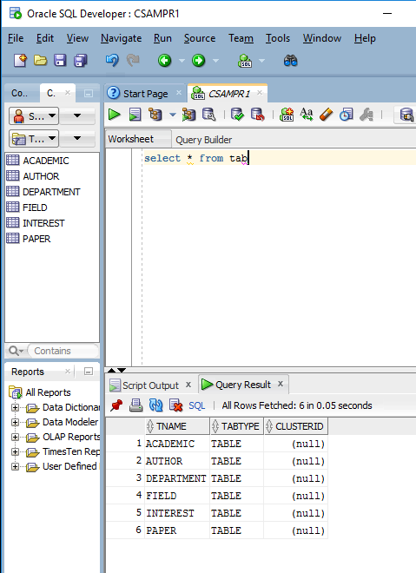
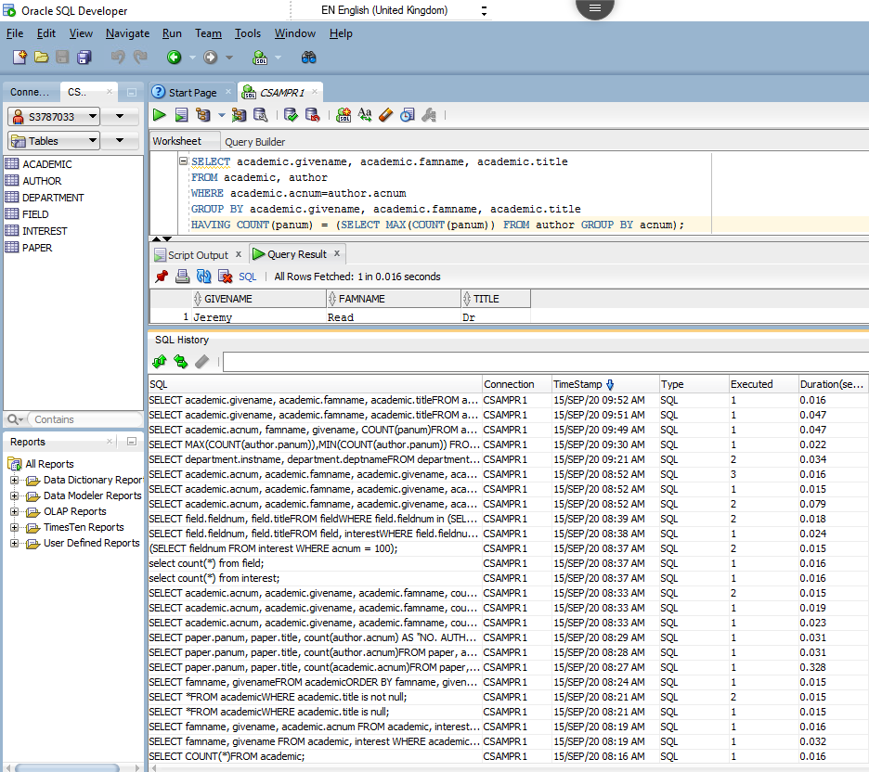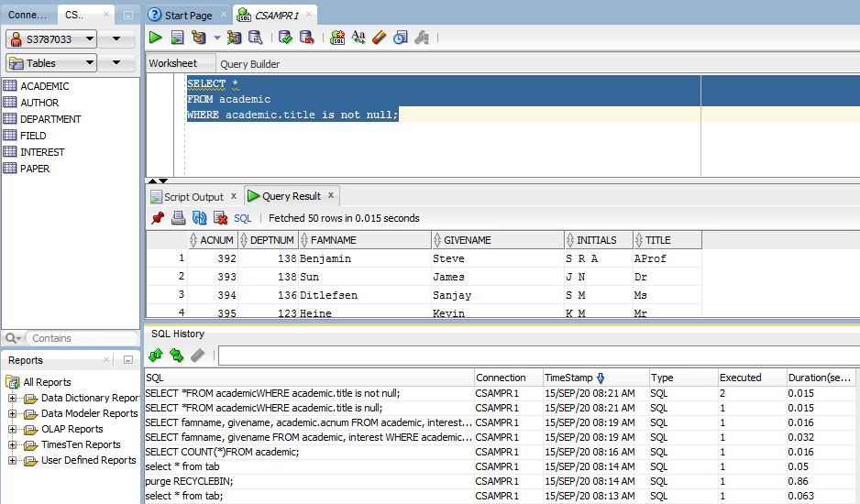

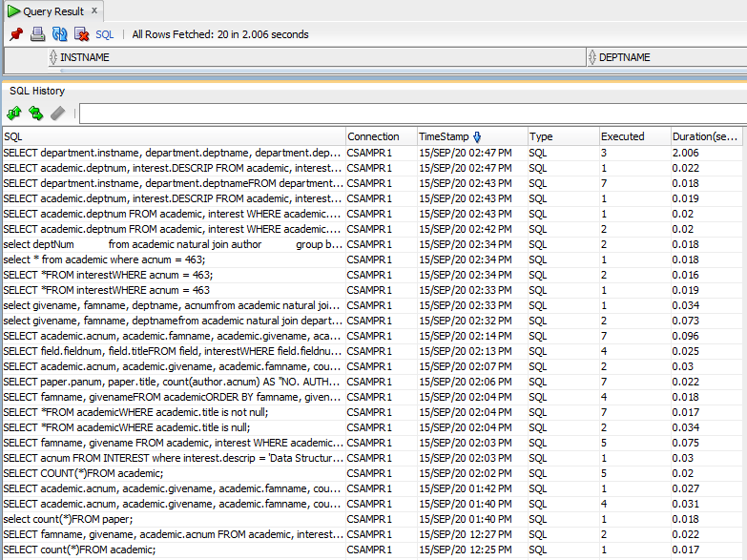
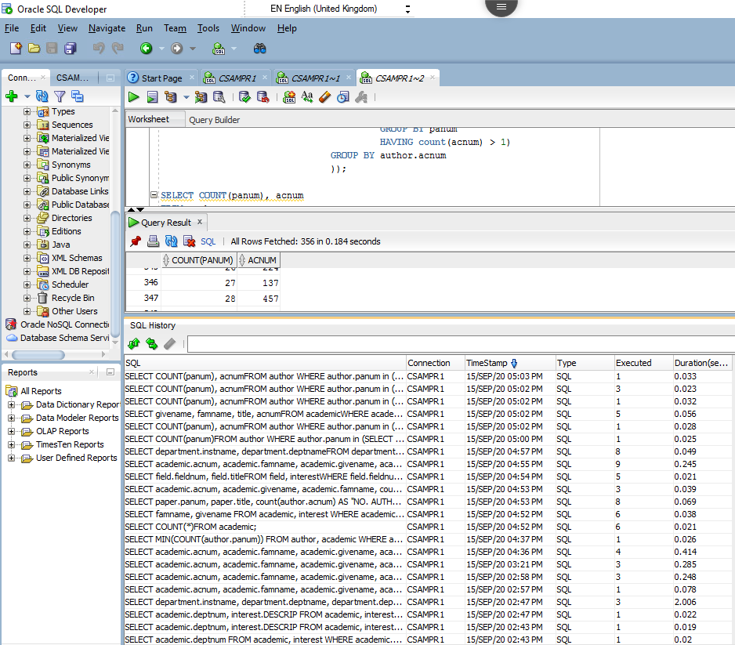

Question 1
Reference number | QC1-19
Text of Your Question | How many academics are there in the database? Write a query to find the answer.

The answer is as follows.
SELECT COUNT(*)
FROM academic;

Question 2
Reference number | QC1-18
Text of Your Question | Return the famname and givename of academics having interests in ‘Data Structures’ (descrip) with acnum in the range [100...399]. The output should be in alphabetical order of famname and then givename.

The answer is as follows.
SELECT famname, givename
FROM academic, interest
WHERE academic.acnum = interest.acnum
AND interest.descrip = 'Data Structures'
AND academic.acnum >= 100 AND academic.acnum <= 399
ORDER BY academic.famname, academic.givename;

Question 3
Reference number | QC1-16
Text of Your Question | Find academics who have a title (title) available in the database. Write a query to return all details of these academics.

The answer is as follows.
SELECT *
FROM academic
WHERE academic.title is not null;

Question 4
Reference number | QC1-14
Text of Your Question | List the famname, givename of all academics in the database, in alphabetical order.

The answer is as follows.
SELECT famname, givename
FROM academic
ORDER BY famname, givename;

Question 5
Reference number | QC2-15
Text of Your Question | List the panum, title, and total number of academics (under the heading "NO. AUTHORS") for each paper, in increasing order (i.e. ascending order) of panum.

The answer is as follows.
SELECT paper.panum, paper.title, count(author.acnum) AS "NO. AUTHORS"
FROM paper, author
WHERE paper.panum = author.panum
GROUP BY paper.panum, paper.title
ORDER BY paper.panum;

Question 6
Reference number | QC2-14
Text of Your Question | For each academic, give the acnum, givename, famname and the total number of fields s/he has worked in. Note that if an academic has not worked in any fields, his/her total should be zero.

The answer is as follows.
SELECT academic.acnum, academic.givename, academic.famname, count(interest.fieldnum)
FROM academic LEFT JOIN interest on academic.acnum = interest.acnum
GROUP BY academic.acnum, academic.givename, academic.famname;

Question 7
Reference number | QC2-13
Text of Your Question | List the field number and title of fields interested by the academic whose acnum is 100.

The answer is as follows.
SELECT field.fieldnum, field.title
FROM field, interest
WHERE field.fieldnum = interest.fieldnum
AND interest.acnum = 100;

Question 8
Reference number | QC2-19
Text of Your Question | The research productivity of an academic is measured by the number of his/her papers. List details (acnum, famname, givename and title) of the most productive academic together with the total number of his/her papers.

The answer is as follows.
SELECT academic.acnum, academic.famname, academic.givename, academic.title, count(author.panum)
FROM academic, author
WHERE academic.acnum = author.acnum
HAVING COUNT(author.panum) >= ALL (SELECT MAX(COUNT(author.panum)) FROM author, academic WHERE author.acnum = academic.acnum GROUP BY author.acnum)
GROUP BY academic.acnum, academic.famname, academic.givename, academic.title;

Question 9
Reference number | QC3-19
Text of Your Question | Explain the following query in English. A literal explanation will receive 0 marks.

The answer is as follows.
select givename, famname, deptname
from academic natural join department
where acnum not in
(select acnum
from academic natural join interest)
and deptNum in
(select deptNum
from academic natural join author
group by deptNum
having count(panum)>100)

It returns the given name, family name and department number of the academics who don’t have an interest and belong to a department thats members in total have co(authored) over 100 books.

Question 10
Reference number | QC3-20
Text of Your Question | Find departments where there are academics that have at least two research interests without any description. List their instname and deptname in alphabetical order.

The answer is as follows.
SELECT department.instname, department.deptname
FROM department
WHERE department.deptnum IN (SELECT academic.deptnum FROM academic, interest WHERE academic.acnum = interest.acnum AND interest.descrip IS NULL GROUP BY academic.deptnum HAVING count(academic.deptnum) >= 2);

-- Assumption: The requery is requesting the interest does not have a description, not the department not having a description. As confirmed by tutor.

Question 11
Reference number | QC3-16
Text of Your Question | The productivity of an academic is measured by the total number of paper s/he has written. Find the papers that have the most productive author/s or the least productive author/s. Output the acnum, title, and the givename, famname of the most productive author/s or the least productive author/s together with the number of their papers.

The answer is as follows.
SELECT academic.acnum, academic.famname, academic.givename, academic.title, count(author.panum)
FROM academic, author
WHERE academic.acnum = author.acnum
HAVING COUNT(author.panum) = ALL (SELECT MAX(COUNT(author.panum)) FROM author, academic WHERE author.acnum = academic.acnum GROUP BY author.acnum)
OR COUNT(author.panum) = ALL (SELECT MIN(COUNT(author.panum)) FROM author, academic WHERE author.acnum = academic.acnum GROUP BY author.acnum)
GROUP BY academic.acnum, academic.famname, academic.givename, academic.title;

-- Assumption: A person has to have written atleast 1 book to be considered an author. This means that the least productive is 15 rather than 0. This was confirmed by tutor.

Question 12
Reference number | QC3-15
Text of Your Question | Find the academic/s who have the biggest number of co-authors. Output the givename, famname, and title of the academic.

The answer is as follows.
SELECT givename, famname, title
FROM academic
WHERE academic.acnum = ANY (SELECT author.acnum
FROM author
WHERE panum in (SELECT panum
FROM author
GROUP BY panum
HAVING count(acnum) > 1)
GROUP BY acnum
HAVING SUM(panum) >= (SELECT MAX(SUM(panum))
FROM author
WHERE panum in (SELECT panum
FROM author
GROUP BY panum
HAVING count(acnum) > 1)
GROUP BY acnum));

