

Hulse War Letters Analysis

**Class, Excellence, and Heroism**

HIST2803A, War and Society

Instructor: Aleksandra Bennett

TA: Mallory White

Author: Patrick M Kelley

Student Number: 100239483

Captain Edward Hulse was a soldier of great and genuine ability. He was upper class, and very much aware of it. He also had incredible merit as a soldier and commander. However, most of Hulse’s combat experience was gained during smaller, lower intensity battles where the most severe casualties were limited. Captain Hulse’s confidence—in many ways well deserved—led him to take risks that would ultimately result in his death once he did participate at the heart of the battle of Neuve Chappelle.

Captain Sir Edward Hamilton Westrow Hulse, Baronet was truly part of his country’s social elite. His full name *does* mark him with the stamp of Great Britain’s aristocracy. When he succeeded his father to Baronet, he became the seventh Hulse to hold the title. His family owned lands as well as their estate at Breamore House. For some perspective on his degree of wealth, please reference an image of Breamore House in Figure One. It is truly impressive, even by modern standards. Capt. Hulse references his home frequently throughout his letters. He clearly thinks fondly of his family, as well as the servants there and the people of the village, and considers himself to have a duty towards them.[1]

Hulse had many advantages because of his upper class background. He was educated at Oxford.[2] He would have previously been acquainted with leadership because of his title of Baronet and of having the responsibility of running a household staff. His health and stature would also have likely been superior due to the lifestyle advantages of his class.

The benefits of coming from a wealthy family can be seen on nearly every page of his letters. Nearly every letter contains directions to his family to send packages to him at the front, including orders for hundreds of cigarettes and regular shipments of chocolate, and subsequent thanks after they are received.[3] Such comforts would not only help Hulse personally, but he likely gained social and leadership advantages by sharing them with his colleagues or his men. When convalescing after a bout of dysentery, his class again provided him advantages. His mother crossed the channel and simply walked right into the hospital he was staying at and taking him to stay with her at a hotel instead. The two even took drives together in a motor car around the countryside![4] One can imagine that the mother of a private would not be granted such permissions, as is suggested in the note.

Hulse was well aware of his class, and it is obvious from his letters that he considered himself to be a better kind of person. Capt. Hulse also had the benefits of servants in the field, whom he did not trust.[5] Many of his insults directed at the Germans were class based, referencing their mere middle-class status of “bourgeois”.[6] Hulse usually also dined separately from his own men.[7] Hulse revealed his condescending attitude towards his own men occasionally. When a German soldier surrenders to the British, many men take it to be a good sign. Hulse privately opines that it was “considered by the ultrasuperstitious [sic] private soldier, of which there are many, as of good augury.”[8] His attitude towards them was clear: they were uneducated and nearly medieval in their thinking. When discussing the success of vaccination against typhoid, he used dismissive language describing the “anti-inoculationists [sic]”, whom he also rightly considered to be ignorant.[9] He refers to trade unions as “dirty organizations.”[10]

Hulse’s concern for his fellow officers pointedly revealed his class bias. There was rarely a mention of anyone who was not an officer. The only references to the names of non-officers in the letters were of Charlie[11] (one of his servants from Breamore House), Dolley[12] (a man on one of his raiding parties), and Jamieson[13] (a private with a good singing voice whom he still qualified as “the nearest thing to a gentleman possible,” indicating that he was *not* a gentleman). In ninety three pages where he mentioned officers names in nearly every letter, these were the only three names that were not officers. Hulse is fairly explicit in his opinion that he was a better man by virtue of his aristocracy when, in assessing the Canadian reinforcements, he wrote that “discipline cannot be grafted on to men who have been brought up to regard no one but themselves as master, and that every man is as good as another.”[14] How telling.

The truth of the matter was, though, that Capt. Hulse *was indeed* a superb soldier, and he did deserve to have a high opinion of himself. It was not merely class based bluster. To characterize him as professional is inadequate, and does not do him sufficient justice.

Foremost, Hulse was a strong leader. He went to great pains to inspire esprit-de-corps in his men. He had his men engage in competitive singing with the Germans on several occasions, including during the Christmas Truce.[15] On one occasion, Hulse’s sense of the theatrical led him to even us star-shell rounds as fireworks and coordinated rifle fire to put on a show for the Germans and to boost his troops’ morale.[16] He wasn’t afraid to invent and to sing clever songs for his men personally[17], and even shared whiskey out to his men, against regulations, to congratulate them.[18] Hulse trained his men extensively, sincerely believing that the discipline would keep them alive and effective, while trying to experiment with new tactics.[19] He commented on the lack of discipline showed by the Canadians as a liability, but hoped that he could use that to their advantage by helping them close to hand-to-hand combat distance with the Germans.[20] Hulse constantly had his men improving their trenches[21], and this was eventually recognized by command who seem to reposition his unit frequently, knowing that they would improve the trenches wherever they went.[22] Given the relative safety of the trenches, Hulse’s discipline saved not only many of his own men’s lives, but the lives of men in many other units as well.

Hulse was personally a superb soldier as well, engaging in and leading several trench raids in a commando-style that would make modern day special forces proud. When he was ordered on a suicidal mission to raid the enemy trenches several days after the battle of Ypres, he successfully led his men to the enemy trenches, attacked the enemy inflicting heavy casualties, and returned to his lines while losing only two men. It is worth noting that his order of battle placed himself behind only two scouts while all of the rest of his men were *behind* him.[23] He then later on repeated his stealthy approach to the enemy trench *completely alone*![24] Disappointed by his inability to speak German and to collect intelligence, he returned a few days later with a man who did speak it to listen in on the enemy again![25] Hulse relates another story where he engaged in a sniper duel with a highly skilled German, and through a combination of clever distraction and superior marksmanship kills the enemy sniper.[26] This was not a man who led from the rear; he displayed superior combat abilities and led by example. Hulse did not just believe that he was a superior soldier, he truly was.

Most of Hulse’s time at the front, however, was not spent engaged in the most intense and most dangerous battles of the war. He was mostly engaged in low-intensity conflicts. Figure Two shows a Gantt chart visualization of Hulse’s time spent on the front lines contrasted with his time in rear areas, such as when he was billeted or in convalescence. His position relative to the enemy is then overlaid with the timing of major, high-intensity battles. Hulse only has a handful of days in direct, intense conflict with the enemy prior to the battle of Neuve Chapelle.

At the beginning of hostilities, Hulse was en route to the front or in support areas, and completely missed any contact with the enemy during the battle of Mons.[27] During the battle of Le Cateau, his troops exchange a few shots with the Germans through a corn field, but only two soldiers were wounded. After this, they began a retreat largely without enemy contact.[28] Both of these major battles largely passed Hulse’s unit by.

Hulse did experience four or five days of intense fighting during the battle of the Marne, but some of it is easily characterized as low-intensity fighting. He certainly mentions being targeted by enemy artillery, but there was no indication whatsoever of infantry charges or engagements. So, he was also not in direct contact with the enemy for most of the Marne.[29]

Much of the battle of Aisne was a bit sketchy on details in Hulse’s notes. If one gives him the benefit of the doubt, he has another five days of direct conflict with the enemy from September thirteenth to the seventeenth. After that, however, he was acting as a billeting officer and filling a logistical role. The most generous one can be is that he has seven days of direct contact with the enemy, but it was more likely only four or five.[30] By September the twenty-first he had been out of action for at least two days, and he was then taken from his trenches and sent to the rear to recover from dysentery. He missed at least half of the battle of the Aisne.

He convalesced at Havre for the entirety of the battle of La Bassée, and for the vast majority of the battle of Ypres. He only returned to the trenches on perhaps November the fourteenth,[31] after the most intense fighting at Ypres was over. Certainly he sees some action here, but only perhaps five or six days, and not at the most intense part of the battle.

There were no more major engagements at all until the battle of Neuve Chapelle. So in the eight months prior to the battle where he was killed, Hulse sees eight to sixteen days of major engagements. That’s all. One should not underestimate the danger that he placed himself in on his trench raids at the end of November or later, but these were not major engagements. His odds of survival would have been quite good so long as he stuck to his trenches and kept his head down, which is exactly what he did for most of the intervening months. Hulse himself illustrated the safety of the trenches in his letters.[32]

Hulse’s aristocratic background and the advantages that it gave him and his superior skills as a soldier, combined with his only limited exposure to high-intensity conflict, gave Hulse a sense of overconfidence. After returning from his trench raid, virtually a suicide mission, he casually remarked that for his men the raid was “was very good for them.”[33] After some of his men panic on a ration run, he personally led them the next night to show them how it was done.[34] He could not wait to get into battle, saying on one occasion “I wish to goodness I could get up and have a slap at them.”[35] When he describes the death of a friend, one can sense Hulse projecting his own feelings on to the situation when he wrote “The great thing is that he died as he would have wished, near British troops in battle and successful against repeated attacks and heavy odds.”[36]

Once Hulse did engage in the major offensive of the battle of Neuve Chapelle, his fate had become almost inevitable. When his superior officer was wounded, Hulse crosses into the field of enemy fire to rescue him, and was killed.

Edward Hulse viewed the conflict through the lens of class. It granted him significant advantages that most other soldiers did not possess and coloured every corner of his letters. He was an excellent leader, as can be seen from his care for the morale of his troops. He was an elite soldier, evidenced by his superior marksmanship and daring trench raids. But his experience of the war was primarily low-intensity engagements, leading him to disregard risk and to act too aggressively. When finally faced with a major, high-intensity engagement, the toxic combination of ability and overconfidence would cost him his life.

One will never truly know what Hulse was thinking when he rushed to the side of his friend and commander. Was he convinced of his own invincibility, not believing that it could happen to him? Did he genuinely not fear death? Was he mindless of the risks, and only thinking of his ambition for promotion by rescuing a superior officer? Had so many of his friends already perished in the mud at Ypres that he couldn’t bear to lose another? With certainty and without exaggeration, we can say that Captain Edward Hulse was a good leader, a superb soldier, a brave man, and absolutely committed to his duty.

**Figure One**

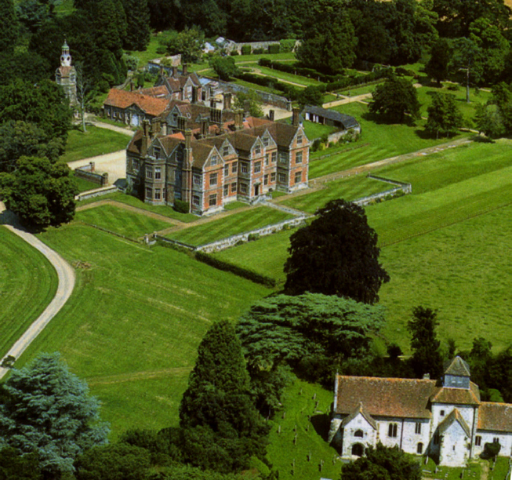

Breamore House and Chapel. Source: <http://www.breamorehouse.com/>, February 10, 2015.

**Figure Two**



1. Ibid., 4. See also 7, 50, 53, 55, 70, 79.
2. Ibid, ix.
3. Ibid., 12, 26, 35, etc.. Page 84 shows an order for two boxes of one hundred cigarettes!
4. Ibid., 18-19.
5. Ibid., 49. See also Ibid., 18, 46, 60, 69, 71.
6. Ibid., 51, 58. His reference to another German as “a pasty-faced student type, [who] talked four languages well” (page 57) probably fits this category of insult as well.
7. Ibid., 60.
8. Ibid., 73.
9. Ibid., 76.
10. Ibid., 91.
11. Ibid., 50, 55, 79.
12. Ibid., 73.
13. Ibid., 91.
14. Ibid., 90.
15. Ibid., 54, 58.
16. Ibid., 72.
17. Ibid., 82.
18. Ibid., 87.
19. Ibid., 83, 87.
20. Ibid., 90.
21. Ibid., 35, 48.
22. Ibid., 84-87.
23. Ibid., 38-42.
24. Ibid., 42.
25. Ibid., 48.
26. Ibid., 81-82.
27. Ibid., 6.
28. Ibid., 6-7.
29. Ibid., 8-9.
30. Ibid, 11-12.
31. Ibid., 31.
32. Ibid., plates between 12 and 13.
33. Ibid., 41.
34. Ibid., 34.
35. Ibid., 28.
36. Ibid., 35.