Pratyush Shakya
B.Sc. (Hons) Computer Science – AI
Level 3

Task 1:
https://app.moqups.com/OXZlSE0HhmANGAgw11eMJYegMSLkCPNS/edit/page/ad64222d5
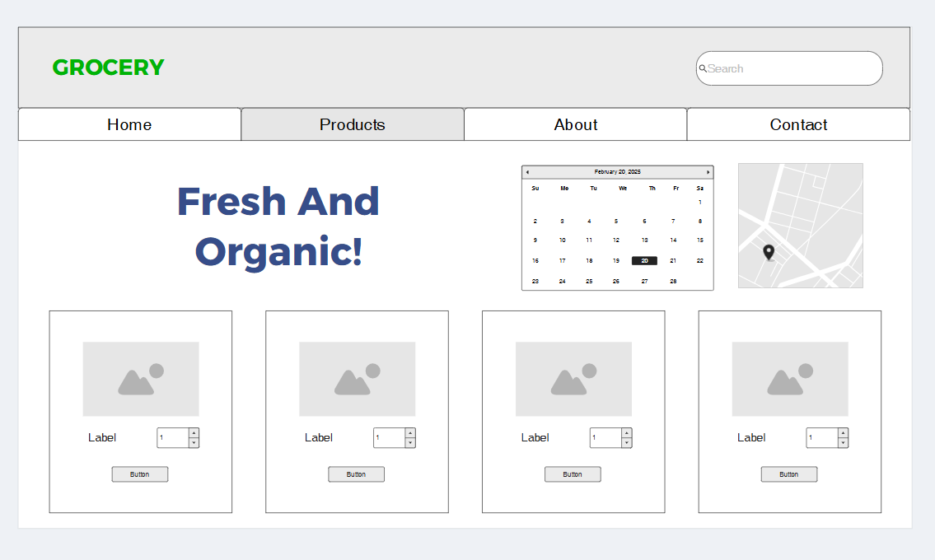

Task 2:
https://app.moqups.com/WKgBKKftEGHq2VyU8qi8UecS8mkvbyHJ/view/page/ad64222d5
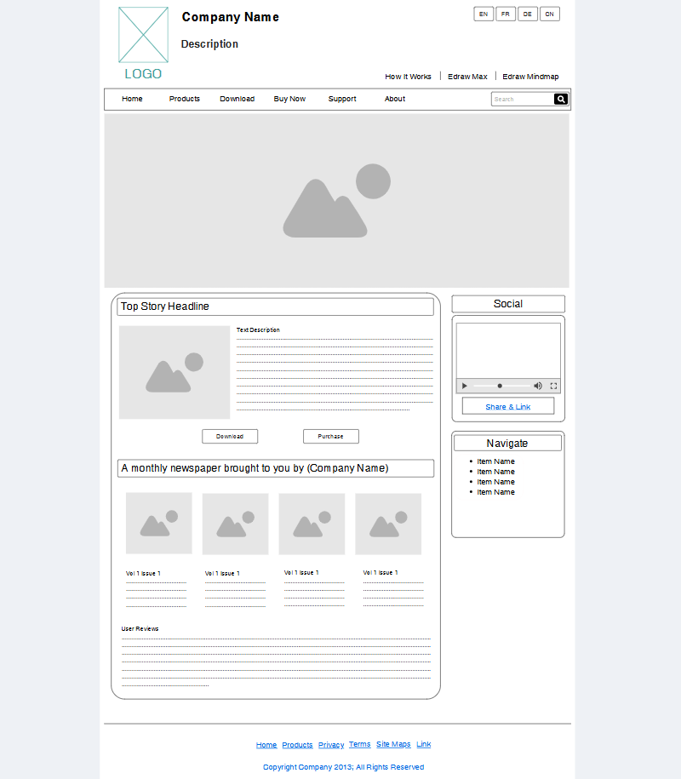

Task 3:
https://app.moqups.com/AR0wxqggjuI4ruyYd0zeiZCAJWnI1hxL/view/page/ad64222d5


