Contents

Overview 3

Introduction 3

Features at a Glance 3

License 3

Legal Disclaimer 3

Found a bug 3

Installation 4

Install required packages 4

Install plugin 7

Using in your application 7

How it works for Interactive Reports 8

Installing a separate rendering engine from Moritz Klein (commi235), for Interactive Reports only. 9

How it works for Interactive Grids 9

Configuration Settings 10

Return Data – for Interactive Report only 10

Maximum Rows 10

Export Hyperlinks - for Interactive Report only 10

Custom Column Width - for Interactive Report only 10

Add Download XLSX Icon to “Download Dialog” 11

IG Fetch Portion (Interactive Grid only) 11

FAQ (How to) 11

Replace default file name (Excel.xlsx) to the custom file name 11

Use this functionality for all Interactive Reports or Interactive Grids in your application 12

Adding a custom download button 12

How to exclude report columns from export/make columns that are visible in Excel but not visible in Interactive Report (not for Interactive Grid) 13

How to uninstall plugin 14

Overview

Introduction

The "**GPV Interactive Report/Grid to MSExcel v2**" APEX plugin provides a simple data export from Interactive Report or Interactive Grid into Microsoft Excel.

Features at a Glance

These features of Interactive Report/Grid are supported:

* Correct export of data types (String/Date/Number)
* Filtering and Sorting
* Control Break
* Computations
* Aggregations
* Highlighting
* Auto adjustable Column Width
* Date/Number Formats
* Custom downloaded file name (see FAQ)
* Can be easy implemented for all Interactive Reports/Grids in an application (see FAQ)

License

The "GPV Interactive Report/Grid to MSExcel" APEX plugin and IR_TO_MSEXCEL, IR_TO_XLSX packages are currently available for use in all personal or commercial projects under both the MIT and GPL licenses. This means that you can choose the license that best suits your project and use it accordingly. Both licenses have been included in this software.

Legal Disclaimer

The program(s) and/or file(s) are supplied as is. The author disclaims all warranties, expressed or implied, including, without limitation, the warranties of merchantability and of fitness for any purpose. The author assumes no liability for damages, direct or consequential, which may result from the use of these program(s) and/or file(s).

Found a bug

If you have found a bug, please send us debug information. To do this, set **Return Data** plugin options to **“Debug Information”.** Try to get your data again. You’ll get text a file with debug information.

Please send this file to [pavelglebov@outlook.com](mailto:pavelglebov@outlook.com). Or if you have skills to fix it become a contributor at [GitHub](https://github.com/glebovpavel/IR_to_MSExcel). You're always welcome!

Installation

Install required packages

This plugin requires IR_TO_XSLX, IR_TO_MSEXCEL, APEXIR_XLSX_PKG.sql and AS_ZIP packages. To install these packages, please use the all-in-one installation script install_all_packages.sql.

To do this, navigate to the “SQL Workschop > SQL Scripts”. Upload file **install_all_packages.sql**.

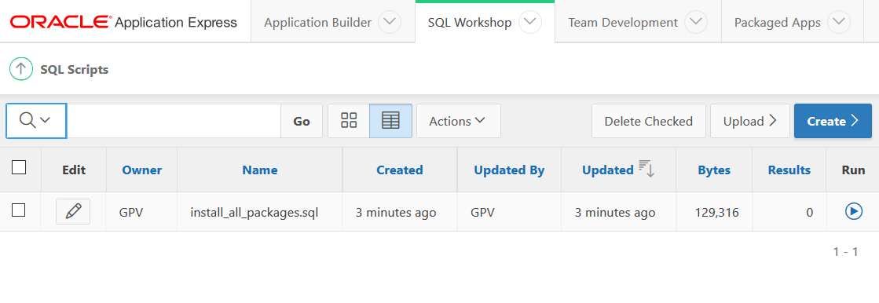

This script will create all required packages. Run this script by pressing the Run-icon.

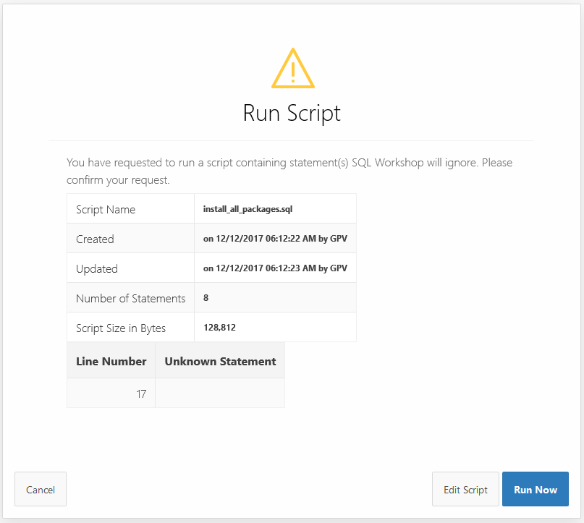

Press “Run Now” button.

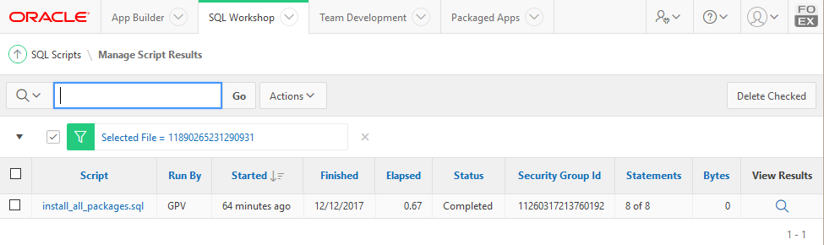

After execution take a look at the execution results. Open the “*Manage Script Results*” tab by pressing the link in the **View Results** column.

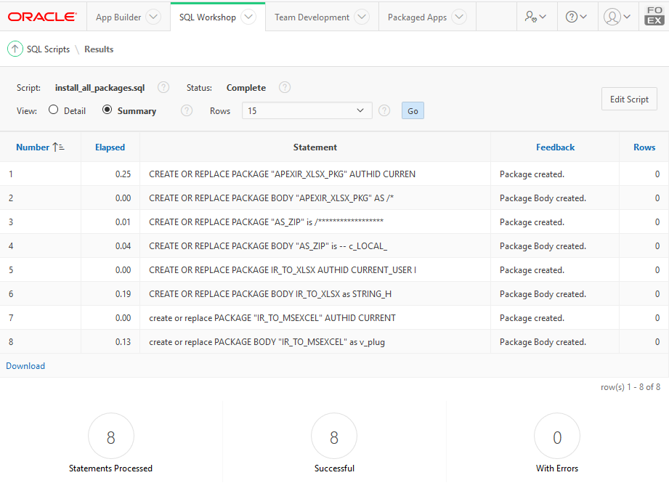

There should be no errors.

Additionally (very rare) you should get access to the SYS.UTL_FILE and SYS.DBMS_LOB packages.

GRANT EXECUTE ON SYS.UTL_FILE TO #USER#;

GRANT EXECUTE ON SYS.DBMS_LOB TO #USER#;

Where #USER# should be replaced to APEX Application Parsing Schema.

Install plugin

Navigate to “*Shared Components > Plug-ins*” and click **Import**. [This Oracle document](https://docs.oracle.com/cd/E59726_01/doc.50/e39147/deploy_import.htm#HTMDB26010) shows you how to upload the plugin-file “dynamic_action_plugin_at_frt_gpv_ir_to_msexcel.sql” and to install the plug-in using the file above.

Using in your application

1. Create a new Dynamic Action on Event “**On Download XLSX[GPV Interactive Report/Grid to MS Excel v2]**”.

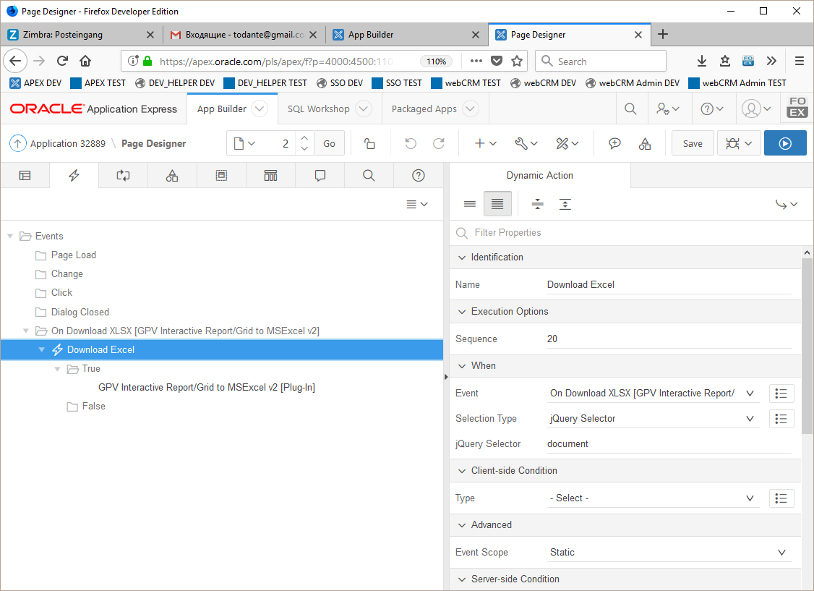

Set

* “*Selection Type*” => “**jQuery** **Selector**”
* “*jQuery Selector*” => “**document**”

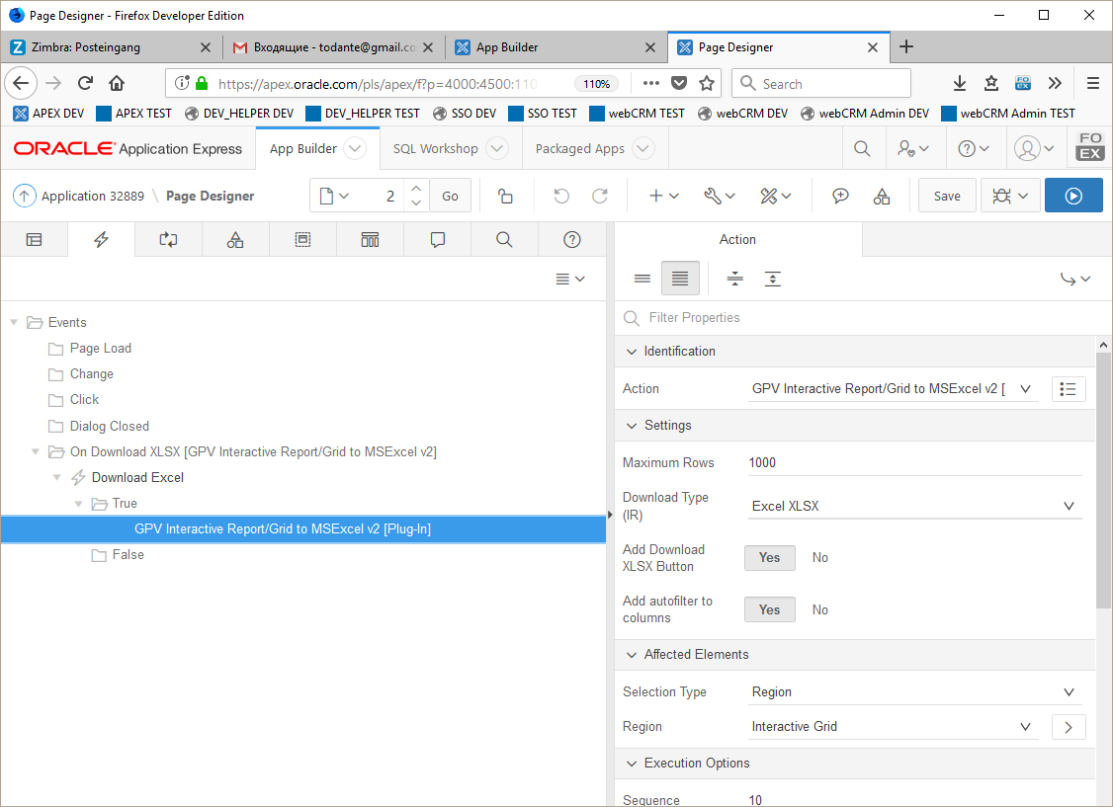

Select “*Action*” => “**GPV Interactive Report/Grid to MS Excel v2**”

The plugin is ready to use with the default settings.

**How it works for Interactive Reports**

The plugin adds “Download XLSX” Icon to the “Download menu”. By pressing on this icon the user gets an XLSX-file.

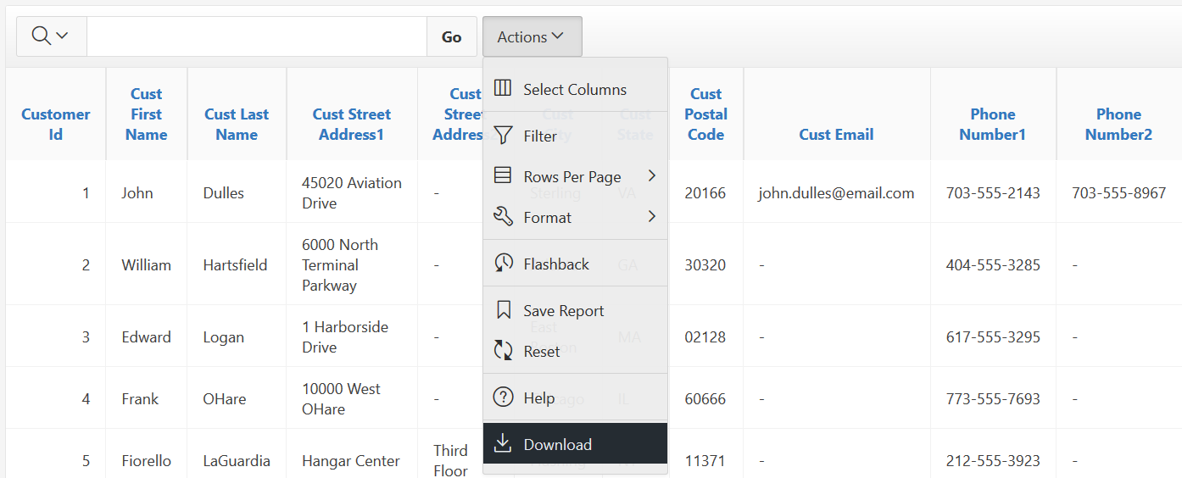

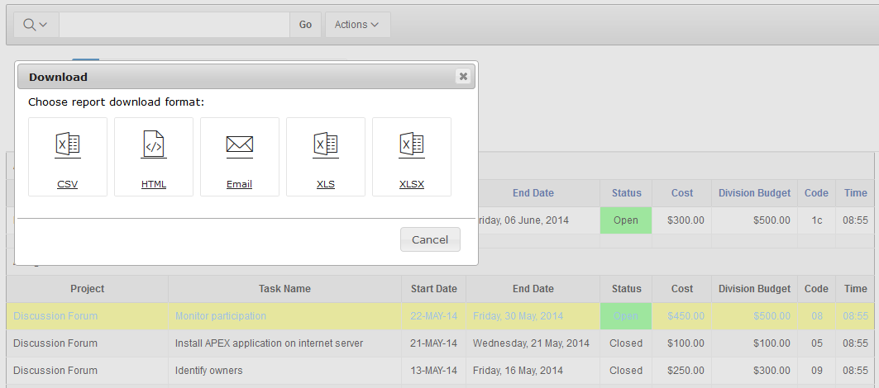

**Installing a separate rendering engine from Moritz Klein (commi235), for Interactive Reports only.**

Download and install all required packages from GitHUB (<https://github.com/commi235/APEX_IR_XLSX>).

The existing (mock) package APEXIR_XLSX_PKG.sql must be replaced.

After that you can use “**Download Type**” => “commi235 Render Engine”

**How it works for Interactive Grids**

The plugin adds “XLSX”-Button to the Actions => Download menu of Interactive Grid. By pressing on this button the user instantly gets an XLSX-file.

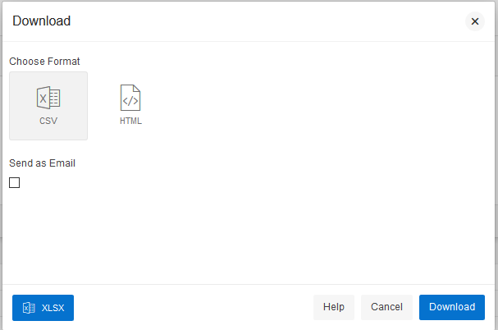

Configuration Settings

Return Data – for Interactive Report only

Choose "Excel XLSX" to return the Interactive Report as a MS-Excel file.

Choose "Debug TXT" to view debug information.

Choose “commi235 Render Engine” to use a separate render engine from Moritz Klein (needs to be installed separately).

Maximum Rows

Rows greater than this value will not be exported.

To export all the rows set the value to 1000000000.

When empty - value from Interactive Report Attributes-> Maximum Row Count will be used.

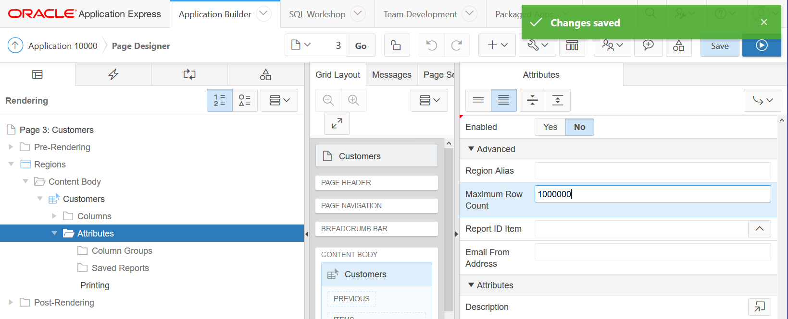

Export Hyperlinks - for Interactive Report only

If is set to “As Hyperlinks”, then IR columns with type “Link” are exported as Links (URL).

Custom Column Width - for Interactive Report only

Comma - delimited list of columns with their widths.

For example, if you want to set width of COMPANY_NAME column to the 15 (Excel width points), and CTL column to the 6 points, you should fill this parameter as:

**COMPANY_NAME:15,CTL:6**

## **Add Download XLSX Icon to “Download Dialog”**

For Interactive Report:

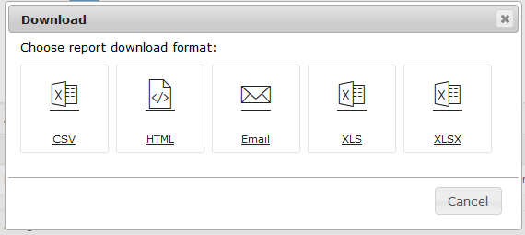

This Icon will be added

For Interactive Grid:



This Button will be added

## **IG Fetch Portion (Interactive Grid only)**

Interactive Grid fetches data from Database by portions of rows. Here one can set a size or each portion of rows. Default – 1000.

# FAQ (How to)

Replace default file name (Excel.xlsx) to the custom file name

When not empty, the value from *Report Attributes*-> *Filename* field will be used.

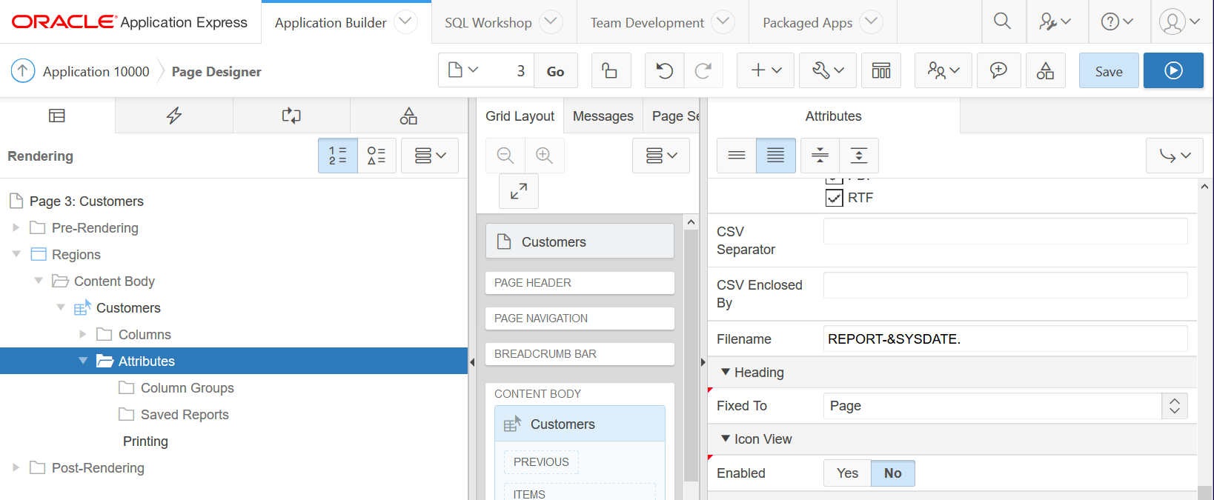

Use this functionality for all Interactive Reports or Interactive Grids in your application

Install the plugin on Page 0 as described above in “**Using in your application**” section.

When you want to exclude this functionality from a couple of pages, use **Conditions**.

The plugin supports Interactive Grids and interactive Reports simultaneously.

Adding a custom download button

1. First create a Button
2. Create Dynamic Action on Event “**Click**” for this Button.
3. Create True Action an set “*Action*” to “GPV Interactive Report/Grid to MSExcel v2 [Plug-in]”.
4. In “*Affected Elements*” Section set “*Selection Type*” => “Region”.
5. Set “Region” to your Interactive Report or Interactive Grid region.

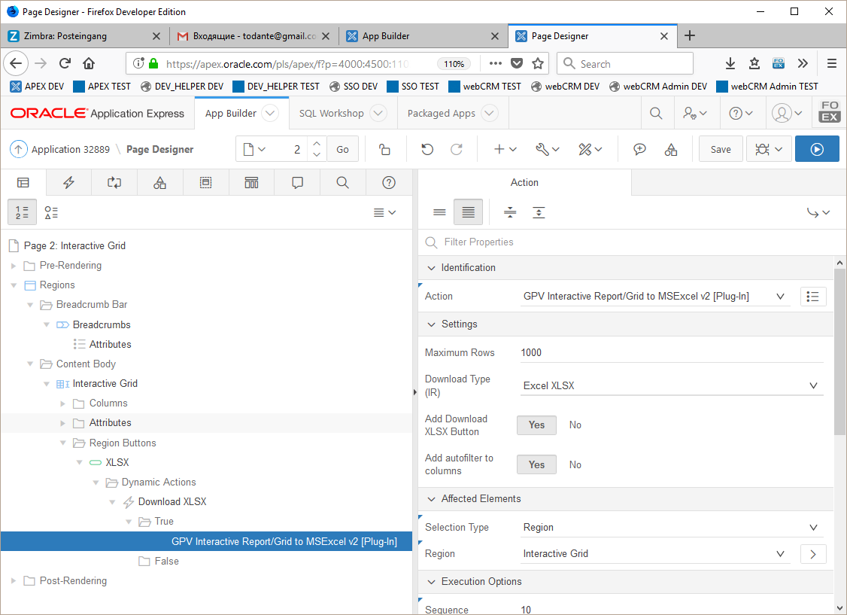

How to exclude report columns from export/make columns that are visible in Excel but not visible in Interactive Report (not for Interactive Grid)

Use **Conditional Display** column property for this.

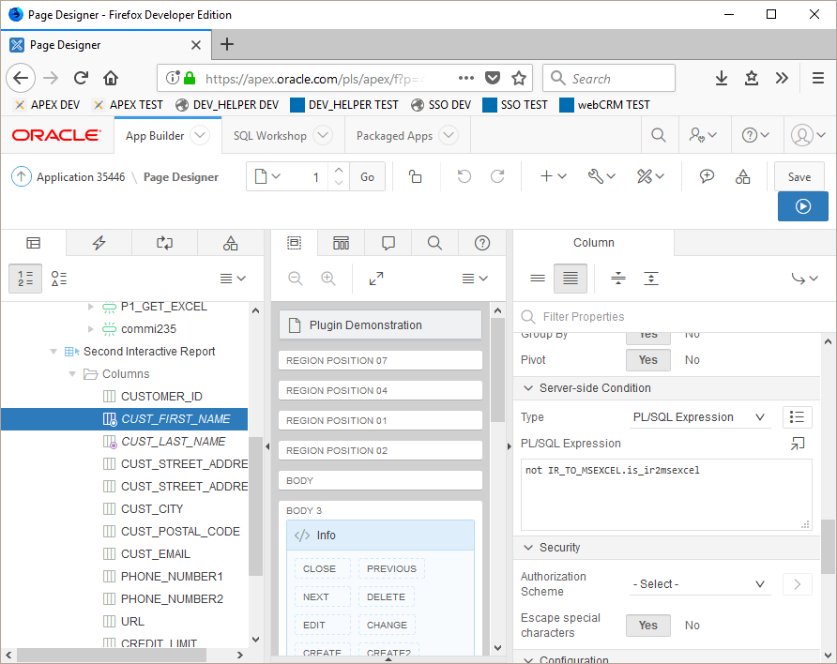

Use ***not ir_to_msexcel.is_ir2msexcel*** Expression to exclude column from export,

And  ***ir_to_msexcel.is_ir2msexcel*** Expression to make column visible on export only.

How to uninstall plugin

First make sure that the plugin are not used in your application components any more:

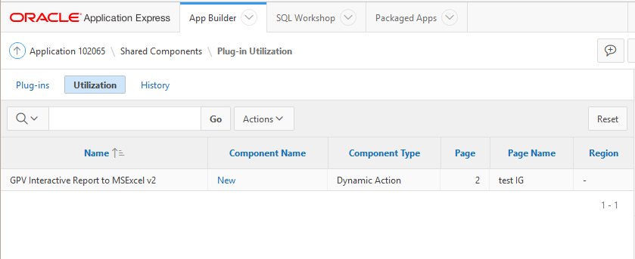

If Utilization Report don’t contain “GPV Interactive Report/Grid to MSExcel v2” records, on plugin-page appears Delete – Button.

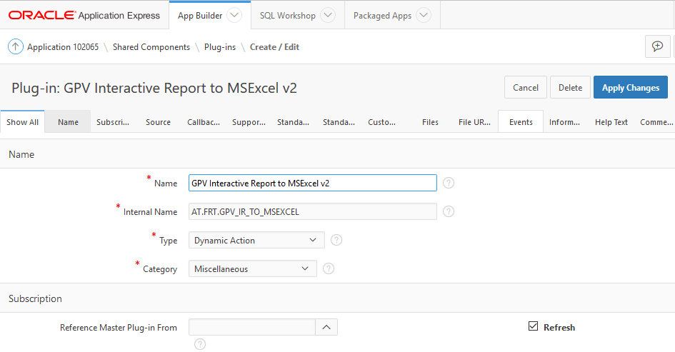

Drop all plugin packages:

drop package IR_TO_XLSX;

drop package IR_TO_MSEXCEL;

drop package APEXIR_XLSX_PKG;

drop package AS_ZIP;