Przemysław Cich, gr. 1, IS IMiIP, st. 2

Multiscale Modelling – I Report

1. User Interface

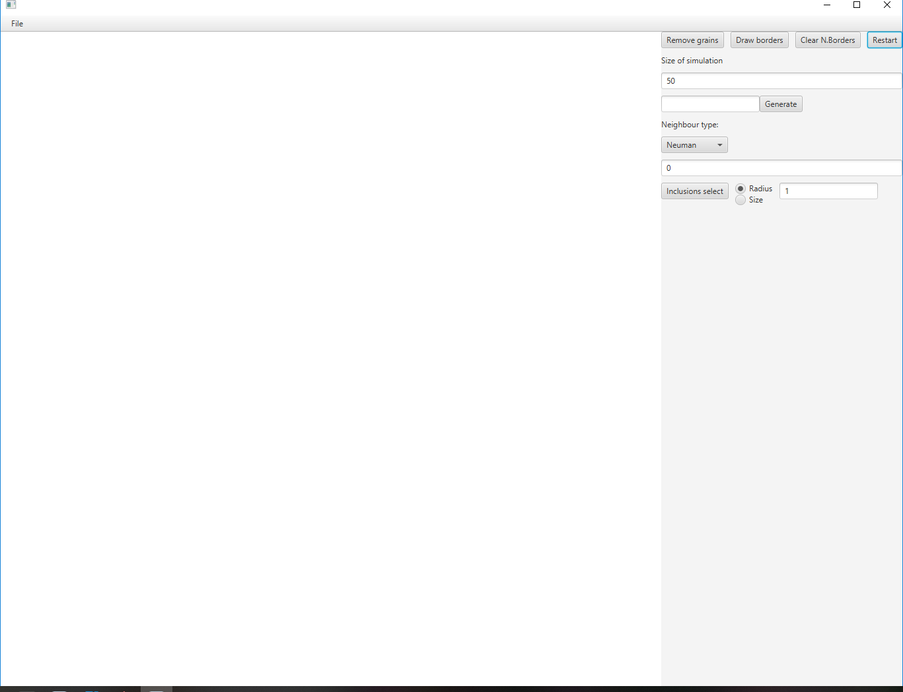Figure 1: Application GUI

Application consist of two major part. Working area, which allows to create and display grains and their growth, and control menu. Menu allows user to adjust many parameters of the grain growth simulation. The most important ones are: size of the simulation, automatic generation of grains, inclusion generation. The application is also able to save and load microstructure from and to bpm or json file via top menu.

Detailed UI description:
- Top buttons ( Reset, Draw borders ) - applies global changes to the workarea ( reset, substructure etc )
- Size of simulation textfield – specify simulation size
- Neighbourhood type – choice between curvature or moore grain growth
- Generate button and textfield – generates given nyumber of grain
- Inclusion select – allows to change select mode to inclusion ( clicking on workarea will generate inclusion)
Least, clicking on the workarea with left-mouse button will generate single grain, clicking on exsisting grain will mark it for substructure generation and right click will merge it to single grain.

2. Technology

Project was written in Kotlin Programming Language with the use of TornadoFx library ( Kotlin dsl port for javaFX). Technology was chosen on personal preferences and desire to learn new skills.

3. Scenarios

- Firs scenario: grain growth of 30 grains, squere inclusion size 4 , standard neuman neighbourhood:
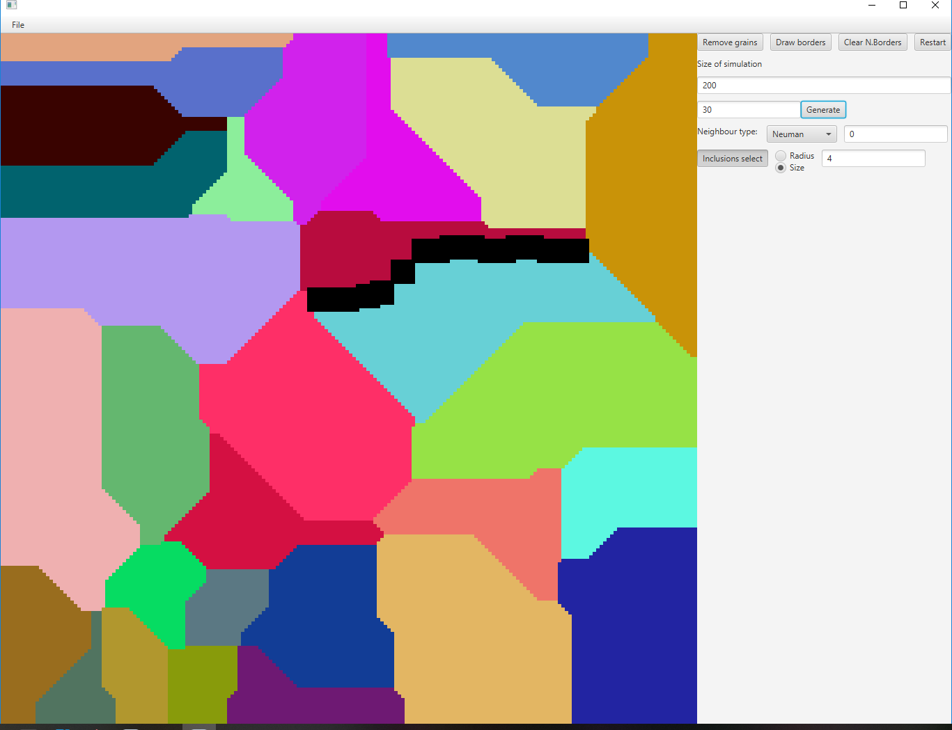Figure 2: Grain growth with inclusion
- Second scenario: Grain growth of 40 grains with neighbourhood more 2 (curvature ingluence) value 50 , and substructure:
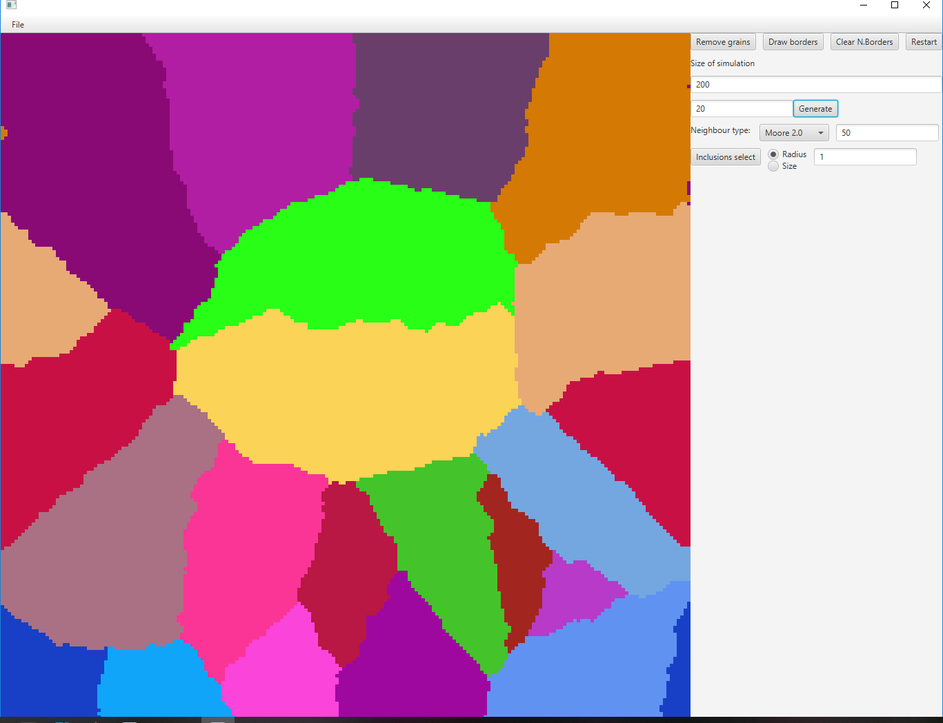Figure 3: After curvature influence simulation

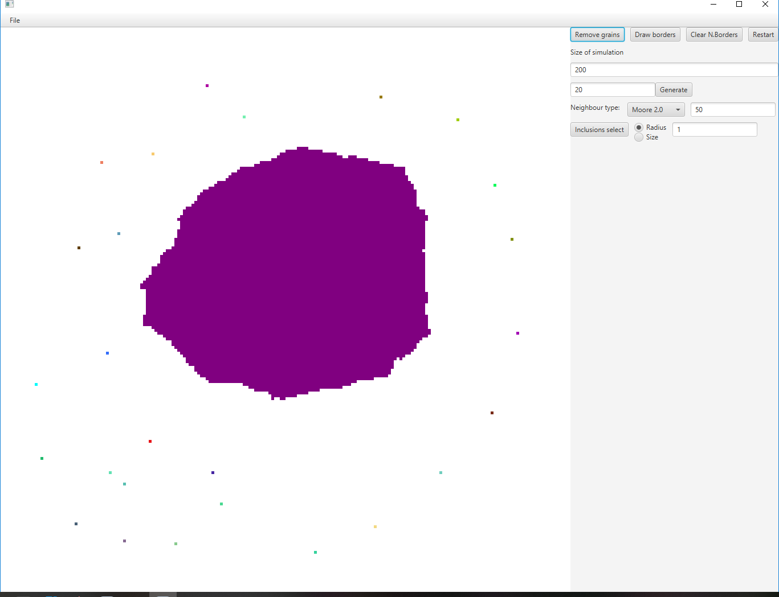Figure 4: Selecting grains that are not ereased, and generating new ones
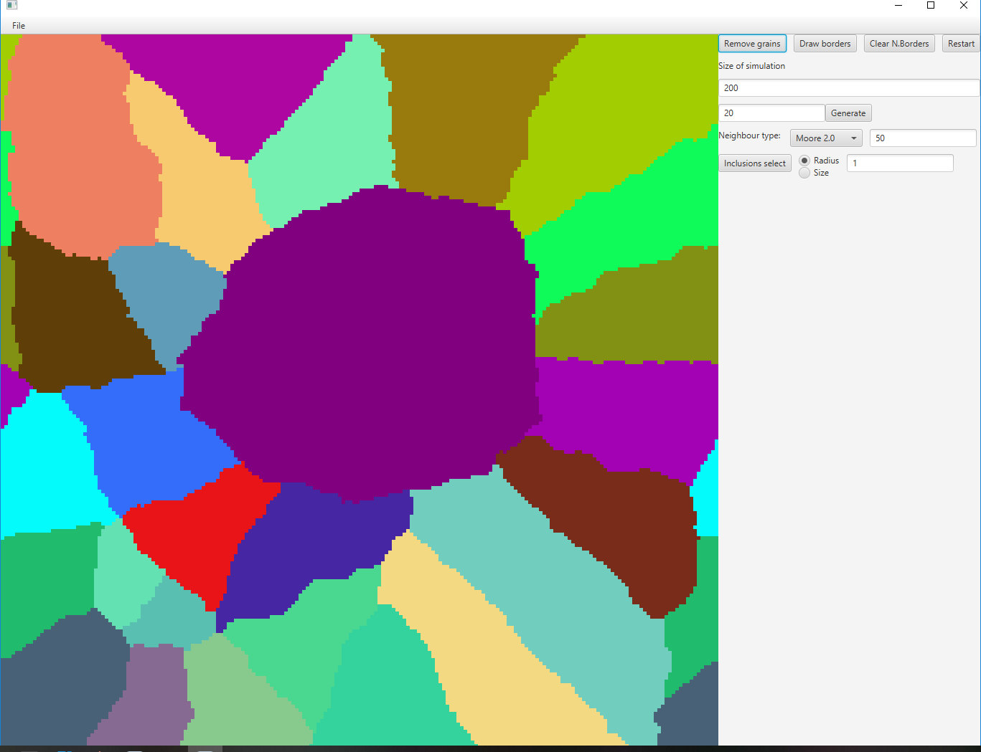Figure 5: Final simulation

3. Grain growth of 30 grains, creating boarders of selected ones, another simulation, neighbourhood neuman:
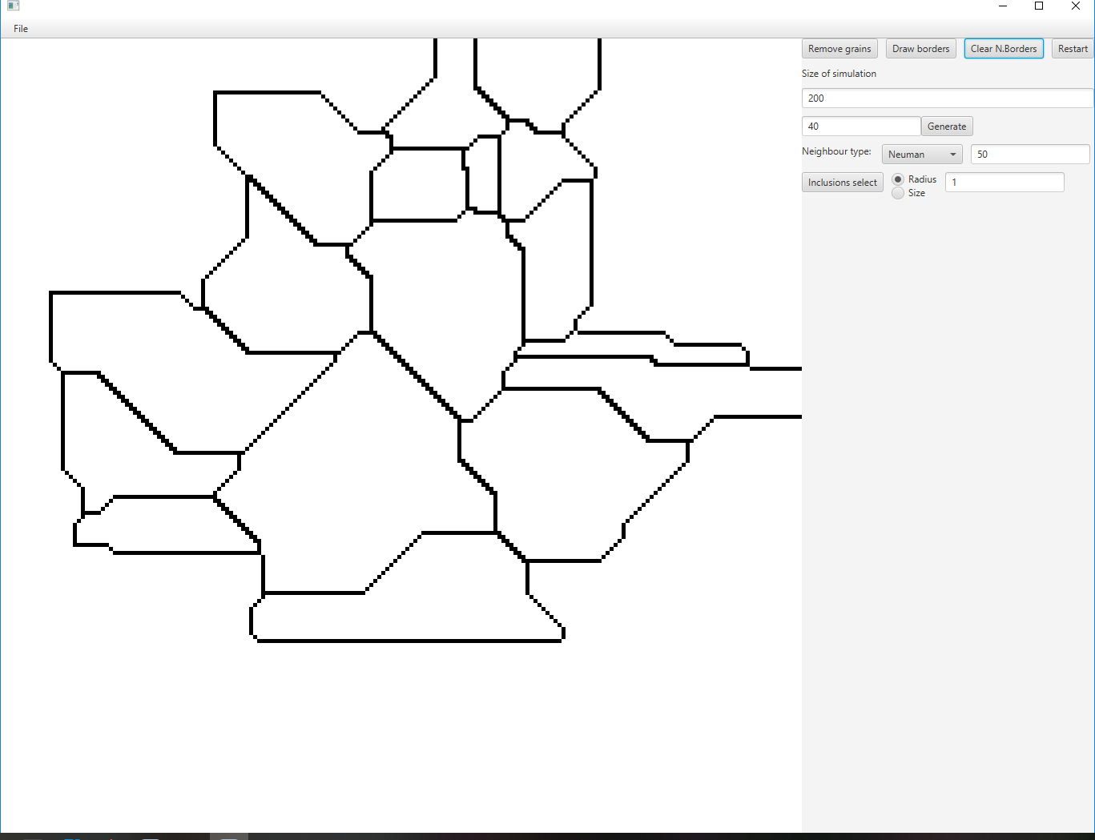Figure 6: Grains growth and borders drawing ( with selection)

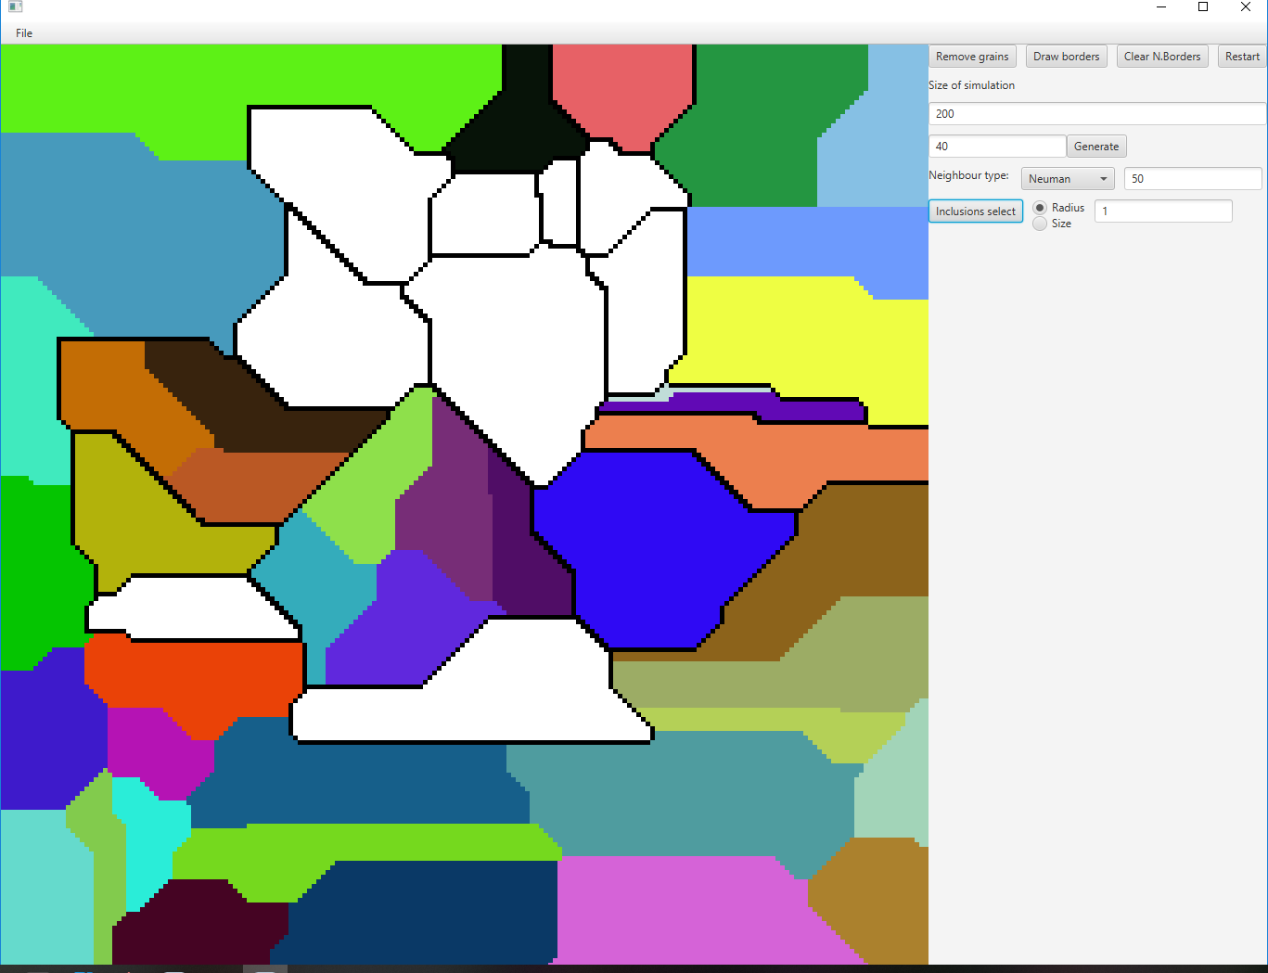Figure 7: Final simulation

4. Real structure comparison

- High Copper alloy
- Form: Strip
- Alloy: C17200
- Temper: TD04
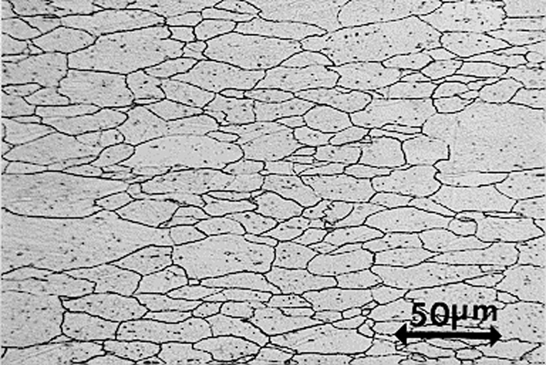Figure 8: Real microstructure

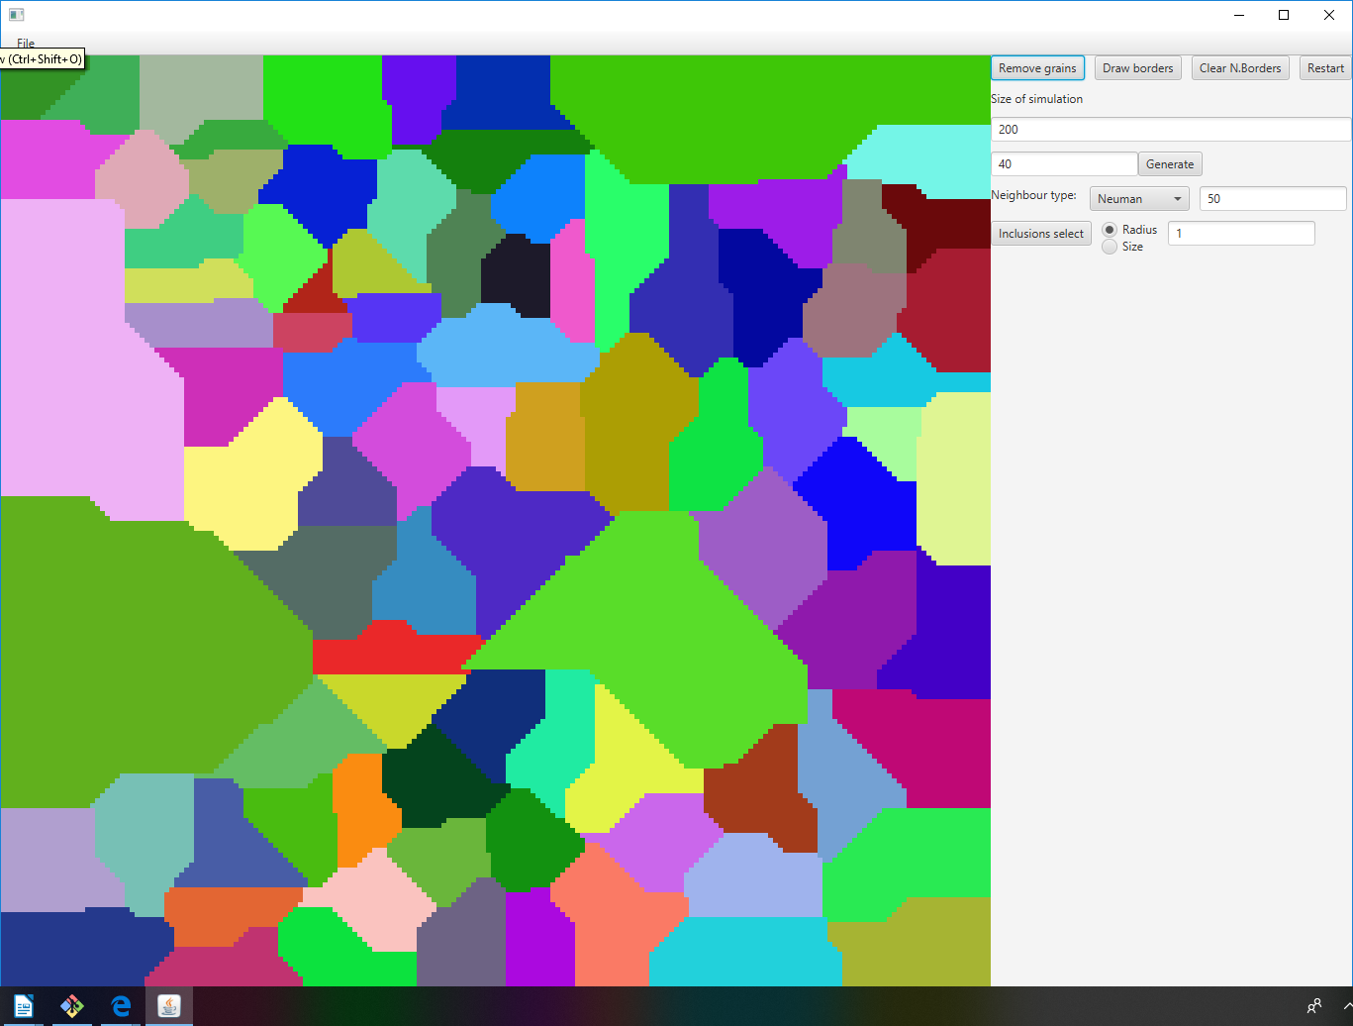Figure 9: Simulated microstructure

The simulation closely resembles real life example, the only issue is the middle (green) grain which became straight and unnatural (probably cause is the size of the simulation ).

- High Copper Alloy
- Plate
- Alloy: C17200
- Temper: M20

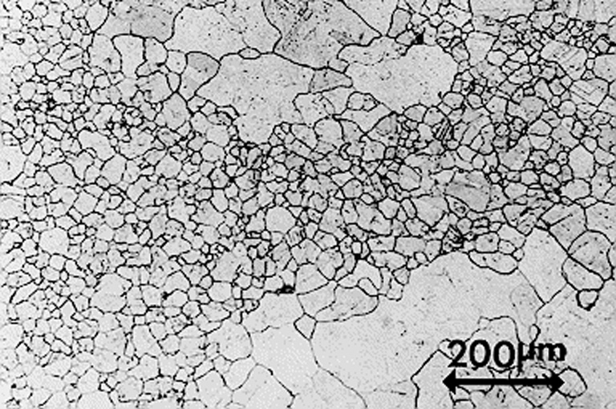Figure 10: Real Microstructure

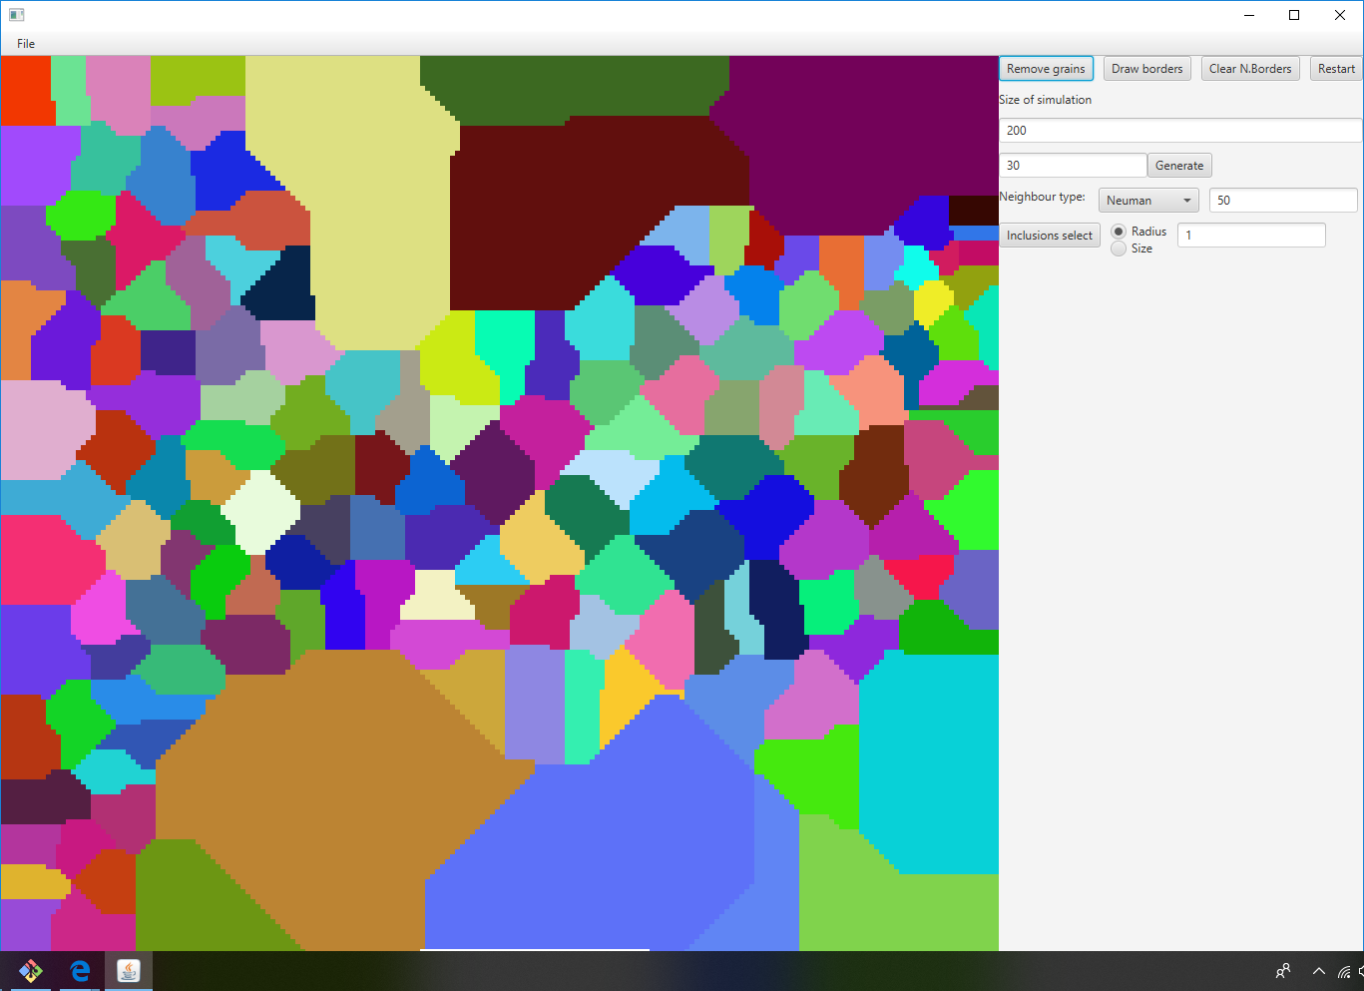Figure 11: Simulated microstructure

In this case the simulation and real microstructure are also very similar. The size and shape of the grains are close enough to the material. Again the issue of the straight edges remains, but because the grains are much smaller ( especially the ones inside ) it is less of a problem.

5. Summary

After testing various configurations and settings, I discovered that program allows to simulate many typical microstructure, it’s ui and functionality while minimal allows for free manipulation of structure. Tested scenarios shows that it is fairly easy to generate grains, perform growth, removed some grains and start growth anew. It is also possible to create only borders of grain and simulate grain growth in this domain. Comparison of real and simulated microstructure, shows that there are very similar and their. The size, and also the shape ( after neuman neighbourhood ) is very similar to original alloy. The only real problem is different number of grains, but that can be compensated by adding more grains and making domain bigger. The performance of the small simulation in acceptable. In low resolution of simulation ( less then 100x100) it is very fast. However it degrades fast ( quadratic ) with increase in size , and bigger simulation are significantly slower.

References

Copper alloys and micriostructures:
https://www.copper.org/resources/properties/microstructure/be_cu.html

