A) Practical Exam for 2026 Spring – Page 01
Subject Code | SBA301
Subject Name | Integrate single page application with Spring Boot
Time | 90 minutes (include submit time)
Exam Type | PE Practical Exam (Trial)
Note
a) Allow student to connect to Internet within 10 minutes when setting up project at the beginning examination
b) Student can only use resources in local computer
c) Student must modify backend app to allow connection from ReactJS app

B) Exam Requirements
Develop the following pages in ReactJS (latest version) and React-Bootstrap using axios to connect with provided RESTful API run on Spring Boot.
Project Code |  |  |  | SMS
B.1 Screen Layout

B.1.1 Screen Layout of Shoes List

Logo |  |  |  |  |  |  |  |  |  |  | Date: dd/MM/yyyy
 | Shoes List
 | Category: |  |  | name:
 |  |  |  | Shoes Name:
 |  |  |  |  |  |  |  |  | Filter |  | Add New
 | Shoes List
 | # | Shoes Name |  |  | Category |  | Manufacturer |  | Price(đ) |  | Action
 | 1 | Giày Thể thao |  |  | Sport |  | Bach Dang |  | 20 | Delete | View
 | Show x of y records |  |  |  |  |  |  |  | Previous 1,2,3 …. Next
Screen 1: List Screen

 |  |  |  |  | Confirmation
 |  | Are you sure you want to delete shoes "Giay The Thao"?
 |  |  |  |  | Yes |  |  |  | Close
 |  |  |  |  | Screen 2: Confirmation Screen

Screen Definition
# | Field name |  | Mandatory | Length | Description |  |  | Type
1 | Shoes Name |  | Yes | 100 |  |  |  | Text box
2 | Category |  | Yes | NA | It is one in the list get from API |  |  | Dropdown
3 | Shoes List |  | Yes |  | Display the list of shoes matched with filter conditions
4 | Add New |  |  |  |  |  |  | Button
5 | Filter |  |  |  |  |  |  | Button
6 | View |  |  | NA | Go to “View Details“page |  |  | Hyperlink
7 | Delete |  |  | NA | Delete the shoes on the row |  |  | Hyperlink

Functional Requirements |  | Mark
1) | a) When the user go to the page, all shoeses in the database will be displayed in the list.  If there is no result, the message “No records found” is displayed in the result list  b) When the user enter filter conditions and click filter buttons, the software will query data and display the result matching with search condition  c) The result need to have pagination
2) | When the user click on "Add New" button on the Shoes List, the software will display the Add New Shoes screen.
3 | When the user click on "Delete" button in a row on the shoes list , the software will show a dialog confirmation  a) If user select "Yes" option, the software will  - call API to delete the shoes from database  - show the "Deleted successfully" message on the screen  - and call API to update the shoes list  b) If user select "Close", the software close the dialog
4 | When the user clicks on “View”, the software will display the “View Details” page contain the detail information

B.1.2 Screen Layout of Shoes Details

 |  | VIEW DETAILS
 |  |  |  |  |  |  | Shoes Name: | Giay The Thao
 |  |  |  |  |  |  | Manufacturer: | Bach Dang
 |  |  |  |  |  |  | Type: | Sport
 |  |  |  |  |  |  | Price (đ): | 10000
 |  |  |  |  |  |  | Production date: | 20/01/2025
 |  |  |  |  |  |  | Import Date: | 25/01/2025
 |  |  |  |  |  |  |  | Quay Lai

Screen 3: Detail Screen

B.1.3 Screen Layout of Add New Shoes

Logo |  |  |  |  |  |  |  |  |  | Date: dd/MM/yyyy
 | Add New Shoes
 |  |  |  | Shoes name:
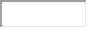
Price:
 |  |  |  | Manufacture:
 |  |  |  | Production Date |  |  |  | Import Date | 
 |  |  |  | Category:
 |  |  |  |  | Save
 |  |  |  |  |  |  | Back
@Copyright 2026

Screen Definition
# | Field name |  | Mandatory | Length | Description |  |  |  | Type
1 | Shoes Name |  | Yes | 100 | No duplicate |  |  |  | Text box
2 | Price |  | Yes | 5 | Greater than 0 and less than <10000 |  |  |  | Text box
3 | Manufacturer |  | Yes | 100 |  |  |  |  | Text box
4 | Production Date |  | Yes | 10 | Format dd/MM/yyyy |  |  |  | Textbox
5 | Import Date |  |  | 10 | Format dd/MM/yyyy |  |  |  | Textbox
4 | Category |  | Yes | NA | It is one in the list get from API |  |  |  | Dropdown
5 | Save |  |  |  |  |  |  |  | Button
6 | Back |  |  | NA | Go to “Shoes List“page |  |  |  | Button

Functional Requirements |  | Mark
1) | When user enter data, and then click on “Save” button  a. Validate the input data as requirements in screen definition  b. Call API to store data, show the "Created new shoes successfully"  c. and then display the new record in the list  In case, the input data is invalid, the system will show the detailed error message
2) | When the user clicks on “Back” button, the software will display the Shoes List screen. The page is displayed same with the page when the user goes to the app

B.2 User interface
User interface Requirements
1) | Screen must have layout as described in Screen Layout section
2) | Item label must follow the description in Screen Layout section
3) | Graphical design must be clear, high contrast and understandable

B.3 Project structure requirements
3.1 | The project folder must be in Visual Studio Code format and the name must following convention : <ClassName>_<StudentID>_<ProjectCode>_PE
3.2 | The project must be in React JS (latest version), React-bootstrap and using Vite, JavaScripts type run on NodeJS
3.3 | Use latest version of React JS, React-Router-DOM, React-Bootstrap, axios and Vite for the project  Note: Do not allow use other libraries
3.4 | Component name and component attributes must be named according to requirements of the application
3.5 | Please zip the project folder and then submit the zip file to EOS  Note: Follow the submit guideline in the enclosed document when submit your project
3.6 | The application must be configured to connect to REST API run at port 8080
3.7 | Path to access the application must be http://localhost:5173/
3.8 | Project folder must contain jsconfig.json file  {  "compilerOptions": {  "baseUrl": ".",  "paths": {  "*": ["../../node_modules/*"]  }  }  }
Notes:
If the provided API project gets errors, please update the API project to run the API project for developing NodeJS module. But please note all errors that you found and then enclosed with project submission

B.4 Project configuration requirements
Configuration in NodeJS server for the project must follow the convention
# | Requirements
1 | Server port | 5173
2 | Server name is default | localhost
3 | Path for the application page | /

B.5 Database and URL configuration for REST API
The following URLs and database configuration for RESTful API. Please follow these configurations for use RESTful API application
- Configuration for application.properties
The following configuration can be changed to run RESTful API application if necessary but when submitting the project these configurations must be kept same in the table
# | Items
1 | Database name | SBA301_2026_PE
2 | spring.datasource.password | sa
3 | spring.datasource.username | sa
4 | Add codes for backend to allow connection from Frontend

- URL of API Description
The following table describe the RESTful API
# | Path | Method | Description
1 | http://localhost:8080/api/shoes/search | GET | Get all shoes objects by condition
2 | http://localhost:8080/api/shoes | POST | Create shoes
3 | http://localhost:8080/api/shoes /{id} | PUT | Update shoes
4 | http://localhost:8080/api/shoes /{id} | DELETE | Delete shoes
5 | http://localhost:8080/api/categories | GET | Get all shoes category
6 | http://localhost:8080/api/shoes/{id} | GET | Get shoes detail

B.6 Grading Policies
The following items are mandatory requirements. If one of item is violated, your result will be graded zero.
(Các mục sau là các yêu cầu bắt buộc phải tuân thủ. Nếu bài làm vi phạm một trong các mục sau, bài làm sẽ bị chấm điểm 0)
# | Item
1 | The requirements noted in the following sections:  B.3 Project structure requirements  B.4 Project configuration requirements

C) PE Submit Guideline
Please follow the following steps to delete node_modules folder in the project and then zip project sources
Step 1: Go to folder contain the project
Step 2: Open the project folder, the folder structure like below
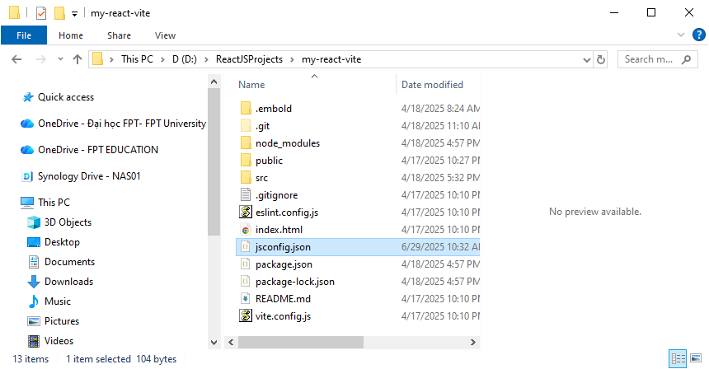
Delete this folder
Step 3: Delete “node_modules” folder
Note: Should check carefully to avoid mistakes. You should copy the project to other folder to backup before doing this task
Step 4: Go to folder that you opened in the step 1
Step 5: Right click on the project folder name and then select “send to” “Compressed (zipped) folder”

