X. Project Plan

Author: Wojtek

X.1 Specification

The following chapter describes the specification of the developed system. It is based on the customer requirements. Mehr text

X.1.1 Project Scope

The system shall support a driver with taking his car out of a parking lot. The system is designed to work with the cars of the customer. It should use sensors, build around the car, to take the car out of every parking position in the most convenient and safe way. The system should provide a graphical user interface within the car display, to provide overview over the process of taking out the car.

X.1.2 Supported parking positions

The two main parking positions shall be supported, as shown in the pictures below:

1. Lengthwise parking

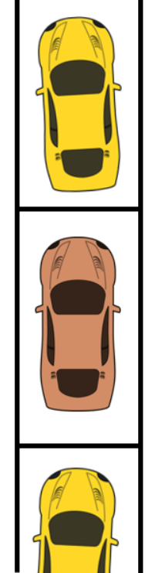

1. Transversal parking

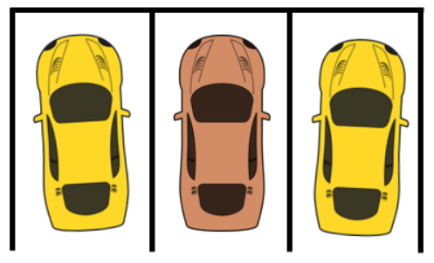

A car moved out of a lengthwise parking lot has to face the same direction as before being taken out, while a car taken out of a transversal parking lot is moved 90\* anti-clockwise when being taken out. In both cases, the cars have to leave the parking lot entirely, and must not enter the opposite lane at any time of the process.

X.1.3 Sensors

The system uses a number of sensors placed on and within the automobile. They are used to ensure a secure process of taking out the vehicle off the parking lot:

* Speed Sensor

Acquire the current speed

* Distance Sensor

Acquire the distances between the vehicle and obstacles

X.1.4 Required Controls

The parking system requires the control or a possibility to interact with a number of car components to work properly and to its full potential:

* Transmission control

Switch between forwards and reverse driving

* Engine control

Set the desired car velocity

* Board computer control

Display the user interface

* Brake control

Decrease the velocity

* Steering control

Change the vehicles direction

The board computer is not mandatory for the system to work, but highly recommended.

X.1.5 Obstacles

The parking assistance system shall be able to take obstacles into account. There are two kinds of obstacles we are facing when running the process of taking out a car of a parking lot:

Static obstacles:

Static obstacles are not moving themselves. Their distance towards our vehicle controlled by the parking assistant system only changes by the movement of the vehicle itself. We do not have to predict where the obstacle might be positioned at some other point in time.

Static obstacles are objects like:

* Parked cars
* Houses
* Walls
* Burgundy
* Trees

Dynamic obstacles:

Dynamic obstacles have a movement, or the potential to move during our process of taking out the car of a parking lot. Their distance to our vehicle can change without our car having any velocity. If there is any possibility, an obstacle might interfere with our vehicle, or the predicted path of our vehicle, it has to be taken into account during the process. If the distance between an obstacle and our vehicle is reducing by a higher ration than the velocity of the car, the car has to stop.

Dynamic obstacles are objects like:

* Moving cars
* Human beings
* Animals