X. Project Plan

Author: Markus

On the start of a project there are several things which have to be defined for the organisation of the working process. Based on the specification which is approved and signed by the client the initial planning is a crucial step to achieve a successful project outcome.

There are some major aspects which have to be considered when planning a project:

time which Is needed to fulfill the accruing tasks

resources which are responsible to fulfill tasks

costs which emerge through the use of resources over a specific time

Planning these aspects is the initial step during the project. The period of time is about 5 months while every team member’s work hours are determined with about 100 hours.

X.1 Planning aims

The planning of the project doesn’t only exist to have a documentation about what to be done. A good planning provides the possibility to measure the impacts on the time/cost of different occuring scenarios during the project. The SMART rule defines how project objectives should be defined:

**S**pecific: goals should be defined clearly

**M**easurable: progress should be measurable

**A**ttainable: goals should meet specific targets

**R**easonable: the goal should be achievable and realistic

**T**ime-bound: the goal should be bound to a fixed date

In the next step, which is the definition of tasks, these rules have to be considered.

X.2 Task overview

The initial step after defining the specification is to create and schedule the tasks and milestones to achieve the fulfilling of the requirements. The aim is to generate an overview over the things which have to be done and when they have to be done. So each task gets a meaningful description, an estimated duration and a starting date. To achieve this overview, the freeware tool GanttProject has been used.

Normally not every task which has to be done can be defined beforehand, because sometimes the customer requirements change during the development or it wasn’t possible to discover all necessaray tasks on project start.

Because of the fact that the time period for this project is 5 months, while the work hours of each team member is determined with about 100 hours, it was decided that the initial planning starts in December while the actual development of the system starts in March so that between these months the team members are able to concentrate on working at their company and on other master courses.

The final project plan for the TSMW project looks as follows:

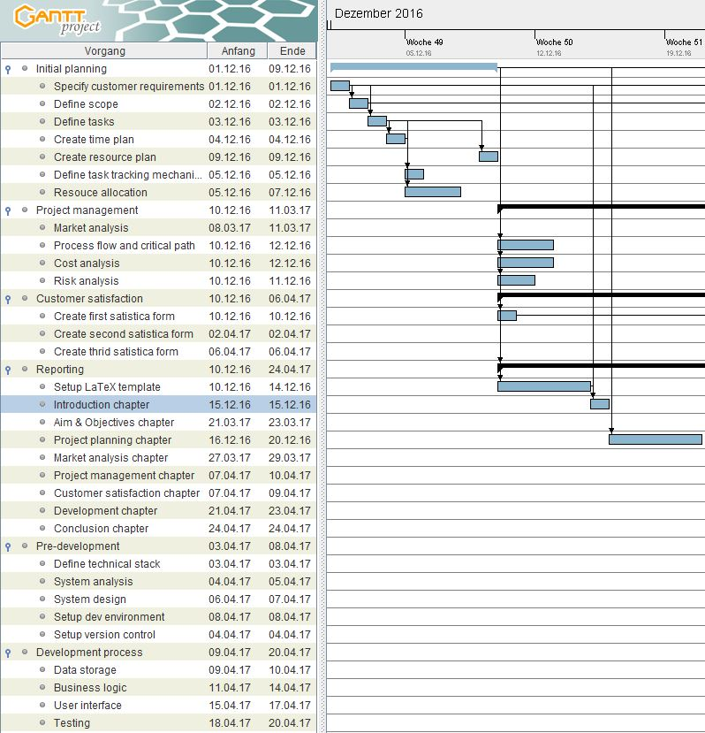

Screenshot 1 - final project plan

The screenshot shows the layout of the GanttProject application as well as the defined tasks for December 2016 in the chart. It also shows the aspect that the tasks aren’t independent from each other, e.g. the tasks can only be created if the scope of the project is defined.

X.3 Resource overview

As soon as the tasks are defined it is necessary to plan the human resources. The module description states that each team member participates with 100 hours of work in this project, so the tasks must be distributed consistent. It’s the aim that each team meber works on the tasks which are related to their role, however this can’t be achieved 100% accurately, so it may be the case that the software architect works on a project management related task.

Because the time period of the project is almost 5 months, the initial planning tasks are executed in December, while the real project work begins end of February. This was coordinated with the acceptance of alle team members.

The resource overview was also created with the freeware tool GanttProject and looks as follows:

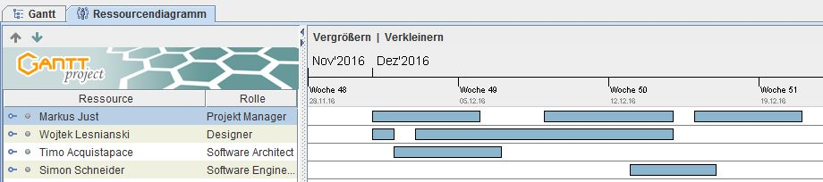

Screenshot 2 - resource plan december

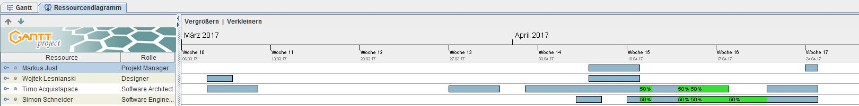

Screenshot 3 - resource plan march/april

X.4 Cost overview

Die Kosten, die diese sProjekt mit sich bringt entstehen hauptsähclich aus zwei Quellen:

Personalkosten

Lizenzen für Entwicklungstools

X.5 Task tracking mechanism

GanttProject doesn’t only provide mechaisms for project planning, it also provides the possibility to track the current process. This can be achieved by setting the initial plan as the base plan and after that, the real time spent on a task can be entered. The GanttProject tool shows the impact on the whole time plan when a task is finshed late/early as it can be seen below:

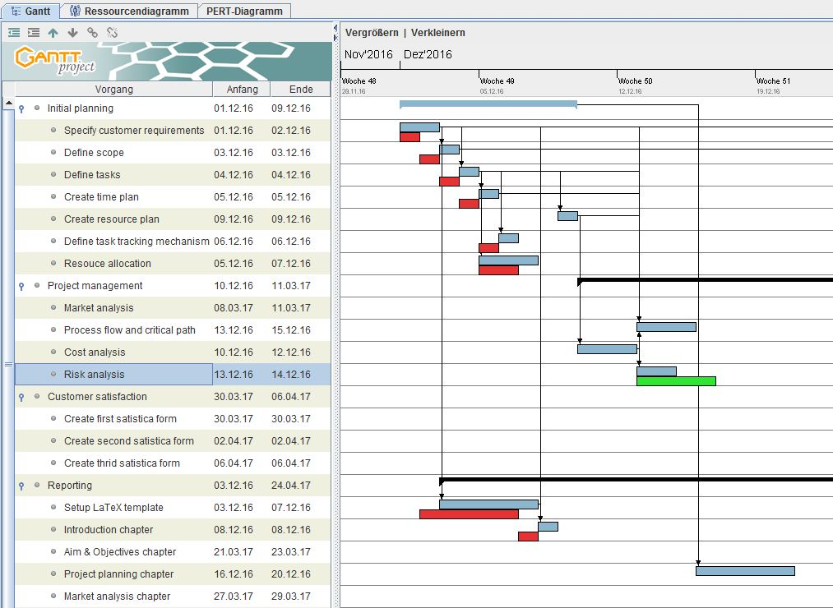

The grey bars show the actual progress of the project. The red/green bars show the differences to the initial plan. If the bar is red it means the initial estimated time plan for this task couldn’t be followed for this task. If the bar is green it means this task has been finished earlier than expected.

Each team member should enter the beginning and the duration of the tasks he finished to make sure that the progression of the project goes forward as it was planned and the project can be succesfully finished until the deadline.

X.6 Critical path

Das Planungsinstrument des kritischen Pfads stammt aus der Netzplantechnik, mit deren Hilfe logische Anordnungsbeziehungen und Zeitdauern von Vorgängen eine wichtige Rolle spielen. Eine Kette von Aufgaben, deren Dauer die Gesamtprojektdauer bestimmt, wird dabei kritischer Pfad („critical path“) genannt. Diese Aufgaben sind also voneinander abhängig und haben keinen Zeitpuffer. Verzögert sich beispielsweise die Lieferung eines Materials um 6 Tage, so wird sich auch der Endtermin des Projekts um diese Zeitspanne verschieben.

Der kritische Pfad kann zwar keine Engpässe verhindern, zeigt jedoch Risikostellen auf und ermöglicht so den Einsatz von präventiven Maßnahmen gegen eine Verzögerung im Projektabschluss, wie zum Beispiel die Umverteilung von Ressourcen. Andere Aufgaben, die über Pufferzeit verfügen, können innerhalb dieser ohne Auswirkungen auf das Projektende verschoben werden.

Um den kritischen Pfad zu visualisieren, müssen zunächst alle Start-und Enddaten von Aufgaben sowie deren Abhängigkeiten definiert werden. Anschließend wird jede Aktivität als Vorgangsbalken dargestellt und diese untereinander, je nach Abhängigkeit, durch Pfeile miteinander in Beziehung gesetzt.