X.1 Resource Allocation

Available resources were always one of the biggest goods Project Managers had to work with, to keep customers happy. Especially with the growing agile approach popularity, where development iterations become smaller, it is of high importance to use all resources the most efficient way. Efficiency in this case, does not always mean, to put the most fitting developer on a task, but also consider where the other resources are allocated at the time. Putting a developer on a task that is not fitting him perfectly might still be a good idea if another developer would not be able to do anything otherwise.

There are various methods which aim at the best possible resource allocation and they all first require the user, possibly the project manager, to break down jobs in tasks and classify the tasks and the resources in a specific way. The better the breakdown and the classification is, the better the project manager can allocate his resources.

For this project we will use the method described in the lectures of Dr. Ali Mousavi 1)

This method focuses on classifying tasks and identifying the best possible human resource to fulfill the task. First the human resources get their Indicators of Capability:

* The Enablers (E) – cognitive capabilities, skills and roles
* The Preferences (P) – personal traits
* Past Attainments (A) – past experience in similar roles

It takes an experienced project manager and good self-assessment of the developer to put together a representative and well-founded list of enabler properties.

In the following, we will calculate the impact and utilization of a specific human resource on a specific job as an example. Since we are a small company we take the job implementation as one big job which we separate into tasks:

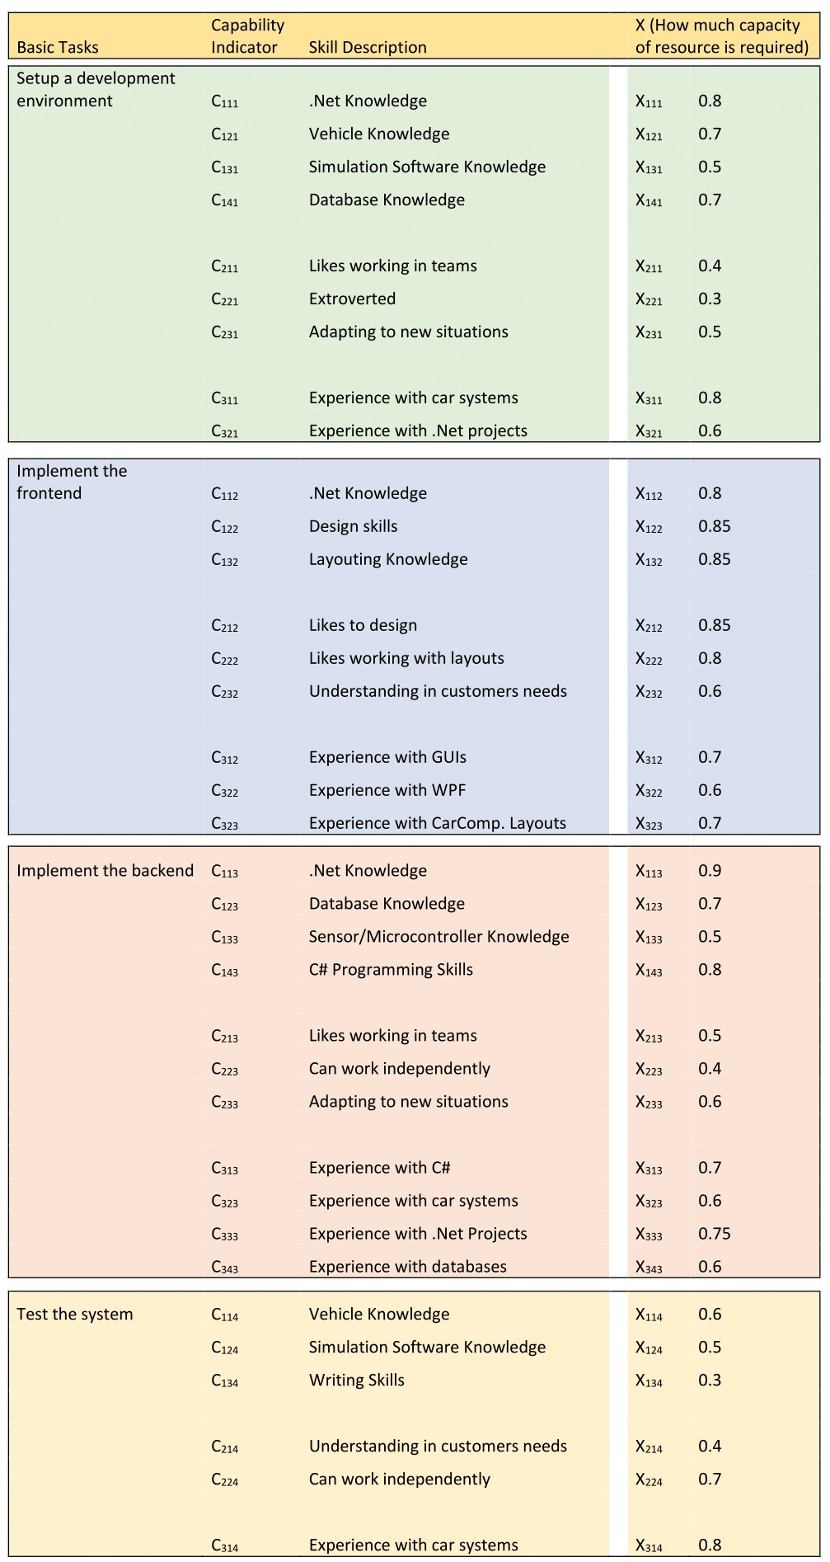

After writing down the most important skills needed for the single tasks, we can put them all together in a separate table, considering the highest X:

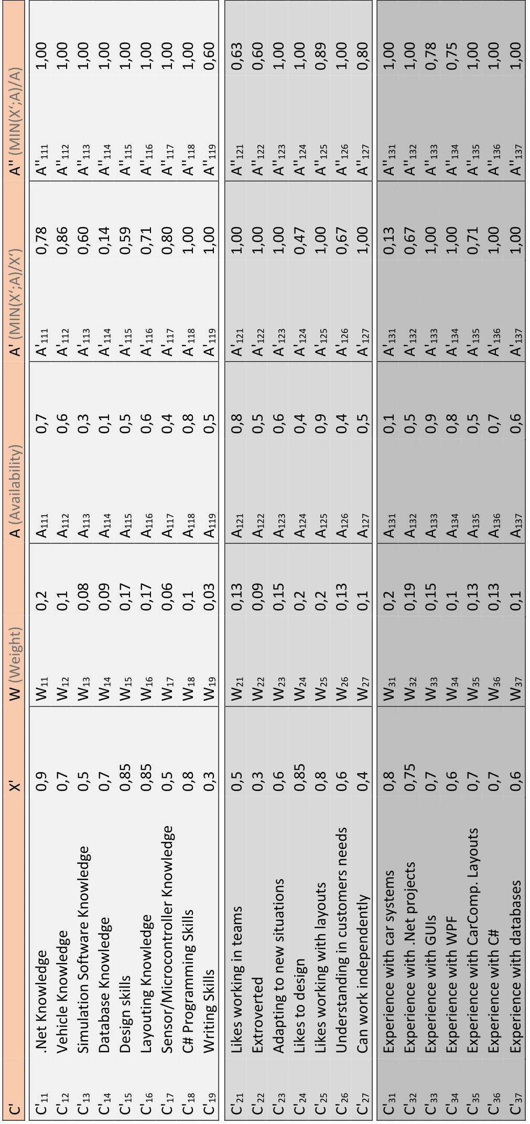

Considering the weight of a skill W and the availability of the human resource A we can calculate the values A’ and A’’.

Mean values:

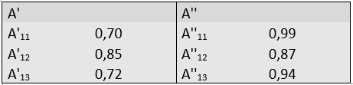

With those values we can calculate the Impact and Utilization of a Human Resource for a job:

**Impact:** 0,68

**Utilisation:** 0,81

Those values would have to be compared to the values of other candidates, which would be too much for this assignment.