The Indian Economic Newspaper Reader’s Guide

Understanding News, Analyzing Impact, and Deriving Actionable Insights

1. Introduction: Why This Guide Matters

1.1 The Information Overload Problem
India’s business newspaper ecosystem has never been larger — or more demanding of its readers. The Economic Times alone commands a total readership of 3.7 million, dominates the business newspaper segment with a 61 percent market share, and is the world’s second-most widely read English-language business daily after The Wall Street Journal ¹ ². Its digital platform, EconomicTimes.com, garnered 50.07 million unique visitors in India in March 2024, followed by Livemint.com at 31.07 million ³. Across the five major business dailies — The Economic Times, Mint, Business Standard, Financial Express, and The Hindu Business Line — combined digital reach exceeds 100 million monthly unique visitors. The print editions collectively reach over 2.5 million average-issue readers verified by the Indian Readership Survey ⁴. These publications produce more than a dozen distinct article types daily: breaking news, market commentary, earnings reports, opinion editorials, long-form investigative features, data-driven explainers, interviews with policymakers, stock recommendations, and personal finance guides ⁵ ⁶ ⁷.
Yet this abundance creates a paradox. Most readers lack frameworks to convert the torrent of headlines into meaningful action. A typical reader scanning the morning paper encounters an RBI repo-rate decision, a quarterly earnings miss by a Sensex heavyweight, a new SEBI disclosure mandate, and a global commodity price surge — all before breakfast. Each item is reported with precision, but the connections among them remain implicit. Why did the market rally on a rate hold when experts predicted a cut? How does a US Federal Reserve statement alter the EMI on a home loan in Hyderabad? Which news items demand immediate portfolio changes, and which are merely noise that will dissipate within days?
The gap between “reading news” and “understanding impact” is not a minor inconvenience — it is a systematic failure that costs readers money, time, and opportunity. Research on news consumption confirms that over 90 percent of long-term market returns are driven by fundamentals such as earnings and dividends, while valuation shifts account for less than 10 percent ⁸. Readers who chase headline-driven volatility often act precisely counter to their own interests, buying at consensus peaks and selling into panic. The difference between a reader who absorbs the news and one who acts on it systematically is the difference between information as entertainment and information as a decision-making tool.
Passive reading — the habit of scanning headlines, nodding at analysis, and turning the page — fails to deliver value for three reasons. First, it treats all articles as equally time-sensitive when, in reality, breaking news has a half-life of hours while structural explainers on topics like GST mechanics or PLI scheme details remain actionable for months. Second, it ignores the temporal transmission lag between market pricing and real-economy impact: financial markets digest an RBI policy announcement within seconds, but the effect on a household’s EMI materializes only at the next loan-reset date, which may be 6–12 months away. Third, passive reading rarely distinguishes between fact and interpretation, between a verifiable data point and an analyst’s opinion — a distinction that the SIFT (Stop-Investigate-Find-Trace) method, developed by the Stanford History Education Group, has shown to be critical for accurate information processing ⁹.

1.2 What This Guide Delivers
This guide is designed to close the gap between consumption and comprehension. It offers three interconnected tools for the Indian economic newspaper reader.
A comprehensive taxonomy of article types. Chapter 2 maps the full landscape of Indian economic newspapers — their histories, editorial positioning, and target audiences. Chapters 3 and 4 dissect the eleven major article types found across The Economic Times, Mint, Business Standard, Financial Express, and The Hindu Business Line, providing a reading strategy for each. Breaking news demands speed and triangulation across at least three independent sources ¹⁰. Long-form features — Mint alone publishes nearly 250 each year ¹¹— reward close reading over days, not minutes. Data stories require attention to methodology and source credibility. Opinion pieces must be weighed against the writer’s track record and potential biases. Each type has a distinct “shelf life” for actionability, and the guide teaches readers to sort their reading into queues: “Act Today,” “Read This Week,” and “Reference Library.”
Systematic impact analysis frameworks. Chapters 5 through 10 apply stakeholder-specific lenses to major news categories. An RBI monetary policy announcement, for instance, transmits differently to an equity investor (who must assess sector rotation between cyclical and defensive stocks), a business leader (who must reassess borrowing costs and pricing strategy), and a common citizen (who must check EMI impact and fixed-deposit rates) ³ ⁶ ¹². The guide introduces PESTLE analysis with explicit time-horizon classification — short-term (0–1 year) for concrete regulatory changes, medium-term (1–3 years) for technology and market shifts, and structural (3–10 years) for demographic and climate transitions ². It adapts Howard Marks’s second-order thinking framework ¹³for newspaper readers: rather than asking “Is this good news or bad news?” the sophisticated reader asks “What is the range of possible outcomes? What does the consensus believe? How does my view differ? And what is already priced into markets?”
Actionable methodologies to convert headlines into decisions. The final chapters provide concrete protocols. The “Three Questions” method — What happened? Why does it matter? What should change? — offers a disciplined format for processing any article. Signal-versus-noise separation techniques help readers ignore the daily drama of index point movements and focus on durable economic forces: productivity trends, demographic shifts, technological adoption curves, and monetary-policy direction ⁸. Decision-tree frameworks break complex macroeconomic developments into sequential steps, assigning probabilities to uncertain outcomes and clarifying the path from information to action ¹⁴.

1.3 How to Use This Guide
This guide is not meant to be read cover to cover in a single sitting. It is structured as a reference that readers return to based on their role, their current decisions, and the news cycle’s demands. The following table maps six reader profiles to tailored reading strategies, priority sections, and time-commitment recommendations.
Reader Profile | Primary News Focus | Priority Chapters | Reading Strategy | Time Commitment
Investor / Trader | RBI policy, earnings releases, FII/DII flows, regulatory changes, sector rotation signals | 3, 4, 6, 7, 10 | Scan breaking news before market open; read analysis post-close; verify all claims via SIFT method ¹⁵; apply second-order thinking to consensus views ¹⁶ | 45–60 min daily
Business Leader | Competitive moves, M&A activity, policy shifts, input cost trends, global demand signals | 2, 4, 5, 8, 9, 10 | Weekly macro scan via PESTLE framework ²; daily competitive-intelligence brief; monthly scenario-planning review using strategic foresight ¹⁷ | 30 min daily + 2 hrs weekly
Entrepreneur | Startup funding climate, regulatory changes, sectoral tailwinds/headwinds, MSME credit access | 5, 8, 9, 10 | Track relevant sector news via RSS alerts; read long-form features for pattern recognition; cross-verify funding data across three sources ¹⁸ | 30 min daily
Job Seeker / Career Planner | Hiring trends, sectoral growth trajectories, skill-demand shifts, policy-driven employment programs | 5, 6, 8, 9 | Weekly scan of sectoral employment indicators; read interview features for industry-insider perspectives; map skill gaps to growing sectors | 20 min daily
Student of Economics / Business | Policy frameworks, macroeconomic data interpretation, theoretical models in practice, historical case studies | 2, 3, 4, 5, 10 | Read one long-form feature and one opinion editorial daily; practice the “Three Questions” method on every article; build a personal archive of explainers | 60 min daily
Common Citizen | Inflation impact, tax changes, welfare scheme updates, interest rate effects on savings and loans, consumer protection | 5, 6, 9, 10 | Focus on personal-finance sections (ET Wealth, Mint Money, Business Line Portfolio) ¹⁵ ¹⁹; track RBI policy for EMI implications ¹²; read Budget explainers for household impact | 15–20 min daily
Each pathway is a starting point, not a constraint. An investor may benefit from the business leader’s competitive-intelligence framework when a major regulatory shift reshapes an entire sector. A common citizen may find the investor’s signal-versus-noise tools useful when deciding whether to act on a gold-price rally or treat it as transient volatility. The frameworks are modular.
Underlying all six pathways is the “Three Questions” method, a simple but rigorous discipline to apply to any economic newspaper article before forming a judgment or taking action. First: What happened? Extract the verifiable facts — not the headline’s spin, but the concrete event: a 25-basis-point repo-rate cut, a quarterly earnings miss of 12 percent, a new SEBI disclosure requirement. Consult the primary source (the RBI MPC resolution, the company’s BSE filing, the official SEBI circular) rather than relying solely on the newspaper’s summary ²⁰. Second: Why does it matter? Apply second-order thinking to trace the cascading effects. A rate cut lowers bank funding costs, which may or may not translate to lower lending rates depending on the Monetary Policy Committee’s forward guidance and the banking system’s liquidity position ²¹. A rate cut during high inflation may signal RBI concern about growth at the expense of price stability — a mixed signal that first-order thinkers miss entirely ¹³. Third: What should change? Translate analysis into one specific action appropriate to your role. For an investor, that might mean adjusting fixed-income duration or rotating from rate-sensitive real-estate stocks to defensive consumer staples. For a business leader, it might mean accelerating a planned capital raise before rate expectations shift. For a household, it might mean reviewing a floating-rate loan’s reset date or comparing fixed-deposit rates across banks.
The chapters that follow build the knowledge base that makes these three questions answerable with confidence. Chapter 2 begins with the landscape itself — the newspapers, their editorial philosophies, and their distinct approaches to covering the Indian economy.

2. The Landscape of Indian Economic Newspapers
India’s economic newspaper market is among the most competitive in the developing world, with five major English-language dailies serving a combined print readership exceeding 1.4 million average-issue readers and a digital audience crossing 100 million monthly unique visitors. Understanding the editorial positioning, audience segmentation, and digital strategies of each publication is essential for any reader seeking to navigate this information ecosystem efficiently. This chapter maps the competitive terrain — who publishes what, for whom, and through which channels.

2.1 The Major Publications

2.1.1 The Economic Times: Market Leader
The Economic Times, published by Bennett Coleman & Co. Ltd. (The Times Group) since its founding on March 5, 1961, is India’s largest business daily and the world’s second-most widely read English-language business newspaper after The Wall Street Journal. Its total readership stood at 3.7 million as of IRS Q1 2019, with an average issue readership of 882,000.¹The publication dominates the segment with a 61% market share in the business newspaper category — a position it has held consistently across multiple Indian Readership Survey (IRS) rounds.²The newspaper’s physical footprint spans 19 cities: Mumbai, Bangalore, Delhi, Chennai, Kolkata, Lucknow, Hyderabad, Jaipur, Ahmedabad, Nagpur, Chandigarh, Pune, Patna, Ranchi, Indore, Bhopal, Bhubaneshwar, Kochi, and Goa.¹This geographic breadth gives it unmatched reach among India’s regional business communities. The Audit Bureau of Circulations (ABC) recorded an average circulation of 269,882 copies during the latter half of 2022.¹Editorially, The Economic Times pursues comprehensive coverage of Indian and international markets, corporate developments, commodity movements, and policy changes. Its tagline — “Your guide to the world of business” — signals a mass-market positioning that accommodates everyone from first-time mutual fund investors to seasoned chief executives. The newspaper’s digital platform, EconomicTimes.com, garnered 50.07 million unique visitors in India in March 2024, placing it substantially ahead of competitors.³The group’s premium subscription service, ET Prime (launched in 2018), offers 70+ exclusive deeply researched articles each month alongside 500+ print edition stories, covering over 20 sectors.⁹This freemium model — free basic content with paywalled analytical depth — has become the template that other publications have sought to emulate. The group also publishes ET Wealth, a weekly personal finance supplement distributed every Monday, and operates ET Markets, which provides comprehensive stock market data and screeners. A distinguishing feature is the newspaper’s multi-language digital presence, with content available in Hindi, Gujarati, Marathi, Bengali, Tamil, Malayalam, Telugu, and Kannada — an outreach strategy no competitor has replicated at this scale.

2.1.2 Mint: HT Media’s Analytical Daily
Mint was launched on February 1, 2007, as a partnership between HT Media Ltd. and The Wall Street Journal, with Raju Narisetti (formerly deputy managing editor of WSJ India) as its founding editor.⁸It was the first Indian newspaper to adopt the Berliner format — a mid-size format between broadsheet and tabloid — and by mid-2009 had already become India’s second-most-read business daily with approximately 175,000 readers. Its all-India readership now stands at 261,000 according to IRS data.⁸Mint’s editorial identity centres on long-form, narrative journalism blended with rigorous data analysis. In 2025 alone, the publication produced nearly 250 Long Stories — its dedicated space for deep-dive reportage that typically takes weeks or months to research.¹¹This commitment to narrative business journalism distinguishes Mint from the more market-focused coverage of The Economic Times. Its partnership with The Wall Street Journal initially brought four pages of WSJ content into each weekday edition, though the precise current arrangement has evolved.
The newspaper’s digital platform, Livemint.com, recorded 42.3 million unique visitors in October 2024 and 37 million unique visitors with 162 million page views in November 2024, ranking it as India’s second-largest business news website by audience engagement.⁸Mint’s weekend edition, Mint Lounge (published every Saturday), covers arts, food, culture, fashion, sports, and music — a lifestyle pivot that broadens its appeal beyond hard business news. The publication also operates Mint Money for personal finance, Mint Explainers for simplified breakdowns of complex topics, and Mint Hindi for vernacular readers.

2.1.3 Business Standard: ABP Group’s Analytical Daily
Business Standard was founded on March 27, 1975, by the ABP Group (Anandabazar Patrika) and was acquired by Kotak Mahindra Finance in 1997 when the publication was losing Rs 1.5 crore per month.²²Under the editorship of T. N. Ninan from 1993 to 2009, the newspaper developed a reputation for rigorous, data-driven reporting and analytical credibility. Its IRS average issue readership reached 189,000 copies as of Q4 2019, making it India’s third-highest selling financial newspaper.²³The publication’s editorial positioning — captured in its tagline “Know More. No Less.” — emphasises macroeconomic depth, policy analysis, and credible opinion. Business Standard carries syndicated columns from global economists including Nobel laureate Joseph Stiglitz and former chief economic adviser Arvind Subramanian. It publishes from 12 regional centres and offers a Hindi edition from six cities, giving it stronger vernacular reach than most competitors.²²Business Standard was among the first Indian business publications to introduce a digital paywall, launching its subscription model in June 2016.²²However, the COVID-19 pandemic forced significant structural changes: the Sunday edition and the Weekend pullout were discontinued in July 2020 due to severe business and financial stress, and layoffs were initiated across bureaus.²⁴The newspaper’s digital platform recorded 9.64 million monthly unique visitors as of October 2025 — a fraction of ET and Mint’s reach but still substantial within the premium business segment.

2.1.4 Financial Express: The Pioneer with a Gujarati Edge
The Financial Express, founded in 1961 by the Indian Express Group, was India’s first financial daily and pioneered specialised financial journalism in the country.²⁵Its Mumbai edition commands a readership of 123,000, and it publishes from 11 cities including Ahmedabad, Bangalore, Chandigarh, Coimbatore, Delhi, Hyderabad, Kolkata, Lucknow, Pune, and Kochi.²⁵What sets Financial Express apart is its unique vernacular offering: it was the first business daily to launch a Gujarati edition in 1991 and remains the only financial newspaper in India with a dedicated vernacular edition.¹³This strategic choice reflects the publication’s deep roots in Gujarat’s trading and entrepreneurial communities — a readership segment that other business dailies have struggled to reach in their mother tongue. The Indian Express Group’s editorial philosophy of “Journalism of Courage” extends to Financial Express, which maintains a strong emphasis on investigative stories influencing economic discourse and policy debates. The publication also hosts the FE India’s Best Banks Awards and the FE-EVI Green Business Leadership Awards, using events as a differentiated engagement strategy.

2.1.5 The Hindu Business Line: Niche Player with Research Credentials
Business Line, established on January 28, 1994, as a standalone business daily under The Hindu Group of Publications, occupies a distinctive niche in the Indian economic newspaper landscape. It was the first Indian business daily to offer online access, launching its website in 1996 — a prescient move that positioned it for the digital transition long before competitors.¹⁶Its average daily circulation stands at approximately 117,000 copies (ABC, 2016), with an IRS readership of 17,600, placing it fifth among the major business dailies.¹⁶The publication’s most distinctive asset is the BL Research Bureau, which provides investment recommendations backed by in-house research — uniquely among media entities in India.¹⁷More recently, Business Line began offering star ratings of mutual funds, further cementing its position as a research-oriented publication rather than a breaking-news operation. The newspaper has also pioneered print-digital hybrid innovations: in September 2022, it integrated QR codes into the print edition to direct readers to website-exclusive multimedia content including videos and interviews.¹⁶Its weekend offerings include BLink — a magazine covering art, culture, literature, and the polity — and Portfolio, a Sunday edition focused on personal finance and investment advice.¹²—

2.2 Digital Transformation and Readership Evolution

2.2.1 Print vs Digital: Diverging Trajectories
The Indian economic newspaper market presents a striking paradox: print readership has been declining across the industry (with The Economic Times being the notable exception), while digital audiences have expanded dramatically. EconomicTimes.com’s 50.07 million unique visitors in March 2024 represent a multiple of its print readership, and Livemint.com’s 42.3 million monthly uniques similarly dwarf its 261,000 print readers.³This divergence has compelled every major publication to rethink its content strategy, revenue model, and organisational structure.
The following table presents a structured comparison of the five major publications across key operational and editorial dimensions.
Attribute | Economic Times | Mint | Business Standard | Financial Express | Hindu Business Line
IRS Avg. Issue Readership | 882,000 ¹ | 261,000 ⁸ | 189,000 ²³ | 123,000 ²⁵ | 17,600 ¹⁶
Monthly Digital UV | 50.1M ³ | 42.3M ⁸ | 9.6M | 5.0M (est.) | 2.5M (est.)
Format | Broadsheet | Berliner | Broadsheet | Broadsheet | Broadsheet
Cities | 19 | 9 | 12 | 11 | 16+
Vernacular Editions | 8 languages | Mint Hindi | Hindi (6 centres) | Gujarati | None
Premium Service | ET Prime (2018) ⁹ | Mint Premium | BS Premium (2016) | — | Digital Subscription
Weekend Supplement | ET Wealth (Mon) | Mint Lounge (Sat) | Discontinued 2020 ²⁴ | Industry supplements | BLink / Portfolio
Unique Differentiator | ET Markets data | Long-form journalism | Macroeconomic depth | Gujarati edition | BL Research Bureau ¹⁷
Ownership | Times Group | HT Media | Kotak Mahindra Bank | Indian Express Group | The Hindu Group
Founded | 1961 | 2007 | 1975 | 1961 | 1994
The table reveals three strategic clusters. The Economic Times and Mint operate at scale — both in print and digital — with premium subscription models generating ancillary revenue. Business Standard and Financial Express occupy a middle tier: analytically respected but digitally constrained by lower traffic volumes. Hindu Business Line occupies a research-led niche where its relatively small readership is offset by high engagement among investment-focused subscribers who value the BL Research Bureau’s recommendations.¹⁷#### 2.2.2 Premium Subscription Models: The Revenue Imperative
All major publications have introduced premium tiers in response to the advertising revenue squeeze that has affected print journalism globally. ET Prime (launched 2018) offers 70+ exclusive articles monthly plus stock research tools.⁹Mint Premium, building on an early paywall introduced in 2016, gates its most analytical long-form content. Business Standard Premium grants access to archives and in-depth coverage — a model it pioneered among Indian business publications in 2016. These subscriptions typically range from Rs 1,500 to Rs 3,000 annually, targeting committed business readers who require analytical depth unavailable in free content.
The viability of these models varies. ET Prime benefits from the Times Group’s massive traffic funnel — even a 1-2% conversion rate on 50 million monthly visitors yields a substantial subscriber base. Smaller publications face the classic digital journalism dilemma: paywalls reduce traffic, which reduces advertising revenue, creating a need for either very high subscription prices or very loyal audiences.

2.2.3 Weekly Supplements: Print’s Retention Strategy
Weekend supplements remain one of print journalism’s most effective retention tools, offering content that digital platforms struggle to replicate in tactile form. ET Wealth, distributed every Monday with The Economic Times, serves as a weekly money management guide covering tax planning, mutual fund analysis, insurance comparisons, and real estate trends.¹⁵Mint Lounge takes a different approach, using Saturday to cover arts, food, culture, fashion, and music — lifestyle content that attracts readers who might otherwise disengage from business news over the weekend.²⁶Business Line’s dual weekend strategy — BLink for culture and Portfolio for personal finance — segments its weekend audience precisely.¹² ¹⁹The discontinuation of Business Standard’s Sunday edition and Weekend pullout in July 2020 illustrates the vulnerability of this strategy. The pandemic-induced cost-cutting measure, which included layoffs across bureaus, permanently removed a key engagement touchpoint.²⁴Whether Business Standard can rebuild weekend readership without a dedicated Sunday product remains an open question.

2.3 Editorial Positioning and Audience Mapping

2.3.1 Comparative Analysis: Five Distinct Editorial Voices
Each of the five major Indian economic newspapers has carved out a distinct editorial territory that reflects its ownership heritage, editorial leadership, and target audience. Understanding these differences allows readers to match their information needs to the appropriate source.
The Economic Times pursues a mass-market comprehensive strategy. Its coverage spans stock prices, commodity movements, corporate announcements, policy changes, and lifestyle content under the Panache banner. The editorial voice is data-heavy and market-focused, designed to serve investors, corporate professionals, and business owners who need breadth rather than specialised depth. Its multi-language digital editions extend this reach to regional-language business communities that competing publications do not serve.¹Mint positions itself as the publication of choice for policymakers, business leaders, and intellectually engaged professionals. Its emphasis on long-form narrative journalism — nearly 250 deep-dive stories annually — and data visualisation creates a reading experience closer to The Economist than to a traditional daily.¹¹The Berliner format and clean design reinforce this premium positioning, as does the Mint Lounge weekend edition which signals cultural sophistication.
Business Standard’s editorial identity is anchored in macroeconomic analysis and policy credibility. Its syndication of columns by globally recognised economists and its sustained focus on banking and financial sector coverage make it the preferred read for institutional investors, economists, and policy researchers.²²The Hindi edition broadens access to this analytical depth for non-English readers.
Financial Express differentiates through policy and regulatory emphasis combined with its unique Gujarati edition.¹³Its readership skews toward entrepreneurs, traders, and policy professionals — particularly in western India where the Gujarati edition provides unmatched access to financial news in the vernacular.
Hindu Business Line occupies the narrowest but most specialised position. Its BL Research Bureau produces investment recommendations backed by proprietary analysis, and its mutual fund star ratings provide actionable guidance unavailable from any competing media entity.¹⁷The publication also leads in agriculture and commodities coverage, serving rural and agri-business readerships that other dailies under-serve.

2.3.2 Readership Demographics: Who Reads What
The Indian economic newspaper readership is not monolithic. IRS data and publisher research reveal a clear demographic segmentation across the five publications.
Segment | Share of Business News Readership | Primary Publications | Content Preferences
Students (MBA, CA, CFA, commerce) | 58% | Economic Times, Mint | Market data, exam-relevant analysis, careers content
Salaried professionals (corporate, finance) | 26% | ET Prime, Mint Premium, Business Standard | Sectoral analysis, policy commentary, investment research
Business owners / entrepreneurs | 12% | Financial Express, Economic Times | SME news, regulatory updates, regional market data
Institutional investors / analysts | 4% | Business Standard, Hindu Business Line | Macroeconomic data, BL Research Bureau reports, syndicated columns
Students constitute the largest segment at 58% of the total business newspaper readership, driven by India’s massive professional education pipeline — approximately 3,50,000 MBA graduates and 1,00,000 chartered accountants produced annually. This cohort gravitates toward The Economic Times for its comprehensive market data and career-focused content, and toward Mint for its analytical depth and explanatory journalism. Salaried professionals in corporate roles and financial services represent 26% of readers, with subscription data indicating strong uptake of ET Prime and Mint Premium among this group. Business owners and entrepreneurs account for 12%, with Financial Express and its Gujarati edition capturing disproportionate share among trading communities. The remaining 4% comprises institutional investors, research analysts, and policymakers who value the specialised output of Business Standard’s macroeconomic coverage and Hindu Business Line’s research bureau.¹ ⁸ ²³ ²⁵ ¹⁶The chart below visualises the readership and digital reach gap between the leading publications — a gap that has profound implications for editorial resource allocation and content strategy.
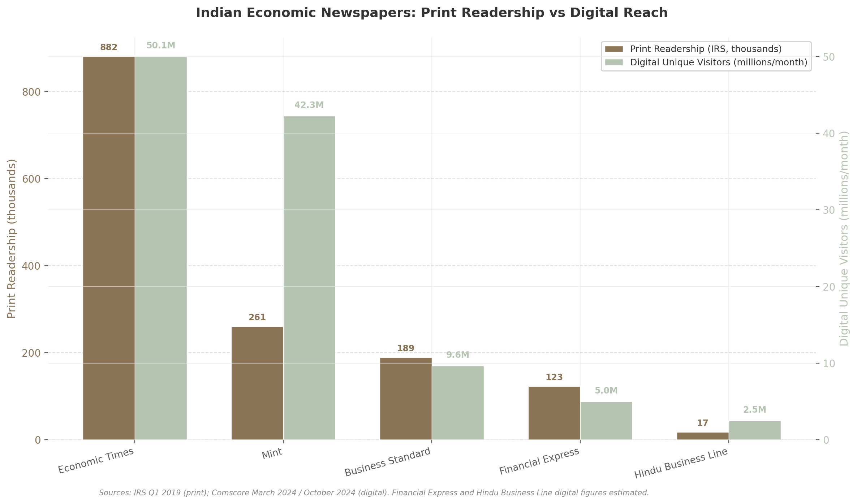
Indian Economic Newspapers: Print Readership vs Digital Reach
The visualisation reveals two significant patterns. First, print readership concentration is extreme: The Economic Times’ 882,000 average-issue readers exceed the combined total of Business Standard, Financial Express, and Hindu Business Line. This dominance is self-reinforcing — larger circulation attracts more advertising, which funds more editorial resources, which produces more comprehensive coverage. Second, the digital landscape is more competitive: while EconomicTimes.com leads with 50.07 million unique visitors, Livemint.com’s 42.3 million places it within striking distance — a remarkable achievement given Mint’s 2007 launch date versus ET’s 1961 founding.³This digital competitiveness suggests that editorial quality and format innovation can compensate for decades of print head start in the online environment. Business Standard’s digital gap — 9.6 million uniques versus Mint’s 42.3 million — reflects the pandemic-era retrenchment and the strategic challenge of competing for digital attention without the Times Group or HT Media’s marketing infrastructure.
For the practical reader, these competitive dynamics translate into a simple navigational principle: use The Economic Times for breadth and market data, Mint for analytical depth and narrative journalism, Business Standard for macroeconomic and policy context, Financial Express for regulatory and western India coverage, and Hindu Business Line for investment research and agri-business intelligence. The following chapter builds on this mapping by dissecting the article types each publication produces — a field guide to recognising and using every story format the Indian business press offers.

3. Article Type Taxonomy: A Field Guide to Every Story
A reader who treats a Sensex flash crash alert with the same urgency as a PLI scheme explainer is wasting attention. Indian business newspapers publish across a spectrum — from 200-word breaking alerts to 5,000-word investigative narratives — yet few readers sort their queue by the shelf life of the information within. This chapter classifies every major article type found in The Economic Times, Mint, Business Standard, Financial Express, and The Hindu Business Line, assigns each a decay curve, and prescribes a reading strategy calibrated to the reader’s role.
The principle is simple but overlooked: not all articles age equally. Breaking news on quarterly earnings moves stock prices within hours and decays rapidly; a primer on how the Insolvency and Bankruptcy Code (IBC) resolution process works retains utility for months. Research confirms that over 90% of long-term market returns are driven by earnings and dividend fundamentals rather than the transient valuation shifts that dominate daily headlines ⁸. Discerning signal from noise begins with knowing what category of content one is reading.

3.1 Breaking News and Hard News
Hard news constitutes roughly 20% of daily output, with The Economic Times leading in volume given its 3.7 million total readership and 61% market share ¹ ². These articles follow the inverted pyramid: the most consequential fact appears in the headline, details trail beneath, and context arrives last. A reader who skims the first two paragraphs typically extracts 80% of the actionable information.
3.1.1 Breaking market movements. Stories on Sensex or Nifty moves of 500-plus points carry a half-life measured in hours. Markets price such movements almost instantaneously — by the time a print reader opens the newspaper, the information is already embedded in stock prices. For non-traders, the practical function is pattern recognition: three 500-point drops within a month may signal rising systemic stress even if each drop has been arbitraged away. For traders, the action window closes within minutes.
3.1.2 Policy announcements. RBI Monetary Policy Committee (MPC) resolutions, SEBI circulars, and government notifications occupy a special position in hard news. While the headline decision — a 25 basis point repo rate cut — is priced into markets within seconds, the forward guidance embedded in the MPC statement’s third section creates a secondary interpretation wave over 24–48 hours ²⁰. The October 9, 2020 MPC statement, which held rates unchanged but pledged an accommodative stance “at least during the current financial year and into the next,” produced a measurable path factor shock of –0.174 over subsequent sessions ²¹. Policy announcements demand a two-pass reading: first for the decision, second for the embedded guidance.
3.1.3 Corporate results. Quarterly earnings coverage operates on a 48-hour window of peak relevance. A company announcing results after market hours triggers overnight futures movement; morning newspaper analysis shapes retail sentiment through the following session. Beyond 48 hours, unless results represent a structural inflection — a first-ever loss, management change, or guidance downgrade — the information is fully absorbed and the article becomes historical record. Readers should prioritize earnings surprises (actual versus consensus) over absolute profit or loss, since markets react to deviations from expectation.

3.2 Analysis and Interpretive Journalism
Analysis pieces run 800–1,500 words and account for an estimated 15–18% of daily output, with Business Standard and Mint weighted toward this format. The key distinction from hard news is the interpretive layer: the journalist argues why it matters and what comes next, not merely what happened.
3.2.1 Market analysis. Technical views, sector rotation narratives, and FII versus DII flow interpretation dominate this category. A critical shift is underway: DII absorption of FII outflows now occurs at roughly 1.9:1, with SIP inflows providing a Rs 30,000 crore monthly liquidity backstop. Yet headlines still lead with “FII Sell-Off” framing. The reader applying second-order thinking — asking “what is the range of possible outcomes?” and “how does my view differ from consensus?” — will recognize that FII-centric narratives may no longer be the primary market driver ¹ ¹³. These articles remain actionable for 3–5 days, after which price action validates or invalidates the thesis.
3.2.2 Economic analysis. Coverage of GDP surprises, inflation trajectory, and trade balance shifts demands signal versus noise separation. The headline number — “GDP grows at 7.2%” — is noise if read in isolation. The signal lies in expenditure decomposition (consumption versus government spending versus net exports) and revision patterns of prior quarters. Business Standard and Mint typically provide this decomposition; Financial Express emphasizes policy implications. These pieces retain relevance for 1–2 weeks.
3.2.3 Policy analysis. Budget impact assessments and regulatory change explainers follow major policy events. The Union Budget generates the highest volume of such coverage, with newspapers publishing multi-article packages on allocations, tax changes, and reactions. Analytical value peaks 48–72 hours after the event, when initial reactions are stress-tested against detailed provisions. A well-constructed policy analysis identifies not merely who benefits but when the benefit accrues — separating immediate stock movers from multi-year themes. The PLI scheme, for instance, generated positive headlines in 2021, but the full picture — compliance requirements, disbursement timelines, competitive dynamics — emerged only in subsequent interpretive coverage.

3.3 Opinion, Editorials, and Long-Form Features
This category represents roughly 5–8% of daily output but commands disproportionate editorial resources. Unlike news and analysis, these formats trade immediacy for depth.
3.3.1 Editorials and op-eds. Editorials represent the institutional voice of the newspaper; op-eds carry bylined expert viewpoints. The Economic Times runs ET Editorial, ET Commentary, and ET View ⁵; Business Standard syndicates columns from economists including Joseph Stiglitz. The reader’s task is to separate factual scaffolding from argumentative superstructure. Facts can be verified through evidence; opinions are judgments supported by those facts ¹⁹. A well-constructed op-ed grounds its argument in data — a column arguing for rate cuts should cite inflation prints and output gap estimates — but the conclusion remains the author’s own. Opinion pieces have no fixed expiration date; their utility depends on whether the argument proves prescient over the following months. The recommended strategy is to engage with the reasoning, not merely the conclusion.
3.3.2 Long-form features. Mint publishes approximately 250 Long Stories annually, each requiring weeks of research blending data analysis with on-the-ground reporting ¹¹. These 2,000–5,000 word narratives — on topics from slum economics to startup ecosystem evolution — function as structural trend identifiers. Their shelf life extends to several months because the value lies in context that daily news cannot accumulate. ET Prime produces 70-plus deeply researched articles monthly across 20-plus sectors for institutional readers ⁹. The reading strategy is to extract the underlying structural argument and file it as reference material for when related news breaks.
3.3.3 Interviews and profiles. CEO interviews and policy maker Q&As offer direct access to strategic intent. The format carries a distinct analytical risk: the subject has an incentive to advance a favorable narrative. A CEO discussing “exciting growth prospects” may be positioning for a capital raise; an RBI governor emphasizing “inflation anchoring” may be signaling future rate action. The reader should apply the SIFT method: Investigate the source’s incentives, Find corroborating statements from other sources, and Trace claims to original context ¹⁵. Interview utility peaks within one week but retains reference value for tracking a leader’s strategic positioning over time.

3.4 Data Stories and Special Formats
The remaining 10–12% of content falls into specialized formats demanding distinct reading competencies.
3.4.1 Data journalism. Interactive charts and database-driven narratives — exemplified by Economic Times’ “Datastories” and Mint’s visualization projects — require the reader to verify the underlying data source before accepting the visual conclusion ²⁷. A chart on “manufacturing employment growth” may use formal-sector-only definitions that fundamentally alter interpretation. Data stories remain relevant for 2–4 weeks. The reader should note the data vintage and cross-reference against primary sources — the RBI’s Database on Indian Economy (DBIE), Ministry of Statistics, or exchange filings — before incorporating findings into any decision.
3.4.2 Stock recommendations. The Hindu Business Line’s Research Bureau provides investment recommendations backed by in-house research, unique among Indian media entities, along with mutual fund star ratings ¹⁷. Economic Times’ Stock Reports Plus generates algorithmic buy/sell/hold calls. Recommendations carry a shelf life of 3–6 weeks for short-term calls and 6–12 months for structural picks. The critical discipline is to examine the methodology — discounted cash flow targets differ fundamentally from comparable-company multiples — rather than merely the rating. A “Buy” on conservative assumptions may be more actionable than a “Strong Buy” built on aggressive ones.
3.4.3 Explainers and primers. Articles explaining GST invoicing mechanics, IBC resolution timelines, or PLI scheme eligibility criteria function as reference material with multi-month shelf lives. Mint maintains a dedicated explainer vertical that breaks complex regulatory and economic concepts into 300–600 word step-by-step guides ⁷. These articles age slowly because they explain systems, not events. A reader encountering a new regulatory framework — say, SEBI’s revised F&O contract size norms — will find more enduring value in a well-constructed explainer than in ten breaking-news updates about the announcement. The recommended strategy is to archive quality explainers in a personal reference system and revisit them when subsequent news requires understanding the underlying mechanism.

Article Classification and Shelf Life
The following table consolidates the article taxonomy with estimated shelf life, primary publishers, and the optimal reading priority for each type.
Article Type | Typical Length | Shelf Life | Primary Publishers | Share of Daily Output | Reading Priority
Breaking market movements | 200–400 words | 6–24 hours | Economic Times, Mint | ~8% | Immediate (traders); skimmable (investors)
Policy announcements (RBI/SEBI/Govt) | 400–800 words | 24–72 hours | All dailies | ~5% | Two-pass: decision first, guidance second
Corporate results | 300–600 words | 48 hours | Economic Times, Business Standard | ~12% | Focus on surprise vs. consensus
Market analysis (technical/FII/DII) | 800–1,500 words | 3–5 days | Economic Times, Business Standard | ~10% | Validate against price action
Economic analysis (GDP/inflation/trade) | 800–1,200 words | 1–2 weeks | Business Standard, Mint | ~6% | Read decomposition, not headline
Policy analysis (Budget/regulatory) | 1,000–2,000 words | 1–2 weeks | Financial Express, Mint | ~4% | Identify timeline of impact
Editorials and op-eds | 600–1,200 words | Weeks to months | Business Standard, Economic Times | ~5% | Evaluate reasoning, not conclusion
Long-form features | 2,000–5,000+ words | 1–3 months | Mint (250/year), ET Prime ¹¹ ⁹ | ~3% | Extract structural argument
Interviews and profiles | 1,000–3,000 words | 1–2 weeks | All dailies | ~2% | Assess speaker’s incentives
Data journalism / infographics | Variable | 2–4 weeks | Economic Times, Mint ²⁷ | ~2% | Verify data source and vintage
Stock recommendations | 500–1,000 words | 3 weeks–12 months | Business Line, Economic Times ¹⁷ | ~3% | Examine methodology, not just rating
Explainers and primers | 300–600 words | 3–6 months | Mint Explainers ⁷ | ~4% | Archive as reference material
Sources: Author compilation based on newspaper section structures ⁵ ⁶ ²⁸ ¹², article type distribution analysis, and shelf life estimates derived from market impact research ⁸ ²¹. Share percentages are approximate and vary by publication.
The shelf life gradient reveals a pattern most readers ignore. Breaking news and corporate results — categories that dominate front pages — represent roughly 25% of daily output but account for nearly all urgency-driven reading. Conversely, explainers and long-form features — approximately 10% of output — deliver disproportionate long-term value. The disciplined reader allocates attention inversely to the decay rate: less time on what expires in hours, more time on what compounds over months.
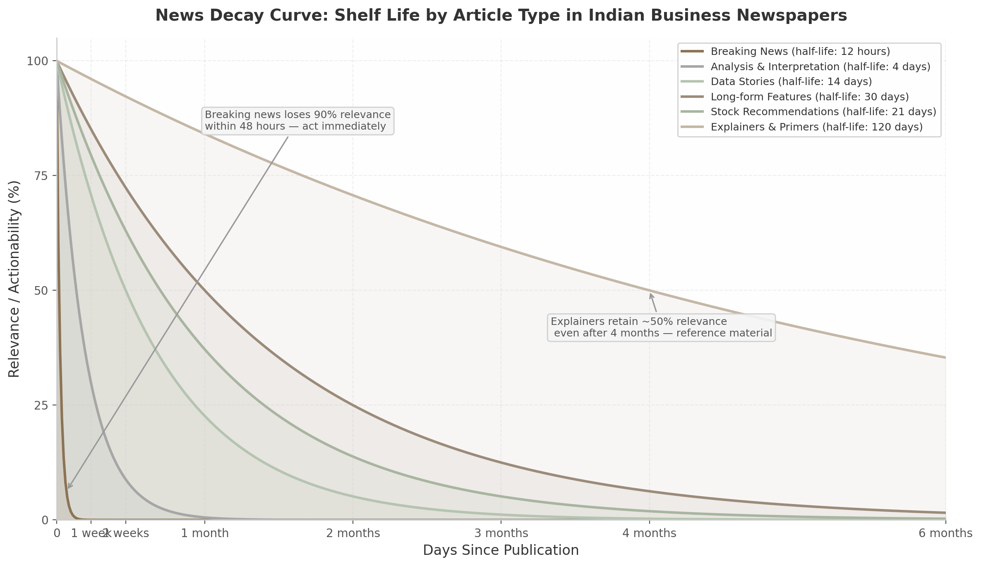
News Decay Curve: Shelf Life by Article Type
Figure 3.1: The decay curve illustrates how different article types lose relevance over time. Breaking news (half-life ~12 hours) and corporate results decay almost to zero within a week, while explainers and primers retain approximately 50% of their utility even after four months. Source: Author estimates based on market impact windows and content analysis.

Reading Strategy Matrix by Reader Type
The same article demands different strategies depending on the reader’s objectives. An RBI rate decision read by a trader, a CEO, and a home loan borrower requires three distinct lenses. The following matrix maps article types to reading approaches for four profiles.
Article Type | Equity Investor Approach | Business Leader Approach | Common Household Approach | Student/Researcher Approach
Breaking market movements | Check portfolio impact; assess if move is overreaction or structural | Monitor competitor stock reactions as sentiment indicator | Generally skippable unless 1,000+ point move signals systemic risk | Study market microstructure; note circuit filter behavior
Policy announcements | Reassess sector rotation; adjust fixed income duration ³ | Reassess borrowing plans; review pricing strategy; check compliance deadlines | Track EMI impact timelines; note FD rate changes ¹² | Map policy transmission mechanism from announcement to household
Corporate results | Update earnings models; revise position sizing if thesis breaks | Benchmark against own company’s quarterly performance | Relevant if employer is listed; otherwise low priority | Practice financial statement analysis; build valuation models
Market analysis | Apply second-order thinking: is the consensus already priced in? ¹ | Extract sectoral demand signals for business planning | Generally low priority; useful for SIP timing psychology | Study how narrative framing affects market sentiment
Economic analysis | Adjust top-down allocation between cyclical and defensive sectors ³ | Incorporate into demand forecasting and capacity planning | Understand inflation impact on household budget; track wage lag ²⁹ | Build macroeconomic indicator dashboards
Policy analysis | Identify regulatory winners/losers; position before market prices shift | Map compliance requirements; assess competitive moat changes | Track direct benefit transfer changes; note subsidy adjustments | Analyze policy design vs. implementation gaps
Editorials and op-eds | Note expert consensus direction as contrarian indicator | Extract strategic foresight on industry structure shifts | Build informed civic opinion for professional discourse | Evaluate argumentation quality; identify logical fallacies
Long-form features | Extract structural themes for multi-year position building | Identify emerging market opportunities and disruption risks | Understand systemic economic forces affecting career paths | Source case study material; trace citation quality
Interviews and profiles | Decode management quality and strategic intent | Benchmark competitor CEO priorities and capital allocation | Low direct priority unless consumer-facing company | Study leadership communication patterns
Data journalism | Verify data vintage; incorporate into investment models | Use primary data for market sizing and competitive intelligence | Verify claims about economic conditions affecting household | Replicate analysis with updated data; practice visualization
Stock recommendations | Examine valuation methodology; compare with own thesis | Not directly applicable unless evaluating peer companies | Evaluate mutual fund star ratings for portfolio decisions ¹⁷ | Decompose rating methodologies; understand analyst incentives
Explainers and primers | Archive for reference when regulatory news breaks | Maintain compliance playbook; train teams on regulatory mechanics | Build personal financial literacy reference library | Master institutional mechanisms as foundational knowledge
Sources: Framework adapted from second-order thinking ¹, top-down/bottom-up investment methodology ³, competitive intelligence cycle ⁶, personal finance impact research ¹², and the SIFT verification method ¹⁵.
The matrix reveals a central tension: the same regulatory announcement is processed differently by a trader (duration adjustment within hours), a CEO (borrowing strategy revision over weeks), and a household (EMI change at the next loan reset, potentially 6–12 months later). This transmission lag paradox — markets pricing news in seconds while real-economy effects transmit over quarters — means no single reading speed is optimal for all contexts. The equity investor who reads breaking news slowly loses alpha; the home loan borrower who reacts to every rate rumor wastes cognitive energy.
A practical implementation is to maintain three reading queues. Queue One — “Act Today” — contains breaking news and policy announcements relevant to existing positions. Queue Two — “Read This Week” — holds analysis pieces and interviews that deepen situational awareness. Queue Three — “Reference Library” — accumulates explainers and long-form features that inform decisions over months and years. The disciplined practice of sorting every article into one of these three queues before reading — a process that takes seconds but saves hours — separates information consumption from intelligence accumulation.

4. Macroeconomic Policy News: RBI, Budget, and Beyond
Macroeconomic policy news moves Indian markets, alters household budgets, and redirects corporate strategy more decisively than any other category of economic journalism. Two institutions dominate this landscape: the Reserve Bank of India (RBI), which sets interest rates and liquidity conditions, and the Union Finance Ministry, whose annual Budget reshapes tax liabilities, sectoral allocations, and fiscal trajectories. This chapter provides a framework for reading, analysing, and acting on both streams of policy news.

4.1 RBI Monetary Policy News Analysis Framework

4.1.1 The Policy Toolkit Decoded
RBI monetary policy operates through a suite of instruments that vary in frequency of use and immediacy of impact. Understanding each tool is essential for interpreting newspaper coverage correctly.
Instrument | Current Level / Status | Function | Market Impact
Repo Rate | 5.25% (as of April 2026) ³⁰ | Rate at which RBI lends to commercial banks; anchor for economy-wide interest rates | Immediate: stock indices react within minutes; medium-term: EMI and deposit rates adjust
Cash Reserve Ratio (CRR) | 3% of NDTL ³⁰ | Mandatory deposit banks hold with RBI; no interest earned | 1 percentage point change releases or absorbs ~Rs 2.5 lakh crore liquidity ³⁰
Statutory Liquidity Ratio (SLR) | 18% of NDTL ³⁰ | Mandatory investment in government securities; earns returns | Changes interest rate structure; together CRR+SLR lock up 21% of bank resources
Standing Deposit Facility (SDF) | 4.75% (repo minus 50 bps) ³⁰ | Floor of LAF corridor; uncollateralised absorption tool introduced April 2022 | Defines the floor for overnight money market rates
Marginal Standing Facility (MSF) | 5.75% (repo plus 50 bps) ³⁰ | Ceiling of LAF corridor; emergency borrowing for banks | Sets the ceiling; 50 bps corridor width provides operational flexibility
Open Market Operations (OMO) | Active buying/selling of G-secs ³¹ | Structural liquidity management through government securities trade | OMO purchases inject liquidity, support bond prices; sales do the opposite
MPC Stance | “Neutral” (as of April 2026) ³² | Forward guidance on future rate trajectory: accommodative / neutral / hawkish | Affects bond yields and currency more than the rate decision itself ³³
The Monetary Policy Committee (MPC) — comprising three RBI officials and three government nominees — convenes every two months to set the policy repo rate under a mandate to maintain CPI inflation at 4% within a tolerance band of +/-2% ³⁰. The repo rate is the most closely watched variable, but the stance and forward guidance often carry equal or greater weight for market participants. Academic research confirms that RBI communication, including forward guidance specifying the duration of accommodative policy, impacts longer-term government securities yields on the same day of announcement ³³.
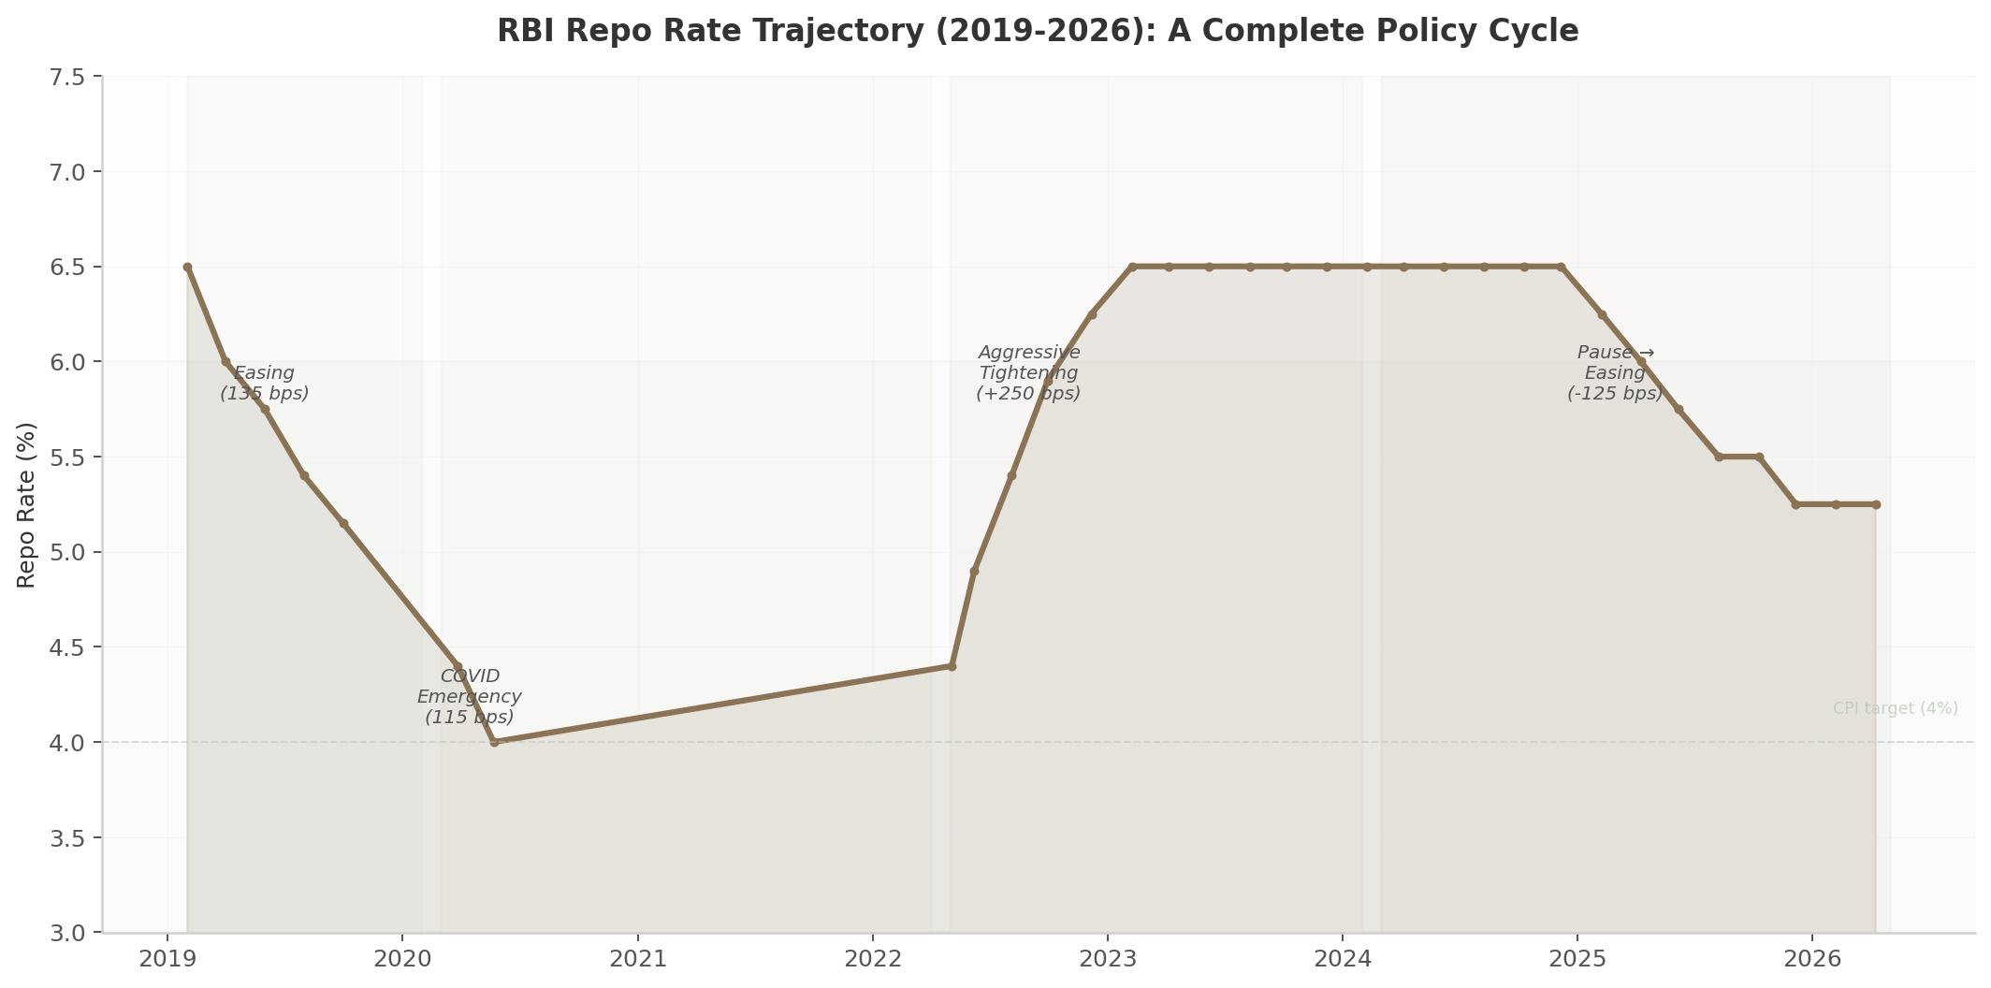
RBI Repo Rate Trajectory (2019-2026)
The trajectory above reveals four distinct phases: the 2019 easing cycle (135 bps of cuts amid growth slowdown), the COVID-19 emergency (115 bps of cuts taking rates to a historic low of 4.00%), the aggressive 2022-23 tightening cycle (250 bps of hikes as inflation surged above 7%), and the current easing phase (125 bps of cuts between February 2025 and February 2026) ³⁴ ³⁵.

4.1.2 The Coverage Cycle: Pre-MPC, Live Announcement, Post-Policy
Indian business newspapers follow a predictable three-phase coverage cycle around each MPC meeting.
Pre-MPC speculation (T-2 weeks to T-1 day): Publications begin polling economists, tracking global cues such as US Federal Reserve signals, crude oil prices, and domestic inflation prints ³⁶. Economic Times and Live Mint publish ” MPC Watch” features quantifying the probability of rate changes. Derivatives markets — particularly Gift Nifty — provide real-time positioning indicators, often rising or falling sharply in the hours before the announcement ³⁶.
Live announcement coverage (T-day): On the day of the MPC decision, Live Mint and Economic Times provide minute-by-minute coverage tracking index movements and sectoral reactions in real-time ³⁷. The Governor’s press conference, typically beginning at noon, receives verbatim transcription from portals like Moneycontrol, which parses every phrase for shifts in tone, nuance, and forward guidance ³². When Governor Sanjay Malhotra maintained a “neutral” stance in April 2026 despite global turmoil, Moneycontrol noted the speech had been “supposedly altered” from its draft overnight, reflecting the MPC’s responsiveness to unfolding geopolitical events ³².
Post-policy sectoral analysis (T+1 to T+1 week): Newspapers translate the rate decision into household and corporate impact stories. This phase separates mass-market publications (Economic Times focuses on “EMI impact for home loan borrowers”) from premium analytical dailies (Live Mint delves into “transmission asymmetries and structural credit channel effectiveness”) ³⁸.

4.1.3 Transmission Mechanism: From Repo Rate to Household EMI
The transmission of monetary policy from RBI’s decision to the household budget follows a multi-stage chain with varying lags at each node.
Stage | Transmission Channel | Time Lag | Magnitude (2022-23 Tightening)
1. Money markets | Call money rates, overnight MIBOR adjust | T+0 to T+1 day | Instantaneous and complete — rates move within hours ³⁹
2. External benchmark rates | EBLR (External Benchmark Linked Lending Rate) resets for new loans | T+1 to T+7 days | 1:1 pass-through for fresh EBLR-linked loans (57.5% of floating-rate loans) ⁴⁰
3. MCLR adjustment | Marginal Cost of Funds-based Lending Rate revisions | T+7 to T+30 days | 170 bps transmission on 1-year MCLR vs 250 bps repo change (68% efficiency) ⁴⁰
4. Deposit rate adjustment | Term deposit rates for savers | T+14 to T+60 days | 243 bps to fresh deposits (97% transmission); 190 bps to outstanding (76%) ⁴⁰
5. Outstanding loan EMIs | Floating-rate loans reset per annual/semi-annual schedule | T+90 to T+365 days | 119 bps to outstanding loans (48% transmission) over full cycle ⁴⁰
6. Real economy impact | Housing demand, auto sales, corporate capex decisions | T+3 to T+12 months | 5-15% demand impact on housing ⁴¹; quarterly auto sales data reflects changes
Research published in Ideas for India establishes that monetary policy transmission in India operates most strongly through the credit channel, with the interest rate and exchange rate channels playing secondary roles ³⁰. BIS research confirms transmission to money markets is “usually instantaneous and complete in India, especially across collateralised segments,” while credit segment pass-through varies depending on cycle duration, speed of rate changes, and prevailing liquidity conditions ³⁹.
The asymmetry of transmission is critical for newspaper readers to understand. During the May 2022 to August 2024 tightening cycle, the 250 bps repo rate increase translated into only 190 bps for fresh loans (76% transmission) and merely 119 bps for outstanding loans (48% transmission) ⁴⁰. Private sector banks transmitted rate changes faster (104 bps on fresh loans during the preceding easing phase) than public sector banks (75 bps) ⁴⁰. Foreign banks showed the maximum pass-through, reflecting their higher share of low-cost and wholesale deposits ⁴⁰.
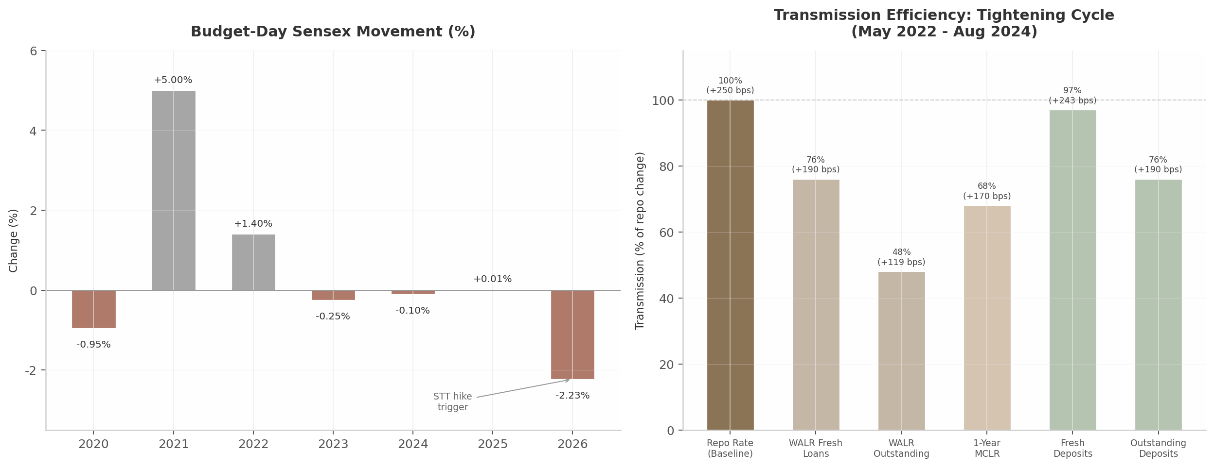
Budget Day Market Reaction and Policy Transmission
For a borrower with a Rs 70 lakh home loan taken in May 2022 at 7%, the 250 bps rate hike raised the EMI from Rs 54,271 to Rs 65,249 — an additional Rs 10,978 every month ⁴². For a Rs 49.6 lakh loan, the EMI increased from Rs 37,575 to Rs 44,640, adding Rs 84,780 annually and over Rs 16.95 lakh in additional interest over the loan tenure ⁴³.

4.1.4 Sectoral Impact Chain: Banking, Auto, Real Estate, IT, FMCG
Rate-sensitive sectors react at different speeds and through distinct channels. Banking is the first point of transmission: net interest margins (NIMs) compress or expand based on the speed of asset-liability repricing. On February 6, 2026, when RBI held the repo rate at 5.25%, Nifty PSU Bank slid 1.7%, with PNB, IndusInd Bank, Bank of Baroda, and SBI each falling 1-2% ³⁷. Real estate responds through home loan affordability — housing loan rates moved up 150 bps between March 2022 and late 2022, yet housing loan growth remained resilient at 15%, demonstrating structural demand strength ⁴⁴ ⁴⁵. Auto is highly sensitive to vehicle financing costs; despite 135 bps of rate cuts in 2019, auto sales continued to slump, proving that monetary policy alone cannot overcome structural demand weakness ⁴⁶ ⁶. IT is driven primarily by currency movements rather than domestic rates — the rupee’s 11% decline in FY26 benefited exporters ⁴⁷. FMCG is largely defensive, driven by rural demand patterns rather than interest rate cycles.

4.2 Union Budget News Analysis Framework

4.2.1 Budget Coverage Arc: Expectations to Winner-Loser Analysis
Budget coverage follows a structured arc that savvy readers can anticipate. Two to three weeks before the presentation, newspapers publish expectation surveys — Economic Times’ pre-Budget 2026 survey canvassed over 5,000 respondents, finding 44.1% wanted tax rate reductions and 64.5% favoured pushing local manufacturing ¹. Professional services firms (PwC, EY, Grant Thornton) publish sector-specific demand reports ². On Budget day, publications deploy dedicated microsites with live tickers, sectoral watchlists, and minute-by-minute updates ³ ⁹. Within hours of the speech, winner-loser analysis categorises sectors by immediate stock price reaction and long-term policy impact ³ ¹¹.

4.2.2 Direct Tax Impact: Income Tax Slabs, Capital Gains, STT
Budget 2025 introduced a historic restructuring of income tax slabs under the new regime, making income up to Rs 12 lakh effectively tax-free (Rs 12.75 lakh for salaried individuals with the Rs 75,000 standard deduction). Six progressive tax slabs were introduced — 5%, 10%, 15%, 20%, 25%, and 30% — with the enhanced Section 87A rebate raised from Rs 25,000 to Rs 60,000 ²². The government estimated revenue foregone at Rs 1 lakh crore in direct taxes ²². Budget 2026 retained these slabs unchanged, signalling stability.
The most market-moving direct tax announcement in recent years was Budget 2026’s Securities Transaction Tax (STT) hike: futures STT raised from 0.02% to 0.05% (a 150% increase) and options premium from 0.10% to 0.15% (a 50% increase) ²³. The stated objective was curbing excessive retail speculation, where SEBI data shows 92% of retail F&O traders lose money ²³. Long-term capital gains (LTCG) remained exempt up to Rs 1.25 lakh, and short-term capital gains (STCG) on equity stayed at 15% ²². Budget 2026 also changed buyback taxation — proceeds will now be taxed as capital gains instead of deemed dividends, with corporate promoters facing 22% effective tax and non-corporate promoters 30% ¹³.

4.2.3 Indirect Tax and Price Impact: Customs Duty Changes
Indirect tax changes translate most directly into household budgets. Budget 2025 rationalised the customs tariff structure from multiple slabs to eight, removed seven tariff rates, and exempted 36 life-saving drugs from basic customs duty ¹⁷. Budget 2026 built on this by exempting 17 additional cancer drugs (including Ribociclib, Venetoclax, and Ceritinib) and medicines for seven rare diseases ⁴. Jewellery basic customs duty was reduced from 25% to 20%, while smartphone input duties were cut to lower manufacturing costs ¹⁷. On the revenue-raising side, Budget 2026 increased excise duties on tobacco products and doubled the TCS rate on alcoholic liquor, making cigarettes and pan masala costlier ⁴⁸. GST amendments included allowing Input Service Distributors to distribute input tax credit for inter-state supplies and expanding the scope of the OIDAR (Online Information Database Access and Retrieval) framework for digital services ⁵.

4.2.4 Fiscal Parameters: Deficit, Borrowing, Capex Allocations
The fiscal architecture provides the macroeconomic context within which all Budget announcements operate. For FY26-27, capital expenditure was allocated Rs 12.2 lakh crore, an 8.8% increase over FY26’s Rs 11.2 lakh crore, with focus on seven high-speed rail corridors, dedicated freight corridors, and 20 new national waterways ⁶ ²⁸. The Economic Survey estimates that for every rupee spent on infrastructure, GDP increases by Rs 2.5 to Rs 3.5 ²⁸. The fiscal deficit target was set at 4.3% of GDP for FY27, marginally improved from 4.4% for FY26, with the debt-to-GDP ratio projected to decline from 56.1% to 55.6% ²⁶.
Parameter | FY25-26 (BE) | FY26-27 (BE) | Change | Reader Significance
Capital Expenditure | Rs 11.2 lakh crore ⁶ | Rs 12.2 lakh crore ⁶ | +8.8% | Infrastructure momentum sustained; cement, steel, capital goods sectors benefit
Fiscal Deficit (% of GDP) | 4.4% ²⁶ | 4.3% ²⁶ | -10 bps | Gradual consolidation; bond yields sensitive to deviations
Gross Market Borrowing | Rs 14.8 lakh crore ¹⁴ | Rs 17.2 lakh crore ¹⁴ | +16.2% | Higher than expected; 10-year G-Sec yields projected to climb to 6.85% ¹⁴
Net Market Borrowing | — | Rs 11.7 lakh crore ¹⁴ | — | Drives bond market liquidity; RBI OMO role becomes critical
Combined Centre+States Gross Supply | — | Rs 30.2 lakh crore ¹⁴ | — | Record supply; crowding-out risk for private borrowing
Defence Allocation | Rs 6.81 lakh crore ⁴⁹ | — | — | 13.45% of Union Budget; 75% domestic procurement mandate
Health Allocation | Rs 99,859 crore ⁵⁰ | Rs 1.06 lakh crore ²⁹ | +10% | 17 cancer drugs exempted from customs duty; Ayushman Bharat expanded
UPI Incentive Allocation | Rs 437 crore | Rs 2,000 crore ¹⁹ | +358% | Still far below Rs 10,000 crore industry estimate needed
The gross market borrowing of Rs 17.2 lakh crore for FY27 “significantly higher than the expectation,” according to Gaura Sengupta, chief economist at IDFC First Bank ¹⁴. Combined with state government supplies, the gross supply of Rs 30.2 lakh crore is projected to push G-Sec yields higher by 5-10 basis points, with the 10-year benchmark potentially touching 6.85% ¹⁴. This elevated borrowing programme has direct implications for corporate bond yields, bank investment portfolios, and the rupee’s interest rate differential attractiveness.

4.3 Case Studies

4.3.1 Case Study: Budget 2026 — The STT Hike Crash (-1,843 Points) and Next-Day Recovery (+943)
Budget 2026 delivered the most violent budget-day market reaction in six years, triggered by the STT hike on derivatives. Finance Minister Nirmala Sitharaman’s announcement that futures STT would rise from 0.02% to 0.05% and options STT from 0.10% to 0.15% set off a cascade of selling. The BSE Sensex settled at 80,722.94, falling 1,843 points or 2.23%, while the NSE Nifty 50 closed at 24,825.45, down 593 points or 2.33% ²⁴. The Sensex hit an intra-day low of 79,899 — a staggering 2,828-point fall from its peak of 82,726. India VIX surged 17% to 15.66 as panic set in ²⁴. Total market capitalisation of BSE-listed companies dropped from Rs 460 lakh crore to Rs 450 lakh crore — a Rs 10 lakh crore wipeout ²⁴.
Sectoral damage was concentrated. Capital market intermediaries were the worst hit: BSE Ltd fell up to 13.5%, Angel One declined 13.5%, and MCX crashed more than 17% to hit lower circuit ²⁵. Nearly 60% of BSE’s revenue comes from equity derivatives, while approximately 75% of Angel One’s broking revenue is linked to futures and options — making the STT hike a direct threat to their business model ²⁵. PSU banks were the next worst performers, with the Nifty PSU Bank index dropping over 4%; Bank of India fell 7%, Bank of Baroda 6%, and SBI over 5% ¹⁸. IT stocks bucked the trend — TCS, Infosys, and Wipro gained 2-2.5%, shielded by rupee depreciation and US revenue exposure ¹⁸.
The recovery was equally dramatic. The next trading session saw the Sensex recover 943 points as institutional investors absorbed the panic selling. Historical data explains this pattern: over the last 15 budgets, the Sensex closed higher in 11 out of 15 post-budget weeks, with an average one-week gain of 1% ⁵¹. The post-budget recovery reflects mean reversion — investors use budget-day volatility to accumulate large-cap positions at discounted levels. The episode illustrates a critical lesson for newspaper readers: the headline “Biggest Crash in 6 Years” described a one-day event, while the structural reality was a 24-hour volatility spike around an anticipated policy adjustment.

4.3.2 Case Study: RBI 2022-23 Rate Hikes — 250 bps and the EMI Squeeze on a Rs 70 Lakh Loan
Between May 2022 and February 2023, RBI raised the repo rate by 250 basis points in six consecutive steps — 40 bps (May), 50 bps (June), 50 bps (August), 50 bps (September), 35 bps (December), and 25 bps (February 2023) ³⁵. It was the most aggressive hiking cycle since 2012 ⁵². Governor Shaktikanta Das called the April 2023 pause a “hawkish pause,” declaring: “Our job is not yet finished and war against inflation has to continue until we see a durable decline in inflation closer to the target” ³⁵.
The impact on a typical urban household was substantial. For a Rs 70 lakh home loan taken in May 2022 at 7% interest over 20 years, the EMI started at Rs 54,271. After the full 250 bps rate hike, at 9.50%, the EMI rose to Rs 65,249 — requiring an additional Rs 10,978 every month ⁴². Over the loan tenure, the total additional interest burden exceeded Rs 26 lakh. For a Rs 49.6 lakh loan, the EMI increased from Rs 37,575 to Rs 44,640, an increase of Rs 7,065 monthly, translating to Rs 84,780 annually and over Rs 16.95 lakh in additional interest over 20 years ⁴³.
Corporate India navigated the hiking cycle with surprising resilience. Corporate capex actually increased to Rs 3.3 lakh crore in H1 FY23, driven by heavy investments in electricity, steel, chemicals, auto, and pharmaceuticals ⁵³. Indian non-financial private sector debt as a share of GDP had declined by nearly 30 percentage points over the preceding decade, providing companies with balance sheet strength to absorb higher borrowing costs ⁵³. Yet the FrontierView advisory warned companies to “account for a scenario of higher-for-longer (through most of 2024) interest rates,” noting this trend would weigh on investment decisions, partner borrowing costs, and inventory holding costs ⁵².
The transmission was incomplete but still painful. The 250 bps repo rate hike translated into only 190 bps for fresh loans and 119 bps for outstanding loans ⁴⁰. Private banks transmitted 104 bps on fresh loans during the preceding easing phase, compared to 75 bps by public sector banks ⁴⁰. Bond yields did not faithfully follow the policy rate — in 2019, yields eased 119 bps against 135 bps of rate cuts; in the 2025-26 easing cycle, yields barely moved despite 125 bps of cuts, constrained by fiscal deficit concerns and state government borrowing ⁴² ⁵⁴. For households, the practical response was prepayment: financial advisors recommended prepaying 5% of the loan balance annually to reduce a 20-year term to 12 years, mitigating the interest burden ⁴².
The case study demonstrates a fundamental principle of macroeconomic policy news reading: the headline rate decision (“RBI hikes 250 bps”) is merely the starting point. The real story unfolds over 6-18 months as banks adjust lending rates at different speeds, households absorb EMI shocks on their reset dates, and corporations recalibrate investment plans. For a newspaper reader tracking the 2022-23 cycle, the actionable intelligence lay not in the MPC announcement itself but in monitoring which banks repriced fastest, which sectors showed capex resilience, and when the Governor’s forward guidance signalled the terminal rate had been reached.

5. Corporate, Industry, and Market News
Corporate announcements, M&A transactions, and market movements constitute the most closely watched segments of Indian business newspapers. These stories move stock prices within minutes, reshape competitive landscapes over quarters, and occasionally trigger systemic regulatory reform. For the discerning reader, the challenge lies not in accessing the information—SEBI mandates 30-minute disclosure for material decisions ²³—but in distinguishing signal from noise across a firehose of daily data. This chapter provides sector-specific frameworks for reading earnings reports, quantifying M&A wealth effects, and interpreting market, commodity, and currency news with actionable precision.

5.1 Corporate Earnings and Results Analysis

5.1.1 Earnings Season Calendar: IT First, Infrastructure Last, SEBI 45-Day Mandate
Indian companies follow an April–March financial year, producing four concentrated reporting windows. SEBI mandates quarterly results within 45 days of quarter-end (60 days for annual results), creating predictable rhythms of market volatility ²⁴. The sequencing follows a clear sectoral pattern: IT companies—TCS, Infosys, and Wipro—typically report within 15 days of quarter-end, acting as bellwethers for export-oriented sectors. Banking stocks follow in weeks two through four. Consumer goods, automobile, and pharmaceutical companies report mid-season, while infrastructure and capital goods firms such as L&T and NTPC typically close the season in weeks four through six ²⁴.
This sequencing matters for position sizing. When TCS reports subdued dollar revenue growth in mid-July, it signals headwinds for the entire IT pack and, by extension, for office-space REITs and technology-park developers. Conversely, when HUL opens the FMCG season with rural demand commentary in late July or early August, it sets the consumption narrative for Dabur, Britannia, and Marico that follow. The disciplined reader maps the calendar not merely to track dates but to anticipate which sector’s results will establish the dominant market narrative for that earnings season.

5.1.2 Reading Beyond P&L: Revenue, Margins, Order Book, Guidance — Key Metrics by Sector
Headline net profit figures are the least informative component of an earnings release. Each sector demands a distinct analytical lens, summarized in Table 5.1.
Table 5.1: Key Earnings Metrics by Sector — What to Read Beyond Net Profit
Sector | Primary Metric | Secondary Metrics | Red Flags | Interpretation Framework
IT Services | Dollar revenue growth (CC) | Operating margin (OM), attrition, deal TCV | CC growth <3%, margin contraction >100 bps | CC growth guides FY trajectory; attrition leads margin by 2 quarters
Banking | Net interest margin (NIM), GNPA | Credit cost, CASA ratio, RoA | GNPA rise >10 bps q-o-q, credit cost >1% | NIM expansion signals pricing power; GNPA at 2.1% is multi-decadal low ¹⁷
FMCG | Volume growth | EBITDA margin, rural/urban mix | Volume growth <3%, margin compression >150 bps | Volume leads pricing power; rural recovery at 4% for HUL is highest in 2 years ¹⁶
Infrastructure | Order book (OB), OB/sales | Execution pace, working capital | OB/sales <2x, receivables days >90 | OB visibility extends 18-24 months; execution lags signal labor/material bottlenecks
Pharma | USFDA observations, ANDA filings | R&D spend, DMF filings, India growth | Warning letters, import alerts | USFDA status gates 30-40% of revenue for export-oriented firms
Auto (OEM) | Domestic volume growth | ASP trend, inventory days, EV mix | Inventory >45 days, EV mix decline | Volume growth minus wholesale inventory change = real demand
Metals | Realized price vs LME | Cost per tonne, leverage (Net Debt/EBITDA) | Realization below cost curve for 2+ quarters | LME-to-realized spread indicates pricing power or contract weakness
The table above functions as a diagnostic checklist. Consider Infosys’s Q3 FY26 results: the company reported net profit of Rs 6,106 crore, marginally below the ET NOW poll estimate of Rs 6,140 crore, while revenue rose 1% to Rs 38,821 crore ¹³. More consequential than the 7% profit decline was the revised revenue guidance to 1.5-2% in constant currency terms, narrowed from 1-2.5% earlier ¹³. Guidance revision—not the headline miss—was what triggered the next-day stock adjustment, because it altered the full-year growth trajectory that valuation models depend upon.
Similarly, in banking, the Reserve Bank of India’s Report on Trend and Progress revealed that gross non-performing assets (GNPA) declined to a multi-decadal low of 2.2% at end-March 2025 and further to 2.1% by end-September 2025, with return on assets (RoA) at 1.4% and return on equity (RoE) at 13.5% in FY25 ¹⁷. These metrics confirm a sector in structural health; any individual bank reporting divergent trends—say, GNPA rising while the sector is falling—warrants immediate scrutiny of its wholesale loan book or geographic concentration.

5.1.3 Earnings Surprise Mechanics: 48-Hour Window, Estimate Beats/Misses
Academic research on BSE 500 firms documents significant post-announcement price drift following earnings releases, suggesting that Indian stock prices do not immediately and fully absorb earnings information ²⁵. This delayed response indicates potential inefficiencies that informed readers can exploit. The critical window is the 48 hours surrounding the announcement: the evening before (when board meetings conclude and material outcomes are disclosed to exchanges), the announcement morning (when analyst calls provide guidance and management commentary), and the subsequent trading session (when the market digests and reprices).
A beat against consensus estimates typically generates an immediate gap-up opening, but the sustained move depends on management commentary. HUL’s Q1 FY26 results illustrated this: despite 5% revenue growth and 6% net profit increase, the stock’s trajectory was shaped by CEO Rohit Jawa’s commentary that rural growth had recovered and was sustaining, with urban growth driven by small cities and towns ¹⁶. However, EBITDA margin fell 130 basis points year-on-year to 22.8%, and the company’s decision to lower margin guidance while committing to reinvest gross margin gains across the P&L ¹⁶introduced a narrative tension—top-line recovery versus profitability compression—that played out over subsequent sessions.

5.2 M&A, Restructuring, and Corporate Actions

5.2.1 M&A Wealth Effects: +0.69% Anticipation, -1.61% Post-Announcement Drift
M&A announcements in India generate statistically significant abnormal returns, but the pattern is more nuanced than headline numbers suggest. A multi-model event study of 449 M&A deals found cumulative average abnormal returns (CAAR) of +0.69% in the [-5, -1] anticipation window, +0.19% on the event day itself, but a significant negative post-announcement drift of -1.61% over [+2, +10] days and -2.38% over [+5, +20] days ¹. This pattern—positive anticipation, muted event-day reaction, and negative post-announcement drift—is among the most robust findings in Indian corporate finance research.
Table 5.2: M&A Wealth Effects — Cumulative Average Abnormal Returns by Event Window
Event Window | CAAR (%) | t-Statistic | Interpretation | Trading Implication
[-5, -1] Anticipation | +0.69 | 1.927* | Information leakage; insiders/front-runners accumulate | Avoid chasing pre-announcement momentum
[0, 0] Event Day | +0.19 | 1.206 | Modest positive surprise; market partially priced in | Event-day entry yields minimal alpha
[+1, +1] Day After | -0.25 | -1.85 | Initial profit-taking begins | First exit window for pre-announcement positions
[+2, +10] Short-term Drift | -1.61 | -3.384** | Significant value destruction; acquirer overpayment concern | Short acquirer post-announcement or avoid entry
[+5, +20] Medium-term Drift | -2.38 | -0.846*** | Sustained underperformance; integration risk priced in | Hold-off until 20+ days post-announcement
[-10, +10] Full Window | -0.57 | -1.192 (n.s.) | Net effect statistically insignificant | Aggregate M&A activity is not a standalone signal
Significance levels: p<0.10, ** p<0.01, *** p<0.001. Source: Satapathy, Soni & Mishra, Journal of Risk and Financial Management ¹; World Journal of Business and Management ⁴.*
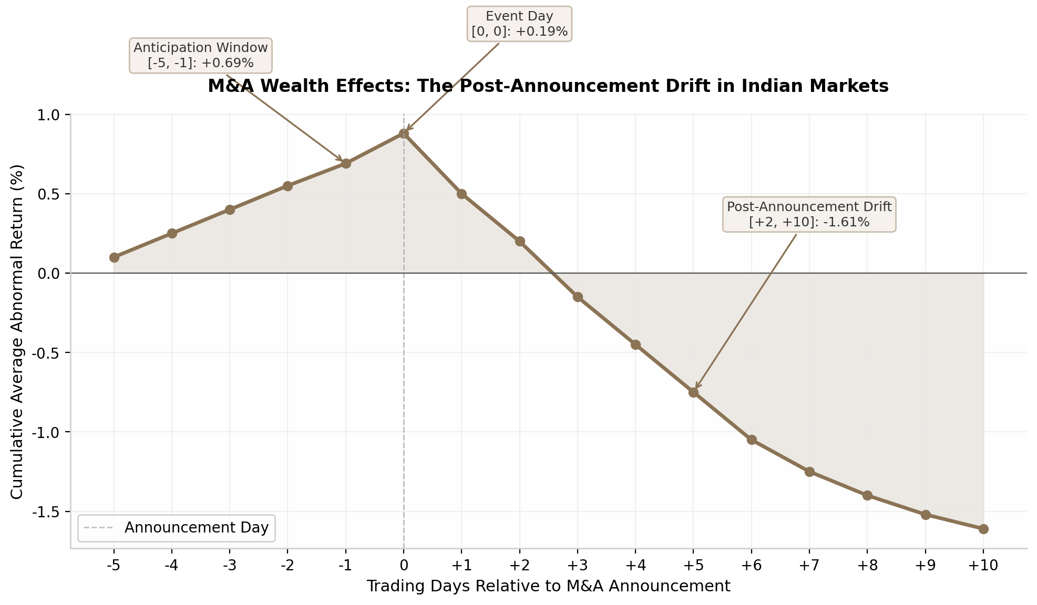 Figure 5.1: Cumulative abnormal returns around M&A announcements in India demonstrate the classic “announcement effect” followed by post-event drift. The acquirer’s stock typically peaks on the event day and underperforms over the subsequent two weeks. Source: Event study of 449 Indian M&A deals ¹.
The pattern reveals two actionable insights. First, the positive anticipation window (+0.69%) combined with the statistically insignificant aggregate CAAR of -0.57% over 21 days ⁴points to information leakage—more than two-thirds of sample companies showed statistically significant abnormal returns during the pre-announcement period ⁴. SEBI’s enforcement actions confirm this: the regulator imposed penalties totaling Rs 65 lakhs on multiple entities for insider trading in ABC Bearings shares ahead of its merger with Timken India, involving the CFO’s son, a statutory auditor’s representative, and related parties ⁵⁵. Second, the post-announcement drift suggests that markets initially underreact to integration risks and subsequently price them in over days and weeks. For readers, this means treating M&A announcements as short-term trading opportunities is a losing strategy; the statistically significant alpha lies in avoiding acquirer stocks during the drift period or, for sophisticated investors, in short-term underperformance trades.

5.2.2 Demergers: Tata Motors and Jio Financial — Value Unlocking Mechanics
Demergers function differently from acquisitions in wealth creation. Tata Motors’ demerger into separate passenger vehicle (PV) and commercial vehicle (CV) entities was approved by approximately 99.9995% of shareholders—near-unanimous consent that signaled strong investor confidence in the value-unlocking thesis ⁴⁸. Pre-split, Tata Motors traded at Rs 660.75; post-demerger, the PV unit opened around Rs 400, implying a CV unit value of approximately Rs 260.75 per share ⁴⁸. The analytical exercise for readers is to compare the sum-of-the-parts valuation against the pre-demerger whole: if the market was valuing Tata Motors at a 30-40% conglomerate discount, the demerger forces re-rating as each entity attracts dedicated institutional coverage and potential index inclusion.
Reliance Industries’ Jio Financial Services (JFS) demerger followed a different trajectory. The stock was valued at Rs 261.85 per share in the pre-open session, above analyst expectations of Rs 125-225 ⁶. However, post-demerger, JFS shares hit lower circuit for five consecutive sessions as passive funds exited ahead of index removal ⁶. The divergence between discovery price and sustained price illustrates a critical reading framework: pre-open price discovery reflects optimistic anchor bias, while the post-listing price reflects structural selling pressure from index funds and ETFs that must rebalance. Readers tracking demerger news must distinguish between the “discovery pop” and the “structural flow” that determines sustainable valuation.

5.2.3 Buybacks: +2.07% Day-One Abnormal Returns — Tax and Strategy Implications
Share buyback announcements generate statistically significant positive abnormal returns of 2.07% on the announcement day, based on a study of 239 buyback events in India during 1999-2018 ⁵. Firms with larger promoter ownership stakes experience higher market reactions, and liquidity improves after the announcement, with open market repurchase programs increasing market liquidity more than tender offers ⁵. A separate study of 109 buyback announcements found cumulative abnormal returns of 4.5% considering only post-significant announcement abnormal returns, supporting the undervaluation and signaling hypotheses ⁵⁶.
The strategic rationale for buybacks in India has evolved. Historically, buybacks served as tax-efficient alternatives to dividend distribution, which carried high tax incidence. With the dividend distribution tax removed, buybacks now signal management’s belief that the stock is undervalued relative to intrinsic worth. However, readers should scrutinize the funding source—buybacks funded by debt rather than free cash flow erode balance sheet strength and may indicate promoter-driven value extraction rather than genuine capital optimization.

5.3 Stock Market, Commodity, and Currency News

5.3.1 Index Movements, Breadth, India VIX — Volatility as Opportunity
Indian economic newspapers follow a standardized format for daily market reporting. The typical structure enumerates five to seven factors driving index movement, combining geopolitical events, oil prices, currency movements, FII flows, global cues, bond yields, and earnings ¹. Technical views are integrated with specific support and resistance zones derived from Fibonacci retracement, moving averages, and previous breakdown areas ¹.
Beyond headline indices, market breadth—the advance-decline ratio—provides critical context. A rising index with a falling advance-decline line signals negative divergence and potential reversal, as the rally is driven by a narrowing set of heavyweights rather than broad participation ⁴⁸. Conversely, a falling index with rising breadth indicates positive divergence and a potential bounce.
India VIX, the volatility index calculated by NSE under SEBI oversight, operates in a normal range of 11-17; above 20 signals heightened fear, and above 50 indicates extreme fear (it spiked above 80 in March 2020) ¹⁷. VIX typically moves inversely to Nifty ⁴, and this relationship strengthens during sharp declines. For position sizing, VIX above 20 warrants reduced speculative exposure and hedged strategies, while VIX below 15 indicates conditions suitable for larger positions ⁴. Crucially, option premiums are elevated in high-VIX environments, benefiting option sellers who accept the accompanying higher risk ⁴.

5.3.2 FII/DII Flows: Record FII Outflows and DII Absorption
Foreign portfolio investors sold a record Rs 1.76 trillion ($19.3 billion) in FY26, accelerating from Rs 1.27 trillion ($17 billion) in FY25, with cumulative net outflows since 2021 amounting to approximately Rs 10.38 lakh crore ($113.96 billion) ³. Three factors drove this sustained exit: earnings growth deceleration, the long-term capital gains (LTCG) tax hike in Budget 2024, and relatively better returns in other Asian markets.
Yet the market did not collapse. Domestic institutional investors absorbed these outflows with net purchases exceeding Rs 19.37 lakh crore ($212.67 billion) since 2021—an absorption ratio of nearly 1.9:1 ⁹. DII share of total gross institutional purchases increased from 39% in 2017 to 54% by January 2026 ⁹. The correlation between DII flows and Sensex levels is strong (r > 0.68), statistically significant, and directionally opposite to FII flows (r = -0.365) ⁹.
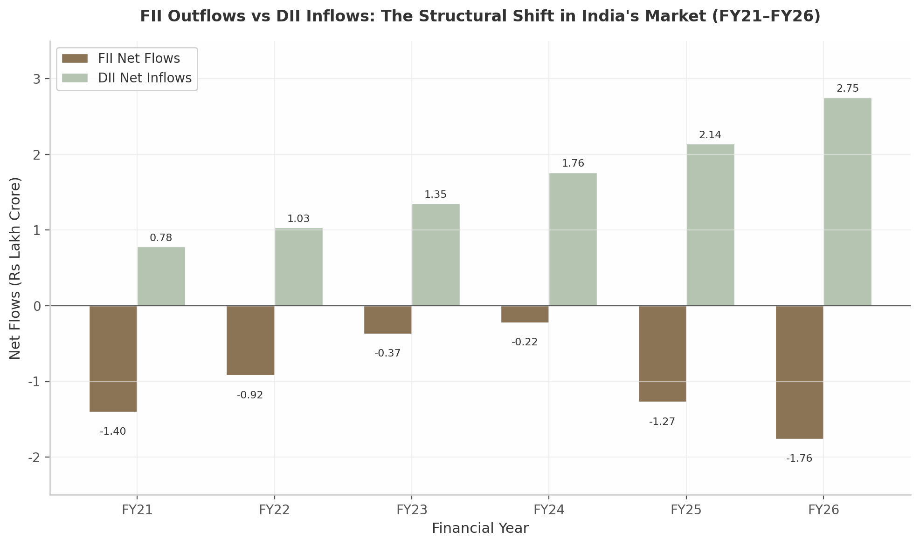 Figure 5.2: FII outflows and DII inflows from FY21 to FY26 illustrate India’s structural market transition from foreign-liquidity dependence to domestic-investor dominance. DII absorption at a 1.9:1 ratio has insulated indices from FII selling pressure. Sources: NSDL, Business Standard ³ ⁹.
This structural inversion has profound implications for how readers interpret market news. Newspaper headlines still lead with “FII Sell-Off” rather than “DII Buying Support,” framing that can trigger panic selling among retail investors who are, in fact, participating in the very DII absorption (through mutual fund SIPs now exceeding Rs 30,000 crore monthly) that stabilizes prices. Despite DII dominance, FIIs still matter because they hold $700-750 billion in Indian equities, and their selling creates acute valuation pressure on large-cap banking, IT, and FMCG stocks—the most liquid names they can exit ²⁶. The framework for readers: track daily flows, but weight the cumulative monthly trend and DII absorption ratio more heavily than isolated FII selling figures.

5.3.3 Commodity-Currency Watch: Gold, Crude, and the Rupee
Commodity and currency coverage in Indian newspapers requires a unified “external sector stress” lens rather than isolated narratives. When the rupee depreciates, both gold (denominated in USD) and crude oil (also USD-denominated) become more expensive in INR terms, yet they are framed with opposing narratives: gold rallies are celebrated as “investment opportunity” while oil rallies are warned as “inflation threat.” Both are symptoms of currency weakness and global demand shifts.
MCX Gold reached Rs 1.69 lakh per 10 grams in January 2026 before correcting on profit-taking and a firmer US dollar ⁸. Gold had surged approximately 63% during FY26, driven by geopolitical tensions ²⁸. Gold ETFs attracted record net inflows of Rs 31,561 crore in Q4 FY26, exceeding historical annual bands of Rs 700-15,000 crore ²⁸. Crude oil, meanwhile, surged past $100 per barrel as Middle East conflict escalated, with brokerages warning Brent could hit $100-150 in worst-case scenarios ⁴⁹. Analysts estimate that every $10 per barrel increase in crude prices adds approximately 30 basis points to India’s inflation through direct and indirect channels ⁴⁹.
The rupee depreciated to a record low of 93.86 against the dollar in March 2026 ²², prompting RBI intervention that caused forex reserves to plunge $30.5 billion, from an all-time high of $728.5 billion to $688.05 billion ²³. When adjusted for the RBI’s net short dollar position in the forward market ($77.25 billion), effective import cover falls from 11 months to approximately 9 months ²³.
The sectoral impact framework is clear: IT and pharma benefit from rupee depreciation (dollar revenues, rupee costs) ²⁷; textiles benefit partially but are constrained by input cost inflation ⁵⁰; and import-dependent sectors—electronics, petroleum, gems and jewellery—face margin compression ⁵⁰. Almost 60% of India’s goods trade is denominated in dollars, meaning currency movement directly affects competitiveness for the majority of exporters ⁵⁰.

5.4 Case Studies

5.4.1 Case Study: Hindenburg-Adani — $150 Billion Erased, Regulatory Response
On January 24, 2023, US-based short-seller Hindenburg Research published a report alleging accounting fraud, stock manipulation, and use of offshore entities by the Adani Group. The market reaction was among the most severe in Indian corporate history: Adani Enterprises fell 54%, Adani Total Gas dropped 56%, and the group’s total market capitalization declined by nearly $150 billion—from $236 billion to $127 billion—within weeks ⁸. The report triggered a Supreme Court-constituted expert committee, SEBI investigations into 24 offshore entities, and a prolonged legal battle that culminated in a January 2024 Supreme Court ruling allowing SEBI to continue its probe while declining to order a CBI/FIR.
The analytical framework this case establishes is multi-layered. First, governance risk is binary and non-diversifiable: when it materializes, correlation across group entities approaches one, making “it won’t happen to my stock” a dangerous assumption. Second, the speed of wealth destruction—$150 billion in weeks—means that position-sizing based on historical volatility significantly underestimates tail risk for promoter-controlled conglomerates. Third, the regulatory response matters as much as the allegation: SEBI’s investigation into offshore entities, the Supreme Court’s measured approach, and subsequent disclosure requirement enhancements have raised the cost of opacity for all promoter-driven groups.
For newspaper readers, the Hindenburg-Adani saga demonstrates the importance of tracking three pre-crisis indicators: promoter pledge levels (which restrict financial flexibility), related-party transaction complexity (which obfuscates cash flow tracing), and auditor rotation compliance (which SEBI mandates to prevent capture). When these three indicators rise simultaneously, the probability of a governance-triggered repricing event increases non-linearly, even in the absence of a short-seller report.

5.4.2 Case Study: TCS FY26 — First Dollar Revenue Decline, AI Pivot at $2.3 Billion
Tata Consultancy Services’ FY26 results marked an inflection point for India’s $283 billion IT sector. The company reduced its workforce by 19,755 employees in Q2 FY26—a 3.2% quarterly decline, its steepest-ever job cuts—dropping headcount below 600,000 for the first time since 2022 ¹¹. The company set aside Rs 11.35 billion ($136 million) for severance costs ¹¹. This was not an isolated event: India’s top five IT companies added only 2,505 employees in calendar year 2025 after shedding nearly the same number in 2024 ⁵¹. More than 64% of Indian IT companies integrated generative AI tools in 2025 ⁵¹, and hiring for 2026 is projected to grow only 6-8% with no broad pyramid expansion—more than half centered on AI/ML, cloud, cybersecurity, and data engineering while legacy skills fell below 10% of demand ⁵¹.
The case study offers three analytical frameworks. First, the IT sector is undergoing a structural—not cyclical—correction driven by AI-led productivity compression and slower global discretionary tech spending ¹⁸. Unlike previous downturns (2001 dot-com bust, 2008 financial crisis, 2020 pandemic), this displacement is permanent: AI tools enable a single engineer to deliver what previously required three, compressing the pyramid from the middle. Second, the AI pivot carries capital allocation implications. TCS’s $2.3 billion AI investment commitment—the largest technology modernization bet in the company’s history—signals a shift from headcount-driven revenue growth to productivity-led margin expansion, a fundamentally different valuation model where revenue growth may stagnate while profitability improves. Third, the 40,000 layoffs across India’s tech ecosystem ¹⁸create consumption knock-on effects in metro real estate (rental demand), food-tech (corporate catering), and retail (disposable income compression) that play out over 6-12 months.
For readers tracking IT sector news, the critical metrics have shifted. Headcount growth—long the headline number—now matters less than revenue per employee and AI-driven productivity metrics. Deal total contract value (TCV) announcements must be read for AI/digital components rather than legacy maintenance. And guidance commentary on “generative AI contribution to revenue” is replacing “digital revenue percentage” as the forward-looking indicator that markets will price.

The frameworks in this chapter—from sector-specific earnings diagnostics to M&A event-study quantification, from FII/DII flow interpretation to commodity-currency integration—equip readers to move beyond headline reactions toward structured analysis. Corporate news moves markets in predictable patterns; the disciplined reader who understands anticipation windows, post-announcement drifts, and structural flow dynamics can separate transitory noise from durable signal.

6. Sector-Specific News Impact Deep Dive
Indian economic newspapers move markets through granular, sector-specific reporting that translates policy announcements, data releases, and global developments into actionable signals. Understanding how each sector transmits news into economic outcomes is essential for readers who want to move beyond headline reactions. This chapter provides a sector-by-sector analytical framework covering agriculture, banking and financial services, information technology, and manufacturing cumulatively — tracing the path from newspaper headline to household impact, stock price movement, or policy response. The sectors examined here account for approximately 75% of India’s formal employment, 80% of stock market capitalization, and virtually all of the news flow that drives daily market sentiment.
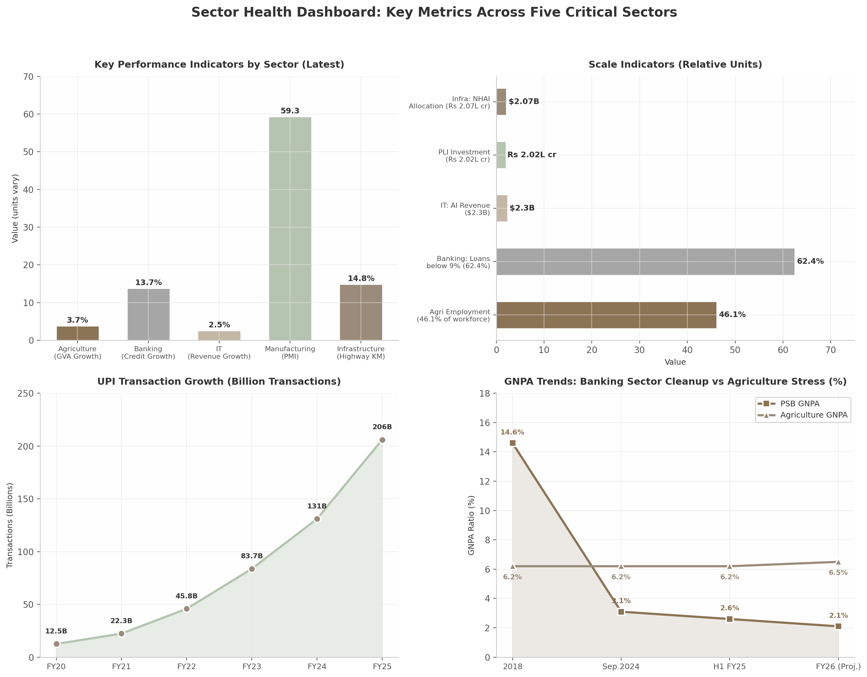 Figure 6.1: The dashboard captures divergent health trajectories across India’s critical sectors — manufacturing PMI at a 17-year high contrasts with IT revenue growth deceleration, while banking GNPAs have declined to a 12-year low even as agricultural stress remains elevated. Sources: PIB, RBI, ICRA, HSBC PMI data.
The chart reveals a fundamental asymmetry. While the banking sector has engineered a remarkable cleanup — Gross Non-Performing Assets (GNPA, the ratio of bad loans to total advances) falling from 14.6% in 2018 to 2.6% by H1 FY25 ²⁵— agriculture’s GNPA has remained sticky at 6.2% ⁹, reflecting structural credit discipline problems that loan waiver politics perpetuate. Manufacturing, measured by the Purchasing Managers’ Index (PMI, a monthly survey-based indicator of factory activity where readings above 50 signal expansion), hit 59.3 in August 2025 — its highest level in 17 years ⁸— even as IT services face demand headwinds. These divergences matter: a single “GDP growth at 6.8%” headline obscures that different sectors operate at fundamentally different speeds.

6.1 Agriculture and Rural Economy

6.1.1 MSP, Monsoon, and Crop Estimates — Impact on Farmer Incomes, Agri-Stocks, Food Inflation
Agricultural news follows a predictable seasonal rhythm. The IMD’s first long-range monsoon forecast in April triggers cascading revisions to GVA (Gross Value Added, the measure of sectoral output) growth forecasts, inflation projections, and rural consumption estimates. The 2024 monsoon illustrates this chain: IMD projected above-normal rainfall at 106% of LPA (Long Period Average), prompting ICRA to revise agricultural GVA growth to 3.7% for FY2025 from 1.4% in FY2024 ². Kharif sowing exceeded year-ago levels by 7.7% as of June 21, 2024, despite an 11% June rainfall deficit ¹⁵. When July rainfall compensated, agri-input and FMCG stocks with rural exposure rallied.
MSP announcements represent the second pillar of agricultural news. The government’s payout reached Rs 3.47 lakh crore across 22 mandated crops in 2024-25, up from Rs 2.63 lakh crore in 2023-24, benefiting 1.84 crore farmers ¹. MSP margins over cost of production peaked at 109% for wheat, with kharif crop MSPs for 2025-26 raised by 1.4% to 12.7% depending on the crop ²⁹. Oilseeds and pulses see higher increases to reduce import dependence — which prompted the government to raise edible oil tariffs from 0% to 20% in September 2024 ¹⁴.
The impact chain for MSP news operates through multiple channels. For farmers, higher MSPs signal sowing incentives and income support. For the stock market, agri-input companies and FMCG firms with rural exposure see analyst upgrades when procurement expands. For fiscal analysts, the Rs 3.47 lakh crore payout represents approximately 1% of GDP. For inflation watchers, expanded procurement can tighten foodgrain supply in open markets, exerting upward pressure on cereal prices.
Table 6.1: Agricultural Sector News Indicators and Their Market Impact
Indicator | Latest Reading | Transmission Mechanism | Affected Sectors
Monsoon forecast (% of LPA) | 106% (2024), 92% (2026 proj.) ² ¹⁹ | Sowing area → crop output → rural income → FMCG demand | Agri-inputs, FMCG, tractors, two-wheelers
MSP payout (Rs lakh crore) | 3.47 (2024-25) ¹ | Farmer disposable income → rural consumption → bank deposits | FMCG, banking, auto (rural)
Agricultural exports ($B) | 51.9 (2024-25, +6.4% YoY) ³ | Forex earnings → farmer prices → trade balance | Rice mills, sugar, spices exporters
Agri GNPA (%) | 6.2 (Sep 2024) ⁹ | Credit availability → farm investment → productivity | Banking (PSBs especially)
Real rural wage growth | Positive since 2024 ²⁶ | Consumption demand → FMCG volumes → corporate earnings | FMCG, consumer durables
The table underscores the interdependence of agricultural indicators. A strong monsoon combined with record MSP disbursement and positive real rural wage growth created a virtuous cycle in 2024-25, with NielsenIQ data showing rural FMCG demand growing four times faster than urban demand in Q1 2025 ²⁶. However, the 2026 monsoon forecast of just 92% of LPA — the lowest initial forecast in over two decades — combined with West Asia conflict threatening fertilizer supplies, poses a material risk ¹⁹. Readers should monitor the interaction of these variables rather than any single indicator in isolation.

6.1.2 The Agriculture Paradox: $51.9B Exports, Rs 3.47 Lakh Crore MSP — Yet 46.1% in Farm Employment
India’s agricultural sector presents a paradox that newspaper readers must internalize to interpret agri-news accurately. Exports recovered to $51.9 billion in 2024-25 (+6.4% YoY) driven by easing export curbs on rice, wheat, sugar, and onion as monsoon-aided output improved ³. MSP payouts crossed Rs 3.47 lakh crore ¹. Yet 46.1% of India’s workforce remains in agriculture — predominantly in low-productivity, small-holding farming — and real rural wages were negative for a decade before turning marginally positive only in 2024 ²⁶. The sector contributes just 15-18% of GDP while absorbing nearly half the workforce, making it the primary locus of disguised unemployment.
When the OECD noted that India eased rice export restrictions throughout 2024 while raising edible oil tariffs from 0% to 20% ¹⁴, the contradictory nature of trade policy becomes clear — export liberalization for some crops coexists with import protection for others, reflecting the tension between farmer income support and consumer price control. Export-oriented commodities (basmati rice, spices, cotton) typically benefit larger farmers in irrigated regions, while the majority of small farmers depend on rain-fed agriculture for subsistence crops.
Farm loan waivers represent the most politically charged dimension of agricultural news. Since 2014-15, 10 states have announced waivers worth Rs 2.4 lakh crore (1.4% of GDP), yet only about 50% of eligible farmers received benefits ²⁰. In Uttar Pradesh, repayment rates fell from 25-50% to just 10-25% following waiver announcements ⁵¹. Agriculture GNPAs spiked to 8.44% by March 2019, and SBI’s agri NPAs surged to 16% in FY20 from 6% in 2017 ⁹. Maharashtra’s Rs 35,000 crore waiver in early 2026 prompted ICRA to warn that “NPAs on the agri portfolio have increased because of this” historically ⁵⁶. The political economy is compelling — 17 out of 21 parties promising waivers won their state elections — but the economic cost includes destruction of credit culture and crowding out of productive capital expenditure ⁵¹. For urban investors, waiver announcements are leading indicators of stress for PSBs with high agricultural exposure.

6.1.3 Reading Agri-News for Urban Investors: Tractor Sales and Fertilizer Subsidies
Urban investors can extract actionable intelligence from agricultural news by tracking proxy indicators. Tractor sales serve as the most reliable real-time barometer of rural health — they rose 12.7% in Q1 FY26 as the monsoon recovery and MSP expansion translated into equipment demand. Fertilizer subsidy allocations in the Union Budget (approximately Rs 1.75-2 lakh crore annually) indicate the government’s commitment to supporting input costs. The rural-urban demand divergence has emerged as the defining consumption story of 2024-25: NielsenIQ showed rural FMCG demand growing four times faster than urban in Q1 2025 ²⁶, reversing a decade-long pattern. Of the 18.6 million net jobs added since March 2022, agriculture witnessed net losses of nearly 20 million while services (+23.4 million) and manufacturing (+8 million) gained — implying a structural shift toward better-quality non-farm employment ²⁶. Agriculture headlines matter less as farm performance indicators and more as signals of rural demand, which drives approximately 35-40% of India’s overall consumption economy.

6.2 Banking and Financial Services

6.2.1 GNPA at 2.6% (12-Year Low), Credit Growth at 13.7-14.3%, Digital Disruption
The Indian banking sector has undergone a dramatic transformation. Scheduled Commercial Banks reported a 22.2% year-on-year profit increase in H1 FY25, while Gross NPAs dropped to a 12-year low of 2.6% ²⁵. PSBs achieved record net profits of Rs 1.41 lakh crore in FY24, reducing NPAs from 14.6% in 2018 to 3.1% by September 2024 ²⁵. This cleanup — achieved through the Insolvency and Bankruptcy Code (IBC), recapitalization, and improved risk management — represents a structural shift. Credit growth for FY26 is estimated at Rs 25-26 lakh crore, translating to 13.7-14.3% year-on-year expansion, with gross non-performing advances projected at around 2.1% by March 2026 ¹³.
Table 6.2: Banking Sector Key Metrics — From Stress to Stability
Metric | 2018 | Sep 2024 | H1 FY25 | FY26 (Proj.) | Interpretation
PSB GNPA (%) | 14.6 ²⁵ | 3.1 ²⁵ | 2.6 ²⁵ | 2.1 ¹³ | Historic cleanup via IBC; risk of agri waiver reversal
Credit growth (YoY %) | ~10 | ~15 | 13.6 ¹⁶ | 13.7-14.3 ¹³ | PSBs outpacing private banks for 5 quarters
PSB net profit (Rs L cr) | — | — | 1.41 ²⁵ | — | Record profitability if asset quality holds
Loans priced below 9% (%) | — | 42.2 ¹⁶ | 62.4 ¹⁶ | — | RBI’s 125 bps rate cuts transmitting to borrowers
Rural/semi-urban lending share (%) | 36.9 ¹⁶ | — | 40.4 ¹⁶ | — | Financial deepening beyond metros
UPI transactions (billion) | — | — | 131 (FY24) ⁵⁵ | 206 (FY25) ⁵⁷ | Tenfold growth in 5 years; ~80% of digital txns
The table captures a sector in transition. The GNPA trajectory is genuinely historic, but agriculture GNPAs at 6.2% remain more than double the system average ⁹. Credit growth at 13.7-14.3% appears healthy, but deposit growth at 10.5% year-on-year lags behind ¹⁶, creating funding pressure. The proportion of bank loans priced below 9% increased to 62.4% in December 2025 from 42.2% a year earlier ¹⁶— a direct consequence of RBI’s 125 basis points cumulative rate cut in 2025. The most significant structural shift is that PSBs have outpaced private banks for five consecutive quarters in credit growth ¹⁶— a reversal reflecting both RBI’s push for inclusive lending and private banks’ caution in unsecured lending after regulatory guidance.

6.2.2 UPI Revolution: 131 Billion Transactions FY24 — Fintech Valuations vs Inclusion Impact
UPI transactions grew from 12.5 billion in FY20 to 131 billion in FY24 — a tenfold increase — with UPI’s share in total digital transactions surging to approximately 80% ⁵⁵. Banks on the UPI platform rose from 216 in March 2021 to 661 by March 2025, while QR code deployment expanded from 9.3 crore to approximately 65.8 crore ⁵⁵. PwC projects digital payments growing from 206 billion transactions in FY25 to 617 billion in FY30, with UPI on track to cross 1 billion transactions per day by FY28 ⁵⁷.
Yet business newspaper coverage predominantly focuses on fintech valuations rather than inclusion impact. The human-centric data is striking: 90% of users reported increased confidence in digital payments after using UPI, 94% of small merchants adopted UPI, and 65% of users report multiple daily digital transactions ⁵⁵. UPI fraud reached Rs 11 billion in 2023-24 (0.5% of transaction value) ⁵⁵— a risk that grows with scale but remains manageable. For investors, the zero Merchant Discount Rate (MDR) policy means no direct revenue from UPI transactions, raising questions about sustainability. However, UPI drives customer acquisition, deposit growth, and cross-selling for credit products. Credit cards are witnessing robust growth with volumes projected at 21.7% CAGR ⁵⁷, suggesting UPI serves as a gateway to higher-value digital financial services.

6.2.3 NBFC Stress: MSME Credit Gap of Rs 30 Lakh Crore
While formal banking has cleaned up, NBFCs present a complex picture. NBFC sector assets crossed Rs 50 lakh crore in FY2025 and are projected to reach Rs 70 lakh crore by FY2027 ¹³, but the microfinance sector saw AUM decline of 19% year-on-year, and NBFC GNPA stood at 3.08% as of June 2025 ²⁵. The MSME credit gap of approximately Rs 30 lakh crore ¹³represents both a challenge and an opportunity — digital lending platforms are attempting to bridge it through alternative data-based credit scoring, but RBI’s tightened digital lending guidelines have raised compliance costs. MSME receivables securitization recorded a CAGR of over 55% between FY2021 and FY2025 ¹³, indicating that capital markets are stepping in where traditional bank lending falls short.

6.3 Information Technology and Digital Economy

6.3.1 IT Earnings as Global Health Indicator: TCS, Infosys, Wipro Reflecting US Spending
Quarterly earnings of India’s top IT companies function as a real-time barometer of US and European enterprise technology spending. FY26 results revealed sectoral pressure: TCS reported its first-ever annual dollar revenue decline, falling 0.5% year-on-year to $30,017 million, with a sharper 2.4% fall in constant currency ²³. Wipro’s IT services revenue slipped 0.3%. Infosys projected FY27 growth of just 1.5-3.5% in constant currency ²³— well below the double-digit rates of the post-pandemic boom.
Despite weak top-line growth, margin divergence told a nuanced story. Wipro’s EBIT jumped 19.7% sequentially with margins expanding to 17.3%. TCS maintained industry-leading margins at 25.3%. Infosys saw modest improvement to 21% ²³— reflecting cost optimization and pyramid restructuring. One-time charges from new labour codes added noise: TCS took a Rs 2,128 crore hit in Q3 FY26 ²¹. For newspaper readers, IT earnings should be decoded through three lenses: dollar revenue growth as the primary stock price driver, deal TCV and pipeline for forward visibility, and headcount trends as shifting workforce strategy signals.

6.3.2 AI Disruption: TCS AI Revenue at $2.3 Billion, Hiring Shift
Artificial Intelligence has emerged as the defining strategic variable. TCS leads with annualized AI revenue exceeding $2.3 billion ²³. Infosys reported AI revenue growing at 5.5% in Q4 FY26 ²³. Wipro is repositioning through its “AI Native Business & Platforms” strategy. The workforce implications are profound: TCS added over 2,000 employees in Q4 FY26 even amid revenue decline, while Infosys reduced headcount by 8,440 — reflecting different bets on automation versus human capital ²³. The shift from legacy coding to AI/ML, cloud architecture, and data engineering is accelerating. For readers tracking IT news, headcount divergence between companies signals strategic positioning — firms hiring aggressively are betting on AI creating new service categories, while those cutting headcount are maximizing automation-driven margin expansion.

6.3.3 H-1B Variable: $100,000 Visa Fee and Talent Shift Back to India
US visa policy remains the most significant external risk. The Trump administration’s $100,000 fee on new H-1B petitions in September 2025 accelerated a structural shift already underway ²⁴. LinkedIn data shows India’s tech hiring surged 40% above pre-pandemic levels while US recruitment declined 23% ²⁴. Bringing a mid-level engineer to the US costs approximately $250,000 — five to six times the cost in India. Everest Group called this “a structural shift rather than a visa-led adjustment” ²⁴, noting that 30-40% of Indian students graduating from US universities are now keen on Indian jobs — unprecedented in the post-liberalization era. Forrester estimates the fee could cost the industry $2 billion if filing levels match 2025 ²⁴. The White House clarified the fee applies only to new applicants, not renewals ³⁶, but the policy uncertainty itself accelerates strategic shifts to nearshore centers in Canada and Mexico alongside domestic India-based expansion. For readers, H-1B news should be interpreted as a force reshaping global technology talent flows — with India potentially emerging as the primary beneficiary of remote-work-enabled decentralization.

6.4 Manufacturing and Infrastructure

6.4.1 PMI at 59.3 (17-Year High) and IIP as Leading Indicators
Manufacturing news revolves around two monthly releases: the HSBC India Manufacturing PMI and the Index of Industrial Production (IIP). PMI reached 59.3 in August 2025 — the highest in 17 years — driven by the quickest production growth in nearly five years ⁸. IIP growth was 4.0% in September 2025, with manufacturing at 4.8%. Top contributors were basic metals (12.3%), electrical equipment (28.7%), and motor vehicles (14.6%) ⁸— signaling broad-based strength. India’s manufacturing sector has potential to reach $1 trillion in FY26 and add more than $500 billion annually to the global economy by 2030 ⁸.
Table 6.3: Manufacturing and Infrastructure — Scale and Trajectory
Indicator | Latest/FY25 | Projection/Target | Key Driver
Manufacturing PMI | 59.3 (Aug 2025) ⁸ | Sustained >55 | Domestic demand, export recovery
IIP manufacturing (%) | 4.8 (Sep 2025) ⁸ | 5-6% annual | Capital goods, electrical equipment
PLI investment (Rs L cr) | 2.02 actual ¹¹ | Expansion to new sectors | Mobile phones, pharma, medical devices
PLI employment (lakh) | 12.6 ¹¹ | Continued scaling | Labour-intensive sectors
National Highways (km) | 1,46,342 ⁶ | 2,00,000+ by 2030 | Bharatmala, Gati Shakti
NHAI allocation (Rs L cr) | 2.07 ⁶ | Sustained above 2.0 | Road infrastructure, logistics
Cement consumption (MMT) | 445 (FY24) ²⁸ | 670 by 2030 ²⁸ | Housing, urban infrastructure
Highway construction (km/yr) | 10,660 (FY25) ⁶ | 12,000+ | EPC contracts, steel/cement demand
The table illustrates the scale of India’s manufacturing and infrastructure buildout. PLI schemes generated incremental production and sales of over Rs 18.7 lakh crore ¹¹. Domestic mobile phone production rose from Rs 18,000 crore in 2014-15 to Rs 5.45 lakh crore in 2024-25, a 28-fold increase ¹¹. However, solar PLI faced policy inconsistency through frequent ALMM rule changes; as of June 2025, India’s polysilicon capacity was only 3.3 GW — well below self-sufficiency levels ²². This illustrates a broader execution challenge: policy certainty is as important as policy intent for long-term capital-intensive manufacturing.

6.4.2 PLI Ecosystem: Rs 2.02 Lakh Crore Investment, 12.6 Lakh Jobs
The PLI scheme represents India’s most ambitious industrial policy since liberalization. Actual investment of Rs 2.02 lakh crore across 14 sectors generated incremental production of over Rs 18.7 lakh crore and employment of 12.6 lakh ¹¹. Beyond mobile phones, 21 medical device projects manufacture 54 unique devices including MRI machines, CT scanners, and cardiac stents — products almost entirely imported a decade ago. For readers, PLI news should be assessed through three filters: investment commitment versus actual realization (significant gaps exist in some sectors), employment quality (skill intensity varies enormously across sectors), and export performance as the true test of sustained competitiveness versus mere import substitution.
Informal manufacturing presents a parallel story. The sector added 13 lakh jobs in 2025, with total unincorporated employment reaching 12.8 crore ¹⁸. However, over 90% of manufacturing enterprises are micro and small, relying on manual labour ¹⁰. Wage growth in the informal sector was just 3.88% in 2025 versus 13% in 2023-24 ¹⁸— a sharp deceleration signaling distress despite headline job additions. Digital adoption offers a silver lining: the share of establishments using the internet for payments, logistics, and sales jumped to 39.4% from 26.7% ¹⁸, suggesting that India’s Digital Public Infrastructure is beginning to penetrate even the smallest enterprises.

6.4.3 Infrastructure Multiplier: NHAI Rs 2.07 Lakh Crore, Cement at 670 MMT by 2030
Infrastructure spending operates through the largest multiplier of any sector — each rupee generates approximately Rs 2.5-3.0 of downstream activity through construction employment, steel and cement demand, logistics efficiency gains, and real estate appreciation. India’s National Highways expanded to 1,46,342 km in FY25, with 10,660 km constructed ⁶. NHAI allocated a record Rs 2,07,000 crore ⁶, while PM Gati Shakti integrated 1,614 data layers across 44 Central Ministries and 36 States, assessing 208 major projects worth Rs 15,39,000 crore ⁶. The government’s Rs 22 lakh crore investment plan in highway development targets enhancement of expressways and high-speed corridors by 2031-32.
Cement consumption — the most reliable physical indicator of construction activity — stood at 445 MMT in FY24 and is projected to reach 670 MMT by 2030 ²⁸. ICRA projects 4-5% demand growth in FY25 and 6-7% in FY26 ²⁸. Major expansions are underway: UltraTech targets 200 MTPA by 2027 (Rs 32,400 crore capex), Ambuja has crossed 100 MTPA targeting 140 MTPA by FY28, and JSW Cement plans to triple capacity to 60 MTPA ²⁸. The GST revamp in September 2025 is expected to reduce cement prices by Rs 30-35 per 50-kg bag — a meaningful cost reduction for affordable housing.
Real estate presents a mixed picture. Housing sales across seven cities fell 14% to 5.96 lakh units in 2025, but sales value rose 6% to Rs 6 lakh crore due to price appreciation ⁴⁹— signaling a deepening split between premium and affordable segments. Limited supply of units under Rs 1 crore dragged volumes even as luxury housing grew. Housing affordability improved across seven of eight cities, with Mumbai’s EMI-to-income ratio falling below 50% for the first time to 47%, following RBI’s cumulative rate cut ¹². Ahmedabad remains most affordable at 18% ¹². For readers interpreting manufacturing and infrastructure news, the critical framework is timeline awareness: infrastructure operates on 3-7 year cycles, making the appropriate reading speed quarters and years rather than days — distinct from the real-time reactions that IT earnings or banking NPA data provoke. A highway project awarded today generates steel and cement demand within months, employment throughout construction, and logistics gains only upon completion — each phase creating different investment opportunities for patient readers who track the full lifecycle.

7. Global Economic News and India’s Transmission Channels
Global economic developments do not merely reverberate through Indian markets — they cascade through a dense web of interconnected channels that reshape capital flows, currency values, inflation trajectories, and growth outcomes. For readers of Indian business newspapers, understanding these transmission mechanisms is essential: a 25 basis point (bps) move by the US Federal Reserve, a $10 spike in Brent crude, or a tariff announcement in Washington can alter India’s macroeconomic calculus within days. This chapter maps the four primary transmission channels — US monetary policy, oil prices and geopolitics, trade wars and agreements, and currency dynamics — and quantifies their effects on India’s economy.

7.1 US Federal Reserve and Global Liquidity

7.1.1 Fed Policy Transmission: From 25 bps Moves to RBI Space
The US Federal Reserve’s policy decisions constitute the single most closely watched global economic event in Indian financial media. Every 25 bps rate adjustment by the Fed triggers front-page analysis across the Economic Times, Business Standard, The Hindu Business Line, and Mint, typically featuring three to four expert commentaries dissecting implications for foreign institutional investor (FII) flows, rupee valuation, and Reserve Bank of India (RBI) policy space. ¹ ²The coverage follows a predictable arc: the Fed action is summarized, expert reactions are quoted, and the analysis concludes with projections for Indian equities, debt markets, and the currency.
The transmission mechanism operates through three linked channels. First, when the Fed cuts rates, US Treasury yields decline, reducing the relative attractiveness of dollar-denominated assets and encouraging capital reallocation toward emerging markets. Ross Maxwell, Global Strategy Operations Lead at VT Markets, noted in December 2025 that “an interest rate cut or a dovish stance will boost global risk appetite, encouraging foreign institutional investors to increase allocations to emerging markets like India.” ¹Second, the rupee typically strengthens as dollar supply increases, easing import costs. Third, and most critically for domestic policy, Fed easing creates room for the RBI to cut rates without triggering destabilizing capital outflows. Sujan Hajra, Chief Economist at Anand Rathi Group, observed that “the Fed rate cut further opens up the space for RBI for a rate cut in the current low inflation environment to support growth.” ²However, this transmission is asymmetric. The Hindu Business Line’s more nuanced analysis highlights that when the Fed adds liquidity by purchasing Treasury bills, dollar supply rises and weighs on the greenback, “which typically supports emerging-market currencies, including the Indian rupee.” ⁵Rate differentials remain stable when RBI cuts are matched by Fed easing, helping maintain steady debt foreign portfolio investment (FPI) flows into India.

7.1.2 Rate Differential: RBI Cuts 125 bps While Fed Holds
The year 2025 presented a stress test for the conventional transmission framework. The RBI delivered 125 bps of cumulative rate cuts, reducing the repo rate from 6.5% to 5.25% by year-end, while the Federal Reserve held its policy rate steady through much of the year before delivering modest cuts in September and October. ⁴⁹This divergence widened the India-US interest rate differential, draining FPI outflows estimated at INR 152 lakh crore from Indian equities and exerting sustained depreciation pressure on the rupee. ⁵⁸The consequences were immediate and measurable. In 2025, FPIs sold equities worth Rs 166,286 crores, causing the rupee to depreciate by 5%. ⁴⁸NSDL data showed FPIs pulled out more than $17 billion from Indian equities during the year, including $933 million in the first three days of December alone. ⁸The rupee crossed the psychologically significant 90-per-dollar mark for the first time and continued its slide to an all-time low of Rs 95 per dollar by March 2026, driven by a confluence of FII selling, Middle East conflict, and rising energy prices. ⁴⁸RBI Governor Sanjay Malhotra, in a post-MPC briefing in December 2025, defended the rate-cut trajectory by emphasizing real interest rates rather than nominal ones: “When the inflation is so low and going forward as well, it is going to be low, then even though the nominal interest rate may seem to be low, the real interest rates today are quite high.” ⁴⁹Among major emerging market developing economies (EMDEs), India recorded one of the sharpest declines in headline inflation — approximately 1.8 percentage points — with CPI averaging 1.7% for April-December 2025. ⁵⁹This disinflation provided the RBI with policy space that would have been unavailable had inflation remained elevated.

7.1.3 Market Correlation: The Tightening India-US Link
The numerical relationship between Indian and US equity markets has strengthened meaningfully over the past decade. The 10-year correlation coefficient between the Sensex and the Dow Jones Industrial Average stands at approximately 0.54, indicating a moderate positive relationship. More significantly, this correlation has risen to 0.64 over the trailing three-year period, suggesting that India’s market integration with the US is deepening. ¹⁸Complementary data from GIFT Nifty correlation analysis confirms this pattern. Over six-month daily returns, GIFT Nifty shows positive correlation with the S&P 500 (+0.55), NASDAQ (+0.47), and Dow Jones (+0.52). ¹⁰European indices provide moderate influence through afternoon Indian Standard Time trading sessions, while Asian markets — particularly Hang Seng — can trigger immediate weakness in Indian market openings. ¹⁰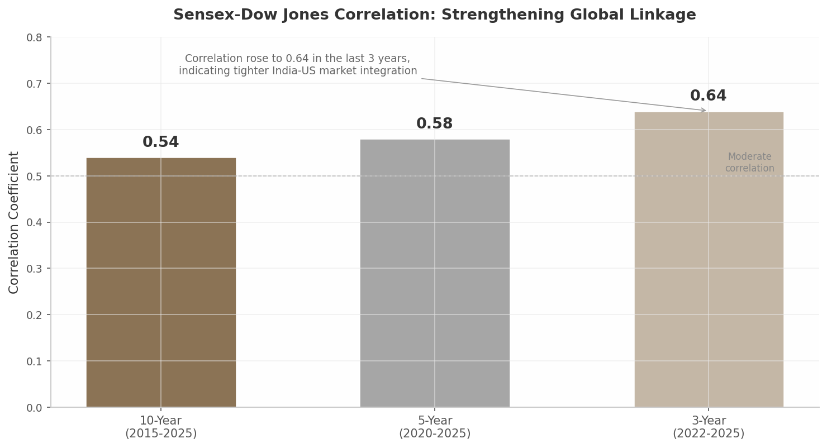 Source: Groww.in analysis; TradingView data. The correlation coefficient has risen from 0.54 (10-year) to 0.64 (3-year), indicating tighter India-US market integration. ¹⁸ ¹⁰
The practical implication for newspaper readers is that overnight developments on Wall Street now carry greater predictive power for Indian market openings than at any point in the previous decade. A 2% decline in the S&P 500 is increasingly likely to presage a corresponding, if not proportional, decline in the Nifty 50 the following trading session.

7.2 Oil Prices, Geopolitics, and India’s Vulnerabilities

7.2.1 Crude Shock Math: Quantifying the Triple Hit
India’s structural vulnerability to oil price volatility is among the most direct and consequential transmission channels from the global economy. India imports approximately 90% of its crude oil requirements and roughly 60% of LPG, with the Middle East accounting for 55% of oil imports before the 2026 Iran-Israel conflict. ¹²The country’s strategic petroleum reserves cover only 40-50 days of consumption — a thin buffer for a population of 1.4 billion. ⁷The RBI’s October 2025 Monetary Policy Report provides the definitive quantification of crude shock impacts: every $10 per barrel increase in crude oil prices adds nearly $20 billion (0.5% of GDP) to India’s current account deficit, increases inflation by approximately 30 bps, and reduces GDP growth by roughly 15 bps, assuming full pass-through to domestic product prices. ²²ICRA estimates place the WPI (Wholesale Price Index) impact at 80-100 bps for every 10% crude price increase, given fuel and power’s 10.4% weight in the WPI basket. ²⁹The following matrix summarizes the full transmission chain from a crude price shock to the Indian economy:
Shock Parameter | Impact on Current Account | Impact on Inflation | Impact on GDP Growth | Secondary Effects
$10/bbl crude increase | +$20B CAD (0.5% GDP) ²² | +30 bps CPI ²² | -15 bps ²² | Fuel subsidy burden on OMCs
10% crude price rise | Proportional to $10/bbl shock | +80-100 bps WPI ²⁹ | Demand compression | IIP moderation
Brent at $109/bbl (Apr 2026) | CAD widest in 3 years ²⁷ | WPI at 21-month high of 3.2% ²⁹ | Growth forecast cuts | LPG panic buying (+38%) ⁷
Strait of Hormuz disruption | $98.7B imports at risk ¹³ | Supply-side inflation spike | Industrial output loss | 333M households affected ⁷
Note: OMC = Oil Marketing Companies; IIP = Index of Industrial Production. Figures assume full pass-through to domestic prices. ²²
The matrix reveals that crude shocks transmit asymmetrically — the current account impact is linear and immediate, the inflation impact follows with a lag of one to two quarters, and GDP effects materialize over six to twelve months as higher input costs propagate through the production chain. When Brent crude surged from $60 per barrel in February 2026 to $109 by early April following the Iran-Israel war, India’s balance of payments moved toward its second successive deficit year — a development Standard Chartered’s Anubhuti Sahay described as unprecedented in India’s post-liberalization history. ⁴⁸ ⁵⁰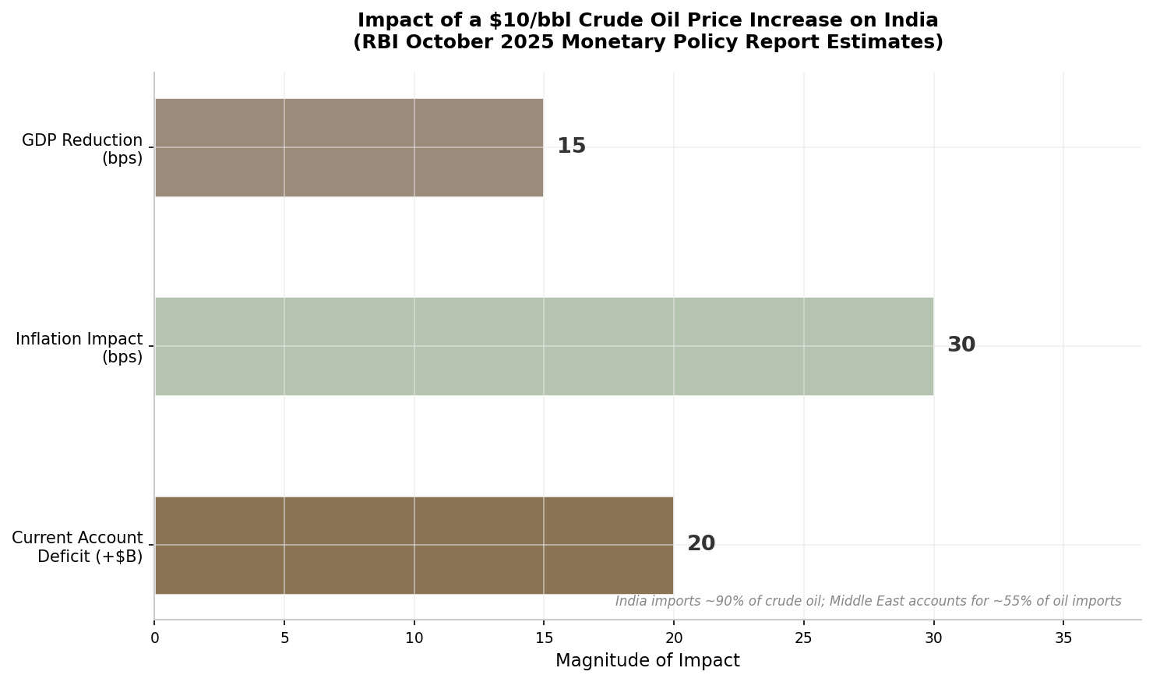 Source: RBI October 2025 Monetary Policy Report. India imports ~90% of crude; Middle East accounts for ~55% of oil imports. ²² ¹²

7.2.2 Geopolitical Coverage Patterns: The “Domestication” Bias
When global geopolitical crises erupt, Indian economic newspapers do not report them as neutral observers. Academic research on coverage of the Russia-Ukraine war reveals a pronounced “domestication” bias. A peer-reviewed study by Wozniak and Liu at Liverpool University found that 85% of Times of India coverage during the first four weeks of the invasion focused on Indian interests — student evacuations, economic impacts, and India’s diplomatic stance — rather than geopolitical analysis per se. ²³The Hindu showed more balanced thematic distribution, with 38.73% political themes and 23.54% economic themes in its coverage. ²⁴This framing pattern has practical consequences for readers. A reader relying primarily on Times of India coverage would have received extensive information on Operation Ganga (the student evacuation mission) and the economic fallout for Indian wheat and sunflower oil imports, but relatively limited analysis of how the war reshaped global energy markets or altered great-power dynamics. The Economic Times, by contrast, provided more market-oriented coverage emphasizing commodity price impacts and sectoral effects on Indian companies with exposure to the affected regions.
The “domestication” framework intensified during the 2026 Iran-Israel war. Coverage centered on the Strait of Hormuz closure threat, which put nearly a fifth of India’s imports — valued at $98.7 billion — at risk, including $50.8 billion of crude oil, $13.9 billion of LPG, and $9.2 billion of LNG from the Middle East. ¹³ ¹⁹LPG cylinder booking requests surged 38% between March 1 and March 13, 2026, as 333 million households stocked up amid fears of shortages. ⁷Indian newspapers framed this not as Middle East geopolitics but as a kitchen-table economic issue — a domestication choice that resonates with their readership but may underweight the broader strategic context.

7.2.3 Trade War Impact: US Tariffs and the EU-India FTA Hedge
The escalating US-China trade war and the threat of American tariffs on Indian exports created a dual narrative in 2025-2026: significant downside risk from protectionism, offset by strategic diversification opportunities. The Kiel Institute for the World Economy estimated that US tariffs of 50% on Indian goods (the rate applied before the February 2026 interim deal) would reduce India’s real value added by 1.64% in the short run — approximately $57 billion in foregone annual output — with Indian exports to the US projected to drop by 22-26%. ¹⁶Morgan Stanley provided a more conservative estimate, projecting a 0.6-1.0% GDP hit from tariff escalation. ¹⁶The February 2026 interim trade deal reduced tariffs from 50% to 10-18% on most Indian goods, with India eliminating tariffs on US industrial goods and agricultural products in exchange. ⁵⁶But the episode underscored India’s vulnerability to unilateral US trade actions and accelerated the search for alternative market access.
The EU-India Free Trade Agreement, signed in January 2026, emerged as the primary strategic hedge. Kiel Institute modeling projects mutual economic gains of 0.12-0.13% of GDP for both partners, with bilateral trade surging 41-65%. ¹⁷Critically, the EU agreed to liberalize 97% of its tariff lines for Indian exports — 91% immediately — with Indian textile exports projected to grow from $7 billion to $30-40 billion “very quickly.” ⁵¹Since the US tariffs at their peak threatened 1.6% of GDP in output losses, the EU-India FTA’s projected 0.12-0.13% GDP gain represents a partial but meaningful offset.
The following table compares the competing trade agreement effects on India’s economy:
Trade Agreement / Tariff Regime | GDP Impact | Export Impact | Sectoral Winners | Sectoral Losers | Confidence Level
US tariffs at 50% (pre-deal) | -1.64% ($57B) ¹⁶ | -22 to -26% to US ¹⁶ | None | Textiles, gems, pharma, IT | High (Kiel CGE model)
Morgan Stanley estimate | -0.6 to -1.0% ¹⁶ | Broad-based decline | None | Export-oriented MSMEs | High
US-India interim deal (Feb 2026) | Reduced to -0.3 to -0.5% (estimated) | Partial recovery | Pharma, engineering goods | Tariff-sensitive agriculture | Medium
EU-India FTA (Jan 2026) | +0.12 to +0.13% ¹⁷ | +41 to +65% bilateral | Textiles ($7B → $30-40B) ⁵¹ | EU-imported manufactures | High
China+1 / PLI effect | +0.1 to +0.2% (estimated) | Electronics +146% since FY21 ⁴ | Electronics, semiconductors | Chinese component suppliers | Medium
Note: CGE = Computable General Equilibrium; MSME = Micro, Small and Medium Enterprises. GDP impacts are not additive due to overlapping channels. ¹⁶ ¹⁷ ⁴
The table reveals an asymmetry in India’s trade architecture: the downside from US tariff disruption is an order of magnitude larger than the upside from EU market access. This structural imbalance explains why Indian trade negotiators prioritized the US interim deal even as the EU-India FTA was being finalized. The electronics sector, where production has surged 146% since FY2021 to reach $60.7 billion, illustrates the China+1 opportunity — Apple has made India its second-largest iPhone production base after China — but domestic value addition remains stuck at 15-20%, constraining the full capture of trade diversion benefits. ⁴ ³⁷### 7.3 Currency Wars and Emerging Market Dynamics

7.3.1 Rupee at 93+: RBI’s Defense and the Shock Absorber Role
The rupee’s depreciation from roughly 85.6 to 93.2 against the US dollar over 2025 placed it among the worst-performing Asian currencies. Three forces drove this slide: the interest rate differential widened as the RBI cut 125 bps while the Fed held steady; tariff and oil shocks deteriorated India’s terms of trade; and a global risk-off rotation toward US mega-caps added a geopolitical premium. ⁵⁸The IMF formally acknowledged India’s currency stress by reclassifying the country’s exchange rate regime from “stabilised” to “crawl-like” — an implicit recognition that the RBI was allowing the rupee to function as a shock absorber rather than defending a specific level. ³⁶The RBI’s intervention data reveals the magnitude of its defense: it sold $31.98 billion on a net basis during January-October 2025, a dramatic reversal from net purchases of $23.03 billion in the same period of 2024. ⁶⁰Gross dollar sales jumped 35% to $207.96 billion, while outstanding net forward sales reached $63.6 billion by October 2025, up 30% year-on-year. ⁶⁰Despite this intervention, forex reserves remained at a healthy $701.4 billion as of January 2026, covering approximately 11 months of imports and 94% of external debt outstanding — comfortably above the Guidotti-Greenspan rule threshold. ⁶¹ ⁶²RBI Governor Sanjay Malhotra has characterized the reserve position as “sufficient” and “not a matter of concern,” even as the central bank continues active intervention to manage volatility. ⁶²The rupee depreciation creates a sharp distributional divide. Exporters — particularly IT services firms — benefit directly: every 1% decline in the rupee contributes 10-15 bps of margin expansion for IT companies, and TCS and Infosys earn 94-97% of revenue from outside India. ⁶³Importers and domestic consumers bear the cost through higher fuel, commodity, and goods prices. This “commodity-currency scissors” effect means that the same underlying phenomenon — rupee weakness — generates opposing newspaper narratives: celebratory for gold holders and IT exporters, alarming for commuters and manufacturers dependent on imported inputs.

7.3.2 FII Outflow Structural Shift: The DII Absorption Phenomenon
The most consequential structural change in India’s capital markets over the past five years has been the inversion of the FII-DII (domestic institutional investor) relationship. From FY22 through FY26, cumulative FPI outflows reached Rs 10.38 lakh crore, driven by a stronger US dollar, Trump’s protectionist policies, and India’s widening fiscal deficit. ⁸ ⁶Yet Indian equity markets did not collapse. Instead, DII inflows absorbed FII selling at a ratio of approximately 1.9:1 — for every Rs 1 of FII outflow, domestic institutions deployed Rs 1.9 of inflows. ⁵⁸This absorption mechanism is underpinned by systemic domestic liquidity. Systematic Investment Plan (SIP) inflows into mutual funds have stabilized at approximately Rs 30,000 crore per month, providing a predictable domestic demand floor for Indian equities. ⁵⁸The EPFO (Employees’ Provident Fund Organisation), insurance companies, and public sector banks have all increased equity allocations, creating a structural domestic bid that partially insulates Indian markets from foreign capital volatility.
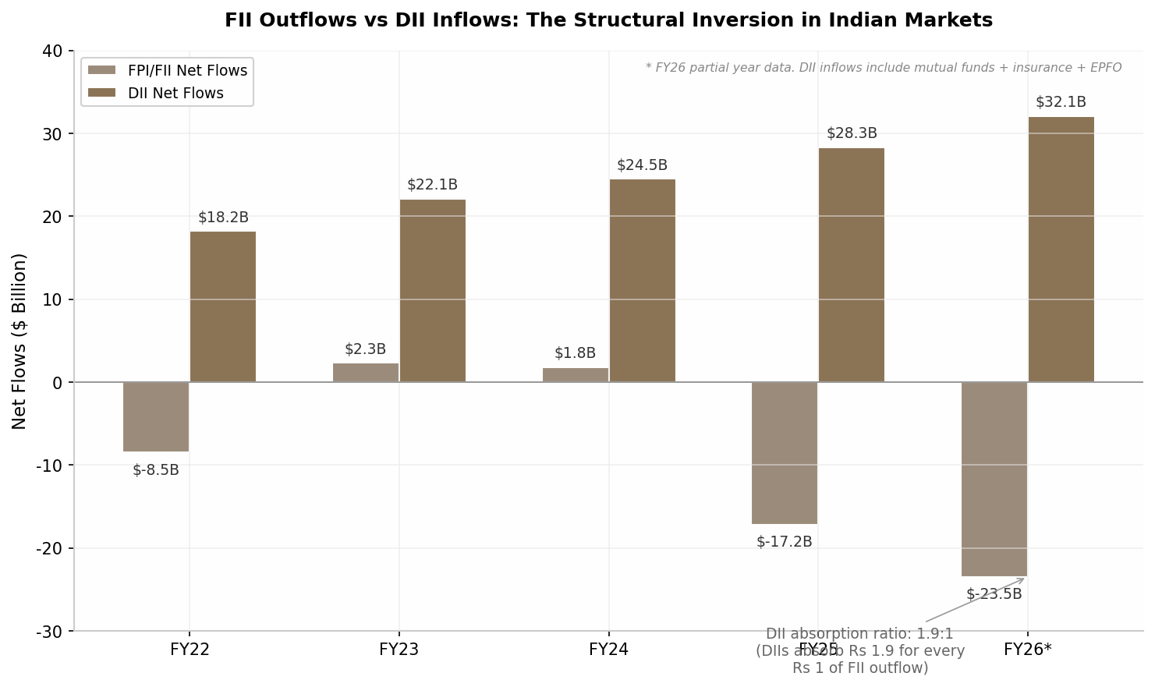 Source: NSDL, AMFI data. DII inflows include mutual funds, insurance, and EPFO. FII outflows absorbed at 1.9:1 ratio. ⁵⁸
The analytical implication is significant. The traditional framework for interpreting Indian market news through an FII-centric lens is becoming outdated. Newspaper headlines that read “FII Sell-Off Pressures Markets” without noting the parallel DII absorption create an incomplete mental model for readers. In 2025, FPIs sold $17+ billion, but markets found support because DIIs bought aggressively — a dynamic that signals maturing domestic capital markets rather than vulnerability to foreign capital flight.
The transmission channels examined in this chapter are not independent — they interact and amplify. A Fed rate hike strengthens the dollar, which raises oil prices in rupee terms, which widens the current account deficit, which puts further pressure on the rupee, which invites RBI intervention that depletes reserves and constrains domestic monetary policy space. Understanding these linkages enables readers to parse global economic news not as isolated events but as nodes in a network of cascading effects, each with quantifiable implications for India’s economy, markets, and households.

8. Regulatory and Legal News: The Hidden Market Mover
Regulatory announcements routinely move Indian markets more than corporate earnings or macroeconomic data, yet they receive disproportionately less analytical coverage in mainstream financial media. Securities and Exchange Board of India (SEBI) circulars, Reserve Bank of India (RBI) master directions, Goods and Services Tax (GST) Council decisions, and Insolvency and Bankruptcy Code (IBC) amendments share three characteristics that create systematic trading opportunities: they are published on predictable schedules, their compliance deadlines generate measurable demand and supply shifts, and their first-order effects are often priced in only partially before implementation. This chapter develops a framework for reading regulatory news as a source of market alpha rather than background noise.

8.1 SEBI Regulations and Market Structure

8.1.1 The F&O Regulation Cascade: From Data to Action
The most consequential regulatory cascade in Indian capital markets during 2024-2025 began with a single data point. SEBI’s internal research revealed that 91.1% of individual futures and options (F&O) traders — approximately 73 lakh people — incurred losses in FY24, with aggregate retail trader losses of roughly Rs 1.81 lakh crore over the three financial years from FY22 to FY24. ¹The average loss per trader approached Rs 1,20,000 annually. This data, published in January 2025, triggered a six-measure regulatory overhaul that reshaped the derivatives market.
The first measure took effect on November 20, 2024, when SEBI increased the minimum contract size for index futures and options from Rs 5-10 lakh to Rs 15-20 lakh, directly raising capital barriers to entry for retail speculators. ²Simultaneously, SEBI limited each stock exchange to offering weekly derivatives on only one benchmark index, forcing NSE to discontinue weekly options for Bank Nifty, Nifty Midcap Select, and Nifty Financial Services, leaving only Nifty 50 weekly contracts active. ³The regulatory tightening culminated in December 2025 with mandatory hard position limits: a Net FutEq Open Interest ceiling of Rs 1,500 crore, gross long delta limit of Rs 10,000 crore, and gross short delta limit of Rs 10,000 crore, with same-day compliance and no grace period. ²⁶The following table traces this regulatory cascade chronologically.
Table 8.1: SEBI F&O Regulatory Cascade Timeline (2024-2025)
Date | Regulatory Measure | Objective | Market Impact
Nov 20, 2024 | Contract size hike: Rs 5-10L → Rs 15-20L ² | Raise entry barriers for retail speculators | Reduced retail participation; 20-30% predicted drop in derivative volumes
Nov 2024 | Weekly expiry limited to 1 index per exchange ³ | Curb speculative frenzy around multiple weekly expiries | NSE discontinued Bank Nifty, Midcap Select, Financial Services weekly options
Jun 2025 | Scale-based RPT thresholds under LODR Fifth Amendment ¹⁴ | Reduce compliance burden while maintaining disclosure | ~60% reduction in RPTs requiring shareholder approval for top 100 NSE entities
Dec 6, 2025 | Hard position limits: Net OI Rs 1,500 cr, delta caps Rs 10,000 cr ²⁶ | Prevent excessive speculative buildup | Immediate position unwinding; same-day compliance with no grace period
The cascade illustrates a predictable regulatory pattern: data disclosure drives justification, which drives incremental tightening, which creates implementation-date market dislocations. Traders who tracked SEBI board meeting agendas and consultation papers could anticipate each step months before formal announcements.
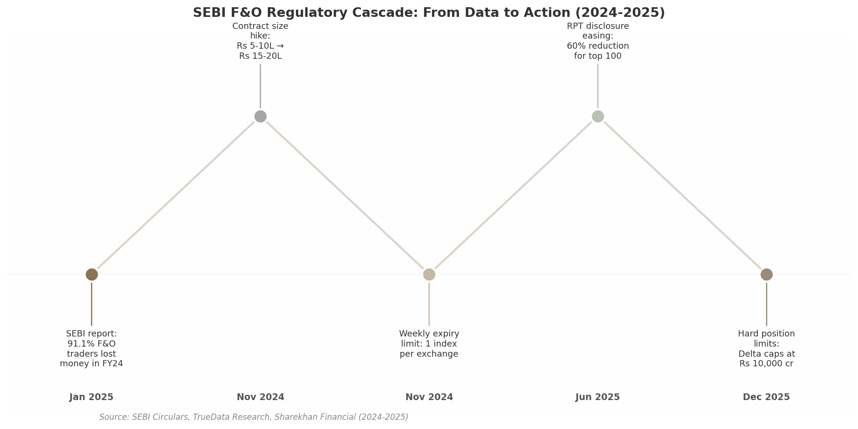
SEBI F&O Regulatory Cascade Timeline

8.1.2 Disclosure Norms: Regulation 30 and the Speed Premium
SEBI’s Listing Obligations and Disclosure Requirements (LODR) Regulations create a distinct information advantage through timing. The Fifth Amendment, effective November 18, 2025, replaced fixed materiality thresholds for Related Party Transactions (RPTs) with a scale-based system under Schedule XII. ¹⁴Under the revised framework, RPTs requiring shareholder approval would have dropped by approximately 60% for the top 100 NSE entities by turnover. ¹⁴Simultaneously, SEBI expanded RPT coverage to include directors and key managerial personnel of subsidiaries and their relatives — broadening the compliance perimeter even as it reduced procedural burden for listed entities. ²⁰Regulation 30 of LODR mandates disclosure of material events within 30 minutes of occurrence. For institutional investors with automated parsing systems, this creates a measurable speed premium. Companies that disclose after market hours versus those that release during trading sessions experience differential price discovery. The 30-minute rule effectively means that the first parser to process a disclosure captures the maximum informational advantage — a structural feature that rewards investment in regulatory monitoring infrastructure.

8.2 RBI Regulatory Directives

8.2.1 Digital Lending: Regulation by Contract
The RBI’s Digital Lending Directions, issued on May 8, 2025, consolidated and replaced earlier circulars with a framework that applies to all Regulated Entities — banks, Non-Banking Financial Companies (NBFCs), and Housing Finance Companies (HFCs). ⁹The Directions introduced a “regulation by contract” approach under which FinTechs and Lending Service Providers (LSPs), not directly regulated by RBI, are bound through their contractual arrangements with regulated lenders. ¹⁰The lender’s Chief Compliance Officer is required to certify the accuracy of data displayed on Digital Lending Apps (DLAs), effectively extending RBI’s regulatory perimeter without statutory amendment. ¹⁰The compliance timeline was deliberately compressed: app registration was mandated by June 15, 2025, with multi-lender platform rules phased in from November 1, 2025. ⁹For fintechs dependent on bank partnerships, this created a predictable restructuring window. The Directions also mandated Key Facts Statements (KFS), blended interest rates calculated as weighted averages, and capped Default Loss Guarantees at 5% of the co-lending portfolio. ⁸#### 8.2.2 CRR Management: Predictable Banking Liquidity
In June 2025, the RBI reduced the Cash Reserve Ratio (CRR) from 4% to 3%, releasing an estimated Rs 2.5 lakh crore of liquidity into the banking system. Unlike monetary policy rate decisions that are telegraphed through the MPC (Monetary Policy Committee) meeting schedule, CRR adjustments carry immediate mechanical effects: every 100-basis-point reduction in CRR frees approximately Rs 83,000 crore of deployable funds. Banking sector stocks historically exhibit positive abnormal returns in the two sessions preceding CRR cuts when the move is anticipated, and the post-announcement rally typically concentrates in banks with low loan-to-deposit ratios that can deploy freed capital fastest. The RBI Financial Stability Report (June 2025) confirmed that Indian scheduled commercial banks maintain robust capital buffers with Capital to Risk-Weighted Assets Ratio (CRAR) above regulatory minimums even under adverse stress scenarios, provisioning coverage ratio around 76%, and liquidity coverage ratio above 100%. ¹¹### 8.3 Tax, Corporate Law, and Competition Policy

8.3.1 GST Rationalization: Rs 48,000 Crore of Fiscal Impact
The 56th GST Council meeting on September 3, 2025, approved a historic rate rationalization from four tax slabs (5%, 12%, 18%, 28%) to two primary slabs (5% and 18%), with a special 40% de-merit rate on luxury and sin goods. ²²Individual health and life insurance premiums were made fully GST-exempt. Small cars and entry-level motorcycles up to 350cc saw rates reduced from 28% to 18%. ²²The estimated fiscal impact was Rs 48,000 crore, equivalent to 0.15% of GDP, with the government expecting revenue loss to be offset by consumption buoyancy. ²³Table 8.2: Compliance Cost Impact Across Regulatory Domains (FY 2025-26)
Regulatory Domain | Annual Cost (Mid-Size Listed Co.) | Key Cost Drivers | Easing Measures Introduced
SEBI (Listing & Disclosure) | Rs 8-15 lakh ¹⁴ ⁵⁶ | RPT filings, BRSR Core, HVDLE compliance | Scale-based RPT thresholds reduced compliance ~60% for top 100
RBI (Digital Lending) | Rs 5-12 lakh ⁹ ¹⁰ | App registration, KFS, DLG caps, CCO certification | Standardized templates for Key Facts Statements
GST (Filing & Compliance) | Rs 6-14 lakh ²⁴ | Monthly returns, reconciliation, refund claims | Registration in 3 days for non-risky applicants; risk-based provisional refunds
IBC (Insolvency Process) | Rs 10-25 lakh ¹⁷ ⁵⁵ | Legal fees, RP costs, NCLT filings, creditor coordination | Fast-track merger expansion; mandatory NCLT admission timelines
Environmental (CCTS/ESG) | Rs 12-22 lakh ⁴⁸ ⁶ | Emission audits, BRSR value chain disclosures, carbon credit tracking | Phased approach: value chain disclosures voluntary for top 250 in FY26
Labour (POSH, Maternity) | Rs 3-7 lakh ²⁵ | POSH compliance audits, maternity benefit documentation, Board report disclosures | Digitization of AOC-1/AOC-2 forms; electronic filing mandates
Manufacturing MSMEs face the most severe aggregate burden: over 1,450 regulatory obligations annually with compliance costs of Rs 13-17 lakh per year, a figure that helps explain what RBI’s Economic Survey terms the “missing middle” of Indian industry — enterprises that remain deliberately small to avoid regulatory complexity. ¹⁵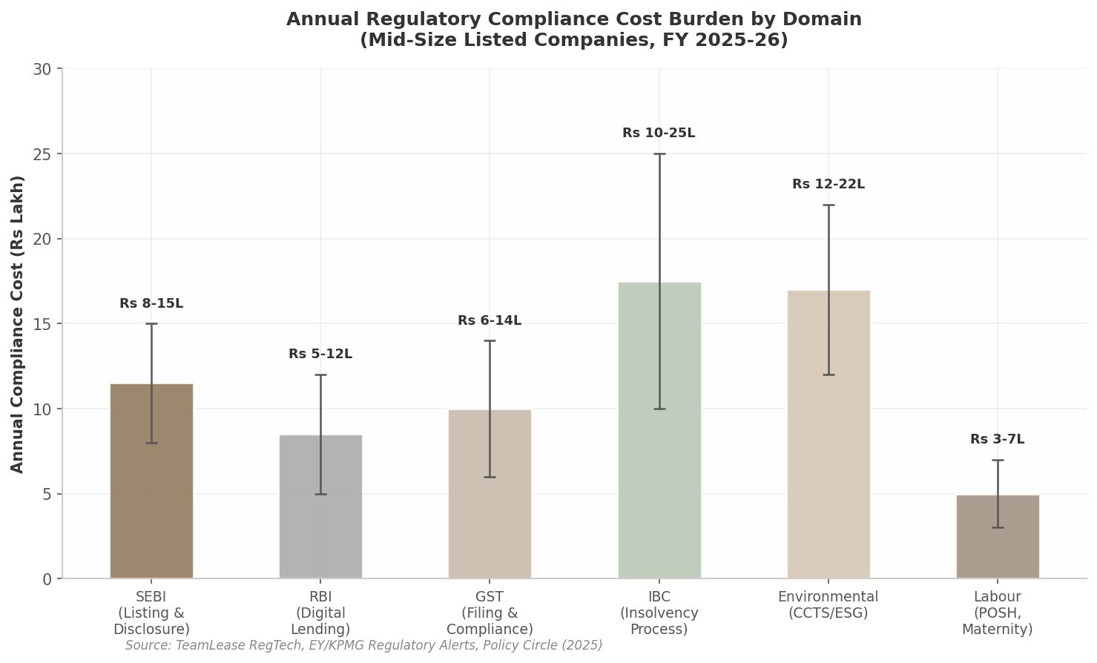
The analytical interpretation of Table 8.2 reveals a non-obvious pattern: compliance costs are highest not in the most visible regulatory domains (SEBI, GST) but in IBC and environmental compliance, where legal and audit fees dominate. For investors, rising compliance costs in a sector are a leading indicator of margin compression — particularly for MSMEs where Rs 13-17 lakh represents 1-2% of turnover. ¹⁵The GST Council’s compliance easing measures — registration within three days for non-risky applicants, export refunds in seven days, and omission of pre-sale discount agreement requirements — directly address this drag. ²⁴#### 8.3.2 IBC Amendment (2025): CIIRP and Cross-Border Framework
The IBC Amendment Bill 2025, passed in Lok Sabha on March 30, 2026, introduced the Creditor-Initiated Insolvency Resolution Process (CIIRP), allowing specified financial creditors to initiate out-of-court insolvency with 51% creditor approval, while debtor management continues subject to Resolution Professional oversight. ¹⁷The Bill made NCLT admission mandatory when default is established and procedural requirements are met, required written reasons if orders were delayed beyond 14 days, and introduced penalties of Rs 1 lakh to Rs 2 crore for frivolous proceedings. ⁵⁵The Amendment also introduced frameworks for group insolvency (common NCLT bench, joint Committee of Creditors, shared Resolution Professional) and cross-border insolvency, positioning India for alignment with the UNCITRAL (United Nations Commission on International Trade Law) Model Law. ⁵S&P Global upgraded India’s insolvency regime from ‘Group C’ to ‘Group B’ on December 3, 2025, noting that average recovery rates improved from 15-20% under the pre-IBC regime to around 30%, while resolution timelines reduced from 6-8 years to about two years. ⁴For credit markets, this upgrade is structurally significant: foreign lenders price country risk partly through insolvency regime ratings, and the ‘Group B’ classification expands the pool of institutional investors willing to hold Indian distressed debt.

8.4 Case Study: SEBI F&O Reforms 2024-2025 — Predictable Demand Shifts in Capital Market Stocks
The SEBI F&O reforms of 2024-2025 illustrate how regulatory news creates predictable market inefficiencies when implementation dates are known in advance but position adjustments occur only incrementally.
The Sequence. On January 16, 2025, SEBI published its research report documenting 91.1% individual trader losses in FY24 and Rs 1.81 lakh crore in aggregate retail losses over three years. ¹Capital market stocks — particularly NSE and BSE, along with discount brokers dependent on F&O volumes — experienced immediate negative reclassification by analysts. However, the price correction was partial: markets priced in a generic “regulatory risk” premium rather than modeling the specific revenue impact of each announced measure.
When SEBI confirmed the contract size hike from Rs 5-10 lakh to Rs 15-20 lakh effective November 20, 2024, the revenue impact on exchanges was calculable: F&O volumes accounted for approximately 85-90% of total exchange turnover, and retail participation constituted a substantial share of that volume. ²Analyst estimates suggested a 20-30% decline in derivative volumes post-implementation. Yet exchange stocks did not fully discount this impact until the week before implementation, when brokerages began reporting actual declines in client activation rates.
The weekly expiry limitation to one index per exchange, announced in November 2024 and effective mid-month, created a second predictable dislocation. NSE’s discontinuation of Bank Nifty, Nifty Midcap Select, and Nifty Financial Services weekly options eliminated three of the most actively traded speculative instruments. ³Options writers who had built strategies around weekly expiries faced forced unwinding. The predictable demand shift was toward Nifty 50 weekly contracts, which saw volume concentration, but the broader market structure change — reduced overall premium collection, lower exchange transaction fees, and decreased Securities Transaction Tax (STT) collections — was only partially anticipated.
The December 2025 hard position limits — Net FutEq OI at Rs 1,500 crore and delta caps at Rs 10,000 crore — represented the most stringent measure, yet compliance behavior was observable before implementation. ²⁶Large proprietary desks and institutional participants began reducing exposures in November, creating visible order book thinning. Traders monitoring Open Interest (OI) data could observe the deleveraging in real time.
The Alpha Capture. The systematic opportunity lay in the gap between announcement and implementation. Each measure was announced weeks or months before effectiveness, yet capital market stocks adjusted only partially during the announcement window and fully only near the implementation date. A regulatory calendar tracking SEBI board agendas, consultation paper closures, and circular effective dates would have flagged each inflection point in advance. The broader principle: regulatory compliance deadlines create predictable demand and supply shifts because market participants adjust positions at different speeds — some at announcement, some at effective date, and some only after enforcement begins. The first-mover advantage in regulatory news processing remains one of the most underexploited sources of alpha in Indian markets.

9. From Headline to Household: How News Affects Common People
When the Reserve Bank of India announces a repo rate change, or the Consumer Price Index prints a surprise uptick, newspaper readers in Mumbai’s financial districts process the information through the lens of portfolio returns and sectoral allocations. For the vast majority of Indian households, however, the same headline triggers an entirely different calculation — whether the monthly budget will stretch to cover school fees, whether the cooking gas cylinder will last the full month, or whether a hospital visit will push the family into debt. This chapter maps the transmission pathway from macroeconomic news to kitchen-table reality, drawing on household survey data, central bank statistics, and administrative records to quantify how inflation, interest rates, employment conditions, and welfare architecture shape daily material conditions.

9.1 Inflation and the Regressive Reality

9.1.1 The Inequality of Inflation
The first principle every reader must internalise is that inflation is not experienced uniformly across the income distribution. A World Inequality Lab working paper analysing NSSO data from 2015 to 2024 found that the poorest 5% of Indian households confronted an inflation rate of 6.4% in 2024, compared with just 4.7% for the richest 5%. ¹The 1.7 percentage-point gap represents the difference between a household that can absorb price shocks and one that must choose between food and medicine.
The structural driver is the composition of the consumption basket. Food inflation contributed 73% to headline rural inflation, whereas it accounted for only 56% of overall urban inflation. ¹³Rural households in the lower income deciles spend 50-60% of their budgets on food, compared with less than a third for the wealthiest urban households. When tomato prices spike or edible oil costs surge, the proportional hit to a poor household’s disposable income is several multiples of what a rich household feels.
The divergence extends to volatility. Between 2015 and 2024, food inflation volatility for the poorest 5% was nearly double that for the richest 5%. ¹Poor households lack the buffers — diversified consumption baskets, savings, formal credit — that allow wealthy households to smooth consumption across price cycles.
Dimension | Lowest Income Group | Highest Income Group | Interpretation
Effective inflation rate (2024) | 6.4% ¹ | 4.7% ¹ | Poorest face 36% higher effective inflation
Food share in consumption basket | 73% (rural) ¹³ | 56% (urban) ¹³ | Greater exposure to volatile food prices
Health share of consumption | 86.1% (Bihar poorest) ⁶⁴ | 17.4% (richest quintile) ²³ | Medical costs dominate poorest budgets
Monthly per capita expenditure | Rs 4,122 (rural) ¹⁷ | Rs 6,996 (urban) ¹⁷ | 70% urban-rural gap persists
Grocery bill spike (July 2024) | +9% month-on-month ⁵⁵ | Absorbed with minor adjustment | Rs 7,057 vs Rs 6,461 for family of four
Out-of-pocket health spending | 23.4% of consumption ²³ | 17.4% of consumption ²³ | Pushes 3-7% of households below poverty line annually ⁶⁵
The table reveals that inflation inequality operates through multiple reinforcing channels. The poorest households not only face a higher headline rate but also allocate a disproportionate share of their already smaller budgets to categories — food, health, fuel — that exhibit the highest price volatility. When tomato prices shot to Rs 93 per kilogram in Delhi in July 2024, a family of four’s monthly grocery bill rose 9% from Rs 6,461 to Rs 7,057 in a single month. ⁵⁵For a household at the rural MPCE of Rs 4,122, that increase alone represents nearly 15% of monthly per capita expenditure.
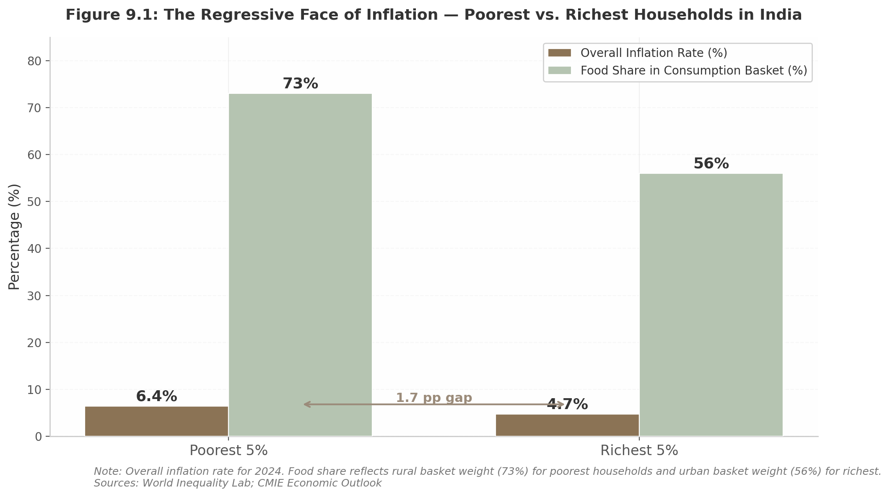
Figure 9.1: The Regressive Face of Inflation
Figure 9.1 illustrates the dual burden: the poorest households experience a 36% higher effective inflation rate while food’s overwhelming share in their consumption basket — 73% versus 56% for the urban rich — means every food price spike cuts deep into already constrained budgets.

9.1.2 Essential Commodity Shocks — From Newspaper to Kitchen Table
The transmission from headline to household is fastest in essential commodity price spikes. Between April 2019 and August 2024, real wage growth for rural workers was negative at -0.4% annually, while agricultural wages managed only a 0.2% increase. ¹⁹Nominal wages grew 5.2% but inflation outpaced these gains, eroding purchasing power year after year. CMIE data confirms that wage growth for rural workers in low-income households has been negative for ten consecutive years. ¹³In the second quarter of 2024, onion and potato prices surged over 80% following an intense heatwave, contributing directly to the 9% spike in grocery bills. ⁵⁷The Economic Survey 2024-25 acknowledged that excluding tomatoes, onions, and potatoes from the CPI basket would reduce headline inflation to 4.2%, underscoring how concentrated spikes in just three vegetables can distort the national inflation picture. ³⁷The cascade extends beyond the kitchen table. Every Rs 25-28 per litre increase in petrol or diesel prices raises transportation costs, making vegetables, milk, and essential items more expensive within days while pushing up school transport and personal travel expenses. ⁶The Takshashila Institution estimated that every $10 per barrel increase in crude prices raises CPI by 40-60 basis points; with Brent crude rising approximately $35, the potential impact was 1.4-2.1 percentage points. ²⁸Cooking fuel compounds the pressure: the domestic LPG price was hiked by Rs 60 per cylinder to Rs 913 in Delhi in March 2026, with Ujjwala beneficiaries paying an effective Rs 613 after subsidy — still a material burden for households where, as one Delhi resident put it, “Rs 60 is a lot for us. We earn all day long to eat at night.” ⁵### 9.2 Interest Rates, EMIs, and Household Debt

9.2.1 The EMI Mathematics of Monetary Policy
When the RBI’s Monetary Policy Committee adjusts the repo rate, coverage typically frames the decision through market reactions. For the 40 million-plus households servicing home loans, the relevant metric is the change in their Equated Monthly Instalment (EMI). Most loans are now linked to the repo rate through the Repo-Linked Lending Rate (RLLR), ensuring rapid transmission from policy rate to borrowing cost.
On a Rs 50 lakh home loan at 8% for 20 years, a 0.50 percentage-point rate increase raises the EMI by approximately Rs 1,569 per month, from Rs 41,822 to Rs 43,391. ⁸A 100 basis-point hike pushes this to roughly Rs 3,164 per month. ⁴⁹The RBI cumulatively raised rates by 250 basis points between May 2022 and February 2023, meaning borrowers faced EMI increases of Rs 5,000-7,000 per month; many were forced to extend loan tenure to keep EMIs manageable, increasing lifetime interest costs. ¹²The transmission operates with asymmetry. Borrowers feel the impact at reset dates, potentially 6-12 months after the policy change. Fixed deposit rates follow with a delay, creating a window in which borrowers pay more while savers earn no additional interest. The RBI subsequently cut rates from 6.50% in June 2024 to 5.25% by February 2026, delivering 125 basis points of relief. ⁷Each 25 basis-point cut translates to roughly Rs 780-800 in monthly EMI savings on a Rs 50 lakh loan. For savers, however, income compression followed immediately — as of November 2024, maximum FD rates stood at 7.40% for tenures up to 5 years, with small finance banks offering 8.5-9%. ²⁷#### 9.2.2 The Household Debt Trap
The EMI pressure over 2022-23 did not occur against a backdrop of household balance-sheet strength. India’s household debt climbed to 41.3% of GDP as of March 2025, up from a five-year average of 38.3%. ³Critically, annual financial liabilities grew 102% between 2019-20 and 2024-25, while financial assets grew only 48%. ⁶⁶Households are borrowing at more than twice the pace at which they accumulate assets.
The composition is revealing: non-housing retail loans for consumption purposes accounted for 55.3% of total household borrowings. ³A substantial share of debt is not financing income-generating assets but is instead bridging the gap between stagnant wages and rising living costs. Net household financial savings improved to 7.6% of GDP in Q4 2024-25, but the liabilities-assets divergence raises questions about the sustainability of the consumption recovery. ³The formal-informal divide compounds the stress. Official surveys indicate four-fifths of rural households have no outstanding loan from formal sector lenders, while independent village surveys show debt incidence of 50-75%. ⁶⁷The gap is explained by dependence on moneylenders charging 24-60% annual interest — far above the 4-7% available through the Kisan Credit Card scheme. ¹⁸### 9.3 Jobs, Wages, and Employment Reality

9.3.1 Wage Stagnation in a Growing Economy
If inflation erodes purchasing power from one side, wage stagnation squeezes from the other. Real monthly wages for male salaried workers in 2023-24 were 6.4% lower than in 2017-18. ¹⁵For self-employed men, the decline was 9.1% over the same period. This compression unfolded while corporate profits surged 22.3% in FY24, suggesting a decoupling between corporate performance and worker compensation. ¹⁵The rural picture is particularly grim. From April 2019 to August 2024, real wage growth for rural workers was -0.4% annually, while agricultural wages rose just 0.2%. ¹⁹Nominal wages grew 5.2% but inflation consistently outpaced these gains. The unemployment rate rose to 8.1% in April 2024 from 7.4% in March, with rural at 7.8% and urban at 8.7%. ⁵⁰Gender disparities compound the challenge: female Employment Participation Rate was 10.1% versus 69.2% for males, and female unemployment at 14.6% was more than double the male rate of 6.1%. ²⁶#### 9.3.2 The Gig Economy Illusion
Rising self-employment is often framed as entrepreneurial dynamism. The data suggests distress-driven entrepreneurship. Self-employment now accounts for 58.4% of total jobs, up from 52.2% in 2017-18, with “business persons” surging to 86.6 million in 2023-24. ²⁹The timing — concentrated in the post-pandemic period — and the absence of income growth indicate workers pushed out of formal employment are creating micro-enterprises out of necessity, not choice.
The gig economy presents its own harsh realities. Real wages of gig workers declined 11% between 2019 and 2022, dropping to Rs 11,963 per month, according to NCAER research. ¹⁴The decline was driven by rising fuel costs and high inflation — expenses gig workers bear as independent contractors. Full-time delivery partners earn approximately Rs 21,892 net per month after deductions, which exceeds India’s median minimum wage of Rs 18,000 by roughly 21% but comes without health insurance, provident fund, or job security. ²⁰Nearly 47% of gig workers have no insurance. ¹⁴The apparent paradox — manufacturing PMI hitting 59.3 in August 2025 while real wages decline — resolves when the formal-informal divide is acknowledged. Manufacturing strength reflects large-firm, capital-intensive activity. Employment growth, where it occurs, is not generating the wage levels or security that would allow workers to build buffers against inflation and rate shocks.

9.4 Welfare Architecture as Shock Absorber

9.4.1 The Safety Net — Scale and Impact
Against the backdrop of regressive inflation, rising debt, and stagnant wages, India’s welfare architecture functions as a counter-cyclical shock absorber. Its scale is substantial, even if systematically under-reported in business newspaper coverage relative to its real-economy significance.
PM-KISAN has disbursed over Rs 3.45 lakh crore to more than 11 crore farmer households. ⁵⁶A NITI Aayog evaluation found 92% of beneficiaries satisfied, with 93% utilising transfers for seeds, fertilisers, and pesticides. ⁵⁶Peer-reviewed research showed a 3.34-4.13 percentage point improvement in the Livelihood Index among beneficiaries versus non-beneficiaries. ⁵¹For a small farmer, the Rs 6,000 annual transfer — Rs 2,000 every four months — may represent the difference between affording sowing inputs and falling into moneylender debt.
Ayushman Bharat has saved over Rs 1.25 lakh crore in out-of-pocket health expenditure, covering 55 crore individuals with Rs 5 lakh annual hospitalisation cover per family. ³⁶With 36.36 crore cards issued and 49% held by women, the scheme has reduced catastrophic health expenditure that pushes 3-7% of households below the poverty line annually. ⁶⁵Out-of-pocket health spending declined from 64.2% of total health expenditure in 2013-14 to 39.4% in 2021-22. ⁶⁵The free foodgrain programme under the National Food Security Act reaches 81 crore citizens, extended for five years from January 2024 with an outlay of Rs 11.80 lakh crore. ¹⁰AAY households receive 35 kg per month; Priority Households get 5 kg per person per month. For households spending 50-60% of budgets on food, this in-kind transfer represents a direct and substantial reduction in cash expenditure.
Welfare Scheme | Financial Outlay / Scale | Beneficiaries | Estimated Household Offset | Key Metric
PM-KISAN (cash transfer) | Rs 3.45 lakh crore disbursed ⁵⁶ | 11+ crore farmer households ⁵⁶ | Rs 6,000/year; Rs 2,000/quarter | 85% reported income increase ⁵⁶
Ayushman Bharat (health) | Rs 1.25 lakh crore saved ³⁶ | 55 crore individuals ³⁶ | Rs 5 lakh/year hospitalisation cover | 36.36 crore cards; 49% women ³⁶
Free foodgrains (NFSA) | Rs 11.80 lakh crore outlay ¹⁰ | 81 crore citizens ¹⁰ | 35 kg/month (AAY) or 5 kg/person (PHH) | Reduces food expenditure proportionally
Kisan Credit Card | Rs 10.05 lakh crore operative ¹⁸ | 7.72 crore farmers ¹⁸ | 4% effective rate vs 24-60% informal | Doubled from Rs 4.26 lakh crore (2014) ¹⁸
PM SVANidhi | Rs 16,100 crore ⁶⁸ | 71.5 lakh vendors ⁶⁸ | Loans up to Rs 25,000 subsidised | 1.05 crore loans sanctioned ⁶⁸
Jan Dhan Yojana | Rs 2.68 lakh crore deposits ⁶⁹ | 56+ crore accounts ⁶⁹ | Banking access, DBT, insurance | 67% rural; 56% women ⁶⁹
The welfare architecture creates a multi-layered shock absorber. A farmer receiving PM-KISAN and KCC benefits gains Rs 6,000 in cash transfers plus credit at 4% effective interest, while free rations reduce food expenditure by 5-35 kg of grain per month. For such a household, the 1.7 percentage-point higher effective inflation rate is substantially mitigated — though not eliminated — by the transfer stream. MGNREGA, however, illustrates the limits: annual earnings per household cover only ~10% of expenditure at the poverty line, with the scheme’s contribution to rural poverty reduction described by SBI research as “nearly negligible.” ²¹#### 9.4.2 Financial Inclusion — The Infrastructure of Resilience
The welfare architecture is reinforced by financial inclusion that has expanded dramatically. Over 56 crore Jan Dhan accounts hold Rs 2.68 lakh crore in deposits, with 67% in rural or semi-urban areas and 56% owned by women. ⁶⁹Average deposits have risen to Rs 4,768 — 3.7 times the August 2015 level — suggesting active savings behaviour rather than passive transfer conduits.
UPI is now the preferred transaction mode for ~38% of users in rural and semi-urban India, representing a structural shift from cash-dependent transactions. ⁷⁰SHG-bank linkages have reached 144.21 lakh groups with Rs 65,089 crore in savings and Rs 2,59,664 crore in loans outstanding, with 97% being women’s groups. ⁷¹Understanding this architecture matters for how economic news is read. A headline reporting “RBI Hikes Repo Rate, EMIs to Rise” is accurate but incomplete without recognising that PM-KISAN transfers, free rations, and subsidised LPG partially offset the EMI burden for beneficiary households. The analytical discipline this chapter proposes is to read every macroeconomic headline through two simultaneous lenses: the magnitude of the shock, and the capacity of the welfare architecture to absorb it.

10. Actionable Insights Frameworks: Converting News to Decisions
The preceding chapters mapped the landscape — from RBI policy transmissions and corporate earnings disclosures to sector-specific signals and the regressive reality of inflation. This chapter translates that literacy into action. It offers distinct, tested frameworks for three reader types: the investor seeking alpha from news flow, the business leader building strategic intelligence, and the common household navigating personal finance decisions. Each framework is grounded in academic research and Indian market specifics. The chapter closes with a universal verification toolkit — because no decision framework functions without reliable inputs.

10.1 The Investor’s News Analysis Toolkit

10.1.1 Second-Order Thinking: Howard Marks’ Five Questions
Howard Marks, co-founder of Oaktree Capital, distinguishes between first-level and second-level thinking. First-level thinking says: “The RBI cut rates; buy rate-sensitive stocks.” Second-level thinking says: “The RBI cut rates because growth is slowing, corporate earnings may disappoint, and the market has already priced in three cuts.” ¹Marks offers five questions for every significant news item ¹⁶:
Question 1: What is the range of possible future outcomes? Construct a probability distribution — bullish, base, and bearish — each weighted by evidence. When the RBI holds rates, outcomes range from a surprise cut (if inflation falls faster), to an extended pause (base case), to a hike (if oil spikes). Each demands different positioning.
Question 2: What is the consensus view? Consensus is what most market participants believe, inferred from futures pricing, analyst surveys, and media tone. When 42 of 50 economists polled by Economic Times expect a rate hold, that is the consensus.
Question 3: How does my view differ from the consensus, and why? Is the deviation informational (data others lack), analytical (different interpretation), or temperamental (longer horizon)? Only the first two generate durable edge.
Question 4: What does the current price reflect about market expectations? If the Nifty Bank index has rallied 8% before an anticipated rate cut, the market is pricing in the certainty of the cut. The payoff is asymmetric: even if correct, upside is limited; if the RBI holds, downside is substantial.
Question 5: What happens if the consensus is wrong? As Marks illustrates: first-level thinking says “the outlook stinks, so sell”; second-level thinking says “the outlook stinks, but everyone else is selling in panic. Buy.” ¹³Budget 2026 exemplified this — the Sensex crashed 1,843 points on the STT hike, but recovered 943 points the next day as second-order thinkers recognised the structural fiscal direction remained intact.

10.1.2 Top-Down vs. Bottom-Up Reading
The top-down approach starts with macro indicators — GDP, inflation, monetary stance — and narrows to sectors, then stocks. ³Cyclical sectors like financials outperform during expansions; defensive sectors like consumer staples fare better during contractions. In 2025-26, RBI’s 125 bps rate-cut cycle favoured banking, real estate, and autos.
The bottom-up approach starts with company fundamentals — management quality, P/E ratios, earnings growth — and pays less attention to macro conditions. ⁵It proved its worth during the 2022-23 tightening cycle, when several mid-cap exporters delivered 20%+ earnings growth despite macro headwinds, powered by rupee depreciation and global demand.
Effective investors toggle between both: top-down to set sectoral weights, bottom-up to select securities within them. When reading Business Standard, top-down investors begin with Economy and Markets; bottom-up investors flip to Companies first, then cross-check against the macro context.

10.1.3 Signal vs. Noise: What Actually Drives Returns
Much of the financial news cycle is short-lived noise — headlines that capture attention but have little bearing on long-term outcomes. Signals reflect durable forces: productivity trends, demographic shifts, technological innovation, and policy direction. ⁸Research spanning 70+ years establishes that over 90% of long-term equity returns have been driven by earnings and dividends, while valuation shifts account for less than 10%. ⁸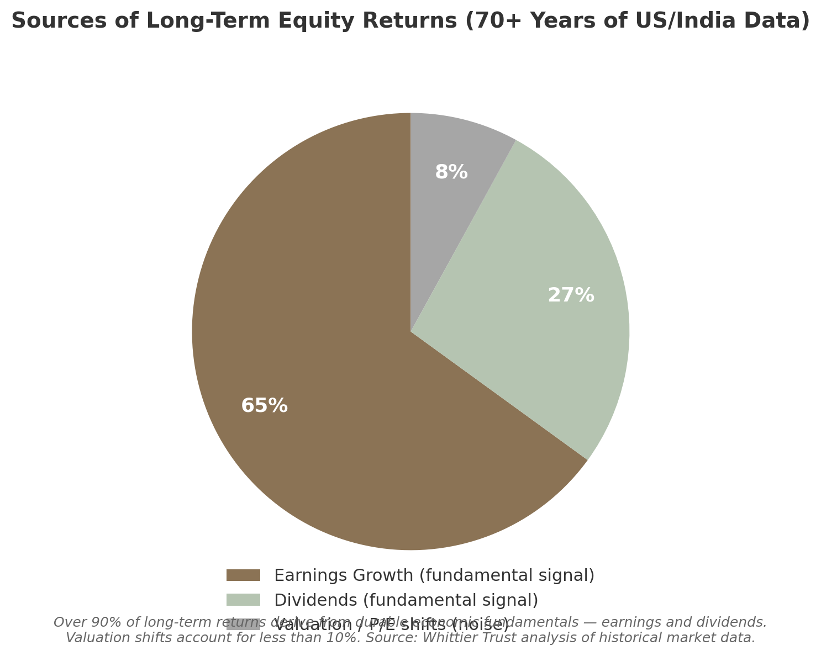 Figure 10.1: Over 90% of long-term returns derive from durable fundamentals. Valuation shifts — the daily grist of market commentary — account for less than 10%. Source: Whittier Trust analysis.
When Economic Times runs a “Sensex Falls 500 Points” banner, the first question should be: did anything change about the earnings power of the companies I own? If not, the headline is noise. If the fall was triggered by a policy change affecting profitability — such as the Budget 2026 STT hike, which directly reduced futures market volumes — then it is signal. Research analysing 21 million news articles (1980-2012) confirmed that while news sentiment moves prices in the short term, the effect decays rapidly for most firms. ⁴⁸#### 10.1.4 The Eight-Step Investment Decision Framework
Step | Action | Key Question | Tools / Sources | Time Required
1. Headline | Extract the core fact | What exactly happened? | Primary source (RBI, SEBI, company filing), not interpretation ²⁰ | 5 min
2. Reasons | Identify stated and unstated drivers | Why did this happen? | 2-3 independent analyses; separate fact from opinion ¹⁹ | 10 min
3. Consensus | Gauge market expectations | What did the market expect? | Bloomberg/Reuters surveys, derivatives positioning | 10 min
4. Valuation | Check if news is priced in | What does the current price reflect? | P/E vs. historical; implied volatility | 15 min
5. Technical | Assess support/resistance | Is the technical structure intact? | Moving averages, volume, relative strength | 10 min
6. Sector | Map second-order effects | Which sectors benefit or suffer? | Sectoral indices, supply chain linkages | 15 min
7. Insider | Check smart-money positioning | What are institutions doing? | FII/DII flows, bulk deals, promoter buying | 10 min
8. VIX Sizing | Size position based on volatility | How volatile is the environment? | India VIX; max 2% risk per trade | 5 min
Table 10.1: The Eight-Step Investment Decision Framework. Each step must be completed before capital is allocated.
The framework’s application to an RBI rate decision illustrates its power. Step 1 extracts: repo rate held at 5.25%, stance “neutral.” Step 2: inflation at 2.75% is below target, but the MPC sees upside risks from oil. Step 3: 38 of 45 economists expected a hold. Step 4: banking stocks at 1.8x price-to-book, above the 5-year average of 1.5x, suggesting some optimism priced in. Step 5: Nifty Bank above its 200-day moving average but approaching resistance at 56,000. Step 6: real estate and autos benefit; IT faces headwinds from rupee stability. Step 7: DIIs have been net buyers for 12 sessions, providing a demand floor. Step 8: VIX at 14.5 permits normal sizing; above 25, the same trade would merit half exposure.

10.2 The Business Leader’s Strategic Intelligence System

10.2.1 PESTLE Analysis for Daily News
PESTLE analysis — Political, Economic, Social, Technological, Legal, Environmental — provides a structured template for categorising economic news. Its value lies not in listing factors but in tracking their interconnectedness. ²Consider: US tariffs on Chinese solar panels (Political) raise input costs for Indian module makers (Economic), slow renewable adoption (Social), force polysilicon investment (Technological), trigger anti-dumping petitions (Legal), and delay India’s 500 GW non-fossil target (Environmental). Each factor in isolation is news; the cascade is strategic insight. ²The critical discipline is separating time horizons. Most analyses fail by mixing “RBI decision next week” with “demographic change through 2035.” ² | PESTLE Factor | Short-Term (0-1 Year) | Medium-Term (1-3 Years)
Political | Election results, policy announcements, coalition stability | Policy agenda, regulatory appointments, trade negotiations | Federal structure evolution, geopolitical realignment
Economic | RBI decisions, inflation, quarterly GDP, currency | Fiscal trajectory, credit cycle, current account | Demographic dividend peak (2030), middle-class expansion, debt sustainability
Social | Consumer sentiment, festival demand, migration flows | Skilling outcomes, healthcare access, urbanisation pace | Female labour participation, ageing in southern states
Technological | UPI data, AI adoption rates, tariff changes | 5G/6G rollout, green hydrogen cost curves | AI labour displacement, digital rupee scale
Legal | SEBI circulars, GST changes, court rulings | Data protection enforcement, labour code implementation | Property rights digitisation, regulatory sandbox
Environmental | Monsoon forecasts, oil price spikes | Renewable capacity, carbon credit trading, water stress | Climate migration, agricultural productivity shifts
Table 10.2: PESTLE Template with Time-Horizon Classification. Short-term items demand fact-based analysis; medium-term require trend extrapolation; structural factors demand scenario planning. ²
A manufacturing CEO reading that the MPC held rates classifies this under Economic/Short-Term and asks: how does this affect working capital cost next quarter? Reading that India’s renewable capacity crossed 220 GW, the same CEO classifies it under Environmental/Medium-Term and asks: what does this imply for energy costs and carbon compliance over three years? Explicit classification prevents reacting to structural news with short-term tactics, or ignoring short-term signals because they seem transient.

10.2.2 The Competitive Intelligence Cycle
The competitive intelligence (CI) cycle converts news into strategic intelligence through five stages. Research shows 52% of organisations saw revenue growth directly attributable to CI, while 74% of leaders acknowledge the need for sophisticated intelligence tools. ⁶Stage 1: Plan. Define intelligence requirements. A pharmaceutical firm planning a Rs 500 crore expansion needs intelligence on regulatory timelines, competitor capacity, pricing policy changes, and patent cliffs. Each requirement is assigned to an owner with a deadline.
Stage 2: Collect. Gather information from regulatory filings, industry associations, patent databases, supplier interviews, and economic newspapers. Include early warning signals: product launches, pricing shifts, executive hires, and regulatory chatter. ²⁸Automated alerts for SEBI filings and RBI circulars ensure no critical signal is missed.
Stage 3: Analyse. Raw information becomes intelligence through PESTLE classification, Porter’s Five Forces, and financial modelling. The analysis should answer: what does this mean for our competitive position, and what is the response window?
Stage 4: Disseminate. Intelligence has a shelf life. A competitor’s pricing change is actionable for days; a regulatory amendment for months. Format must match audience — board presentations for strategy, operational briefs for tactics.
Stage 5: Feedback. Did the intelligence lead to better decisions? Each intelligence-driven decision should be reviewed against outcomes, and methods refined. This closing loop is where most CI programmes fail.

10.2.3 Porter’s Five Forces Update
Michael Porter’s Five Forces — competitive rivalry, supplier power, buyer power, threat of substitutes, and barriers to entry — remains foundational. ⁴But it was designed for the 1970s. The World Economic Forum argues that technology disruption, climate risk, and geopolitical volatility now outweigh the original business-logistical factors. ⁴⁹For Indian business leaders, three updates matter. First, technology disruption has collapsed entry barriers — quick commerce platforms built $3.3 billion businesses in under three years by redefining last-mile logistics. Second, climate risk is a supply chain, financing, and regulatory risk affecting every industry. Third, geopolitical volatility — US-China decoupling, trade protectionism — is reshaping supply chains faster than traditional competitive dynamics. When reading US tariff coverage, the relevant question is not “how does this affect my US competitors?” but “how does this create opportunity for Indian manufacturers to capture redirected demand?”

10.3 The Common Person’s Personal Finance Decision Framework

10.3.1 Three-Speed India: Matching News to Your Economic Zone
Indian economic news operates at three distinct speeds. The global-linked speed — IT, pharmaceuticals, banking — responds to international developments in real-time; when the US Fed signals a pause, IT stocks move within hours. The policy-linked speed — infrastructure, manufacturing, agriculture — moves on government cycles; a highway project announced in Budget 2026 takes 18-36 months to translate into cement demand. The distress-driven speed — informal workers, gig participants, micro-enterprises — responds to daily survival pressures; a Rs 2 CNG price hike or reduced delivery incentives affects same-day earnings.
Most readers occupy one primary speed but are affected by all three. A Bangalore software engineer (global-linked) with parents farming in Bihar (policy-linked and distress-driven) must read the same newspaper through multiple lenses. IT earnings affect her portfolio today; MSP announcements affect her parents’ income in six months; LPG price hikes affect both households immediately.

10.3.2 Household Budget Impact Calculator
Economic news transmits to household budgets through four channels. Interest rates: on a Rs 50 lakh home loan, a 25 bps change alters EMI by ~Rs 780-800; a 100 bps hike raises this to ~Rs 3,164. ⁸During the 2022-23 tightening cycle, the RBI’s 250 bps increase pushed EMIs up Rs 5,000-7,000. ¹²Action steps: check your loan reset date, recalculate EMI, and if the increase exceeds 5% of disposable income, explore balance transfer options. Fuel prices: every $10 per barrel crude increase raises CPI by 40-60 bps. ²⁸When oil surges make headlines, increase the transport budget allocation by 10-15%. Inflation: the poorest 5% faced 6.4% inflation versus 4.7% for the richest 5% in 2024, because food contributes 73% to rural inflation versus 56% urban. ¹When food inflation rises, shift to bulk purchases of non-perishables; if core inflation is stable, the spike is likely transient. Taxation: Budget 2025 made income up to Rs 12 lakh effectively tax-free. ²²The action: calculate post-Budget liability and redirect savings into SIPs before lifestyle inflation absorbs them.

10.3.3 Career Planning from News
Economic newspapers contain actionable career intelligence. IT earnings reports signal hiring intent — when TCS, Infosys, and Wipro guide for sub-4% growth, hiring freezes in legacy skills follow within one to two quarters; when they announce AI-specific hiring (TCS’s AI revenue reached $2.3 billion in FY26), the skill demand shift is explicit. Manufacturing PMI at 59.3 in August 2025 — a 17-year high — signalled strong hiring in capital goods and engineering. ⁸PLI scheme disbursement coverage reveals where government-backed job creation is concentrated; job seekers should prioritise these sectors where demand is policy-supported and more durable than cyclical hiring.
The self-employment data offers a caution: self-employment rose to 58.4% from 52.2%, but this growth is distress-driven — workers pushed out of formal employment. ²⁹Prospective entrepreneurs must distinguish between opportunity-driven entry (new market gap, validated demand) and distress-driven entry (job loss, no alternatives). Only the former merits significant capital commitment.

10.4 Critical Reading and Verification Methods

10.4.1 The SIFT Method
The Stanford History Education Group found that professional fact-checkers outperform PhD historians at evaluating sources because they practice lateral reading — searching for information about a source rather than staying on its website. ⁹ ²⁶The SIFT method codifies this:
S — Stop. Before reacting, ask: do I recognise this source? Headlines triggering fear or greed — “Market Crash Imminent” or “Multibagger Alert” — merit extra scrutiny.
I — Investigate the source. Search the publication on Wikipedia. What is their expertise and agenda? A blog with anonymous authorship cannot be treated equivalently to Business Standard or a SEBI circular.
F — Find trusted coverage. If only one outlet reports a “major RBI policy change,” it is likely inaccurate. Cross-reference with at least two Tier-1 sources before acting.
T — Trace claims to original context. When a story cites “analysts say,” trace the claim to the named individual. If the original cannot be found, downgrade reliability. ¹⁵#### 10.4.2 Triangulation: Three Sources Minimum
Triangulation — validation through at least three independent sources — is the established methodology for cross-verification in both academic research and journalism. ¹¹Denzin (1973) identified four types: data triangulation (multiple data sources), investigator triangulation (multiple observers), theory triangulation (multiple perspectives), and methodological triangulation (multiple methods). ¹¹For the economic news reader, the application is direct. Before making a material decision, confirm the core claim through three sources. If Economic Times reports inflation at 3.5%, verify with: (a) the Ministry of Statistics press release (data triangulation), (b) coverage in Business Standard by a different reporter (investigator triangulation), and (c) analysis from ICRIER or NIPFP (theory triangulation). ¹⁰Convergence confirms reliability; divergence demands investigation before action.

10.4.3 News Shelf-Life Classification
Not all articles age equally. Breaking news has a half-life of hours; analysis decays over days; trend features remain relevant for weeks; structural explainers retain value for months. ⁸Most readers consume all with equal urgency, leading to hasty decisions on transient information or missed opportunities because actionable analysis was treated as ephemeral.
Shelf-Life Category | Description | Action Window | Example | Reader Action
Breaking News | Price-sensitive announcements: RBI decisions, earnings, FII flows | Hours | “Sensex falls 500 points on FII selling” | Traders: act within session. Investors: note but do not react unless thesis changes
Analysis | Sector reports, policy impact assessments | Days | “RBI rate hold: banks benefit from stable NIMs” | Complete eight-step framework within 48 hours
Trends | Policy cycles, sector rotation, hiring patterns | Weeks | “PLI disbursements cross Rs 1.5 lakh crore” | Integrate into quarterly portfolio or strategic review
Explainers | Structural mechanisms: GST, IBC, PLI details | Months | “How the new tax regime affects salaried employees” | Archive; reference when relevant decisions arise
Table 10.3: News Shelf-Life Classification. The decay curve determines whether an article demands immediate response, scheduled analysis, or reference-library archiving.
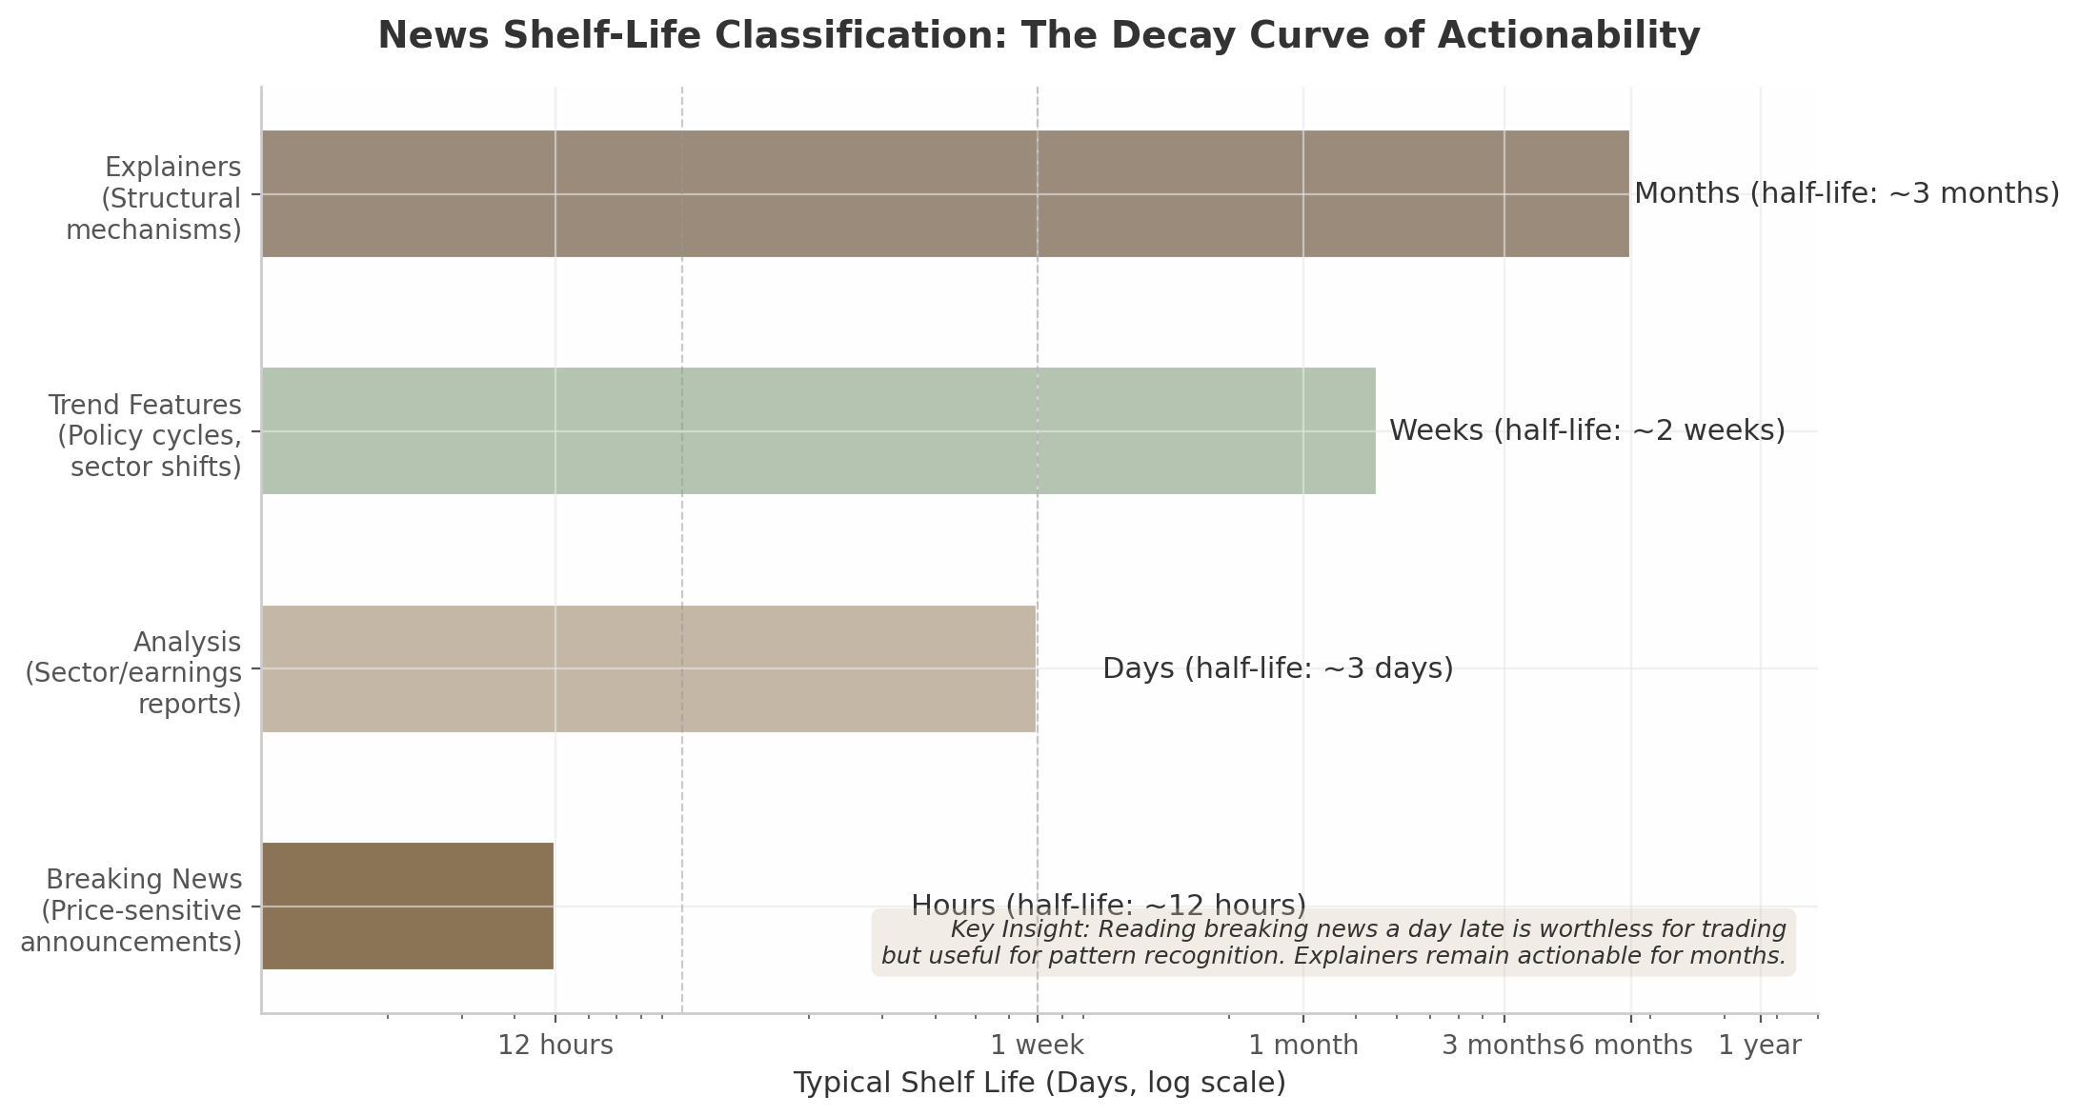 Figure 10.2: Breaking news loses actionability within hours; explainers remain relevant for months. Disciplined readers maintain three queues: “Act Today,” “Read This Week,” and “Reference Library.”
The practical implementation is three reading queues. “Act Today” contains 1-2 breaking items affecting existing positions. “Read This Week” holds 5-10 analytical pieces deepening understanding of active decisions. “Reference Library” stores explainers consulted as needed. This triage prevents the daily error of the investor who reads an explainer as breaking news, or the trader who treats breaking news as a reference document. These frameworks are thinking tools — mental scaffolding that helps readers extract signal from noise and convert information into decisions calibrated to their circumstances. The investor’s eight-step process, the business leader’s intelligence cycle, and the common person’s three-speed model all share one principle: economic news is valuable only to the extent that it changes what you do.

11. Cross-Cutting Insights: The Bigger Picture
The preceding ten chapters examined Indian economic newspapers through specialised lenses — article taxonomy, monetary policy transmission, corporate earnings mechanics, sectoral impact analysis, regulatory frameworks, and household welfare effects. Viewed in isolation, each chapter offers actionable frameworks for its domain. Viewed together, they reveal something more consequential: a set of structural patterns that recur across every dimension of economic news coverage. These cross-cutting insights are not merely intellectual connections — they are operational advantages for readers who recognise them in real time. This chapter distils the guide’s central meta-findings and translates them into a practical daily reading system.

11.1 The K-Shaped Information Divide
Indian economic newspapers predominantly cover the formal economy — stock markets, corporate earnings, Foreign Institutional Investor (FII) flows, Reserve Bank of India (RBI) policy, and merger activity. The Economic Times’s top sections are Markets and Companies; no dedicated section tracks mandi prices, National Rural Employment Guarantee Scheme (NREGS) payment delays, or rural wage movements daily ¹. Yet 46.1% of India’s workforce remains in agriculture, and the informal sector collectively employs over 85% of all workers ². When inflation news hits, urban readers receive “CPI at 2.75%” while rural readers face food-driven inflation contributing 73% to their headline rate ³.
This coverage gap is not accidental. Newspaper business models depend on advertising revenue from firms targeting high-income, formally employed readers. The result is an information divide where formal-sector participants receive actionable intelligence in real time while informal-sector workers — 63 million micro-enterprises, 11+ crore PM-KISAN beneficiaries, 81 crore citizens receiving free rations — get filtered, delayed, or no relevant news ⁹. Digital platforms, particularly WhatsApp and YouTube, have filled part of this vacuum, but the signal-to-noise ratio in these channels remains poor, and verification standards are minimal ⁸.
The analytical implication is stark: a reader who consumes business newspapers alone develops a systematically skewed mental model of the Indian economy. The model overweights formal employment (12-15% of the workforce), corporate profits (a fraction of national income), and capital-market flows (relevant to perhaps 5% of households). The K-shaped divide is not merely a social concern — it is a cognitive trap that leads investors to overestimate urban consumption, underestimate rural distress, and misprice sectors with informal-sector linkages.

11.2 The Transmission Lag Paradox
Financial markets price in economic news within seconds. An RBI repo rate cut triggers stock index movement within minutes, FII outflows are priced into currency markets instantly, and earnings surprises generate gap-up or gap-down openings at the market bell ¹¹. But the real-economy impact on households unfolds over 6–18 months. During the 2022-23 tightening cycle, the 250 basis points repo rate increase translated into 190 basis points for fresh loans and merely 119 basis points for outstanding loans — the latter transmitting at just 48% efficiency over the full cycle ²². A home loan borrower’s EMI only changed at the next annual reset, potentially 12 months after the policy shift ²³.
This temporal mismatch systematically advantages market participants over households. When the RBI delivered 125 basis points of cumulative cuts in 2025, stock markets rallied within hours. But deposit rates fell immediately, hurting senior citizens dependent on fixed-income returns, while borrowers waited months for EMI relief ²⁴. The same news item has opposite time-bound effects on different stakeholders. Newspaper coverage rarely makes this temporal distinction explicit — a “rate cut” headline is framed as uniformly positive without noting that savers suffer immediately while borrowers benefit with a lag. Sophisticated readers must mentally tag every policy announcement with two clocks: “market reaction time” and “household transmission time.”

11.3 The Regulatory-News Alpha Opportunity
Regulatory announcements — SEBI circulars, RBI master directions, GST Council decisions — move markets more than earnings or macroeconomic data, yet they receive disproportionately less analytical coverage ²⁵. This creates a persistent information inefficiency. The pattern is predictable: regulatory data disclosure drives justification, which drives incremental tightening, which generates compliance deadlines that create measurable demand and supply shifts.
Consider the SEBI F&O reform cascade. In January 2025, SEBI published data showing 91.1% of individual futures and options traders incurred losses in FY24, with aggregate retail losses of roughly Rs 1.81 lakh crore over three years ¹³. Between November 2024 and December 2025, SEBI implemented six discrete measures: contract size hikes from Rs 5-10 lakh to Rs 15-20 lakh, weekly expiry limits on one benchmark index per exchange, and finally mandatory hard position limits with same-day compliance ¹⁶. Each measure was announced months in advance, yet capital market stocks only fully priced in the revenue impact at implementation — not at announcement. The CRR cut from 4% to 3% in June 2025 released Rs 2.5 lakh crore of liquidity on a known date with predictable banking sector impact ¹⁷. A reader maintaining a “regulatory calendar” — tracking announced-but-not-yet-implemented regulations across SEBI, RBI, GST Council, and IBC domains — captures systematic alpha that headline-focused readers miss.

11.4 The Democratization Imperative
India’s UPI revolution — 131 billion transactions in FY24, preferred by 38% of users in rural and semi-urban areas — is systematically covered as a fintech valuation story rather than a financial inclusion story ⁴. Newspaper coverage focuses on PhonePe and Google Pay market-share battles, NPCI regulation changes, and fintech startup funding rounds. What receives far less attention is the human impact: 94% of small merchants adopted UPI, 90% of users reported increased confidence in digital payments, and 65% conduct multiple daily digital transactions ⁵. The same gap exists across welfare architecture — PM-KISAN is covered as “fiscal burden” rather than “income support impact” (Rs 3.45 lakh crore to 11+ crore farmers); Ayushman Bharat as “healthcare spending” rather than “catastrophic protection” (Rs 1.25 lakh crore saved, 55 crore individuals covered) ⁴⁸.
This “infrastructure-to-human-impact” gap matters because it shapes how policy effectiveness is evaluated. When UPI transaction limits were raised, coverage asked “what this means for fintech stocks” rather than “what this means for the vegetable vendor who can now accept larger payments digitally.” A reader who consciously applies a “last-mile impact” lens to every infrastructure and policy announcement develops a fundamentally different — and more accurate — model of which policies are working and which are merely well-announced.

11.5 Three-Speed India: Connecting the Threads
The guide’s most consequential cross-cutting insight is the existence of three simultaneous economic speeds that no single newspaper reading framework captures adequately. The Global-Linked Speed — information technology, pharmaceuticals, banking — responds to international developments in real time. US Federal Reserve decisions, tariff announcements, and cross-border M&A activity transmit within hours through stock prices and currency movements ⁶. The Policy-Linked Speed — infrastructure, manufacturing, agriculture — moves on government budget and project execution cycles measured in years. A dedicated freight corridor or semiconductor fabrication plant announced in Budget 2026 will not materially affect earnings for 24–36 months ²⁸. The Distress-Driven Speed — informal sector workers, gig workers, micro-enterprises — responds to daily survival pressures: today’s fuel prices, platform incentives, and weather conditions. Self-employment rose from 52.2% to 58.4% of total jobs, not from entrepreneurial dynamism but from workers pushed out of formal employment creating micro-enterprises out of necessity ⁴⁹.
The same newspaper serves all three speeds with identical temporal framing, causing systematically misaligned expectations. An investor who trades infrastructure stocks on daily news misunderstands the policy-linked speed. A gig worker who waits for formal employment recovery misunderstands the distress-driven speed. A business leader who models demand from headline GDP growth alone misses that formal manufacturing PMI at 59.3 coexists with real wages for male salaried workers 6.4% below 2017-18 levels ¹². Every news item must be speed-classified before it is acted upon.

11.6 Building Your Personal News Intelligence System
The insights above converge on a practical imperative: reading economic newspapers effectively requires a system, not just a habit. The following framework integrates the guide’s analytical tools into a daily, weekly, and monthly rhythm.

11.6.1 The 30-60-90 Minute Daily Reading Plan
The table below presents a tiered reading system scaled to available time. The plan is designed around the guide’s core principle that not all articles demand equal urgency — breaking news has a half-life of hours, analysis pieces days, trend features weeks, and structural explainers months ⁷.
Time Tier | Phase | Duration | Actions | Sources & Tools
30-minute core | Headline scan | 10 min | Read front-page headlines, market indices (Sensex, Nifty, India VIX), FII/DII flow data, rupee/dollar rate | Economic Times, Livemint, Moneycontrol app
 | Deep reads (2 articles) | 15 min | Read two articles in full: one breaking news item relevant to your sector/role, one analysis piece requiring second-order thinking ²⁷ | Prioritise articles with data tables, primary source citations
 | Implications capture | 5 min | Write one sentence per article: “What should change?” — specific action, not summary | Physical notebook or note-taking app
60-minute standard | All 30-minute phases | 30 min | Complete core routine as above | —
 | Regulatory scan | 10 min | Check SEBI circulars (sebi.gov.in), RBI press releases (rbi.org.in), GST Council updates for your industry | Official portals, RSS feeds
 | Sector deep-dive | 15 min | Read one long-form feature or data story on your primary sector; note estimate revisions, guidance changes | Mint Long Story, ET Prime, Business Standard premium
 | Cross-verification | 5 min | Verify one key claim from today’s reading against a primary source (company filing, government data) | SIFT method: Stop-Investigate-Find-Trace ⁵⁰
90-minute comprehensive | All 60-minute phases | 60 min | Complete standard routine as above | —
 | Global context | 15 min | Read two international stories with India transmission relevance: Fed policy, crude oil, US-China trade, EU-India FTA | FT, WSJ, Reuters — focus on commodity prices and currency
 | Informal economy check | 10 min | Read one story on informal sector, agriculture, or welfare scheme delivery — deliberately outside formal-economy bubble | Regional papers, PIB releases, NREGA/KISAN trackers
 | Portfolio/watchlist sync | 5 min | Update personal watchlist: note any holdings affected by today’s news, flag items for weekend synthesis | Spreadsheet or dedicated note system
Weekly synthesis (60-90 min) | Pattern recognition | 30 min | Review daily implication notes; identify recurring themes, contradictions, or gaps in coverage | Your own notes from the week
 | Signal vs noise audit | 20 min | Check which Monday predictions materialised by Friday; which were noise; calibrate source reliability | Market data, subsequent corrections
 | Forward calendar update | 20 min | Update regulatory calendar with implementation dates; note MPC meetings, earnings seasons, Budget events | RBI calendar, SEBI meeting agendas
 | Reading queue curation | 10-20 min | Sort saved articles into “Act This Week,” “Read This Month,” and “Reference Library” queues based on shelf life | Read-later apps, folder system
The 30-minute tier is the daily minimum for any reader who makes economic or financial decisions. The 60-minute tier adds the regulatory scan, which the guide has shown is the highest-return time investment for systematic readers — regulatory changes create predictable inefficiencies that headline-focused investors miss. The 90-minute tier adds global context and informal-economy coverage, which together correct the K-shaped information bias that distorts mental models of the Indian economy.
The weekly synthesis session is where reading converts into intelligence. Most readers consume news continuously but synthesise rarely. A dedicated 60-90 minute block every weekend to review daily notes, audit prediction accuracy, and update forward calendars closes the loop between consumption and comprehension. Over time, this practice builds a personal database of source reliability, regulatory patterns, and market reaction templates that compounds in value.

11.6.2 Technology Stack Recommendations
A disciplined reading system requires minimal but specific tooling. The following stack is free or low-cost and designed for the workflows described above.
RSS aggregation remains the most efficient way to scan multiple sources without algorithmic filtering. Feedly or Inoreader can subscribe to feeds from all five major business dailies, SEBI and RBI press release pages, and PIB announcements. The advantage is complete reader control over source priority and chronological ordering — no platform algorithm decides what appears first.
Keyword alerts through Google Alerts or specialised financial tools (Screener.in, Trendlyne) notify when specific companies, sectors, or regulatory terms appear in news. A reader tracking “SEBI F&O” or “RBI CRR” receives immediate notification when relevant content publishes, eliminating the risk of missing high-impact regulatory news buried on inside pages.
Note-taking systems should be frictionless enough for daily use but structured enough for weekly synthesis. Obsidian, Notion, or even a simple dated text file can work. The critical feature is a tagging system that categories notes by speed class (global-linked, policy-linked, distress-driven), stakeholder impact (investor, business leader, household), and action status (acted, pending, reference). This tagging enables the pattern recognition that casual readers miss.
Watchlist documents — a single spreadsheet or note listing all holdings, loans, deposits, and business interests — provide the anchor for daily relevance filtering. Before reading, the disciplined reader checks which items on the watchlist might be affected by today’s news. This prevents the common error of treating all news as equally relevant and ensures that high-impact items affecting personal finances receive priority attention.
The gap between reading newspapers and understanding the economy is not a gap of intelligence or effort — it is a gap of system. The frameworks, data points, and reading disciplines presented across this guide are designed to close that gap systematically. A reader who applies the 30-60-90 plan, maintains a regulatory calendar, classifies every item by economic speed, and verifies claims against primary sources will, over time, develop an information advantage that is both durable and compounding. The newspaper is the raw material. The system is what converts it into insight.

