My 3-tier individual project for an online game’s marketplace

**Project Goal:**

The goal for my 3-tier application is to create a games marketplace where a user can create an account, allowing them to look through a store selection of games and "purchase" any they are interested in, which are then transferred for that user to their library where they would be able to view the game they acquired.

Additionally, an admin will be able to login to create new game entries for the store, as well as editing and delete current entries, as well as having some power to view and change registered accounts.

**Definition of done:**

I consider the project to be 'done' when it contains all the functionality for both the user and admin. This is:

- The user can view their purchased games

- The user can purchase games from the store

- the admin can manipulate the changes the details of the games already on the store

- the admin can add games to the store

- the admin can change certain user details & delete accounts

**Sprint Goal:**

My goal for this overall sprint it to have the core functionality of the user and admin interacting with the database items. This is:

- The user can view their purchased games

- The user can purchase games from the store

- the admin can make changes to the details of the games already on the store

**Project Retrospective:**

What could have gone better:

* Learning how to use WPF to implement my features took longer than I expected.
* I sometimes spent too much time trying to get a feature working in a particular way which did not work.
* Many of the features (e.g., setting game price) do not have features that handle exceptions from invalid values being added.
* I started with more complex features, causing me to spend a lot of time trying to get those working before I realised, I should start on the simpler features and get those done first, so I do not end up wasting too much time on the areas I struggle on and not leaving enough time for the simpler tasks.
* I started with model first but found I struggle to work with join tables with model first, and so restarted to implement database first which took additional time away from development.

**Sprint Retrospective**

What could be better:

* A wallet function so users could add money to their wallet and only purchase games when they have enough money in their wallet.
* Add a filter system for the store/library that allows the user to display games of certain genres.
* Add a search bar that allows the user/admin to type in and see the game they search for
* Enable the admin page to be only accessible by special admin accounts.
* The application does not have much functionality other than allowing the user to purchase and view games.

**What went well:**

* I believe the functionality I have put in successfully works clearly and well.
* I was able to finish a majority of the most important functionality.
* I learned a lot about the functionality Entity Framework and WPF, and how to use them in conjunction with one another.

**Action Plan:**

* For the next sprint I would like to add the user story features that remain in my backlog
* I would also like to add the additional features mentioned in my sprint retrospective.
* For the next sprint I would prioritise my user story items by importance as well as complexity so I add the most important features that would be the easiest to add, so I have the most important features in before I start working on any more complex features

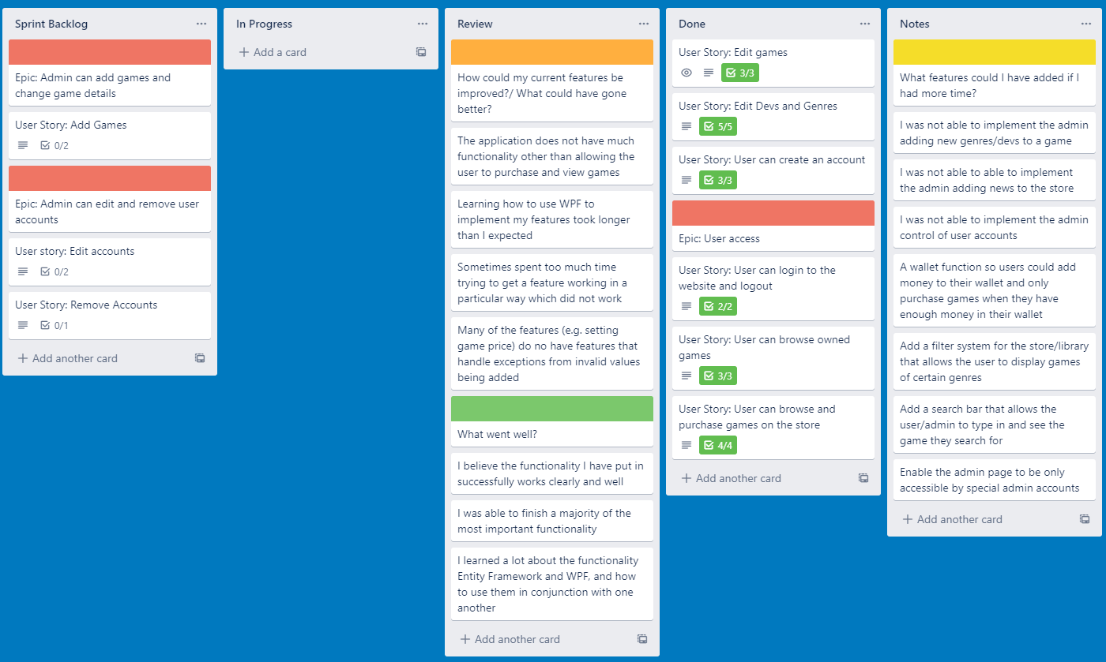**My Trello board**:

**User guide:**

* When the project is opened, connection between the database and model has already been setup, so to start using the application all the user needs to do is run the application with the WPF project as the start-up project.
* From there the user can interact with the application as intended, first clicking on the “Create account” button to make an account for themselves, before navigating back to the login page where they can enter their account details and enter the application to access its full user features.

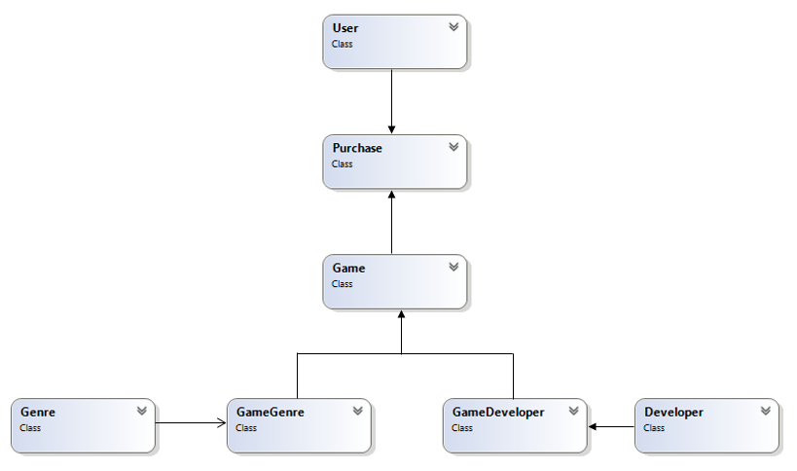**Class Diagram**: