**IIT-JEE-Physics-Screening–2000**

**SCREENING**   
_______________________________________________________________________   
  
**1.** Electrons with energy 80keV are incident on the tungsten target of an X-Ray tube. K-shell electrons of tungsten have -72.5keV energy. X-rays emitted by the tube contain only.   
(A) a continuous X-ray spectrum (Bremsstrahlung) with a minimum wavelength of ~0.155 Å.   
(B) A continuous X-ray spectrum (Bremsstrahlung) with all wavelengths.   
(C) The characteristic X-ray spectrum of tungsten.   
(D) A continuous X-ray spectrum (Bremsstrahlung) with a minimum wavelength of ~0.155 Å and the characteristic X-ray spectrum of tungsten.   
  
**2.** A uniform but time varying magnetic field B (t) exists in a circular region of radius a and is directed into the plane of the paper as shown. The magnitude of the induced electric field at point P at a distance r from the center of the circular region

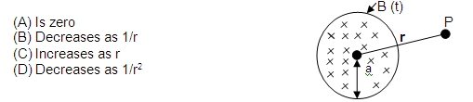  
  
**3.** A large open tank has two holes in the wall. One is a square hole of side L at a depth y from the top and the other is a circular hole of radius R at a depth 4y from the top. When the tank is completely filled with water, the quantities of water flowing out per second from both holes are the same. Then, R is equal to   
(A) L/√2π   
(B) 2πL   
(C) L   
(D) L/2π   
  
**4.** An equilateral triangle ABC formed from a uniform wire has two small identical beads initially located at A. The triangle is set rotating about the vertical axis AO. Then the beads are released from rest simultaneously and allowed to slide down; One along AB and the other along AC as shown. Neglecting frictional effects, the quantities that are conserved as beads slides down are   
       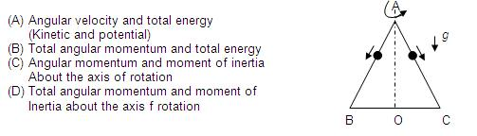  
  
**5.** A cubical block of side L rests on a rough horizontal surface with coefficient of friction μ. A horizontal force F is applied on the block as shown. If the coefficient of friction is sufficiently high so that the block does not slide before toppling, the minimum force required to topple the block is   
                                                                    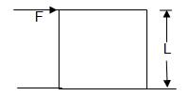  
  
(A) Infinitesimal   
(B) mg/4   
(C) mg/2   
(D) mg(1-μ)

**6.** Imagine an atom made up of proton and a hypothetical particle of double the mass of the electron but having the same charge as the electron. Apply the Bohr atom model and consider all possible transitions of this hypothetical particle to the first excited level. The longest wavelength photon that will be emitted has wavelength λ (given in terms of the Rydberg constant R for the hydrogen atom) equal to   
(A) 9/5R   
(B) 36/5R   
(C) 18/5R   
(D) 4/R   
  
**7.** A monoatomic ideal gas, initially at temperature T1, is enclosed in a cylinder fitted with a friction piston. The gas is allowed to expand adiabatically to a temperature T2 by releasing the piston suddenly. If L1 and L2 are the lengths of the gas column before and after expansion respectively, then T1 /T2 is given by   
(A) (L1 ⁄ L2 ) 2/3   
(B) (L1 ⁄ L2 )   
(C) L2 ⁄ L1   
(D) (L2 ⁄ L1 )2/3   
  
**8.** A point source of light B placed at a distance L in front of the centre of a mirror of width d, hangs vertically on a wall. A man walks in front of the mirror along a line parallel to the mirror at a distance 2L from it as shown. The greatest distance over which he can see the image of the light source in the mirror is   
                                                               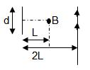  
  
(A) d/2   
(B) d   
(C) 2d   
(D) 3d   
  
**9.** An infinitely long conductor PQR is bent to form a right angle as shown. A current I flows through PQR. The magnetic field due to this current at the point M is H1. Now, another infinitely long straight conductor QS is connected to Q so that the current is I/2 in QR as well as in QS, the current in PQ remaining unchanged. The magnetic field at M is now H2.The ratio of H1/H2 is given by   
                                                       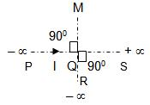  
  
**10.** The plots of intensity versus wavelength for three black bodies at temperatures T1, T2 and T3 respectively are as shown. Their temperatures are such that

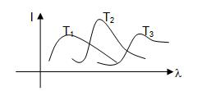  
  
(A) T1 > T2 > T3   
(B) T1 > T3 > T2   
(C) T2 > T3 > T1   
(D) T3 > T2 > T1

**11.** A train moves towards a stationary observer with speed 34 m/s. The train sounds a whistle and its frequency registered by the observer is F1. If the train’s speed is reduced to 17 m/s, the frequency registered is F2. If the speed of sound is 340 m/s then f1/ f2 is   
(A) 18 / 19   
(B) 1 / 2   
(C) 2   
(D) 19 / 18   
  
**12.** A particle of charge q and mass m moves in a circular orbit of radius r with angular speed ω. The ratio of the magnitude of its magnetic moment to that of its angular momentum depends on   
(A) ω and q   
(B) ω, q and m   
(C) q and m   
(D) ω and m   
  
**13.** The dimension of (1/2) Є0 E2 ( Є0 : permittivity of free space; E : electric field ) is   
(A) MLT -1   
(B) ML2T-2   
(C) ML-1 T -2   
(D) ML2T-1   
  
**14.** In a compound microscope, the intermediate image is   
(A) Virtual, erect and magnified   
(B) Real, erect and magnified   
(C) Real, inverted and magnified   
(D) Virtual, erect and reduced   
  
**15.** The period of oscillation of a simple pendulum of length L suspended from the roof of the vehicle which moves without friction, down an inclined plane of inclination α, is given by   
(A) 2π√(L/gcosα)   
(B) 2π√(L/gsinα)   
(C) 2π√(L/g)   
(D) 2π√(L/gtanα)   
  
**16.** In a double slit experiment instead of taking slits of equal widths, one slit is made twice as wide as the other, then in the interference pattern   
(A) The intensities of both the maxima and minima increases   
(B) The intensity of maxima increases and the minima has zero intensity  
(C) The intensity of maxima decreases and that of minima increases  
(D) The intensity of maxima decreases and the minima has zero intensity   
  
**17.** Three charges Q, +q and –q are p;aced at the vertices of a right angle triangle (isosceles triangle) as shown. The net electrostatic energy of the configuration is zero if Q is equal to   
                                                                    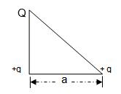  
(A) (-q)/(1+√2)   
(B) (-2q)/(2+√2)   
(C) -2q   
(D) +q

**18.** A long horizontal road has a bead which can slide along its length and is initially placed at a distance L from one end A of the rod. The rod is set in angular motion about A with a constant angular acceleration. If the coefficient of friction between the rod and the bead is μ, and gravity is neglected, then the time after which the bead starts slipping is   
(A) √(μ/α)   
(B) μ/√α   
(C) 1/√μα   
(D) Infinitesimal   
  
**19.** Starting with the same initial conditions, an ideal gas expands from volume V1 to V2 in three different ways, the work done by the gas is W1 if the process is purely isothermal, W2 if purely isobaric and W3 if purely adiabatic, then   
(A) W2> W1> W3   
(B) W2> W3 >W1   
(C) W1 >W2 >W3   
(D) W1 >W3 >W2

**20.** A block of ice at -100C is slowly heated ahs converted to steam at 1000C. Which of the following curves represents the phenomenon qualitatively? 

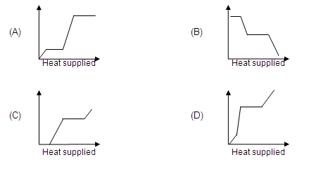  
  
**21.** An ionized gas contains both positive and negative ions. If it is subjected simultaneously to an electric field along the + x direction and a magnetic field along the + z direction then   
(A) Positive ions deflect towards +y direction and negative ions towards –y direction   
(B) All ions deflect towards +y direction   
(C) All ions deflect towards – y direction   
(D) Positive ions deflect towards –y direction and negative ions towards +y direction

**22.** Two radioactive materials X1 and X2 have decay constants 10λ and λ respectively. If initially they have the same number of nuclei, then the ratio of the number. of nuclei of X2 to that of X2 will be 1/e after a time   
(A) 1/10λ   
(B) 1/11λ   
(C) 11/10λ   
(D) 1/9λ   
  
**23.** A parallel plate capacitor of area A, plate separation d and capacitance C is filled with three different dielectric materials having dielectric constants k1, k2 and k3 as shown. If a single dielectric material is to be used to have the same capacitance C in this capacitor then its dielectric constant k is given by   
                                                  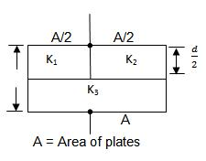  
(A) 1/k = 1/k1 + 1/k2 + 1/(2k3)   
(B) 1/k = 1/(k1 + k2 ) + 1/(2k3 )   
(C) k = (k1 k2)/(k1 + k2 ) + 2k3  
(D) k = (k1 k3)/(k1 + k2 ) + (k2 k3)/(k2 + k2 )   
  
**24.** A thin wire of length L and uniform linear mass density p is bent into a circular loop with centre at O as shown. The moment of inertia of the loop about the axis XX’ is   
                                            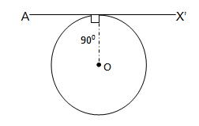  
(A) (pL3)/(8π2 )   
(B) (pL3)/(16π2 )   
(C) (5pL3)/(16π2 )   
(D) (3pL3)/(8π2 )

**25.** The electron in a hydrogen atom makes a transition from an excited state to the ground state. Which of the following statements is true   
(A) Its kinetic energy increases and its potential and total energy decreases   
(B) Its kinetic energy decreases, potential energy increases and its total energy remains the same   
(C) Its kinetic and total energy decreases and its potential energy increases   
(D) Its kinetic , potential and total energy decreases   
  
**26.** An ideal gas is initially at temperature T and volume V. Its volume is increased by ΔV due to an increase in temperature ΔT, pressure remaining constant. The quantity δ = ΔV/VΔT varies with temperature as

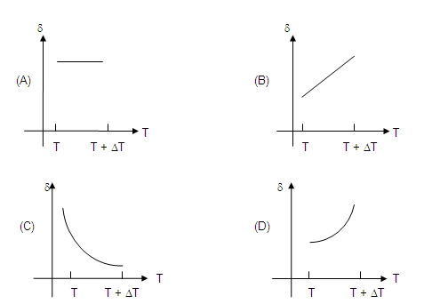  
  
**27.** A wind-powered generator converts wind energy into electrical energy. Assume that the generator converts a fixed fraction of the wind energy intercepted by its blades into electrical energy. For wind speed V, the electrical power output will be proportional to   
(A) v   
(B) v2   
(C) v3   
(D) v4   
  
**28.** A ball is dropped vertically from a height d above the ground. It hits the ground and bounces up vertically to a height d/2. Neglecting subsequent motion and air resistance, its velocity v varies with height h above the ground as

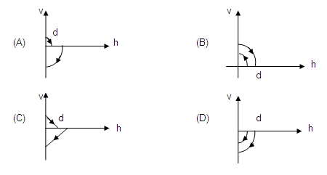

**29.** A coil of wire having finite inductance and resistance has a conducting ring placed co-axially within it. The coil is connected to a battery at time t= 0, so that a time dependent current I1 (t) starts flowing through the coil. If I2 (t) is the current induced in the ring, and B (t) is the magnetic field at the axis of the coil due to I1 (t) then as a function of time (t > 0), the product I2 (t) B (t)   
(A) increases with time   
(B) decreases with time   
(C) does not vary with time   
(D) passes through a maximum   
  
**30.** A hollow double concave lens is made of very thin transparent material. It can be filled with air or either of two liquids L1 or L2 having refracting indices n1 and n2 respectively (n2 > n1 > 1). The lens will diverge a parallel beam of light if it is filled with   
(A) air and placed in air   
(B) air and immersed in L1  
(C) L1 and immersed in L2   
(D) L2 and immersed in L1   
  
**31.** Two long parallel wires are at a distance 2d a part. They carry steady equal currents flowing out of the plane of the paper as shown. The variation of the magnetic field B along the line XX’ is given by   
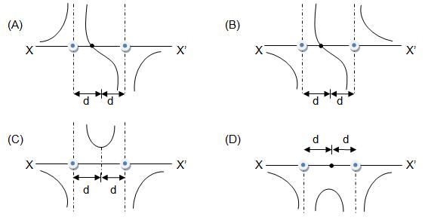  
  
**32.** A diverging beam of light from a point source S having divergence angle α falls symmetrically on a glass slab as shown. The angles of incidence of the two extreme rays are equal. If the thickness of the glass slab is t and its refractive index is n, then the divergence angle of the emergent beam is   
  
                                              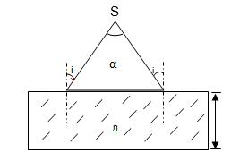  
(A) Zero   
(B) α   
(C) sin–1 (1/n)   
(D) 2sin–1 (1/n)

**33.** A rectangular glass slab ABCD of refractive index n1 is immersed in water of refractive index n2(n1 > n2). A ray of light is incident at the surface AB of the slab as shown. The maximum value of the angle of incidence αmax, such that the ray comes out only from the other surface CD, is given by   
  
  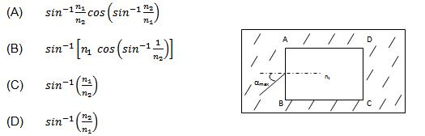  
  
**34.** Two vibrating strings of the same material but lengths L and 2L have radii 2r and r respectively. They are stretched under the same tension. Both the strings vibrate in their fundamental modes, the one of length L with frequency v1. The ratio v1/v2 is given by   
(A) 2   
(B) 4   
(C) 8   
(D) 1   
  
**35.** Two monoatomic ideal gases 1 and 2 of molecular masses m1 and m2 respectively are enclosed in separate containers kept at the same temperature. The ratio of the speed of sound is gas 1 to that in gas 2 is given by   
(A) √(m1 / m2 )   
(B) √(m2 / m1 )   
(C) m1 / m2   
(D) m2 / m1

# IIT-JEE-Physics-Mains–2000

**MAINS**   
  
Time : two hours                                                                 Max. Marks : 100   
______________________________________________________________________   
  
**General Instructions :**   
**1.** There are ten questions in this paper. Attempt all Questions.   
**2.** Answer each question starting on a new page. The corresponding question number must be written in the left margin. Answer all the parts of a question at one place only.   
**3.** Use only Arabic numerals (0, 1, 2 ………….9) in answering the questions irrespective of the language in which your answer.   
**4.** Use of logarithmic tables is not permitted.   
**5.** Use of calculator is not permitted.   
______________________________________________________________________   
  
**PART B**   
  
**1.** (a) A hydrogen like atom of atomic number Z is in an excited state of quantum number 2n. It can emit a maximum energy photon of 204 eV. If it makes a transition to quantum state n, a photon of energy 40.8 eV is emitted. Find n, Z and the ground state energy (in eV) of this atom. Also calculate the minimum energy (in eV) that can be emitted by this atom during de-excitation. Ground state energy of hydrogen atom is –13.6 eV.   
(b) When a beam of 10.6 eV photons of intensity 2.0 W/m2 falls on a platinum surface of area 1.0 × 10-4 m2 and work function 5.6 eV, 0.53% of the incident photons eject photoelectrons. Find the number of photoelectrons emitted per second and their minimum and maximum energies (in eV). Take 1eV = 1.6 × 10-19 J.   
  
**2.** (a) A convex lens of focal length 15 cm and a concave mirror of focal length 30 cm are kept with their optic axis PQ and RS parallel but separated in vertical direction by 0.6 cm as shown. The distance between the lens and mirror is 30 cm. An upright object AB of height 1.2 cm is placed on the optic axis PQ of the lens at a distance of 20 cm from the lens. If A’ B’ is the image after refraction from the lens and the   
  
       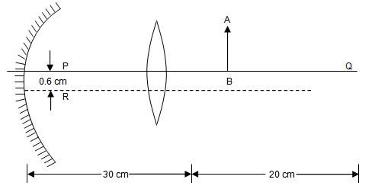  
  
reflection from the mirror, find the distance of A’ B’ from the pole of the mirror and obtain its magnification. Also locate positions of A’ and B’ with respect to the optic axis RS.   
(b) A glass plate of refractive index 1.5 is coated with a thin layer of thickness t and refractive index 1.8. Light of wavelength λ travelling in air is incident normally on the layer. It is partly reflected at the upper and the lower surfaces of the layer and the two reflected rays interfere. Write the condition for their constructive interference constructively.   
  
**3.** A 3.6 m long pipe resonates with a source of frequency 212.5 Hz when water level is at certain heights in the pipe. Find the heights of water level (from the bottom of the pipe) at which resonances occur. Neglect end correction. Now the pipe is filled to a height H (≈3.6 m). A small hole is drilled very close to its bottom and water is allowed to leak. Obtain an expression for the rate of fall of water level in the pipe as a function of H. If the radii of the pipe and the hole are 2 × 10–2 m and 1 × 10–3 m respectively, calculate the time interval between the occurrence of first two resonances. Speed of sound in air is 340 m/s and g = 10 m/s2.

**4.** Two moles of an ideal monoatomic gas is taken through a cycle ABCA as shown in the P–T diagram. During the process AB, pressure and temperature of the gas vary such that PT = constant. If T1 = 300 K, calculate   
  
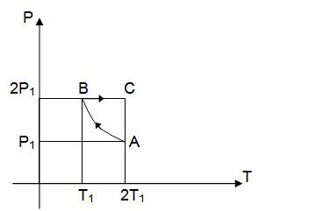  
  
(A) the work done on the gas in the process AB and   
  
(B) the heat absorbed or released by the gas in each of the processes   
Give answers in terms of the gas constant R.   
  
**5.** A thermocole vessel contains 0.5 Kg of distilled water at 30oC. A metal coil of are 5 × 10–3 m2, number of turns 100, mass 0.06 Kg and resistance 1.6 Ω is lying horizontally at the bottom of the vessel. A uniform time varying magnetic field is set up to pass vertically through the coil at time t = 0. The field is first increased from zero to 0.8 T at a constant rate between 0 and 0.2s and then decreased to zero at the same rate between 0.2 and 0.4s. The cycle is repeated 12000 times. Make sketches of the current through the coil and the power dissipated in the coil as a function of time for the first two cycles. Clearly indicate the magnitudes of the quantities on the axes. Assume that no heat is lost to the vessel or the surroundings. Determine the final temperature of the water under thermal equilibrium. Specific heat of metal = 500 J/Kg–K and the specific heat of water = 4200 J/Kg–K. Neglect the inductance of coil.   
  
**6.** Four point charges + 8 μC, – 1 μC and + 8 μC are fixed at the points -√(27/2) m,-√(3/2) m,+√(3/2) m and+√(27/2) m respectively on the y-axis. A particle of mass 6 × 10-4 Kg and charge + 0.1μC moves along the –x direction. Its speed at x = + ∞ is V0. Find the least values of V0 for which the particle will cross the origin. Find also the kinetic energy of the particle at the origin. Assume that space is gravity free. 1/4π ∈0 = 9 × 109 Nm2/C2.   
  
**7.** A circular loop of radius R is bent along aType equation here. diameter and given a shape as shown in figure. One of the semicircles (KNM) lies in the x-z plane and the other one (KLM) in the y-z plane with their centres at origin. Current I is flowing through each of the semicircles as shown in figure.

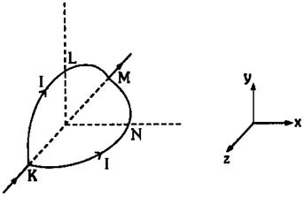  
  
(a) A particle of charge q is released at the origin with a velocity vector V=-V0 î.   
Find the instantaneous force vector F on the particle. Assume that space is gravity free.   
  
(b) If an external uniform magnetic field B0 ĵ is applied, determine the force vectors F1 &  F2 on the semicircles KLM and KNM due to the field and the net force vector F on the loop.

**8.** An object A is kept fixed at the point x = 3 m and y = 1.25 m on a plank P raised above the ground. At time t = 0 the plank starts moving along the + x   
  
                                   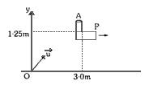  
  
direction with an acceleration 1.5 m/s2. At the same instant a stone is projected from the origin with a velocity vector u as shown. A stationary person on the ground observes the stone hitting the object during its downward motion at an angle of 45o to the horizontal. All the motions are in X-Y plane. Find vector u and the time after which the stone hits the object. Take g = 10 m/s2.   
  
**9.** A rod AB of mass M and length L is lying on a horizontal frictionless surface. A particle of mass m travelling along the surface hits the end ‘A’ of the rod with a velocity V0 in a direction perpendicular to AB. The collision is elastic. After the collision the particle comes to rest.   
(a) Find the ratio m/M.   
(b) A point P on the rod is at rest immediately after collision. Find the distance AP.   
(c) Find the linear speed of the point P after a time πL/3V0 after the collision.   
  
**10.** In the figure masses m1, m2 and M are 20 Kg, 5 Kg and 50 Kg respectively. The coefficient of friction between M and ground is zero. The coefficient of friction between m1 and M and that between m2 and ground is 0.3. The pulleys and the strings are massless. The string is perfectly horizontal between P1 and m1 and also between P2 and m2. The string is perfectly vertical between P1 and P2. An external horizontal force F is applied to the mass M. Take g = 10 m/s2.   
  
                              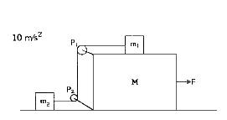  
  
(a) Draw a free body diagram of mass M, clearly showing all the forces.   
(b) Let the magnitude of the force of friction between m1 and M be f1 and 2f2. Find f1 and f2. Write equations of motion of all the masses. Find F, tension in the string and accelerations of the masses.