**IIT-JEE-Physics-Screening–2001**

**SCREENING**   
______________________________________________________________________   
  
**1.** Three positive charges of equal value q are placed at the vertices of an equilateral triangle. The resulting lines of force should ne sketched as in :   
  
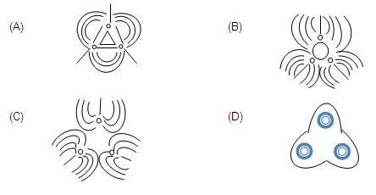  
  
**2.** When a block of iron floats in mercury at 00C, a fraction k1 of its volume is submerged, while at the temperature 600 C, a fraction k2 is seen to be submerged. If the coefficient of volume expansion of iron γFe and that of mercury is γHg, then the ratio k1 / k2 can be expressed as :   
(A) (1+60 γFe )/(1+ 60 γHg )   
(B) (1-60 γFe )/(1+ 60 γHg )   
(C) (1+60 γFe )/(1- 60 γHg )   
(D) (1+60 γHg )/(1+ 60 γFe )   
  
**3.** Three rods made of the same material and having the same cross-section have been joined as shown in the figure. Each rod is of the same length. The left and right ends are kept at 00C and 900C respectively. The temperature of the junction of the three rods will be:   
  
                          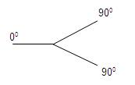  
(A) 450C  
(B) 600C   
(C) 300C  
(D) 200C   
  
**4.** In a given process of an ideal gas, dW = 0 and dQ <0.Then for the gas :   
(A) The temperature will decrease   
(B) The volume will increase   
(C) The pressure will remain constant   
(D) The temperature will increase   
  
**5.** The electron emitted in beta radiation originates from :  
(A) Inner orbits of atoms   
(B) Free electrons existing in nuclei   
(C) Decay of a neutron in a nucleus   
(D) Photon escaping from the nucleus   
  
**6.** The transition from the state n = 4 to n =3 in a hydrogen like atom results in ultraviolet radiation. Infrared radiation will be obtained in the transition :   
(A) 2→1  
(B) 3→2  
(C) 4→2  
(D) 5→4  
  
**7.** In the given circuit with steady current the potential drop across the capacitor must be :   
  
                   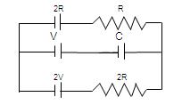  
(A) V   
(B) V/2  
(C) V/3  
(D) 2V/3   
  
**8.** The intensity of X- Rays from a Coolidge tube is plotted against wavelength λ as shown in the figure. The minimum wavelength found is λC and the wavelength of the kC line is λK. As the accelerating voltage is increased :   
  
                                 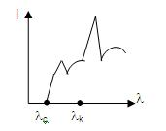  
(A) λK – λC increases   
(B) λK – λC decreases   
(C) λK increases   
(D) λK decreases   
  
**9.** Two beams of light having intensities I and 4 I interfere to produce a fringe pattern on a screen. The phase difference between the beans is π/2at point A and π at point B. Then the difference between the resultant intensities at A and B is :   
(A) 2 I   
(B) 4 I   
(C) 5 I   
(D) 7 I

**10.** A non –planar loop of conducting wire carting a current I is placed as shown in the figure. Each of the straight sections of the loop is of length 2a. The magnetic field due to this loop at the point P (a,0,a) points in the direction :   
  
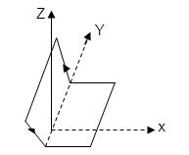  
(A) 1/√2 (-ĵ+k)  
(B) 1/√3 (-ĵ+k+ î )  
(C) 1/√3 (i+ĵ+k)  
(D) 1/√2 (î+k )   
  
**11.** A particle executes simple harmonic motion between X= - A and X= + A. The time taken for it to go from 0 to A/2 is T1 and to go from A/ 2 to A is T2. Then :   
(A) T1 < T2   
(B) T1 > T2   
(C) T1= T2   
(D) T1=2 T2   
  
**12.** In a Young’s double slit experiment, 12 fringes are observed to be formed in a certain segment of the screen when light of wavelength 600nm is used. If the wavelength of light is changed to 400nm, number of fringes observed in the same segment of the screen is given by :   
(A) 12  
(B) 18  
(C) 24  
(D) 30  
  
**13.** A quantity X is given by ∈0 L ∆V/∆t where ∈0 is the permittivity of free space. L is a length, ∆V is a potential difference and 8k is a time interval. The dimensional formula for X is same as that of :   
(A) Resistance   
(B) Charge   
(C) Voltage   
(D) Current   
  
**14.** Consider the situation shown in the figure. The capacitor A has a charge q on it whereas B is uncharged. The charge appearing on the capacitor B a long time after the switch is closed is :   
  
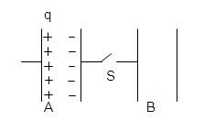  
(A) Zero   
(B) q/2  
(C) q   
(D) 2q   
  
**15.** A uniform electric field pointing in positive X-direction exists in a region. Let A be the origin, B be the point on the x-axis at x=+1 cm and C be the point on the y-axis at y= +1 cm. Then the potentials at the potentials at the points A, B and C satisfy :   
(A) VA < VB  
(B) VA > VB  
(C) VA < Vc  
(D) VA > Vc   
  
**16.** A coil having N turns is wound tightly in the form of spiral with inner and outer radii and b respectively. When a current passes through the coil, the magnetic field at the centre is:   
(A) (μ0 NI)/b (B) (2μ0 NI)/a   
(C) (μ0 NI)/(2(b-a))  ln b/a   
(D) (μ0 IN)/(2(b-a)) ln b/a   
  
**17.** A radioactive sample consists of two distinct species having equal number of atoms initially. The mean life of one species is τ and that of the other is 5τ. The decay products in both cases are stable. A plot is made of the total number of radioactive nuclei as a function of time. Which of the following figures best represents the form of this plot :   
  
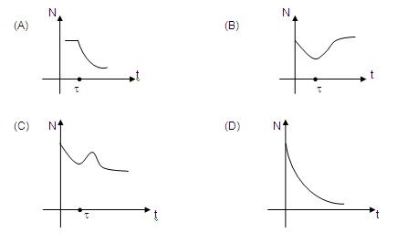  
  
**18.** In the given circuit, it is observed that the current I is independent of the value of the resistance R6 .The resistance values must satisfy :   
  
         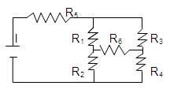  
(A) R1 R2 R5= R3 R4 R6   
(B) 1/( R5)+ 1/R6 = 1/(R1+ R2 )+1/(R3+ R4)   
(C) R1 R4 = R2 R3   
(D) R1 R3= R2 R4

**19.** A metallic square loop ABCD is moving in its own plane with velocity V in a uniform magnetic field perpendicular to its plane s shown in the figure, Electric field is induced :   
  
                      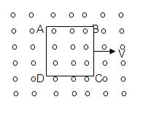  
(A) in AD, but not in BC   
(B) in BC, but not in AD   
(C) neither in AD nor in BC   
(D) in both AD and BC   
  
**20.** A simple pendulum has a time period T1 when on the earth’s surface, and T2 when taken to a height R above the earth’s surface where R is the radius of the earth. The value of T2/T1 is :   
(A) 1  
(B) √2   
(C) 4  
(D) 2   
  
**21.** Two particles of masses ma and m2 in projectile motion have velocities vectors v1 <  v2 respectively at time t=0. They collide at time t0. Their velocities become  v'1 and v'2 at time 2t0 while still moving in air. The value of |(m1 v'1+ m2v'2 ) - (m1 v1+ m2v2 )| is:   
(A) Zero   
(B) (m1 + m2) gt0  
(C) 2(m1 + m2) gt0  
(D) 1/2(m1 + m2) gt0   
  
**22.** One quarter section is cut from a uniform circular disc of radius R. This section has a mass M. It is made to rotate about a line perpendicular to is its plane and passing through the centre of the original disc. Its moment of inertia about the axis of rotation is :   
  
                       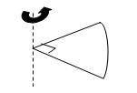  
(A) 1/2 MR2  
(B) 1/4 MR2  
(C) 1/8 MR2  
(D) √2MR2  
  
**23.** A small block is shot into each of the four tracks as shown below. Each of the tracks rises to the same height. The speed with which the block enters the track is the same in all cases. At the highest point of the track the normal reaction is maximum in :   
  
        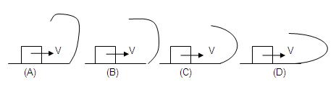  
  
**24.** A ray of light passes through four transparent media with refractive indices μ1, μ2 , μ3 and μ4 as shown in the figure. The surfaces of all media are parallel. If the emergent ray CD is parallel to the incident ray AB, we must have :   
(A) μ1= μ2  
(B) μ2= μ3  
(C) μ3= μ4  
(D) μ4= μ1   
  
**25.** A given ray of light suffers minimum deviation in an equilateral prism P. Additional prism Q and R of identical shape and of the same material as P are now added as shown in the figure. The ray will suffer :   
(A) Greater deviation   
(B) No deviation   
(C) Same deviation as before  
(D) Total internal refection.

**26.** A wire of length L and 3 identical cells of negligible internal resistances are connected in series. Due to the current, the temperature of the wire is raised by ∆T in a time t. A number N of similar cells is now connected in series with a wire of the same material and cross-section but of length 2L. The temperature of the wire is raised by the same amount ∆T in the same time. The value of N is :   
(A) 4  
(B) 6  
(C) 8  
(D) 9  
  
**27.** An insect crawls up a hemispherical surface very slowly (see the figure). The coefficient of friction between the surface and the insect is 1/3. If the line joining the centre of the hemispherical surface to the insect makes an angle α wit the vertical, the maximum possible value of is α given by:   
(A) cot α = 3   
(B) tan α =3   
(C) sec α=3   
(D) cosec α=3   
  
**28.** A string of negligible mass going over a clamped pulley of mass m supports a block of mass M as shown in the figure. The force on the pulley by the clamp is given by:   
(A) √2 Mg   
(B) √2 mg   
(C) √((M+m)2+m2 g)   
(D) √((M+m)2+M2  g)   
  
**29.** The pulleys and strings shown in the figure are smooth and of negligible mass. For the system to remain in equilibrium, the angle θ should be:   
(A) 00   
(B) 300   
(C) 450   
(D) 600   
  
**30.** The ends of a stretched wire of length L are fixed at x =0 and x =L. In one experiment the displacement of the wire is y1= A sin(πx/L) sin ωt and energy is E1 and in other experiment its displacement is y2= A sin(2πx/L) sin 2ωt and energy is E2 . Then :   
(A) E2=E1   
(B) E2=2E1   
(C) E2=4E1   
(D) E2=16E1   
  
**31.** P-V plots for two gases during adiabatic processes are shown in the figure. Plots 1 and 2 should correspond respectively to :   
(A) He and O2   
(B) O2and He   
(C) He and Ar   
(D) O2 and N2   
  
**32.** Two pulses in a stretched string, whose centres are initially 8 cm apart, are moving towards each other as shown in the figure. The speed of each pulse is 2 cm / s. After 2 seconds the total energy of the pulses will be :   
(A) Zero   
(B) Purely kinetic   
(C) Purely potential   
(D) Partial kinetic and partly potential   
  
**33.** A hemispherical portion of radius R. The volume of the remaining cylinder is V and mass M. It is suspended by a string in a liquid of density ρ where it stays vertical. The upper surface of the cylinder is at a depth h below the liquid surface. The force on the bottom of the cylinder by the liquid is:   
(A) Mg   
(B) Mg -Vρg   
(C) Mg +πR2h ρg   
(D) ρg(V + πR2h)   
  
**34.** Two particles A and B of masses mA and mB respectively and having the same charge are moving in a plane. A uniform magnetic field exists perpendicular to this plane. The speeds of the particles are vA and vB respectively and the trajectories are as shown in the figure. Then :   
(A) mA vA < mB vB   
(B) mA vA > mB vB   
(C) mA < mB and vA < vB   
(D) mA = mB and vA = vB   
  
**35.** Two circular coils can be arranged in any of the three situations shown in the figure. Their mutual inductance will be :   
(A) Maximum in situation (a)   
(B) Maximum in situation (b)  
(C) Maximum in situation (c)  
(D) The same in all situations

**MAINS**   
  
Time : two hours                                                               Max. Marks : 100   
______________________________________________________________________   
  
**General Instructions :**   
1. There are ten questions in this paper. Attempt all Questions.   
2. Answer each question starting on a new page. The corresponding question number must be written in the left margin. Answer all the parts of a question at one place only.   
3. Use only Arabic numerals (0, 1, 2 ………….9) in answering the questions irrespective of the language in which your answer.   
4. Use of logarithmic tables is not permitted.   
5. Use of calculator is not permitted.   
______________________________________________________________________   
  
**1.** An ice cube of mass 0.1 Kg at 00C is placed in an isolated container which is at 2270C. The specific heat S of the container varies with temperature T according to the empirical S = A + BT, where A = 100 cal/Kg-K and B = 2 × 10–2 cal/K2. If the final temperature of the container is 270C, determine the mass of the container.   
(Latent heat of fusion for water = 8 × 104 cal/Kg,   
Specific heat of water = 103 cal/Kg-K).   
  
**2.** A small ball of mass 2 × 103 Kg having a charge of 1 µ C is suspended by a string of length 0.8 m. Another identical ball having the same charge is kept at the point of suspension. Determine the minimum horizontal velocity which should be imparted to the lower ball so that it can make complete revolution.   
  
**3.** An inductor of inductance L = 400 mH and resistors of resistances R1 = 2 Ω and R2 = 2  are connected to a battery of e.m.f. E = 12 V as shown in the figure. The internal resistance of the battery is negligible. The switch S is closed at time t = 0.   
  
             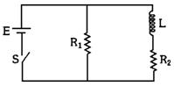  
  
What is the potential drop across L as a function of time? After the steady state is reached, the switch is opened. What is the direction and the magnitude of current through R1 as a function of time?   
  
**4.** A 5 m long cylindrical steel wire with radius 2 × 10–3 m is suspended vertically from a rigid support and carries a bob of mass 100 Kg at the other end. If the bob gets snapped, calculate the change in temperature of the wire ignoring radiation losses.   
(For the steel wire : Young’s modulus = 2.1 × 1011 Pa;   
Density = 7860 Kg/m3; Specific heat = 420 J/Kg-K)   
  
**5.** The refraction indices of the crown glass for blue and red light are 1.51 and 1.49 respectively and those of the flint glass are 1.77 and 1.73 respectively. An isosceles prism of angle 6o is made of crown glass. A beam of white light is incident at a small angle on the prism. The other flint glass isosceles prism is combined with the crown glass prism such that there is no deviation of the incident light. Determine the angle of the flint glass prism. Calculate the net dispersion of the combined system.   
  
**6.** In a nuclear reactor 235U undergoes fission liberating 200 MeV of energy. The reactor has a 10% efficiency and produces 1000 MW power. If the reactor is to function for 10 years, find the total mass of uranium required.   
  
**7.** A nucleus at rest undergoes a decay emitting an α-particle of de-Broglie wavelength, λ = 5.76 × 10–15 m. If the mass of the daughter nucleus is 223.610 a.m.u. and that of the α-particle is 4.002 a.m.u., determine the total kinetic energy in the final state. Hence, obtain the mass of the parent nucleus in a.m.u.   
(1 a.m.u. = 931.470 MeV/c2)

**8.** A vessel ABCD of 10 cm width has two small slits S1 and S2 sealed with identical glass plates of equal thickness. The distance between the slits in 0.8 mm. POQ is the line perpendicular to the plane AB and passing through O, the middle point of S1 and S2. A monochromatic light source is kept at S, 40 cm   
  
               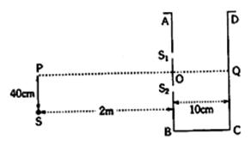  
  
below P and 2 m from the vessel, to illuminate the slits as shown in the figure alongside. Calculate the position of the central bright fringe on the other wall CD with respect to the line OQ. Now, a liquid is poured into the vessel and filled upto OQ. The central bright fringe is found to be at Q. Calculate the refractive index of the liquid.   
  
**9.** A thin biconvex lens of refractive index 3/2 is placed on a horizontal plane mirror as shown in the figure. The space between the lens and the mirror is then filled with water of refractive index 4/3. It is found that when a point object is placed 15 cm above the lens on its principal axis, the object coincides with its own image. On repeating with another liquid, the object and the image again coincide at a distance 25 cm from the lens. Calculate the refractive index of the liquid.   
  
                 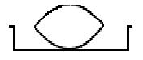  
  
**10.** A radioactive nucleus X decays to a nucleus Y with a decay constant λx = 0.1 sec–1. Y further decays to a stable nucleus Z with a decay constant y = 1/30 sec–1. Initially, there are only X nuclei and their number is N0 = 1020. Set up the rate equations for the populations of X, Y and Z. The population of the Y nucleus as a function of time is given by NY (t) = {N0 x/(x – y)} {exp (–y t) –exp (–x t)}. Find the time at which Ny is maximum and determine the populations X and Z at that instant.   
  
**11.** A monoatomic ideal gas of two moles is taken through a cyclic process starting from A as shown in the figure. The volume ratios are VB/VA = 2 and in the figure. The volume ratios are VD/VA = 4. If the temperature TA at A is 27oC, calculate,   
  
               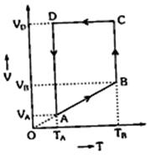  
(a) the temperature of the gas at point B,   
(b) heat absorbed or released by the gas in each process,   
(c) the total work done by the gas during the complete cycle.   
Express your answer in terms of the gas constant R.

**12.** A boat is travelling in a river with a speed 10 m/sec along the stream flowing with a speed 2 m/sec. From this boat, a sound transmitter is lowered into the river through a rigid support. The wavelength of the sound emitted form the transmitter inside the water is 14.45 mm. Assume that attention of sound in water and air is negligible.   
(a) What will be the frequency detected by a receiver kept inside the river downstream?

(b) The transmitter and the receiver are now pulled up into air. The air is blowing with a speed 5 m/sec in the direction opposite the river stream. Determine the frequency of the sound detected by the receiver.

(Temperature of the air and water = 20oC; Density of river water = 103 Kg/m3;   
Bulk modulus of water = 2.088 × 109 Pa; Gas constant R = 8.31 J/mol–K;   
Mean molecular mass of air = 28.8 × 10-3 Kg/mol; CP/CV for air = 14)   
  
**13.** A current of 10 A flows around a closed path in a circuit which is in the horizontal plane as shown in the figure, the circuit consists of eight alternating arcs of radii r1 = 0.08 m and r2 = 0.12 m. Each subtends the same angle at the centre.   
  
                  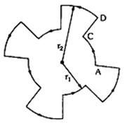  
  
(a) Find the magnetic field produced by this circuit at the centre.   
  
(b) An infinitely long straight wire carrying a current of 10 A is passing through the centre of the above circuit vertically with the direction of the current being into the plane of the circuit. What is the force acting on the wire at the centre due to the current in the circuit? What is the force acting on the arc AC and the straight segment CD due to the current at the centre?   
  
**14.** A car P is moving with a uniform speed of 5√3 m/s towards a carriage of mass 9 Kg at rest kept on the rails at a point B as shown in figure. The height AC is 120 m. Cannon balls of 1 Kg are fired from the car with an initial velocity 100 m/s at an angle 30o with the horizontal. The first cannon ball hits the stationary carriage after a time t0 and sticks to it. Determine t0.   
  
                    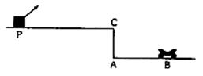  
At t0, the second cannon ball is fired. Assume that the resistive force between the rails and the carriage is constant and ignore the vertical motion of the carriage throughout. If the second ball also hits and sticks to the carriage, what will be the horizontal velocity of the carriage just after the second impact?   
  
**15.** Two heavy metallic plates are joined together at 90o to each other. A laminar sheet of mass 30 Kg is hinged at the line AB joining the two heavy metallic plated. The hinges are frictionless. The moment of inertia of the laminar sheet about an axis parallel to AB and passing through its centre of mass is 1.2 Kg m2. Two rubber obstacles P and Q are fixed, one on each metallic plate at a distance 0.5 m from the line AB. This distance is chosen so that the reaction due to the hinges on the laminar sheet is zero during the impact. Initially the laminar sheet hits one of the obstacles with angular velocity 1 rad/s and turns back. If the impulse on the sheet due to each obstacle is 6 N-s,   
  
                      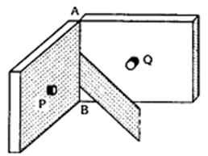  
  
(a) Find the location of the centre of mass of the laminar sheet from AB.   
(b) At what angular velocity does the laminar sheet come back after the first impact?   
(c) After how many impacts, does the laminar sheet come to rest?