**IIT-JEE-Physics-Screening-2002**

**1.** A simple pendulum is oscillating without damping. When the displacement of the bob is less than maximum, its acceleration vector vector a is correctly shown in   
  
     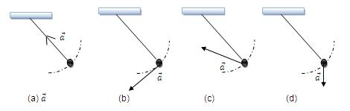  
  
  
**2.**        A wooden block, with a coin placed on its top, floats in water as shown in figure. The distance *l* and *h*  are shown there. After some time the coin falls into the water. Then   
                  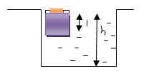  
(A)*l* decreases and *h* increases   
(B)       *l* increases and *h* decreases   
(C)       Both *l* and *h* increase   
(D)       Both *l* and *h* decrease   
    
**3.**        A cylinder rolls up an inclined plane, reaches some height, and then rolls down (without slipping throughout these motions). The directions of the frictional force acting on the cylinder are   
(A)       Up the incline while ascending and down the incline while descending.   
(B)       Up the incline while ascending as well as descending.   
(C)       Down the incline while ascending and up the incline while descending.   
(D)       Down the incline while ascending as well as descending.   
    
**4.**        A circular platform is free to rotate in a horizontal plane about a vertical axis passing through its centre. A tortoise is sitting at the edge of the platform. Now the platform is given an angular velocity ω0. When the tortoise move along a chord of the platform with a constant velocity (with respect to the platform ), the angular velocity  of the platform ωt)  will vary with time t as   
    
      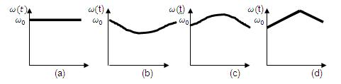  
 **5.**        Two blocks of masses 10 kg and 4 kg are connected by a spring of negligible mass and placed on a frictionless horizontal surface. An impulse gives a velocity of 14 m/s to the heavier block in the direction of the lighter block. The velocity of the centre of mass is   
(A)    30m/s   
(B)    20m/s   
(C)     10m/s   
(D)     5m/s   
    
  
  
λ) 2λ 2λ/3 λ/3 λ

**6.**         A particle, which is constrained to move along the x-axis, is subjected to a force in the same direction which varies with the distance x of the particle from the origin as F(x)= - kx + ax3 . Here k and a are positive constants. For x ≥ 0 the functional value of the potential energy U(x) of the particle is   
  
     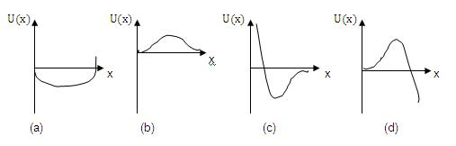  
  
**7.**         A siren placed at railway platform is emitting sound of frequency 5 kHz. A passenger sitting in a moving train A records a frequency of 5.5 kHz while the train approaches the siren. During his return journey n a different train B he records a frequency of 6.0 kHz while approaching the same siren. The ratio of the velocity of train B to that train A is   
(A)       242/252   
(B)       2   
(C)       5/6   
(D)       11/6   
    
**8.**         A sonometer wire resonates with a given tuning fork forming standing waves with five antinodes between the two bridges when a mass of 9 kg is suspended from the wire. When this mass is replaced with mass M, the wire resonates with the same tuning fork forming three antinodes for the same positions of the bridges. The value of M is   
(A)       25 kg   
(B)       5 kg   
(C)       12.5 kg   
(D)       1/25 kg   
    
**9.**        An ideal spring with spring-constant k is hung from the ceiling and a block of mass M is attached to its lower end. The mass is released with the spring initially unstretched. Then the maximum extension in the spring is   
(A)       4Mg/k   
(B)       2Mg/k   
(C)       Mg/k   
(D)       Mg/2k   
    
**10.**     A geo-stationary satellite orbits around the earth in a circular orbit of radius 36,000 km. then, the time period of a spy satellite orbiting a few hundred km above the earth's surface (Rearth =6400km) will approximately be   
(A)       ­1 / 2 hr   
(B)       1 hr   
(C)       2 hr   
(D)       4 hr     
    
λ) 2λ 2λ/3 λ/3 λ

**11.**      The effective resistance between points P and Q  of the electrical circuit shown in the figure is   
          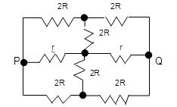  
  
(A) 2Rr/(R+r)   
(B) 8R(R+r)/(3R+r)   
(C) 2r+4R   
(D) 5R/2 + 2r   
  
**12.** A particle of mass m and charge q moves with a constant velocity v along the positive x-direction. It enters a region containing a uniform magnetic field B directed along the negative z-direction, extending from x=a to x=b. The minimum value of v required so that the particle can just enter the region x>b is   
(A) qbB/m   
(B) q(b-a)B/m   
(C) qaB/m   
(D) q(b+a)B/m   
  
  
**13.**      Two equal point charges are fixed at x=-a and x=+a on the x-axis. Another point charge Q is placed at the origin. The change in the electrical potential energy of Q , when it is displaced by a small distance x along the x-axis, is approximately proportional to   
   (A)       x   
   (B)       x2   
   (C)       x3   
   (D)       1/x   
    
**14.**       A long straight wire along the z-axis carries a current I in the negative z-direction, the magnetic vector field vector B at a point having coordinate (x, y) on the z=0 plane is   
     (A)       μ0i(yi - xj)/ 2π (x'2 + y'2)   
     (B)       μ0i(xi + yj)/ 2π (x'2 + y'2)   
     (C)       μ0i(xj - yi)/ 2π (x'2 + y'2)   
     (D)       μ0i(xi - yj)/ 2π (x'2 + y'2)   
    
**15.**      As shown in the figure, P and Q  are two coaxial conducting loops separated by some distance. When the switch S is closed, a clockwise current Ip flows in P (as seen by E) and an induced current IQ1 flows in Q. The switched remains closed for a long time. When S is opened, a current IQ2 flows in Q. Then the direction IQ1 and IQ2 (as seen by E) are   
  
                     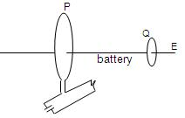  
  
  
(A)       Respectively clockwise and anti-clockwise   
(B)       Both clockwise   
(C)       Both anti-clockwise   
(D)       Respectively anti-clockwise and clockwise   
    
λ) 2λ 2λ/3 λ/3 λ

**16.**        A 100 W bulb B1, and two 60 W bulbs B2 and B3, are connected to a 250 V source, as shown in the figure. Now W1, and  W2 and W3 are output powers of the bulbs B1, B2 and B3 respectively. Then      
  
                    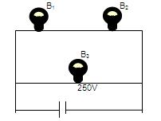  
  
  
(A)       W1>W2 =W3   
(B)       W1>W2 >W3   
(C)       W­1<W2 =W3   
(D)       W1<W2<W3   
    
**17.**    Two identical capacitors have the same capacitance C. One of them is charged to potential V1 and the other to V2. The negative ends of the capacitors are connected together. When the positive ends are also connected, the decrease in energy of the combined system is   
(A)    1/4 [C ( V12 - V22 )]   
(B)    1/4 [C ( V12 + V22 )]   
(C)    1/4 [C ( V1 - V2)2]   
(D)    1/4 [C ( V1 + V2)2]   
    
**18.**      A short circuited coil is placed in a time-varying magnetic field. Electrical power is dissipated due to the current induced in the coil. If the numbers of turns were to be quadrupled and the radius halved, the electrical power dissipated would be   
(A)       Halved   
(B)       The same   
(C)       Doubled   
(D)       Quadrupled   
    
**19.**    The magnetic field lines due to a bar magnet are correctly shown in   
  
          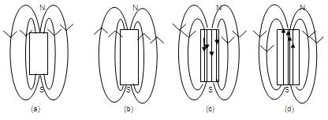  
  
  
**20.**      An ideal gas is taken through the cycle A → B → C → A as shown in figure. If the net heat supplied to the gas in cycle is 5J, the work done by the gas in the process C → A is   
  
           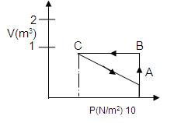  
  
  
(A)       5 J                     
(B)       -10 J   
(C)       -15 J       
(D)       -20 J        
    
λ) 2λ 2λ/3 λ/3 λ

**21.**       Which of the following graphs correctly represents the variation of  β = - (dv/dp)/ V with P   for an ideal gas at constant temperature?   
  
       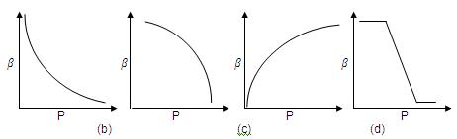  
  
  
**22.**      The potential difference applied to an X-ray tube is 5kV and the current through it is 3.2 mA. Then the number of electrons striking the target per second is   
(A)       2 x 1016   
(B)       5 x 106   
(C)       1 x 1017   
(D)       4 x 1015   
    
**23.**     An ideal black-body at room temperature is thrown into a furnace. It is observed that   
(A)       Initially it is the darkest body and at later times the brightest.   
(B)       It is the darkest body at all times.   
(C)       It cannot be distinguished at all times.   
(D)       Initially it is the darkest body and at later times it cannot be distinguished.   
    
**24.**      A hydrogen atom and a Li++ ion are both in the second excited state. If lH and lLi are their respective electronic angular momenta, and EH and ELi  their respective energies then   
(A)         lH > lLi and | EH | > | ELi |  
(B)         lH = lLi and | EH | < | ELi |   
(C)         lH = lLi and | EH | > | ELi |   
(D)         lH < lLi and | EH | < | ELi |   
    
**25.**      The half-life of   215At  is 100μs. The time taken for the radioactivity of a sample of 215At to decay to 1/16th of its initial value is   
(A)       400 μs   
(B)       63 μs   
(C)       40 μs   
D)        300 μs   
    
**26.**    Which of the following processes represents a Υ-decay?   
(A)       AXZ + Υ →  AXZ-1 + a + b   
(B)       AXZ +1n0 → A-3XZ-2 + c   
(C)       AXZ → AXZ + f   
(D)       AXZ +  e-1 → AXA-1 + g   
    
**27.**      An observer can see through a pin-hole the top end of a thin rod of height h, placed as shown in the figure. The beaker height is 3h and its radius h. when the beaker is filled with a liquid up to a height 2h, he can see the lower end of the rod. Then the refractive index of the liquid is   
  
                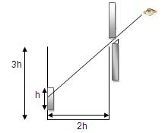  
  
  
(A)   5/2   
(B)    √5/2   
(C)   √3/2   
(D)   3/2   
    
λ) 2λ 2λ/3 λ/3 λ

**28.**      Which one of the following spherical lenses does not exhibit dispersion? The radii of curvature of the surfaces of the lenses are as given in the diagrams.   
  
          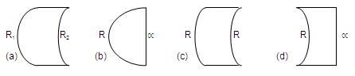  
  
  
**29.**     In the ideal double-slit experiment, when a glass-plate (refractive index 1.5) of thickness t is introduced in the path of one of the interfering beams (wave-length λ) , the intensity at the position where the central maximum occurred previously remains unchanged. The minimum thickness of the glass-plate is   
(A)       2λ   
(B)       2λ/3   
(C)       λ/3   
(D)       λ   
    
**30.**     Two plane mirrors A and B are aligned parallel to each other, as shown in the figure. A light ray is incident at an angle 300 at a point just inside one end of A. the plane of incidence coincides with the plane undergoes reflections (including the first one) before it emerges out is                                              
  
          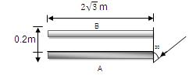  
  
  
(A)       28   
(B)       30                                                      
(C)       32   
(D)       34

**MAIN**   
**Time : Two hours                                                                             Max. Marks : 60**   
**______________________________________________________________**  
**Instructions**   
**1.**     The Question Paper has 4 printed pages and has 12 questions. Please ensure that the copy of the Question Paper you have received contains all the questions.   
**2.**     Attempts ALL questions. Each question carries 5 marks.   
**3.**     Answer each question starting on a new page. The corresponding Question number must be written in the left margin.   
**4.**     Do not write more than one answers for the same question. In case you attempt a question more than once, please cancel the answer(s) you consider to be wrong. Otherwise, only the answer appearing last will be evaluated.   
**5.**     Use only Arabic numerals (0, 1, 2 .............9) in answering the questions irrespective of the language in which your answer.   
**6.**   Use of logarithmic tables is NOT PERMITTED.   
**7.**   Use of calculators is NOT PERMITTED.   
**8.**     Both magnitude and direction of vector quantities, if any, in your answer should be indicated clearly.   
**9.**     Irrational numbers, if any, in your answer need not be expressed in decimal form.   
**10.** If the final answer appears in the form of a ratio or a product of two numbers, that need not to be further simplified.   
**_______________________________________________________________**   
    
**1.**        Two narrow cylindrical pipes A and B have the same length. Pipe A is open at both ends and is filled with a monoatomic gas of molar mass MA. Pipe B is open at one end and closed at the other end, and is filled with a diatomic gas of molar mass MB. Both gases are at the same temperature.   
(a)       If the frequency to the second harmonic of the fundamental mode in ppe A is equal of the frequency of the third harmonic of the fundamental mode in pipe B, determine the value of MA/MB.   
(b)       Now the open end of pipe B is also closed (so that the pipe is closed at both ends. Find the ratio of the fundamental frequency in pipe A to that in pipe B.   
    
**2.**         A cubical box of side 1 meter contains helium gas (atomic weight 4) at a pressure of 100 N/m2. During an observation time of 1 second, an atom travelling with root-mean-square speed parallel to one of the edges of the cube, was found to make 500 hits with a particular wall, without any collision with other atoms. Take R = 25/3 J/mol-K and k = 1.38 × 10-23 J/K.   
            (a)       Evaluate the temperature of the gas.   
            (b)       Evaluate the average kinetic energy per atom.   
            (c)        Evaluate the total mass of helium gas in the box.   
    
  
 **3.**  A uniform solid cylinder of density 0.8 g/cm3 floats in equilibrium in a combination of two non-mixing liquids A and B with its axis vertical. The densities of the liquids A and B are 0.7 g/cm3 and 1.2 g/cm2, respectively. The height of liquid A is hA = 1.2 cm. The length of the part of the cylinder immersed in liquid B is   
hB = 0.8 cm.   
  
                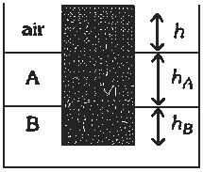  
  
  
(a)       Find the total force exerted by liquid A on the cylinder.   
(b)       Find h, the length of the part of the cylinder in air.   
(c)        The cylinder is depressed in such a way that its top surface is just below the upper surface of liquid A and is then released. Find the acceleration of the cylinder immediately after it is released.   
    
**4.**    A thin uniform wire AB of length 1 m, an unknown resistance X and a resistance of 12 W are connected by thick conducting strips, as shown in the figure. A battery and a galvanometer (with a sliding jockey connected to it) are also available. Connections are to be made to measure the unknown resistance X using the principle of Wheatstone bridge. Answer the following questions.   
  
         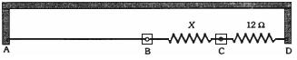  
  
  
(a)       Are there positive and negative terminals on the galvanometer?   
(b)       Copy the figure in your answer book and show the battery and the galvanometer (with jockey) connected at appropriate points.   
(c)        After appropriate connections are made, it is found that no deflection takes place in the galvanometer when the sliding jockey touches the wire at a distance of 60 cm from A. Obtain the value of the resistance X.   
    
**5.**        A hydrogen-like atom (described by the Bohr model) is observed to emit six wavelengths, originating from all possible transitions between a group of levels. These levels have energies between -0.85 eV and -0.544 eV (including both these values).   
            (a)       Find the atomic number of the atom.   
            (b)       Calculate the smallest wavelength emitted in these transitions.   
            (Take hc = 1240 eV-nm, ground state energy of hydrogen atom = -13.6 eV.   
    
**6.**       A point source S emitting light of wavelength 600 nm is placed at a very small height h above a flat reflecting surface AB (see figure). The intensity of the reflected light is 36% of the incident intensity. Interference fringes are observed on a screen placed parallel to the reflecting surface at a very large distance D from it.   
  
          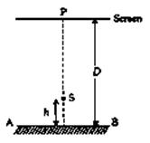  
  
  
(a)       What is the shape of the interference fringes on the screen?   
(b)       Calculate the ratio of the minimum to the maximum intensities in the interference fringes formed near the point P (shown in the figure).   
(c)        If the intensity at point P corresponds to a maximum, calculate the minimum distance through which the reflecting surface AB should be shifted so that the intensity at P again becomes maximum.

**7.**       A rectangular loop PQRS made from a uniform wire has length a, width b and mass m. It is free to rotate about the arm PQ, which remains hinged along a horizontal line taken as the y-axis (see figure). Take the vertically upward direction as the z-axis. A uniform magnetic field vector B = (3i + 4k) B0 exists in the region. The loop is held in the ex-y plane and a current I is passed through it. The loop is now released and is found to stay in the horizontal position in equilibrium.   
  
            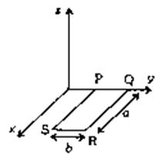  
  
  
            (a)       What is the direction of the current I in PQ?   
            (b)       Find the magnetic force on the arm RS.   
            (c)        Find the expression for I in terms of B0, a, b and m   
    
**8.**         Two metallic plates A and B, each of are 5 × 10-4 m2, are placed parallel to each other at a separation of 1 cm. Plate B carries a positive charge of 33.7 × 10-12 C. A monochromatic beam of light, with photons of energy 5 eV each, starts falling on plate A at t = 0 so that 106 photons fall on it per square meter per second. Assume that one photoelectron is emitted for every 106 incident photons. Also assume that all the emitted photoelectrons are collected by plate B and the work function of plate A remains constant at the value 2 eV. Determine   
(a)       the number of photoelectrons emitted up to t = 10s.   
(b)       the magnitude of the electric field between the plates A and B at t = 10 s and   
(c)        The kinetic energy of the most energetic photoelectron emitted at t = 10 s when it reaches plate B.   
            Neglect the time taken by the photoelectron to reach plate B.   
            Take e0 = 8.85 × 10-12 C2/N - m2.   
    
**9.**       A metal bar AB can slide on two parallel thick metallic rails separated by a distance l. A resistance R and an inductance L are connected to the rails as shown in the figure. A long straight wire carrying a constant current I0 is placed in the plane of the rails and perpendicular to them as shown. The bar AB is held at rest at a distance x0 from the long wire. At t = 0, it is made to slide on the rails away from the wire. Answer the following questions.   
  
           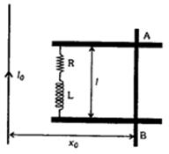  
  
  
(a)       Find a relation among i, di/dt and dΦ/dt , where I is the current in the circuit and F is the flux of the magnetic field due to the long wire through the circuit.   
(b)       It is observed that at time t = T, the metal bar AB is at a distance of 2x0 from the long wire and the resistance R carries a current i1. Obtain an expression for the net charge that has flown through resistance R from   
t = 0 to t = T.   
(c)        The bar is suddenly stopped at time T. The current through resistance R is found to be i1/4 at time 2T. Find the value of L/R in terms of the other given quantities.   
    
**10.**      On a frictionless horizontal surface, assumed to be the x-y plane, a small trolley A is moving along a straight line parallel to the y-axis (see figure) with a constant velocity of (√3 - 1) m/s. At a particular instant, when the line OA makes an angle of 45o with the x-axis, a ball is thrown along the surface from the origin O. Its velocity makes an angle f with the x-axis and it hits the trolley.   
  
         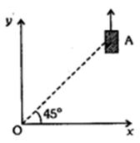  
  
  
(a)       The motion of the ball is observed from the frame of the trolley. Calculate the angle q made by the velocity vector of the ball with the x-axis in this frame.   
(b)       Find the speed of the ball with respect to the surface, if f = 4q/3.   
 **11.**    A spherical ball of mass m is kept at the highest point in the space between two fixed, concentric spheres A and B (see figure). The smaller sphere A has a radius R and the space between the two spheres has a width d. The ball has a diameter very slightly less then d. All surfaces are frictionless. The ball is given a gentle push (towards the right in the figure). The angle made by the radius vector of the ball with upward vertical is denoted by q (shown in the figure).   
  
              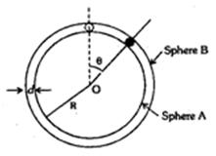  
  
  
(a)       Express the total normal reaction force exerted by the spheres on the ball as a function of angle q.   
(b)       Let NA and NB denote the magnitudes of the normal reaction forces on the ball exerted by the spheres A and B, respectively. Sketch the variation of NA and NB as functions of cos q in the range 0 < q < p by drawing two separate graphs in your answer book, taking cos q on the horizontal axes.   
    
**12.**   Three particles A, B and C, each of mass m, are connected to each other by three massless rigid rods to form a rigid, equilateral triangular body of side l. This body is placed on a horizontal frictionless table (x - y plane) and is hinged to it at the point A so that it can move without friction about the vertical axis through A (see figure). The body is set into rotational motion on the table about A with a  constant angular velocity w.   
  
              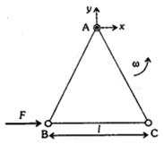  
  
  
(a)       Find the magnitude of the horizontal force exerted by the hinge on the body.   
(b)       At time T, when the side BC is parallel to the x-axis, a force F is applied on B along BC (as shown). Obtain the x-component and the y-component of the force exerted by the hinge on the body, immediately after time T.