**IIT-JEE-Physics-Screening-2003**

**Screening** **_______________________________________________________________**   
  
**1.**         A metallic shell has a point charge 'q' kept inside its cavity. Which one of the following diagrams correctly represents the electric lines of forces?   
  
     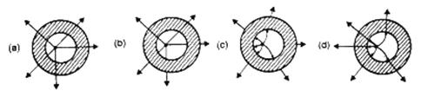  
    
 **2.**       What is the maximum value of the force F such that the block shown in the arrangement, does not move?   
  
       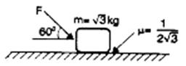   
         
            (a)       20 N                                                      
            (b)      10 N   
            (c)      12 N                                                      
            (d)      15 N   
    
 **3.**        Consider a body, shown in figure, consisting of two identical balls, each of mass M connected by a light rigid rod. If an impulse J = MV is imparted to the body at one of its ends, what would be its angular velocity?   
    
        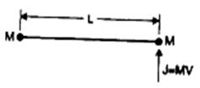  
  
            (a)       V/L                    
            (b)       2V/L   
            (c)       V/3L                                          
            (d)       V/4L   
    
 **4.**         If W1, W2 and W3 represent the work done in moving a particle from A to B along three different paths 1, 2 and 3 respectively (as shown) in the gravitational fields of a point mass m. Find the correct relation between W1, W2 and W3.   
    
         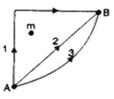  
  
            (a)       W1 > W2 > W3                          
            (b)       W1 = W2 = W3   
            (c)       W1 < W2 < W3                          
            (d)       W2 > W1 > W3   
    
 **5.**      A cube has a side of length 1.2 × 10-2 m. Calculate its volume.   
            (a)       1.7 × 10-6 m3                           
            (b)       1.73 × 10-6 m3   
            (c)       1.70 × 10-6 m3                         
            (d)       1.732 × 10-6 m3   
    
3λ/2 λ/4d λ/d 4λ/d

**6.**         The graph, shown in the adjacent diagram, represents the variation of temperature (T) of two bodies, x and y having some surface area, with time (t) due to the emission of radiation. Find the correct relation between the emissivity and absorptivity power of the two bodies.   
  
           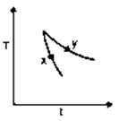  
  
            (a)       Ex > Ey and ax < ay   
            (b)       Ex < Ey and ax > ay   
            (c)       Ex > Ey and ax > ay   
            (d)       Ex < Ey and ax < ay   
    
 **7.**        The adjacent graph shows the extension (Dl) of a wire of length I m suspended from the top of a roof at one end and with a load W connected to the other end. If the cross-sectional area of the wire is 10-6 m2, calculate the Young's modulus of the materials of the wire.   
  
        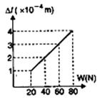  
  
            (a)       2 × 1011 N/m2   
            (b)       2 × 10-11 N/m2   
            (c)       3 × 1012 N/m2   
            (d)       2 × 1013 N/m2   
    
 **8.**       In the adjacent diagram, CP represents a wavefront and AO and BP, the corresponding two rays. Find the condition on q       for constructive interference at P between the ray BP, and reflected ray OP.   
    
       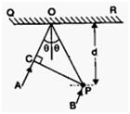  
  
            (a)       cos θ = 3λ/2   
            (b)       cos θ = λ/4d   
            (c)       sec θ - cos θ =  λ/d   
            (d)       sec θ - cos θ =  4λ/d   
    
 **9.**     Two rods, one of aluminum and other made of steel, having initial length l1, and l2 are connected together to form a single rod of length l1 + l2. The coefficients of linear expansion for aluminium and steel are aa and as respectively. If the length of each rod increases by the same amount when their temperature. If the length of each rod increases by the same amount when their temperature are raised by t0C, then find the ration  l1 / (l1 + l2).   
            (a)      αa / αs   
            (b)      αs / αa                     
            (c)          αs / (αa + αs)   
            (d)      αa / (αa + αs)  
    
 **10.**      The size of the image of an object, which is at infinity, as formed by a convex lens of focal length 30 cm. If a concave lens of focal length 20 cm is placed between the convex lens and the image at a distance of 26 cm from the convex lens, calculate the new size of the image.   
            (a)       1.25 cm   
            (b)       2.5 cm   
            (c)       1.05 cm   
            (d)       2 cm   
   
3λ/2 λ/4d λ/d 4λ/d **11.**     A ray of light is incident at the glass-water interface at an angle I, it emerges finally parallel to the surface of water, then the value of mg would be:   
  
        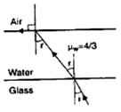  
  
            (a)       (4/3) sin I          
            (b)       1/sin i   
            (c)       4/3                     
            (d)       1   
    
 **12.**      The electric potential between a proton and an electron is given by V = V0 In r/r0, where r0 is a constant. Assuming Bohr's model to be applicable, write variation of rn with n, n being the principal quantum number?   
            (a)       rn ∞ n                             
            (b)       rn ∞  1/n   
            (c)       rn ∞ n2                                        
            (d)       rn ∞  1/n2   
    
 **13.**       If the atom 100Fm257 follows the Bohr model and the radius of 100Fm257 is n times the Bohr radius, then find n.   
            (a)       100   
            (b)       200       
            (c)        4            
            (d)       ¼   
    
 **14.**      When an AC source of emd e = E0 sin (100 t) is connected across a circuit, the phase difference between emf e and the current I in the circuit is observed to be Π/4, as shown in the diagram. If the circuit consists possibly only of R-C or R-L or L-C in series , find the relationship between the two elements.   
  
      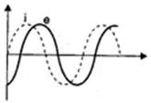  
  
            (a)       R = 1kW, C = 10 mF                
            (b)       R = 1kW, C = 1mF   
            (c)       R = 1kW, L = 10H                   
            (d)       R = 1kW, L = 1H   
    
 **15.**       For a positively charged particle moving in a x-y plane initially along the x-axis, there is a sudden change in its path due to the presence of electric and/or magnetic fields beyond P. The curved path is shown in the x-y plane and is found to be non-circular.   
  
       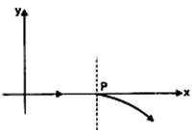  
  
            Which one of the following combinations is possible.   
  
          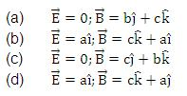

**16.**      Express which of the following set up can be used to verify ohm's law?   
    
           (a)  
                    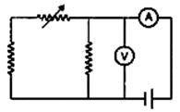  
           (b)  
                   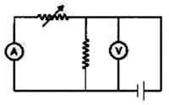  
           (c)  
                  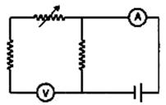  
           (d)  
                  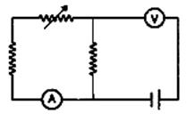  
 **17.**      The PT diagram for an ideal gas is shown in the figure, where AC is an adiabatic process, the find the corresponding PV diagram:   
  
     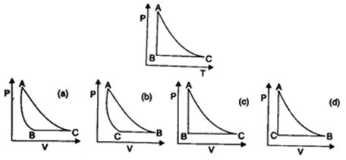  
    
 **18.**      A police car moving at 22 m/s, chases a motorcyclist. The police man sounds his horn at 176 Hz, while both of them move towards a stationary siren of frequency 165 Hz. Calculate the speed of the motorcycle, if it is given that he does not observe any beats.   
                    
          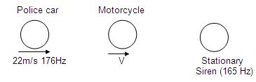  
    
    
            (a)       33 m/s                          
            (b)       22 m/s   
            (c)       zero                              
            (d)       11 m/s   
 **19.**      The uranium nucleus how does its mass vary with volume ?   
            (a)       m ∝ V                                       
            (b)       m ∝ 1/V   
            (c)        m ∝ √V   
            (d)       m ∝ V2   
    
 **20.**     For a particle executing SHM the displacement x is given by x = A cos wt. Identify the graph which represents the variation of potential energy (PE) as a function of time t and displacement x.   
  
     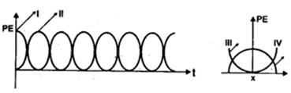  
  
            (a)       I, III                                            
            (b)       II, IV   
            (c)       II, III                                           
            (d)       I, IV   
    
 **21.**      In the experiment for the determination of the speed of sond in air using the resonance column method, the length of the air column that resonates in the fundamental mode, with a tuning fork is 0.1 m. When this length is changed 0.35 m, the same tuning fork resonates with the first overtone. Calculate the end correction.   
            (a)       0.012 m                                    
            (b)       0.025 m   
            (c)       0.05 m                                      
           (d)        0.024 m   
    
 **22.**       A particle undergoes uniform circular motion. About which point on the plane of the circle, will the angular momentum of the particle remain conserved?   
            (a)       centre of the circle                 
            (b)       on the circumference of the circle   
            (c)       inside the circle                      
            (d)       outside the circle   
    
 **23.**    A conducting loop carrying a current I is placed in a uniform magnetic field pointing into the plane of the paper as shown. The loop will have a tendency to:   
  
      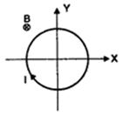  
  
            (a)       contract                                    
            (b)       expand   
            (c)       move towards +ve x-axis      
            (d)       move towards -ve x-axis   
 **24.**       A current carrying loop is placed in a uniform magnetic field in four different orientation, I, II, III and IV, arrange them in the decreasing order of potential energy :   
  
       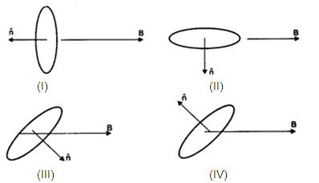  
    
    
            (a)       I > III > II > IV                
            (b)       I > II > III > IV   
            (c)       I > IV > II > III                
            (d)       III > IV > I > II   
    
 **25.**    2 kg of ice at 20oC is mixed with 5 kg of water at 20oc in an insulating vessel having a negligible heat capacity. Calculate the final mass of water remaining in the container. It is given that the specific heats of water and ice are 1 kcal/kg/oC and 0.5kcal/kg/oC while the latent heat of fusion of ice is 80 kcal/kg :   
            (a)       7 kg                                           
            (b)       6 kg   
            (c)      4 kg                                           
            (d)       2 kg   
    
 **26.**       In the shown arrangement of the experiment of the meter bridge if AC corresponding to null deflection of galvanometer is x, what would be its value if the radius of the wire AB is doubled?   
  
      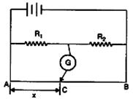  
  
            (a)       x                                                
            (b)       x/4   
            (c)       4x                                              
            (d)       2x   
  **27.**      The three resistance of equal value are arranged in the different combinations shown below. Arrange them in increasing order of power dissipation :   
  
     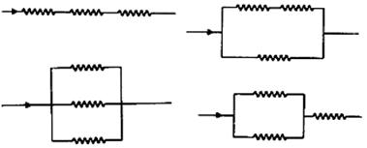  
  
            (a)       III < II < IV < I                
            (b)       II < III < IV < I   
            (c)       I < IV < III < II                
            (d)       I < III < II < IV   
    
  
**28.**       A nucleus with mass number 220 initially at rest emits an a-particle. If the Q value of the reaction is 5.5 MeV, calculate the kinetic energy of the a-particle :   
            (a)       4.4 MeV                                   
            (b)       5.4 MeV   
            (c)       5.6 MeV                                   
            (d)       6.5 MeV   
 **Mains** **_______________________________________________________________**   
  
  
    
**NOTE :** All these questions of **ASKIITIANS Mains 2003** are based on the memory of the student who appeared in the examination. The publisher and the author do not take any responsibility for any sort of discrepancy whatsoever.   
    
 **1.**       N-divisions on the main scale of a vernier calipers coincide with N+1 divisions on the vernier scale. If each division on the main scale is of a units, determine the least count of the instrument.   
    
 **2.**        Characteristic X-rays of frequency 4.2 × 1018 Hz are produced when transitions from L shell to K shell take place in a certain target material. Use Mosley's law to determine the atomic number of the target material. Given Rydberg constant   
R = 1.1 × 107 m-1.   
    
 **3.**         In a resonance tube experiment to determine the speed of sound in air, a pipe of diameter 5 cm is used. The air column in pipe resonates with a tuning fork of frequency 480 Hz when the minimum length of the air column is 16 cm. Find the speed of sound in air at room temperature.   
    
 **4.**         An insulated box containing a monoatomic gas of molar mass M moving with a speed v0 is suddenly stopped. Find the increment in gas temperature as a result of stopping the box.   
    
 **5.**        A soap bubble is being blown at the end of a very narrow tube of radius b. Air (density r) moves with a velocity v inside the tube and comes to rest inside the bubble. The surface tension of the soap solution is T. After some time the bubble, having grown to a radius r, separates from the tube. Find the value of r. Assume that r > > b so that you can consider the air to be falling normally on the bubble's surface.   
    
 **6.**        Show by diagram, how can we use a rheostat as the potential divider.   
    
 **7.**        A radioactive element decays by b emission. A detector records n beta particles in 2 seconds and in next 2 seconds it records 0.75n beta particles. Find mean life correct to nearest whole number. Given In ½2½ = 0.6931, In ½3½ = 1.0986.   
   
  **8.**      A particle of mass m, moving in a circular path of radius R with a constant speed v2 is located at point (2R, 0) at time t = 0 and a man starts moving with a velocity   
  
        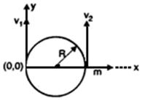  
v1 along the positive y-axis from origin at time t = 0. Calculate the linear momentum of the particle w.r.t. the man as a function of time.   
    
 **9.**      In the figure, light is incident on the thin lens as shown. The radius of curvature   
  
         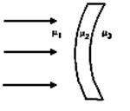  
for both the surface is R. Determine the focal length of this system.   
    
 **10.**       In a photoelectric experiment setup, photons of energy 5 eV falls on the cathode having work function 3eV. (a) If the saturation current is iA = 4mA for intensity 10-5 W/m2, then plot a graph between anode potential and current. (b) Also draw a graph for intensity of incident radiation 2 × 10-5 W/m2.   
    
 **11.**     Eight point charges are placed at the corners of a cube of edge a as shown in   
  
        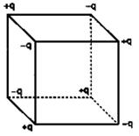  
figure. Find the work done in disassembling this system of charges.   
    
 **12.**    There is a crater of depth R/100 on the surface of the moon (radius R). A projectile is fired vertically upward from the crater with a velocity, which is equal to the escape velocity v from the surface of the moon. Find the maximum height attained by the projectile.   
    
 **13.**     A positive point charge q is fixed at origin. A dipole with a dipole moment vector p is placed along the x-axis far away from the origin with vector p pointing along positive   
x-axis. Find :   
(a) the kinetic energy of the dipole when it reaches a distance d from the origin, and   
(b) the force experienced by the charge q at this moment.   
 **14.**      Two infinitely long parallel wires carrying currents I = I0 sin wt in opposite directions are placed a distance 3a apart. A square loop of side a of negligible resistance with a capacitor of capacitance C is placed in the plane of wires as   
  
       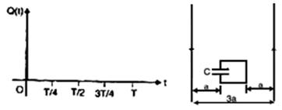  
shown. Find the maximum current in the square loop. Also sketch the grap showing the variation of charge on the upper plate of the capacitor as a function loop as positive.   
    
 **15.**   A ring of radius R having uniformly distributed charge Q is mounted on a rod suspended by two identical strings. The tension in strings in equilibrium is T0.   
  
          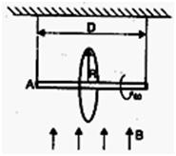  
Now a vertical magnetic field is switched on and ring is rotated at constant angular velocity w. Find the maximum w with which the ring can be rotated if the strings can withstand a maximum tension of 3T0/2.   
    
 **16.**       A liquid of density 900 kg/m3 is filled in a cylindrical tank of upper radius 0.9 m and lower radius 0.3 m. A capillary tube of length l is attached at the bottom of the tank as shown in the figure. The capillary has outer radius 0.002 m and inner   
  
          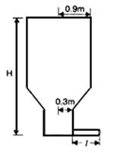  
radius a. When pressure P is applied at the top of the tank volume flow rate of the liquid is 8 × 10-6 m3/s and if capillary tube is detached, the liquid comes out from the tank with a velocity 10 m/s. Determine the coefficient of viscosity of the liquid.   
            [Given : pa2 = 10-6 m3 and a2 / l = 2 × 10-6 m]   
    
 **17.**     A string of mass per unit length m is clamped at both ends such that one end of the string is at x = 0 and the other is at x = l. When string vibrates in fundamental mode amplitude of the mid point of the string is a, and tension in the string is T. Find the total oscillation energy stored in the string.

**18.**       A prism of refracting angle 30o is coated with thin film of transparent material of refractive index 2.2 on face AC of the prism. A light of wavelength 6600 A is incident of face AB such that angle of incidence is 60o, find   
  
           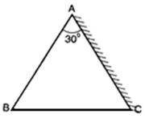  
              
(a)       the angle of emergence, and   
  
(b)       the minimum value of thickness of the coated film on the face AC for which the light emerging from the face has maximum intensity.   
    
 **19.**     Two point masses m1 and m2 are connected by a spring of natural length I0. The spring is compressed such that the two point masses touch each other and then they are fastened by a string. Then the system is moved with a velocity v0 along positive x-axis. When the system reaches the origin the string breaks (t = 0). Then position of the point mass m1 is given by x1 = v0t - A(1 - cos wt) where A and w are constants.   
            Find the position of the second block as a function of time. Also find the relation between A and I0.   
    
 **20.**     The top of an insulated cylindrical container is covered by a disc having emissivity 0.6 and conductivity 0.167 W/Km and thickness 1 cm. The temperature is maintained by circulating oil as shown : (a) Find the radiation loss to the surroundings in J/m2s if temperature of the upper surface of disc is 127oC, and temperature of surroundings is 27oC. (b) Also find the temperature of the circulating oil. Neglect the heat loss due to convection.   
  
          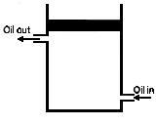  
            [Given σ = 17/3 × 10-8 Wm-2 K-4]