**Parking Management System using OpenCV**

Submitted in partial fulfillment of the requirements for the award of degree of

**BACHELOR OF ENGINEERING**

**IN**

**COMPUTER SCIENCE & ENGINEERING**



**Submitted to: Submitted By:**

**Project Teacher 18BCS16-B**

**NAME: Priyanshu Singh**

**UID: 18BET1057**

**Mentor Signature**

**(Name & E-code)**

**DEPARTMENT OF COMPUTER SCIENCE & ENGINEERING**

**Chandigarh University, Gharuan**

**June 20****22**

**Company Profile and Title Composition**

**Company Name - Cognizant**

Cognizant Technology Solutions Corporation is a **professional services company**. The Company operates through four segments: Financial Services, Healthcare, Products and Resources, and Communications, Media and Technology. The Financial Services segment includes banking, capital markets and insurance companies.

**Explanation of Project Title**

Real Time Parking Management System On-Demand solution provides a complete set of tools to optimize and make ease of parking vehicle using a ordinary CCTV camera connected through the system. All the information regarding the location of parking can feed by any picture of the parking lodge and than activate the application.

**Domain Relevance**

The domain is related to ‘Image Processing’ term is generally refer to a domain where we have to detect objects using cameras and process that data to get relevant output.

The role of Image Processing in business is to make the premises more secure and also provide ease in doing day to day task, The camera base parking make the normal parking technique much faster and more efficient because it doesn’t required any big system which consume a big space.

The technology use here is Python, Python is most in demand programming language which use in multiple domain like Image processing, Machine learning, and Data Science. Due to it’s vast application in different domain we use python.

**Tool Short listing**

* **PyCharm Community edition 2020.1.2**

**Implementation Part**

**Snapshot 1-:**

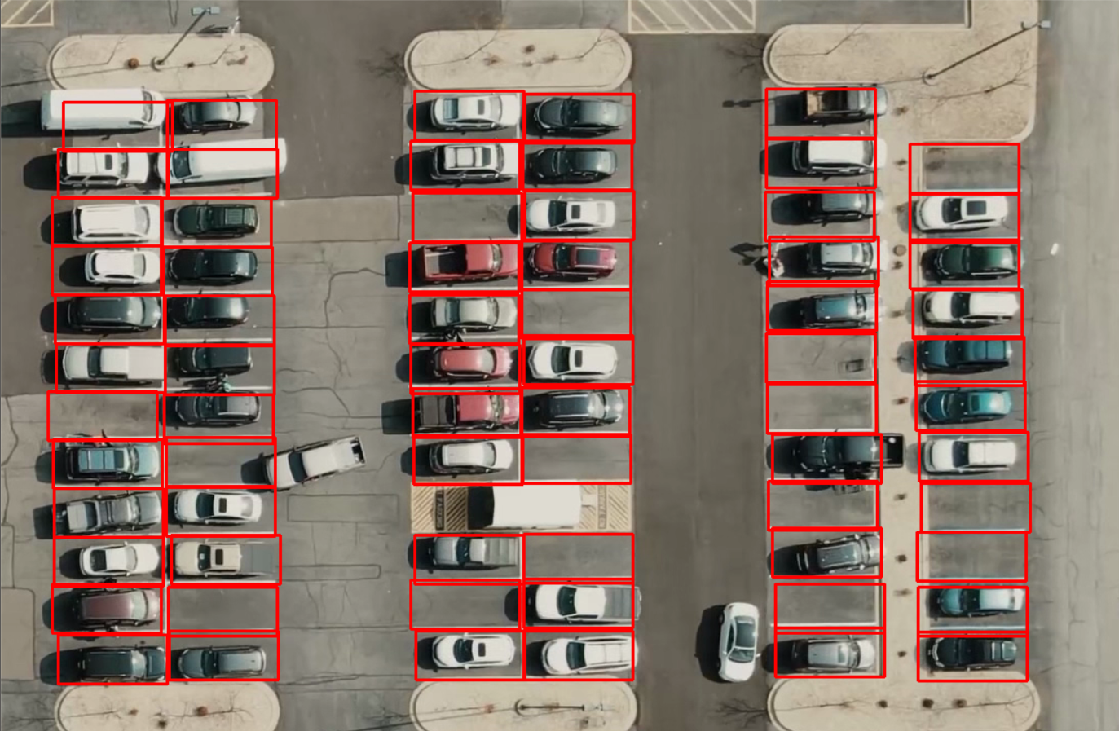

**Red_Rectangle-:** The red rectangle in this picture depicts the area where a car can park and this can be selected or deselected by just clicking your mouse left click or by right click.

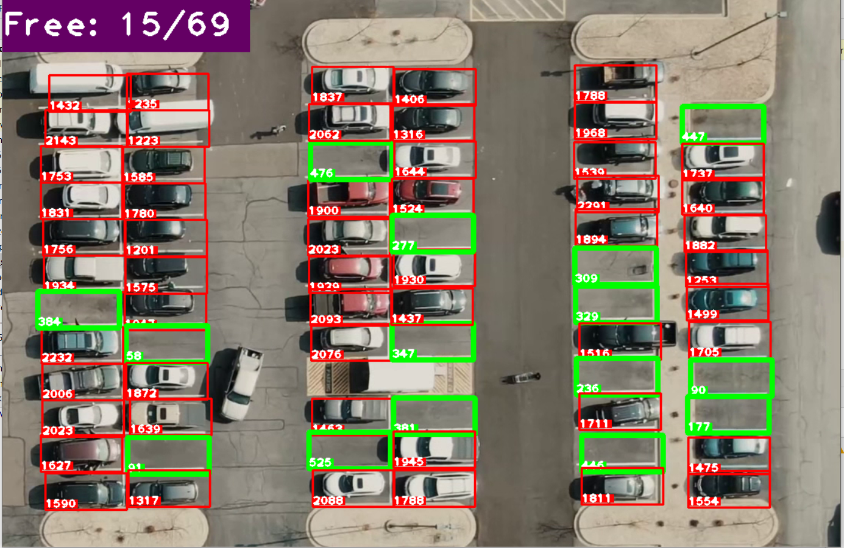

**Green_Rectangle-:** The green rectangle depicts the area where a car parking is available.

**Free: 15/69-:** The number representing 15 out of 69 places are free to park your car.