**Blood Bank Management REST API Assignment Explanation Docs**

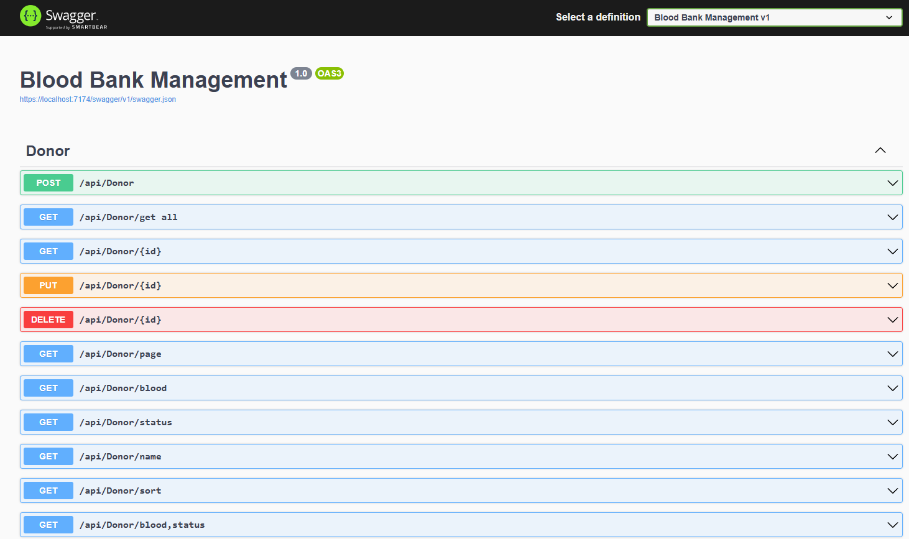

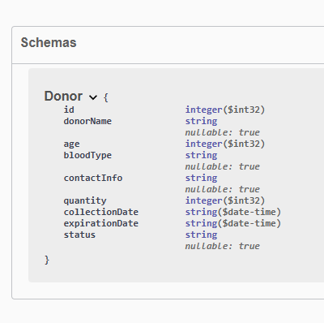 Schema (MODEL), (Class Attributes)

This is the **Swagger UI** interface. It provides a visual representation of the API endpoints, their HTTP methods (e.g., POST, GET, PUT, DELETE), and a way to interact with the API.

**1. Create Donor (POST /api/donors) endpoint**

POST /api/Donor

This endpoint adds a new donor to the system. The input data undergoes strict validation:

* Donor Name
  + Cannot be null or empty.
  + *Error:* "Donor name is required."
* Age
  + Must be between 18 and 75.
  + *Error:* "Invalid age. Age should be between 18 and 75."
* Blood Type
  + Must be one of: A+, A-, B+, B-, AB+, AB-, O+, O-.
  + *Error:* "Invalid blood type."
* Contact Info
  + Must be a valid 10-digit number.
  + *Error:* "Contact info must be a valid 10-digit phone number."
* Quantity
  + Minimum of 200 mL required.
  + *Error:* "Please enter more than 200 mL."
* Expiration Date
  + Set to 42 days from CollectionDate.
  + Status must be Available, Requested, or Expired.
  + *Error:* "Invalid status."
* Donor ID
  + Automatically assigned as the next sequential ID.
* Response
* Success: Donor is added and returned.
* Error: 400 Bad Request with the validation issue.

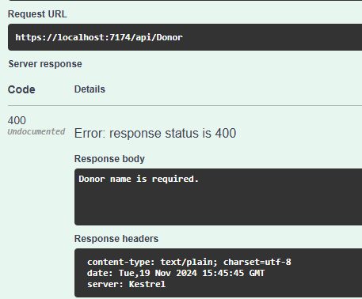 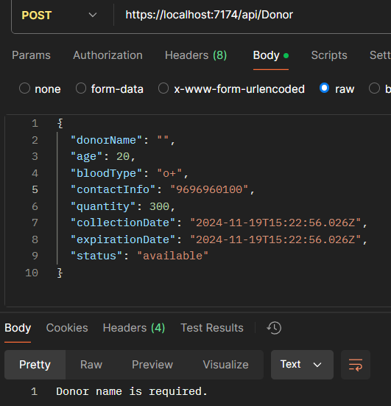

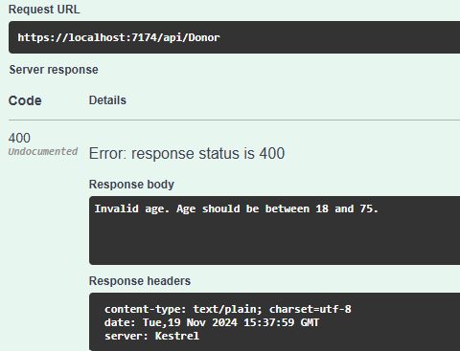 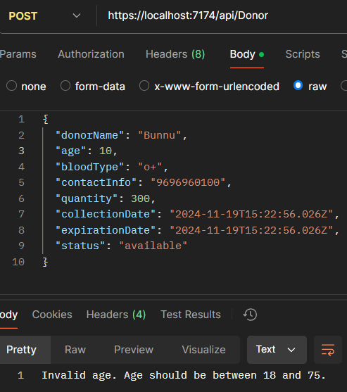

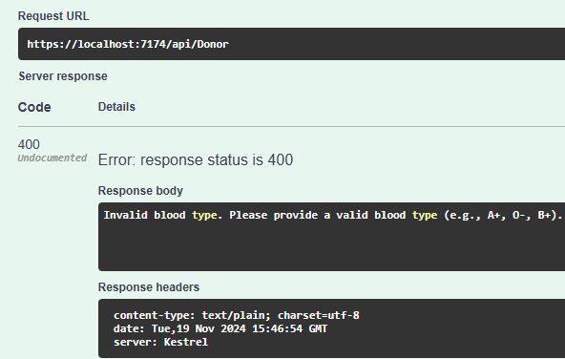 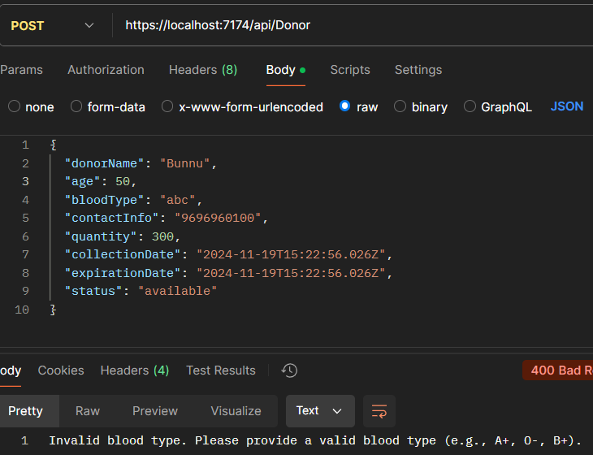

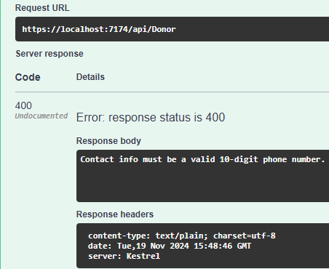 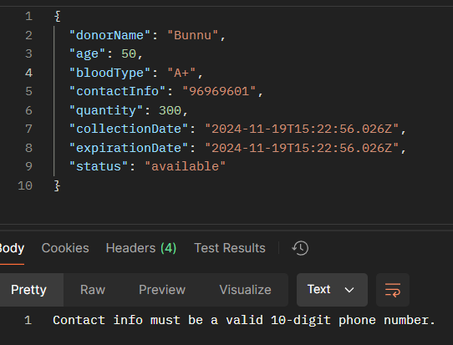

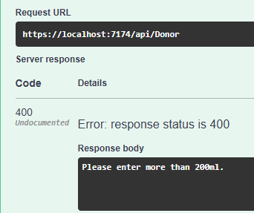 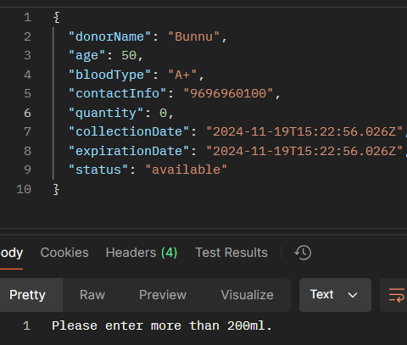

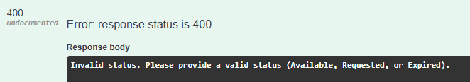

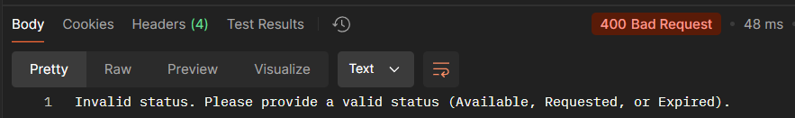

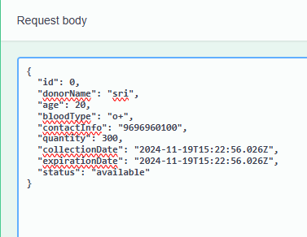 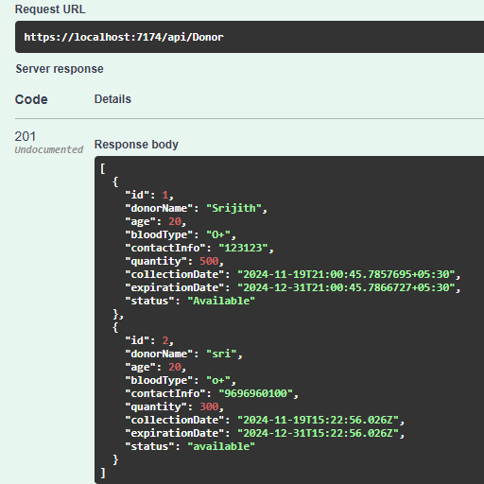

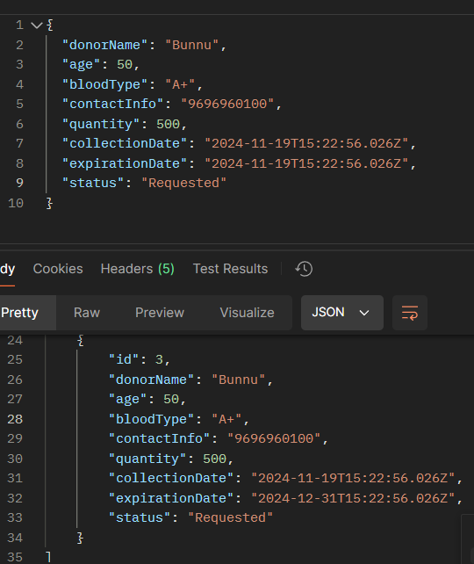

**GET /api/Donor/get_all**

This endpoint retrieves a list of all donors from the system.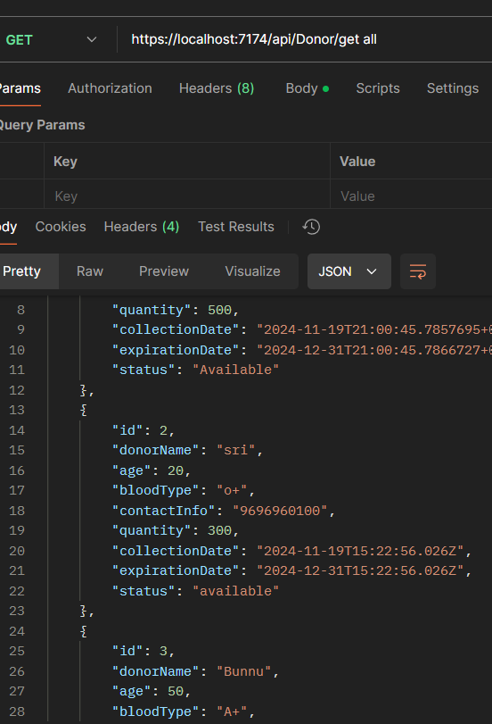 GET in POSTMAN API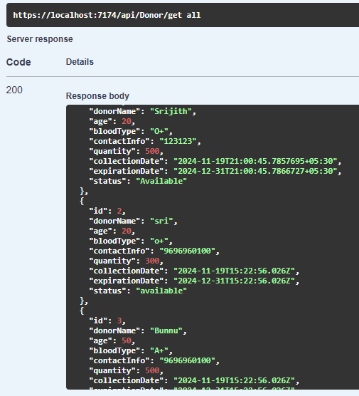 GET in SWAGGER

**Retrieves the details of a specific donor using their unique ID.**

* Validation:
  + Ensures the provided id exists in the system.
  + Returns 404 Not Found if the donor is not found.

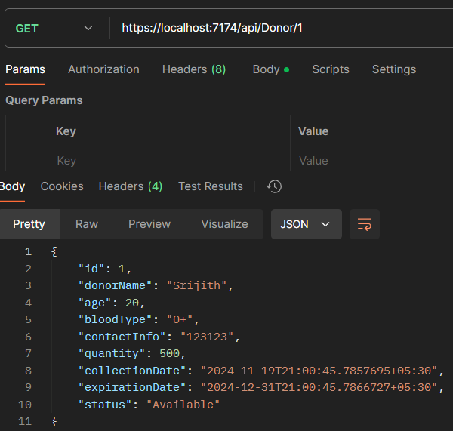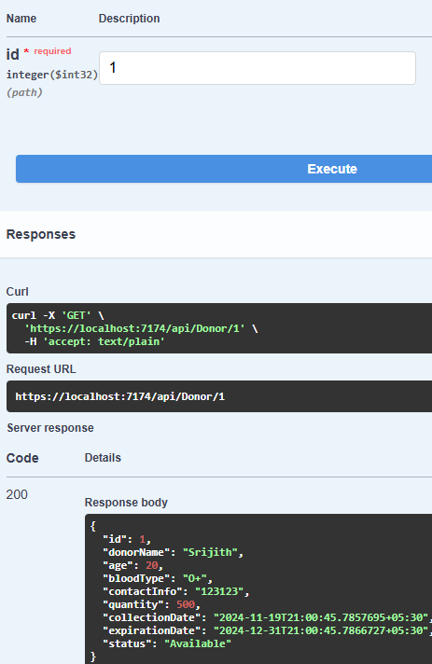

**PUT /api/Donor/{id}**

Updates the details of an existing donor.

* **Validation:**
  + Verifies if the id exists in the system.
  + Checks for all input validations, similar to the POST method (e.g., valid name, age, blood type, etc.).
  + Returns 400 Bad Request for invalid data.
* 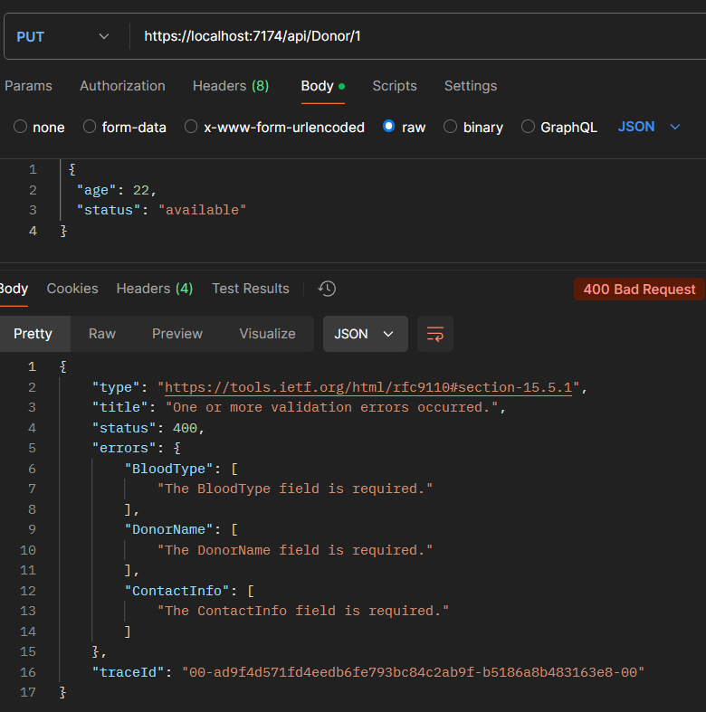**Necessity:** Use this to modify details like contact info, blood quantity, or status.

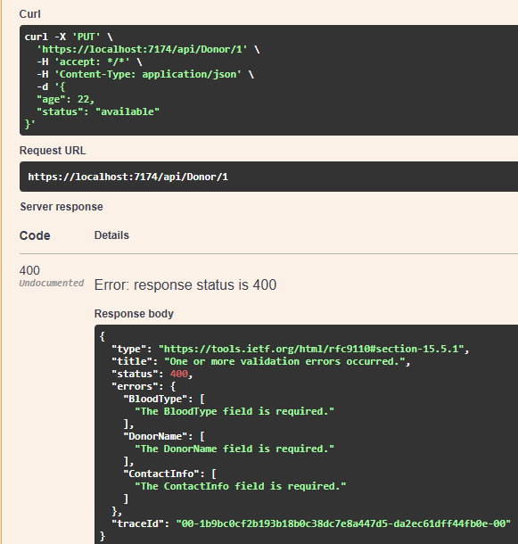

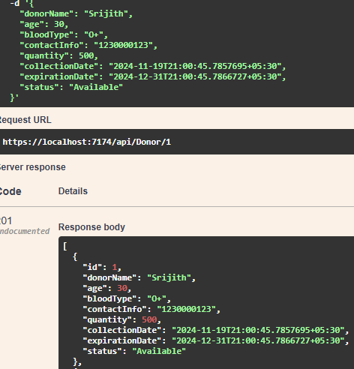Success Case ==🡺

**DELETE /api/Donor/{id}**

Deletes a donor record by their unique ID.

* **Validation:**
  + Ensures the donor exists before attempting deletion.
  + Returns 404 Not Found if the donor is not found.
* **Necessity:** Useful for data cleanup or removing inactive donors.

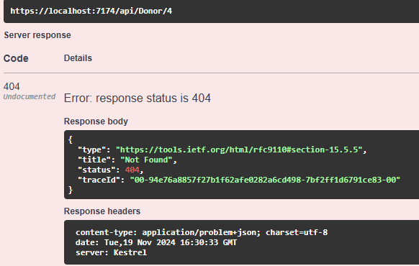

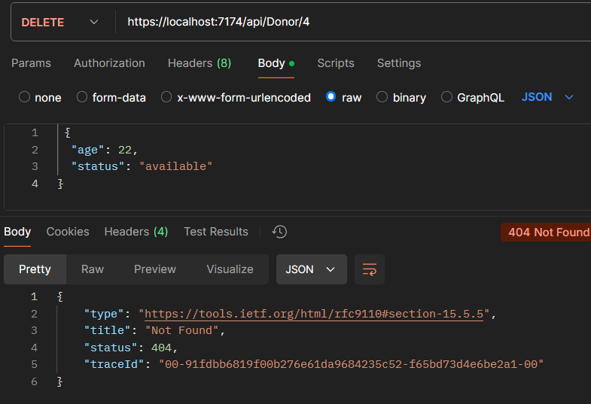

**GET /api/Donor/page**

Retrieves a paginated list of donors.

* **Validation:**
  + Ensures valid pagination parameters are provided (e.g., page, size).
  + Defaults to a specific range if parameters are missing.

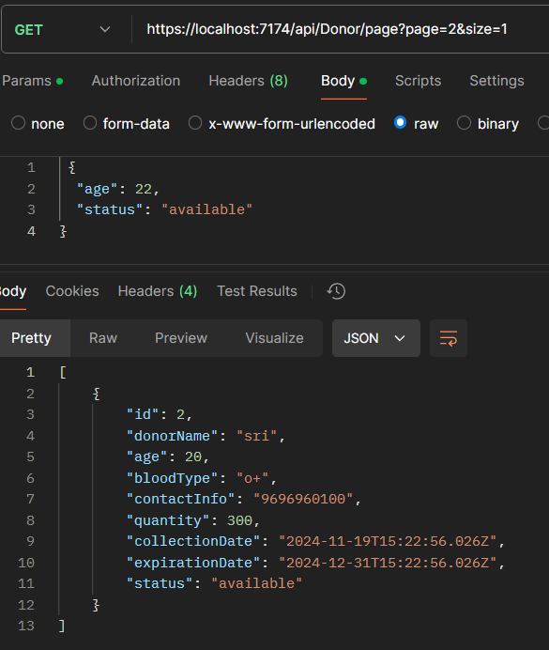

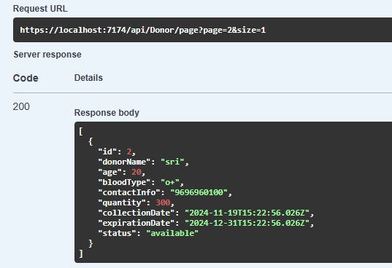

**GET /api/Donor/blood**

Filters donors by blood type.

* **Validation:**
  + Ensures the provided blood type is valid (e.g., A+, B-, O-, etc.).
  + Returns an empty list if no donors match the filter.

Example :- blood type = “O+”

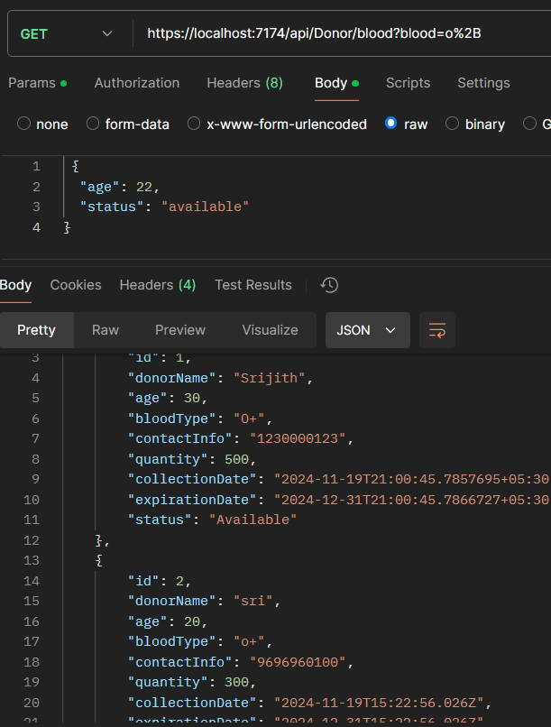

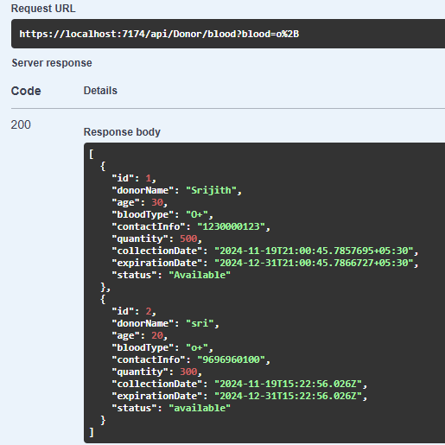

**GET /api/Donor/status**

Filters donors by their status (e.g., Available, Requested, Expired).

* **Validation:**
  + Ensures the provided status is one of the allowed values.

Example input :- Wanted (wrong input)

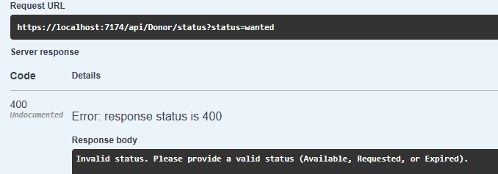

Input :- Available

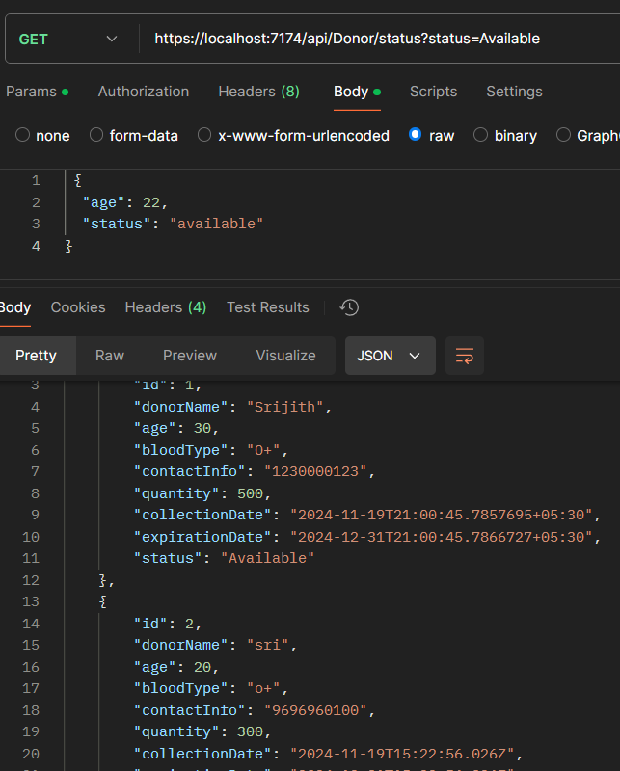

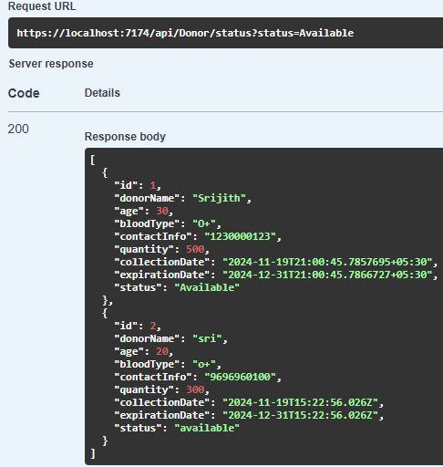

**GET /api/Donor/name**

Retrieves donors filtered by their name or part of their name.

* **Validation:**
  + 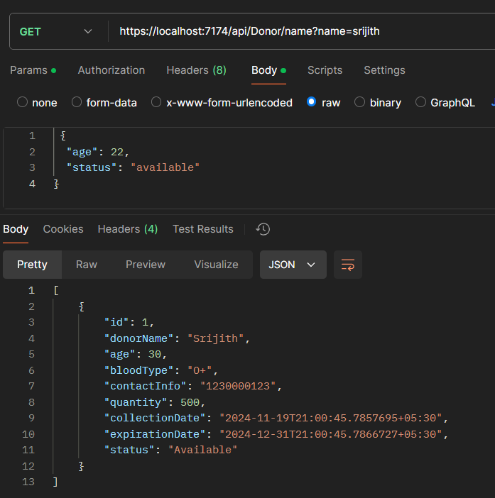Ensures the name parameter is non-empty.

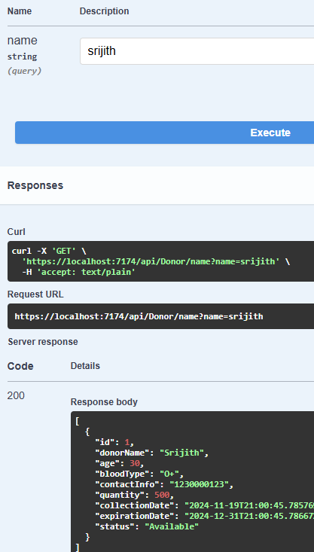

**GET /api/Donor/sort**

Returns a sorted list of donors based on a specific attribute (e.g., name, age).

* **Validation:**
  + Ensures the sort parameter matches a valid attribute.
  + Defaults to ascending order if no direction is specified.

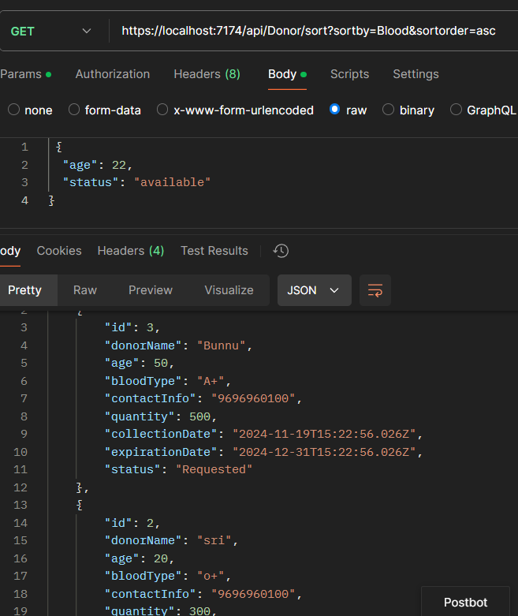

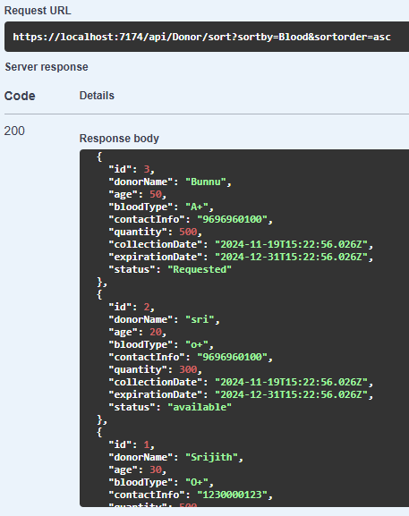

**GET /api/Donor/blood_status**

Filters donors by a combination of blood type and status.

* **Validation:**
  + Verifies both blood type and status are valid.

Example :- Blood = a+ , Status = “demo” (invalid input)  
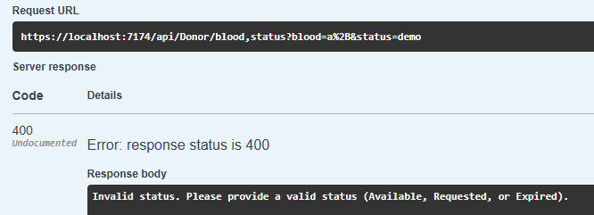

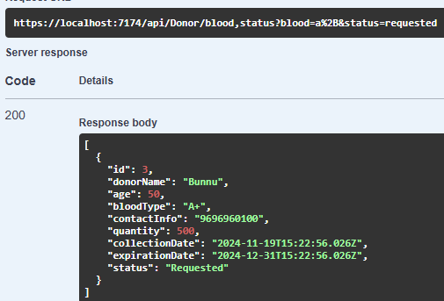Example :- Blood = A+ , Status = “requested”

