**Name :** Krisha Manish Patel

**PRN Number:** 12010321

**Branch:** Artificial Intelligence and Data Science

**Class:** TY-AI&DS-B

**Roll Number:** 15

**Batch:** B1

**Subject:** Operating System

**Date:** 13/09/22

**Assignment 5**

**Shell Programming**

**Problem Statement:**

Write shell programs to:

1. Find if a string is Palindrome or not.
2. Find if a number is prime or not.
3. Sort an array using Quick Sort.

**Solution:**

**Palindrome:**

**Code:**

echo -e "Enter a String : \c"

read input

reverse=""

len=${#input}

for (( i=$len-1; i>=0; i-- ))

do

reverse="$reverse${input:$i:1}"

done

if [ $input == $reverse ]

then

echo "String '$input' is a palindrome"

else

echo "String '$input' is not a palindrome"

fi

**Output:**

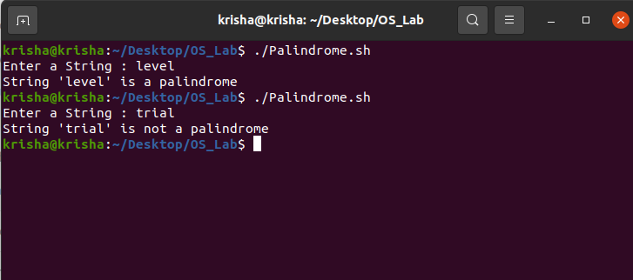

**Prime Number:**

**Code:**

echo -e "Enter a number : \c"

read n

for((i=2; i<=$n/2; i++))

do

ans=$(( n%i ))

if [ $ans -eq 0 ]

then

echo "$n is not a prime number."

exit 0

fi

done

echo "$n is a prime number."

**Output:**

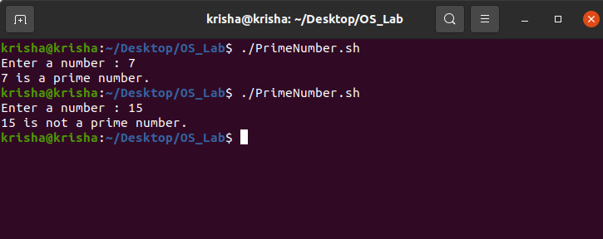

**Quick Sort:**

**Code:**

function quicksort()

{

left=$1

right=$2

if [[ $1 -lt $2 ]]

then

pivot=${array[$1]}

while(( $left < $right ))

do

while((${array[$left]} <= $pivot && $left < $2))

do

left=$(($left + 1))

done

while((${array[$right]} > $pivot))

do

right=$(($right-1))

done

if [[ $left -lt $right ]]

then

temp=${array[$left]}

array[$left]=${array[$right]}

array[$right]=$temp

fi

done

temp=${array[$right]}

array[$right]=${array[$1]}

array[$1]=$temp

temp=$right

quicksort $1 $((right-1)) array

quicksort $((temp+1)) $2 array

fi

}

echo -e "Enter the number of elements : \c"

read limit

echo "Enter $limit elements :"

for((i=0;i<$limit;i++))

do

read array[i]

done

quicksort 0 $((limit-1)) array

echo "Elements after quick sort are :"

for((i=0;i<limit;i++))

do

echo ${array[$i]}

done

**Output:**

