Customer satisfaction report

Emily Nordmann

# Overview

This report presents the results of the annual customer satisfaction survey at Goggles Inc.

* caller_id is a unique ID for each caller
* employee_id is a unique ID for each employee taking calls
* call_start is the date and time that the call arrived
* wait_time is the number of seconds the caller had to wait
* call_time is the number of seconds the call lasted after the employee picked up
* satisfaction is the customer satisfaction rating on a scale from 1 (very unsatisfied) to 5 (very satisfied)

## Call time versus wait time

This plot shows the relationship between how long a caller waits for their call to be picked up (shown on the x-axis) and how long their call lasted once the person taking the call picked up (show on the y-axis). The plot shows that there is a positive relationship between wait time and call time, that is, the longer people have to wait, the longer they then tend to spend on the call.

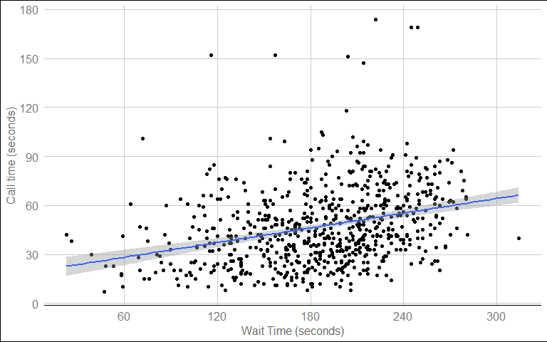

Relationship between length of wait and subsequent call time