Bethe-Bloche Equation

Gerhard Viljoen

1/18/2019

# Create a Bethe-Bloch function

#Planck's constant:  
h <- 6.62607004e-34  
  
#Speed of light m/s  
c <- 299792458  
  
#Fine structure constant  
alpha <- 1/137  
  
#Mass of an electron Mass/GeV  
  
m.e <- 0.005  
  
#Density n, atomic number Z, the fraction of the speed of light the particle is moving at, beta, and the particle's velocity v are specified as parameters to the equation  
  
  
dE.dx <- function(n,Z,v,beta){  
 -4 * pi * h^2 * c^2 * alpha^2 * ((n * Z)/(m.e * v^2)) * log(((2 * beta^2 * gamma^2 * c^2 * m.e)/(I.e)) - beta^2,base=exp(1))  
}  
  
#For an electron traversing a silicon detector:  
  
v <- seq(0.1*c,c,100000)  
  
beta <- v/c  
  
#Lorentz factor  
  
gamma <- 1/(sqrt(1-(v^2/c^2)))  
  
n <- 1  
  
  
  
Z <- 14  
  
#Effective ionization potential of the material  
  
I.e <- 10 * Z  
  
electron.y = dE.dx(n=n,Z=Z,v=v,beta=beta)  
  
require(latex2exp)

## Loading required package: latex2exp

m.e <- 273.13*m.e  
  
pion.y = dE.dx(n=n,Z=Z,v=v,beta=beta)  
  
  
  
plot(x=beta*gamma, y=-pion.y,type="l",main="Bethe-Bloch Curve of a Pion moving through Silicon", xlab = TeX("$\\beta\\cdot\\gamma$"),ylab=TeX("$-dE/dx$"),col="blue",cex.main=0.8)

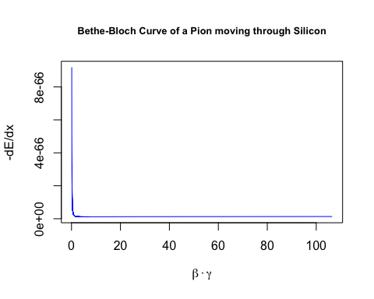

plot(x=beta*gamma, y=-electron.y,type="l",main="Bethe-Bloch Curve of an Electron moving through Silicon", xlab = TeX("$\\beta\\cdot\\gamma$"),ylab=TeX("$-dE/dx$"),col="red",cex.main=0.8)

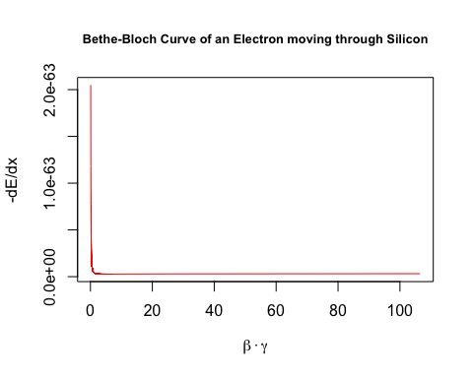

v <- seq(0.8*c,c,100000)  
  
beta <- v/c  
  
#Lorentz factor  
  
gamma <- 1/(sqrt(1-(v^2/c^2)))  
  
n <- 1  
  
m.e <- 0.005  
  
electron.y = dE.dx(n=n,Z=Z,v=v,beta=beta)  
  
m.e <- 273.13*m.e  
  
pion.y = dE.dx(n=n,Z=Z,v=v,beta=beta)  
  
plot(x=beta*gamma, y=-pion.y,type="l",main="Bethe-Bloch Curve of a Pion moving through Silicon \nat Speeds Upwards of 80% of the Speed of Light", xlab = TeX("$\\beta\\cdot\\gamma$"),ylab=TeX("$-dE/dx$"),col="blue",cex.main=0.8)

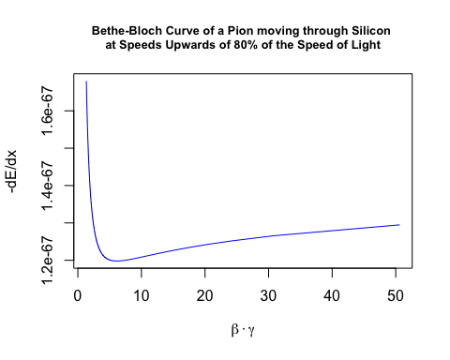

plot(x=beta*gamma, y=-electron.y,type="l",main="Bethe-Bloch Curve of an Electron moving through Silicon \nat Speeds Upwards of 80% of the Speed of Light", xlab = TeX("$\\beta\\cdot\\gamma$"),ylab=TeX("$-dE/dx$"),col="red",cex.main=0.8)

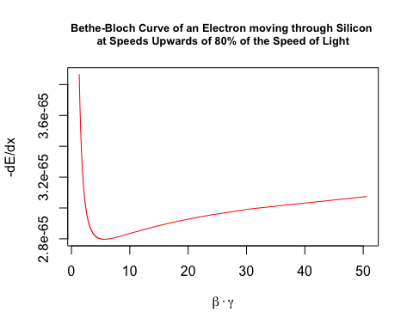

v <- seq(0.9*c,c,100000)  
  
beta <- v/c  
  
#Lorentz factor  
  
gamma <- 1/(sqrt(1-(v^2/c^2)))  
  
n <- 1  
  
m.e <- 0.005  
  
electron.y = dE.dx(n=n,Z=Z,v=v,beta=beta)  
  
m.e <- 273.13*m.e  
  
pion.y = dE.dx(n=n,Z=Z,v=v,beta=beta)  
  
plot(x=beta*gamma, y=-pion.y,type="l",main="Bethe-Bloch Curve of a Pion moving through Silicon \nat Speeds Upwards of 90% of the Speed of Light", xlab = TeX("$\\beta\\cdot\\gamma$"),ylab=TeX("$-dE/dx$"),col="blue",cex.main=0.8)

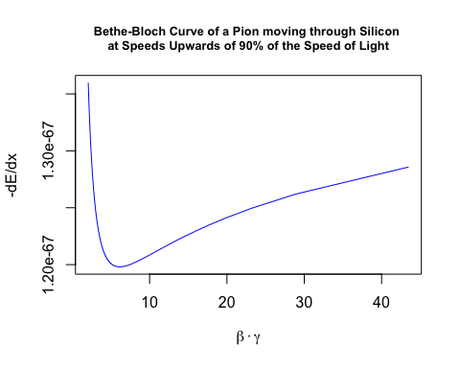

plot(x=beta*gamma, y=-electron.y,type="l",main="Bethe-Bloch Curve of an Electron moving through Silicon \nat Speeds Upwards of 90% of the Speed of Light", xlab = TeX("$\\beta\\cdot\\gamma$"),ylab=TeX("$-dE/dx$"),col="red",cex.main=0.8)

