**Imagine a world where patients are able to safely utilize natural medicines from our beautiful and healing planet to be cured.**

**A world where treating the underlying root cause of mental illness is possible - instead of simply symptoms…**

**That world is now. Welcome to a brighter future – for ourselves, for each other, and the planet.**

**Welcome to: HarmReductionAdvocate.com - Psychedelic Education and Harm Reduction Consulting Services**

[Schedule a Consultation](https://www.harmreductionadvocate.com/contact)

**About Our Services**

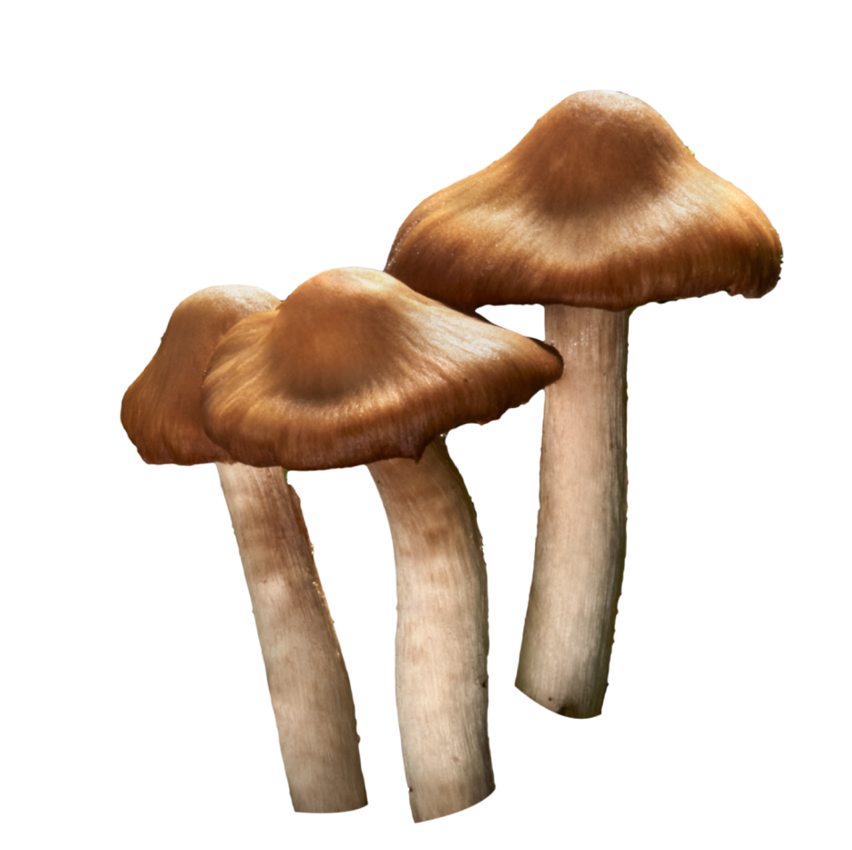

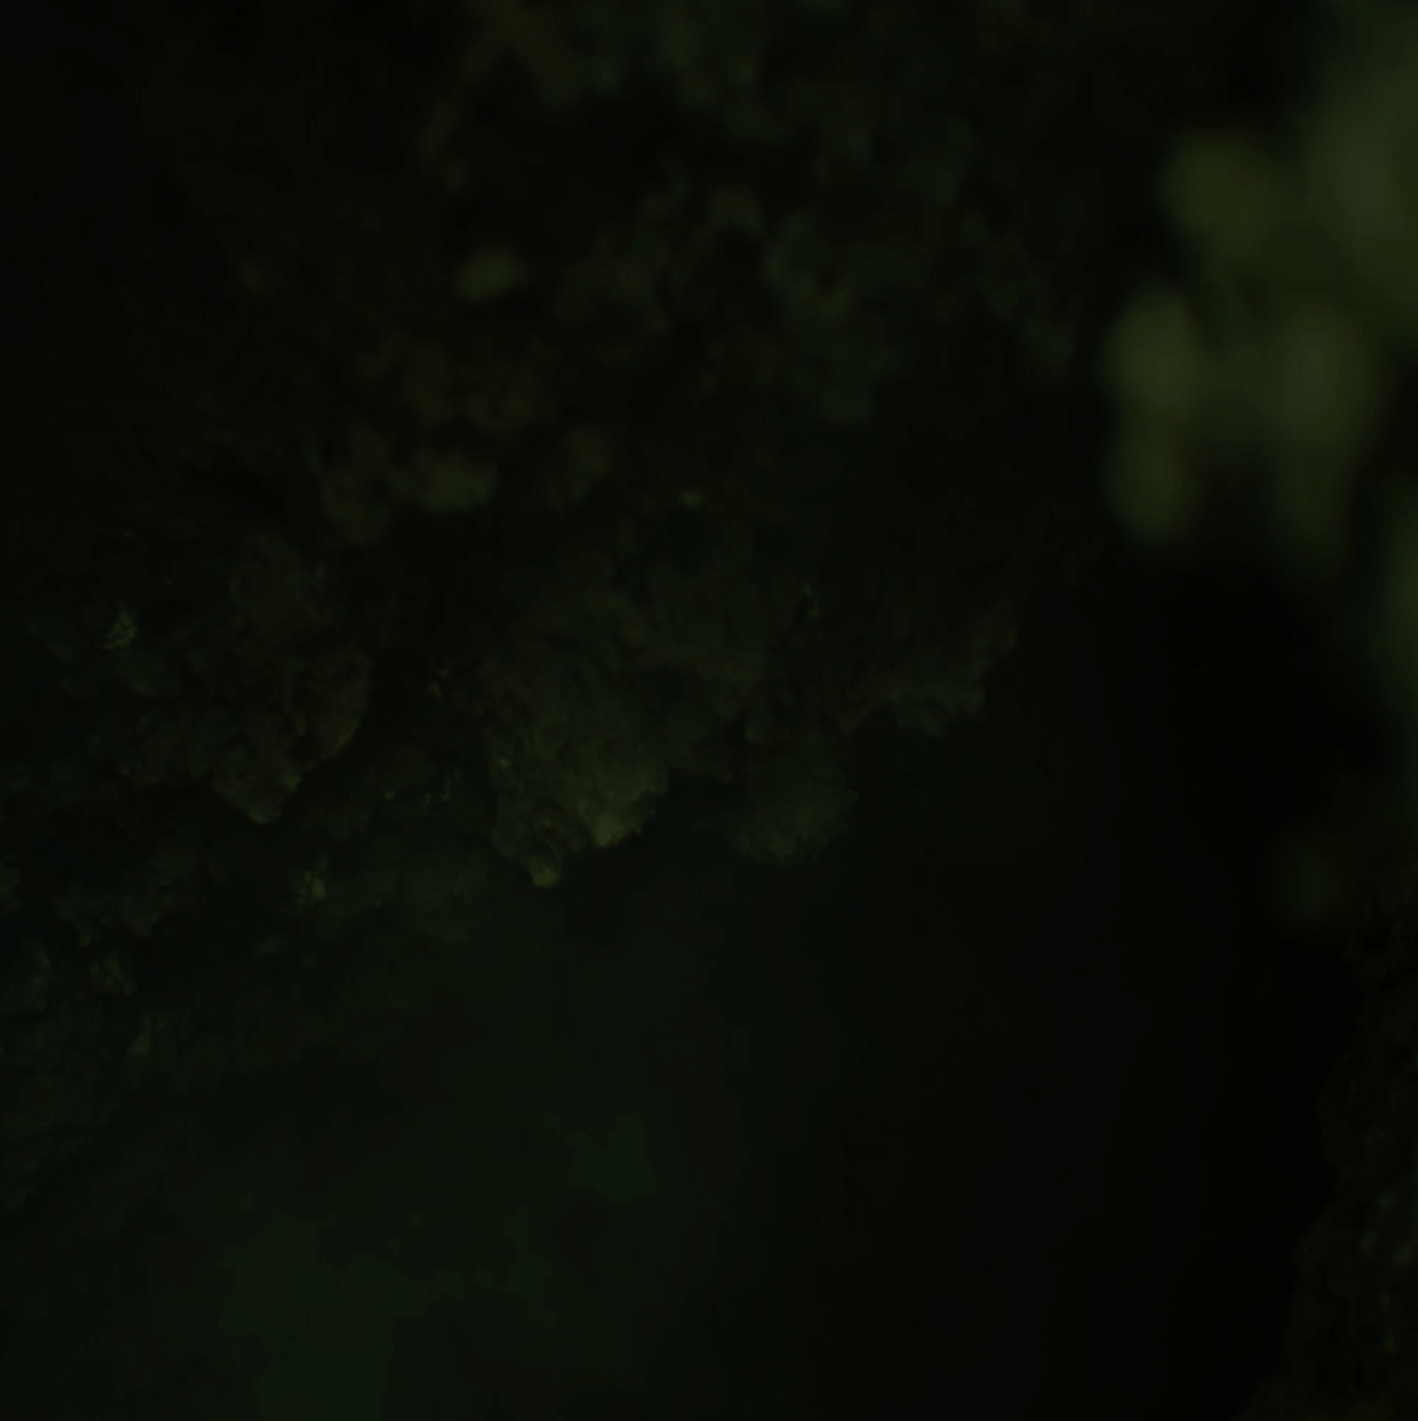

**Psychedelic-assisted therapy is a potentially powerful tool which research suggests may help individuals engage in deep healing, but it doesn’t come without risks.**

**Depending on your current lifestyle and medical history and the substances used there may be negative interactions that could lead to long-term health consequences. Our service aims to promote mindful respect for, and safe use of, these substances.**

**Psychedelics do, however, offer the hope of saving and transforming lives.**

**One of R.E.L.’s methods for harm reduction is advancing the general public's knowledge about psychedelic therapies. We work towards this goal by carefully collecting and disseminating scientific evidence supporting the safety and efficacy of psychedelic substances for different conditions.**

**You’ll also find a discussion space on our blog, where we deep-dive into some of these studies to provide a more accessible and casual explanation of topics.**

**Disclaimer: R.E.L’.’s education and consulting services are not a substitute for medical advice or services, as provided by an appropriately licensed physician, psychiatrist, or similar, we aim to bridge the gap for folks who may not have immediate access to those services.**

[About Us](https://www.harmreductionadvocate.com/about)

[Blog](https://www.harmreductionadvocate.com/blog)

[Educational Resources](https://www.harmreductionadvocate.com/educational-resources)

**Book an Appointment**

There’s hope, no matter what you’re facing. Let’s chat.