Game Design Document

# 

# **General Information**

**Target Platform:** Mobile/Android - PC - Web GL

**Game Engine:** Unity Engine

**Development team:** Jaxon Haldane, Dominic Sarbu, Emmanuel Williams

**Genre:** Endless Runner / Sidescroller / Collectothon

# **Game overview**

The game is a Endless Runner style game with a theme of underwater arctic. The background will move giving the illusion the player is moving. The player will then have to click a button ( or the screen if on mobile ) and make the character dive to avoid obstacles that appear. The player will do this for as long as possible until they hit an obstacle and die.

The player will be able to collect items like coins and power ups along the way. Power ups will help the player survive like a shield which would allow the player to take 1 hit without dying. Coins would be a collectible that would add up over time and then the player could spend it on store items.

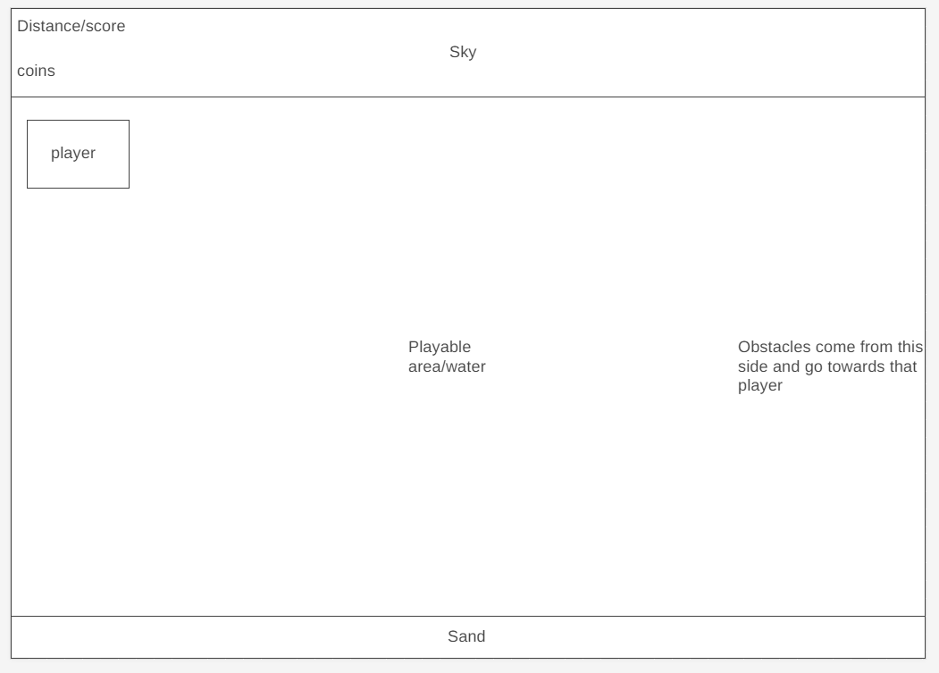

# **Gameplay Loop**

The playable area will be in between the sky and a layer of sand so that the player will not go out of the bounds and that the screen is not just a blue ocean. The objects that the player avoids will come from the right of the screen and scroll to the left towards the player. The distance the player has traveled and the amount of coins collected will be displayed in the top left so that they are out of the way of the players view of the game but still easy to see. Distance will only show how far you have gone during that run and when you die and start again it will reset, coins will also do the same but what you earned that round will add on to a total.

# **User Interface (UI)**

Brief descriptions and wireframes of UI/GUI features and assets.

## 

## **Main Menu**

The Main Menu will appear after the title and will give the player the option to:

* play the game
* look at the character and items you may want to equip
* go to the shop and buy items, upgrades or powerups.

The menu will display:

* A preview of your character on the right
* What is the players best run
* The players total amount of coins

## **Shop**

## **Results / Score Screen**

After a run is completed (by running into an obstacle), the player character will fly forward ~25 extra meters before stopping, then the game will add the newly collected ***coins*** to the players total amount of ***coins*** owned and save the information to a document, then finally a Results window will open, which will display: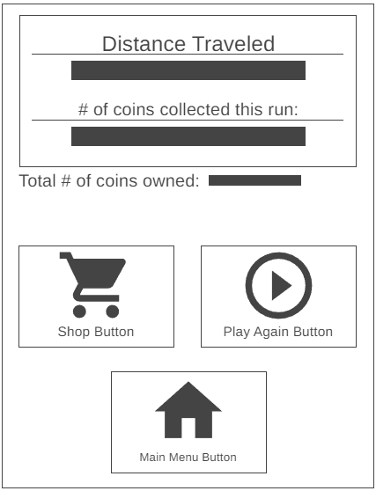

* **The *distance* the player traveled during that run**
* **The amount of *coins* collected during that run**
* & **The total amount of *coins* the player owns**

As well as three buttons:

* **Shop**
* When this button is pressed, the Results window will slide to the left, then a shop menu will open next to the results window. Pressing the Shop button while the Shop is open will close it and slide the Results Window back to the middle of the screen.
* **Play Again**
* Pressing this button will close the results window, and begin a new run immediately.
* **Menu**
* Pressing this button will return the player to the Main Menu screen.

# **Mechanics**

Brief descriptions and explanations of mechanics and systems - further explained in the TDD

## Input

Input will be handled using the left mouse button (or tapping the screen on mobile/android)

## **Movement**

During gameplay, the player character will always be towards the left side of the screen, only to be moved up by clicking and holding the left mouse button (or tapping and holding the screen on mobile/android), and down by letting go of the input.

## **Obstacles**

Obstacles will come from the right of the screen, moving towards the left. Any obstacle that comes in contact with the player will make the player die and end the run. Obstacles will gradually come at the player faster as the player gets further into the run.

Obstacles will include:

* Icebergs at the top of the screen
* Aquatics
  + Sharks
  + Seals
  + Other big fish
* Mines

## **Coins / Currency**

Coins are an in-game collectable currency which are collected within each run by running into the coins. They can be used to purchase accessories, as well as upgrade powerups and purchase new ones as well.

## Powerups

## Shop

### Checking Currency

### Purchasing Powerups

## Procedural Generation

# Pseudocode

**RED** = **Code comment**

**BLUE** = **Main Code**

## Movement

| **Check for input.**  IF the left mouse button is clicked / screen tapped    **Check if the players vertical position is within range for upwards movement.**  IF Player Position (Y) is LESS THAN the max height    **Move the player character UP.**  INCREASE Player Position (Y) over time, multiplied by Player SPEED    **Otherwise, check if the players vertical position is higher or equal to the**  **maximum height.**  ELSE IF Player Position (Y) is GREATER THAN or EQUAL TO the max height    **If so, keep the players vertical position to the maximum height, keeping**  **it from going out of bounds.**  SET Player Position (Y) EQUAL TO the max height  **Check for input.**  IF the left mouse button is released / screen released    **Check if the players vertical position is higher than the floor.**  IF Player Position (Y) is GREATER THAN the floor (minimum) height    **If so, move the player down.**  DECREASE Player Position (Y) over time, multiplied by GRAVITY    **Otherwise, if the players vertical position is the same as the floor - AKA:**  **the player is grounded.**  ELSE IF Player Position (Y) is EQUAL TO the floor (minimum) height    **Do nothing.**  RETURN    **Otherwise, if the players vertical position is below the floor height.**  ELSE IF Player Position (Y) is LESS THAN the floor (minimum) height    **Make the players vertical position equal the minimum position, making**  **the player grounded.**  SET Player Position (Y) EQUAL TO the floor (minimum) height |
| --- |

# Brainstorming **Results**

**Endless runner:**

## **Main Focus**

* Obstacles
* Procedural generation | Dominic
* Player Controller | Emmanuel
  + Movement
  + Collision
* UI | Jaxon

## **Secondary Focus**

* Powerups
* Shop
* coins/collectables
* Objectives

## **Theme**

* Underwater/Ocean/Arctic

## **Assets**

### **Player**

* + Dolphin
  + Penguin
  + Seal
  + Fish

### **Obstacles**

* + Island/Iceberg
  + Fish
  + Mines
  + Plastic

### **Background**