Deliverable 1)

As expected, when arbitrary torques are applied to the robot, the movement of the robot is very chaotic with its manipulators swinging around wildly. This is not unlike all other similar simulations we have done in the past when we apply torque vectors with a controller. Chart, line chart

Figure 1: X, Y & Psi of the Mobile Robot

The figure above plots the X & Y positions of the robot along with the orientation of the robot Psi. Since arbitrary torque vectors were even applied across the robot, rather than moving in a straight line the robot began turning as moved. This is likely due to the chaotic nature of the manipulators when torques are applied without a controller.

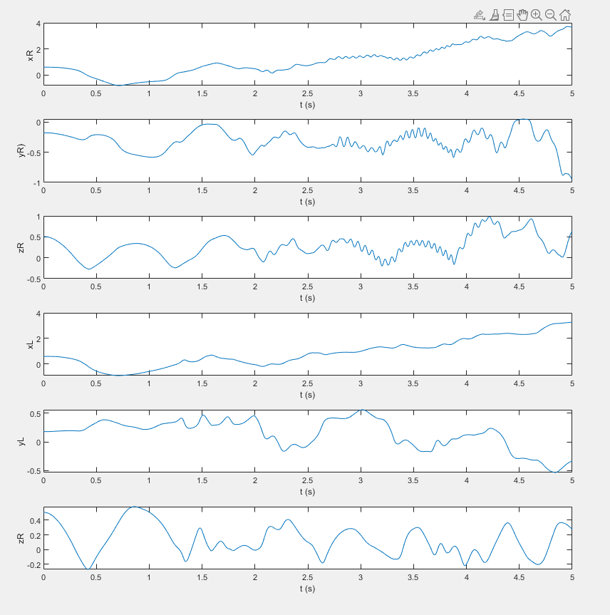

Figure 2: X,Y, & Z positions of the left & right end effectors.

When a controller is not implemented on the manipulator of the robot, this system becomes very chaotic. This is not unlike any of the homework as when we simulated robots without controllers, they would move in the same chaotic way.