Art collection analysis: Monet and Degas

Irina Barašin, Faris Delić, Toni Krstić

# Introduction

The analysis of art collections through quantitative methods offers a unique perspective on the visual and aesthetic qualities that define different artists' works. In this study, we employ a data-driven approach to examine and compare the paintings of two renowned Impressionist artists, Claude Monet and Edgar Degas. By plotting various features derived from the pixel values of their paintings in a two-dimensional space, we aim to uncover patterns and distinctions that might not be immediately evident through traditional art critique.

# Data

We have 1054 paintings from Claude Monet for years between 1858-1897, and 627 paintings from Edgar degas for years 1853-1910. Methods used were computing of brightness and saturation mean and median, brightness standard deviation and entropy, all found in python script. Libraries used were cv2, numpy and PIL for plotting images over points in the graph.

# Style space

A style space is a projection of quantified properties of cultural artifacts (or their parts) into a two-dimensional plane, where the X and Y axes represent specific properties or combinations of properties. The position of each artifact is determined by its values for these properties.

When discussing images, we can redefine this concept: a style space is a projection of quantified visual properties of images onto a 2D plane. For instance, in the example above, the X-axis represents average brightness, and the Y-axis represents average saturation. Additionally, we can use three visual properties to map images in a three-dimensional space. Although two or three properties can't capture all aspects of a visual style, we can create multiple 2D visualizations, each using different combinations of visual properties, to explore the various dimensions of visual style.

Here we map all Degas’ and Monets’ paintings as follows: X-axis: brightness mean,Y-axis: saturation mean

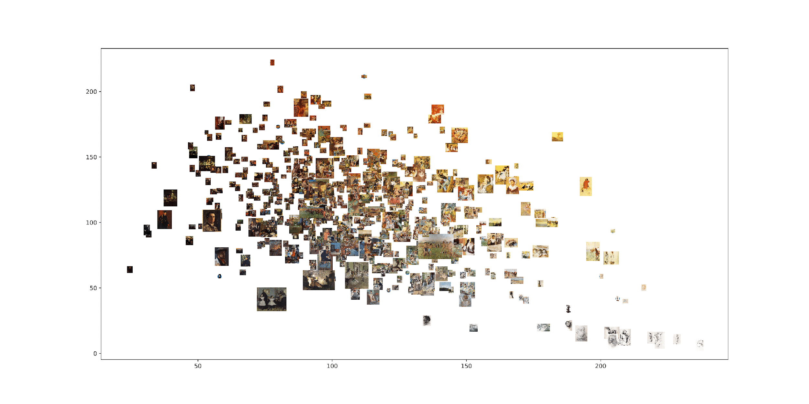*Degas*

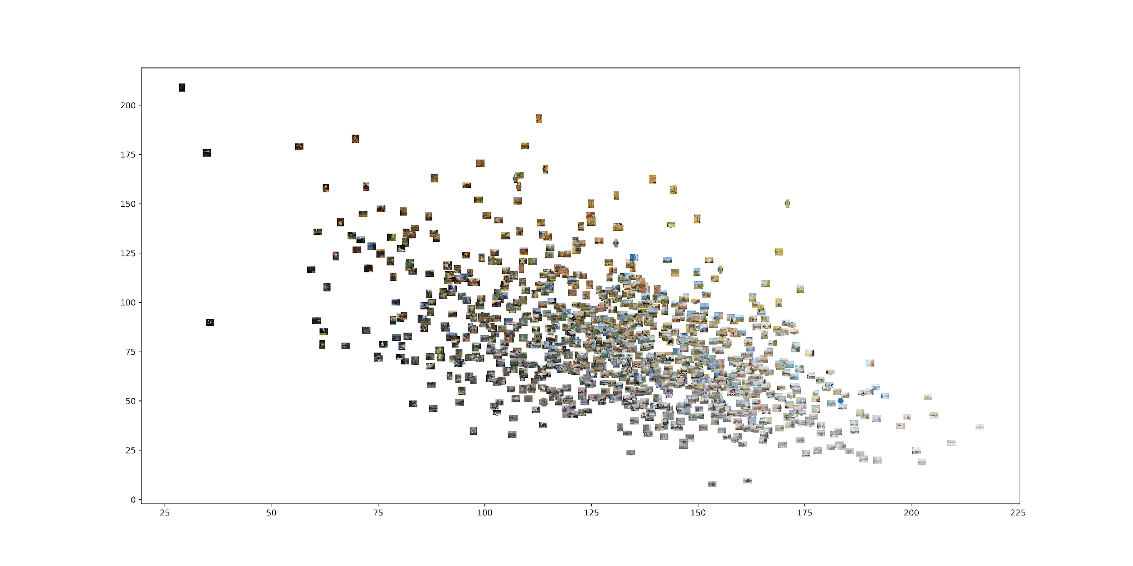*Monet*

This allows us to compare all images in a set (or sets) according to their visual values. For example, here we see that both artists' plots form similar shape, with Degas using darker colors (his plot being denser in top left area), and Monets’ paintings focused more on the bottom right side.

# Patterns in style space

Plotting allows us to observe distribution of paintings and look for clusters of subsets with similar style, observe density of points, etc. In the example below, we see how Degas’ paintings are more evenly spaced and spread out across graphs, whereas Monet’s are focused on the bottom right corner, where they are also most dense.

It can also be concluded that Degas’ and Monet’ in essence, used opposite color pallets, even though they overlap in some parts.

X-axis = brightness median.

Y-axis = saturation median.

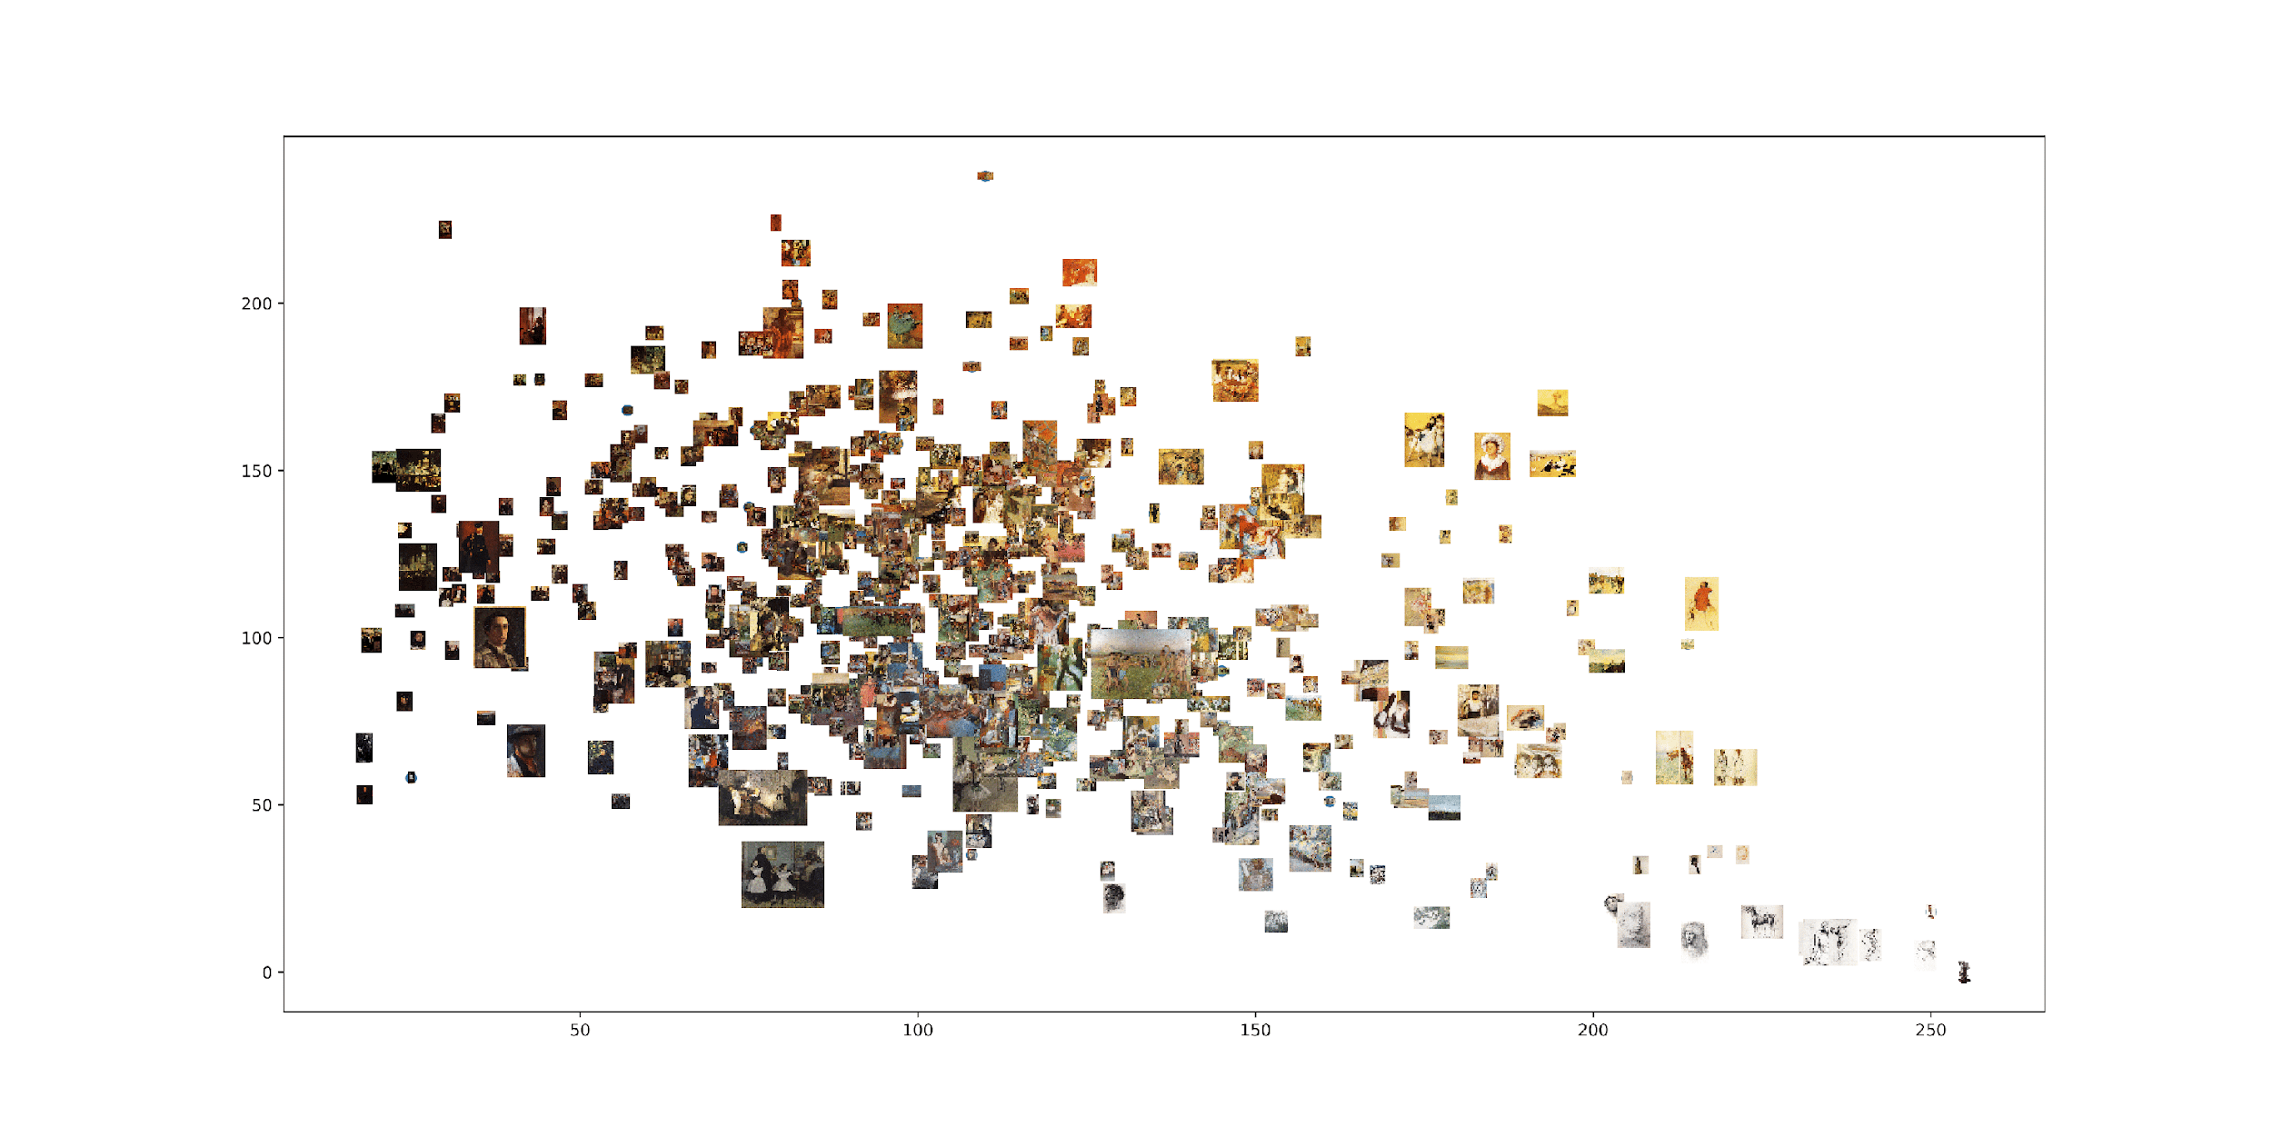*Degas*

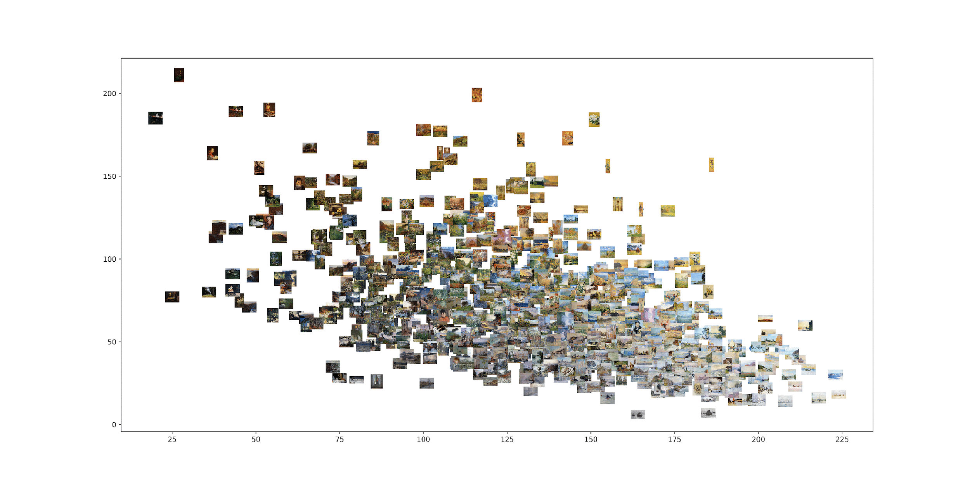*Monet*

# Density

Imagine a style space where the axes are set by the smallest and largest possible visual values. This means all existing images and all potential future images will lie within the boundaries defined by these minimum and maximum values. Because the mean brightness and brightness standard deviation are correlated, all possible images will fit within a half-ellipse with coordinates: 0,0 (left), 255,0 (right), and 127.5, 126.6 (top). A particular artist's works will generally occupy only a specific region within this ellipse.

X-axis: standard deviation, Y-axis: entropy

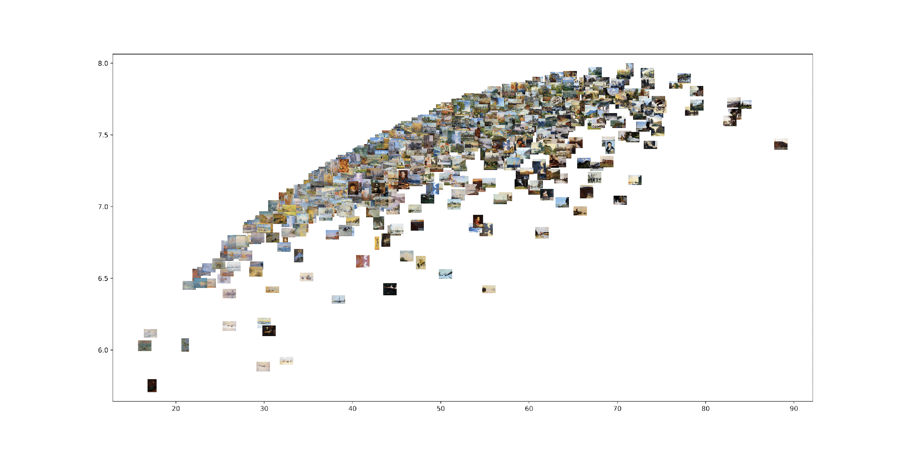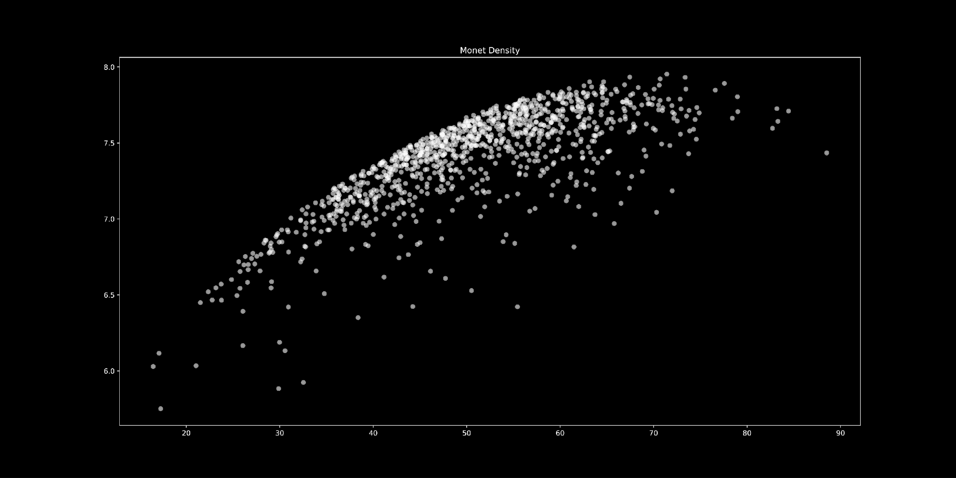*Monet*

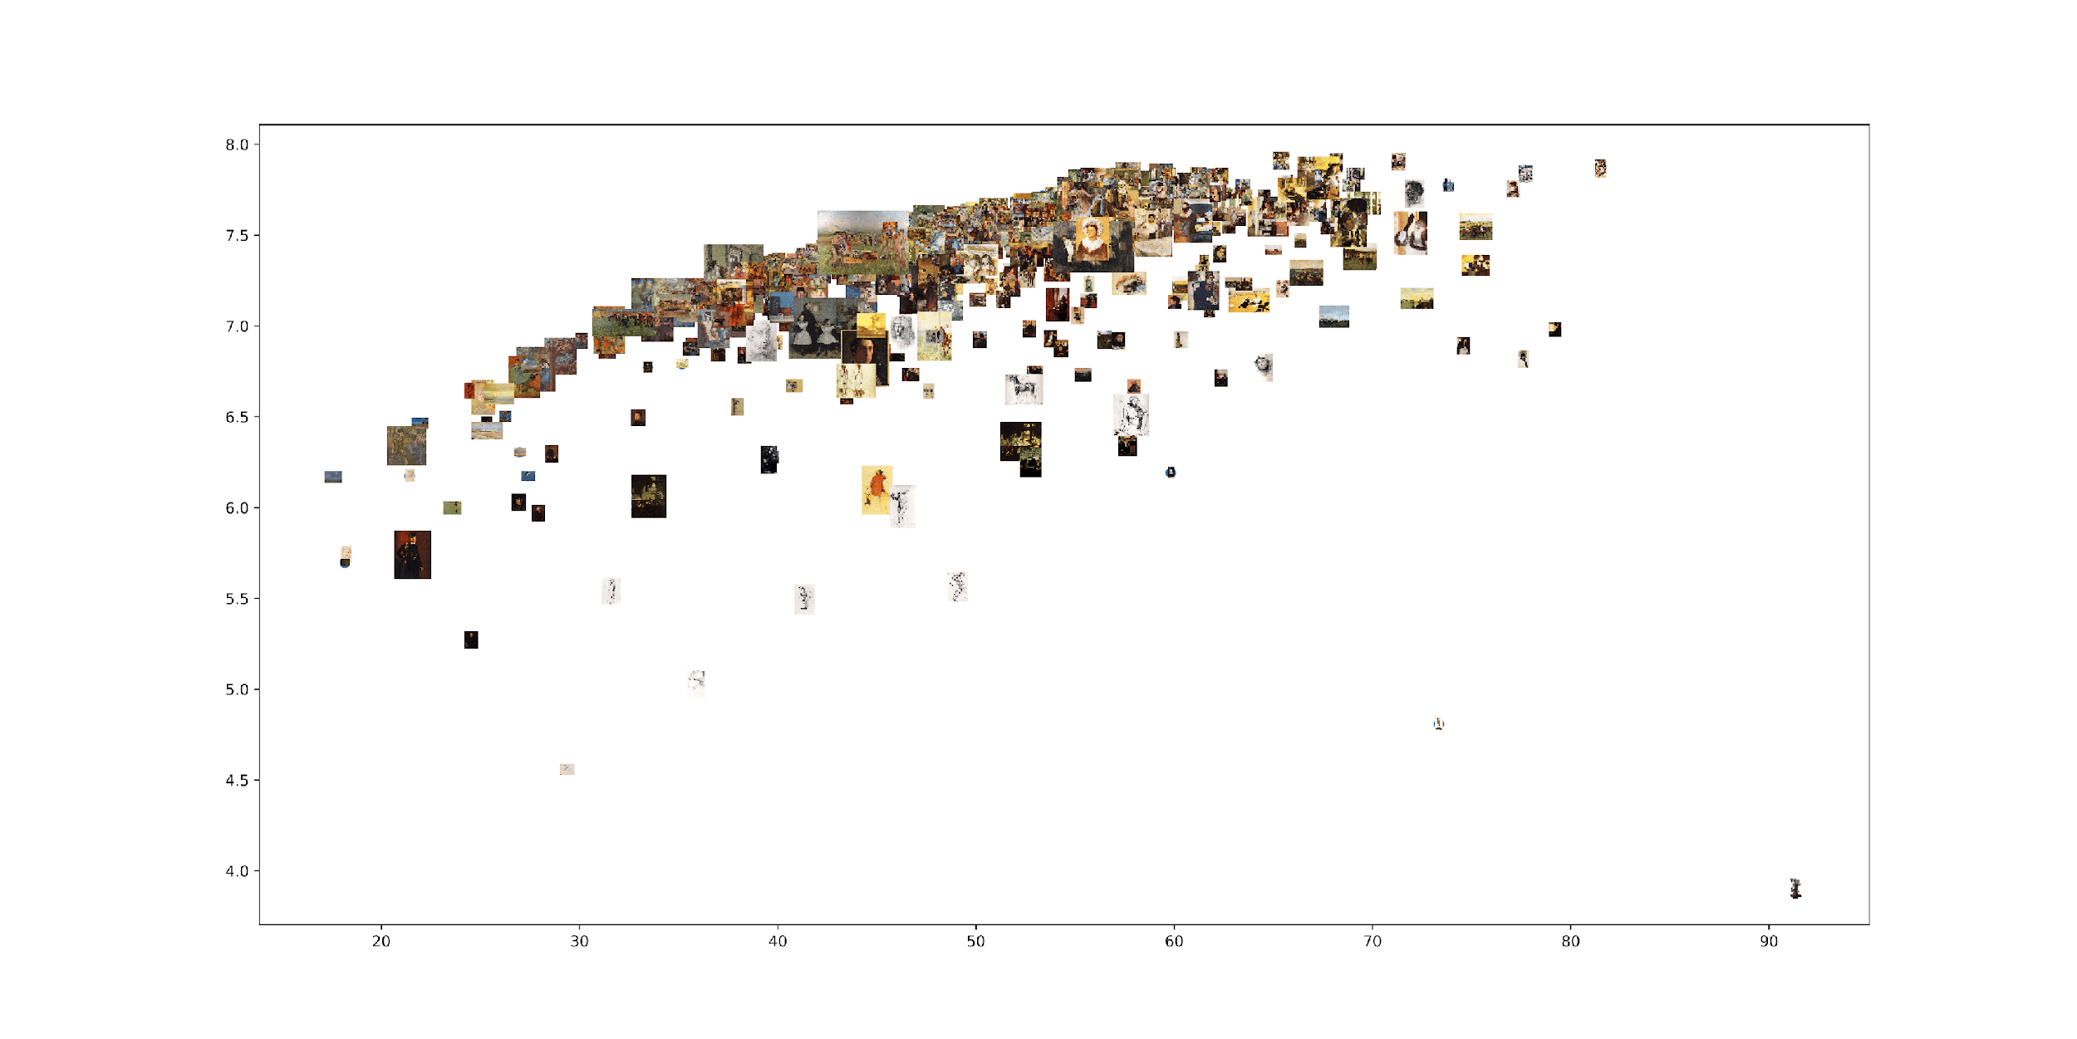

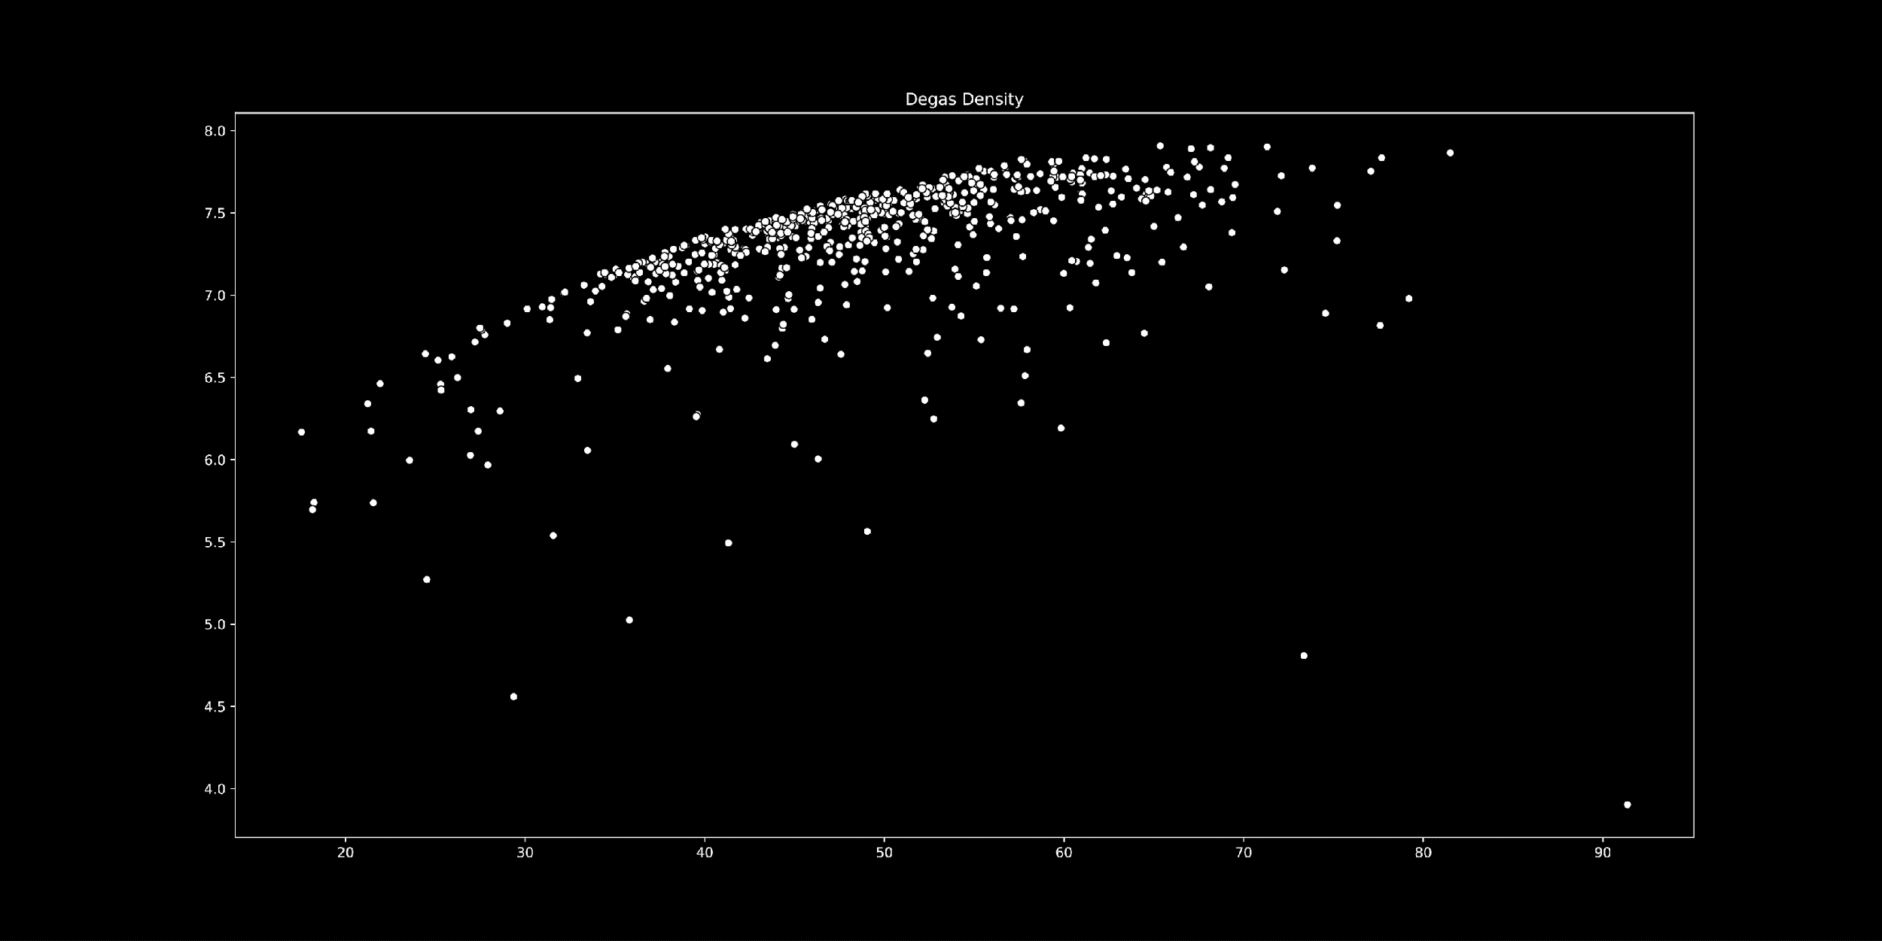*Degas*

In above example, we can see both artists’ work occupying same part of half-ellipse, with one major difference: Monets’ paintings are more ‘versatile’ and spread out, which can be seen in plot with points, while Degas’ paintings form much tighter cluster at the top of the ellipse, with fewer outliers at the bottom of it.

# Visualizing parts of an image set in relation to the whole set

The concept of visualizing parts of a set is to overlay it onto a background that represents the complete set. This approach lets us visualize the footprint of these subsets in relation to the overall footprint of all images, highlighting how individual parts compare to the larger collection.

For this, we choose to show Degas’ portraits of people and paintings generally involving people, in day-to-day activities, in relation to all his work, that, with him being impressionist, in most part contains nature.

Some of the paintings plotted in ‘portraits’ subset are:

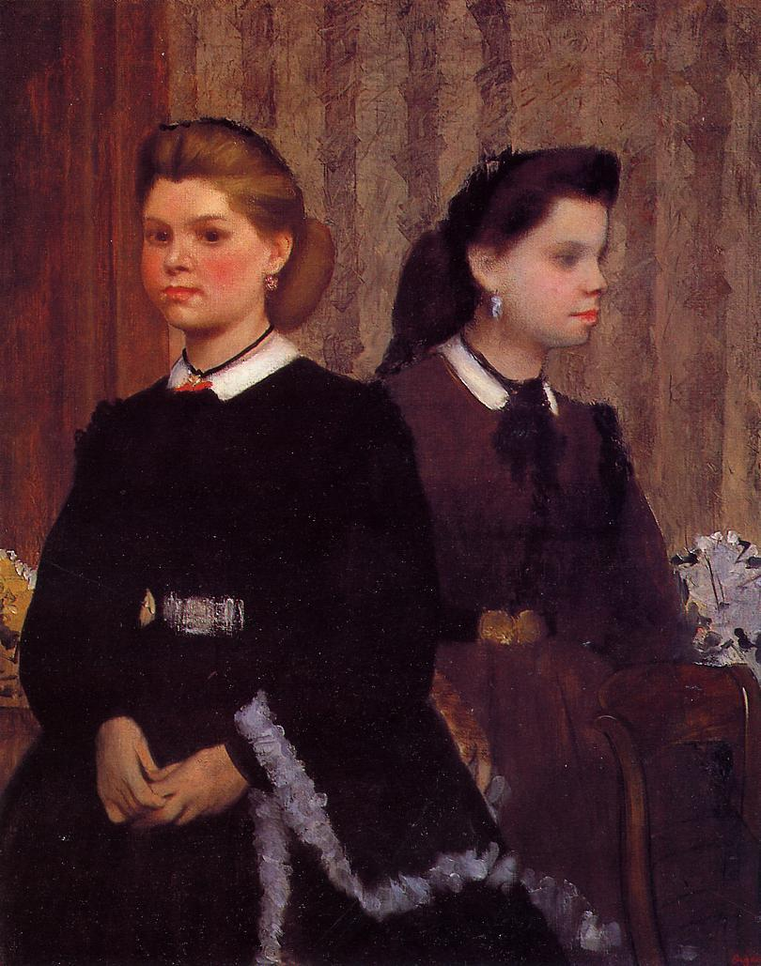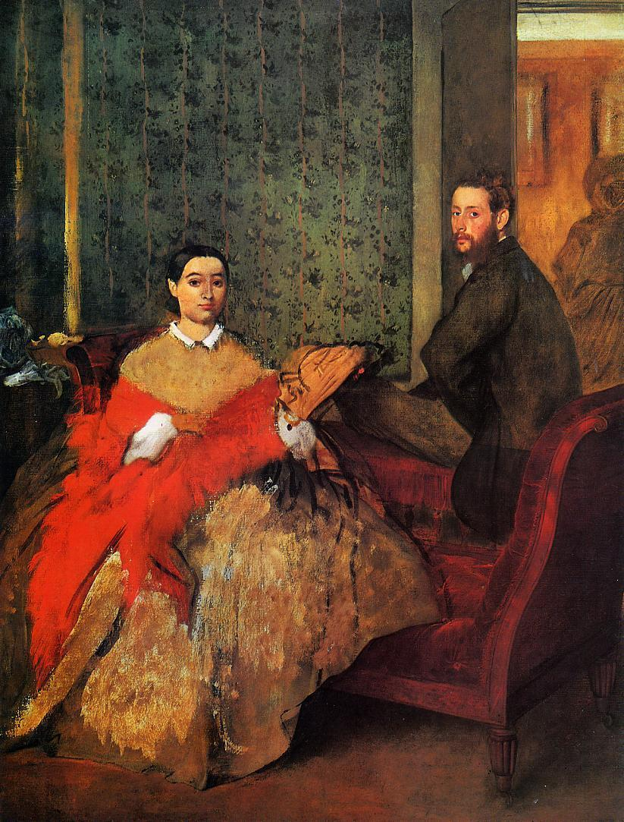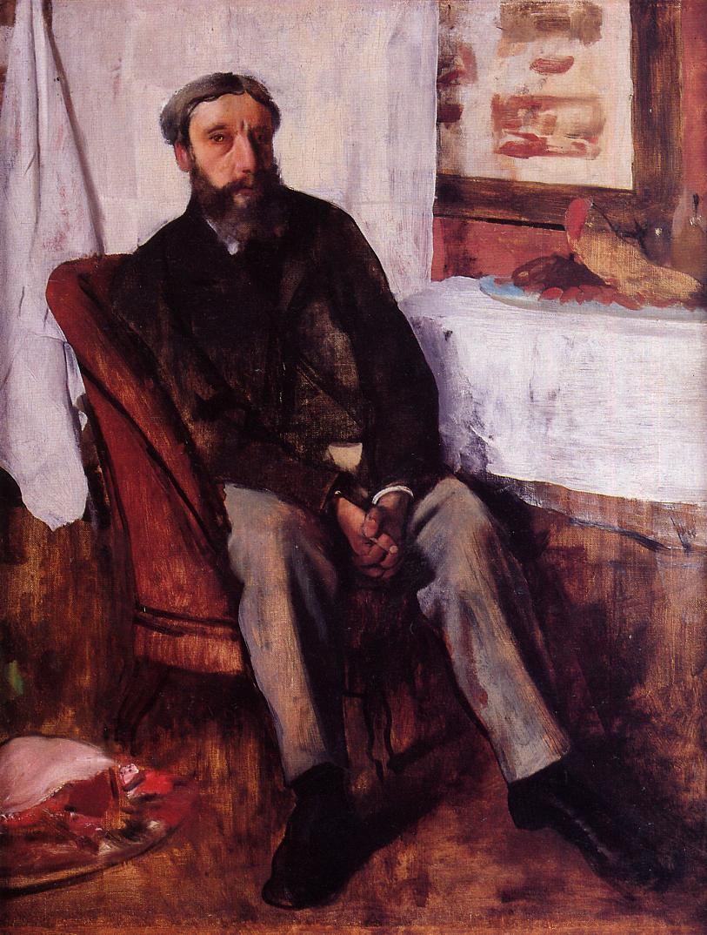

X-axis = brightness mean

Y-aixs = brightness standard deviation

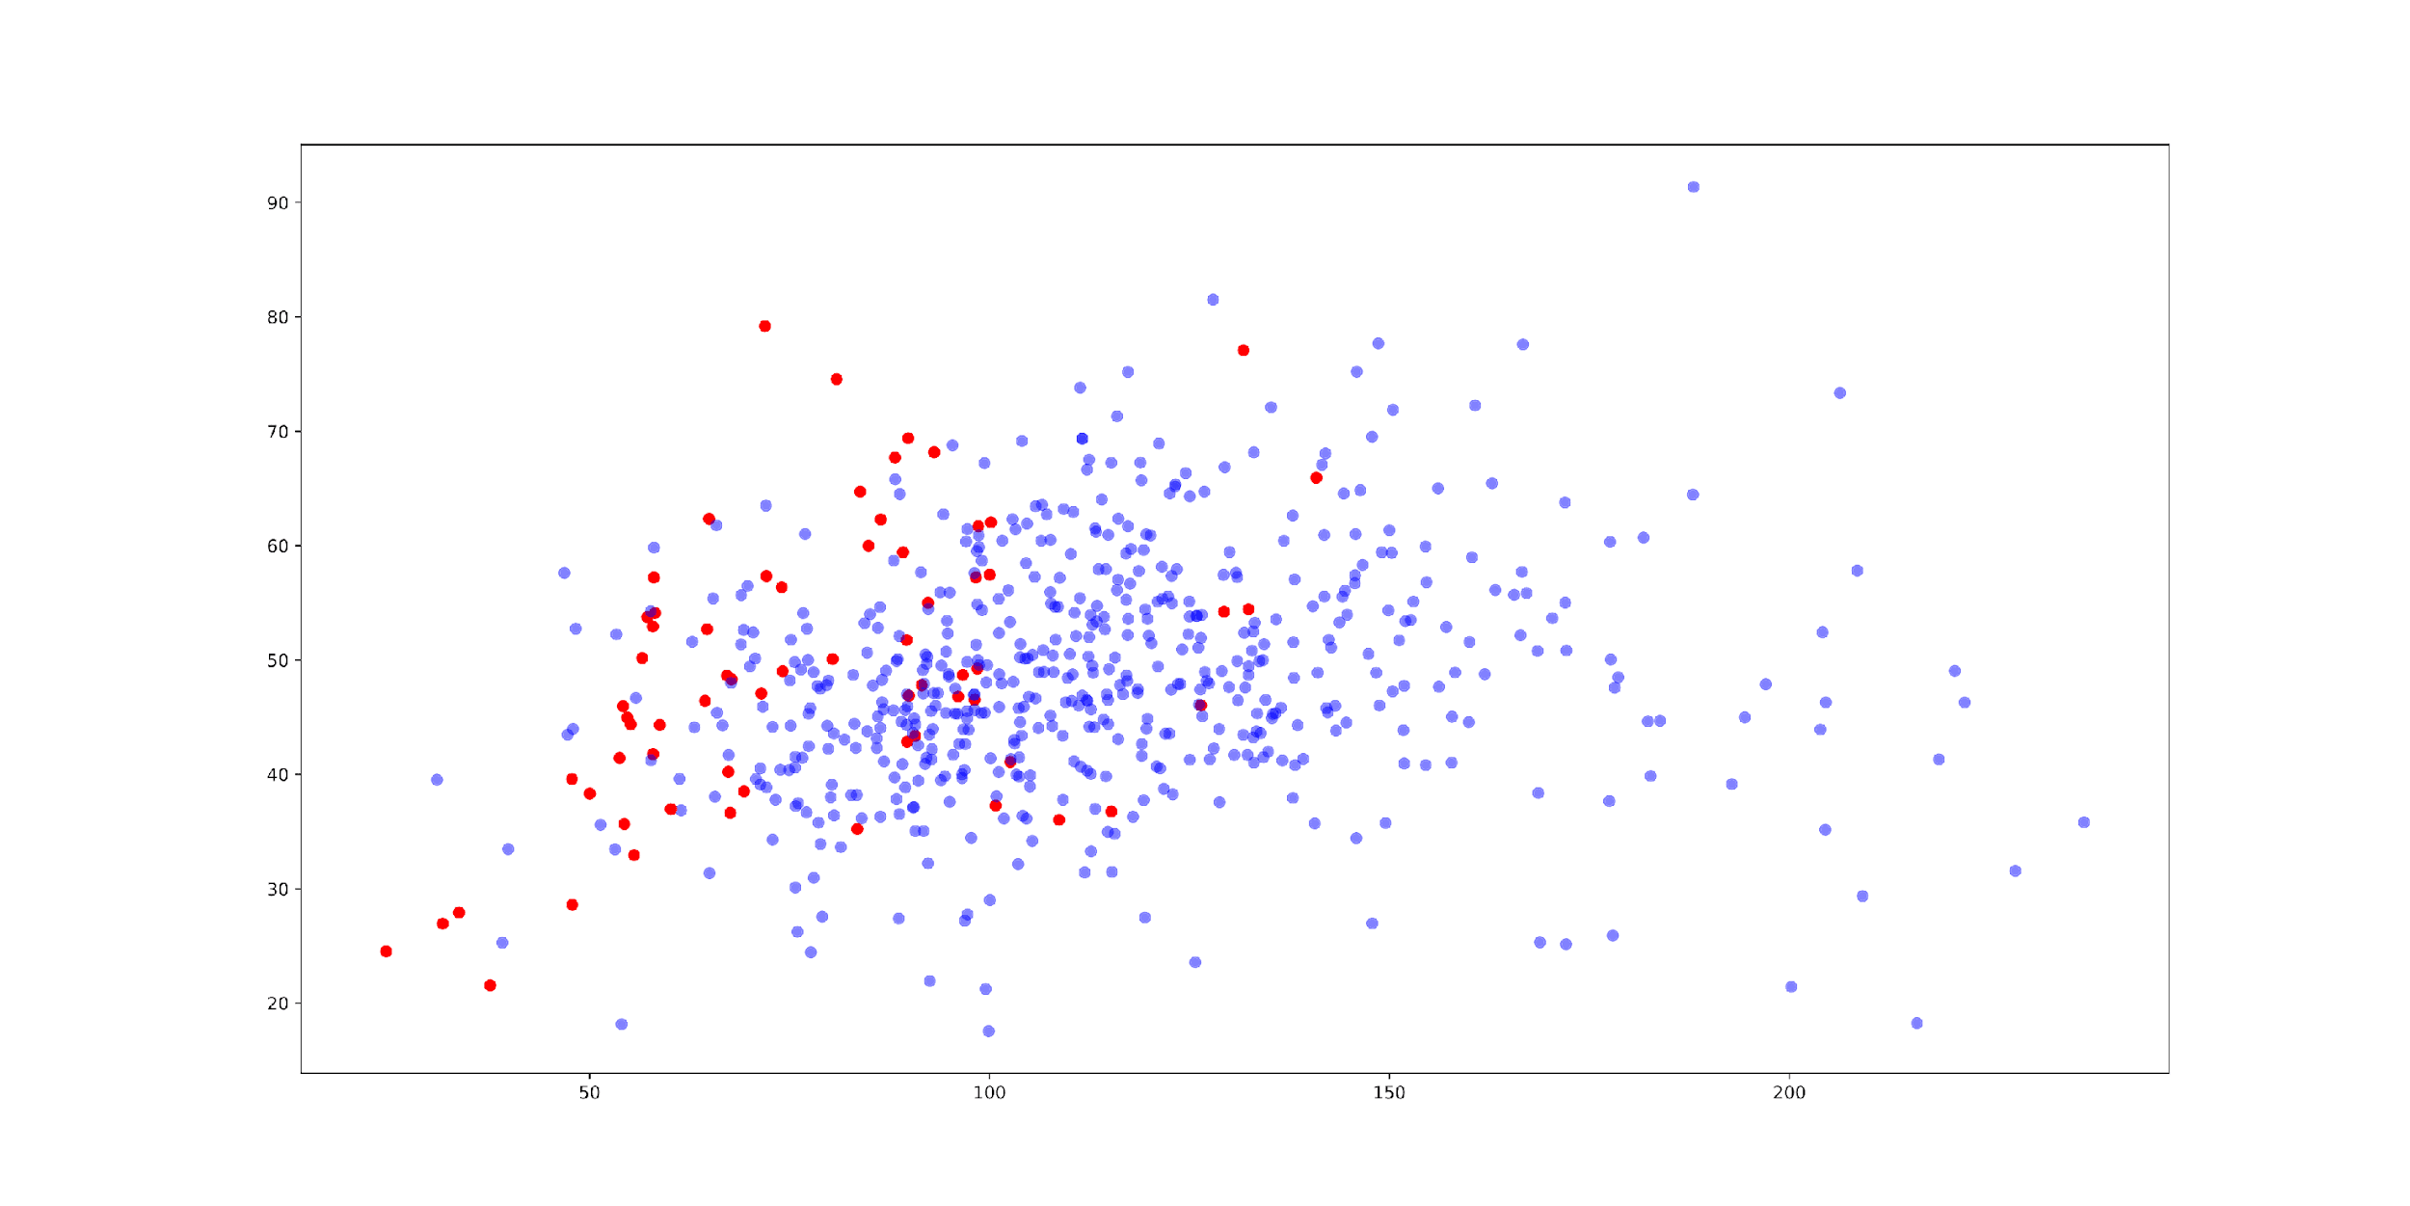

Here we can conclude that almost all of those lie on the left side, having brightness mean less than 150, and if we look at his paintings containing people, there are mostly darker colors used.

Visualizing evolution in style space: 1d

To study temporal patterns across a sequence containing thousands of images, we can map the sequence positions onto the X-axis and one of the visual features onto the Y-axis. By using points and/or lines to represent each image, the result is a familiar line graph. This method allows us to observe changes and trends in visual features over time, providing a clear visualization of temporal patterns.

Since for both artists’ we have paintings mapped by year, we can plot progress of their style in 2d graph with chosen feature in y-axis, and time, in our case year, on x-axis.

Here we conclude that Monets’ preferred color palette stays consistent across years, with fewer outliers, while plot of Degas’ paintings is much more spread out on y-axis.

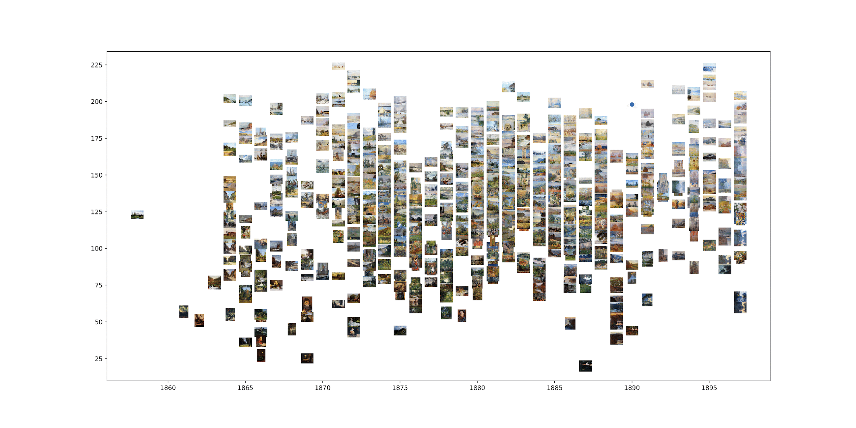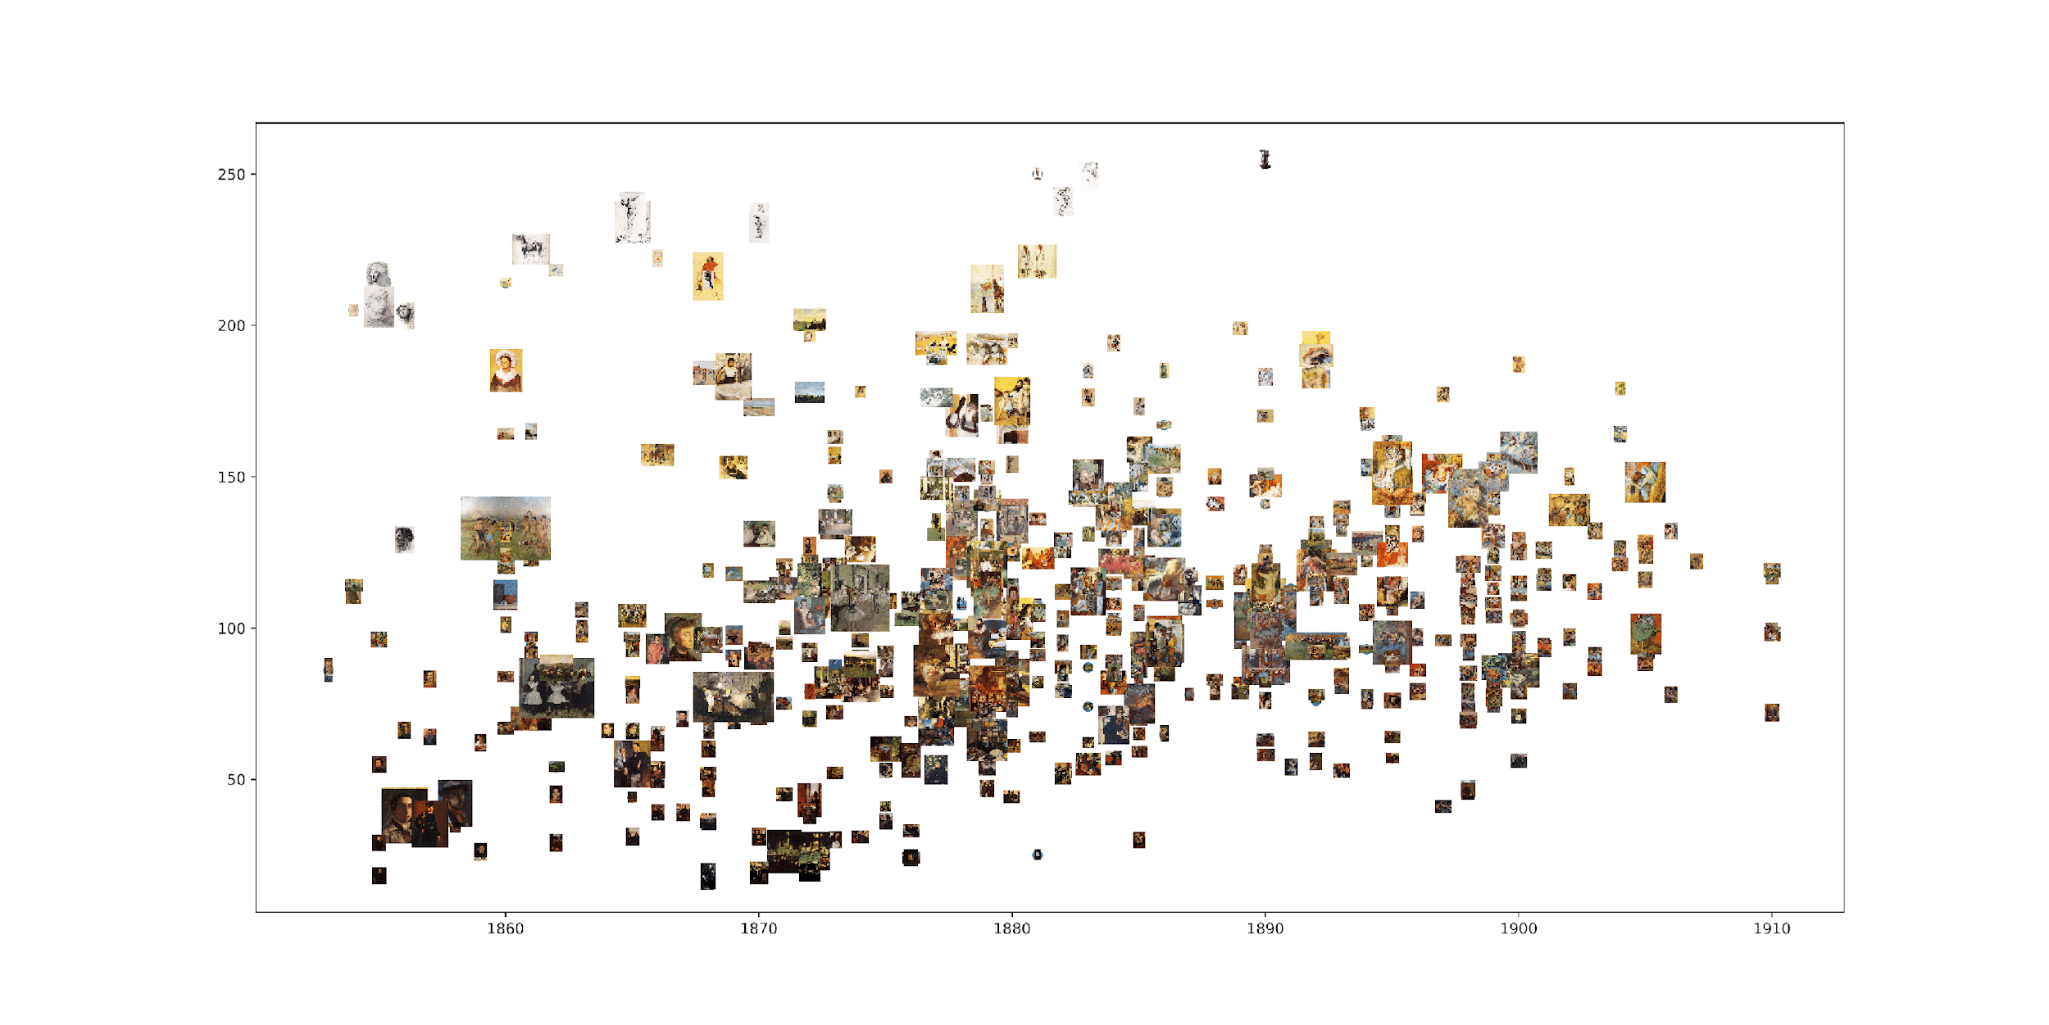

# Literature

* Lev Manovich. (2011). *Style Space: How to compare image sets and follow their evolution*