StockLens Equity Research

MSFT (MSFT)
US Market | Sector: Technology | Industry: Software - Infrastructure

Executive Summary
MSFT operates in the Technology sector (Software - Infrastructure). The company currently has a gross margin of N/A and an operating margin of N/A. It is listed on the US Market.

Key Financial Metrics
- Gross Margin: N/A
- Operating Margin: N/A
- Net Margin: N/A
- Current Ratio: N/A
- Debt to Equity: N/A
- Return on Equity: N/A

1-Year Price History
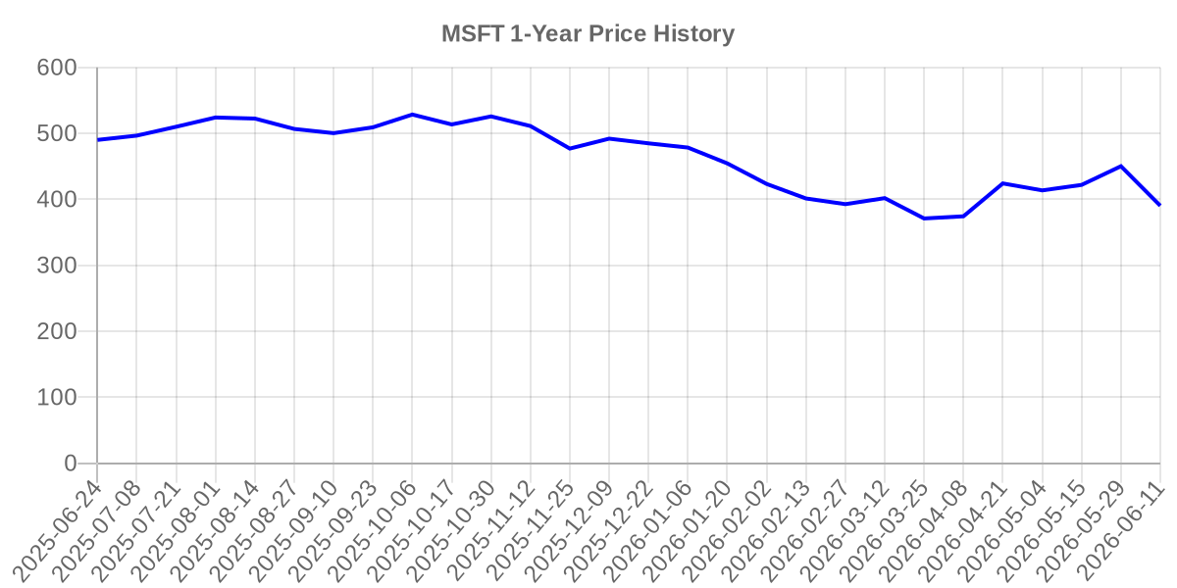

Income Statement
Metric | 2023 | 2024 | 2025
Total Revenue | $211.91B | $245.12B | $281.72B
Gross Profit | $146.05B | $171.01B | $193.89B
Operating Expenses | $57.53B | $61.58B | $65.36B
Operating Income | $88.52B | $109.43B | $128.53B
Net Income | $72.36B | $88.14B | $101.83B

Balance Sheet
Metric | 2023 | 2024 | 2025
Total Assets | $411.98B | $512.16B | $619.00B
Total Liabilities | $205.75B | $243.69B | $275.52B
Total Debt | $59.97B | $67.13B | $60.59B
Stockholders Equity | $206.22B | $268.48B | $343.48B

Cash Flow Statement
Metric | 2023 | 2024 | 2025
Operating Cash Flow | $87.58B | $118.55B | $136.16B
Investing Cash Flow | ($22.68B) | ($96.97B) | ($72.60B)
Financing Cash Flow | ($43.94B) | ($37.76B) | ($51.70B)
Free Cash Flow | $59.48B | $74.07B | $71.61B

Business Description (SEC 10-K)
The Microsoft Cloud provides integration across the technology stack while offering openness, improving time to value, reducing costs, and increasing agility. Our cloud business benefits from three economies of scale: datacenters that deploy computational resources at significantly lower cost per unit than smaller ones; datacenters that coordinate and aggregate diverse customer, geographic, and application demand patterns, improving the utilization of computing, storage, and network resources; and multi-tenancy locations that lower application maintenance labor costs.
We prioritize security above all else and we offer our customers integrated AI-driven products addressing security, compliance, identity, management, and privacy across customers' multi-cloud, application, and device assets.
The Ambitions That Drive Us
To achieve our vision, our research and development efforts focus on three interconnected ambitions:
&#8226;
Reinvent productivity and business processes to help organizations and individuals work and collaborate more securely and efficiently.
&#8226;
Build the intelligent cloud and intelligent edge platform to provide a foundation for our customers' digital workloads including hybrid consistency, developer productivity, data and AI capabilities, and trusted security and compliance.
&#8226;
Create more personal computing to enable users to interact with technology in more intuitive, engaging, and dynamic ways.
Our Future Opportunity
We are focused on helping customers use the breadth and depth of the Microsoft Cloud to get the most value out of their digital spend while leading the AI platform wave across our solution areas. We continue to develop complete, intelligent solutions for our customers that empower people to be productive and collaborate, while safeguarding businesses and simplifying IT management. Our goal is to lead the industry in several distinct areas of technology over the long term, which we expect will translate to sustained growth. We are investing significant resources in:
&#8226;
Transforming the workplace to deliver new, modern, modular business applications, drive deeper insights, and improve how people communicate, collaborate, learn, work, and interact with one another.
&#8226;
Building and running cloud-based services in ways that utilize ubiquitous computing to unleash new experiences and opportunities for businesses and individuals.
&#8226;
Applying AI and ambient intelligence to drive insights,...

Risk Factors (SEC 10-K)
Source code, the detailed program commands for our operating systems and other software programs, is critical to our business. If our source code leaks, we might lose future trade secret protection for that code. It may then become easier for third parties to compete with our products by copying functionality, which could adversely affect our results of operations. Unauthorized access to or disclosure of source code or other intellectual property also increases the security risks described elsewhere in these risk factors.
Third parties may claim that we infringe their intellectual property. From time to time, others claim we infringe their intellectual property rights, including current copyright infringement and other claims arising from AI training and output. To resolve these claims, we may enter into royalty-bearing data access or licensing agreements on terms that are less favorable than currently available, stop selling or redesign affected products or services, or pay damages to satisfy indemnification commitments with our customers. Adverse outcomes could also include monetary damages or injunctive relief that may limit or prevent importing, marketing, and selling our products or services that have infringing technologies. We have paid significant amounts to settle claims related to the use of technology and intellectual property rights and to procure intellectual property rights as part of our strategy to manage this risk, and may continue to do so, which could adversely affect our results of operations.
GENERAL RISKS
If our reputation or our brands are damaged, our business and results of operations may be harmed . Our reputation and brands are globally recognized and are important to our business. Our reputation and brands affect our ability to attract and retain consumer, business, and public-sector customers. There are numerous ways our reputation or brands could be damaged. These include product safety or quality issues, our environmental impact and sustainability, supply chain practices, or human rights record. We may experience backlash from customers, government entities, advocacy groups, employees, and other stakeholders that disagree with our product offering decisions, public policy positions, or corporate philanthropic initiatives. Damage to our reputation or our brands may occur from, among other things:
&#8226;
The introduction of new features, products, services, or terms of service that customers, users, or partners do not ...

