1. Core Java Volume I – Fundamentals
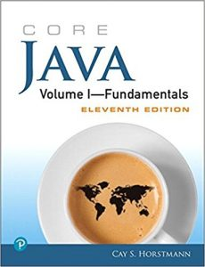
Author – Cay S. Horstmann
Latest Edition – 11th Edition
Publisher – Prentice Hall
Core Java Volume I – Fundamentals is a Java reference book (Best book for Java)that offers a detailed explanation of various features of Core Java, including exception handling, interfaces, and lambda expressions. Significant highlights of the book include simple language, conciseness, and detailed examples. The latest edition of the Core Java Volume I – Fundamentals comprehensively updated for covering Java SE 9, 10 & 11. The book helps Java programmers develop an ability to write highly robust and maintainable code.
You can buy the book here.

2. Effective Java
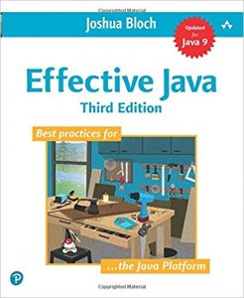
Author – Joshua Bloch
Latest Edition – 3rd Edition
Publisher – Addison Wesley
A must-have book for every Java programmer and Java aspirant, Effective Java makes up for an excellent complementary read with other Java books or learning material. The book offers 78 best practices to follow for making the code better. Effective Java divides all the mentioned best practices into 11 distinct sections, such as Concurrency, Generics, and Methods, to make it easier for the reader to grasp it all. The book offers something to Java programmers of any skill level. Effective Java is written by Joshua Bloch, who is also the author of many key Java classes and API, including java.lang and Java Collection framework. The context of the latest edition of the book built around Java 7, 8, and 9.
You can buy the book here.

3. Java: A Beginner’s Guide
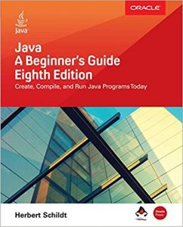
Author – Herbert Schildt
Latest Edition – 8th Edition
Publisher – McGraw-Hill Education
If you are a seasoned Java programmer looking to enhance your Java knowledge, don’t be averted by the title of the book, Java: A Beginner’s Guide. It is, in fact, one of the most comprehensive books for learning Java. Anyone with basic programming knowledge can easily benefit from the Java: A Beginner’s Guide. The Java book covers all concepts pertains to Core Java. The latest edition of the Java: A Beginner’s Guide is fully revised to include Java 11 SE. The book offers several hands-on exercises as well as a quiz section at the end of every chapter to let the readers self-evaluate their learning.
You can buy the book here.

4. Java - The Complete Reference
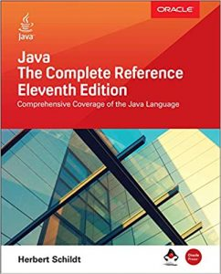
Author – Herbert Schildt
Latest Edition – 11th Edition
Publisher – McGraw Hill Education
Java - The Complete Reference is a convenient Java reference book with over 1000 pages. It contains every aspect of Java that you need to master. In addition to examining essential portions of the Java API library, Java - The Complete Reference covers fundamental programming principles, Java language syntax, and keywords. The book is full of discussions and apt examples to better Java learning.
You can buy the book here.

5. Head First Java
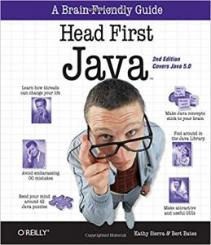
Author – Kathy Sierra & Bert Bates
Latest Edition – 2nd Edition
Publisher – Shroff/O’Reilly
The most important selling points of Head First Java is its simplicity and super-effective real-life analogies that pertain to the Java programming concepts. It is also the best book to learn java and to start your learning journey with Java Development. Head First Java covers almost all OOPS concepts and fascinatingly explains them. Despite several readers claiming it to be a dated book, as it covers nothing beyond Java 5.0, Head First Java is still found on the shelves of numerous Java veterans. Thus, it a must-have book for every Java pursuer and developer.
You can buy the book here.
Some important topics covered by Head First Java include common OO mistakes, distributed programming with RMI and network sockets, and threads. Additionally, the book overs 42 mind-bending puzzles that will ensure a better understanding of Java.

1. C Programming Absolute Beginner's Guide
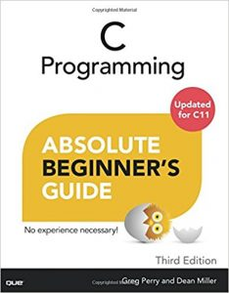
‘C Programming Absolute Beginner's Guide (3rd Edition)’ by Greg Perry and Dean Miller aims to help beginners write powerful and beautiful C programs without becoming an expert in the language. This is the best book for c programming. The book is a fast way to get into the comfort zone with C language, with step by step instructions. The book consists of 32 chapters, each discussing the core concepts of C programming along with clear and concise examples to help you understand better. Each chapter discusses a concept(s) in brief and then straightaway moves to code, following a practical over theory approach. The reader learns concepts such as organizing programs, storing and displaying data, variables, operators, I.O, functions, strings, and much more.
The book has been curated by renowned authors and editors of various notable programming books over the years. Greg Perry has over 75 books to his name, all related to computers and programming. Meanwhile, Dean Miller has over 20 years of experience in publishing and has shaped bestselling books such as ‘Teach yourself in 21 days’ and the ‘Unleashed’ book series.
You can buy the book here.

2. The C Programming Language (2nd Edition)
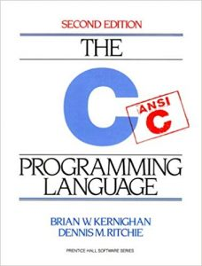
Even though the book was initially published four decades ago in 1978, ‘The C Programming Language’ by Brian W. Kernighan and Dennis M. Ritchie continued to be considered the holy book for C programmers of all skill levels and accepted as one of the best books to learn C programming. The book comprises of challenging exercises which cover all significant concepts of C, helping you become a proficient C programmer.
The book is a collaborative work of Kernighan and Ritchie, the latter being the creator of C and both considered to be pioneers in computer programming. This book acted as a specification of the language for many years after its release as it introduced several features of the language, and covers the following ANSI C standard. It clearly and briefly explains C concepts such as types, operators, expressions, control flow, and functions. While it covers the concepts, it merely explains their uses rather than what they are. Therefore, fundamental programming knowledge is necessary before you begin with this book. The second edition of the book released in 1988, where the authors stated they had improved the descriptions of critical concepts and features. The new edition also has new examples, while the old ones have been refined to augment the learning mechanism.
You can buy the book here.

3. Learn C the Hard Way
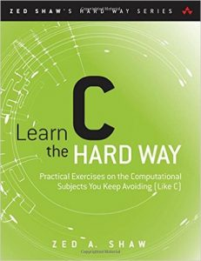
‘Learn C the Hard Way’ by Zed A. Shaw is a clear and direct introduction to modern C programming. The book crafts in such a way that it is the perfect choice for all programmers who wish to learn C programming and are eager to advance their skills. The book will not only help you learn C programming but also introduce you to many new skills which sought in the programming world.
The book has carved a name for itself in the C programming world due to the code exposure it provides to its readers, not just the necessary code for small programs, the book includes real code, something which you might see in projects on Github. The reader will have to work through all the code one by one to understand C programming, all with little or no handholding. The book includes 52 brilliantly designed exercises created to help you master rigorous defensive programming techniques, a skill that will help you in any programming language you take up in the future.
Apart from programming concepts such as files, linkers, arrays, strings, functions, memory allocation, libraries, data structures, stacks, and queues, the book also discusses skills such as defensive coding, debugging, automated testing, illegal memory access and breaking and hacking one’s code. The book accompanies a DVD containing over 5 hours of video lectures and tutorials which complement the book perfectly.
You can buy the book here.

4. Head First C
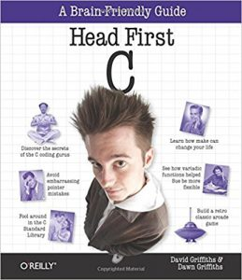
‘Head First C’ by David Griffiths and Dawn Griffiths provides a comprehensive learning experience for C programming. The book, released in 2012, is not just about how to learn C programming but also about how to become a great programmer. Moving over how-to and beyond syntax, this book features labs, which test your abilities with specific projects to help you put your new skills to use and build your confidence.
The book discusses basic and advanced vital areas and concepts, including C language basics, pointers, dynamic memory management, multi-threading, and network programming. The book imitates the style and contents of a college-level course, making it a model textbook for students who wish to learn C programming.
You can buy the book here.

5. C Programming: A Modern Approach
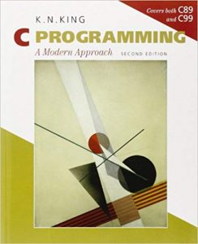
‘C Programming: A Modern Approach (2nd Edition)’ by K. N. King is an approachable and well-written book that covers the basic and advanced concepts of the C language to help beginners and intermediate programmers alike. The author is an associate professor at Georgia State University and has published several books for C, Java and Modula-2 programming
The first edition of the book, published in 1996, has a comprehensive and detailed approach of the author made the book accessible to a broad range of readers, including novice programmers to advanced students. The book was adopted by many educational institutions around the world as their primary C programming text, making the first edition one of the leading C programming textbooks for over ten years. The second edition was released in 2008 and carefully preserved the book’s popular features while bringing it up to date with the new standards. It also adds many new exercises and projects, along with extensive revisions and updates to summarise the majority of C concepts in one textbook. It's one of the best c books for beginners.
You can buy the book here.

