Ergebnisse

Najat Brüne

2024-01-20

# Analyse der initialen Überraschung

i1_w_MW <- daten$i1_ue_w_MW   
i1_f_MW <- daten$i1_ue_f_MW

## Deskriptive Statistik

## >>> i1_w_MW  
## Min. 1st Qu. Median Mean 3rd Qu. Max.   
## 1.00 1.00 1.03 1.05 1.07 1.63   
##   
## vars n mean sd min max range se  
## X1 1 66 1.05 0.1 1 1.63 0.63 0.01  
##   
##   
## >>> i1_f_MW  
## Min. 1st Qu. Median Mean 3rd Qu. Max.   
## 1.00 1.10 1.25 1.31 1.40 2.37   
##   
## vars n mean sd min max range se  
## X1 1 66 1.31 0.3 1 2.37 1.37 0.04  
##   
##   
## >>> i1_f_MW - i1_w_MW  
## Min. 1st Qu. Median Mean 3rd Qu. Max.   
## -0.4300 0.0325 0.1850 0.2570 0.3680 1.3700   
##   
## vars n mean sd min max range se  
## X1 1 66 0.26 0.31 -0.43 1.37 1.8 0.04

## Grafische Analyse

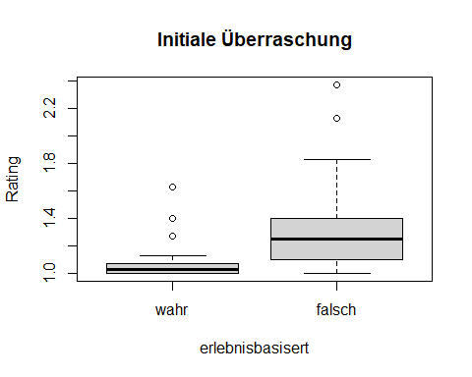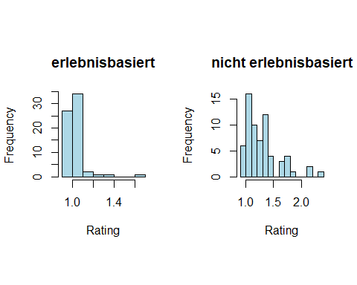

## t-Test

## >>> Vorbedingungen prüfen  
## >>> Grafische Beurteilung der Normalverteilung der Differenzen

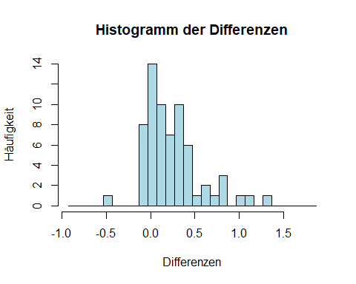

## >>> Shapiro-Wilk-Test zur Überprüfung der Normalverteilung  
## Shapiro-Wilk normality test  
##   
## data: differences  
## W = 0.89602, p-value = 4.429e-05  
##   
## >>> t-Test  
##   
## Paired t-test  
##   
## data: i1_f_MW and i1_w_MW  
## t = 6.6321, df = 65, p-value = 7.711e-09  
## alternative hypothesis: true mean difference is not equal to 0  
## 95 percent confidence interval:  
## 0.1796934 0.3345490  
## sample estimates:  
## mean difference   
## 0.2571212   
##   
## z-value: -5.656811   
##   
## >>> Effektstärke  
##   
## Cohen's d  
##   
## d estimate: 1.154337 (large)  
## 95 percent confidence interval:  
## lower upper   
## 0.7098457 1.5988281

## Nicht parametrischer Test mittels Wilcoxon-Vorzeichen-Rang-Test

## >>> Vorbedingungen prüfen

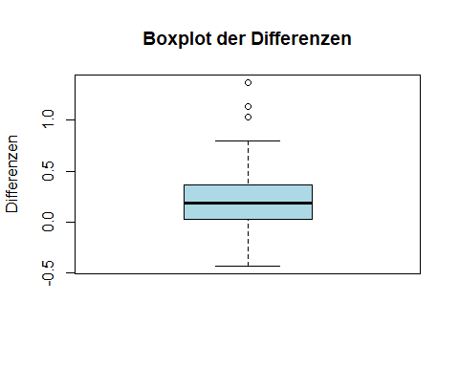

## >>> Wilcoxon-Vorzeichen-Rang-Test  
##   
## Wilcoxon signed rank test  
##   
## data: i1_f_MW and i1_w_MW  
## V = 1769.5, p-value = 3.213e-09  
## alternative hypothesis: true location shift is not equal to 0  
## 95 percent confidence interval:  
## 0.1700152 0.3199496  
## sample estimates:  
## (pseudo)median   
## 0.2350101   
##   
## z-value: -5.805254   
##   
## Effektstärke (r) für den Wilcoxon-Test: 0.7145774

## Nicht parametrischer Test mittels Vorzeichen-Test

## >>> Vorzeichen-Test  
##   
## Dependent-samples Sign-Test  
##   
## data: i1_f_MW and i1_w_MW  
## S = 52, p-value = 1.803e-08  
## alternative hypothesis: true median difference is not equal to 0  
## 95 percent confidence interval:  
## 0.1 0.3  
## sample estimates:  
## median of x-y   
## 0.185   
##   
## Achieved and Interpolated Confidence Intervals:   
##   
## Conf.Level L.E.pt U.E.pt  
## Lower Achieved CI 0.9360 0.1 0.3  
## Interpolated CI 0.9500 0.1 0.3  
## Upper Achieved CI 0.9644 0.1 0.3  
##   
## z-value: -5.509155   
##   
## Effektstärke (r) für den Vorzeichen-Test: 0.6781301

# Analyse der Diskrepanzerkennung

i1_w_MW <- daten$i1_dd_w_MW   
i1_f_MW <- daten$i1_dd_f_MW

## Deskriptive Statistik

## >>> i1_w_MW  
## Min. 1st Qu. Median Mean 3rd Qu. Max.   
## 0.000 0.100 0.215 0.294 0.470 1.000   
##   
## vars n mean sd min max range se  
## X1 1 66 0.29 0.25 0 1 1 0.03  
##   
##   
## >>> i1_f_MW  
## Min. 1st Qu. Median Mean 3rd Qu. Max.   
## 0.100 0.740 0.900 0.819 0.930 1.000   
##   
## vars n mean sd min max range se  
## X1 1 66 0.82 0.19 0.1 1 0.9 0.02  
##   
##   
## >>> i1_f_MW - i1_w_MW  
## Min. 1st Qu. Median Mean 3rd Qu. Max.   
## -0.370 0.400 0.515 0.526 0.740 1.000   
##   
## vars n mean sd min max range se  
## X1 1 66 0.53 0.3 -0.37 1 1.37 0.04

## Grafische Analyse

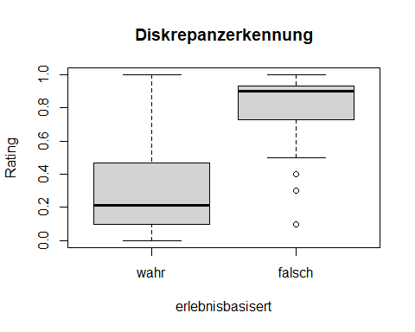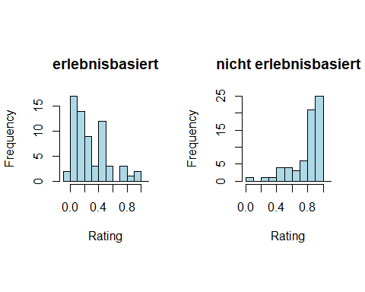

## t-Test

## >>> Vorbedingungen prüfen  
## >>> Grafische Beurteilung der Normalverteilung der Differenzen

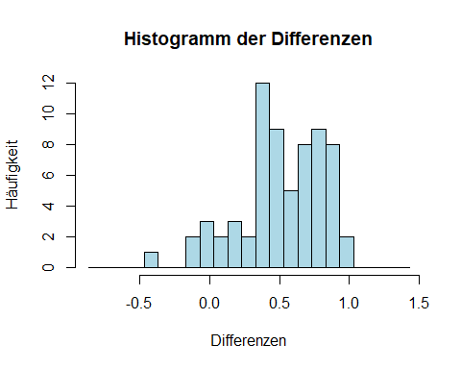

## >>> Shapiro-Wilk-Test zur Überprüfung der Normalverteilung  
## Shapiro-Wilk normality test  
##   
## data: differences  
## W = 0.94661, p-value = 0.006658  
##   
## >>> t-Test  
##   
## Paired t-test  
##   
## data: i1_f_MW and i1_w_MW  
## t = 14.436, df = 65, p-value < 2.2e-16  
## alternative hypothesis: true mean difference is not equal to 0  
## 95 percent confidence interval:  
## 0.4528901 0.5983220  
## sample estimates:  
## mean difference   
## 0.5256061   
##   
## z-value: -9.558798   
##   
## >>> Effektstärke  
##   
## Cohen's d  
##   
## d estimate: 2.369457 (large)  
## 95 percent confidence interval:  
## lower upper   
## 1.735849 3.003064

## Nicht parametrischer Test mittels Wilcoxon-Vorzeichen-Rang-Test

## >>> Vorbedingungen prüfen

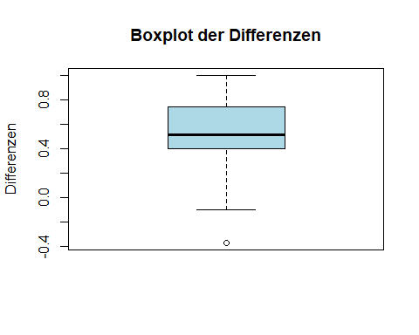

## >>> Wilcoxon-Vorzeichen-Rang-Test  
##   
## Wilcoxon signed rank test  
##   
## data: i1_f_MW and i1_w_MW  
## V = 2122, p-value = 6.899e-12  
## alternative hypothesis: true location shift is not equal to 0  
## 95 percent confidence interval:  
## 0.4699858 0.6299193  
## sample estimates:  
## (pseudo)median   
## 0.564953   
##   
## z-value: -6.760014   
##   
## Effektstärke (r) für den Wilcoxon-Test: 0.8321002

## Nicht parametrischer Test mittels Vorzeichen-Test

## >>> Vorzeichen-Test  
##   
## Dependent-samples Sign-Test  
##   
## data: i1_f_MW and i1_w_MW  
## S = 61, p-value = 4.019e-14  
## alternative hypothesis: true median difference is not equal to 0  
## 95 percent confidence interval:  
## 0.4452109 0.6847891  
## sample estimates:  
## median of x-y   
## 0.515   
##   
## Achieved and Interpolated Confidence Intervals:   
##   
## Conf.Level L.E.pt U.E.pt  
## Lower Achieved CI 0.9360 0.4600 0.6700  
## Interpolated CI 0.9500 0.4452 0.6848  
## Upper Achieved CI 0.9644 0.4300 0.7000  
##   
## z-value: -7.469696   
##   
## Effektstärke (r) für den Vorzeichen-Test: 0.919456

# Analyse der Differenzen zwischen f- und w-Werten

In dieser Analyse werden die Werte der Diskrepanzerkennung und der Initialen Überraschung getrennt nach erlebnisbasiert (w|f) addiert, wobei die Werte der Initialen Überraschung auf Werte zwischen 0 und 1 normiert werden, damit diese auf dem Skalenniveau der Diskrepanzerkennung liegen.

## >>> i1_w_MW  
## Min. 1st Qu. Median Mean 3rd Qu. Max.   
## 0.000 0.120 0.248 0.321 0.511 1.320   
##   
## vars n mean sd min max range se  
## X1 1 66 0.32 0.27 0 1.31 1.31 0.03  
##   
##   
## >>> i1_f_MW  
## Min. 1st Qu. Median Mean 3rd Qu. Max.   
## 0.100 0.825 0.985 0.975 1.130 1.660   
##   
## vars n mean sd min max range se  
## X1 1 66 0.97 0.27 0.1 1.66 1.55 0.03  
##   
##   
## >>> i1_f_MW - i1_w_MW  
## Min. 1st Qu. Median Mean 3rd Qu. Max.   
## -0.585 0.455 0.660 0.654 0.879 1.620   
##   
## vars n mean sd min max range se  
## X1 1 66 0.65 0.38 -0.58 1.62 2.21 0.05  
##   
##   
## >>> Vorbedingungen prüfen  
## >>> Grafische Beurteilung der Normalverteilung der Differenzen

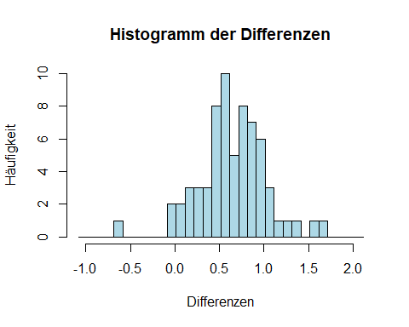

## >>> Shapiro-Wilk-Test zur Überprüfung der Normalverteilung  
## Shapiro-Wilk normality test  
##   
## data: differences  
## W = 0.98141, p-value = 0.425  
##   
## >>> t-Test  
##   
## Paired t-test  
##   
## data: i1_f_MW and i1_w_MW  
## t = 13.911, df = 65, p-value < 2.2e-16  
## alternative hypothesis: true mean difference is not equal to 0  
## 95 percent confidence interval:  
## 0.5602521 0.7480813  
## sample estimates:  
## mean difference   
## 0.6541667   
##   
## z-value: -9.367899   
##   
## >>> Effektstärke  
##   
## Cohen's d  
##   
## d estimate: 2.414366 (large)  
## 95 percent confidence interval:  
## lower upper   
## 1.735018 3.093714

# Anhang

## Daten

| i1_dd_w_MW | i1_dd_f_MW | i1_ue_w_MW | i1_ue_f_MW |
| --- | --- | --- | --- |
| 0.03 | 0.30 | 1.03 | 1.03 |
| 0.47 | 0.97 | 1.10 | 1.33 |
| 0.30 | 0.93 | 1.00 | 1.80 |
| 0.07 | 0.93 | 1.10 | 1.13 |
| 0.47 | 0.97 | 1.10 | 1.03 |
| 0.27 | 0.77 | 1.07 | 1.17 |
| 0.23 | 0.97 | 1.00 | 1.43 |
| 0.47 | 0.90 | 1.13 | 1.07 |
| 0.10 | 0.50 | 1.03 | 1.30 |
| 0.17 | 0.90 | 1.03 | 1.20 |
| 0.20 | 0.90 | 1.03 | 1.03 |
| 0.80 | 0.90 | 1.10 | 1.17 |
| 0.50 | 0.93 | 1.03 | 1.37 |
| 0.47 | 0.67 | 1.10 | 1.03 |
| 0.07 | 0.57 | 1.00 | 1.40 |
| 0.13 | 0.90 | 1.00 | 1.00 |
| 0.30 | 0.97 | 1.00 | 1.40 |
| 0.43 | 0.93 | 1.03 | 1.37 |
| 0.03 | 0.97 | 1.00 | 2.37 |
| 0.57 | 0.50 | 1.03 | 1.17 |
| 0.07 | 0.87 | 1.00 | 1.07 |
| 0.07 | 0.53 | 1.03 | 1.03 |
| 0.47 | 0.73 | 1.13 | 1.07 |
| 0.03 | 0.90 | 1.00 | 1.27 |
| 0.07 | 0.90 | 1.07 | 1.37 |
| 0.47 | 0.90 | 1.00 | 1.17 |
| 0.10 | 0.93 | 1.00 | 1.10 |
| 0.07 | 0.93 | 1.10 | 2.13 |
| 0.00 | 0.70 | 1.00 | 1.73 |
| 1.00 | 0.63 | 1.63 | 1.20 |
| 0.17 | 0.87 | 1.00 | 1.63 |
| 0.30 | 0.73 | 1.00 | 1.17 |
| 0.13 | 1.00 | 1.00 | 1.07 |
| 0.07 | 0.93 | 1.07 | 1.37 |
| 0.10 | 0.87 | 1.07 | 1.10 |
| 0.03 | 0.53 | 1.03 | 1.07 |
| 0.07 | 0.97 | 1.07 | 1.50 |
| 0.30 | 0.93 | 1.03 | 1.00 |
| 0.27 | 0.93 | 1.03 | 1.10 |
| 0.80 | 0.97 | 1.10 | 1.23 |
| 0.13 | 0.53 | 1.00 | 1.30 |
| 0.37 | 1.00 | 1.07 | 1.43 |
| 0.57 | 0.93 | 1.07 | 1.10 |
| 0.93 | 0.87 | 1.10 | 1.40 |
| 0.50 | 0.40 | 1.07 | 1.40 |
| 0.47 | 0.87 | 1.00 | 1.67 |
| 0.57 | 1.00 | 1.00 | 1.27 |
| 0.17 | 0.90 | 1.00 | 1.20 |
| 0.13 | 0.73 | 1.07 | 1.00 |
| 0.13 | 0.50 | 1.00 | 1.17 |
| 0.33 | 0.50 | 1.07 | 1.63 |
| 0.00 | 1.00 | 1.00 | 2.13 |
| 0.13 | 0.97 | 1.00 | 1.80 |
| 0.50 | 0.90 | 1.00 | 1.10 |
| 0.37 | 0.93 | 1.00 | 1.37 |
| 0.13 | 0.87 | 1.00 | 1.10 |
| 0.03 | 0.93 | 1.00 | 1.00 |
| 0.30 | 0.77 | 1.03 | 1.00 |
| 0.87 | 0.90 | 1.07 | 1.27 |
| 0.13 | 0.87 | 1.27 | 1.33 |
| 0.27 | 0.80 | 1.03 | 1.27 |
| 0.47 | 0.87 | 1.40 | 1.80 |
| 0.10 | 0.10 | 1.03 | 1.00 |
| 0.17 | 0.90 | 1.03 | 1.83 |
| 0.17 | 1.00 | 1.00 | 1.33 |
| 0.77 | 0.90 | 1.00 | 1.47 |