**Kingston University, BSc (Hons) (top-up)**

**Draft Coursework – Subject to Moderation**

**Coursework Coversheet**

**Part 1 - To Remain with the Assignment after Marking**

|  |  |
| --- | --- |
| **Student ID: E174226** | **Student Name: J A Shasheen Kaushika** |
| **Module Code:** | **Module Name: Mobile Application Development** |
| **Assignment number:** | **ESoft Module Leader:** |
| **Date set:** | **Date due:2024/12/3** |

**Guidelines for the Submission of Coursework**

1. Print this coversheet and securely attach both pages to your assignment. You can help us ensure work is marked more quickly by submitting at the specified location for your module. You are advised to keep a copy of every assignment.

2. Coursework deadlines are strictly enforced by the University.

3. You should not leave the handing in of work until the last minute. Once an assignment has been submitted it cannot be submitted again.

**Academic Misconduct**: **Plagiarism** and/or **collusion** constitute **academic misconduct** under the University's Academic Regulations. Examples of academic misconduct in coursework: making available your work to other students; presenting work produced in collaboration with other students as your own (unless an explicit assessment requirement); submitting work, taken from sources that are not properly referenced, as your own. By printing and submitting this coversheet with your coursework you are confirming that the work is your own.

|  |  |  |  |
| --- | --- | --- | --- |
| |  | | --- | | ESoft Office Use Only:  Date stamp: work received | | |  | | --- | |  | |

**Kingston University, BSc (Hons) (top-up)**

**Coursework Coversheet**

**Part 2 – Student Feedback**

|  |  |
| --- | --- |
| **Student ID: E174226** | **Student Name: J A Shasheen Kaushika** |
| **Module Code:** | **Module Name:** **Mobile Application Development** |
| **Assignment number:** | **ESoft Module Leader:** |
| **Date set:** | **Date due:** |

|  |
| --- |
| Strengths (areas with well-developed answers) |

|  |
| --- |
| Weaknesses (areas with room for improvement) |

|  |
| --- |
| Additional Comments |

|  |  |  |
| --- | --- | --- |
|  |  |  |
| **ESoft Module Lecturer:** | **Provisional mark as %:** |  |
| **ESoft Module Marker:** | **Date marked:** |

**Mobile Application Development Coursework 1**

**Part B – Cross Mobile Application Development**

This individual coursework 1 (Part B) requires developing a mobile mini-application using the Flutter framework, technical documentation, demonstration video and source code. This part contributes 50% to the total marks.

1. **Implementation:**  
     
   * Global news articles API: <https://newsapi.org/>

Students must research and develop a mini mobile application using the provided weather API. They must use Flutter and state management methodologies to develop this news application. Students can decide the features for their mini application. When developing the news application, focus on the following factors:

* + Develop the mobile application with 5 features (searching, sorting, new category etc. without user login).
  + Use a suitable software architecture/design for your application.
  + Use mobile development best practices for development.
  + Use the 3rd party library.
  + Use UI/UX best practices.
  + Technical documentation, demonstration Video and source code.
  + prepare a minimum of 5 screens.
  + User state Management for your application

1. **Technical documentation**

**Prepare the technical documentation, highlighting your work under the following topics. Use the following format for the document:**

**Formatting:**

* **Font Sizes:** Main topics - Font Size 16, Subtopics - Font Size 14, Paragraphs - Font Size – 11
* **Font family:** Times New Roman.
* **Documentation Format:** PDF
* The following topics should be included in the documentation.

**Table of Contents**1. An overview of the project and available features.  
2. Project architecture/design of the application.  
 2.1 Project Architecture/ design.   
 2.2 Project Structure of the Application (Feature or type).  
   2.3 API   
 - API structure  
 - API data  
 - API implementation  
 - CURD operation explain with implemented code  
 - Implemented other features.

3. State Management   
4. Third-party libraries.  
5. UI/UX Design   
 - Developed design

- Wireframes

- UI/UX best practice

8. Test Case.

9. Issues/Errors and failures in your application.

10. Reference (Harvard)

1. **Submission**The final submission should include the demonstration video, technical documentation, source code and the app’s final release file (APK).

* **Demonstration video summation:**Students must create a demonstration video showcasing the implemented features of their application with their own voice. The video should be uploaded to the student's Google Drive and shared with the setting 'Anyone with the link.' The demonstration video link must be included in the appendix of the technical report.
* **Final release file (APK) summation:**Students must build a final release APK. This final release APK should be uploaded to the student's Google Drive and shared with the setting 'Anyone with the link.' The final release APK link must be included in the appendix of the technical report.
* **Source code summation:**

Students must create a public repository on their own GitHub (or Bitbucket, GitLab, etc.). Push the source code to this repository. Include the repository link in the appendix of the technical report.

1. **Marking criteria**

|  |  |
| --- | --- |
| Mark | Characterized by |
| 0 | No work or work totally irrelevant |
| 1 | Work started on right lines but no result |
| 2 | Some result, with major lack and/or errors |
| 3 | Acceptable result but incomplete, or some good result with minor errors |
| 4 | Good result but can be further improved |
| 5 | Excellent result |

|  |  |  |  |  |
| --- | --- | --- | --- | --- |
|  | **Item** | **Weight** | ***Mark***  ***(0 to 5)*** | ***Weight x Mark*** |
| **Software Implementation** | |  |  |  |
|  | RnD and Implemented features | 1 | 5 | 5 |
| 1 | Souse code (Structuring/Architecture and data flow) | 4 | 5 | 20 |
| 2 | UI/UX (Design and wireframe / UI/UX best practices) | 3 | 5 | 10 |
| 3 | API with CRUD operations | 5 | 5 | 25 |
| 4 | More features | 1 | 5 | 5 |
| **Software Implementation** | |  |  |  |
| 5 | Technical documentation | 4 | 5 | 20 |
| 6 | Demonstrations video | 2 | 5 | 10 |
| 7 | Final release file (APK) | 1 | 5 | 5 |
|  | Total |  |  | 100 |

**Academic Integrity:**

Academic integrity means demonstrating honest, moral behaviours when producing academic work. This involves acknowledging the work of others, giving appropriate credit to others where their ideas are presented as part of your work and the importance of producing work in your own voice. Contributions by artificial intelligence (AI) tools must be properly acknowledged. As part of a learning community students share ideas and develop new ones - you need to be able to interpret and present other people's ideas and combine these with your own when producing work.

**Plagiarism (including copying, self-plagiarism and collusion)**

The act of presenting the work of another person (or people) and/or content generated by artificial intelligence (AI) tools as your own without proper acknowledgement. This includes copying the work of another student or other students.

The University expects students to take responsibility for the security of their work (i.e. with written work, to ensure that other students do not get access to electronic or hard copy of the work). Failure to keep work secure may allow others to cheat and could result in an allegation of academic misconduct for students whose work have been copied, particularly if the origin of the work is in doubt.

**Self-plagiarism**

The act of presenting part or all of your work that has been previously submitted to meet the requirements of a different assessment, except where the nature of the assessment makes this permissible.

**Collusion**

The act, by two or more students of presenting a piece of work jointly without acknowledging the collaboration. This could include permitting or assisting another to present work that has been copied or paraphrased from your own work.

The University also defines collusion as the act of one student presenting a piece of work as their own independent work when the work was undertaken by a group. With group work, where individual members submit parts of the total assignment, each member of a group must take responsibility for checking the legitimacy of the work submitted in his/her name. If even part of the work is found to contain academic misconduct, penalties will normally be imposed on all group members equally.

**Purchasing or Commissioning**

The act of attempting to purchase or purchasing work for an assessment including, for example from the internet, or attempting to commission, or commissioning someone else to complete an assessment on your behalf.

The procedures for investigating suspected cases of academic misconduct are set out in Academic Regulations 6 Academic Integrity - Taught Courses 2023/24

**Acknowledging Generative AI in coursework**

Where generative AI has contributed to an assignment the following information should be included in the submission:

A statement on the use of generative AI as part of the assessment, including the extent of use, and how it was used as part of all stages in creating the final submission, e.g., including planning, and generating ideas. This should normally be provided at the end of a written assignment with the heading ‘Acknowledgement of AI Contribution’. For other assignment types, module staff will advise on how this should be done.

**You must meet all deadlines set. Failure to do so will result in a penalty.**

Work submitted late but within a week of the deadline will be capped at 40% and receive a grade of LP (Late Pass) unless it is not of a passing standard in which case it will receive a grade of LF (Late Fail). Work submitted beyond a week of the deadline without approval will get 0% with a grade of F0. If, however, you have a serious problem, which prevents you from, meeting the deadline you may be able to negotiate an extension in advance. In the first instance you should contact the module team for advice. However, any extension will need to be formally agreed by the Faculty via the Mitigating Circumstances process, your work will then be marked without penalty.

Mobile Application Development

Course work 02

E174226

J A Shasheen Kaushika



Table of contents

Contents

Table is figures 12

News App 13

Overview 13

Purpose 13

Features 13

Technical Stack 14

Project Architecture/Design of the application 15

Project Architecture/Design 15

Project Structure of the Application (Feature or Type) 16

API 16

API Structure 16

API Data 17

API Implementation 17

CRUD Operations Explained with Implemented Code 18

State management 20

Key Aspects: 20

State Update Logic: 20

Third-party libraries 21

Library Name 21

UI/UX Design 23

1. Developed Design Overview 23

2. Wireframes & Layout Explanation 24

3. UI/UX best practices 27

Test cases 28

Verify Search Functionality 28

Verify Article Load and Readability 29

Issues/Errors and failures 32

UI/UX Issues 32

Functional Errors 32

Backend and API Issues 32

Reference 34

Appendix 35

# Table is figures

Figure 1 News app 15

Figure 2 Folder Structure 16

Figure 3 API Data 17

Figure 4 API Implementation 18

Figure 5 Read 18

Figure 6 Sort 19

Figure 7 http 21

Figure 8 UI/UX design 23

Figure 9 Home screen UI 24

Figure 10 article screen UI 25

Figure 11 Article view UI 26

Figure 12 Search function 29

Figure 13 article screen 31

# News App

# Overview

The News App is a feature-rich mobile application built using **Flutter** and designed to provide users with the latest news articles worldwide. The app leverages the **News API** to fetch news data in real-time and offers a user-friendly interface to browse, search, and sort articles across various categories. It also incorporates state management with **Provider** for efficient data handling.

## Purpose

The News App aims to address the growing need for a centralized and accessible platform to browse news articles from multiple categories and regions. In an age where information overload is common, the app simplifies news consumption by offering intuitive search, sorting, and categorization features. It is designed to make accessing and understanding news convenient, tailored, and efficient for users. Furthermore, the app serves as a practical demonstration of modern Flutter development, incorporating best practices in state management, API integration, and UI design.

## Features

**1. Search Bar with Real-Time Suggestions**

Users can quickly find articles by typing keywords in the search bar. Results update dynamically as the user types.

**2. Category Tabs for Easy Navigation**

Categorize news articles for effortless navigation. Examples include tabs like **Technology**, **Sports**, **Health**, and more.

**3. Sort Menu**

The app includes a dropdown menu to sort articles by:

* **Newest First**
* **Oldest First**
* **Relevance**

**4. List of Articles**

Display articles in a visually appealing list format, including:

* Thumbnail image
* Title
* Short description

**5. Article Detail View**

On selecting an article, users are directed to a detailed screen that displays:

* Full article content
* Published date
* Link to the original source

## Technical Stack

**1. Flutter Framework**

* **UI Toolkit:** Flutter for creating a cross-platform, natively compiled mobile app.

**2. State Management**

* **Provider:** Used to manage application state effectively.

**3. API Integration**

* **News API**: Fetch real-time news articles from https://newsapi.org/.

**4. Packages Used**

* provider: State management
* http: API requests
* flutter/material: Core Flutter components

# Project Architecture/Design of the application

## Project Architecture/Design

The News App is structured using a modular architecture to ensure maintainability, scalability, and reusability. It employs the following design principles:

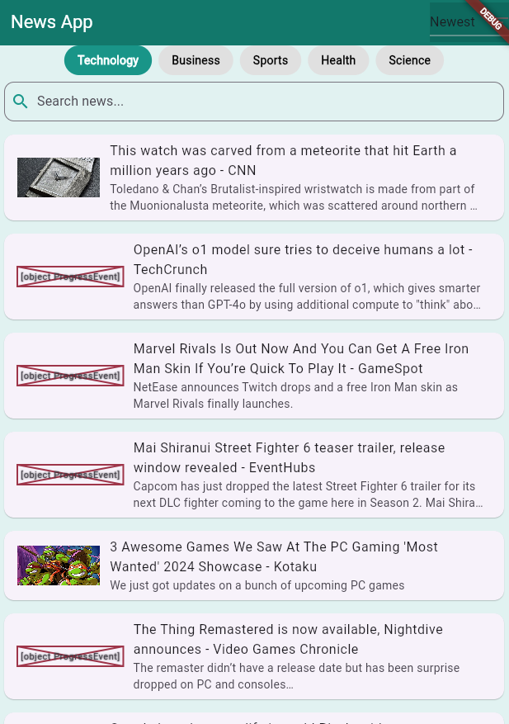

Figure 1 News app

**Model-View-Controller (MVC) Pattern**

* **Model:** Handles the data, including fetching and processing from the News API.
* **View:** The UI components rendered for users (e.g., screens, widgets).
* **Controller:** The Provider acts as the controller, managing state and business logic (Gallardo, 2023).

**Layered Structure**

* **Data Layer:** Responsible for API integration and data fetching.
* **Logic Layer:** Manages state and logic using Provider.
* **Presentation Layer:** Handles all UI components and user interactions.

## Project Structure of the Application (Feature or Type)

**Folder structure**

The project is organized into distinct directories based on feature type and responsibility, allowing for clean code management and easy scalability.

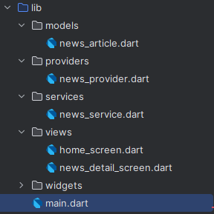

Figure 2 Folder Structure

## API

### API Structure

The app integrates with the News API to fetch real-time news articles based on specific query parameters like category and country (Telerik Blogs, 2023).

* **Base URL**: https://newsapi.org/v2/top-headlines
* **Key Parameters**:

country: Specifies the country for news articles (e.g., us for United States).

category: Filters news articles by category (e.g., technology, sports).

apiKey: Required for authentication.

### API Data

The API returns a JSON response with the following structure

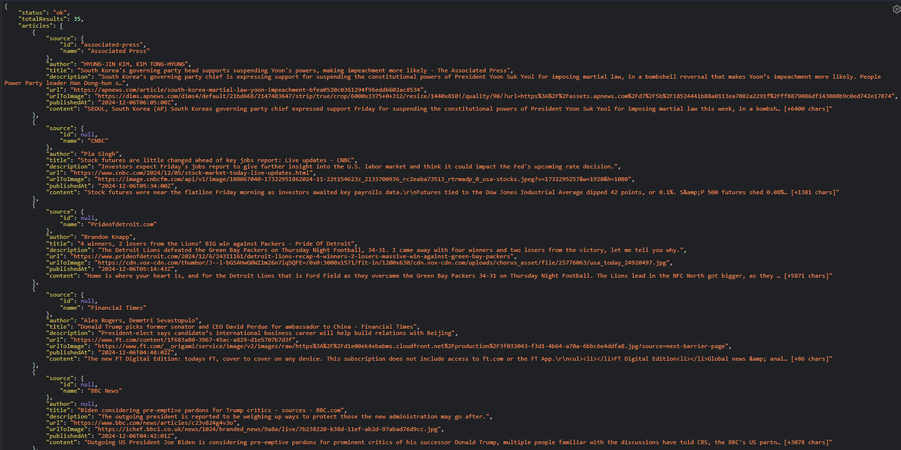

Figure 3 API Data

### API Implementation

API integration is handled in news_provider.dart using the http package

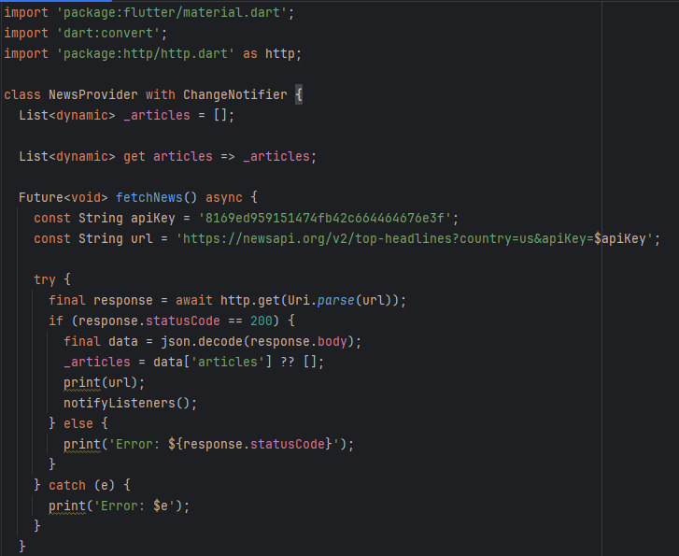

Figure 4 API Implementation

### CRUD Operations Explained with Implemented Code

**Read**

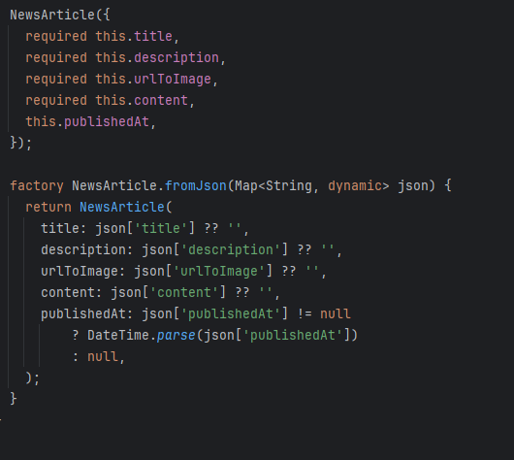

Figure 5 Read

**Sort**

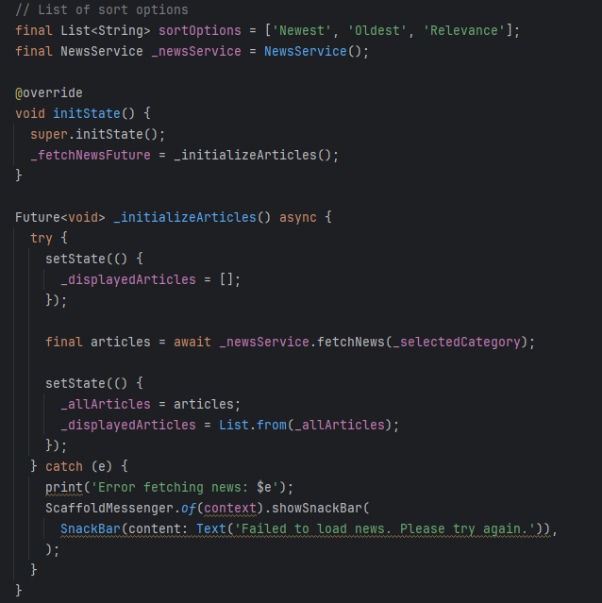

Figure 6 Sort

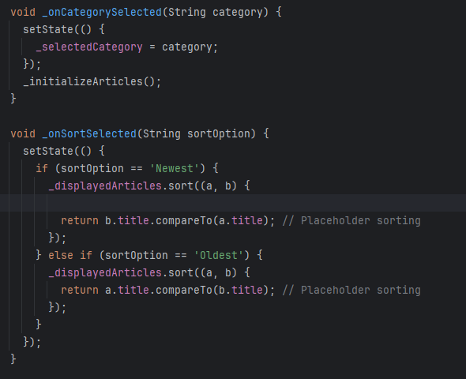

**Implemented Other Features**

* **Search Functionality**: Filter articles based on user queries.
* **Sorting**: Sort articles by date or relevance.
* **Categorization**: Navigate news by categories like Technology, Sports, etc.
* **Dynamic Updates**: Automatically refreshes the UI upon data changes.

# State management

The News App uses the **Provider** package for state management. This approach ensures efficient communication between different parts of the application and a responsive user interface. The Provider pattern simplifies state sharing across widgets by allowing listeners to rebuild only when necessary (SearchAppArchitecture, n.d.).

## Key Aspects:

1. **Centralized State**:
   * The application stores and manages news articles in a centralized state using the NewsProvider class.
   * This class fetches news articles from the API, applies filtering or sorting logic, and notifies listeners about updates.

## State Update Logic:

* + When an API call completes, the data is stored in a list (e.g., _articles in NewsProvider).
  + After modifying the data (e.g., sorting or filtering), the notifyListeners() method triggers UI rebuilds for all listeners.

1. **Reactive UI Updates**:
   * Widgets that depend on the state (e.g., article lists, search results) automatically rebuild when the state changes, ensuring real-time updates.
2. **Simplified Code Structure**:
   * State updates are streamlined through the Provider package. For example, calling notifyListeners() ensures dependent widgets automatically rebuild, avoiding manual state checks.
   * Each widget subscribes only to the state it depends on, reducing unnecessary rebuilds.
   * By decoupling the UI and business logic, Provider enables cleaner and more maintainable code.

# Third-party libraries

## Library Name

* The full name of the library and the package manager (e.g., pub.dev for Flutter packages).
* **Example:**

**Library Name:** http

**Version:** ^0.15.0

**2. Purpose of the Library**

* A brief explanation of why the library was chosen and how it fits into your project. This helps the reader understand its role.
* **Example:**

**http**: This library is used for making network requests, allowing the app to fetch news data from an external API. It simplifies the process of sending HTTP requests and handling responses.

**Installation Instructions**

* Include the version number of the library (if fixed) and provide clear steps to install it via Flutter’s package manager (e.g., pubspec.yaml).
* After adding this to pubspec.yaml, run flutter pub get in the terminal to install the library.

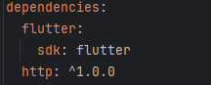

Figure 7 http

**Key Features and Benefits**

* Highlight the key features of the library and how it benefits the project.
* **Example for provider:**

**provider**:

* + - **Purpose:** State management solution for Flutter apps, helping to manage the app's data and making it available to different parts of the app.
    - **Key Feature:** Allows easy propagation of changes in the state across multiple widgets without the need for complicated setState calls.
    - **Benefits:** Simplifies app state management, especially when dealing with multiple widgets that need access to shared data.

# UI/UX Design

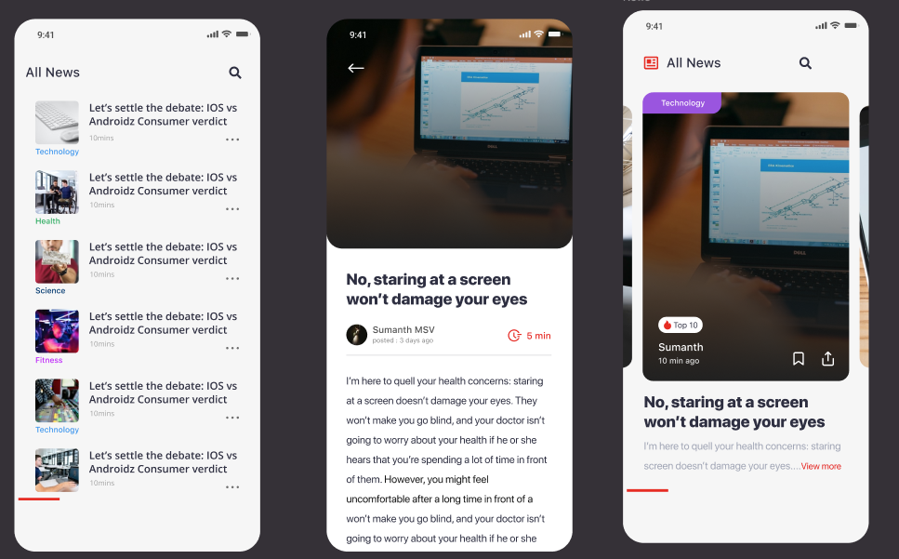

Figure 8 UI/UX design

## Developed Design Overview

**Purpose:** The design focuses on delivering a user-friendly interface that prioritizes news content with a clean, modern layout. The aim is to allow users to easily browse, read, and interact with news articles from various categories (UXPin, 2017).

**Core Design Principles:**

* **Minimalist and Clean Layout:** Simple and intuitive design with a focus on content (news articles). The interface provides an organized way of displaying information without clutter.
* **Visual Hierarchy:** Information is presented in a clear order with article titles at the top, making it easy for users to quickly identify and navigate through stories.
* **Consistency:** Consistent use of fonts, icons, and colors across the app, ensuring a cohesive and seamless experience.

**Design Tools Used:**

* The designs were likely developed using design tools like **Figma** for the wireframes and prototypes.

## Wireframes & Layout Explanation

The wireframe consists of **three main screens** for different app states: the **Home Screen**, the **Article Preview Screen**, and the **Full Article View**.

* **Home Screen:**

**Category Filter:** At the top, there is a category filter, such as "All News," with a search bar for easy access to different topics (e.g., Technology, Health, Science).

**Article List View:** The news articles are displayed as a vertically scrollable list. Each article preview includes a title, category tag, and an estimate of the reading time (e.g., "10 mins"). The list also includes a thumbnail image that visually represents the article, enhancing the user's experience.

**Navigation Bar:** A bottom navigation bar for accessing other sections of the app like saved articles, preferences, and settings.

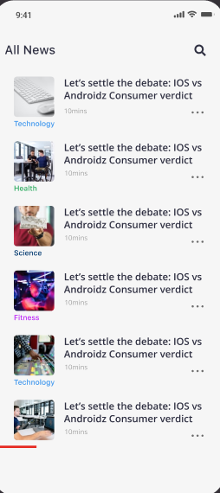

Figure 9 Home screen UI

* **Article Preview Screen:**

**Article Details:** Each article’s preview includes the headline, a brief excerpt of the article, and metadata like the author’s name and time of posting. The preview helps the user decide whether they want to read the full article.

**Action Buttons:** Users have the option to save the article or share it. These buttons are visible and easy to interact with.

**Tagging:** An article is tagged with its category (e.g., Technology) and, in this case, it is marked as "Top 10," indicating it’s trending, which can attract more attention.

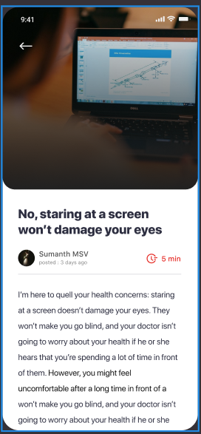

Figure 10 article screen UI

* **Full Article View:**

**Detailed Content:** Upon clicking an article, users are taken to a full view where the article's content is displayed clearly, with text and images. The font size and line spacing have been optimized for readability.

**Progress Bar:** A subtle progress indicator (e.g., “5 min read”) tells the user how much content is left, improving the reading experience.

**Interactive Features:** The app includes the option to save or share the article for later reading.

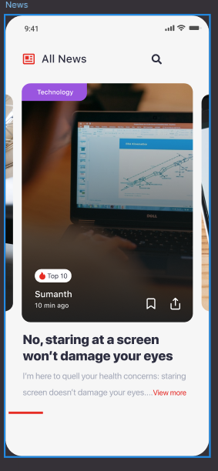

Figure 11 Article view UI

## UI/UX best practices

**Navigation and User Flow**

* **Seamless Navigation:**

**Home Screen:** Users can easily swipe through categories, search for specific news, or scroll through the news feed.

**Article Interaction:** Tapping an article thumbnail brings the user to the preview screen, where they can quickly decide to read the full article or share/save it.

**Bottom Navigation:** Clear and accessible navigation options are always available, allowing users to move between different sections (home, saved, settings).

**B. Consistent and Intuitive Layout**

* **Card-based Layout:** Articles are presented in a **card-style layout**, each with an image, title, and other metadata. This layout is easy to scan and aesthetically clean.
* **Typography:**

The use of large, bold fonts for the article title and smaller text for the content description enhances legibility.

Consistent fonts for categories, article titles, and metadata help maintain uniformity throughout the app.

**C. Interactive Feedback**

* **Action Buttons:** The share and save buttons provide immediate feedback when pressed helping users know their action was completed.
* **Reading Time:** The "5 min" reading time displayed is a good practice, giving users an estimate of how long it will take to read the article, enhancing the experience.

**D. Accessibility Features**

* **Color Contrast:** Text is displayed with sufficient contrast to ensure it is readable for users with visual impairments.
* **Navigation Simplicity:** The navigation structure is simple, with a clear bottom navigation bar and easy access to different sections of the app.

**F. Visual Elements and Aesthetics**

* **Imagery:** The use of images (e.g., a photo of a laptop) alongside article previews adds visual appeal and breaks up the text, making the content feel less dense.
* **Consistency in Layout:** The consistent layout of articles with titles, images, and short descriptions makes it easy for users to find and consume content.

**G. Responsive Design**

* **Adaptive Layout:** The app is designed to be responsive, adjusting to various screen sizes (e.g., phones and tablets). The articles, images, and text reflow based on the screen width, ensuring the design looks great on any device.

The UI/UX design of the Flutter News App emphasizes simplicity, accessibility, and ease of navigation, all while maintaining a visually appealing interface. The design effectively highlights the most important aspects of the news articles, providing users with an optimized reading experience. By focusing on **clean layouts**, **consistent design**, and **user feedback**, this app ensures an engaging experience for news consumers.

# Test cases

## Verify Search Functionality

**Test Case Title:** Verify that the search functionality works correctly.

**Preconditions:**

* The app is installed and opened.
* News data is available in the app.

**Test Steps:**

1. On the **Home Screen**, click on the **Search Bar** at the top of the screen.
2. Type a keyword (e.g., "Technology").
3. Verify that the search results filter in real-time as text is entered.
4. Verify that the results displayed are relevant to the search query.
5. Click on any article in the search results to navigate to the **Article Preview Screen**.

**Expected Results:**

* As the user types in the search bar, relevant results should appear in real-time.
* The articles displayed should match the search query.
* Clicking an article should navigate the user to the **Article Preview Screen**.

**Postconditions:**

* The user is either on the **Article Preview Screen** or returns to the **Home Screen** after completing the search.

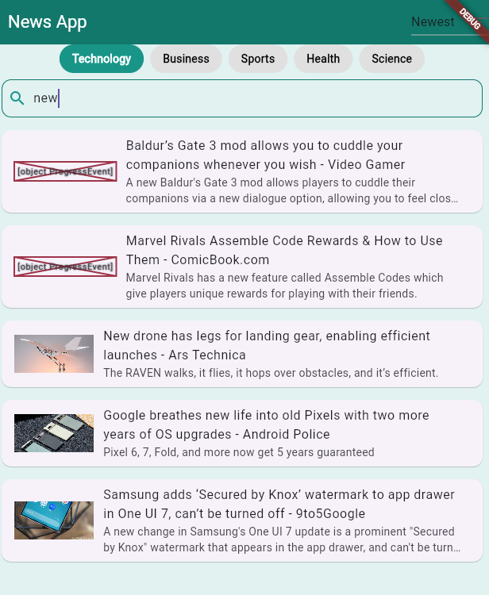

Figure 12 Search function

## Verify Article Load and Readability

**Test Case Title:** Verify that articles load correctly and are readable on the **Article View Screen**.

**Preconditions:**

* The app is installed and opened.
* News content is available.

**Test Steps:**

1. Click on any article from the **Home Screen** to navigate to the **Article Preview Screen**.
2. On the **Article Preview Screen**, click on the article to open the full article.
3. Verify that the article content loads without delay.
4. Check for the readability of the article (font size, line spacing, etc.).
5. Scroll through the article to ensure that all content is properly loaded and readable.

**Expected Results:**

* The article content should load quickly and be displayed in an easy-to-read format.
* The font size and line spacing should be appropriate for comfortable reading.

**Postconditions:**

* The user can read the article in full, with no issues in formatting or layout.

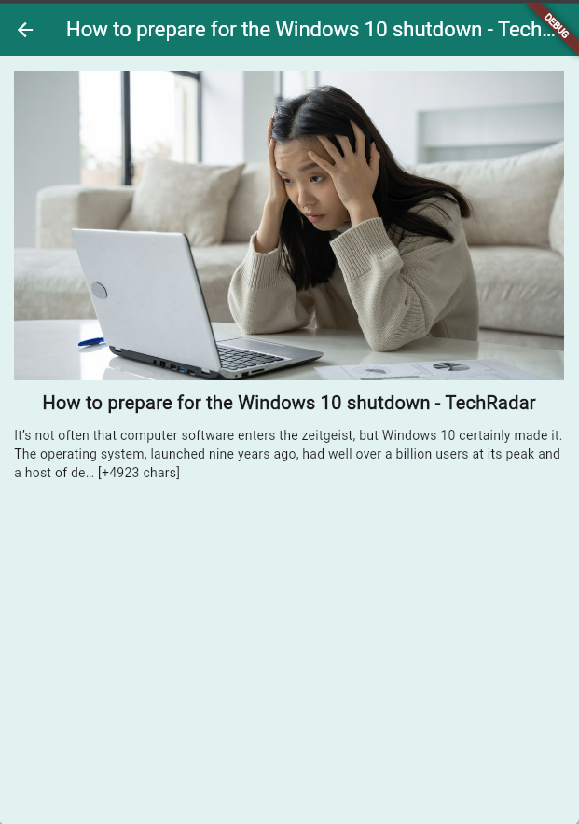

Figure 13 article screen

The test cases provided ensure that the **Flutter News App** functions correctly across multiple user flows and interactions, including article listing, navigation, saving, sharing, searching, and readability. By following these test cases, you can validate that the app delivers a smooth and user-friendly experience for all features.

# Issues/Errors and failures

## UI/UX Issues

* **UI Misalignment:**

**Issue:** On different screen sizes or devices, certain UI elements (e.g., text, images, buttons) may appear misaligned or cut off.

Lack of responsive design or improper use of layout constraints.

**Solution:** Use **Flutter's LayoutBuilder** and **MediaQuery** to make the UI responsive and ensure elements scale correctly.

* **Text Overflow:**

**Issue:** Long text (e.g., article titles or descriptions) might overflow and be truncated, making it difficult for users to read.

## Functional Errors

* **Article Not Opening:**

**Issue:** Clicking an article in the home screen doesn't open the article preview screen.

Incorrect routing or navigation issues in the Flutter app.

**Solution:** Ensure that the route for the article preview is defined correctly in the app's **Navigator**.

* **Search Function Not Returning Results:**

**Issue:** When users enter a search query, no results are returned or results are irrelevant.

Misconfigured search functionality or issues with filtering logic on the backend.

**Solution:** Ensure proper implementation of search algorithms and check if the backend is returning the correct data for the query.

## Backend and API Issues

* **API Not Returning Correct Data:**

**Issue:** The app fetches incorrect or outdated data (e.g., outdated news articles or incorrect article details).

Issues with the backend API or improper request formatting.

**Solution:** Ensure that the backend API is returning the correct data and implement proper caching mechanisms on both the client and server sides.

* **API Timeout or No Response:**

**Issue:** The app fails to fetch data due to network issues or the backend API timing out.

Poor network connectivity or API server performance.

**Solution:** Implement **retry mechanisms** for network requests, handle timeouts gracefully, and provide **loading/error messages** to the user.

These issues and errors can affect the user experience, functionality, and performance of the **News App**. It's crucial to continuously test the app, address any errors, and improve features to ensure a seamless and engaging experience for users.

# Reference

Gallardo, E.G. (2023). *What Is MVVM Architecture? (Definition, Advantages) | Built In*. [online] builtin.com. Available at: <https://builtin.com/software-engineering-perspectives/mvvm-architecture>.

SearchAppArchitecture. (n.d.). *What is State Management?* [online] Available at: <https://www.techtarget.com/searchapparchitecture/definition/state-management>.

Telerik Blogs. (2023). *What Is an API and How Does It Work—Definition and Features*. [online] Available at: <https://www.telerik.com/blogs/what-is-api-how-does-work-definition-features>.

UXPin (2017). *Design Consistency Guide: Best Practices for UI and UX Designers*. [online] Studio by UXPin. Available at: <https://www.uxpin.com/studio/blog/guide-design-consistency-best-practices-ui-ux-designers/>.

# Appendix

App link (GitHub) : <https://github.com/Psychoboiiii/News.git>

APK File: [app-release.apk](https://esoftlk-my.sharepoint.com/:u:/g/personal/e174226_esoft_academy/EUgUVLgnVv9LrjuhaPajReQB4utkM6HdMAngTe0ANl7lzw?e=GMwFQ9)

Video link: [E174226.mkv](https://esoftlk-my.sharepoint.com/:v:/g/personal/e174226_esoft_academy/Efjm9oERrVtFmWDRJ8vXFrcBxbEGwYFsUSJLEkW75ovhTQ?nav=eyJyZWZlcnJhbEluZm8iOnsicmVmZXJyYWxBcHAiOiJPbmVEcml2ZUZvckJ1c2luZXNzIiwicmVmZXJyYWxBcHBQbGF0Zm9ybSI6IldlYiIsInJlZmVycmFsTW9kZSI6InZpZXciLCJyZWZlcnJhbFZpZXciOiJNeUZpbGVzTGlua0NvcHkifX0&e=LFQQyQ)