DATA 260: Agentic AI
Instructor: Prof. Dr. Simon Shim
Student Name: Trapti Kulshrestha
STUDENT ID: 019124833
Homework: 4

Section 0: Personal Configuration:
SID4 | 4833
PORT_BASE: | 8333
PREFIX | s4833
SEED | 4833
VERIFY_SEED | 264833
DOMAIN_ID: | 1
Assigned Domain | Clinical Trial Listings

Hardware: Apple MacBook Air M4
Local Model:
Tagged Commit Hash: f24a2925c7cabf60576502727ba20d5b7941710a
GitHub Repository: https://github.com/Psycoder0611/data260-4833/tree/hw3

Project Setup:
For Homework 4, I continued working on my existing DATA 260 repository rather than creating a separate project. I created a new working branch named hw4-work to keep my previous homework work separate from the new implementation.
I also created the reports/hw04/ directory and its raw/ subdirectory to organize my report, experiment results, and supporting evidence.

.

Part 1 – React Client

1.1 React Client Setup and Routing
I created the React client using Vite inside the existing repository and verified that the development server was running successfully on localhost:5173.

I wrapped the application with BrowserRouter so React Router can manage navigation between the required pages.

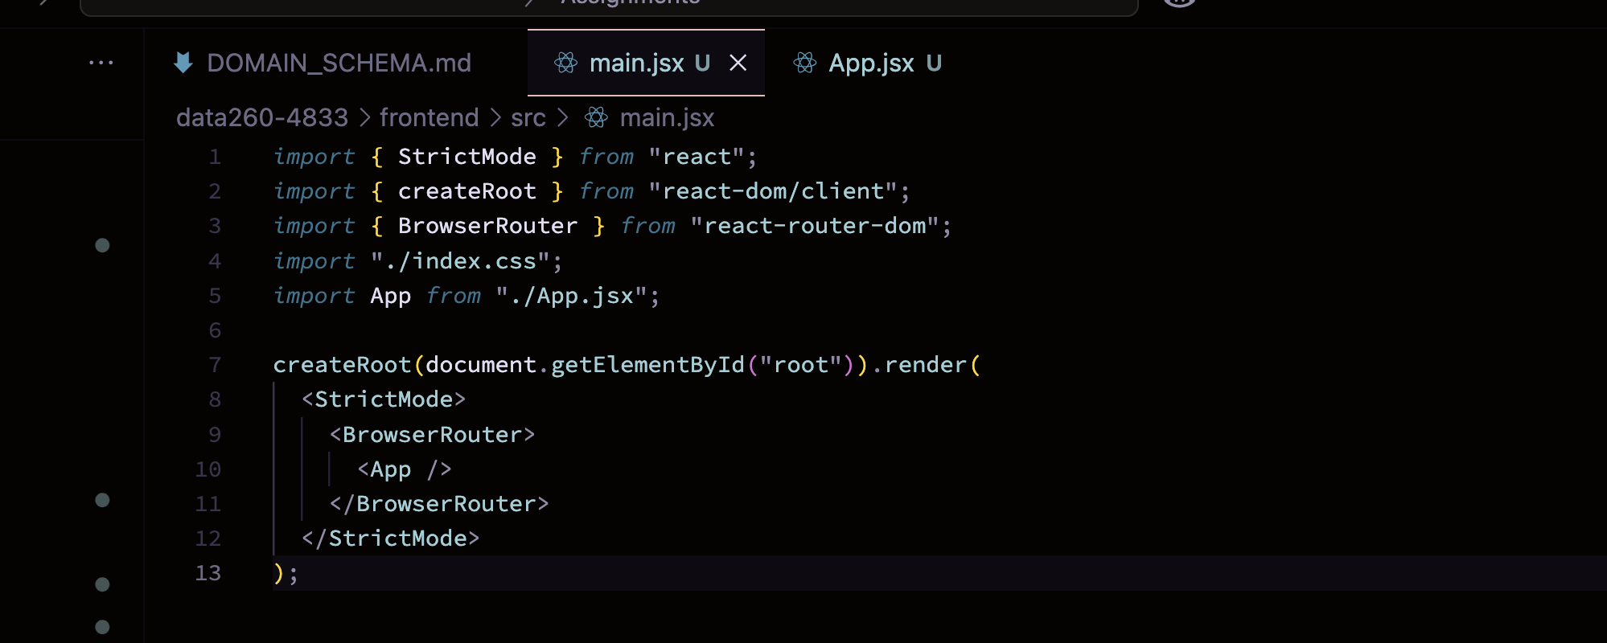
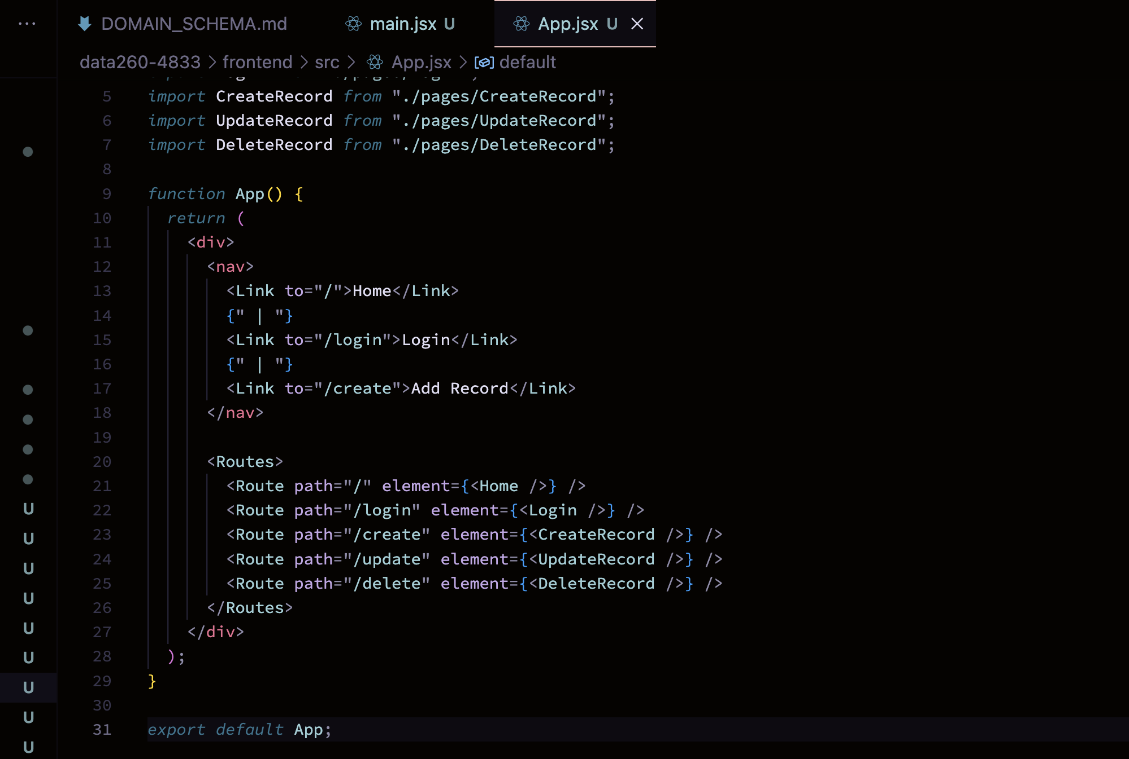
Result / Observation:
The React application successfully navigates between the Home, Login, Create, Update, and Delete routes using React Router.

1.2 Login Component – Login.jsx
I created a Login.jsx component containing email and password fields as required. I used React's useState hook to maintain the current value of each input. The form currently captures the credentials on submission; it will be connected to the FastAPI server-side session endpoint in Part 2.
I used the useState hook to store the current email and password entered by the user. Each input updates its corresponding state value through the onChange event. The handleSubmit function prevents the default browser form submission and currently captures the entered credentials. The actual authentication request will be connected to FastAPI in Part 2.
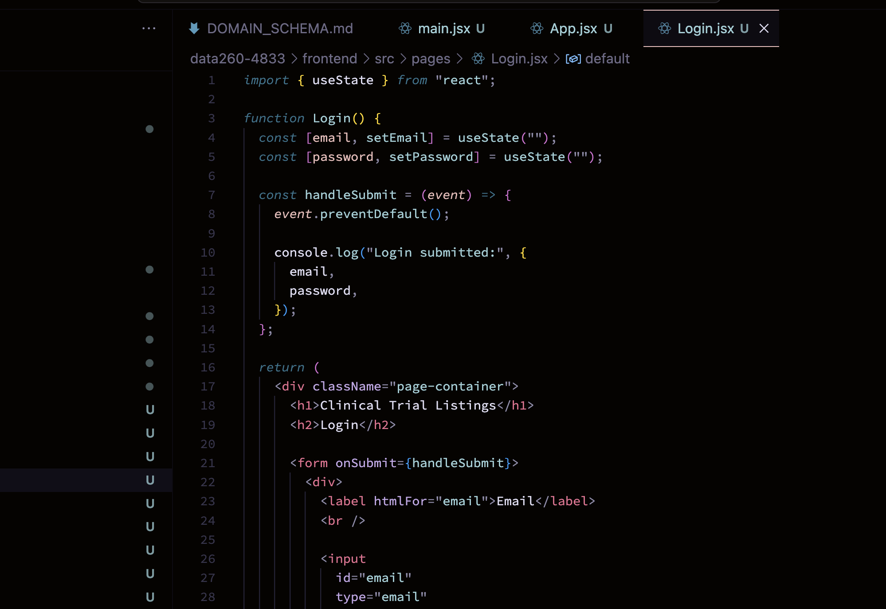
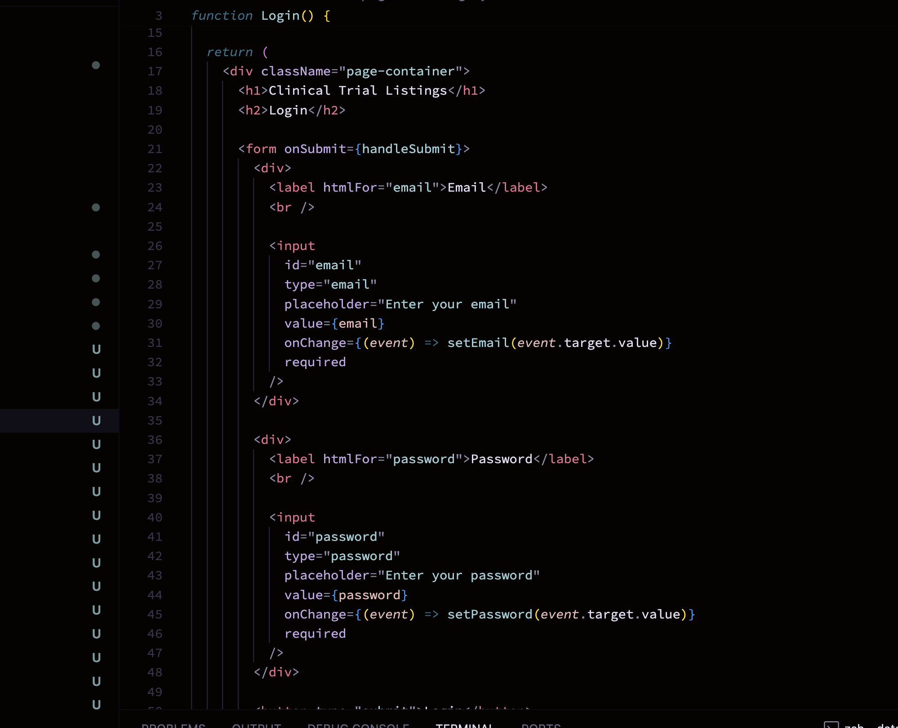
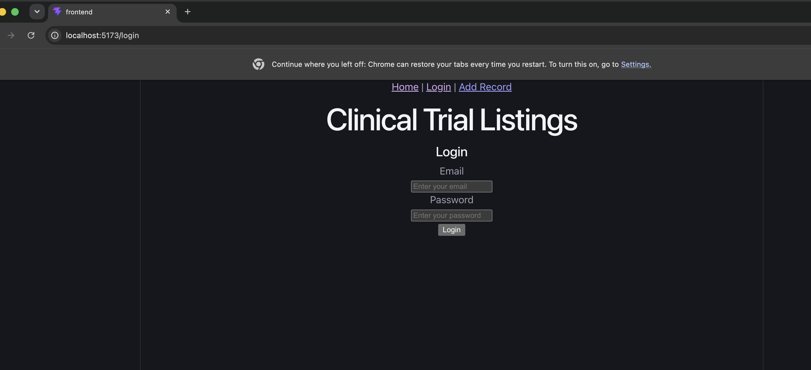
Screenshot1 : localhost:5173/login showing the complete login form.
Result / Observation: The Login component successfully displays the required email and password fields and captures the values entered by the user. Backend authentication will be connected in Part 2.

1.3 Home Page – Home.jsx
1.3A Unauthenticated Home
The Home.jsx component is rendered at the root route /. At this stage, when there is no authenticated session, the page displays the message Login required. This ensures that protected clinical trial data is not shown to an unauthenticated user.
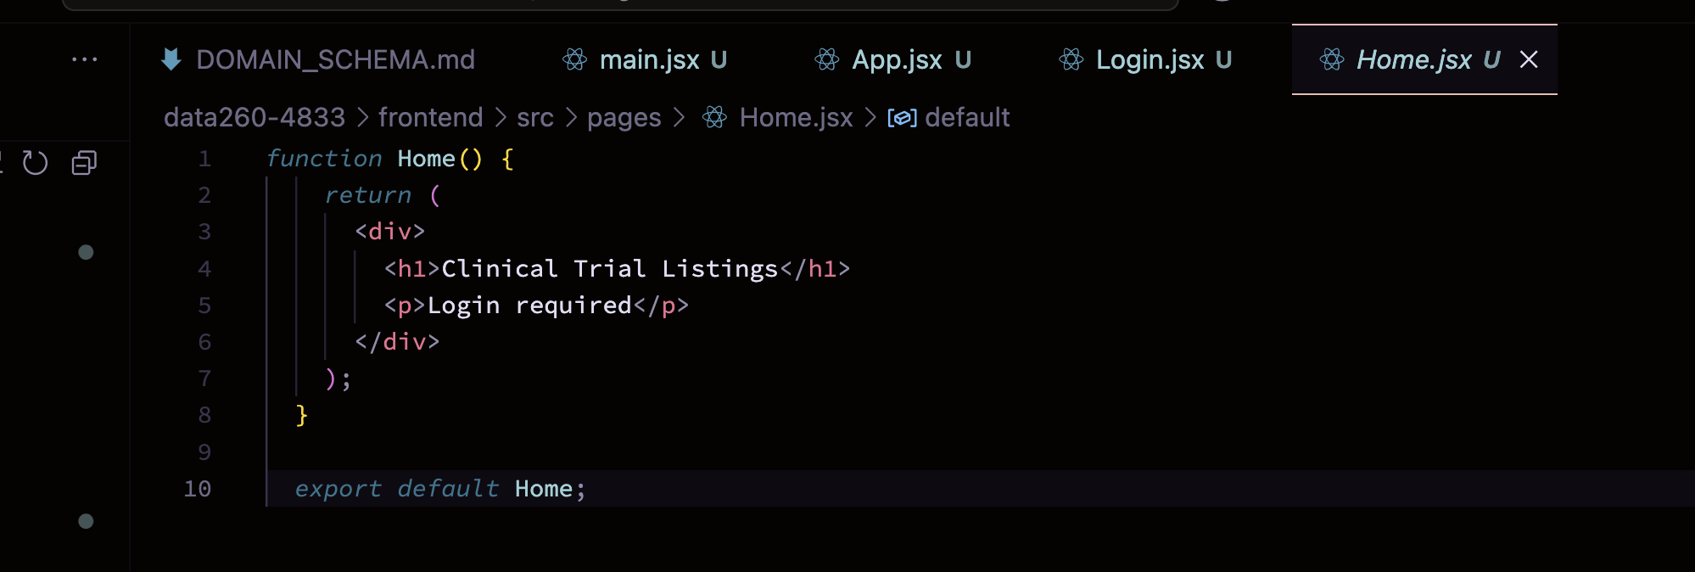
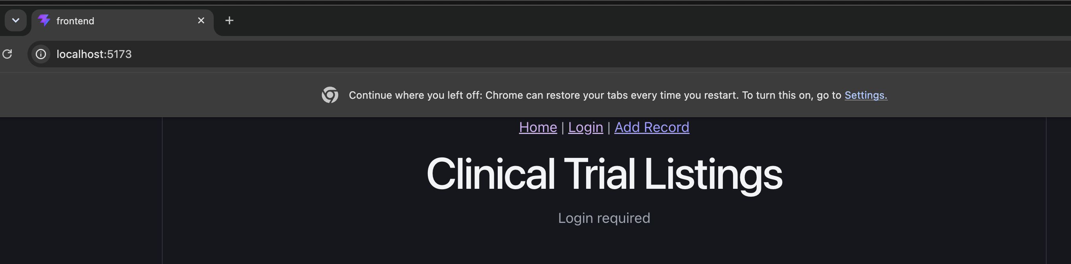
Result / Observation:
The Home page correctly displays Login required when the application is accessed without an authenticated session.
1.3B Authenticated Home / Record List:
After a successful login, the Home component verifies the authenticated session through the FastAPI /api/me endpoint and then requests the clinical trial records from /api/hw4/trials. Because the test records had already been deleted during CRUD testing, the authenticated Home page correctly displayed No clinical trials found.
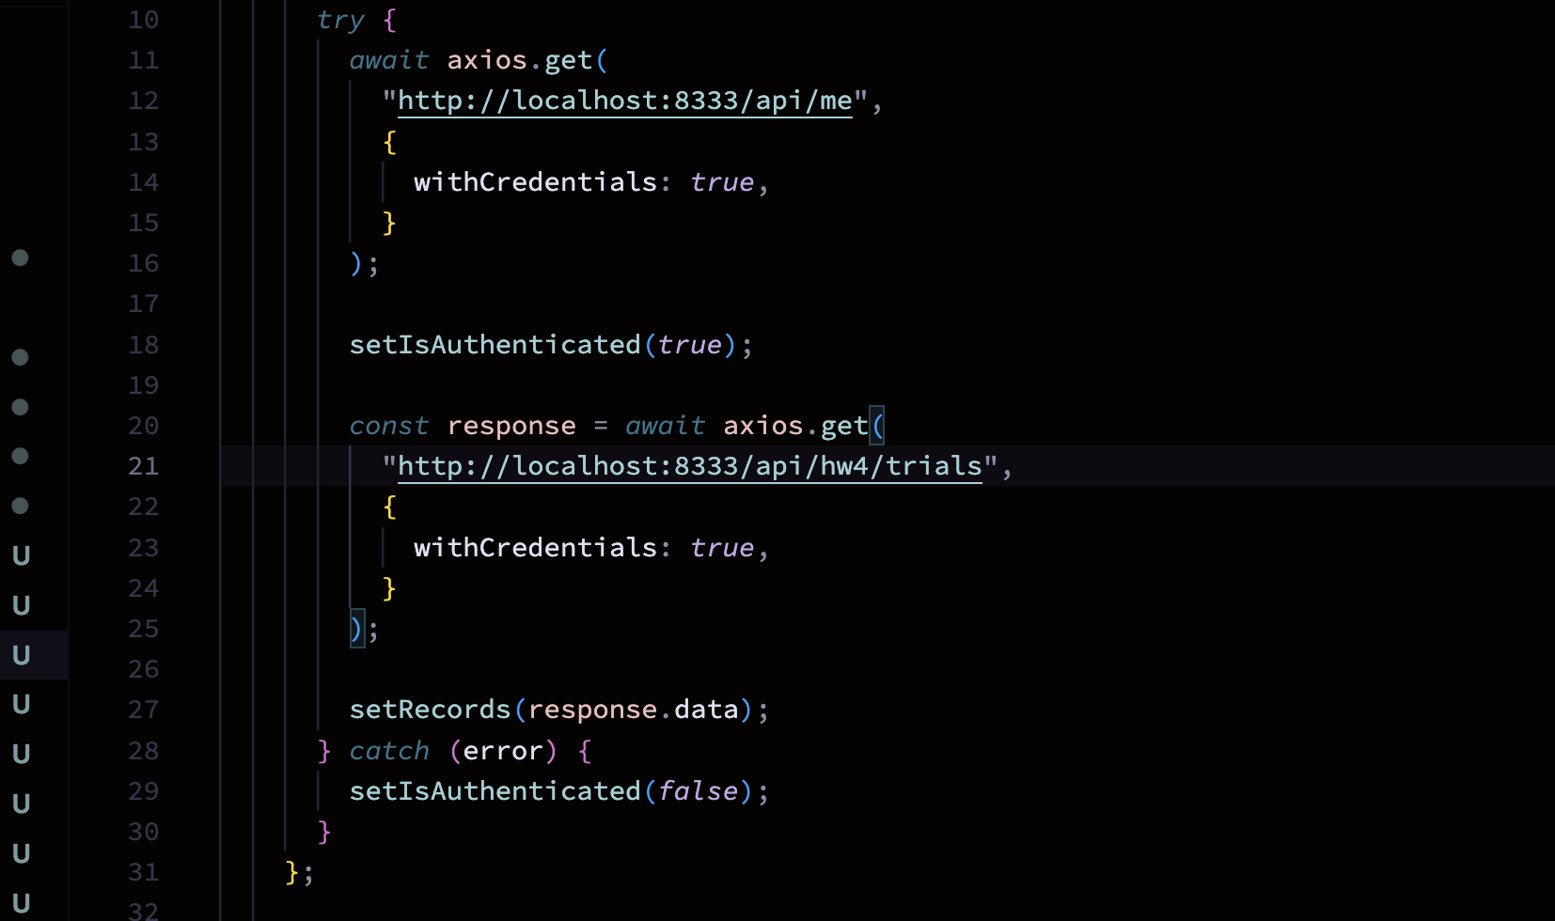

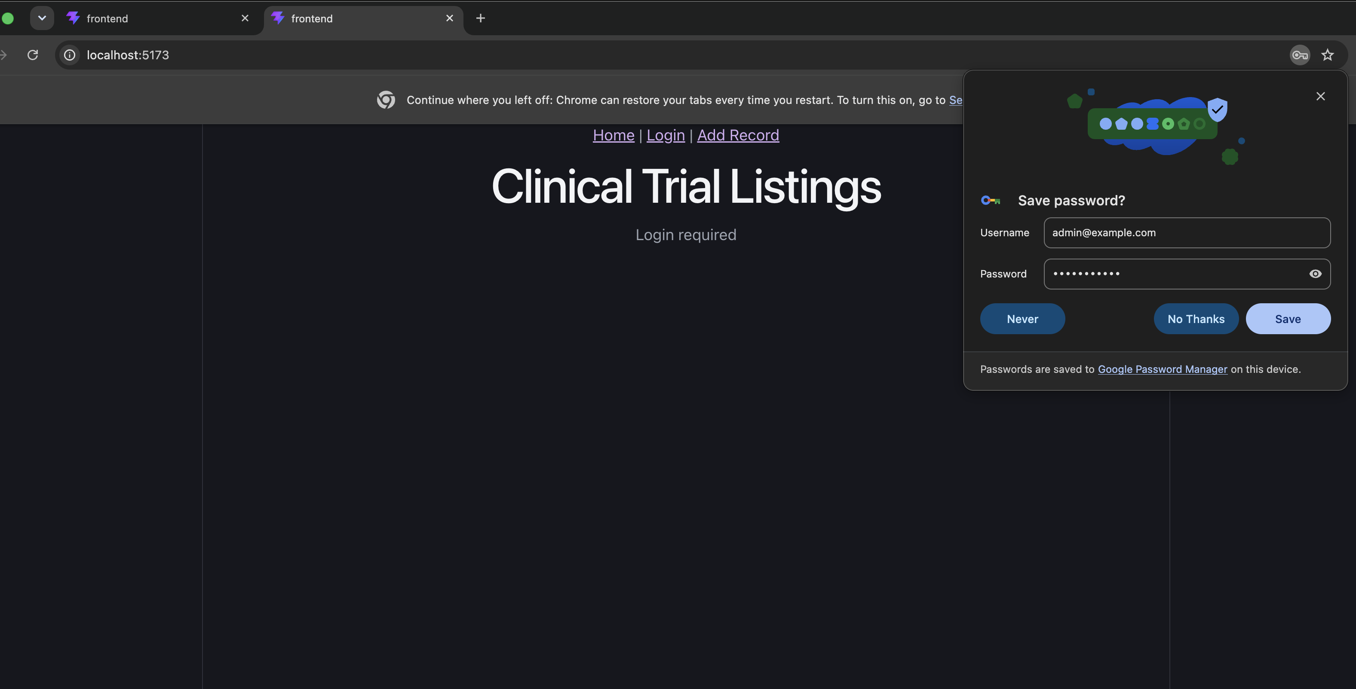
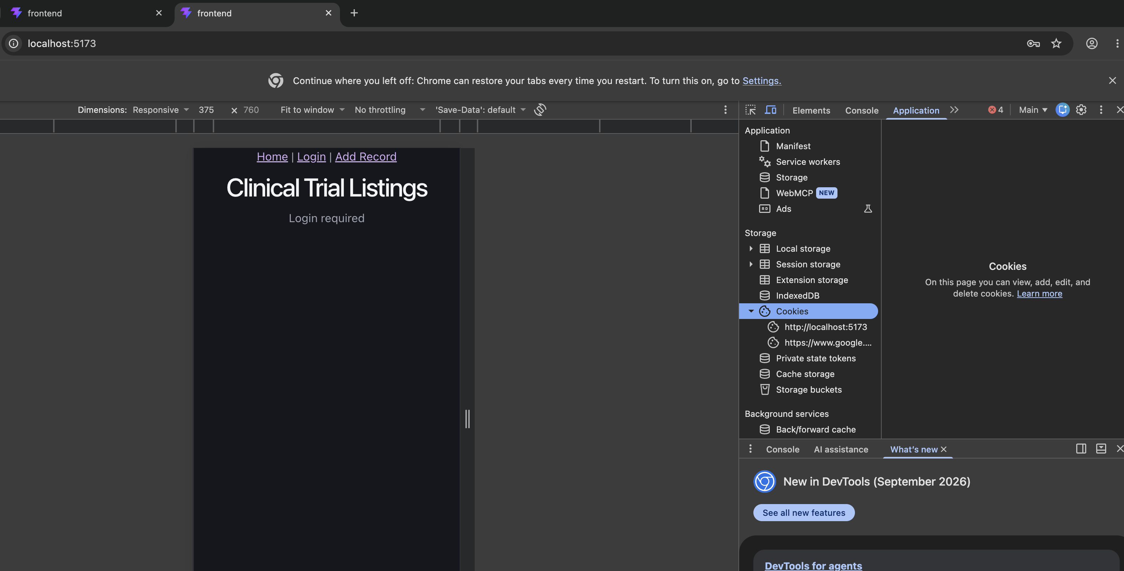
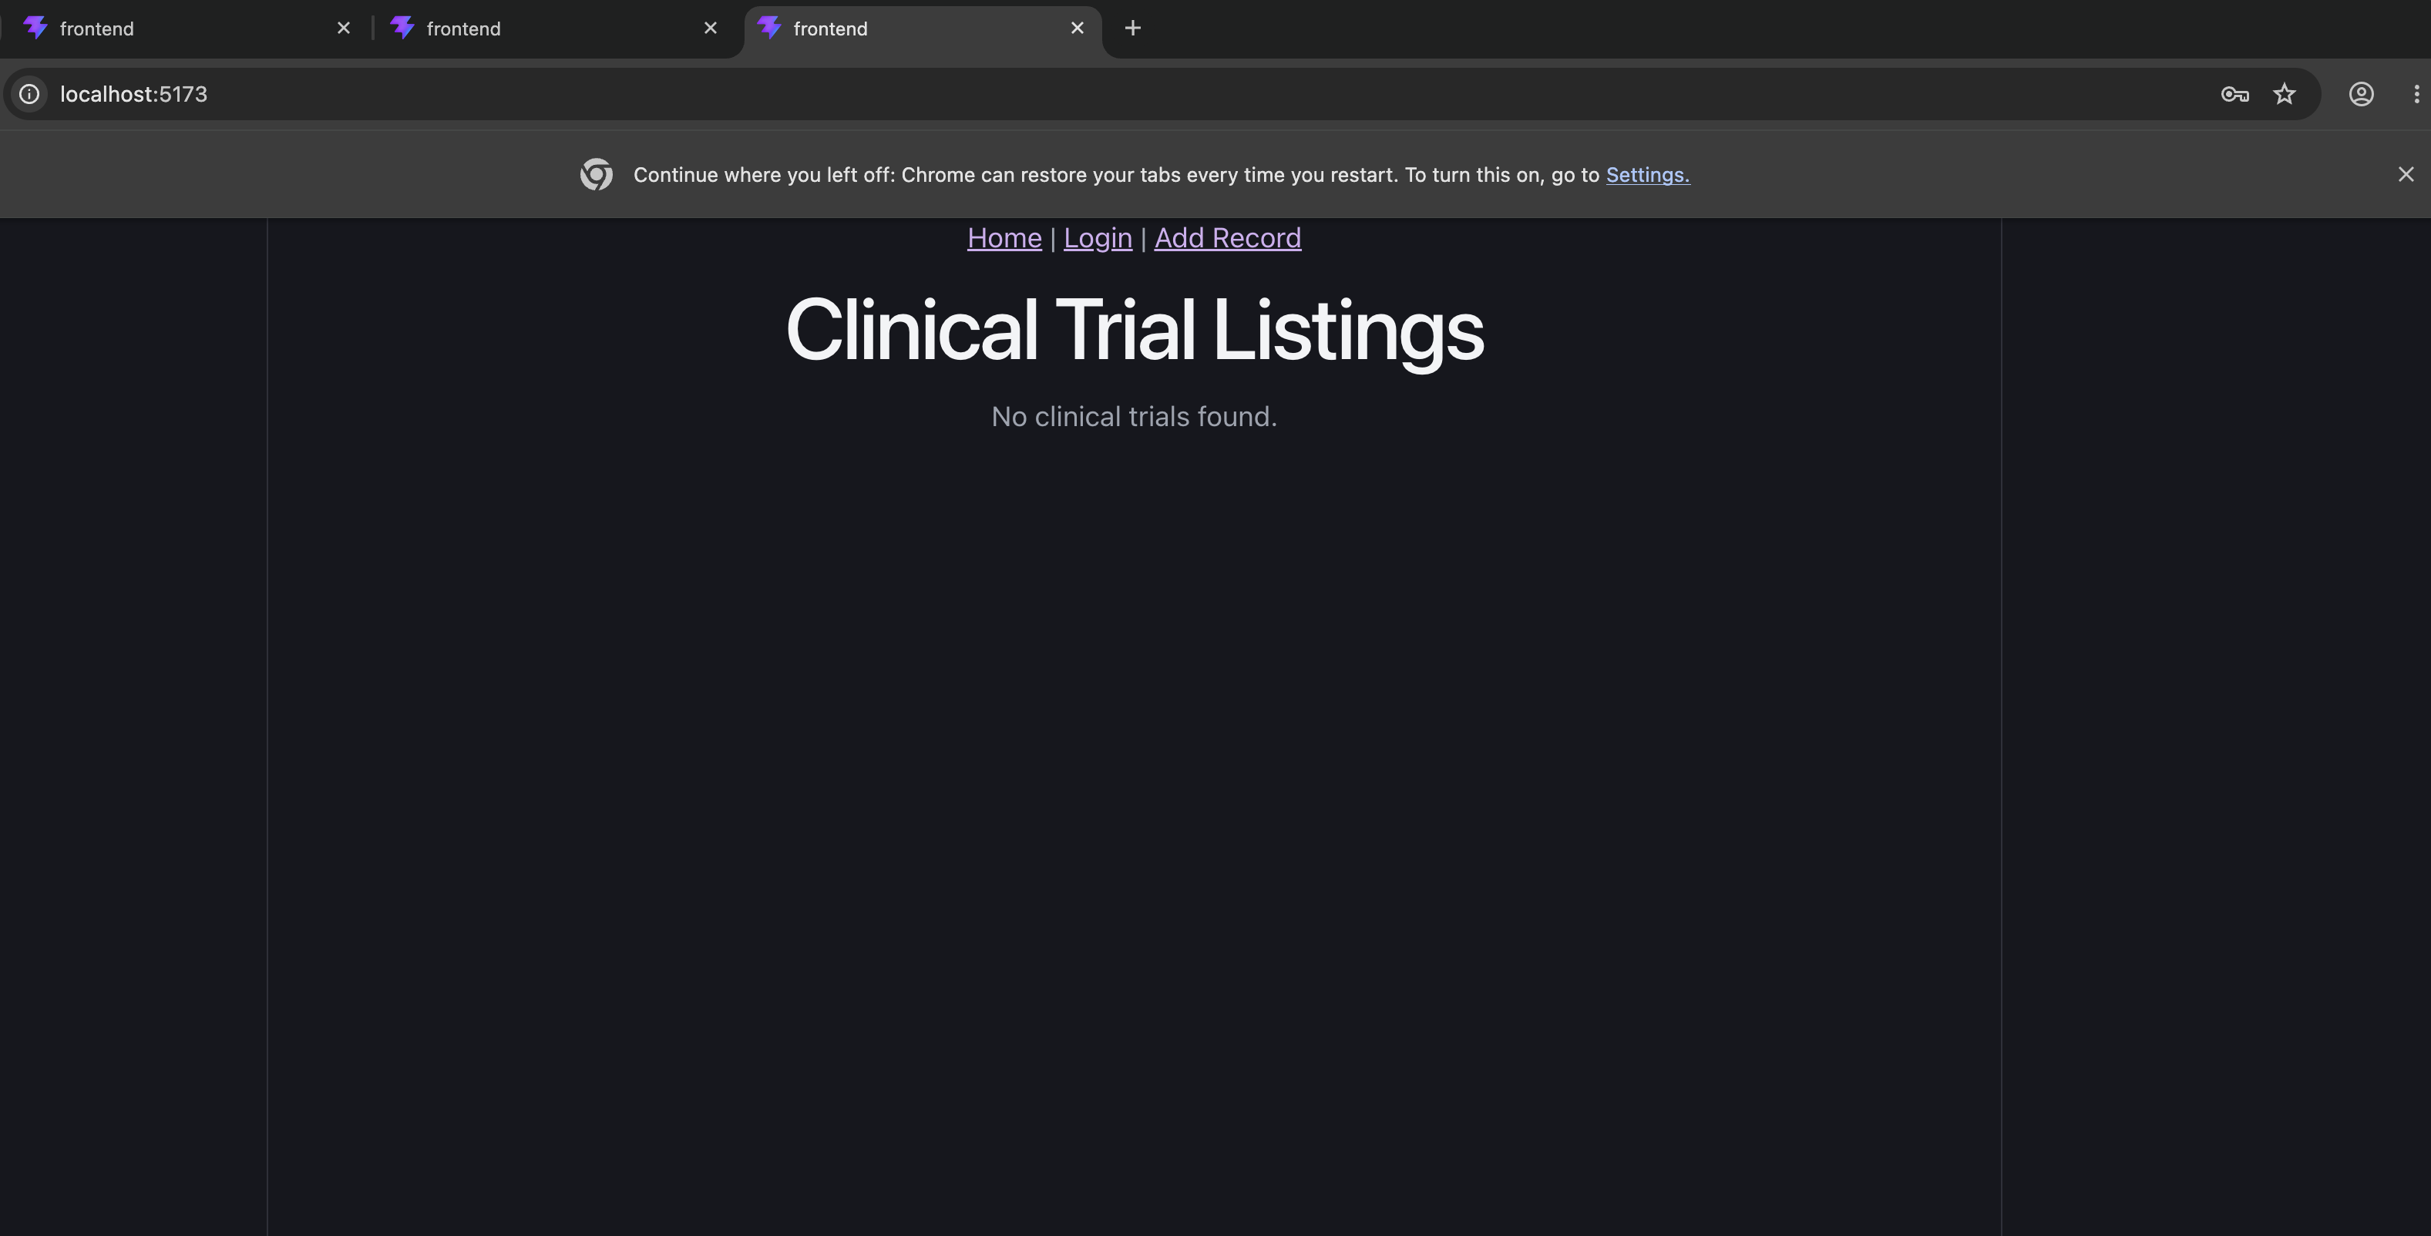
Screenshot: Authenticated Home page successfully connected to FastAPI/MySQL with no current clinical trial records.

1.4 Create Record – CreateRecord.jsx
I connected CreateRecord.jsx to the protected FastAPI POST endpoint using Axios. The component sends the trial title and sponsor to /api/hw4/trials with withCredentials: true, allowing the browser to include the HTTP-only session cookie. After successful creation, the user is redirected to the Home page.
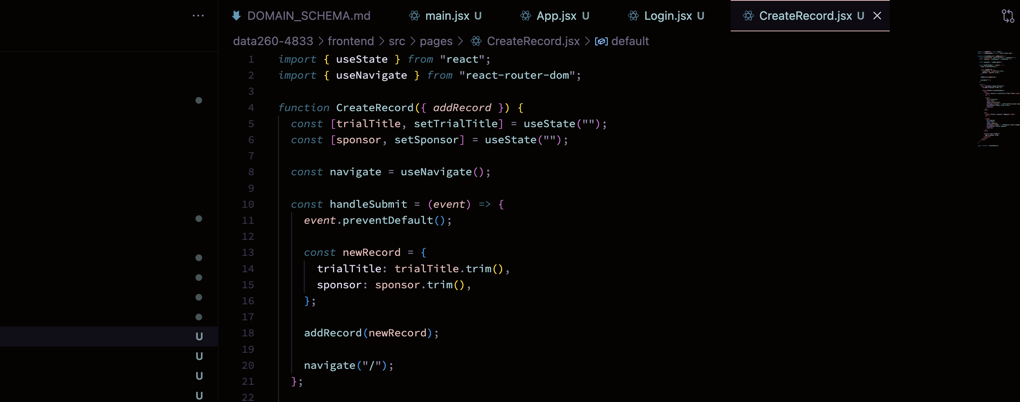
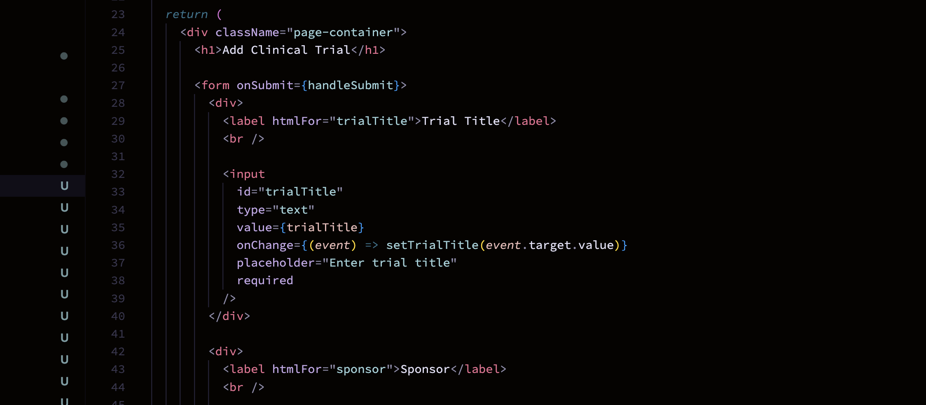
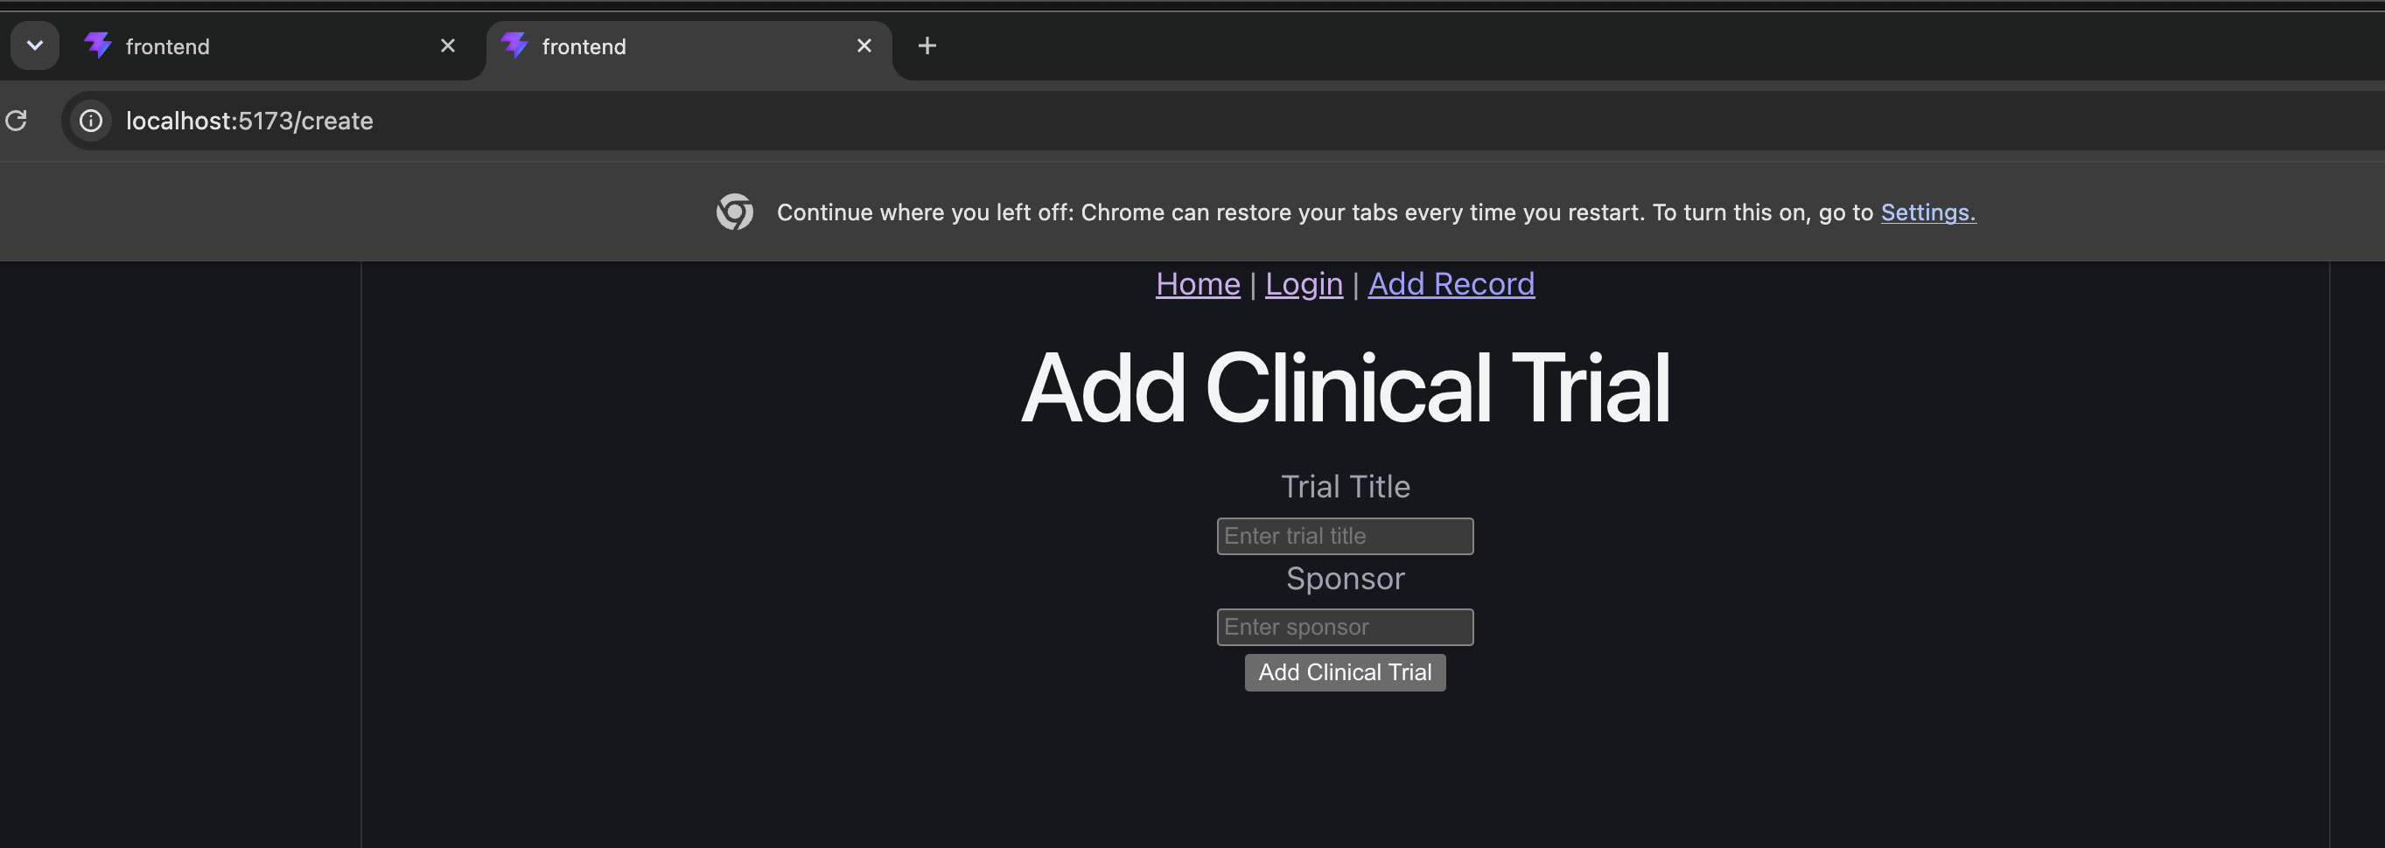

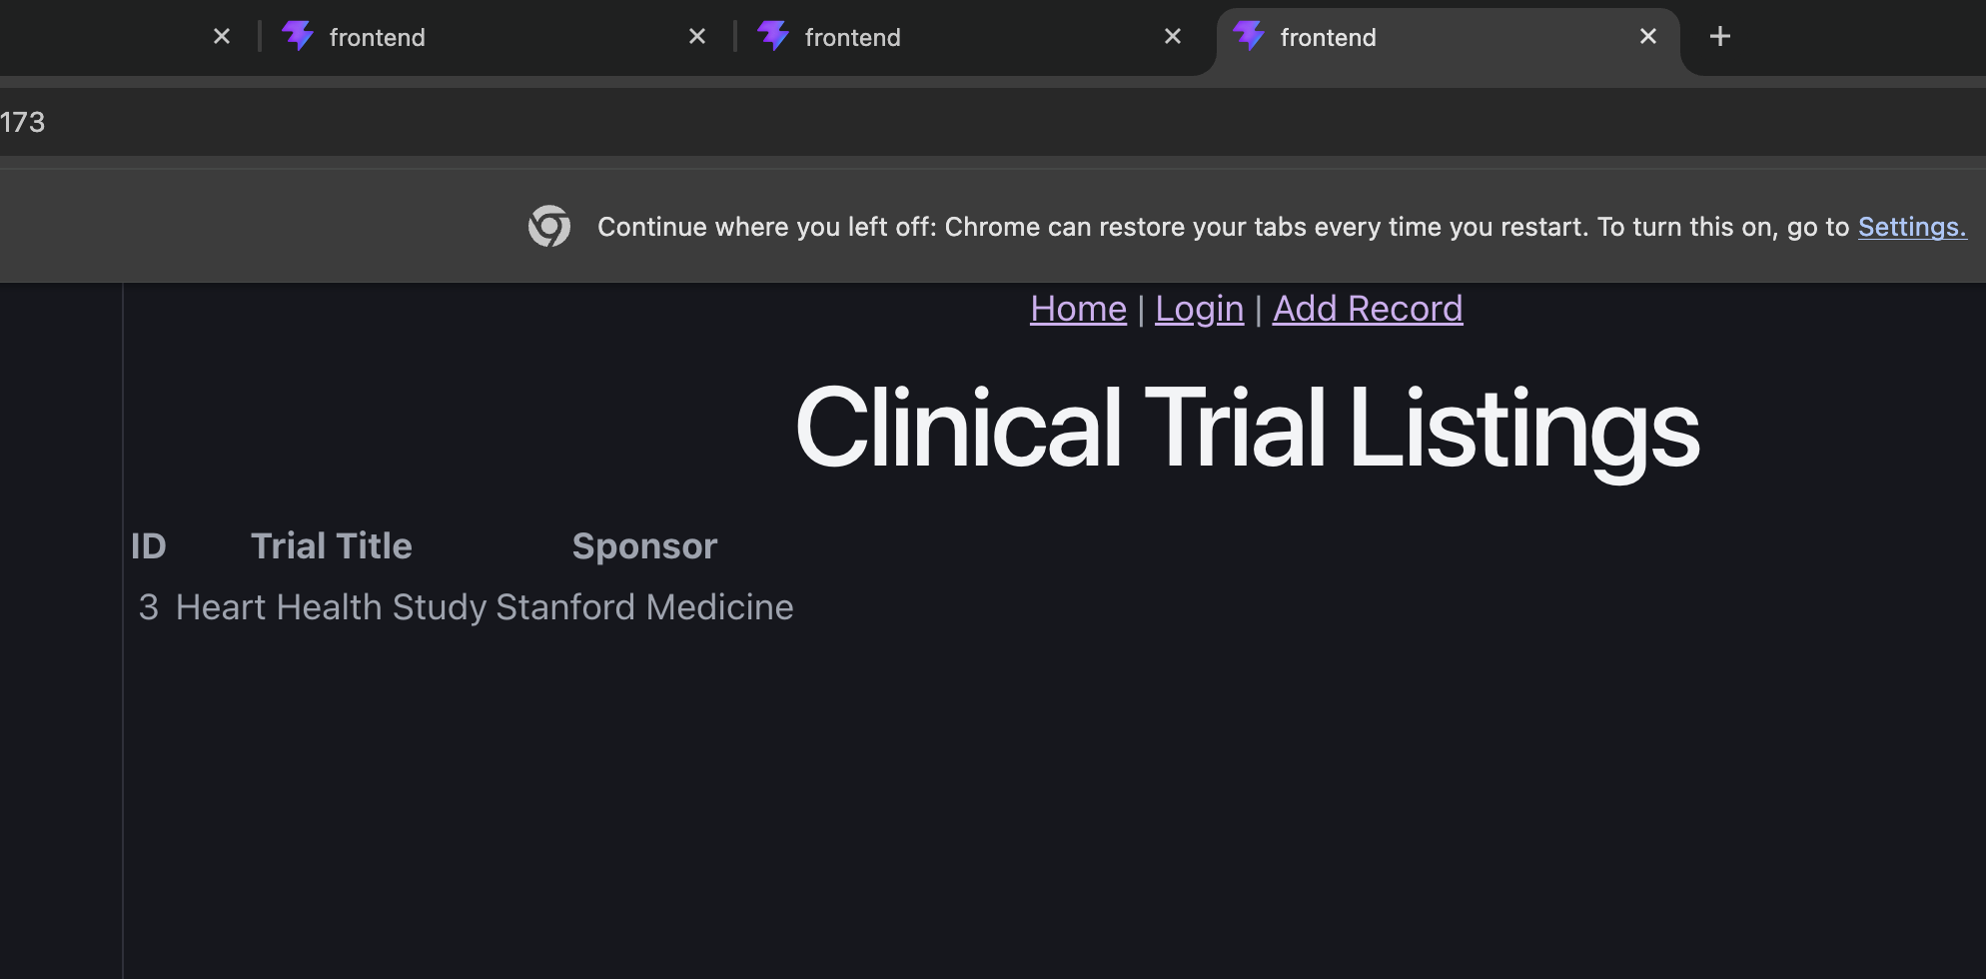
Screenshot : Home page showing the new record after submission

Result / Observation: The Create Record form successfully accepts the clinical trial title and sponsor values. On submission, the component calls the addRecord function passed through props and redirects the user to the Home route using useNavigate.

1.5 Update Record:
I connected UpdateRecord.jsx to the protected FastAPI PUT endpoint. The component sends the selected trial ID together with the updated trialTitle and sponsor values. After the backend commits the change to MySQL, the user is redirected to the Home page.
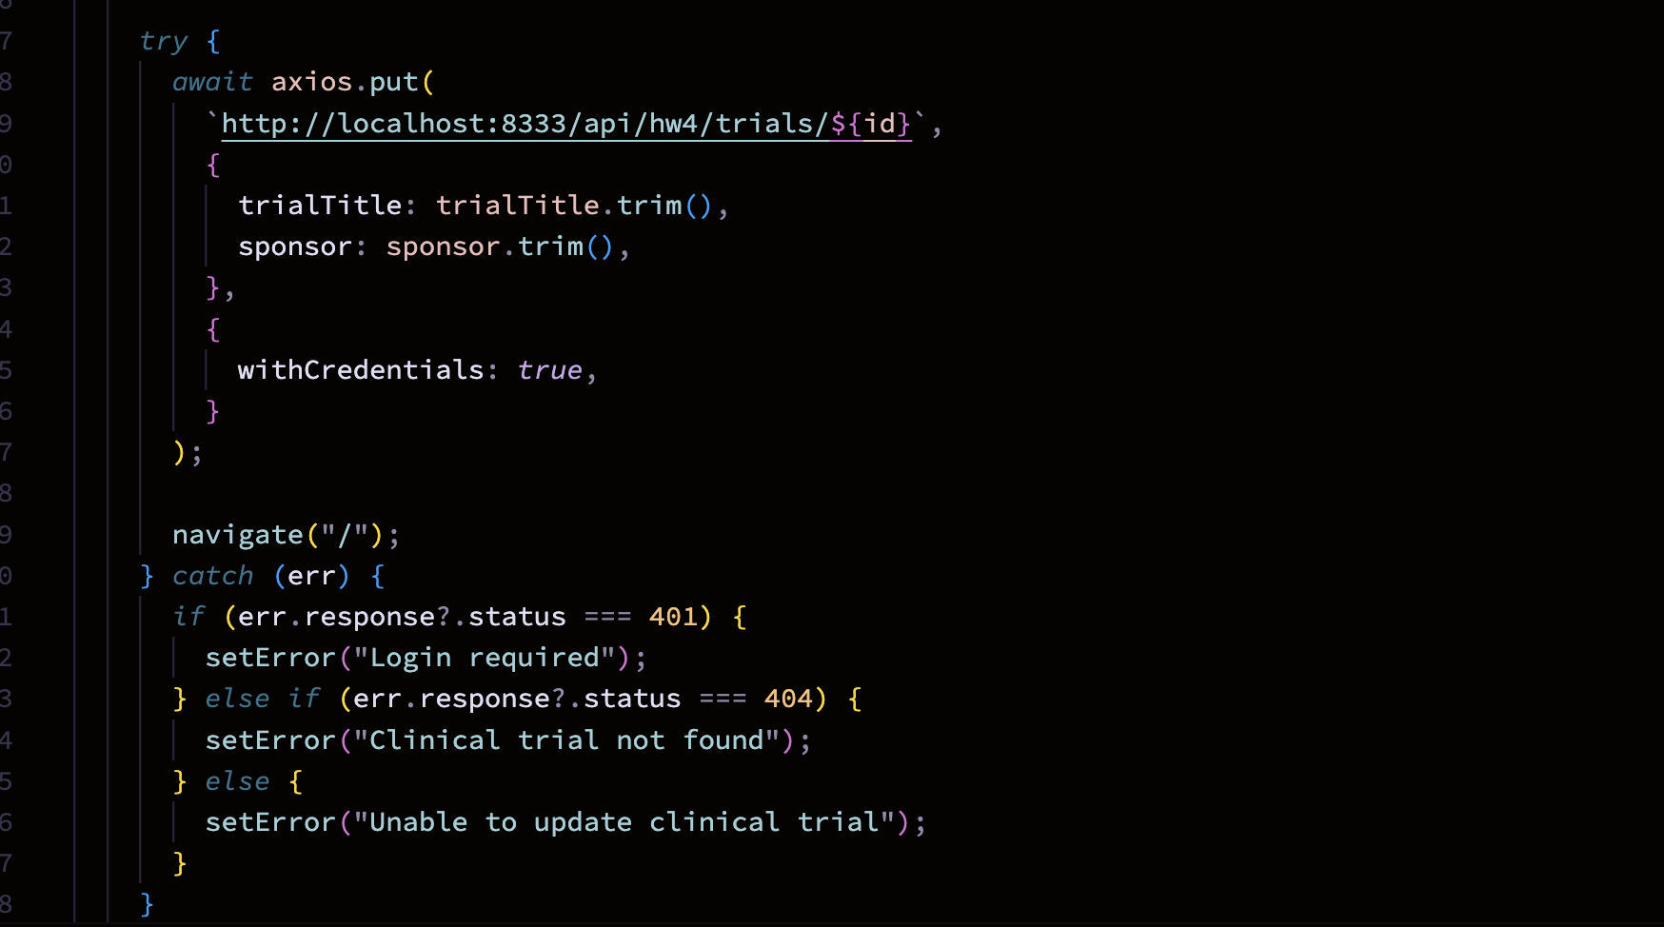
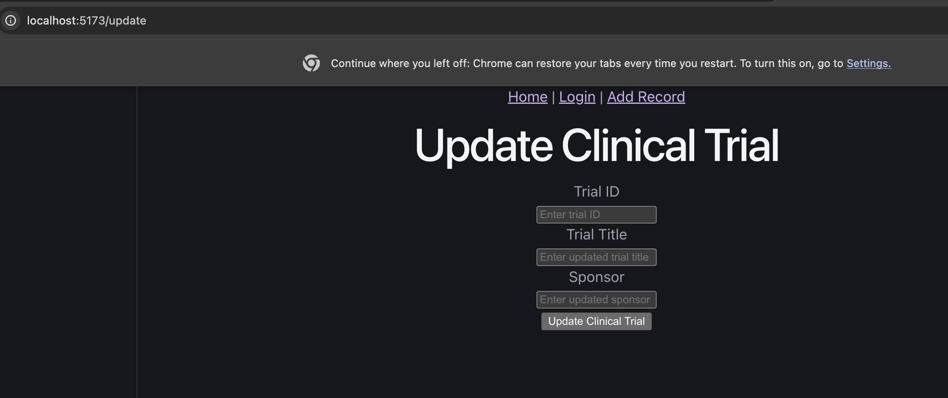Screenshot: Update form filled in before submission
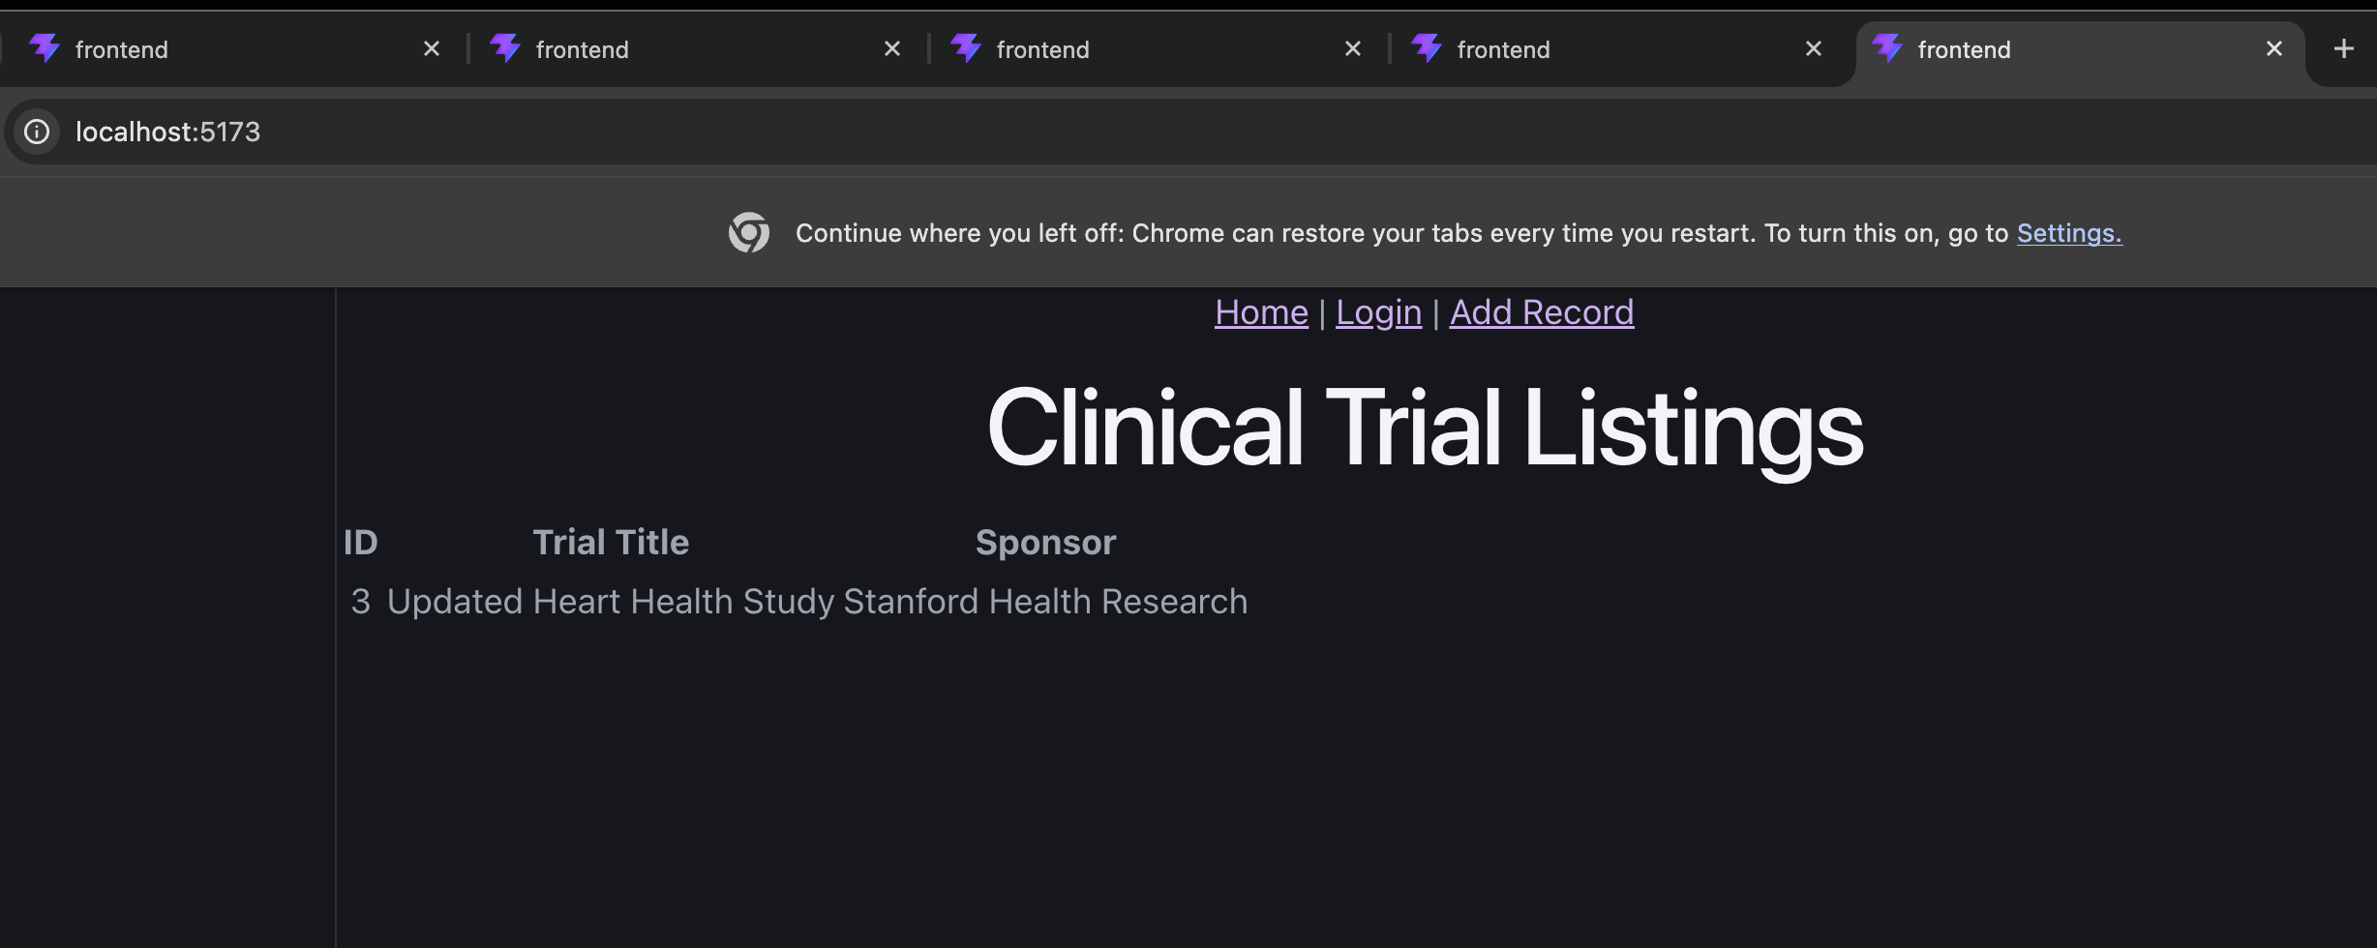Screenshot: Home page showing the updated record

Result / Observation: The selected clinical trial was successfully updated through the FastAPI backend and the modified values were displayed on the Home page.

1.6 Delete Record:
I connected DeleteRecord.jsx to the protected FastAPI DELETE endpoint. The component accepts the selected clinical trial ID and sends an authenticated DELETE request to the backend. After the record is removed from MySQL, the user is redirected to the Home page.
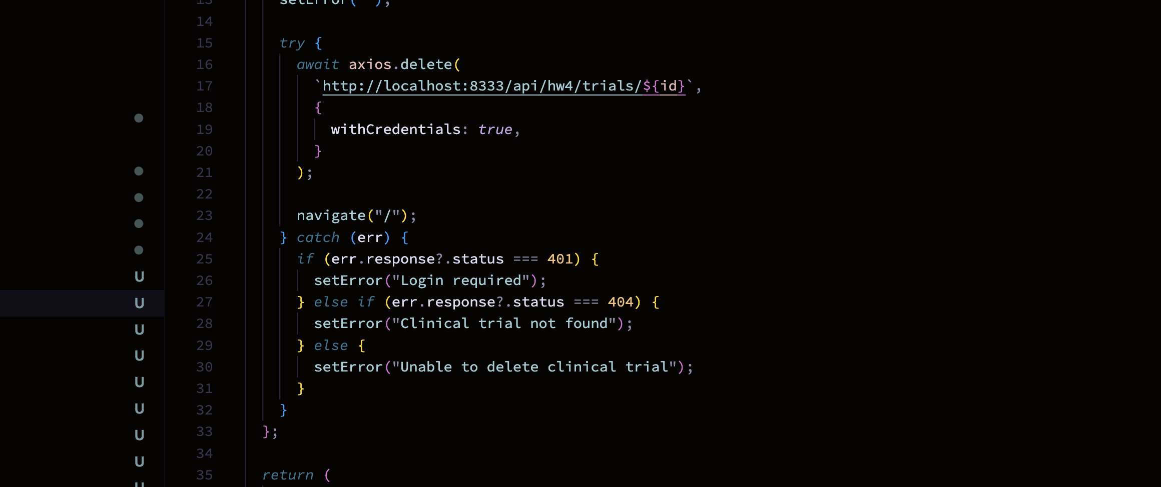
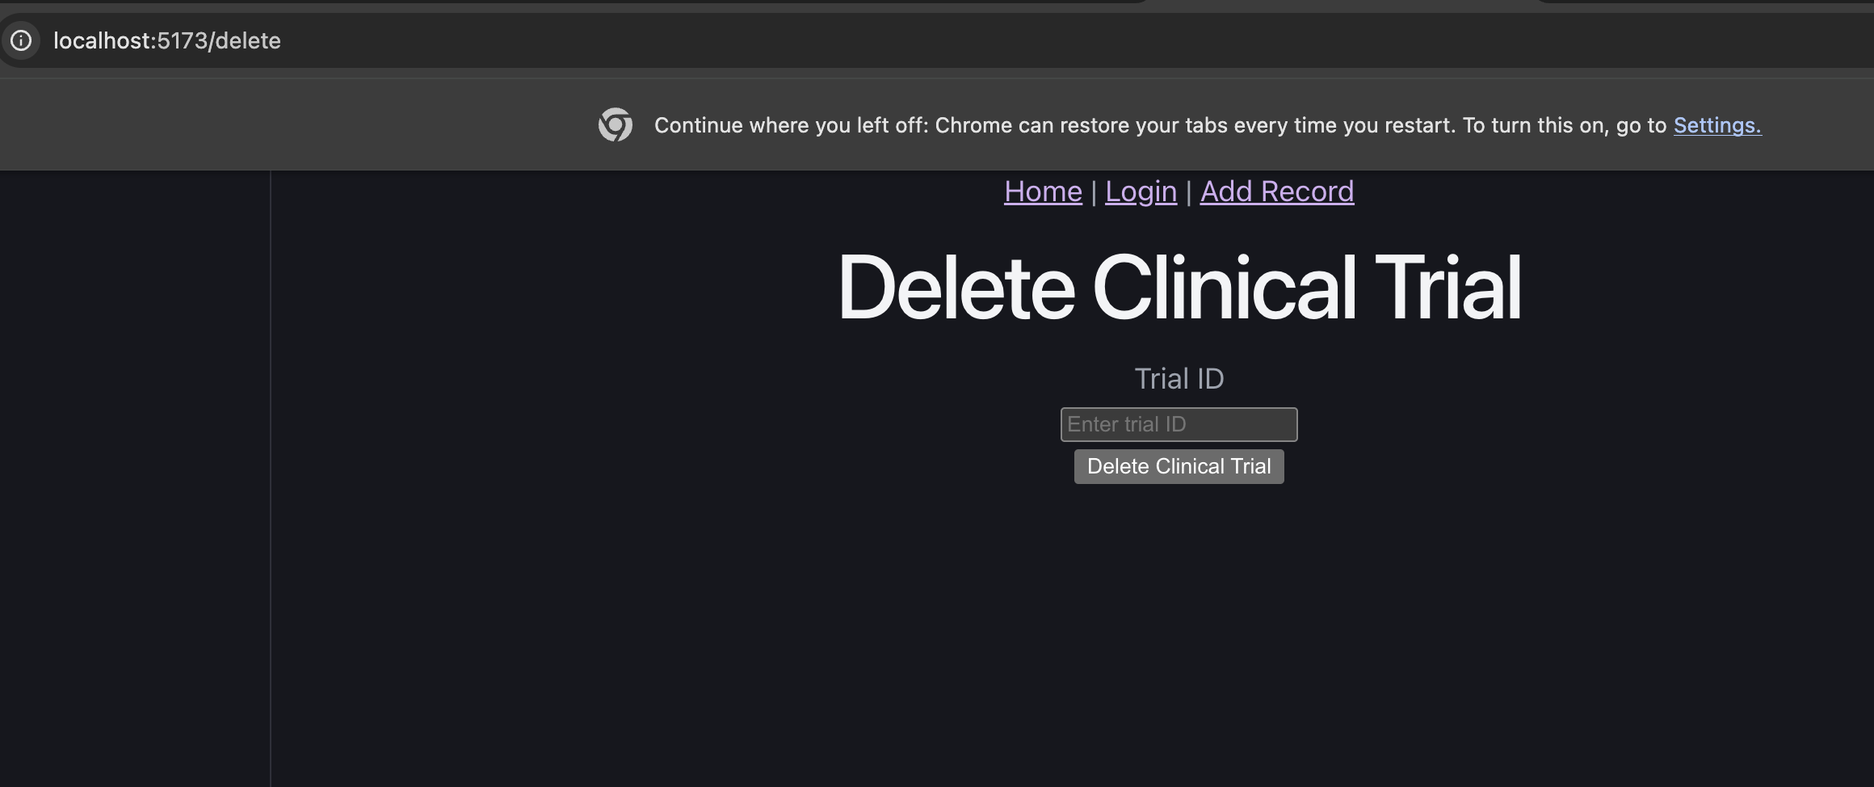
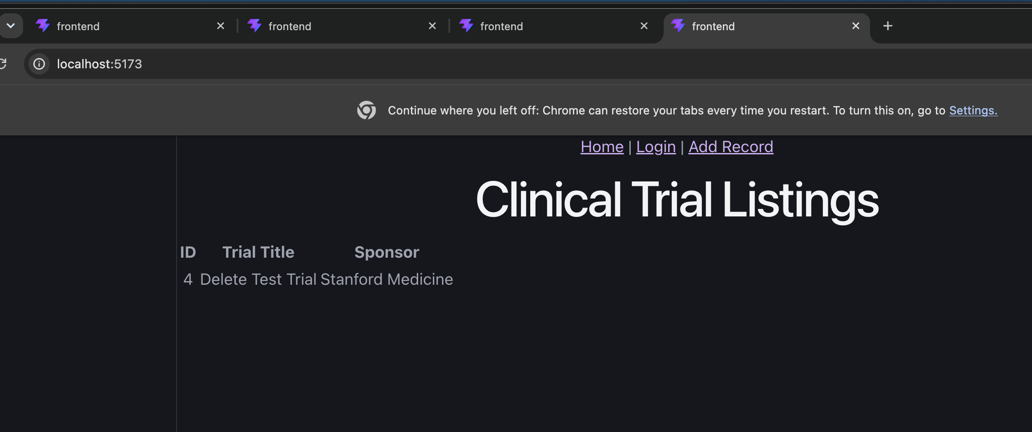
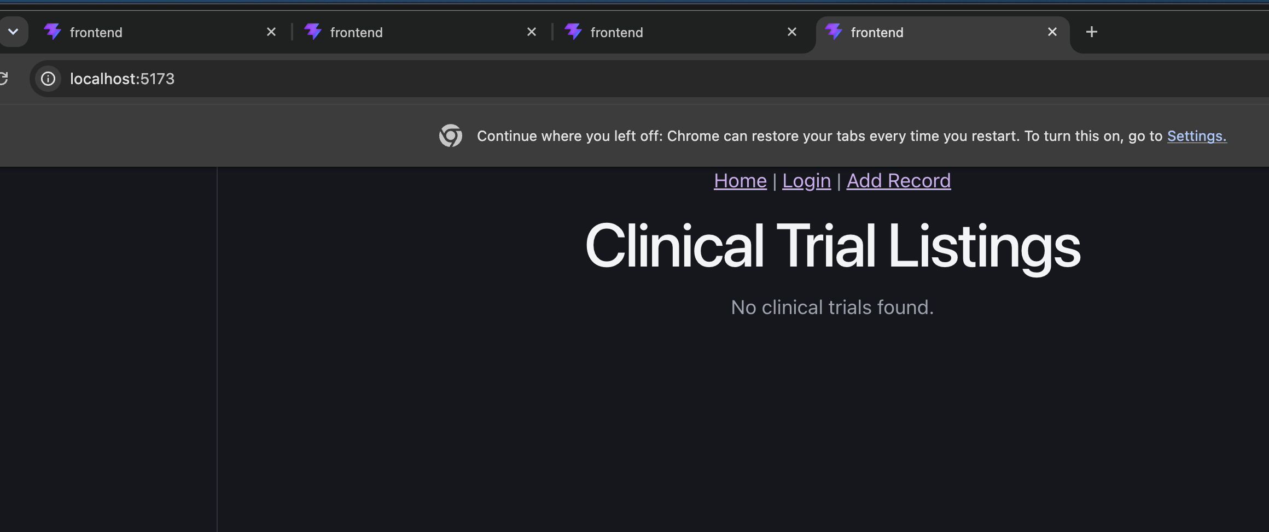 Screenshot: Home page after successful deletion, confirming that the clinical trial record is no longer present.
Result / Observation: The selected clinical trial was successfully deleted through the FastAPI backend. After deletion, the user was redirected to the Home page, where the record was no longer displayed.

1.7 React Hooks, Props, and Router:
I used React hooks and React Router throughout the client application. useState manages form inputs, authentication errors, and record data, while useEffect loads authenticated clinical trial data when the Home component is rendered. useNavigate redirects the user after successful login and CRUD operations.
I also passed the shared apiBaseUrl value from App.jsx to the Create, Update, and Delete components through props. React Router defines separate routes for Home, Login, Create, Update, and Delete pages.
Props:
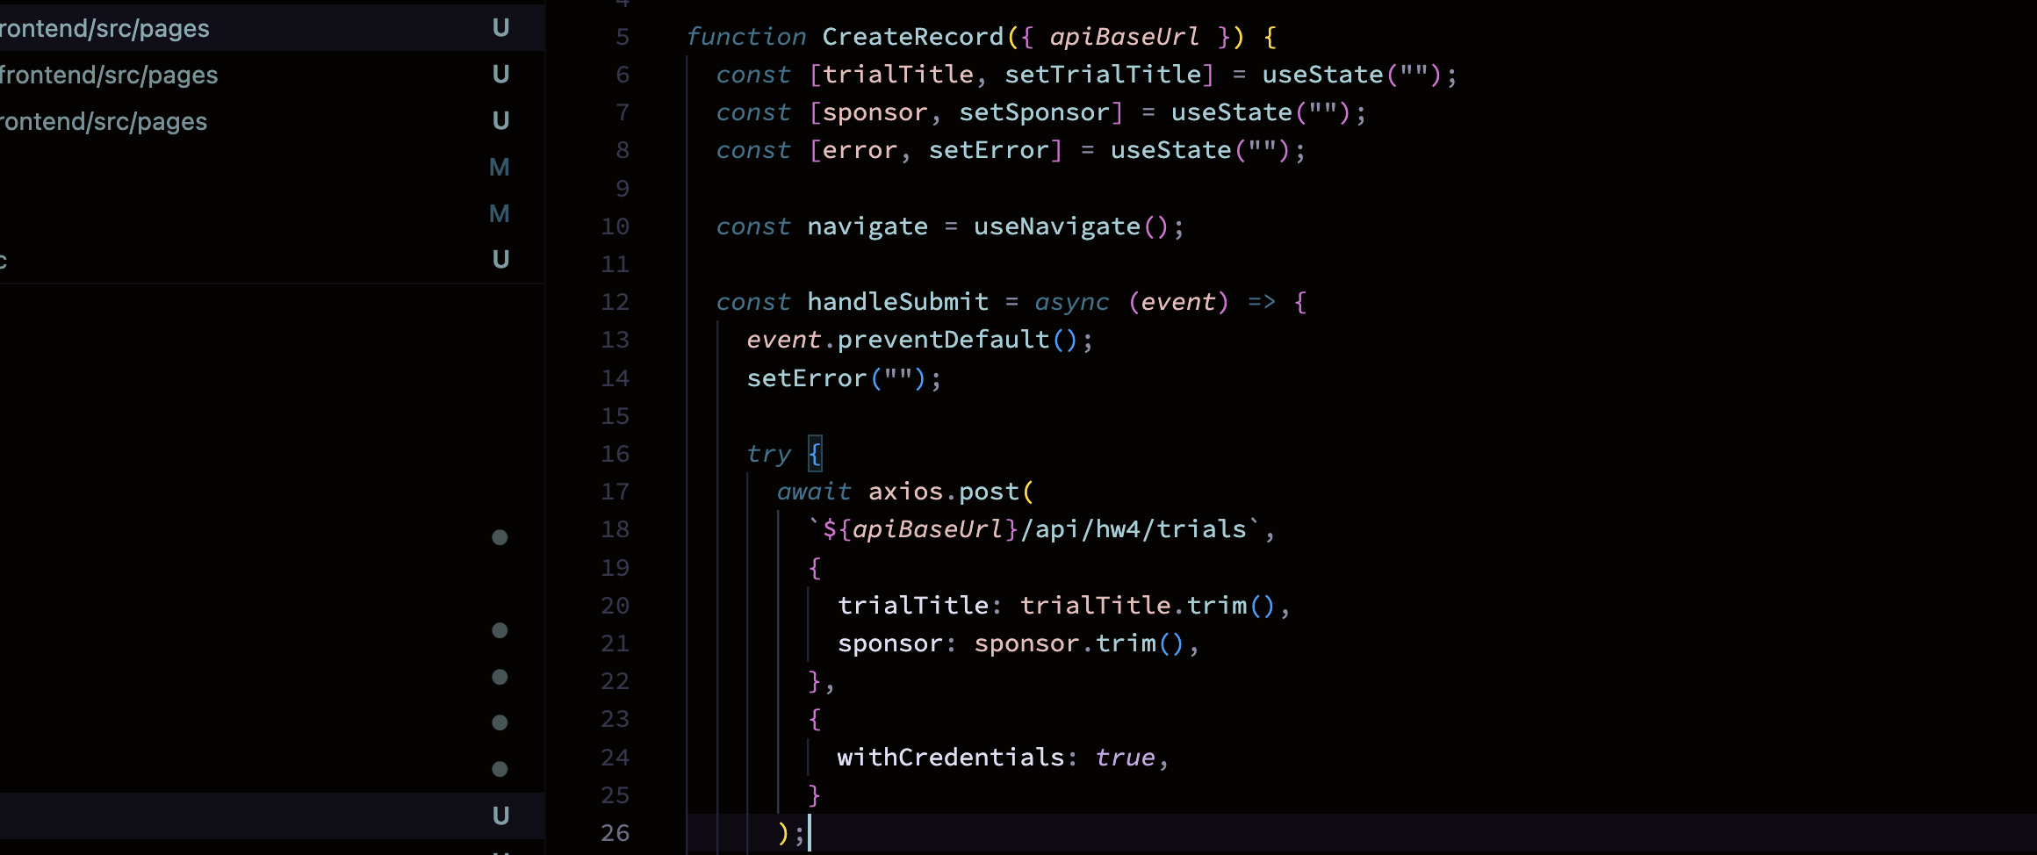
Hooks:
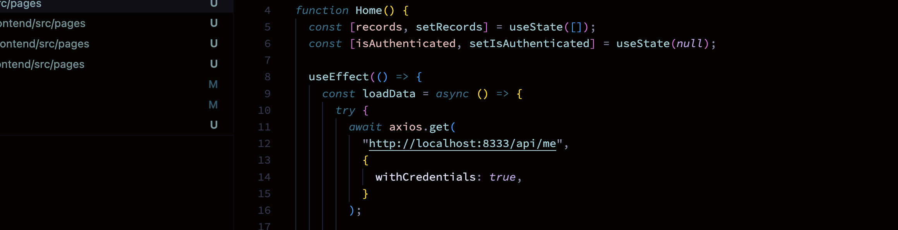
Result / Observation: React hooks successfully manage component state, data loading, and navigation. Props are passed from the parent App component to the Create, Update, and Delete components, and React Router provides navigation between all required pages.

PART-2:

MySQL Database Setup:
For this assignment, I used MySQL 9.4.0, installed through Homebrew on my MacBook.
I started by checking whether MySQL was installed and whether the database server was running. After confirming that the service was active, I connected to MySQL using the root account.
I created a new database named s4833_rel using my assigned prefix, as specified in the homework instructions.
I then selected the database and verified the active database name and MySQL server version.

SQL commands:
CREATE DATABASE IF NOT EXISTS s4833_rel;
USE s4833_rel;
SELECT DATABASE();
SELECT VERSION();
Output: The database was created successfully. The database verification returned s4833_rel, and the server version was 9.4.0.
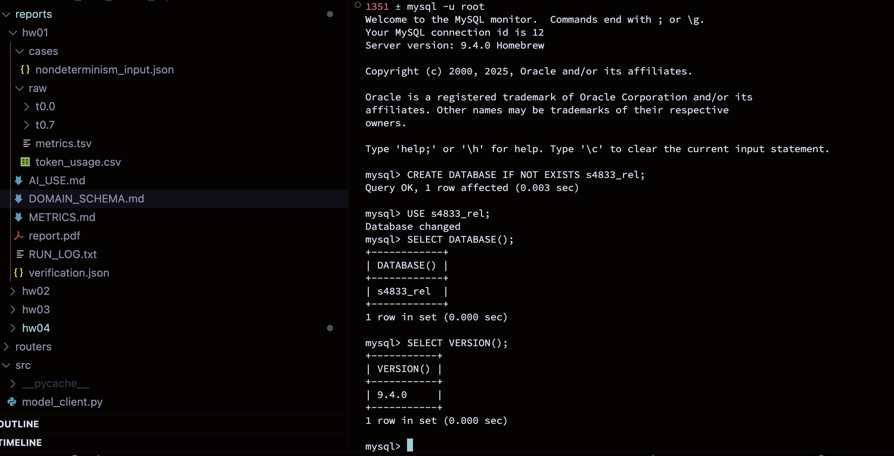 Screenshot 1: MySQL database creation and verification.

2.2 SQLAlchemy Database Connection:
I connected the FastAPI application to the s4833_rel MySQL database using SQLAlchemy and PyMySQL. I created the required db_session_basede26 session factory so API requests can open and close database sessions safely.
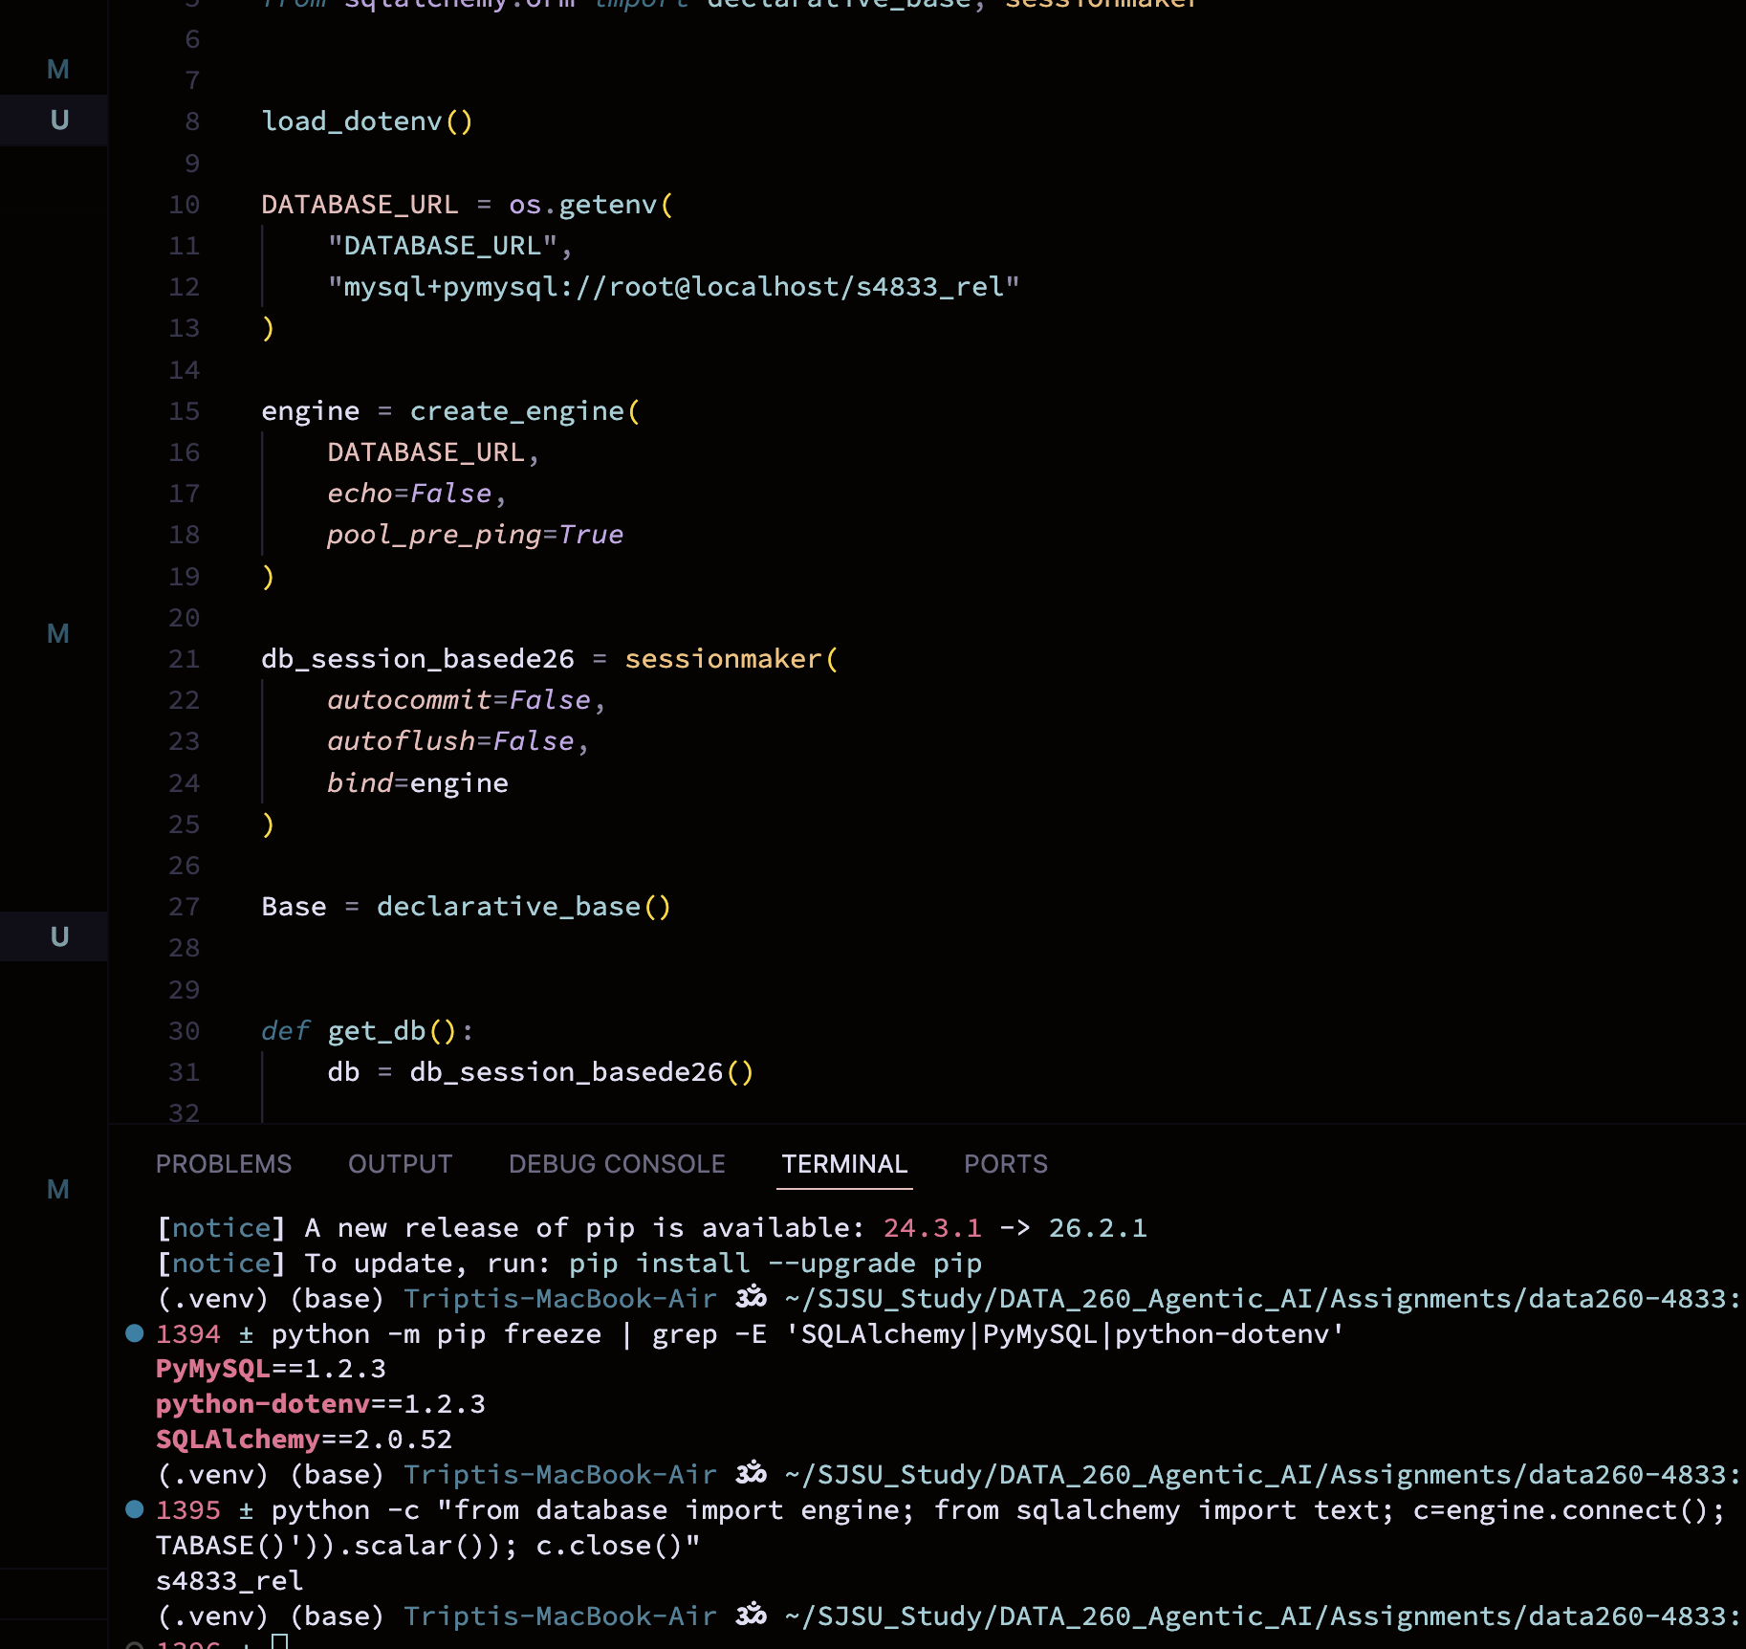
Screenshot 2: SQLAlchemy connection successfully verified against the s4833_rel database.

2.3 Primary Domain Table:
I created the clinical_trials table using a SQLAlchemy model. The id field is configured as an auto-incrementing primary key. The primary domain field is trialTitle and the secondary domain field is sponsor. I retained the additional clinical trial fields from my previous homework so the existing domain application can continue to be extended.

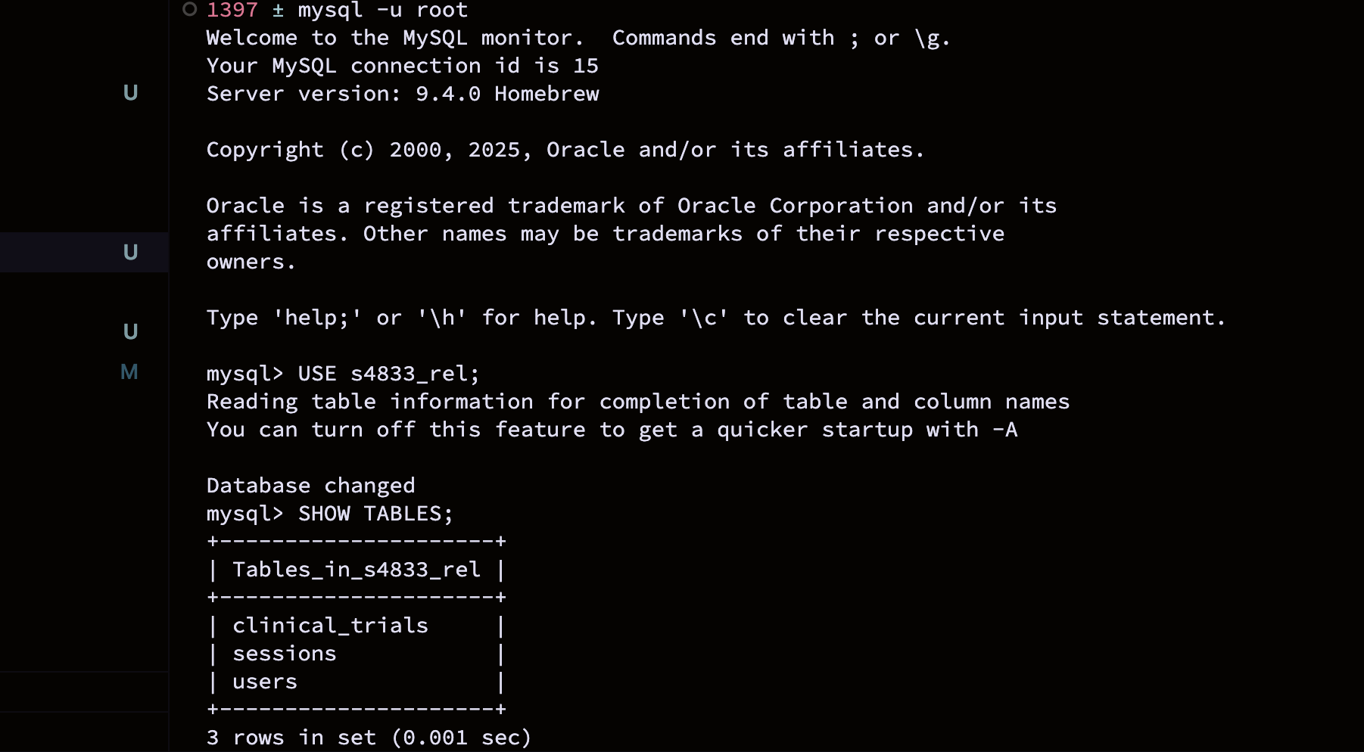
Screenshot 3 — Tables created

2.4 Users Table
I created the users table for authentication. It contains an auto-incrementing id, the user's name, a unique email, and a password_hash. The table is designed so that passwords are stored as hashes rather than plain text.

2.5 Sessions Table
I created the sessions table for server-side session management. The id field stores the opaque session token, user_id links the session to the authenticated user, and created_at and expires_at store the session lifetime information.

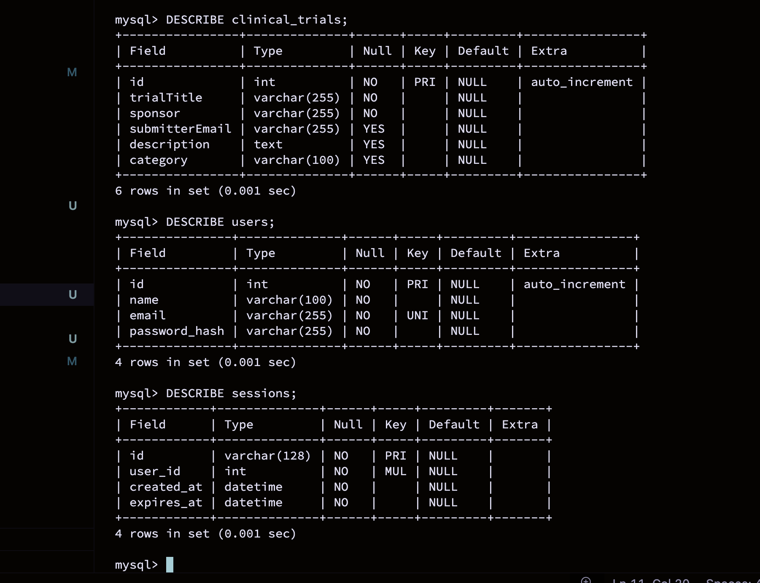Screenshot 4: MySQL table structures for clinical_trials, users, and sessions.

Result / Observation: The required MySQL tables were created successfully. The clinical_trials table contains the domain fields with an auto-incrementing primary key, the users table contains the required authentication fields, and the sessions table contains the fields needed for server-side session tracking.
Only the opaque session token will be sent to the browser in an HTTP-only cookie, while the user and session data remain stored server-side in MySQL.

2.6 Login + HTTP-only Server-Side Session:
I created a test user in the users table and stored the password as a hash rather than plain text. This user will be used to verify the server-side login and session flow.
I implemented the HW4 login endpoint at /api/login. The backend looks up the user by email and verifies the entered password against the stored password hash. After successful authentication, the server generates a random opaque session token and stores the session in the MySQL sessions table with its creation and expiration times.
The same opaque token is returned to the browser as an HTTP-only cookie. The cookie does not contain the user's name, email, password, or other user data. The actual session state remains stored server-side in MySQL.
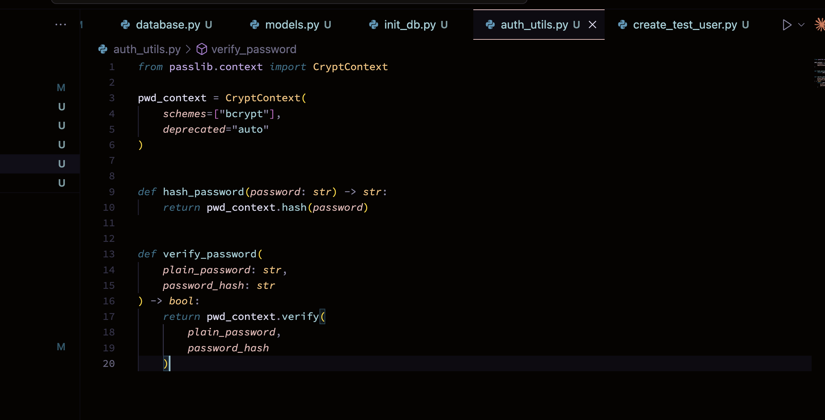

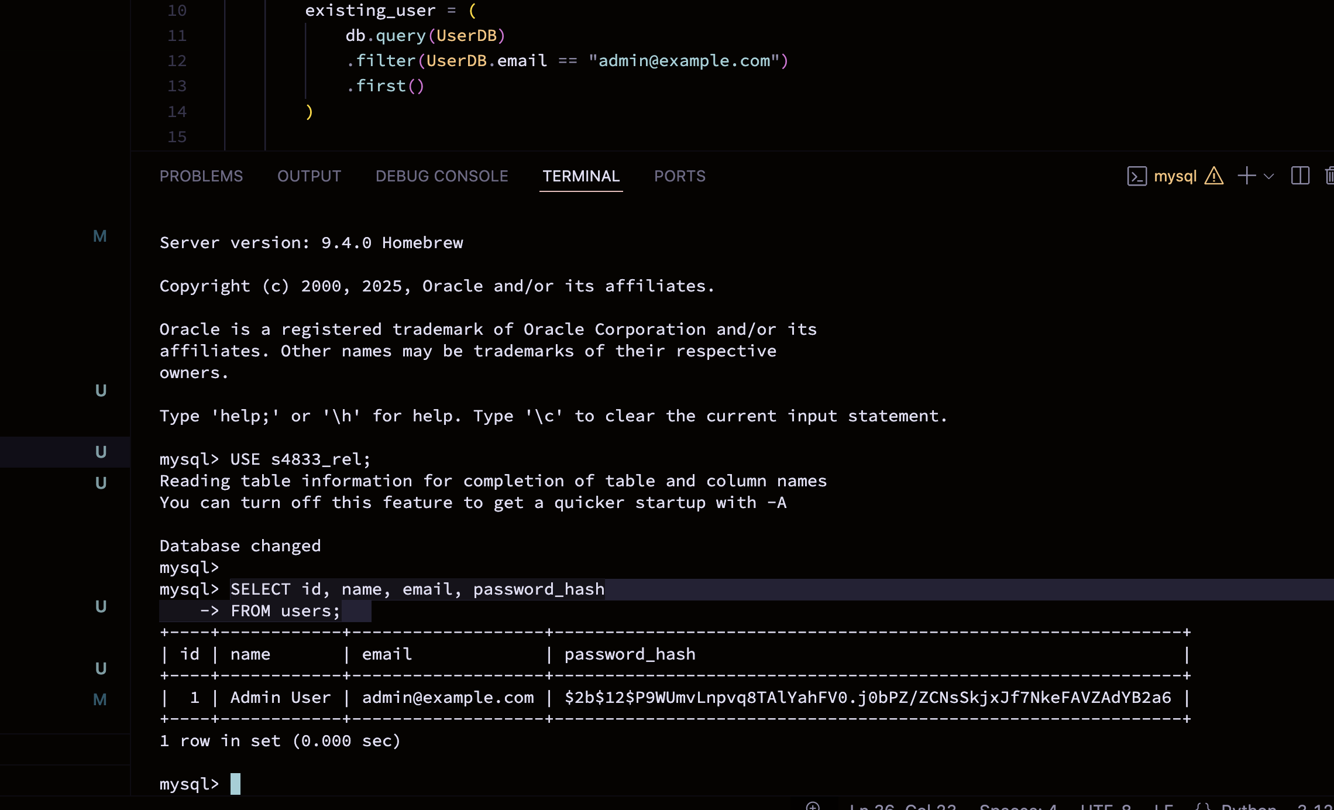
Screenshot 5: Test user stored in the users table with a hashed password.

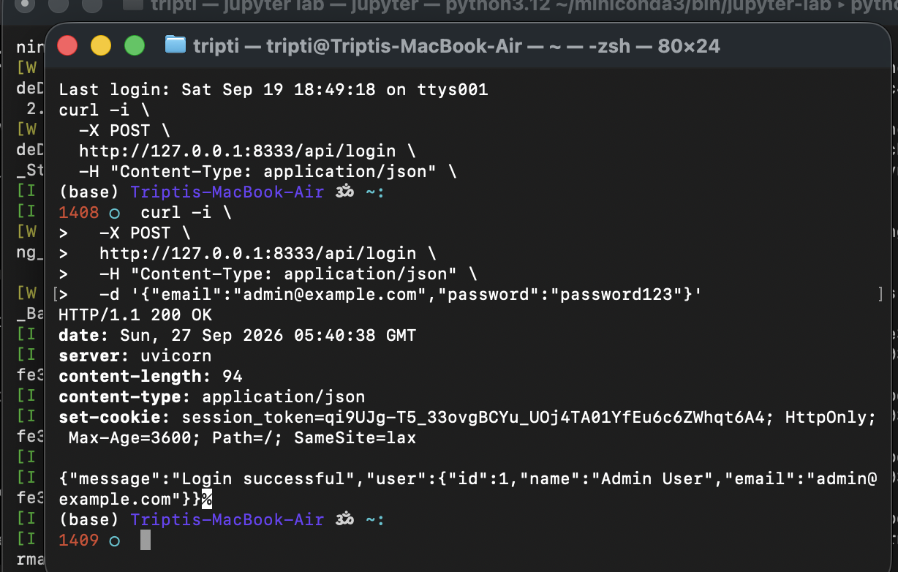Screenshot 6: Successful login response with HTTP-only session cookie.

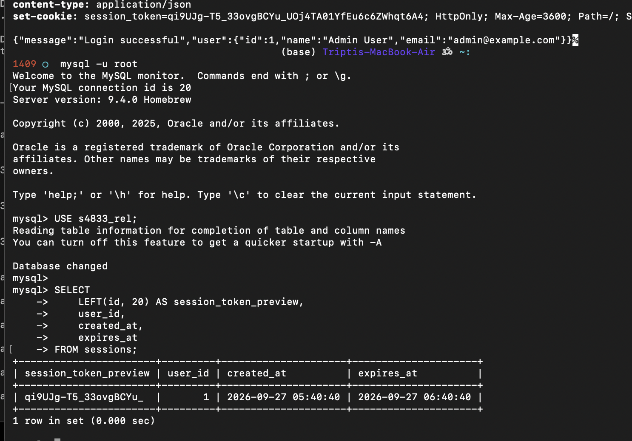
Screenshot 7: Server-side session stored in the MySQL sessions table.
Browser cookie: opaque token only
MySQL: actual server-side session information
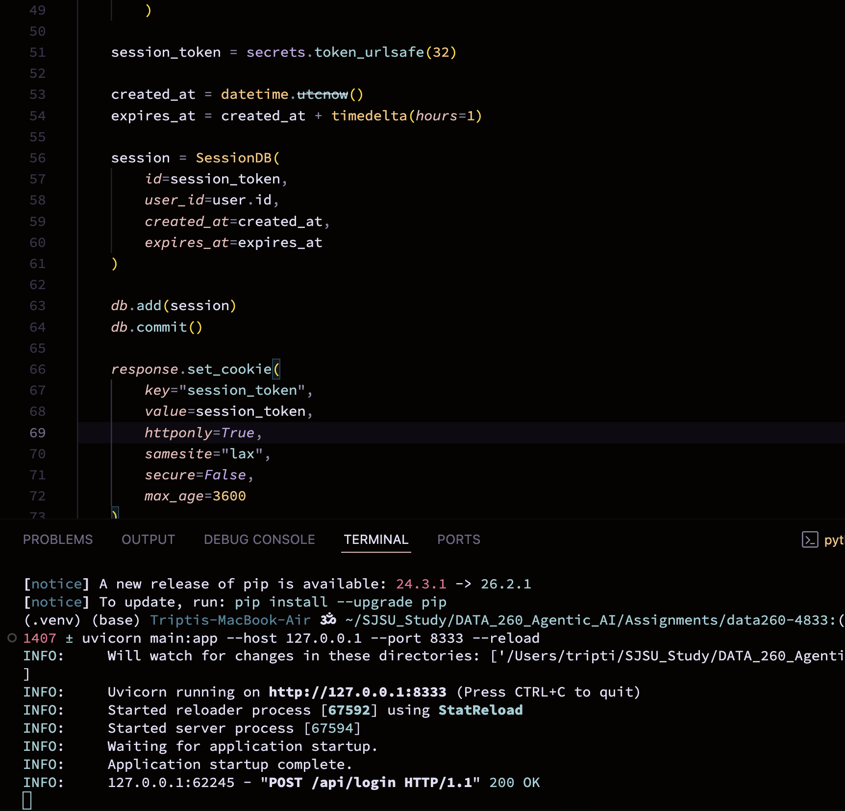
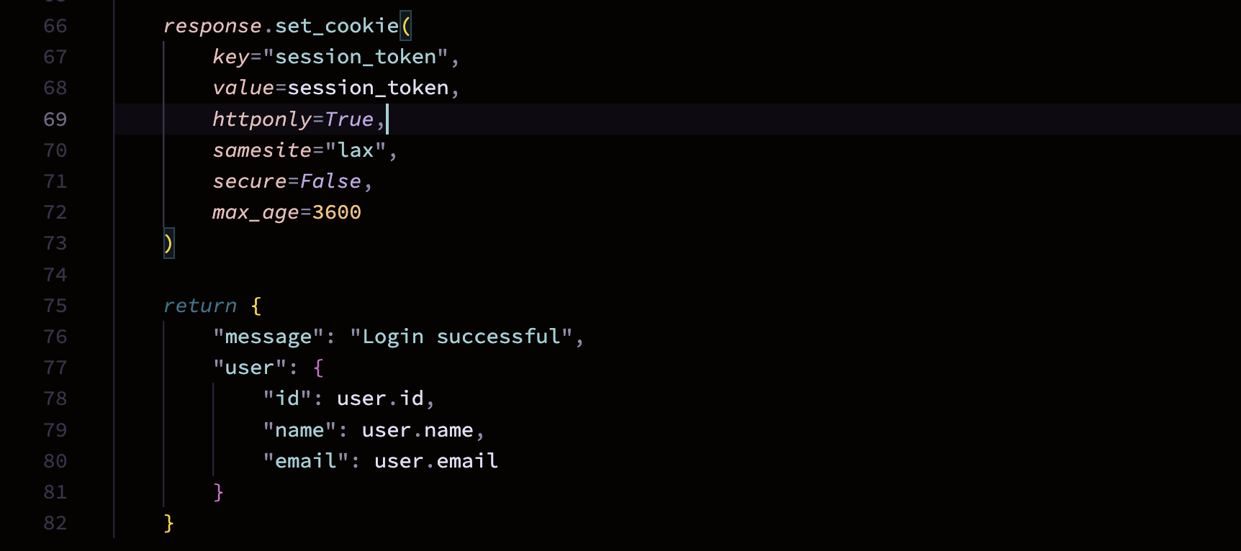
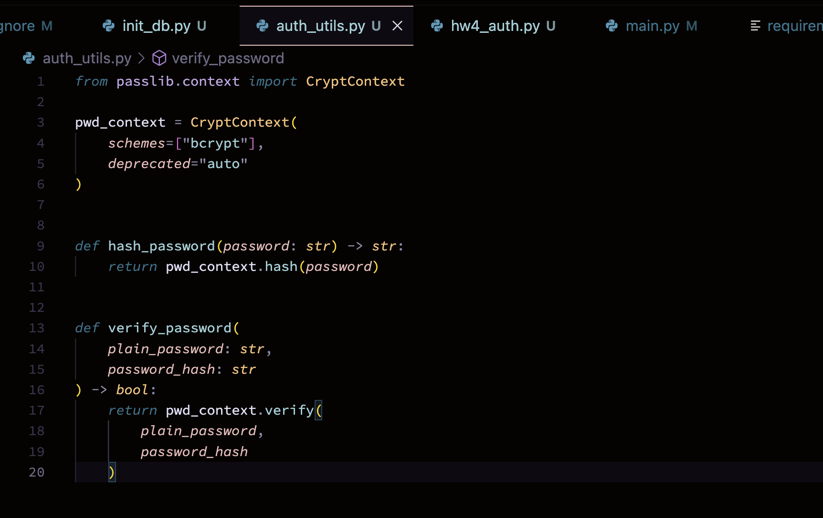
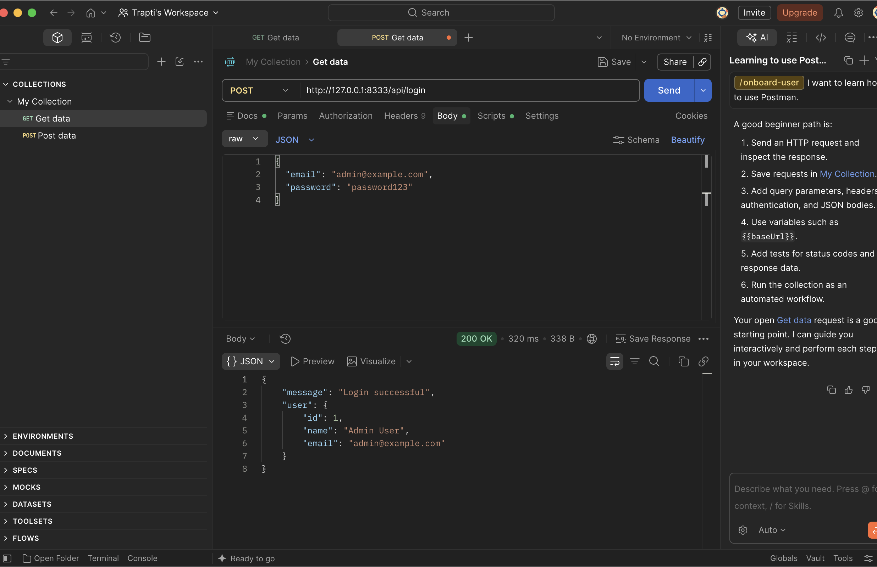
Screenshot: Successful login request in Postman.
Result / Observation:
Result / Observation: Valid credentials successfully created a server-side session in MySQL and returned an opaque session token through an HTTP-only cookie. This confirms that session information is maintained on the server rather than storing user information directly in the browser cookie.

2.7 Protected Routes / Session Validation:
I added a session-validation dependency that reads the opaque session_token from the HTTP-only cookie and verifies that the token exists in the MySQL sessions table. The session must exist, must not be expired, and must reference a valid user. Requests without a valid session are rejected with HTTP 401.
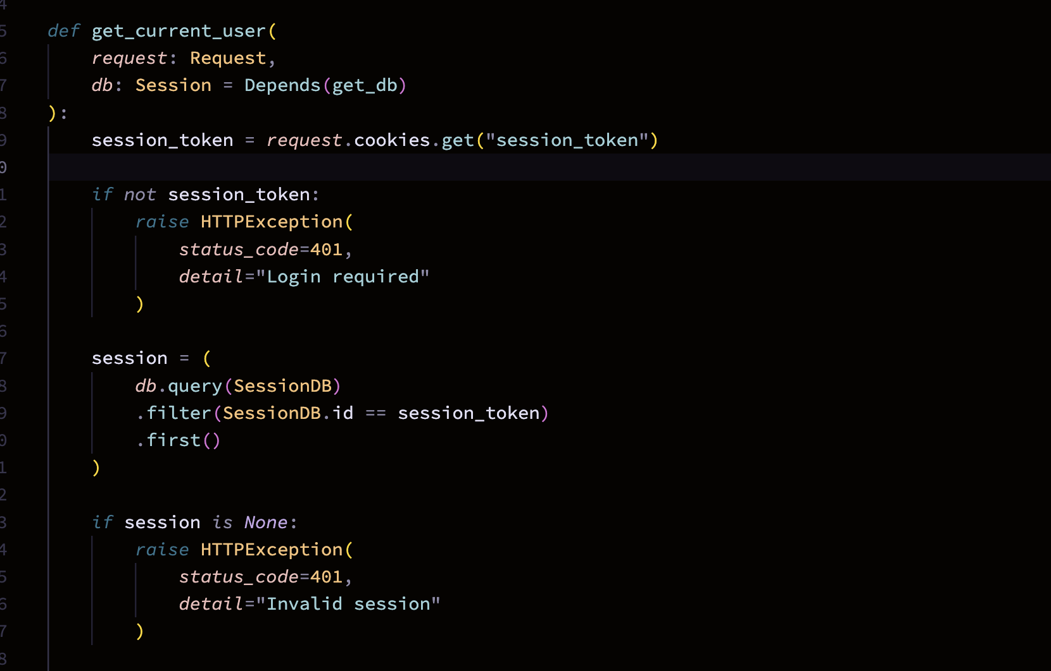
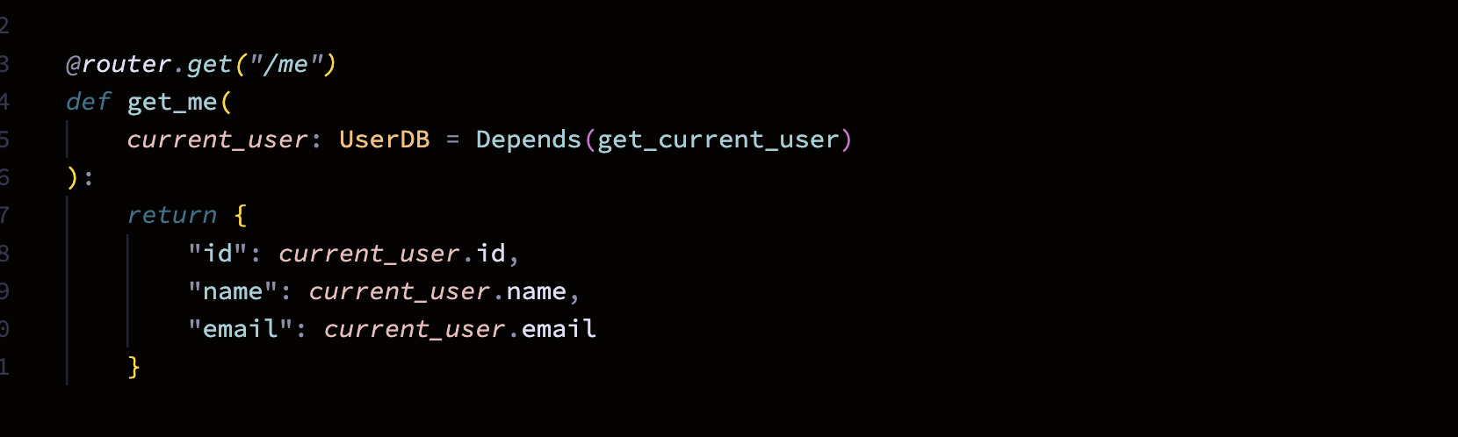
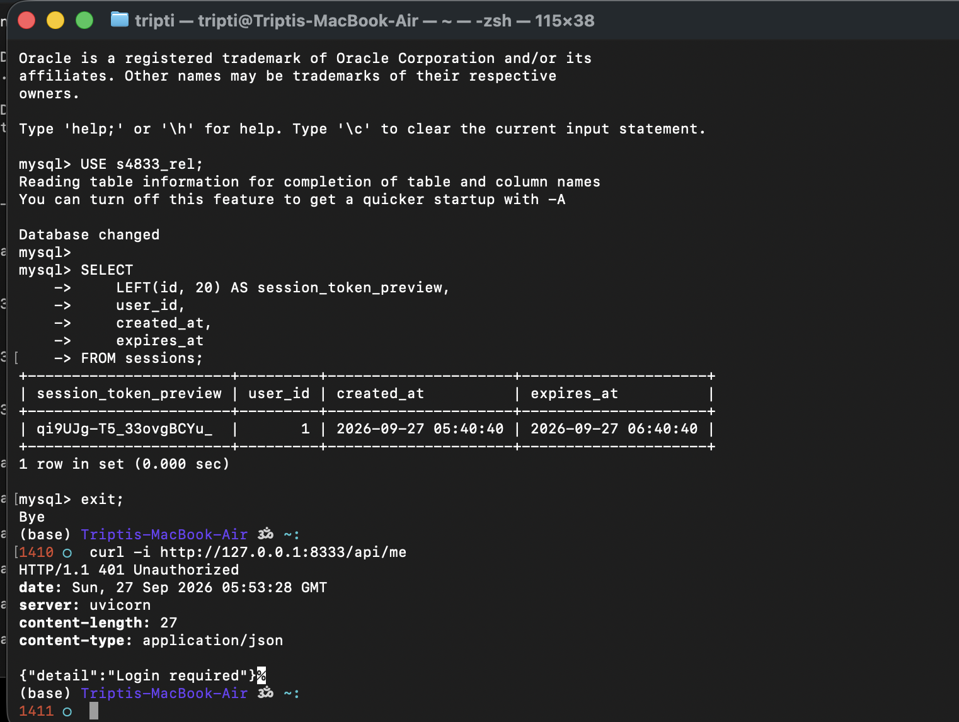Screenshot 8: Protected endpoint rejecting an unauthenticated request.

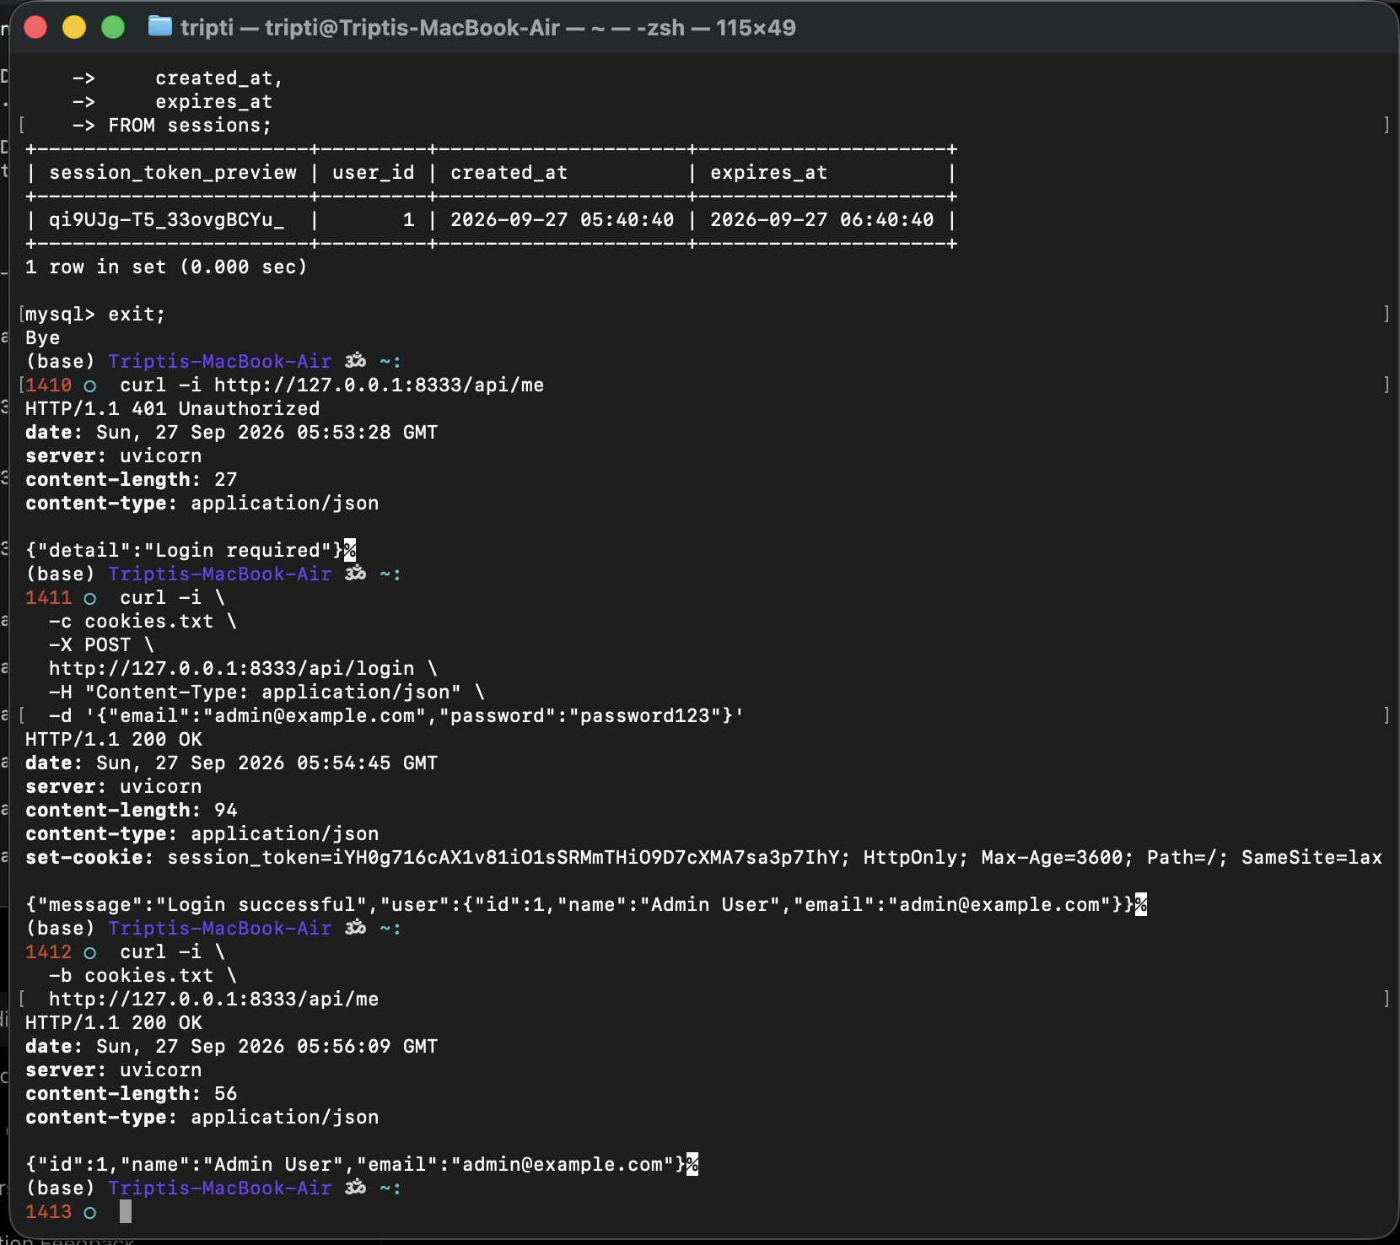Screenshot 9: Protected endpoint successfully accessed using a valid server-side session.

Result / Observation:
Result / Observation: The protected endpoint correctly rejected requests without a session cookie and returned the authenticated user's information when a valid server-side session was supplied.

2.8 CRUD POST:
I implemented a protected POST endpoint to create new clinical trial records. The record is inserted into the MySQL clinical_trials table and MySQL generates the auto-incrementing ID.
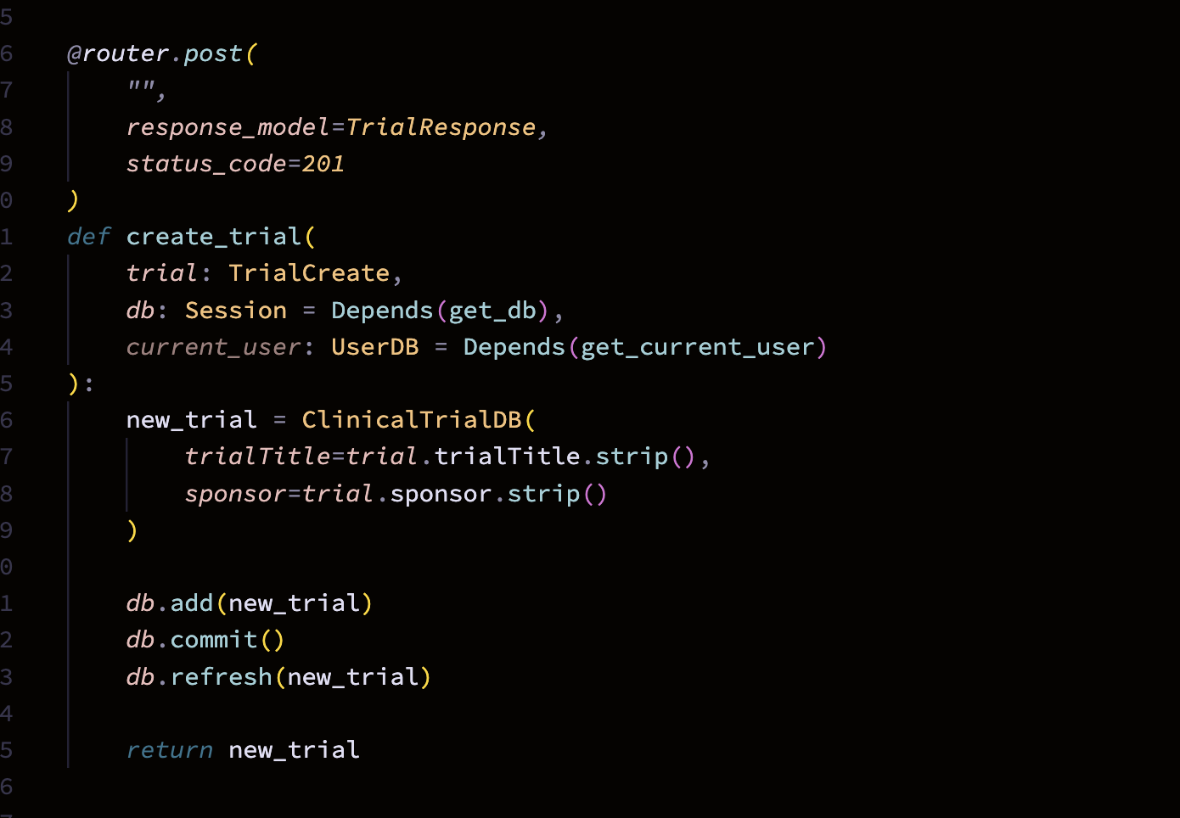
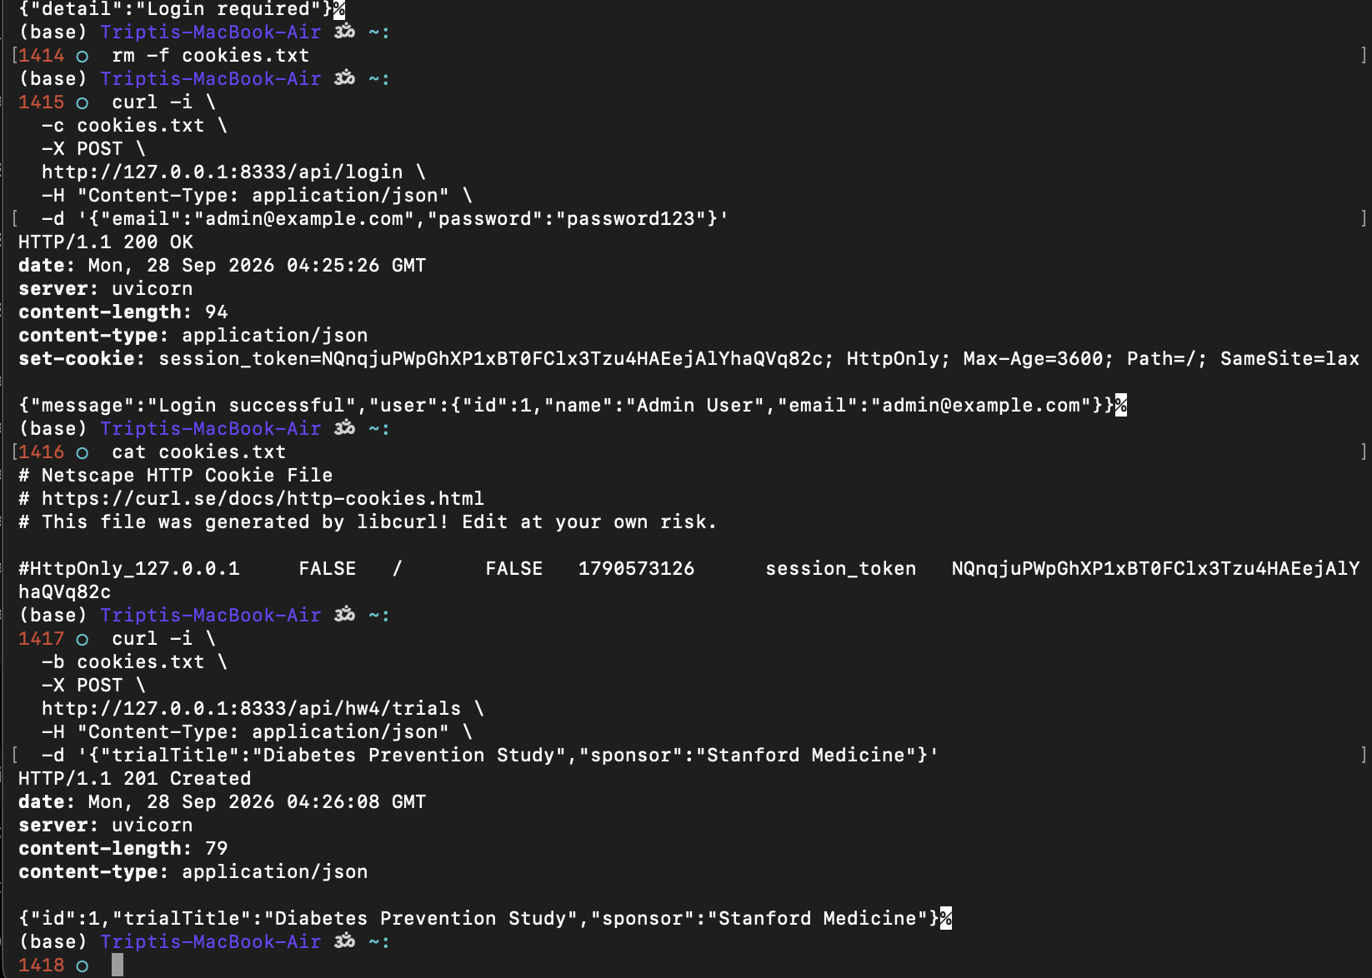
Screenshot 10: Successful creation of a clinical trial using the POST endpoint.

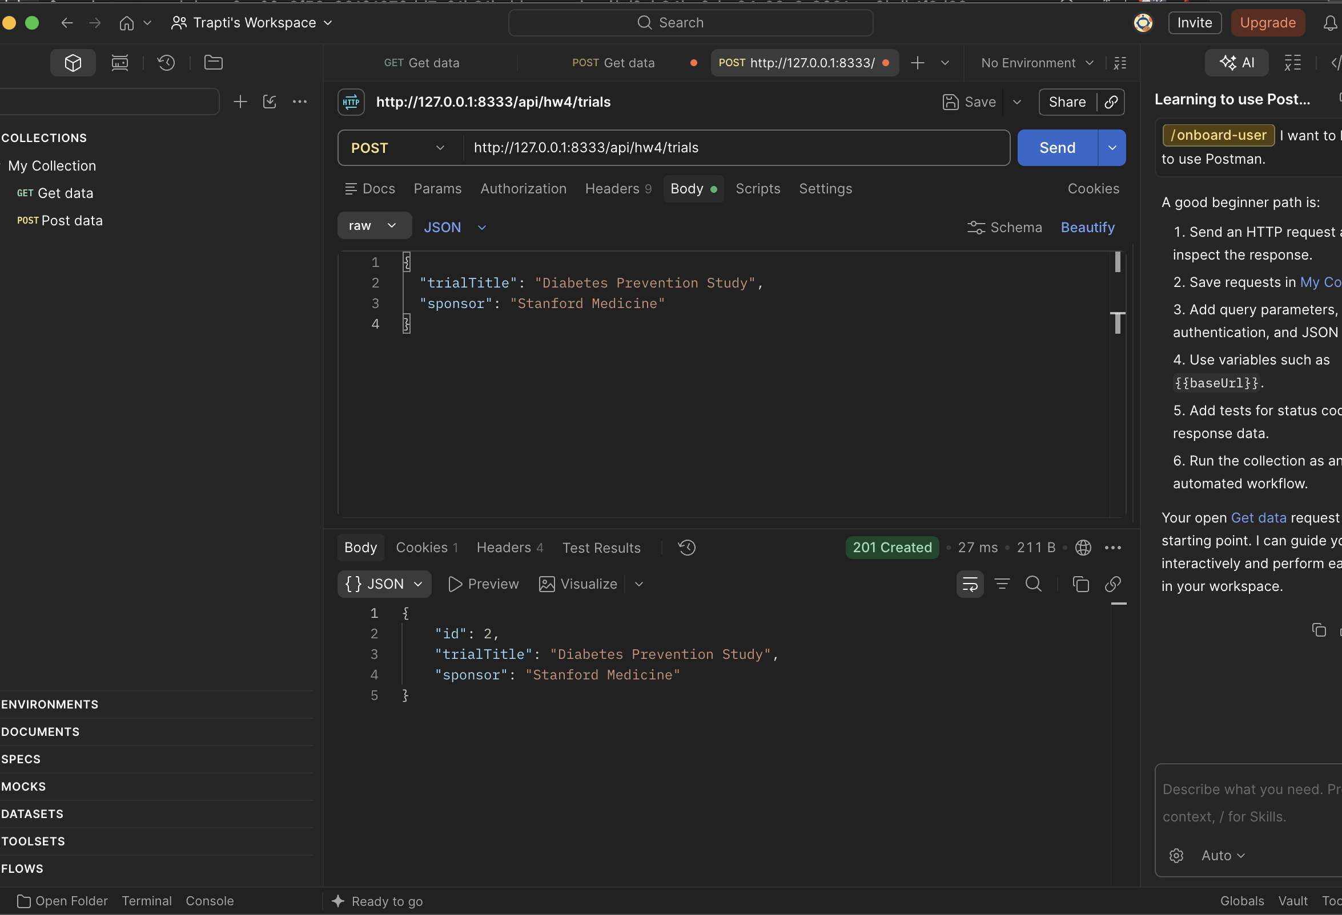Screenshot: Successful creation of a clinical trial using the POST endpoint in Postman.

2.9 CRUD – GET All
I implemented a protected GET endpoint that retrieves all clinical trial records from the MySQL clinical_trials table. The records are returned in ascending order by ID.
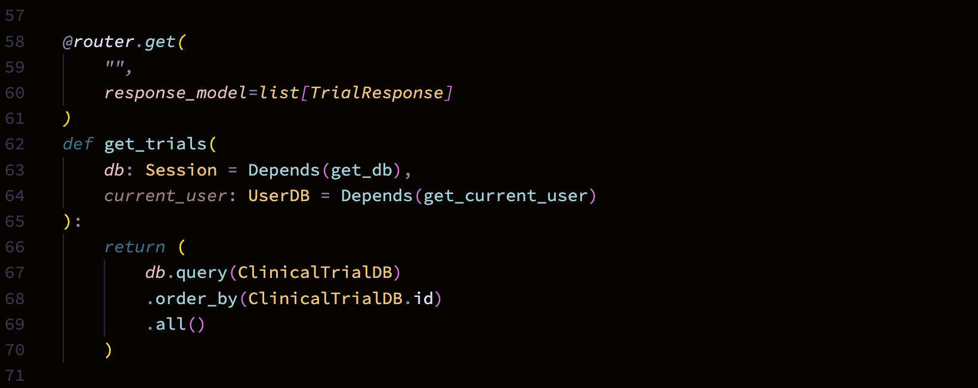
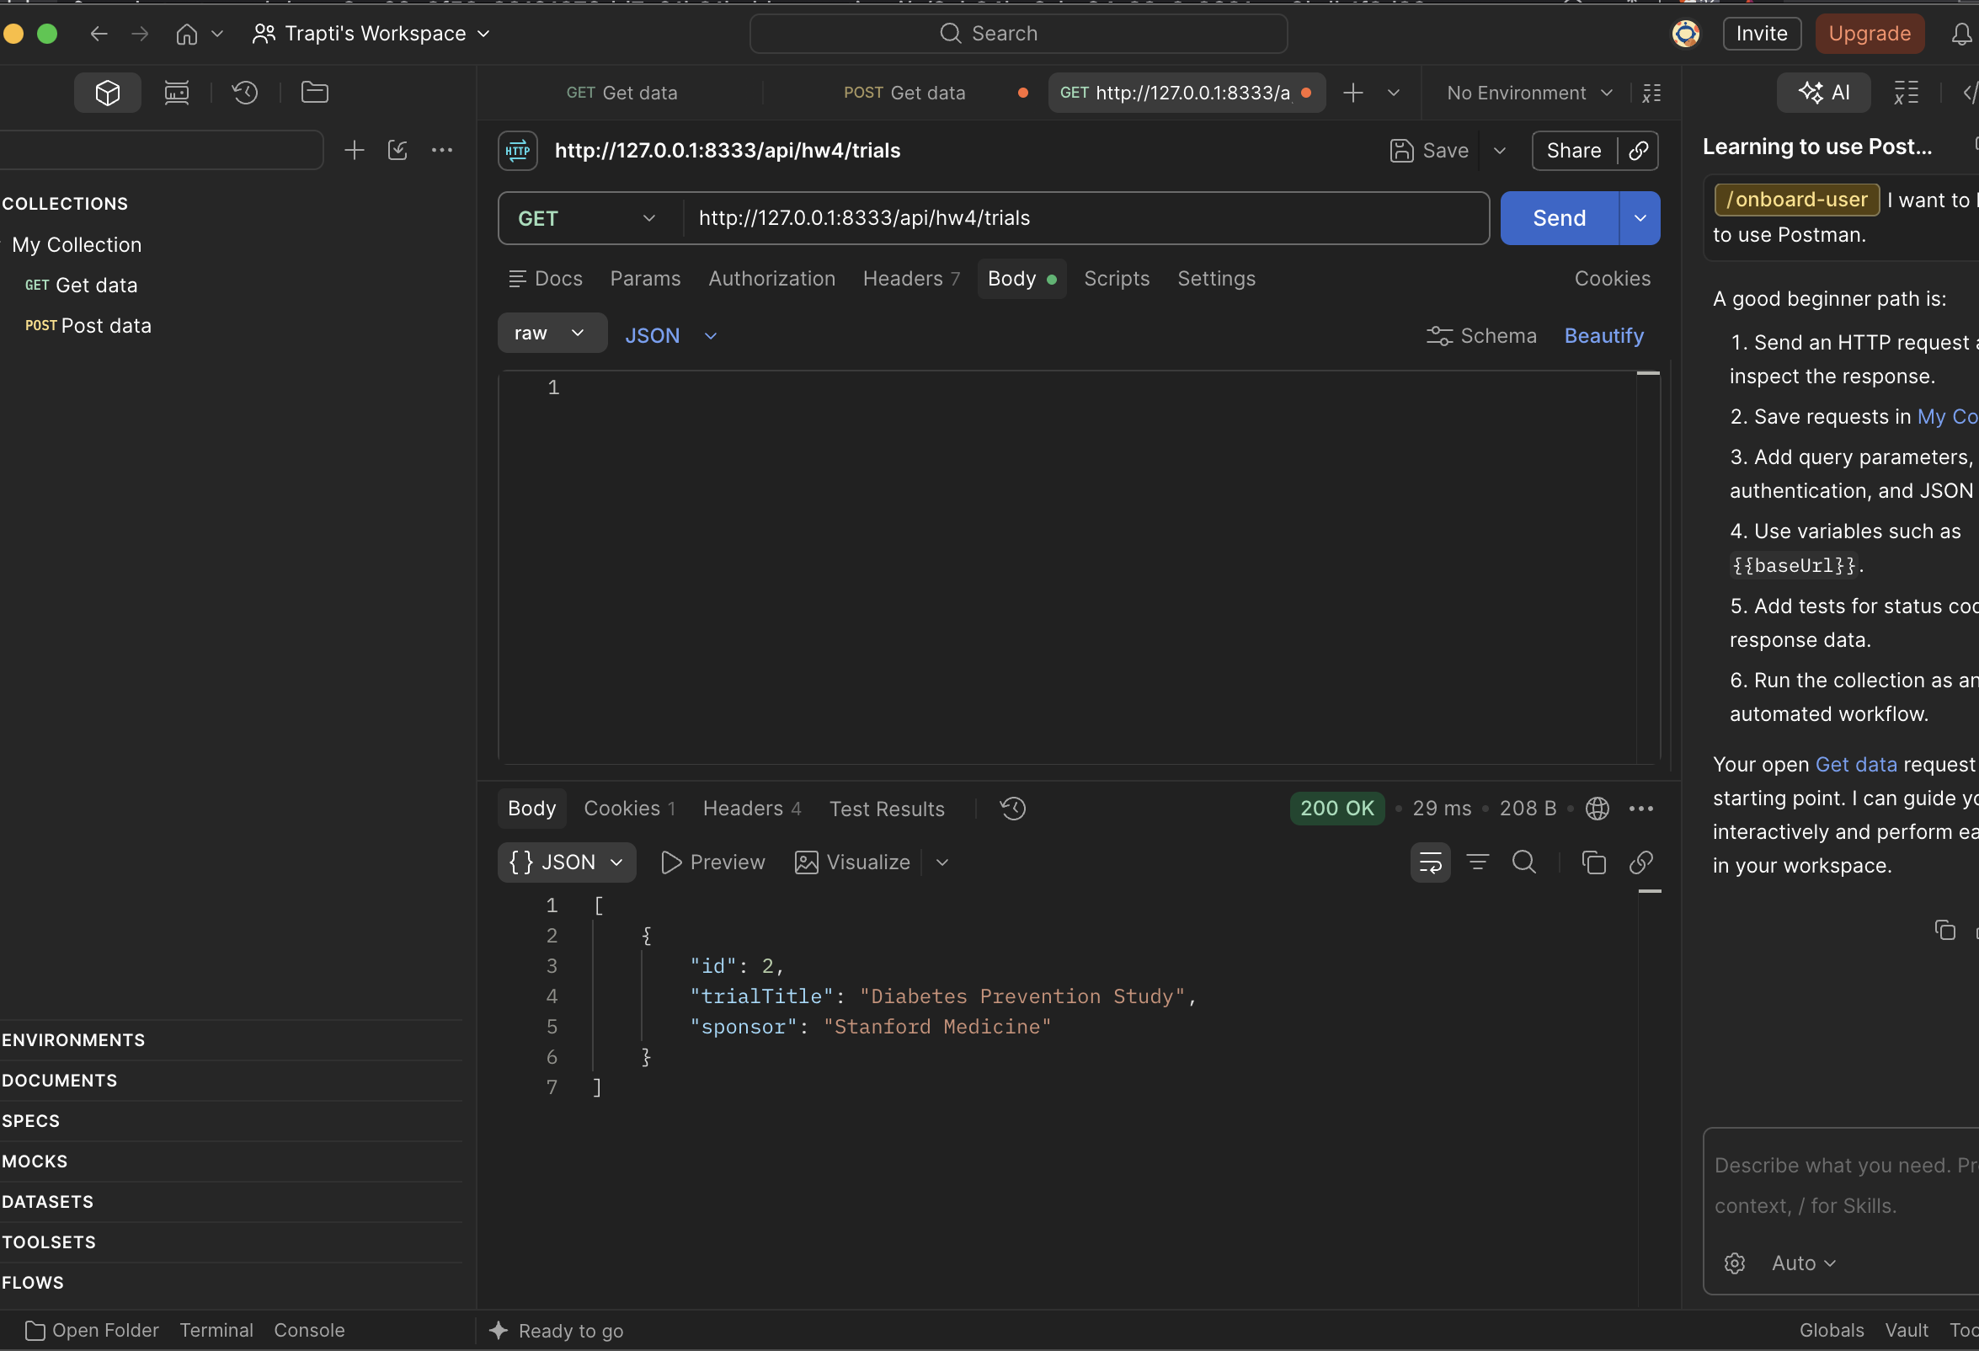
Screenshot: GET endpoint returning all clinical trial records in Postman.

2.10 CRUD GET by ID:
I implemented a protected GET-by-ID endpoint that retrieves one clinical trial using its unique ID. If the requested ID does not exist, the endpoint returns a 404 response.
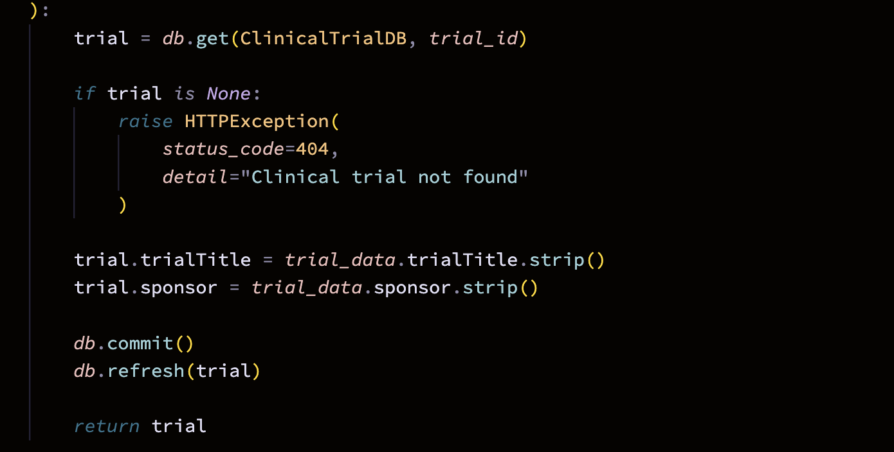
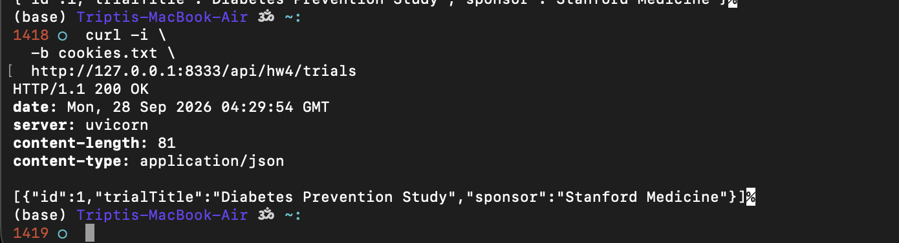Screenshot 12: GET-by-ID endpoint returning a specific clinical trial.
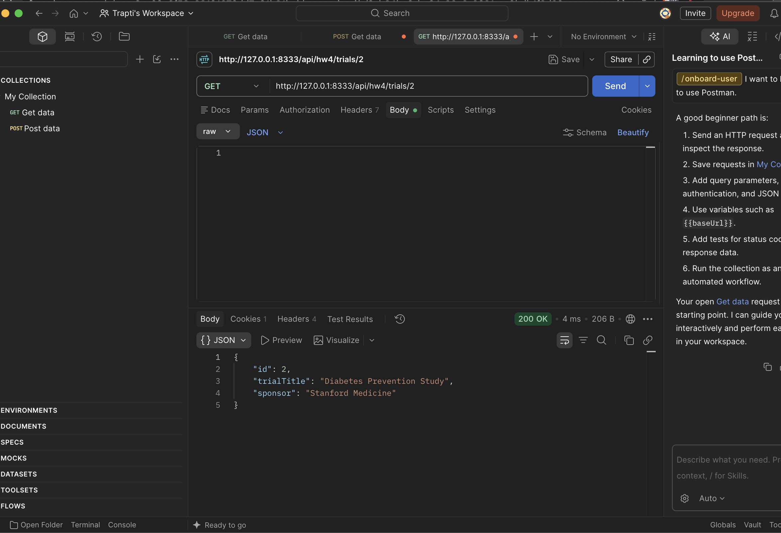
Screenshot: GET-by-ID endpoint returning a specific clinical trial in Postman.

2.11 CRUD PUT:
I implemented a protected PUT endpoint that updates the trial title and sponsor of an existing clinical trial. The updated values are committed to MySQL and returned in the response.
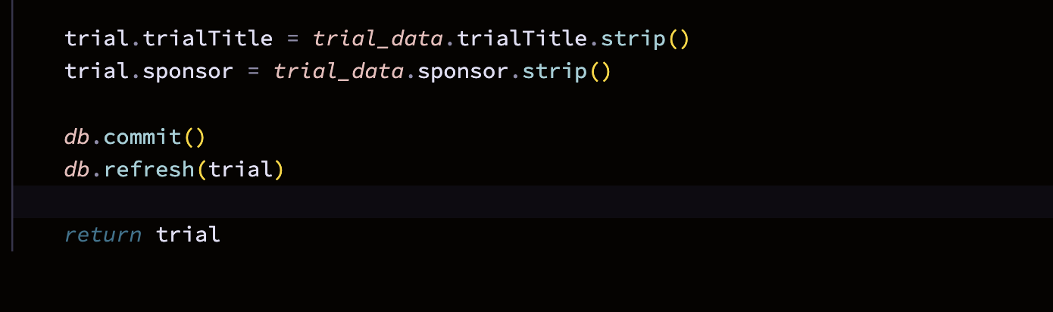
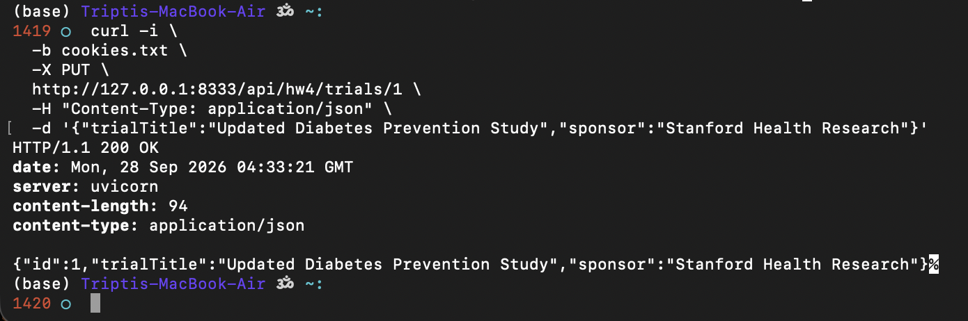Screenshot 13: Successful update of a clinical trial using the PUT endpoint.
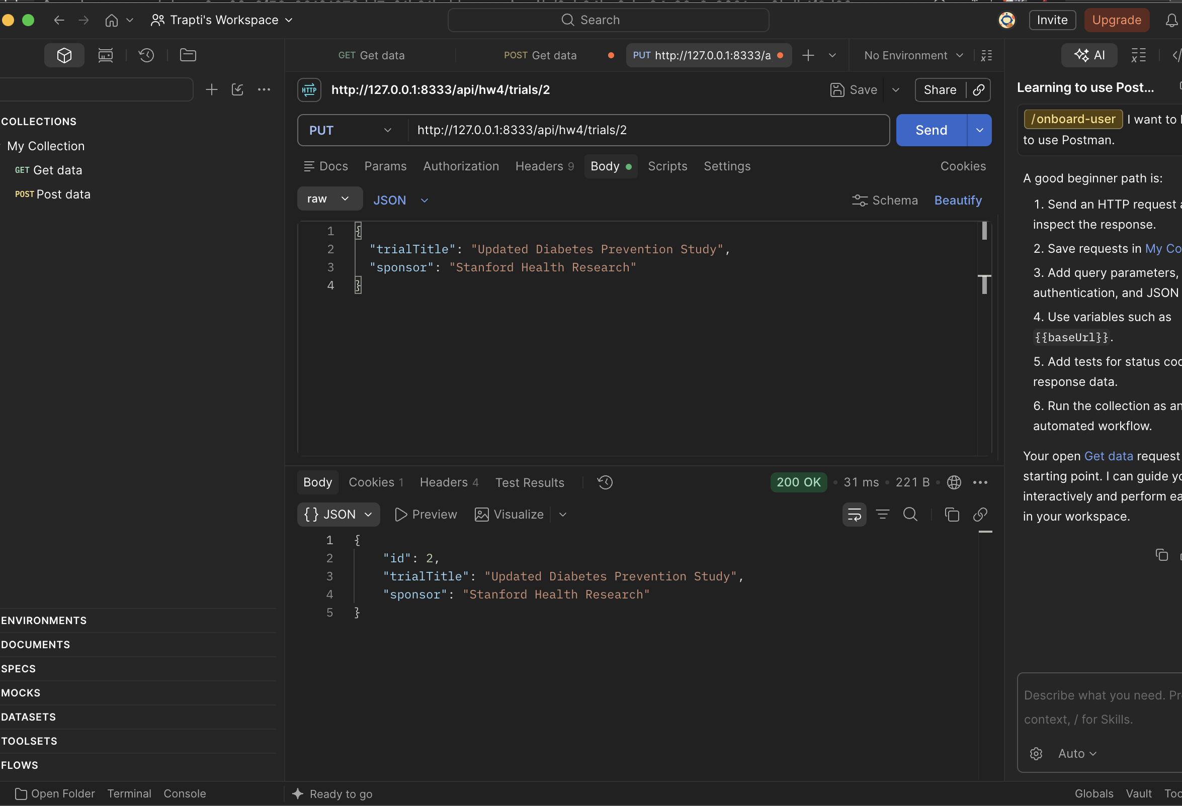
Screenshot: Successful update of a clinical trial using the PUT endpoint in Postman.

2.12 CRUD DELETE:
I implemented a protected DELETE endpoint that removes the selected clinical trial from the MySQL database and commits the deletion.
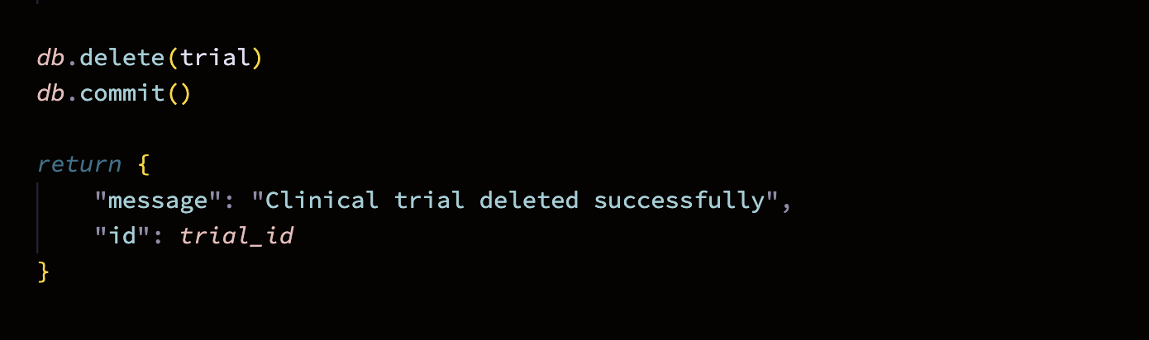
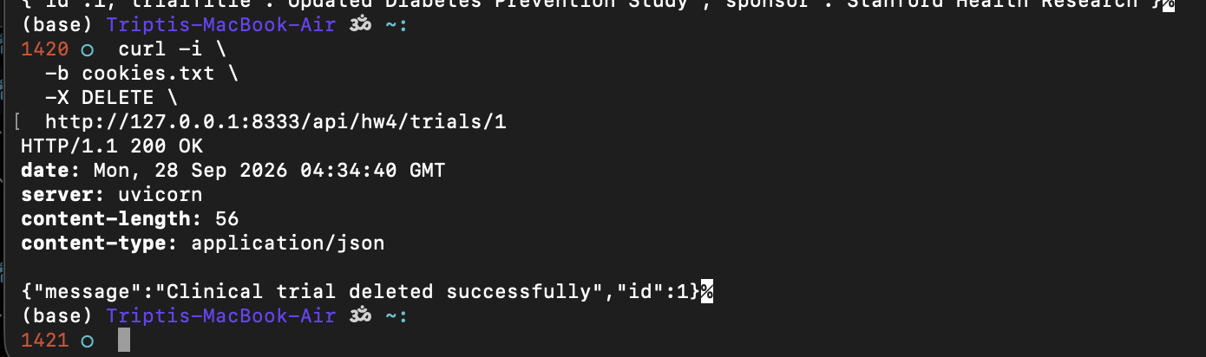Screenshot 14: Successful deletion of a clinical trial using the DELETE endpoint.
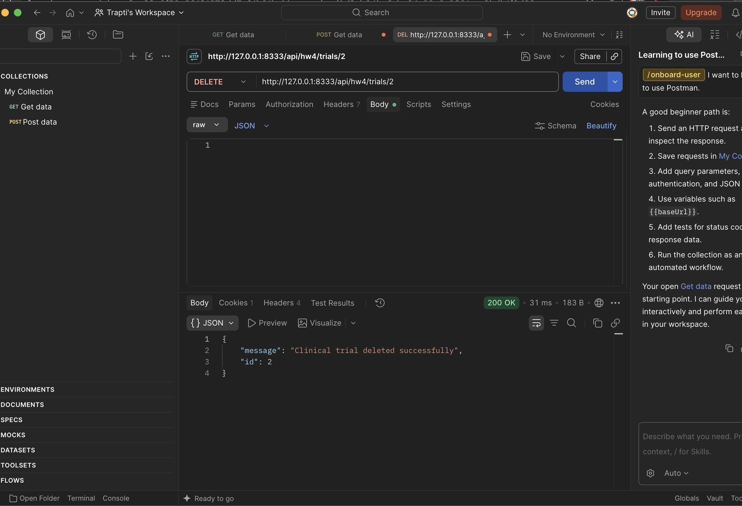Screenshot: Successful deletion of a clinical trial using the DELETE endpoint in Postman.

Result / Observation: The FastAPI backend successfully performed Create, Read, Update, and Delete operations against the MySQL clinical_trials table. Each operation required a valid authenticated session.

Screenshot 14: POST request creating a clinical trial.

2.13 Project Folder Structure:
The project continues to extend the existing data260-4833 repository. The React client is stored under frontend/, while the FastAPI authentication and CRUD routes are organized under routers/. Database connection and SQLAlchemy models remain in shared root-level files.
