

PROJECT AND TEAM INFORMATION

Project Title

Student/Team Information

Team Name:
Team # (Mentor needs to assign)
Team member 1 (Team Lead)
(Last Name, name: student ID: email, picture):
Team member 2
(Last Name, name: student ID: email, picture):

PROJECT PROGRESS DESCRIPTION (35 pts)

Project Abstract (2 pts)
The goal of this project is to develop a system for monitoring and forecasting key system resources—CPU, memory, disk I/O, network throughput, and battery—on a live computer. Real-time data is collected at high resolution, capturing trends, spikes, and anomalies in resource usage.
Using time-series analysis and deep learning models (LSTM/GRU), the system predicts short-term resource requirements, enabling proactive management to prevent performance degradation, CPU or memory bottlenecks, and energy inefficiency. Multivariate forecasting leverages correlations between metrics, while lagged features and rolling statistics improve prediction accuracy.
The project provides both real-time monitoring and forecasting, along with visualizations and structured datasets. This supports optimized resource scheduling, better energy management, and improved system reliability, making it a practical tool for desktops, servers, or edge computing environments.

Updated Project Approach and Architecture (2 pts).
1. System Overview:
The project monitors and forecasts system resources—CPU, memory, disk, network, and battery—in real time. High-resolution data is collected from a live computer, processed, and used for predictive modeling to enable proactive resource management and prevent bottlenecks.
2. Data Collection:
- Library: psutil
- Sampling: Metrics collected every second, stored in CSV
- Features: Lagged metrics, rolling averages, per-core CPU usage
3. Data Processing & Feature Engineering:
- Library: pandas
- Steps: Timestamp parsing, resampling, forward-filling, scaling (MinMax/Standard), and optional one-hot encoding for categorical features
4. Forecasting Model:
- Library: TensorFlow/Keras
- Architecture: LSTM/GRU for multivariate time-series forecasting
- Input: Past metric sequences
- Output: Predicted CPU, memory, disk, network, battery
- Training: MSE loss; evaluated with RMSE, MAE, and R²
5. Visualization & Alerts:
- Library: matplotlib, seaborn (offline); optional Plotly/Dash (real-time)
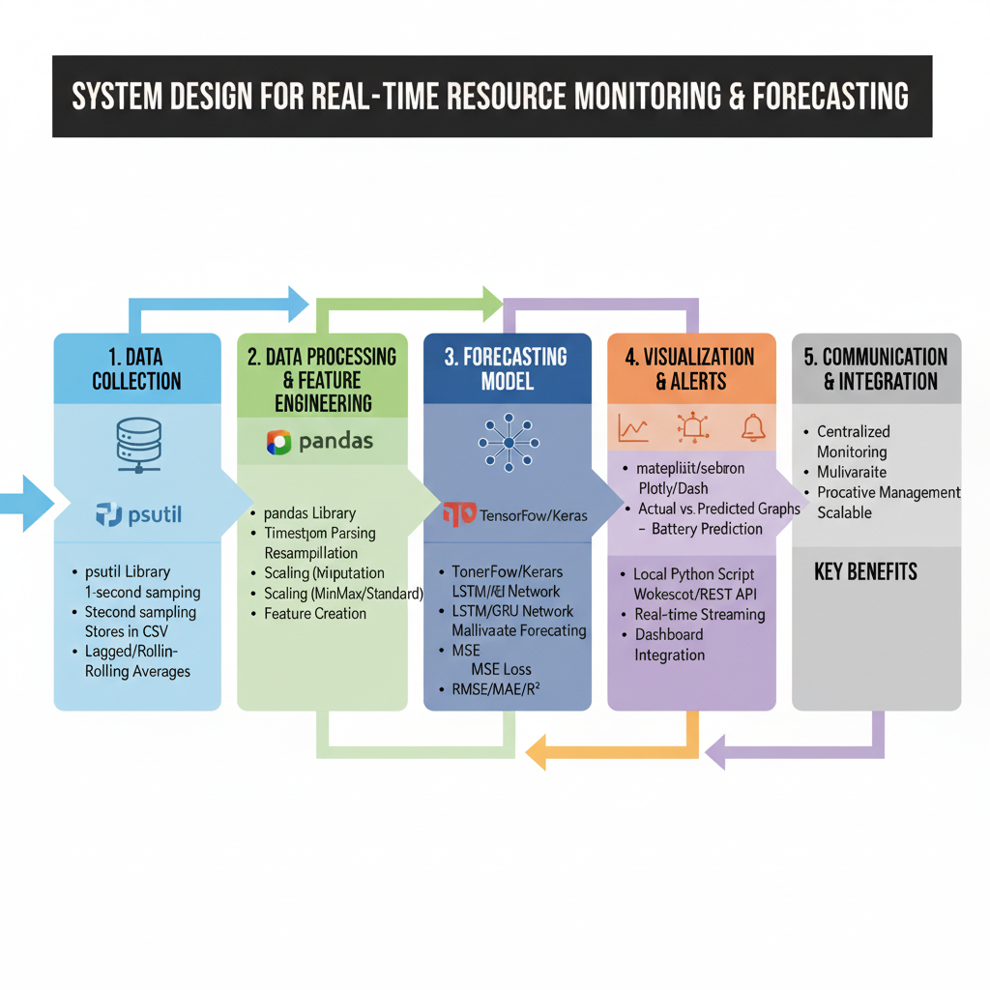
- Outputs: Actual vs predicted metrics, spike detection, correlations, battery trends

Tasks Completed (7 pts)
Task Completed | Team Member
Data Collection: Capture live CPU, memory, disk I/O, network, and battery metrics.  Preprocessing: Clean, resample, scale data; create lagged and rolling features.  Modeling: Train LSTM/GRU models for multivariate time-series forecasting.  Evaluation: Measure accuracy using RMSE, MAE, and R² metrics. | Akshat  Akshat  Nakshatra  Nakshatra and ishu

Challenges/Roadblocks (7 pts)
Data Quality Issues:
Missing or noisy readings (e.g., spikes in CPU or network usage) affect forecasting accuracy.
Solution: Apply forward/backward filling, smoothing filters, and anomaly detection before training.
Feature Engineering Complexity:
Choosing the right lagged/rolling features for time-series models was challenging.
Solution: Experiment with statistical tests (autocorrelation, partial autocorrelation) and use automated feature selection.
Model Generalization:
LSTM/GRU models overfit small datasets or fail to capture sudden workload changes.
Solution: Increase dataset size, apply dropout and early stopping, and test hybrid models (e.g., CNN-LSTM).
Battery Forecasting:
Battery drain patterns vary by workload and device, making prediction less accurate.
Solution: Collect diverse workload data and try separate battery-specific models.
Real-Time Integration:
Initial setup runs as an offline Python script, limiting live use.
Solution: Plan to deploy via REST APIs or WebSocket streams for real-time dashboards.

Tasks Pending (7 pts)
(Describe the main tasks that you still need to complete. Max 250 words).
Task Pending | Team Member (to complete the task)
Model Improvement:  Experiment with advanced models (e.g., hybrid CNN-LSTM or Transformer-based models) to improve prediction accuracy and handle sudden spikes.  Battery Forecasting Module:  Develop and integrate a dedicated sub-model for battery usage prediction with workload-aware factors.  Real-Time Integration:  Transition from offline scripts to a live monitoring pipeline using REST APIs or WebSockets for continuous forecasting.  Visualization Dashboard:  Build an interactive dashboard (e.g., Plotly/Dash) for real-time metrics display, alerts, and historical trend analysis.  Performance Evaluation:  Benchmark the models with unseen data and optimize latency for near real-time predictions. | Nakshatra  Team  Akshat  Ishu  Team

Project Outcome/Deliverables (2 pts)
Cleaned & Processed Dataset:
A comprehensive dataset of real-time system metrics (CPU, memory, disk I/O, network, battery) ready for modeling and future research.
Trained Forecasting Models:
Robust multivariate time-series models (LSTM/GRU, optionally hybrid CNN-LSTM) capable of accurately predicting short-term system resource usage and battery consumption.
Feature-Engineering Framework:
Scripts for automated preprocessing, scaling, lag-feature generation, and data pipeline setup for continuous learning.
Visualization Tools:
Interactive plots and dashboards for monitoring live metrics, comparing predictions vs. actual trends, and analyzing historical data.
Battery Forecasting Module:
A dedicated component to predict battery usage trends under varying workloads.
Real-Time Monitoring Pipeline:
A scalable architecture for integrating model predictions into real-time systems using APIs or WebSockets.

Progress Overview (2 pts)
Completed (On Schedule):
- Data collection pipeline using psutil for CPU, memory, disk I/O, network, and battery metrics.
- Preprocessing and feature engineering scripts (resampling, scaling, lag features).
- Initial exploratory data analysis (EDA) and visualization of collected metrics.
- Baseline forecasting models (LSTM/GRU) for CPU and memory usage.
Behind Schedule:
- Battery forecasting module requires more diverse workload data for improved accuracy.
- Integration of real-time visualization dashboards (Plotly/Dash) is delayed due to time spent on preprocessing refinements.
- Model optimization and hyperparameter tuning are pending to achieve target performance.

Testing and Validation Status (2 pts)
Test Type | Status (Pass/Fail) | Notes
Data Collection:  .  Data Integrity:  Model Accuracy:  Real-Time Inference:  Visualization: | Pass  Pass  Pass  Fail  fail | Verified accurate capture of CPU, memory, disk, network, and battery metrics at 1-second intervals across varied workloads  Ensured clean, consistent time-series data with resampling, alignment, and forward-fill for missing values.  Trained LSTM/GRU models; achieved good CPU and memory forecasts. Battery prediction and extreme spike handling need improvement.  Live predictions worked under normal loads but lagged during sudden resource spikes.  Validated offline graphs for actual vs. predicted metrics and anomaly detection; live dashboards in progress.

Deliverables Progress (2 pts)
Data Collection Pipeline (CPU, Memory, Disk, Network, Battery): (Completed)
High-frequency metrics collection working reliably on live systems.
Data Processing & Feature Engineering: (Completed)
Includes cleaning, resampling, scaling, lagged features, and rolling stats.
Forecasting Models (CPU & Memory): (In Progress)
LSTM/GRU models functional with good baseline accuracy; need tuning for extreme spikes and battery prediction.
Battery Forecasting Module: (Pending)
Basic metrics captured but not fully integrated into forecasting pipeline.
Visualization (Offline Plots): (Completed)
Accurate plots for historical and predicted metrics; anomaly detection visualized.
Real-Time Visualization & Alerts: (In Progress)
Early-stage dashboard integration; live anomaly detection pending.
System Integration (APIs / Dashboard): (Pending)
Local scripts functional but need API or WebSocket support for real-time use.
Testing & Evaluation: (In Progress)
Stress testing ongoing; need additional evaluation for battery forecasting and spike prediction.

