1. **Collision Resolution**

**(a) separate chaining**

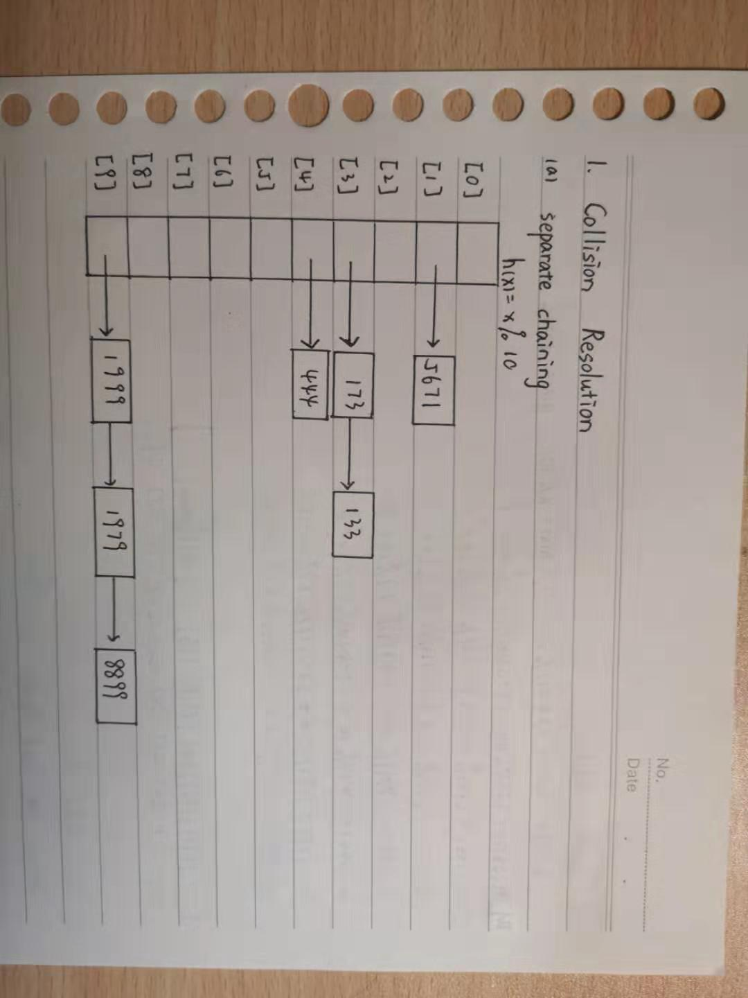

**(b) linear probing**

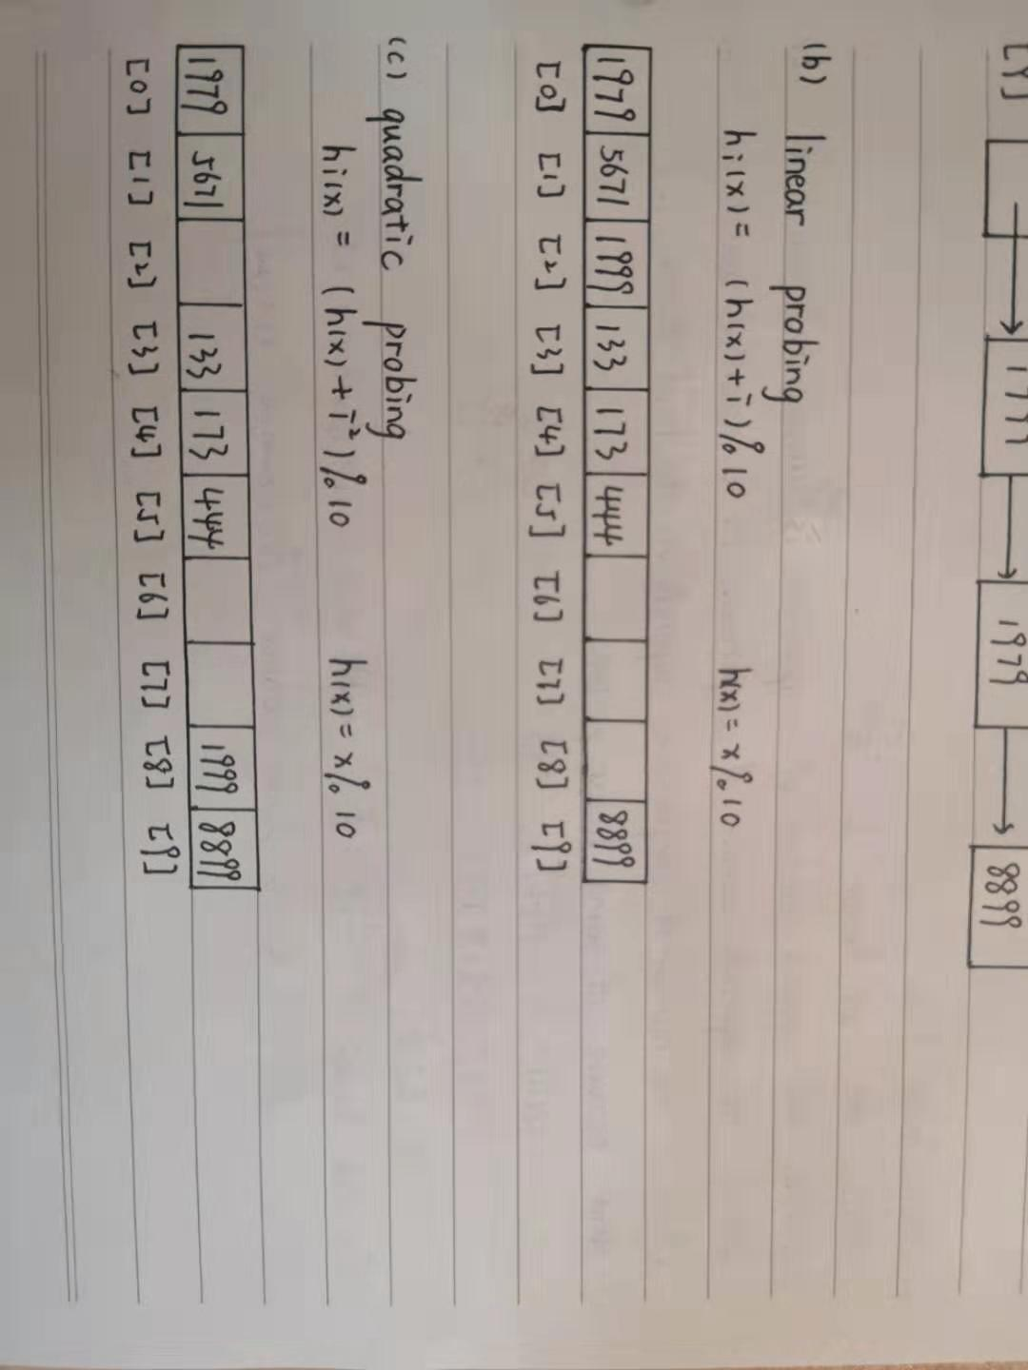

**(c)quadratic probing**



**(d)double hashing**

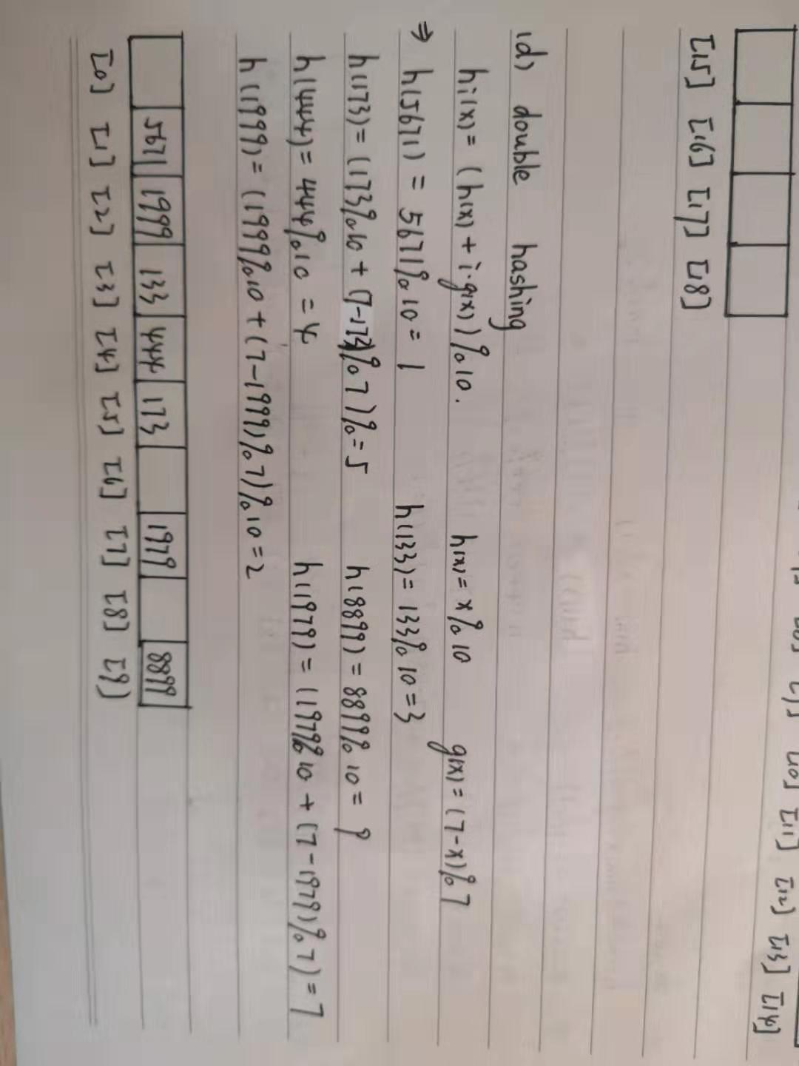

1. **Hash Table Size**

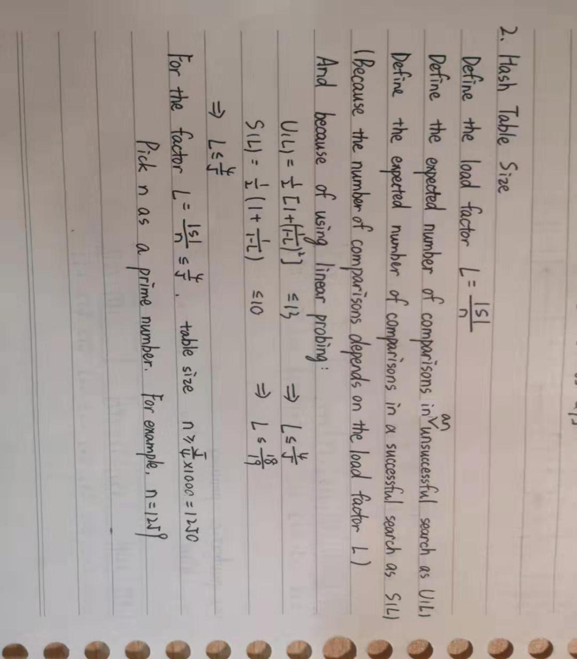

1. **Rehashing**

**(a) separate chaining**

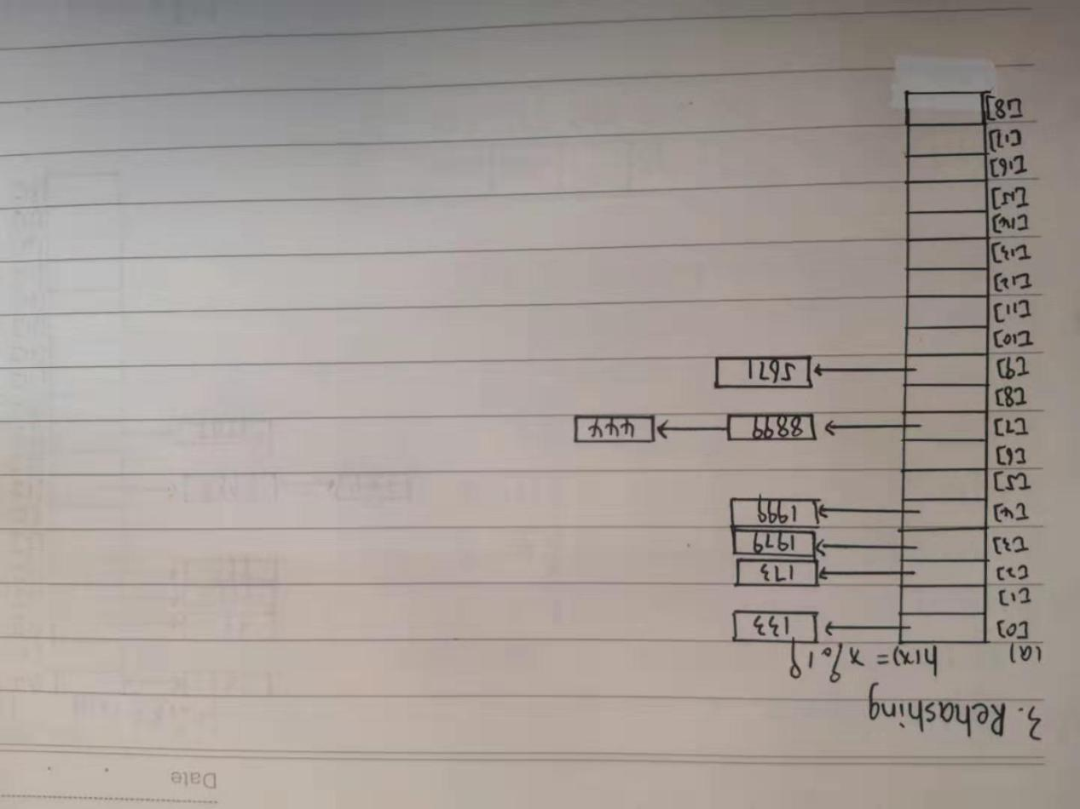

**(b) linear probing**

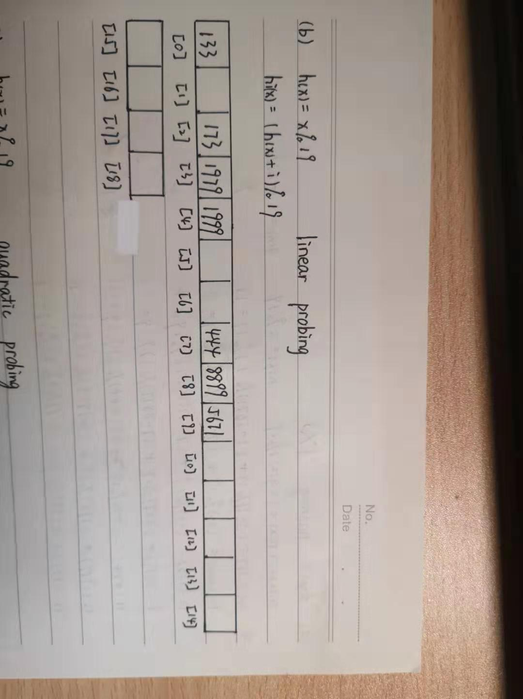

**(c)quadratic probing**

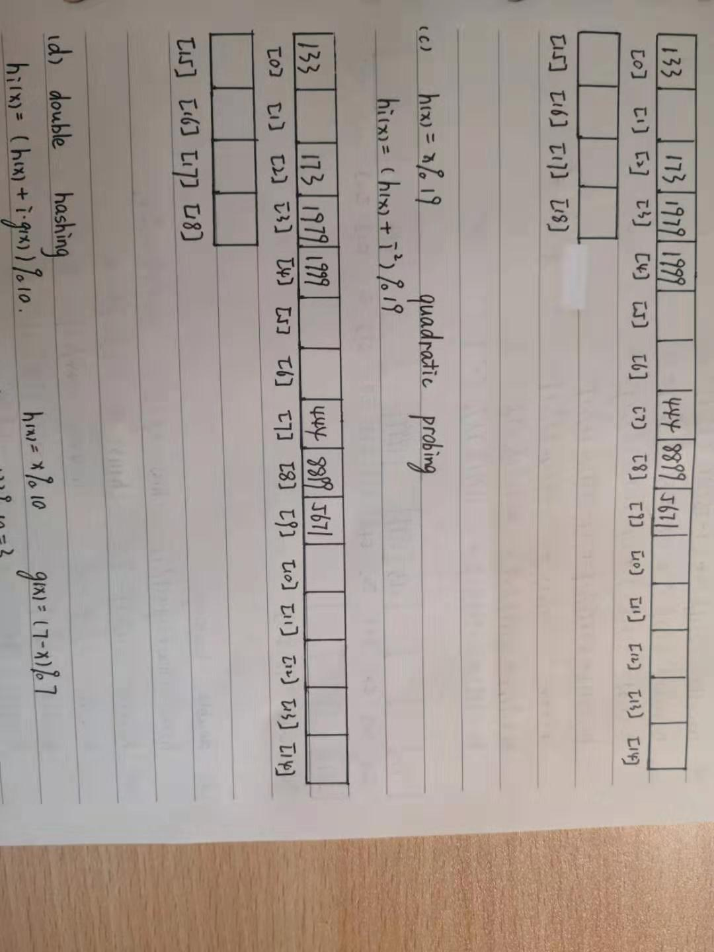

**(d)double hashing**

