**Source of steps to create sample project:**

* https://docs.microsoft.com/en-us/azure/notification-hubs/xamarin-notification-hubs-push-notifications-android-gcm#next-steps

# [Create a Firebase project and enable Firebase Cloud Messaging](https://docs.microsoft.com/en-us/azure/notification-hubs/xamarin-notification-hubs-push-notifications-android-gcm#create-a-firebase-project-and-enable-firebase-cloud-messaging)

I have created project at firebase

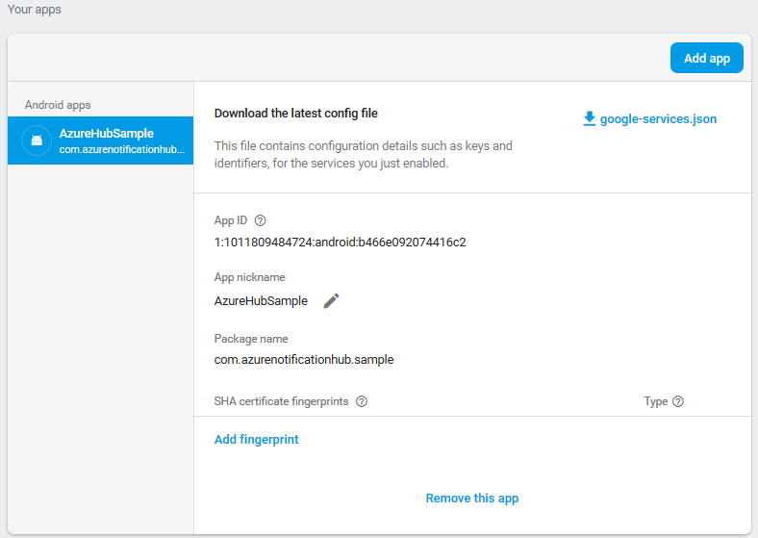

And downloaded google-services.json

# [Create a notification hub](https://docs.microsoft.com/en-us/azure/notification-hubs/xamarin-notification-hubs-push-notifications-android-gcm#create-a-notification-hub)

## Create a notification hub

Created notification hub named “AzureSample”, namespace “[AzureNotificationHubHSample](https://portal.azure.com/)”  
Location West Europe (My location is Ukraine)

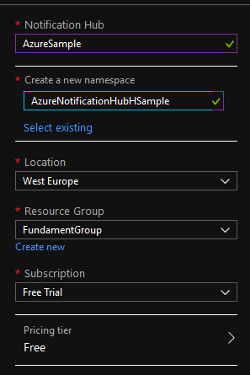

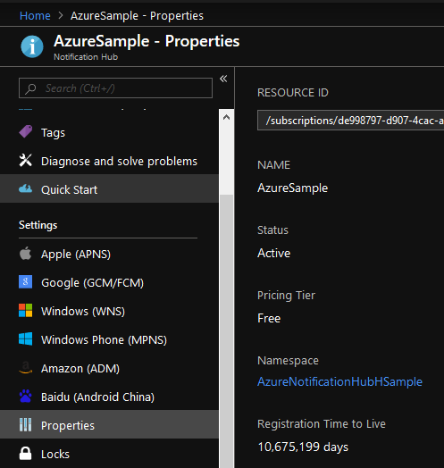

## Configure GCM settings for the notification hub

Got server key from Firebase console

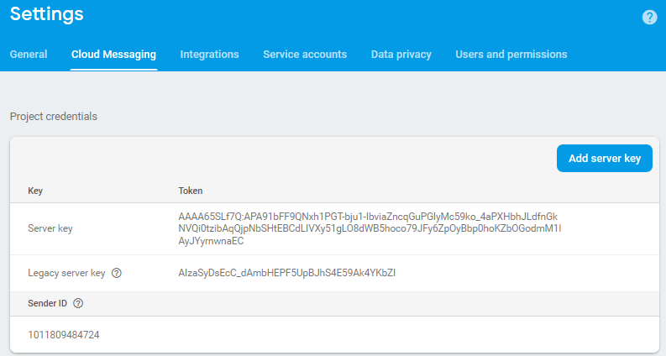

Put to FCM API Key and pressed Save button

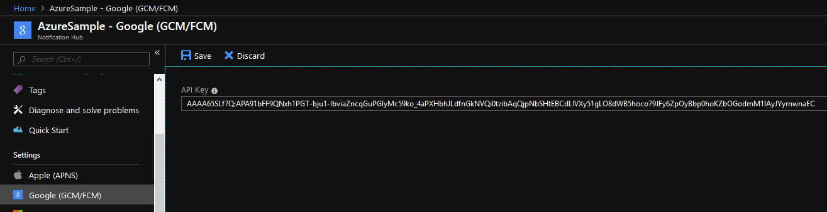

# [Create a Xamarin.Android app and connect it to notification hub](https://docs.microsoft.com/en-us/azure/notification-hubs/xamarin-notification-hubs-push-notifications-android-gcm#create-a-xamarinandroid-app-and-connect-it-to-notification-hub)

## Create Visual Studio project and add NuGet packages

Created blank App

Installed NuGets:

* **Xamarin.GooglePlayServices.Base**
* **Xamarin.Firebase.Messaging**
* **Xamarin.Azure.NotificationHubs.Android**

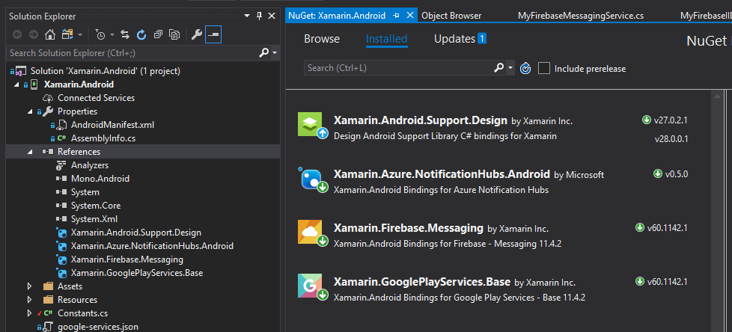

## Add the Google Services JSON File

Inserted “google-services.json”

Original content

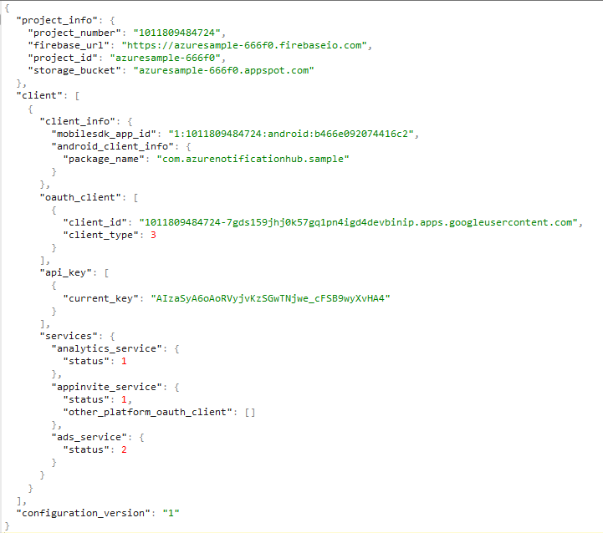

Inserted content

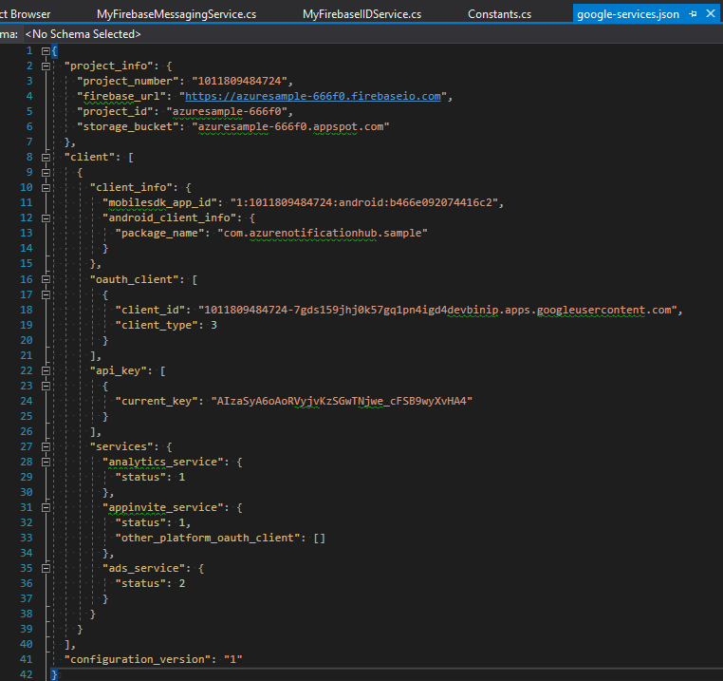

Set to Build Action to GoogleServicesJson

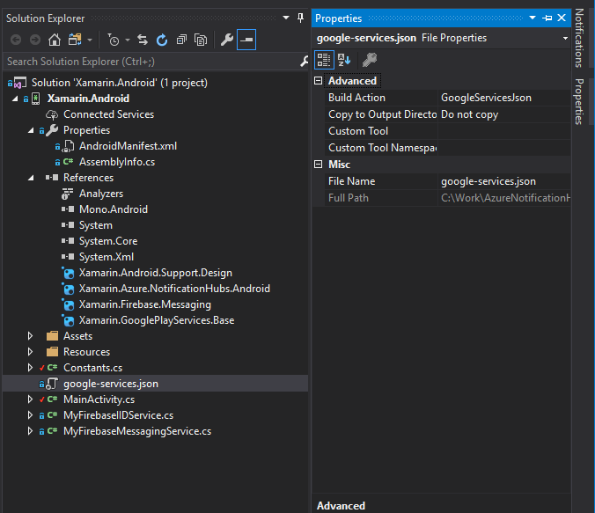

## Set up notification hubs in your project

Added to AndroidManifest.xml receiver and changed package name as in Firebase console:

Source:



AndroidManifest final:

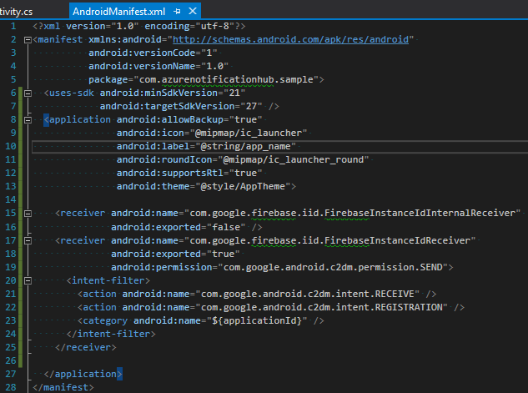

Created **Constants.cs**

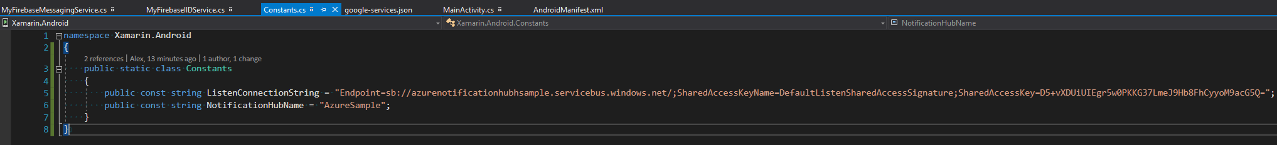

ListenConnectionString source:

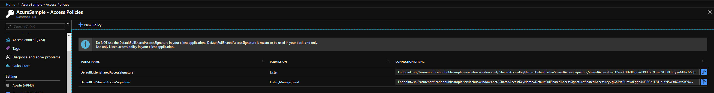

NotificationHubName source:



Final project structure:

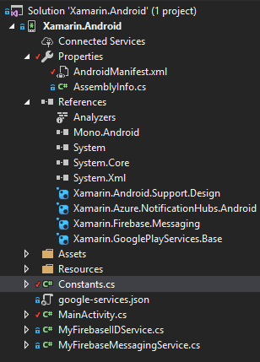

Modified MainActivity:

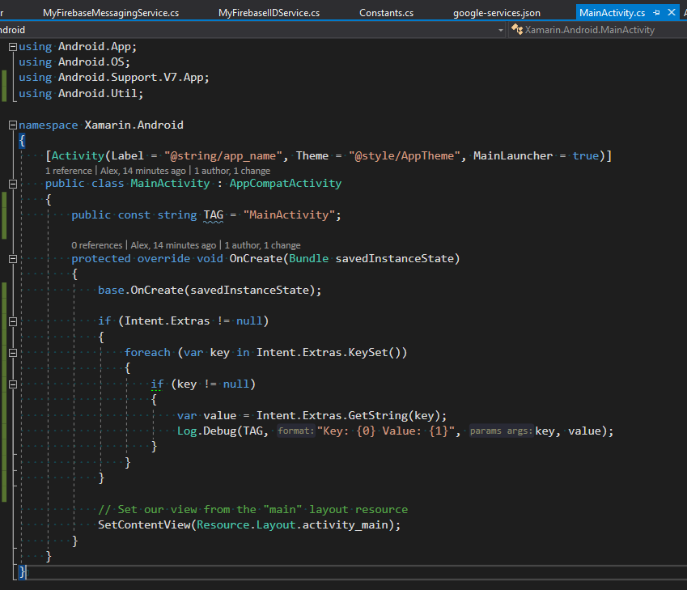

Added MyFirebaseIIDService.cs

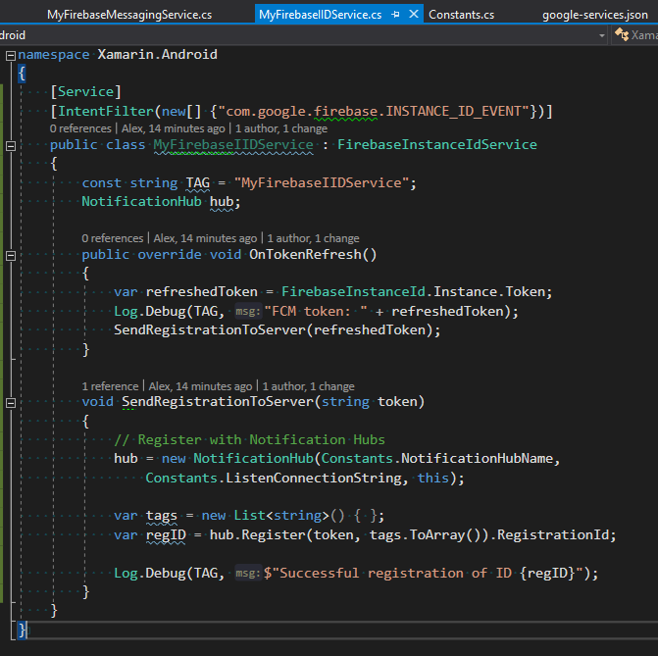

Added MyFirebaseMessagingService.cs

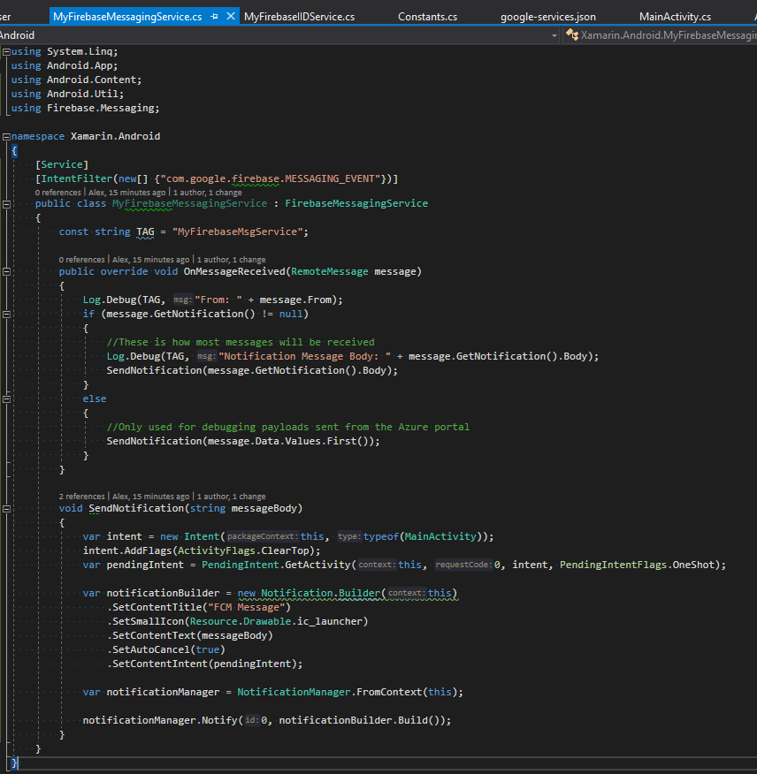

**Run** your app on your device (My device is Samsung Galaxy S7)

# [Send test notification from the Azure portal](https://docs.microsoft.com/en-us/azure/notification-hubs/xamarin-notification-hubs-push-notifications-android-gcm#send-test-notification-from-the-azure-portal)

Try to send notification and get that result:

