Michael Welk

DL5OCD  dl5ocd@darc.de

DATV-NotSoEasy V1.0

Content

1 Introduction 2

2 Installation 2

3 RX-configuration and usage 4

3.1 RX with new F5OEO firmware 5

4 TX-configuration and usage 7

4.1 DATV Relay 17

5 OBS Setup 19

6 Program start 25

7 F5OEO FW with MQTT 27

8 GSE hints 28

9 DATV-NotSoEasy Light 30

10 Roadmap 31

# Introduction

ffplay/ffmpeg compiled by DL5OCD 04.08.2023 with VVC (H.266) and libx264/265 support

For privat usage only!

I am not responsible for any damages on your system.

This software enables you to receive and transmit streams encoded with VVC (H.266) and AV1.

VVC/AV1 is an experimental implementation and not working perfect with some constellations! It is a work in progress.

This is a special version as part of the ffmpeg-suite.

Up to 3 receivers are supportet.

Requirements:

-A running Minitioune installation from F6DZP or other software with enabled UDP-Stream i.e. OpenTuner

-A modern PC with Windows 64bit (I tested it on Win 11, other versions might also work)

-This software

-At least 500MB free diskspace

-OBS (tested with 27, 28 and 29)

-Virtual Audio Cable or something similar or OBS 27 with VC-Plugin.

**Contribution:**

**Special thanks to Frank DD0CW for some initial parameters for ffmpeg!**

**Special thanks to Jacinto CU2ED and Phil M0PIT for beta testing and new suggestions!**

# Installation

Download:

<https://drive.google.com/file/d/1dwJjqGvSFw4En6y8rm2a_SCgKVhA-EAQ/view?usp=sharing>

**Windows:**

1. Unpack the DATV-NotSoEasy.zip to your directory.
2. With the new MQTT F5OEO FW you need to install mosquitto-2.0.15-install-windows-x64.exe

You will find it in the Mosquitto directory. This enables you to sent MQTT-Commands to the Pluto.

**Linux (Ubuntu), step 3-5 are not needed if you do not use the new F5OEO-FW:**

1. Unpack the DATV-NotSoEasy.zip to your directory. Start install.sh as root (sudo ./install.sh).

Or install it manually following the next steps:

1. Copy ffmpeg and ffplay to /usr/local/bin:

cd ffmpeg

sudo cp ffmpeg /usr/local/bin

sudo cp ffplay /usr/local/bin

As an alternative, compile and/or install FFMPEG by your own.

1. Install xfce4-terminal:

sudo apt-get install xfce4-terminal

1. Install MQTT-Explorer:

snap install mqtt-explorer

1. Install Mosqiutto client:

sudo apt-get install mosquitto-clients

1. Install v4l2 utils:

sudo apt-get install v4l-utils

1. Optional OBS newest version:

sudo add-apt-repository ppa:obsproject/obs-studio

sudo apt update

sudo apt-get update && sudo apt-get install obs-studio

1. Optional installation of the ALSA-Loopback Device

This provides a kind of virtual audio cable, e.g. to decouple the audio signal from OBS.

sudo modprobe snd-aloop

sudo nano /etc/modules

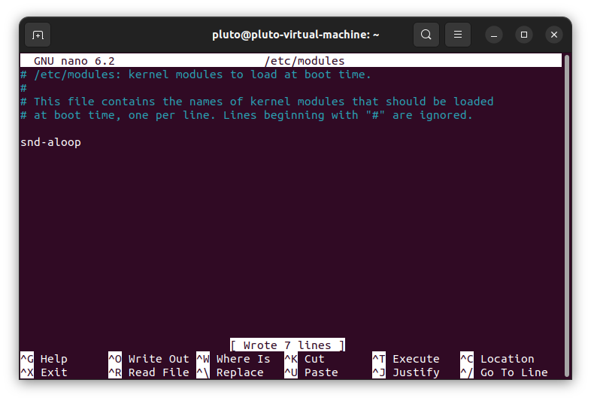

Ctrl+o to save, ctrl+x to exit.

1. Optional Device index for OBS Virtual Cam

To prevent the index and thus the device /dev/videox from constantly changing under Linux, simply copy the file under scripts/99-obs-vc.rules

to /etc/udev/rules.d and restart udev. In the config-tx.ini then use the device /dev/obs_vc for video.

# RX-configuration and usage

Just edit the "config-rx.ini" with your favorite editor:

############## Global configuration ###############

# Set the IP-Address where the TS-Stream is sent to:

IP1=230.0.0.10

IP2=230.0.0.10

IP3=230.0.0.10

# Set the port of the TS-Stream here:

PORT1=10000

PORT 2=10001

PORT 3=10002

Change IP and port to your output of the TS-Stream of Minitioune or other software.

Within MiniTioune this can be changed in the minitiouneConfig.ini:

TS_AddrUDP=230.0.0.10

TS_Port=10000

Just tune in a H266 station with Minitioune from F6DZP or other software (sound ok but no picture) and then start

"START-FFPLAY.bat/.sh" (double-click).

Select number of connected receivers.

Select your desired screen resolution of the window where you watch the video.

Be shure you start "START-FFPLAY.bat/.sh" after(!) you tuned in the signal!

After a few seconds you will decode the station in a seperate window.

As an alternative you can use MPV-Player, just click "START-MPV-STREAM(1-3).bat/.sh". There is support for 1 receiver atm.

When you switch between different stations it might be usefull to restart ffplay or MPV again.

# 3.1 RX with new F5OEO firmware

With the new MQTT firmware it is now possible to use Longmynd in Pluto. To do this, a USB HUB with its own power supply must be connected to the Pluto.

The Pluto, the Ethernet adapter and a Minitiouner are connected to this.

To use it in config-tx.txt simply set DATVOUT=yes. When starting DATV-NotSoEasy, parameters are queried which set the RX accordingly.

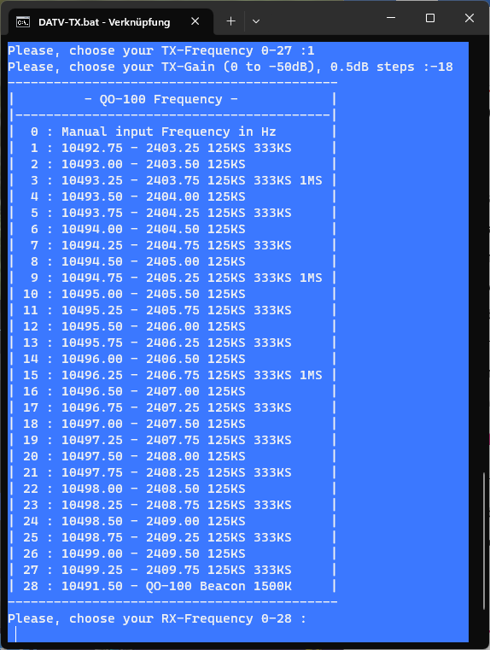

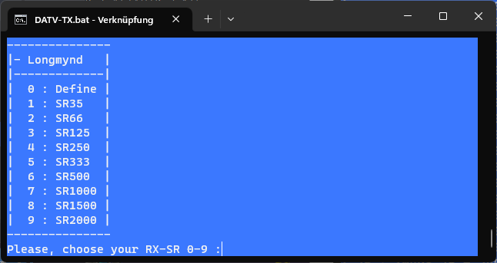

# TX-configuration and usage

Remark:

-------

If you want to try H.266, you have to disable Remux within the Pluto (F5OEO FW, some versions)!

Be aware that the delay of H.266 is higher than with H.265 and is highly experimental,

the quality/SR`s also depends on your Hardware. This program is independent of F5OEO-FW versions,

it should work with every version.

You can adjust the parameters of the frontend by yourself.

Nothing is hidden, so it is Open Source, so you can adjust every single parameter.

Feel free to share your findings.

Hint for H.266 usage: If you have a constant video stream like a camera you can decrease MAXDELAY down to 200 (this will be multiplied by 10).

This will lead to a much lower latency. If you play videos it is a good idea to increase MAXDELAY up to 2000.

Best results will be archived when CPU-Load stays below 80%.

Open the "config-tx.ini" with your favorite editor and adjust the global configuration to your needs:

Öffnen Sie die "config-tx.ini" mit Ihrem bevorzugten Editor und passen Sie die globale Konfiguration an Ihre Bedürfnisse an:

############### Global configuration ################

# Use new MQTT F5OEO firmware (yes/no)?

# If set to no, all Mosquitto and GSE settings will be ignored!!!

FW=yes

# Set the Callsign and service provider here:

CALLSIGN="DL5OCD_Michael"

SERVICEPROVIDER="DATV-NotSoEasy0.98"

# Set the Pluto IP where the stream is sent to (default was MCAST 230.10.0.1, TSSOURCEADDRESS MQTT):

PLUTOIP=192.168.2.35

# Set the Pluto-port of the stream here (default was 1234):

# In case of a DATV-Relais, please set this to default 1234 to match the input from Longmynd

#PLUTOPORT=1234

PLUTOPORT=8282

# Set virtual audio cable device here (grab the name from Win Device Manager).

# Valid devices might also be "CABLE Output (VB-Audio Virtual Cable)" or something similar.

# With the VC plugin for OBS 27, you can also use "OBS-Audio"

# Valid devices can be displayed with .\ffmpeg -list_devices true -f dshow -i dummy

AUDIODEVICE="CABLE-B Output (VB-Audio Cable B)"

# Set OBS Virtual Camera device here (grab the name from OBS).

# Valid devices might also be "OBS-Camera" (OBS 27 with VC plugin) or something similar.

# Valid devices can be displayed with .\ffmpeg -list_devices true -f dshow -i dummy

VIDEODEVICE="OBS Virtual Camera"

# Set hardware or software encoding here (nvidia or soft):

ENCTYPE=soft

# Set audio codec normal AAC (aac), AAC+ (libfdk_aac), AC3 (ac3):

AUDIOCODEC=libfdk_aac

# Set input type DSHOW, NETWORKUDP, NETWORKRTMP or FILE

# For UDP and RTMP set the stream accordingly.

INPUTTYPE=DSHOW

# Set type and IP for the network input or a movie to play from file

# If you want to play from a file, set STREAM=myfile.mp4 and INPUTTYPE=FILE

# Via UDP set udp://230.0.0.11:20000 or something similar

# Via RTMP set the LAN-IP of this PC

STREAMUDP=udp://230.0.0.11:20000

STREAMRTMP=rtmp://192.168.2.182:20000/live/aaaa

STREAMFILE=\path\to\myfile

# Mode (DVB-S) or (DVB-S2) calculation of the bit rates

DVBMODE=DVB-S2

############### Mosquitto settings (new FW only) ################

# Set the Pluto cmd-root (just edit the call)

CMD_ROOT=cmd/pluto/DL5OCD_Michael

# Set the path to Mosquitto (it is ok like it is)

MOSQUITTO="c:\program files\mosquitto\mosquitto_pub.exe"

# Reboot Pluto (on) or (off) and switch to passthrough after quit DATV-NotSoEasy?

# Hint: Not needed with newer FW versions, when switching to SDR-Console the Pluto is working without reboot.

REBOOT=off

# Pluto TX TSsourcemode : Source of transport stream {0 = udp, 1 = file, 2 = internal patern}

TSSOURCEMODE=0

# Pluto TX TSsourcefile : File path if TSsourcemode=file. It could be useful to set up a nfs sharing file on your PC

TSSOURCEFILE=\path\to\file

# PTT at startup: On (0) PTT Off (1)

# In case of a DATV-Relais, it is better to set this to 0. Transmission starts at Pluto boot.

MUTE=1

# Pluto TX Mode, set dvbs2-ts value for TS input, set dvbs2-gse value for IP input GSE mode on the Pluto ethernet address.

# Set pass value to put the Pluto in passthrough mode (eg for sdr console or gnu radio)

# GSE mode works better with short frames.

# In GSE-Mode, dvbs2-gse is automatically chosen!!! No need to change this here!!!!!!!!!!!!!!!

TXMODE=dvbs2-ts

# PLuto TX Pilots, 0 value for no pilots, 1 value for pilots

PILOTS=0

# Pluto TX frame type, short or long

# In GSE-Mode, short is automatically chosen!!! No need to change this here!!!!!!!!!!!!!!!

FRAME=long

# PLuto TX FECmode : set fixed value for CBR (Constant BitRate) modulator, need setting muxrate value for ffmpeg

# set variable value for VBR (Variable Bitrate) in this case actual FEC is adjusted according to input bitrate, between

# a min FEC value provided by the above TX FEC value and a max FEC value of 8/9 (Short frame) or 9/10 (long frame QPSK)

# FEC min value is 1/4 for QPSK, 3/5 for 8PSK and 2/3 for 16APSK.

# If you choose variable fecmode you must set the FEC according to this min value

# In case of a DATV-Relais, it might be a good idea to set this to variable, so FEC is adjusted depending on input bitrate.

# Set TX-FEC to 1/4 (QPSK) and FECRANGE=6 or 7 to archive a good dynamic range.

#FECMODE=fixed

FECMODE=variable

# Pluto TX FECrange {0..11} : When FECMODE=variable, this constraint the max fec : initial fec+fecrange

# Set FECRANGE to a proper value, i.e. starting with TX QPSK FEC 1/4 FECRANGE=7 means FEC 4/5 max.

# Value depends on your system (antrenna, power...).

FECRANGE=7

# VBR (on) or (off). If you want all encoders to use VBR, set this to on.

# This only works when you are in variable FEC-Mode (FECMODE=variable)!!!!!

# This is not recommended for low SR`s

VBR=on

# PLuto TX agcgain value, with agcgain the Pluto gain is adjusted to try to maintain a constant Report value

# (D1, D2, D3, etc...) according to FEC, in variable FEC mode this value is the Max Pluto gain for the higher FEC.

# Pluto Gain value, be careful when setting this value, be sure you have understood what it means

# -100 mean no AGC - set GAINVARIABLE=1 if you want to enable it

AGCGAIN=-100

# Switch variable gain on (1) or off (0)

GAINVARIABLE=0

# Pluto TX RIT value in Hz

NCO=-20000

# Pluto Longmynd DATV output (on) or (off), if set to yes, you need to connect a powered USB-HUB and a Minitiouner

# This enables you to receive DATV stand alone. A MPV- or FFPLAY window will be opened.

DATVOUT=off

# Pluto Longmynd DATV output IP, to this IP the normal stream is sent to receive DATV transmissions.

# This is the IP where the MPV/FFPLAY or any other client is listening.

# This can be a unicast address like 192.168.2.101 or a multicast address like 230.0.0.1

# In case of multicast every client in the local network can receive the stream

# If set to the IP of the Pluto, DATV-NotSoEasy acts as a DATV-Relais.

# This is related to PLUTOIP=x.x.x.x in the global configuration section. Set PLUTOPORT=1234

# Be shure that the input do not exceed the output bitrate

#DATVOUTIP=192.168.2.35

#DATVOUTIP=230.0.0.1

DATVOUTIP=192.168.2.101

# Pluto Longmynd DATV output Port, do not change!

DATVOUTPORT=1234

# Program for RX DATV standard transmissions, FFPLAY (ffplay), MPV (mpv)

RXPRG=ffplay

# Offset between RX-Frequency and Longmynd RX-Frequency (Mhz, LNB XO)

RXOFFSET=9750

# LNB supply (0) or (1), not yet working, leave at 1

LNBSUPPLY=1

# LNB polarization vertical 12V (0) or horizontal 18V (1), not yet working, leave at 1

LNBPOL=1

# Tuner RX-Port (0) Top, (1) Bottom

TUNERPORT=0

# DATV-Relay Mode (on) or (off), parameters will be set automatically.

# You can also leave RELAY=off and change parameters by hand in this config-tx.ini

# Settings that are modified when RELAY=on: PLUTOPORT=1234, DATVOUTIP=PLUTOIP, DATVOUT=yes and FECMODE=variable

# Set FECRANGE to a proper value, starting with TX QPSK FEC 1/4 FECRANGE=7 means FEC 4/5 max.

# Value depends on your system (antenna, power...).

RELAY=off

# Power limiter, set max. gain value (dB) here

PWRLIM=-10

############### GSE settings ################

# Tun ip address Pluto, use only for GSE mode

TUNIP=44.0.0.2

# Network for routing via GSE

NETWORK=44.0.0.0/24

# PC IP address to forward for ports UDP 1000-10000, use only for GSE mode

PCFORWARD1=192.168.2.101

PORTSTART=1000

PORTEND=11000

# PC IP address to forward for port TCP 80 (eg http web server), use only for GSE mode

PCFORWARD2=192.168.2.101

PORT=80

# Address to receive bbframe from Linux longmynd (F5OEO version : https://github.com/F5OEO/longmynd), use only for GSE mode

MCAST=127.0.0.1

# Address to receive bbframe from Linux longmynd (F5OEO version : https://github.com/F5OEO/longmynd), use only for GSE mode

MCASTPORT=1234

# IP-Address where Longnynd sends the GSE-Stream to, must be set to the same as MCAST

TSIP=127.0.0.1

# Add a network route (yes) or (no) for the local PC towards the Pluto (will be deleted after DATV-NotSoEasy is quit)?

# This have to be done manually at the moment, start \scripts\ROUTING.bat/.sh as Administrator

# For the time being, leave ROUTE=no

ROUTE=no

############## Optional settings #####################

# Audio sync +- in seconds

OFFSET=-0.2

# Set Video PID

VIDEOPID=256

# Set Audio PID

AUDIOPID=257

# Set PMT PID

PMTPID=4095

# Set MPEGTS START PID (PCR)

MPEGTSSTARTPID=256

# Set Network ID

NETWORKID=1

# Set MPEGTS Transport Stream ID

STREAMID=4095

# Set Service ID

SERVICEID=4095

# Set PAT-Period

PATPERIOD=0.4

# Set PCR-Period

PCRPERIOD=20

# Set keyframe interval hardware encoder

KEYHARD=150

# Set keyframe interval software encoder

KEYSOFT=150

# Set keyframe interval VVC encoder

KEYVVC=75

# Set keyframe interval AV1 encoder

KEYAV1=75

# Set quality for AV1 encoder, lower is better (1-63)

AV1QUAL=30

# Set realtime buffer in Megabytes (buffers for DSHOW, NETWORK...)

RTBUF=300

# Set maximum muxing or demuxing delay in milliseconds

MAXDELAY=2000

# Set Max Interleave Delta in seconds, default 10s

MAXINTERLEAVE=4

# Set factor of video buffers n x video bitrate

BUFFACTOR=4

# Set Thread Queue size for video/audio input in Kilobytes

THREADQUEUE=10

# Set FIFO Buffer for UDP output queue in Megabytes

FIFOBUF=50

# Set auto play for file input, 0 for no loop, -1 for infinite loop, 3 for 3 repeats....

STREAMLOOP=-1

###########################################################################################

This setup works together with OBS Virtual CAM and Virtual Audio Cable or just with a UDP-Stream if you select INPUTTYPE=NETWORK.

It is also possible now to play from files, just place a file into the folder where DATV-TX.bat/.sh resists.

Change

INPUTTYPE=DSHOW

to

INPUTTYPE=FILE

and

STREAM=udp://230.0.0.11:20000

to

STREAM=myfile.mp4

DATV-NotSoEasy now starts streaming the file.

# DATV Relay

With version 0.98 it is now possible to configure a DATV relay. To do this, simply set RELAY=on.

This automatically sets parameters like PLUTOPORT=1234, DATVOUTIP=PLUTOIP, DATVOUT=yes and FECMODE=variable.

When the program is started, parameters for RX and TX are queried.

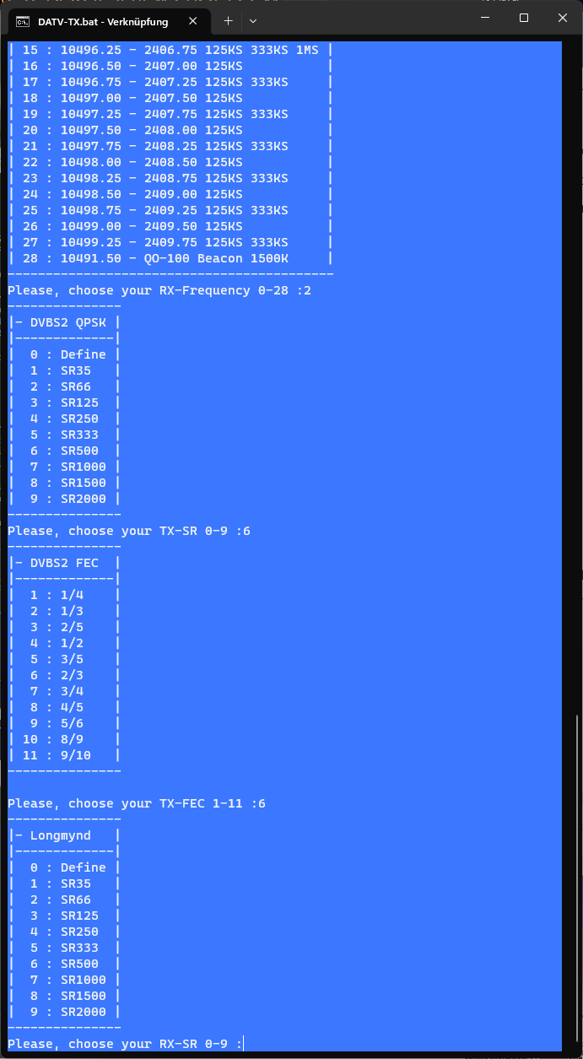

FEC=variable has the decisive advantage that the TX-FEC is automatically set depending on the received signal.

The FEC range can be specified and the TX-FEC should always be set to the lowest value, e.g. to 1/4 for QPSK.

FECRANGE=7 then means that the TX-FEC then moves between 1/4 and max. 4/5. This value depends on the station (antenna, power)

and should be chosen with care.

The relay works almost in real time, i.e. there is no delay between the received and the transmitted signal.

# OBS Setup

**Streaming from DATV-NotSoEasy - DSHOW:**

(Audio Settings) Activate the Monitoring-Device and select your Virtual Cable.

(Advanced Audio Settings) Activate the Virtual Cam and adjust your input devices to “Only Monitor”.

**For stream input into DATV-NotSoEasy – NETWORK UDP:**

(File > Properties > Output > Recording) Set Tybe to User specific, Set Type to URL, URL udp://230.0.0.11:20000, Container mpegts, Videobitrate 2000Kbps, Videoencoder hevc_nvenc,

libx264, libx265, or whatever you prefer. Set audio bitrate to something you want, 64Kbps is sufficient, Audio encoder to aac or aac_mf. Everything else can be left blank.

See attached screenshots in this folder.

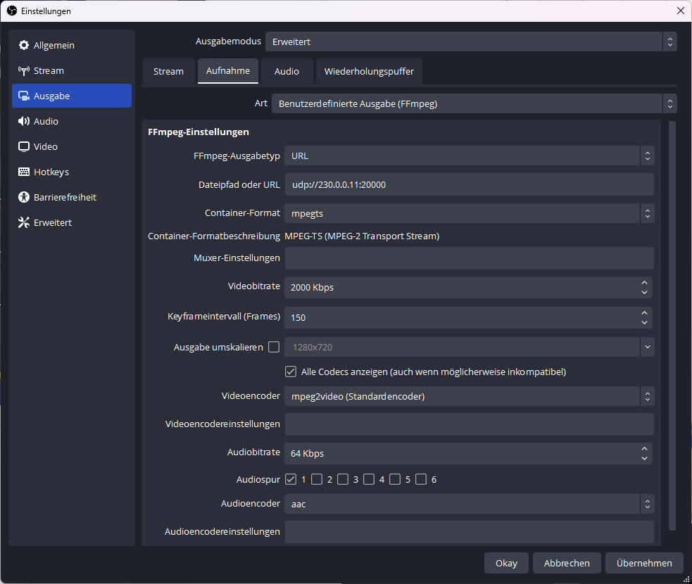

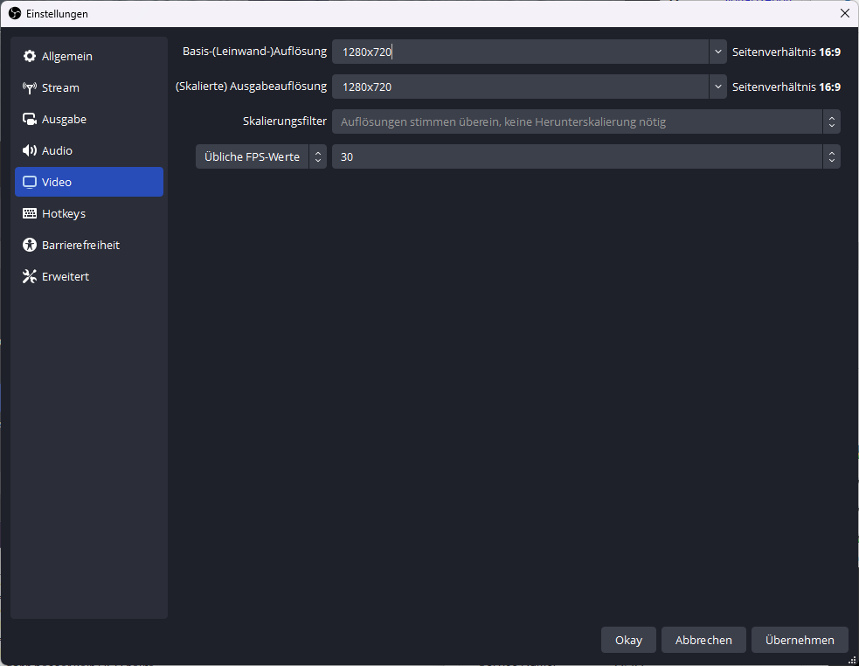

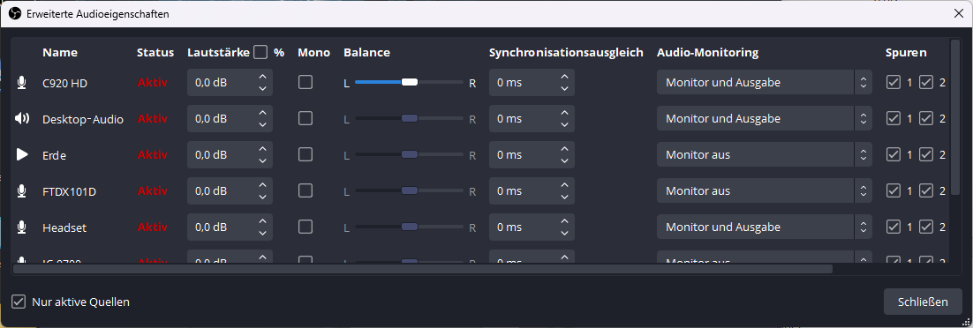

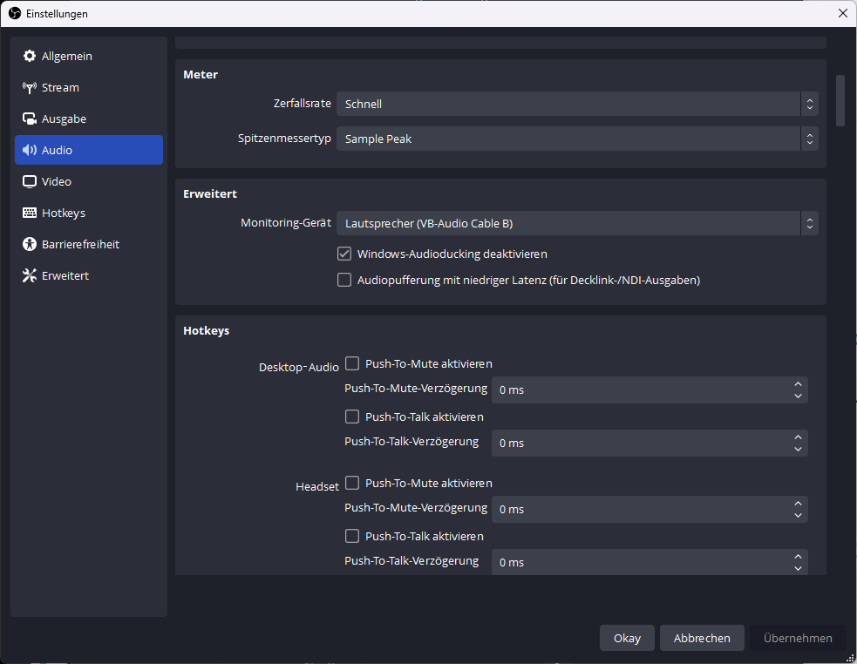

**For stream input into DATV-NotSoEasy – NETWORK RTMP:**

Just set the parameters like in this screenshot:

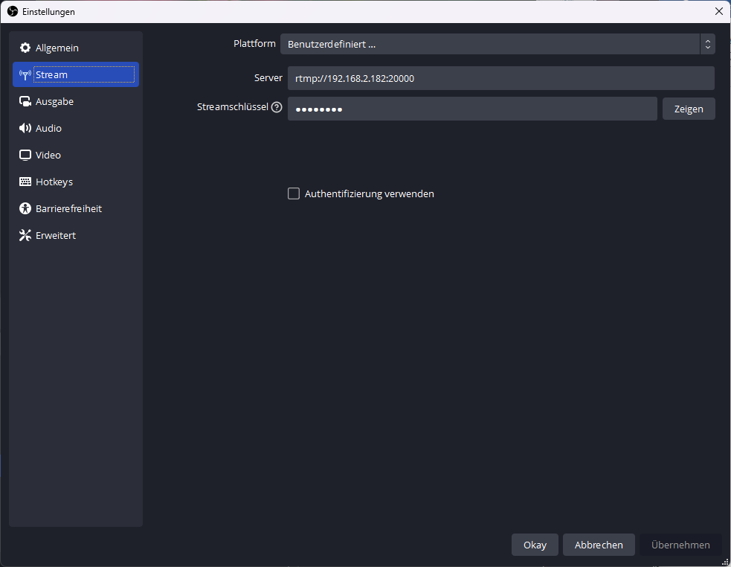

Adjust the IP to your address where DATV-NotSoEasy is running (localhost, 192.x.x.x….)

OBS under Linux:

Audio output via ALSA-Loopback:

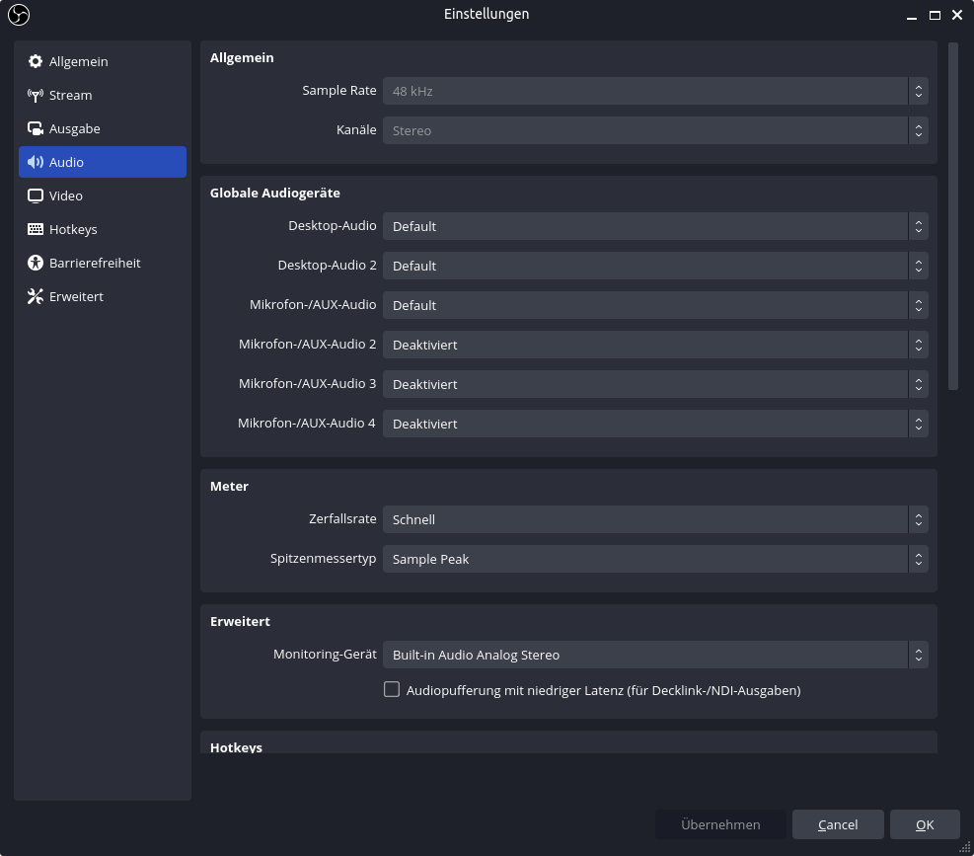

Enable output:

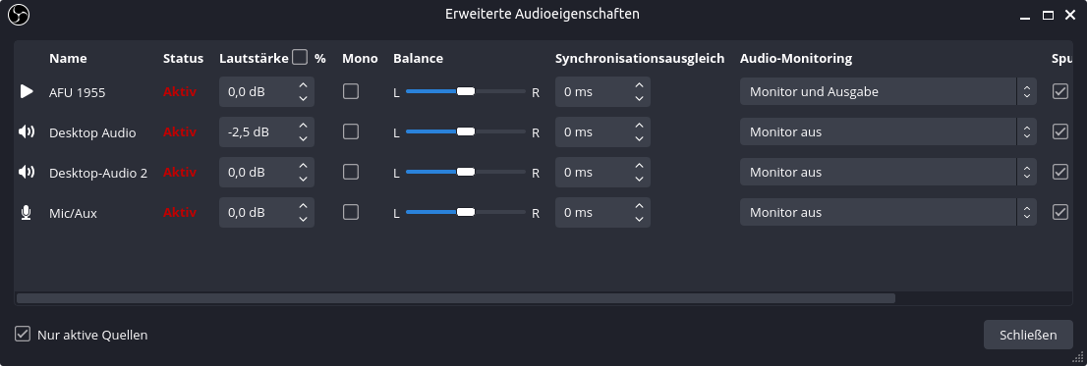

Remark: Start DATV-NotSoEasy before you press on the "Recording" button or start the Virtual Cam before you start DATV-NotSoEasy.

That was it within OBS.

# Program start

Now set your Pluto (not needed anymore with F5OEO FW 2.xxx !!!!!!!) to the corresponding SR/FEC, Rolloff, Frequency etc. (see menu below),

run the DATV-TX.bat/.sh (double-click) and answer a few questions:

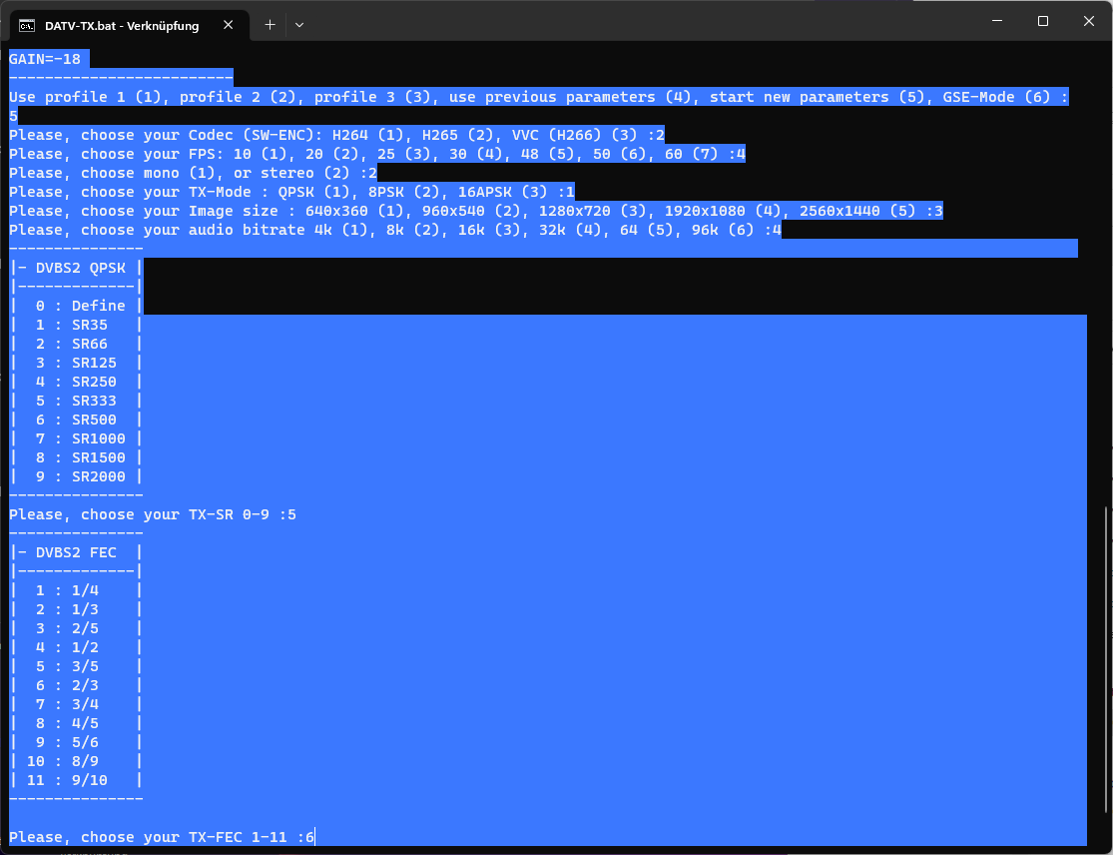

The Program now starts streaming to the Pluto. Watch the output of the program.

Stop the transmission with the Pause/Break button, restart with the ENTER button.

Alternatively:

Start/stop the transmission via the TX button in the F5OEO-FW or a shortcut.

If DATV-NotSoEasy is controlled via network, the record button in OBS can also function as a PTT.

To exit the program, simply press the Q button!!!!!!!!!!!!!!!!

Be shure to focus the window of DATV-NotSoEasy.

Please note that with older F5OEO FW (not 2.xxx !!!!) at SR>1000K the Remux in the Pluto have to be switched on.

Hint:

Best is to set FPS in OBS to match selected FPS in DATV-NotSoEasy.

This is not mandatory but it works best.

To set the favorite settings (3 profiles):

Just open SET-FAVORITE.bat/.sh (double-klick) and follow the instructions.

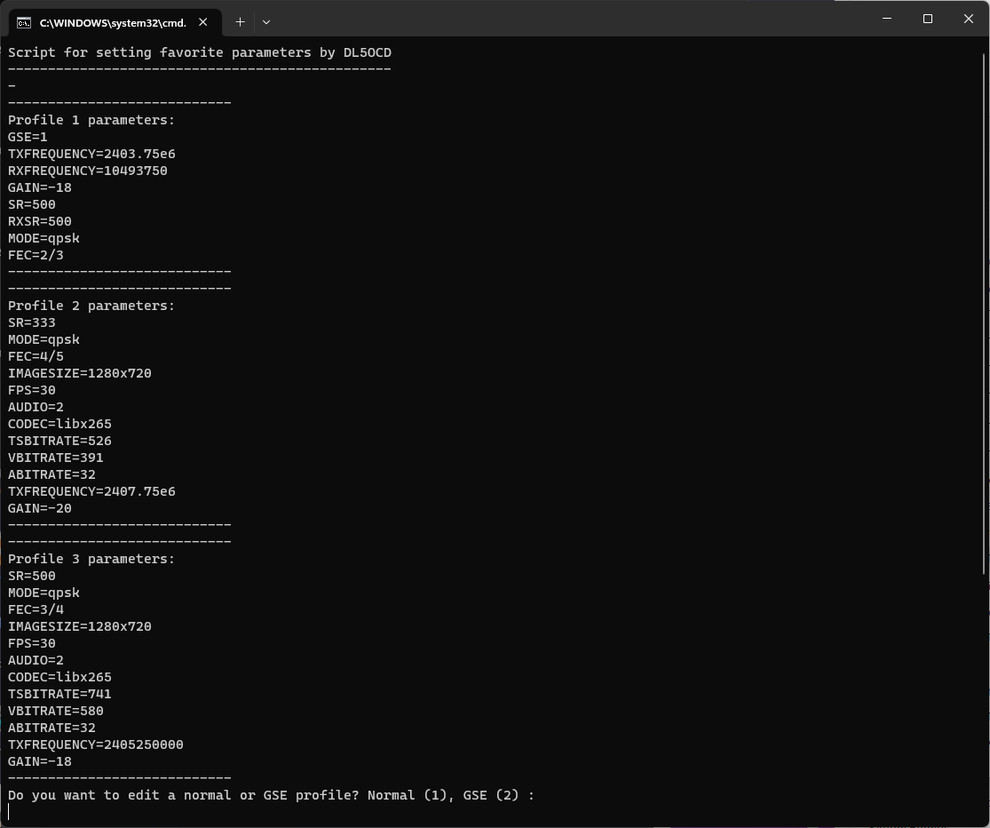

# F5OEO FW with MQTT

If you use the new firmware, you have to install Mosquitto first and load the new FW into the Pluto.

Go to the Mosquitto directory and start mosquitto-2.0.15-install-windows-x64.exe

After the installation is complete and you have adjusted all parameters in config-tx.ini, just start SETUP.bat/.sh in the DATV-NotSoEasy directory

and follow the steps. This is setting your callsign in the Pluto and the structure of the MQTT-Tree.

Very important!!!:

# Use new MQTT F5OEO firmware (yes/no)?

FW=yes

# Set the Callsign and serviceprovider here:

CALLSIGN="DL5OCD"

# Set the Pluto IP where the MQTT commands are send to (incl. routing for GSE):

PLUTOIPMQTT=192.168.2.35

# Set the Pluto cmd-root (just edit the call)

CMD_ROOT=cmd/pluto/DL5OCD

Adjust these variables to your needs.

After everything is set, start DATV-NotSoEasy as usual. You will notice 1 additional window:

CONTROL. Here you can set essential parameters on the fly during transmit. Also a PTT is implemented.

**VBR Notes:**

**VBR only works if**

**FECMODE=variable**

**VBR=on**

**are set.**

**Note that VBR does not have any MUXRATE and MAXRATE. It causes high bit rate spikes.**

But if you set a high FECRANGE and a medium TX-FEC (the variable FEC always sets the Pluto to the minimum value, so for QPSK ¼), it works fine.

The FEC you select during the questions affects the video bitrate and no longer the min/max rate or the mux rate. In VBR there is also no more shaping in ffmpeg.

The stream goes 1:1 into the Pluto – you have to watch out for the buffers. You can see nice peaks there.

In some tests, I have found that artefacts no longer form with rapidly changing videos because the peaks are transmitted immediately.

However, it's a balancing act between buffering in Pluto, video bitrate, and SN/MER to avoid drops. Here you have to experiment a bit to find the best setting.

# GSE hints

In order to also be able to receive IP (GSE mode), Longmynd have to be activated on the Pluto.

# Start Longmynd on Pluto on/off (connect a Minitiouner via USB-Hub with the Pluto)

STARTLONGMYND=on

# Offset between RX-Frequency and Longmynd RX-Frequency (Mhz, LNB XO)

RXOFFSET=9750

In GSE mode, the TX frequency, RX frequency and RX sample rate can be changed on the fly in the TX frequency window during operation.

The GSE station to be received can then be captured here. You can easily follow this in the MQTT browser under Longmynd.

In order to activate the routing for the network 44.0.0.0/24 on the PC, a terminal must be opened in administrator mode.

The command

route add -p 44.0.0.0/24 192.168.2.35

activates the routing to Pluto permanently. The IP address 192.168.2.35 has to be adjusted, this is the IP address of the Pluto LAN interface.

A

route delete 44.0.0.0/24

removes the route from the PC again.

Pictures how to setup OBS for native IP-Streaming are in this folder.

Details can be found here: <https://github.com/F5OEO/pluto-ori-ps/wiki>

H.264:

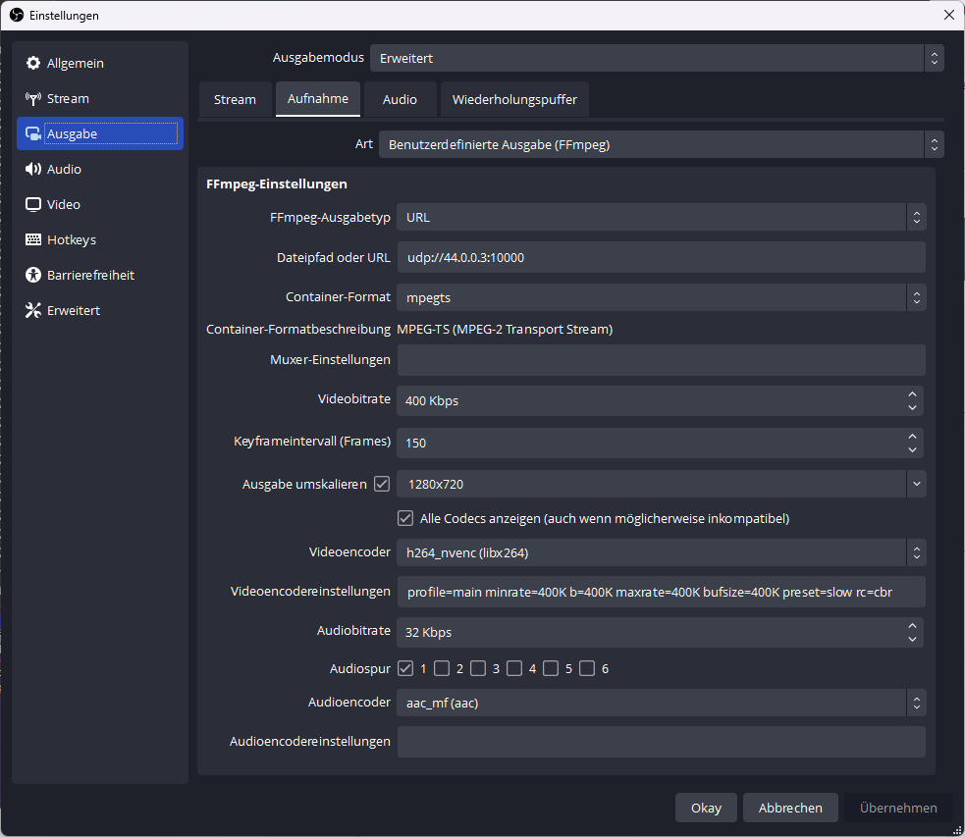

H.265:

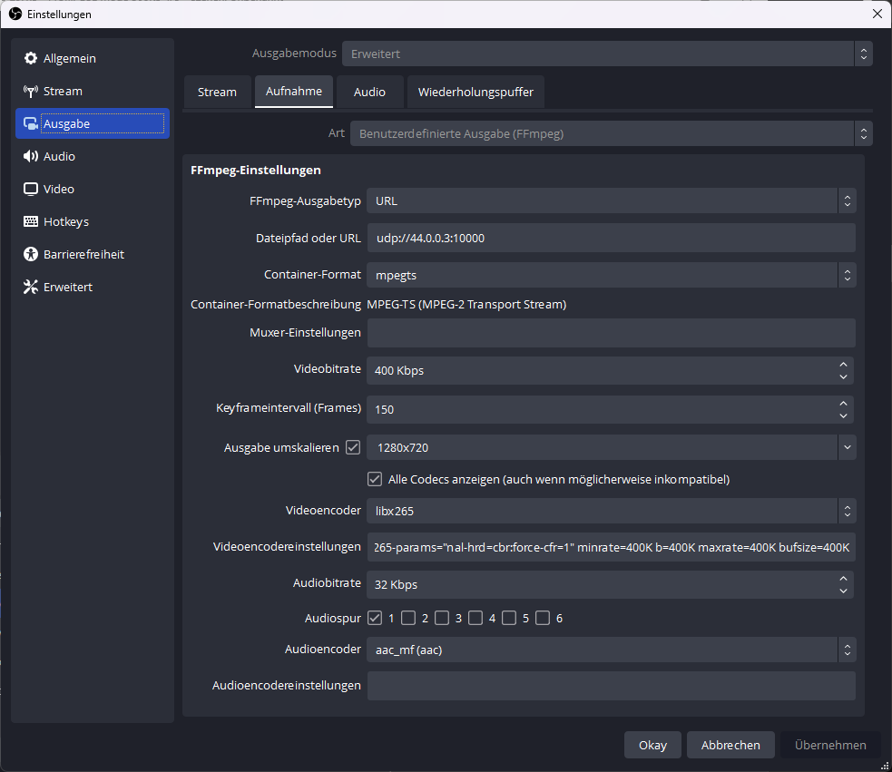

# DATV-NotSoEasy Light

I have added a light version (DATV-TX-LIGHT.bat/.sh), this version only steers the Pluto, no streaming.

The streaming has to be done external via OBS or something similar. It just sets basic things in the Pluto like

SR=1000

MODE=qpsk

FEC=2/3

FREQUENCY=2405.25e6

GAIN=-15

To set the favorite settings (3 profiles):

Just open SET-FAVORITE-LIGHT.bat/.sh (double-klick) and follow the instructions.

Example streaming from OBS 500KS FEC 4/5:

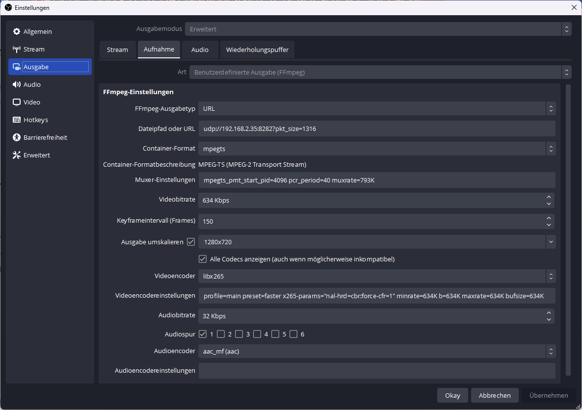

That`s it.

# Roadmap

Roadmap:

-Development of a GUI

Have fun!

73 de DL5OCD