Synchronous I/O Multiplexing in Pt Applications

Marc Boris Duerner, Mike Sharov, Laurentiu Crisan

Introduction
Most applications need to perform I/O in parallel to its normal control flow. The Reactor[1] and Proactor [2] patterns are common ways to implement I/O mutiplexing on the framework level. These methods have distinct advantages and disadvantages and a common application framework ultimately needs to provide both of them. This paper focusses on the concept and implementation of synchronous I/O multiplexing as part of the regular application event handling.

In the Reactor pattern an application registers an event handler to a synchronous dispatcher. The dispatcher will be run in the calling thread and block it until it is possible to perform an I/O operation without blocking. Traditionally, the POSIX system call select or the Win32 system call WaitForMultipleObjects can be used to implement a reactive model. A number of object handles is passed to these functions and they indicate which handles are ready to perform I/O. This pattern has the main advantage of low overhead due to the avoison of mutliple threads and thus context switches and data movement [3]. Besides the higher efficiency, the programmer does not have to take care of concurrency problems (The application is single-threaded). The disadvantage here is that the calling thread will be blocked while it waits for events on the selected I/O channels and can not perform I/O operations itself concurrently.

In the Proactor pattern I/O operations are performed asynchronously by one or more threads. The application may be notified when operations complete. A typical example of proactive I/O is POSIX AIO or I/O completion ports on Win32.
The primary advantage is that operations can be carried out concurrently without blocking the main application thread. This may lead to better concurrency and scalability of the program, but also to less total efficiency because of increased context switches and data movement, which are usually avoided by reactive processing. The program logic is complicated due to concurrency issues and the pure asynchronous program model, however, programming patterns exist to handle this.

In the context of event handling, the main disadvantage of the Reactor pattern may not be much of a problem, when it is part of the main event loop. After all, that is what an event loop does, it blocks while it waits for events and processes them serially, so it is reactive by design. Therefore this is a good place in a framework to implement reactive I/O.

Concept
The IODevice (Pt::IO) is the abstract base class to implement endpoints for input and output and can be used for transparent synchronous I/O. To implement a reactive model, one or more IODevices need to be registered to a manager class (IOMonitor), which waits for I/O and demultiplexes the I/O events. I/O events can be easily and efficiently dispatched using Pt's signals/slot mechanism to notify the appropriate readers. If reading is to be canceled, the IODevice is unregistered or a signal is triggered to close what is being read. The manager instance is ideally part of the main event loop and reactive I/O handling is tighly integrated with the regular event handling model so that application events and I/O can be dispatched by the same instance. A separate manager instance may be required if another event loop must be used. Intergation of the IOMonitor and the event loop depends on the architecture of the external event loop, but might require another thread.

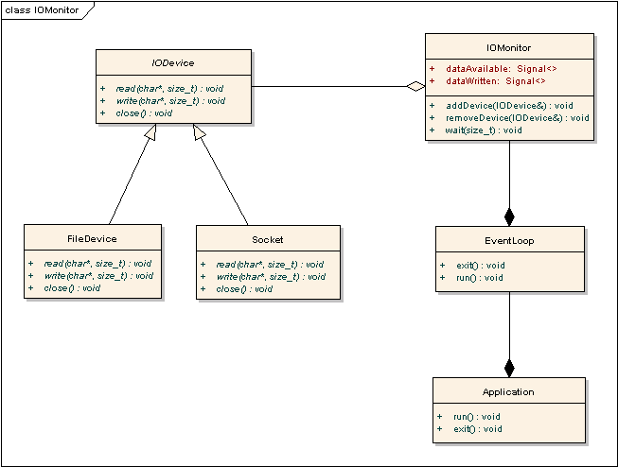
It is desireable to implement a more sophisticated signal/slot support to handle reader notification, but this is not within the scope of this paper. The main challenge is to implement the IOMonitor::wait method on different operating systems. Most systems, however, will support an intergation of I/O with the main event loop directly and very efficiently.

Implementation
POSIX (Unix, Linux, QNX)
The implementation of the IOMonitor is trivial on all operating systems that offer a POSIX conforming API [4]. These systems follow the „everything is a file“ philosophy, so that a file descriptor is behind each IODevice. File handles are not only used for I/O devices, but also for event loops. Under X11 it is possible to get the connection handle and linux kernel event handling involves a number of device files such as /dev/event. The system call select can be used easily to implement the IOMonitor to wait on multile devices and the event loop handles at the same time. Alternatively poll, epoll or kqueue can be used to achieve better scalability when waiting on many handles, because they are of O(1) complexity instead of O(n) like select. This implementation will completely avoid multi-threading in the application and allow a very efficient combination of reactive I/O processing with event handling.

Win32
The windows API [5] offers the system call WaitForMultipleObjects, which works similar to the POSIX call select. The windows socket API (WSA) can be used with WaitForMultipleObjects if it is connected via WSAEventSelect. The serial device API can also use overlapped I/O so that WaitForMultipleObjects can be used to wait dor a serial device. The window system event loop is traditionally handled by calls to GetMessage, but it is possible to use MsgWaitForMultipleObjects to wait for window system events and I/O handles at the same time. However, windows does not follow the „everything is a file“ as closely as unix and so it might be neccessary to use threads for some device types. Notification of WaitForMultipleObjects from another thread is easy though, because it is possible to let it wait on an Win32 event handles. The handle types that are unusable with WaitForMultipleObjects can be handeled in separate threads, which notify the central WaitForMultipleObjects in IOManager::wait. This will not eliminate multithreading completely as it were the case when a uniform select call was available, but minimize the use of worker threads greatly, as they are only required when WaitForMultipleObjects can not be used.

WinCE
The windows CE API [6] is only a subset of the normal Win32 API and unfortunately offers incompatible wait functions for the I/O handle types. The window system event loop is supported in the same way as on desktop win32 systems including MsgWaitForMultipleObjects. This may require to use the function WaitForMultipleObjects to wait for Windows event object handles in the implementation of IOMonitor::wait rather than on device handles itself. Separate threads are used to wait on the actual handles of the IODevices. WaitForMutltipleObject will be signalled by a worker thread through a Windows event oject if I/O occures on one of the handles. At least for some handles it is possible to wait at the same time as it is waited for window system events with MsgWaitForMultipleObjects, so that multithreading is kept at the required minimum. This makes the implementation probably more costly than on other operating systems, but threads are only created on demand and would have to be used in any case to achieve I/O multiplexing. This implementation may come close to how the select POSIX call is implemented in kernel space or in the cygwin POSIX API for Windows desktop systems.

Conclusion
The disadvantages of a reactive I/O model are generally not of a problem if it is implemented as part of the application's event loop. This yields a clean and integrated system for waiting on any kind of IODevice. It avoids extra thread context switches (and multi-threading as whole) and active polling and should only require minimal amount of code on most operating systems. Operating systems that do not provide the required system calls directly provide enough functionality to to reimplement them.

References
1) J. Coplien, D.C. Schmidt; Reactor, Pattern Languages of Program Design; ISBN 0-201-6073-4, Addison-Wesley; 1995

2) D.C. Schmidt; Proactor; 4th annual Pattern Languages of Programming conference; 1997

3) D. C. Schmidt; ACE: An Object-Oriented Framework for Developing Distrubuted Applications, Proceedings of the 6th USENIX C++ Techincal Conference, USENIX Assosiation; 1994

4) W. R. Stevens, S. A. Rage; Advanced Programming in the Unix Enviroment, 2nd Edition; Addison-Wesley, 2005

5) J. Richter; Microsoft Windows Programming for Experts, 4th Edition; ISBN 3-86063-615-4, Microsoft Press; 2000

6) D. Boling; Programming Microsoft Windows CE, 2nd Edition, ISBN 0-7356-1143-1; Microsoft Press; 2001

