Docker Python App - Commands Used

Step-by-Step Commands
- cd dockerfile_python
- dir
- ren dockerfile Dockerfile
- notepad Dockerfile
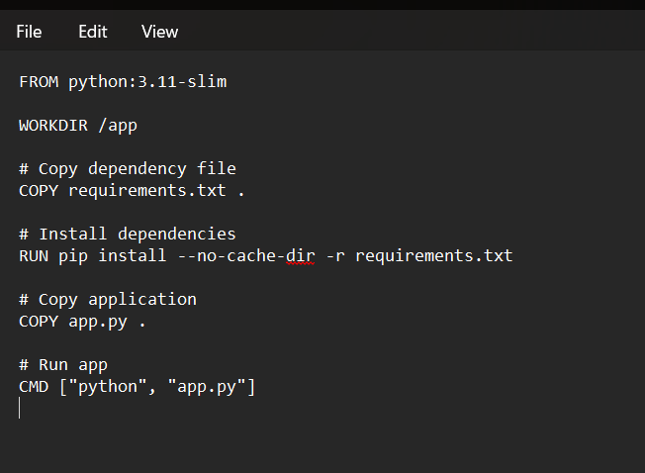
- notepad app.py

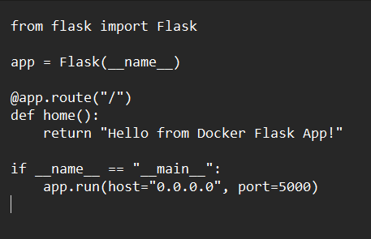

- notepad requirements.txt
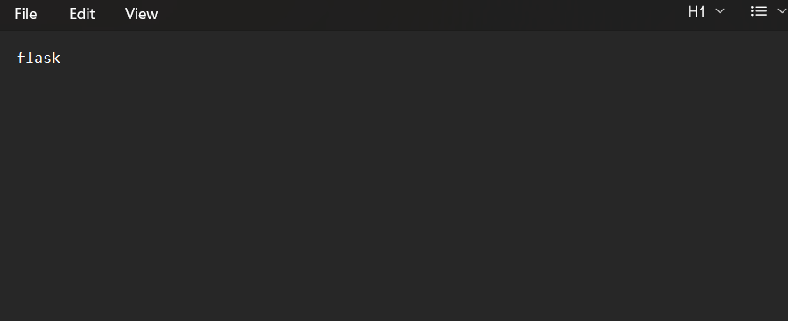
- docker build -t mypythonapp .
- docker images
- docker run --name p1 mypythonapp
- docker run -d --name p1 -p 5001:5000 mypythonapp
- docker ps
- docker ps -a
- docker rm -f p1

