Final Assignment – Paul Sandegård BI24

Question 1
A. Linear Regression: Price Prediction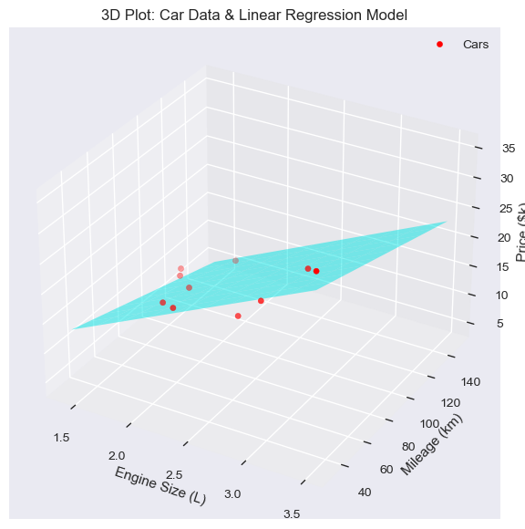
Engine Size vs. Price: Cars with larger engines tend to have higher prices. Both the 3D plane and the 2D trend line show a strong upward slope along the Engine Size axis. Examples include Car 3 (3.5 L) and Car 8 (3.0 L), which have the highest prices.

Mileage vs. Price: Cars with higher mileage tend to have lower prices. The 3D plane slopes downward along the Mileage axis, and the 2D trend line confirms this negative relationship. Car 6 (150 km) is the clearest example of a low price at high mileage.
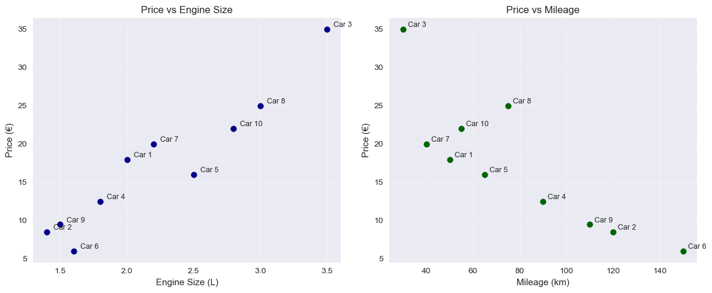
The complementary 2D graphs with car numbers make it easier to see how individual cars follow (mostly for my own)

B. Logistic Regression: Quick Sale Classification
According to the decision boundary line (probability = 0.5), the model predicts the following:
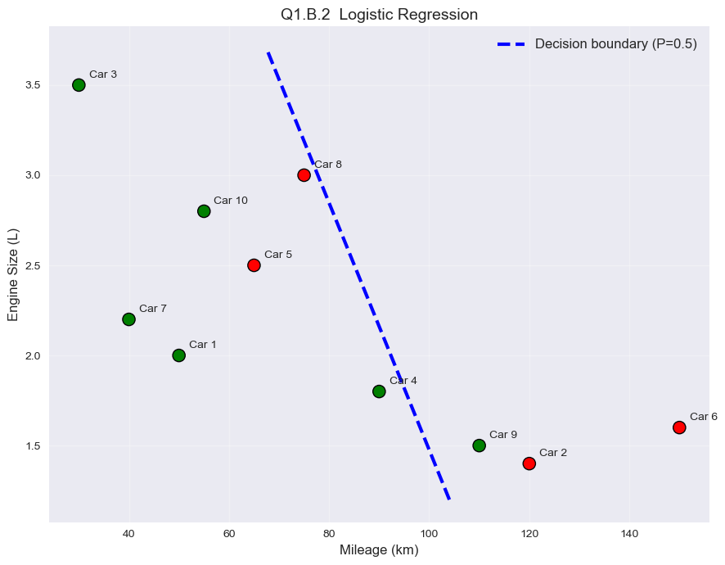
Cars to the left of the line (relatively low mileage and/or large engine size) are expected to sell within 7 days (Y).
Cars to the right of the line (high mileage relative to engine size) are expected to take longer to sell (N).
Most cars (7 out of 10) are classified correctly according to the visualization. The following cars fall on the wrong side of the decision boundary and are therefore misclassified by the model:
- Car No. 5 (2.5 L, 65 km, N) And Car No. 8 (3L,75km, N) lies to the left of the line, ”where the model should be Y”
- Car No. 9 (1.5 L, 110 km, Y) – lies to the right of , Model predicts N
These three exceptions show that there are other factors that influence the selling time beyond just engine size and mileage. Some examples of these could be quality, design, age, etc.

Question 2
A. The "Failure Pathway" Decision Tree
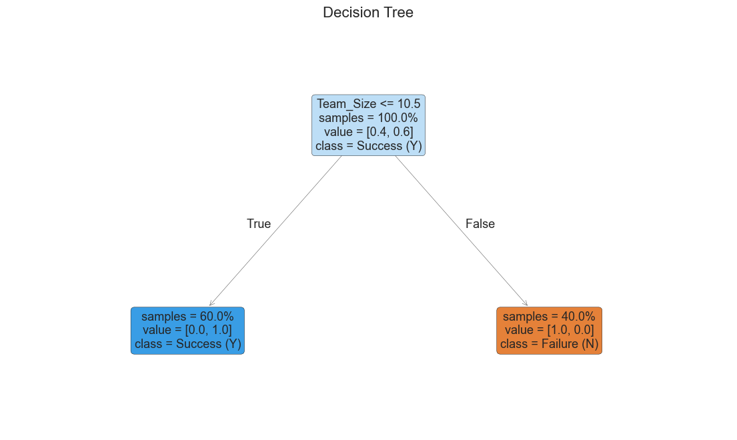
The decision tree shows the shortest and clearest pathway(and also the first in data order) to Y/N.
Team_Size <- 10.5

You could also use, QA Coverage(%) ->70, and Schedule(Days) <-170 to get the same results. 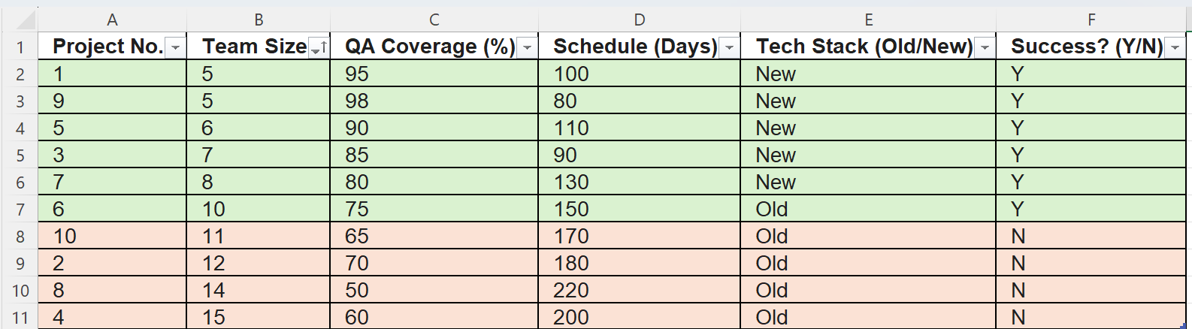
if you wanted to do more unnecessary decisions, you could start with tech stack, or use a unobvious value in the other parameters (I did a unnecessary one in excel).
B. The "Black Box" Consensus
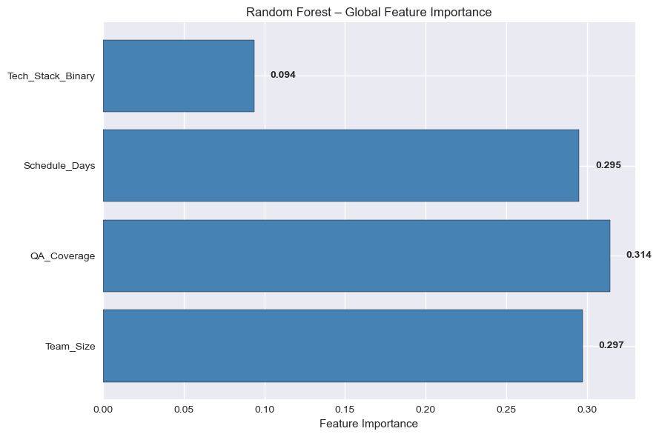
This barchart shows the importance of features based on 100 trees trained through random forrest.
b.4
Hypothesis: No, the features is not ranked most important by random Forrest.
Defence: A single tree can depend heavily on one feature(happens to have one crucial), but random Forrest spreads its importance across many trees. Which leads to some features becoming less important in other areas.

Question 3
A. Initial Setup
Firstly I did my calculations in Excel(less calculation errors, also more visual pleasing then writing on hand)
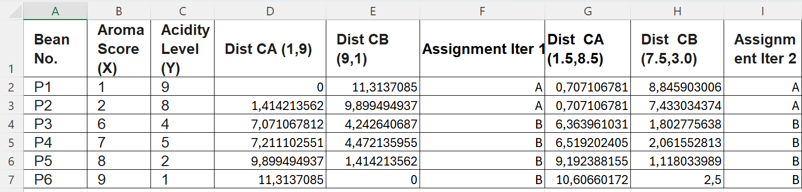

B. Iteration 1
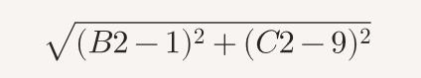
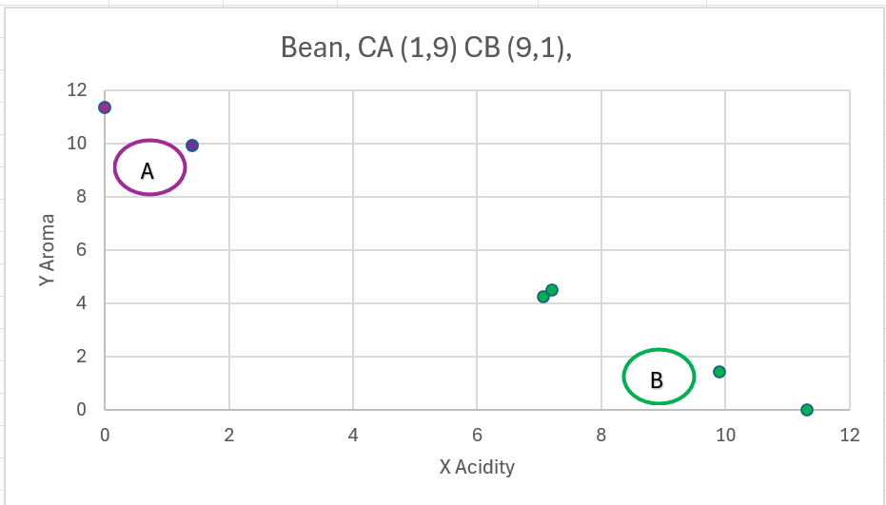
The Euclidean distance from each point to both initial centroids was calculated. Each point was assigned to the nearest centroid. (CA(1,9), Distance to CB(9,1))(CA=A, CB=B).
Resulting assignments: Cluster A: P1, P2 Cluster B: P3, P4, P5, P6
C. Iteration 2
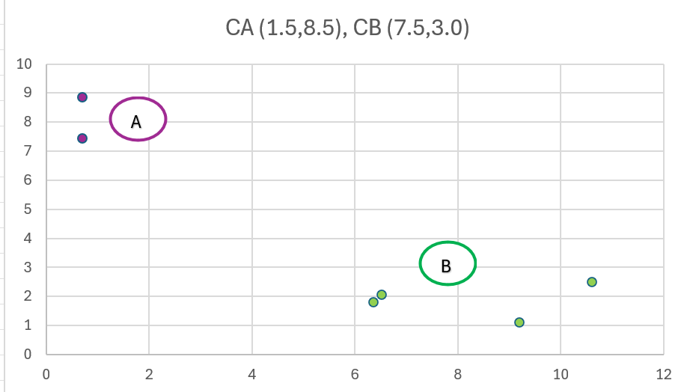
Distances were recalculated using the new centroids, and points were reassigned.
Resulting assignments: Cluster A: P1, P2 Cluster B: P3, P4, P5, P6
The centroids remains unchange, and there’s no further point to do any more iterations.

Question 4
Part A: Unsupervised Exploration (The Hunt for Structure)
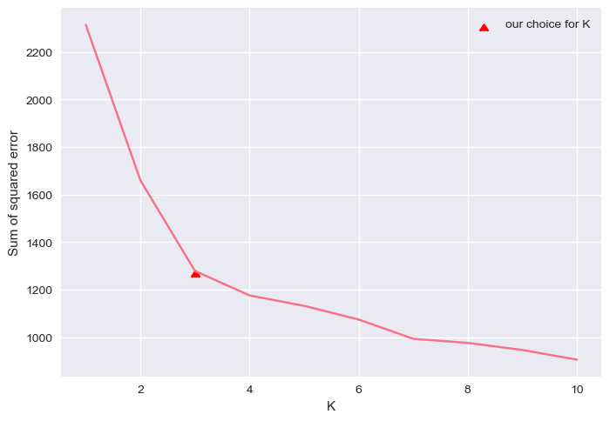
The curve shows a clear "elbow" at K=3, indicating this as the optimal number of clusters.

2–3. Dimensionality Reduction (PCA) and Low-Dimensional Analysis (Silhouette)

PCA was used to reduce the dataset to 2 principal components. The Silhouette Score was then calculated on the PCA data for K=2 to K=10.

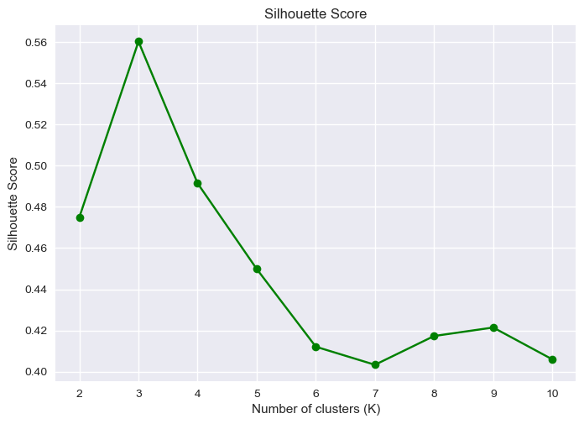
K=2, Silhouette Score=0.4750
K=3, Silhouette Score=0.5602
K=4, Silhouette Score=0.4914
K=5, Silhouette Score=0.4499
K=6, Silhouette Score=0.4122
K=7, Silhouette Score=0.4034
K=8, Silhouette Score=0.4174
K=9, Silhouette Score=0.4215
K=10, Silhouette Score=0.4060

In the silhouette graph the highest score is K=3, and optimal as well as the Elbow one.
Part B: Supervised Classification (The Face-Off)
The clusters without nodes and the same graph with nodes.
Both models were evaluated on the test set. 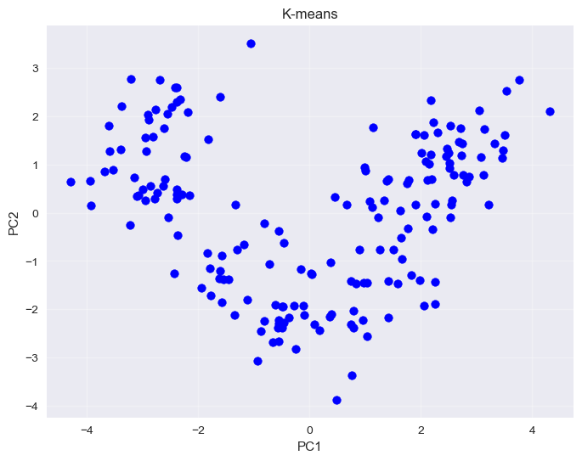
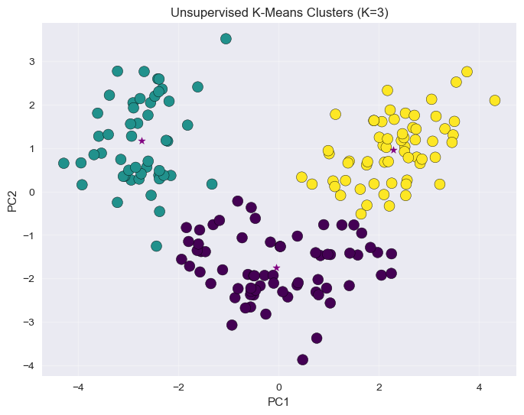

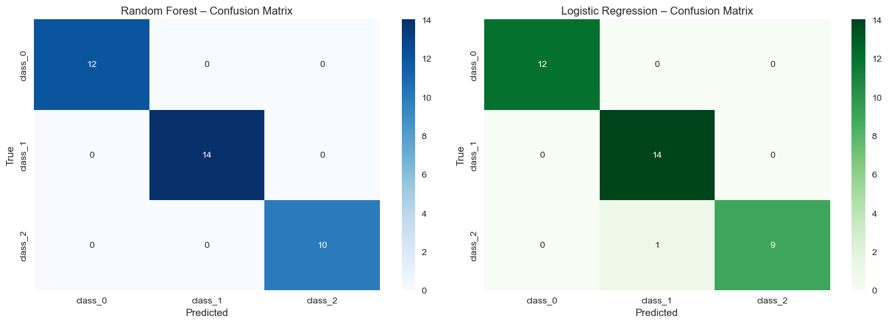

Performance:
- Random Forest achieved perfect(100%) accuracy
- Logistic Regression was nearly perfect (97,2%)
The diffrence between random forest, and logistic are marginal, you could almost pick anyone of them. If you’d choose logistic over random forest, you could argue against it and say that random forest is overfitted at this point, and for that reason I’m also picking logistic of random forest.

Part C: The Tri-View Reality Check
2.
As you can see, I have chosen models K-means and random forest to compare to the ground truth.
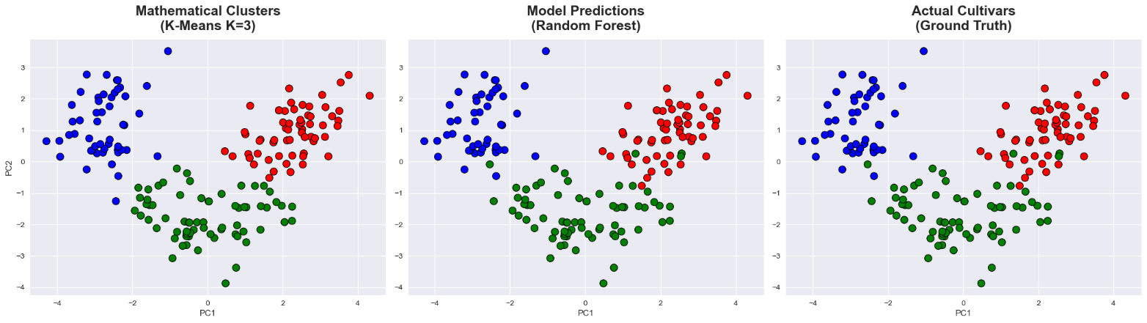
3.
a)
- K-Means with K=3 make three clusters, but they don’t fully match the real classes. This happens because K-Means expects round, equal-sized groups and struggles when classes overlap or have different densities.
- Random Forest on the other hand fits perfectly with the ground truth, unlike k-means it is trained on the true labels and its decision boundaries match the real class structure.
b) K-means struggles with overlapping or uneven cluster, while random forests use labels to capture the true class structure and have higher accuracy, and for that reason random forest is superior to k-means.

c) the green circles on the picture show the regions(4plots) where the supervised predictions disagree. 
Conclusion and reasoning
On this dataset the supervised random forest shows the power of labeled data for accurate classifications on the wine cultivars.

