**CHAPTER 1 – INTRODUCTION**

**1.1 Introduction**

In the digital era, managing data efficiently and securely is paramount. HostCo is a cloud application designed to address this need by providing users with a platform to store, access, and manage their data seamlessly. HostCo offers two distinct user roles: customers and administrators, each with specific functionalities tailored to their requirements.

We prepared a Minor Project of cloud Platform Named HostCo which provides user storage on Cloud for management of their data files. - Cloud File Management System. It is a cutting-edge cloud-based file management system that aims to revolutionize the way users store, organize, and access their files. With its user-friendly interface and comprehensive features, HostCo provides a seamless and secure platform for individuals and businesses to manage their digital assets efficiently.

**1.2 Problem Statement**

Traditional methods of data management, such as local storage solutions, lack the flexibility and accessibility demanded by modern users. Users face challenges in storing, organizing, and accessing their data across multiple devices and locations. Moreover, ensuring data security and privacy remains a significant concern. HostCo aims to tackle these challenges by offering a cloud-based solution that prioritizes ease of use, accessibility, and data security.In tradition system uses stores data on individual computer/ Terminal. For accessing data user need that particular machine on which data is stored. In today’s fast-moving world no one interested to carry his machine/ laptop every time with him. So, everyone needs cloud space so that user can access his data at any time, at any place without need of particular machine.

**1.3 Need of Problem Statement**

The problem statement serves as a blueprint for the project, outlining its objectives, functionalities, and target audience. It provides clarity to the developers and stakeholders about the purpose and scope of the project. Additionally, a well-defined problem statement helps in setting realistic goals, allocating resources efficiently, and evaluating the success of the project upon completion.By addressing the need for efficient cloud data management through HostCo, this project aims to empower users with a reliable and user-friendly solution while meeting the growing demands of data security and accessibility in the digital landscape.

**1.4 Objectives**

* Provide customers with a user-friendly interface for uploading, updating, deleting, and downloading their data on the cloud.
* Empower administrators with tools to oversee user activity, manage user accounts, and monitor data uploads and modifications.
* Ensure data security and privacy through robust encryption mechanisms and access control measures.
* Enhance scalability to accommodate a growing user base and increasing data storage requirements.
* Continuously improve and update the application based on user feedback and evolving technological advancements.
* The objective of this project is to provide storage to user on cloud platform for storage of any type of files i.e. txt, word, image etc.

**1.5 Scope of the project –**

* **User Management:**
* User registration and authentication for customers and administrators.
* User profile management, including account settings and preferences.
* **File Management:**
* Upload, update, delete, and download files for customers.
* Administrative file management capabilities for administrators.
* **Data Security:**
* Implementation of encryption protocols to ensure data privacy and security.
* Regular security updates and vulnerability assessments to mitigate risks.
* **Activity Monitoring:**
* Logging and tracking of user activities for audit and analysis purposes.
* Reporting tools for administrators to monitor platform usage and identify trends.
* **Administrative Controls:**
* Access controls and permissions management for administrators.
* Tools for administrators to manage user accounts and data on the platform.

**CHAPTER 2 – LITERATURE SURVEY**

**Existing System:**

The existing system in the realm of cloud storage servers encompasses a multifaceted landscape of technologies, services, and practices. At its core, cloud storage revolutionizes data management by offering users the ability to store, access, and manipulate vast amounts of data over the internet, without the need for local hardware infrastructure. Major players in this domain, including Amazon Web Services (AWS) S3, Google Cloud Storage, Microsoft Azure Blob Storage, and others, provide diverse storage models such as object, file, and block storage, each tailored to different use cases and requirements. Security stands as a paramount concern, with providers implementing robust measures including encryption, access controls, and compliance certifications to safeguard data integrity and confidentiality. Scalability and performance are key attributes, with cloud storage systems designed to handle massive datasets and support high-throughput access from distributed users. Reliability and durability are ensured through redundancy mechanisms and disaster recovery options, guaranteeing uninterrupted access to data. However, cost considerations loom large, prompting users to carefully evaluate pricing models and optimize usage to minimize expenses. Integration capabilities with other cloud services and on-premises infrastructure further enhance the versatility of cloud storage solutions. Real-world case studies demonstrate the diverse applications of cloud storage, from data backup and archival to content distribution and application hosting. Looking ahead, research trends and emerging technologies such as edge computing and serverless architectures promise to reshape the future landscape of cloud storage, offering new opportunities and challenges for innovation.

Here we can categories some points on the basis Existing System:

1. **Overview of Cloud Storage**: Provide an overview of what cloud storage is and its significance in modern computing. Explain how cloud storage allows users to store and access data over the internet, eliminating the need for local storage hardware.
2. **Major Cloud Storage Providers:** Discuss the prominent cloud storage providers in the market, such as Amazon Web Services (AWS) S3, Google Cloud Storage, Microsoft Azure Blob Storage, Dropbox, and others. Describe their key features, pricing models, and target use cases.
3. **Storage Models:** Explore different storage models offered by cloud storage providers, including object storage, file storage, and block storage**.**
4. **Data Security:** Investigate the security measures implemented by cloud storage providers to protect data from unauthorized access, data breaches, and other security threats.
5. **Scalability and Performance:** Analyze the scalability and performance characteristics of cloud storage systems. Discuss how these systems handle large volumes of data, support concurrent access from multiple users, and ensure low latency for data retrieval.
6. **Reliability and Durability:** Examine the reliability and durability of data stored in the cloud. Evaluate the redundancy mechanisms, data replication strategies, and disaster recovery options provided by cloud storage providers to ensure data availability and integrity.
7. **Cost Considerations:** Discuss the cost factors associated with using cloud storage services, including storage capacity, data transfer, operations, and additional features.
8. **Integration and Interoperability:** Explore the integration capabilities of cloud storage systems with other cloud services, applications, and on-premises infrastructure. Discuss standards and protocols used for data interchange and interoperability.
9. **Use Cases and Case Studies:** Present real-world use cases and case studies where organizations have successfully leveraged cloud storage for various purposes, such as data backup, archival, content distribution, and application hosting.
10. **Research Trends and Future Directions:** Highlight recent research trends and emerging technologies in the field of cloud storage, such as edge computing, serverless architectures, data-centric security, and hybrid cloud deployments.

**Proposed System:**

In the proposed system for cloud storage servers, the focus lies on addressing existing challenges and enhancing capabilities to meet evolving needs. Here's an outline of the proposed system:

1. **Advanced Security Measures**: Integrate cutting-edge encryption techniques, multi-factor authentication, and anomaly detection systems to bolster data security and thwart unauthorized access attempts. Implement privacy-preserving protocols to enhance confidentiality while ensuring compliance with regulatory requirements.
2. **Enhanced Scalability and Performance:** Develop novel approaches for dynamic resource allocation and workload optimization to accommodate fluctuating demands and ensure optimal performance under varying conditions.
3. **Improved Reliability and Durability:** Enhance fault tolerance mechanisms and data redundancy strategies to mitigate the risk of data loss or corruption due to hardware failures or system errors.
4. **Cost-Effective Solutions:** Introduce cost optimization algorithms and automated resource provisioning tools to help users optimize their cloud storage usage and minimize expenses. Offer transparent pricing models with flexible billing options and real-time cost monitoring dashboards to empower users to make informed decisions.
5. **Seamless Integration and Interoperability:** Develop standardized APIs and interoperability frameworks to facilitate seamless integration with third-party applications, services, and legacy systems. Support industry-standard protocols for data interchange and compatibility with emerging technologies such as Internet of Things (IoT) devices and edge computing platforms.
6. **Innovative Use Cases and Applications:** Explore new use cases and applications for cloud storage, such as real-time analytics, machine learning model training, and collaborative data sharing environments. Partner with domain experts and industry stakeholders to co-create innovative solutions tailored to specific verticals or niche markets.
7. **Sustainable and Green Computing Practices:** Incorporate energy-efficient hardware designs, renewable energy sources, and environmentally responsible data center practices to minimize the carbon footprint and promote sustainability in cloud storage operations. Leverage emerging technologies such as edge computing and distributed renewable energy grids to further reduce environmental impact.
8. **User-Centric Design and Accessibility:** Prioritize user experience and accessibility by designing intuitive interfaces, providing comprehensive documentation and tutorials, and offering responsive customer support services. Implement accessibility features and localization support to accommodate diverse user needs and preferences.
9. **Continuous Improvement and Innovation**: Foster a culture of continuous improvement and innovation through ongoing research and development efforts, collaboration with academic and industry partners, and solicitation of user feedback. Embrace agile methodologies and DevOps practices to iterate rapidly and respond to evolving requirements and market dynamics.

**Feasibility System:**

A feasibility study for a proposed cloud storage server system would involve assessing various aspects to determine its viability and potential success. Here's how it could be structured:

1. **Technical Feasibility**:
   * Evaluate the technical requirements and capabilities needed to develop and deploy the proposed system, including hardware, software, networking, and secure
   * ty infrastructure.
   * Assess the availability of skilled personnel and expertise required for system development, maintenance, and support.
   * Investigate the compatibility of the proposed system with existing technologies, standards, and protocols.
   * Consider scalability, performance, and reliability requirements to ensure the system can handle current and future demands.
2. **Economic Feasibility**:
   * Estimate the initial and ongoing costs associated with developing, deploying, and operating the proposed system, including hardware, software, licensing fees, personnel expenses, and infrastructure maintenance.
   * Conduct a cost-benefit analysis to compare the projected benefits of the system (e.g., increased efficiency, cost savings, revenue generation) with its estimated costs.
   * Assess the potential return on investment (ROI) and payback period to determine if the benefits outweigh the costs and justify the investment.
3. **Operational Feasibility**:
   * Evaluate the operational requirements and implications of implementing the proposed system, including staffing, training, workflow changes, and organizational readiness.
   * Assess the potential impact on existing business processes, operations, and stakeholders, and identify any potential challenges or barriers to adoption.
   * Consider the long-term sustainability and scalability of the system and its ability to adapt to evolving business needs and technological advancements.
4. **Legal and Regulatory Feasibility**:
   * Identify and analyze any legal and regulatory requirements, constraints, or risks associated with the proposed system, including data privacy laws, security regulations, intellectual property rights, and industry standards.
   * Assess the system's compliance with relevant laws and regulations and identify any potential legal or regulatory barriers to implementation.
   * Develop strategies to mitigate legal and regulatory risks and ensure ongoing compliance throughout the system's lifecycle.
5. **Schedule Feasibility**:
   * Develop a realistic project schedule outlining the key milestones, deliverables, and timeline for system development, testing, deployment, and maintenance.
   * Identify potential risks, dependencies, and constraints that could impact the project schedule and develop contingency plans to mitigate them.
   * Ensure alignment with business objectives and stakeholder expectations, and regularly monitor progress against the schedule to ensure timely delivery.

Top of Form

**CHAPTER 3: REQUIREMENT ANALYSIS**

**Methods used for Requirement Analysis:**

Requirement analysis for a cloud storage server system typically involves understanding and documenting the needs, expectations, and constraints of stakeholders to define the system's functional and non-functional requirements. Several methods and techniques can be used for requirement analysis. Here are some commonly used ones:

1. **Interviews**: Conducting interviews with stakeholders, including end-users, managers, IT staff, and other relevant parties, to gather their perspectives, preferences, and requirements for the cloud storage server system. Structured interviews with predefined questions or semi-structured interviews with open-ended questions can be used to elicit valuable insights.
2. **Surveys**: Distributing surveys or questionnaires to stakeholders to collect quantitative data on their requirements, preferences, and priorities for the system. Surveys can be administered electronically or in print and can be useful for gathering feedback from a large number of stakeholders across different locations or departments.
3. **Workshops and Focus Groups**: Facilitating workshops or focus groups with stakeholders to engage them in collaborative discussions, brainstorming sessions, and interactive exercises aimed at identifying and prioritizing system requirements. These sessions can foster consensus-building, knowledge sharing, and creativity among participants.
4. **Document Analysis**: Reviewing existing documentation, such as business requirements documents, user manuals, technical specifications, and project charters, to extract relevant information about the system's requirements, constraints, and objectives. Document analysis helps ensure alignment with organizational goals and existing standards.
5. **Observation**: Observing stakeholders in their work environments to gain insights into their workflows, tasks, challenges, and requirements for the cloud storage server system. Direct observation allows analysts to identify implicit requirements and understand the context in which the system will be used.
6. **Prototyping**: Developing prototypes or mock-ups of the cloud storage server system to solicit feedback from stakeholders and validate requirements early in the development process. Prototyping helps stakeholders visualize the system's features and functionalities and provides a tangible basis for discussing and refining requirements.
7. **Use Cases and User Stories**: Creating use cases, user stories, or scenarios to describe how stakeholders will interact with the cloud storage server system to achieve their goals and objectives. Use cases and user stories help capture functional requirements from the perspective of end-users and stakeholders and serve as a basis for system design and development.
8. **Traceability Matrix**: Creating a traceability matrix to establish and maintain traceability between requirements and other project artifacts, such as design documents, test cases, and user stories. A traceability matrix helps ensure that all requirements are addressed and validated throughout the project lifecycle and facilitates impact analysis and change management.

**Data Requirements:**

Data requirements for a cloud storage server system encompass the types of data to be stored, managed, and accessed within the system, as well as the characteristics, volumes, formats, and security considerations associated with the data. Here's a breakdown of key aspects to consider when defining data requirements:

1. **Data Types**:
   * Identify the types of data that will be stored in the cloud storage server system, such as documents, images, videos, audio files, databases, application logs, configuration files, and metadata.
   * Categorize data based on its structure, including structured data (e.g., relational databases), semi-structured data (e.g., JSON, XML), and unstructured data (e.g., text documents, multimedia files).
2. **Data Sources**:
   * Determine the sources from which data will be ingested into the cloud storage server system, such as user uploads, automated data feeds, system logs, IoT devices, third-party integrations, and legacy systems.
   * Identify any data transformations or preprocessing steps required to standardize, clean, or enrich incoming data before storage.
3. **Data Volumes and Growth Rates**:
   * Estimate the volumes of data to be stored in the cloud storage server system, both initially and over time, based on historical data trends, business projections, and anticipated growth rates.
   * Consider factors such as data retention policies, data archival requirements, and expected rates of data ingestion and access.
4. **Data Access Patterns**:
   * Analyze the patterns and frequencies of data access within the cloud storage server system, including read/write operations, data retrieval rates, concurrency levels, and access latency requirements.
   * Identify hot, warm, and cold data tiers based on access frequency and prioritize storage and retrieval mechanisms accordingly.
5. **Data Lifecycle Management**:
   * Define data lifecycle policies and procedures for managing data throughout its lifecycle, including creation, ingestion, storage, retention, archival, retrieval, and deletion.
   * Establish criteria for data retention, expiration, and purging based on regulatory requirements, business needs, and storage costs.
6. **Data Security and Privacy**:
   * Assess data security requirements and define access controls, authentication mechanisms, encryption standards, and auditing/logging procedures to protect sensitive data from unauthorized access, tampering, or disclosure.
   * Ensure compliance with data privacy regulations such as GDPR, CCPA, HIPAA, and industry-specific standards for handling sensitive information.
7. **Data Replication and Backup:**
   * Implement data replication and backup strategies to ensure data availability, durability, and disaster recovery capabilities in case of hardware failures, data corruption, or natural disasters.
   * Define replication policies, recovery point objectives (RPOs), recovery time objectives (RTOs), and backup retention periods based on business continuity requirements.

**Functional Requirements:**

Functional requirements describe what the system should do in terms of its functionality. Here's a breakdown of functional requirements for a cloud storage server system:

1. **User Authentication and Access Control:**
   * Users should be able to authenticate securely using various authentication methods (e.g., username/password, multi-factor authentication).
   * The system should enforce access control policies to restrict unauthorized access to data based on user roles, permissions, and privileges.
2. **Data Upload and Storage**:
   * Users should be able to upload files and data to the cloud storage server system securely via web interfaces, APIs, or client applications.
   * The system should store uploaded data reliably and durably, ensuring data integrity and availability.
3. **Data Retrieval and Download**:
   * Users should be able to retrieve and download stored data from the cloud storage server system efficiently and securely.
   * The system should support various retrieval methods, including direct downloads, streaming, and batch retrieval.
4. **Data Management and Organization**:
   * Users should be able to organize and manage their stored data effectively, including creating folders, organizing files, and applying metadata tags.
   * The system should support file management operations such as copy, move, rename, and delete.
5. **Data Synchronization and Versioning**:
   * The system should support data synchronization across multiple devices and platforms, ensuring consistency and coherence of data.
   * Versioning capabilities should allow users to track and manage multiple versions of files, enabling rollback to previous versions if needed.
6. **Data Encryption and Security**:
   * The system should encrypt data both in transit and at rest to protect it from unauthorized access or tampering.
   * Encryption keys should be managed securely, and encryption algorithms should comply with industry standards.
7. **Data Backup and Disaster Recovery**:
   * The system should provide data backup and disaster recovery capabilities to ensure data resilience and continuity in case of hardware failures, data corruption, or disasters.

**Non-functional Requirements:**  
Non-functional requirements on aspects such as performance, reliability, security, usability, and scalability. Here's a breakdown of non-functional requirements for a cloud storage server system:

1. **Performance**:
   * **Response Time**: The system should respond to user requests within acceptable time limits, such as file upload/download times and data retrieval latency.
   * **Throughput**: The system should support a certain number of concurrent users or transactions per unit of time, ensuring efficient data transfer and processing.
   * **Scalability**: The system should be able to scale horizontally or vertically to handle increasing data volumes, user loads, and resource demands without significant degradation in performance.
2. **Reliability**:
   * **Availability**: The system should be available and accessible to users for a specified percentage of time, minimizing downtime and service interruptions.
   * **Fault Tolerance**: The system should be resilient to hardware failures, network outages, and other disruptions, ensuring data availability and continuity of service.
   * **Data Integrity**: The system should maintain the integrity and consistency of stored data, preventing data corruption or loss due to system errors or failures.
3. **Security**:
   * **Data Encryption**: Data stored in the system should be encrypted both in transit and at rest, protecting it from unauthorized access or interception.
   * **Access Control**: The system should enforce access control policies to restrict access to data based on user roles, permissions, and authentication.
   * **Auditability**: The system should log and audit all user activities, access attempts, and security-related events for compliance and forensic analysis.
4. **Scalability**:
   * **Horizontal Scalability**: The system should be able to scale out by adding more servers or nodes to accommodate increasing data storage and processing demands.
   * **Vertical Scalability**: The system should be able to scale up by upgrading hardware resources (e.g., CPU, memory, storage) to handle growing workloads and user loads.

**Performance Requirements:**

Performance requirements ensure that the system meets user expectations for performance and delivers a satisfactory user experience. Here's a breakdown of performance requirements for a cloud storage server system:

1. **Response Time**:
   * Define maximum acceptable response times for common operations such as file upload, download, data retrieval, and metadata queries.
   * Specify response time targets for different user interactions (e.g., accessing the web interface, searching for files) to ensure a responsive user experience.
2. **Throughput**:
   * Establish throughput requirements in terms of the number of concurrent users or transactions supported by the system.
   * Define throughput targets for data transfer operations, such as upload/download speeds, to accommodate peak usage periods and user demands.
3. **Scalability**:
   * Determine scalability requirements to support growth in data volumes, user loads, and system resources over time.
   * Specify scalability targets for horizontal scaling (adding more servers/nodes) and vertical scaling (increasing hardware resources) to handle increased workload and user concurrency.
4. **Resource Utilization**:
   * Monitor and optimize resource utilization to ensure efficient use of system resources such as CPU, memory, storage, and network bandwidth.
   * Define resource utilization targets and thresholds to identify and mitigate performance bottlenecks or resource contention issues.

**Security Requirements:**

Security requirements for a cloud storage server system are crucial to safeguarding sensitive data, protecting against unauthorized access, ensuring compliance with regulations, and maintaining the confidentiality, integrity, and availability of information. Here's a breakdown of security requirements for such a system:

1. **Access Control**:
   * Define user authentication mechanisms, such as username/password, multi-factor authentication (MFA), biometric authentication, or single sign-on (SSO), to verify user identities before granting access.
   * Implement role-based access control (RBAC) to enforce least privilege principles and restrict access to data based on user roles, responsibilities, and permissions.
   * Define access control policies for different data types, folders, or repositories, specifying who can read, write, modify, or delete data.
2. **Encryption**:
   * Encrypt data both in transit and at rest using strong encryption algorithms (e.g., AES-256) to protect data confidentiality and prevent unauthorized access or interception.
   * Implement end-to-end encryption for data transmission between clients and the cloud storage server system to prevent eavesdropping or man-in-the-middle attacks.
   * Manage encryption keys securely, using key management practices such as key rotation, key vaults, and hardware security modules (HSMs), to prevent key compromise.
3. **Data Integrity**:
   * Implement data integrity checks, such as checksums or cryptographic hashes, to detect unauthorized tampering or modification of data during transmission or storage.
   * Use digital signatures or message authentication codes (MACs) to verify the authenticity and integrity of data exchanged between clients and the cloud storage server system.
4. **Auditing and Logging**:
   * Enable comprehensive logging and auditing of all user activities, access attempts, system events, and security-related incidents within the cloud storage server system.
   * Log relevant metadata, such as user IDs, timestamps, IP addresses, and actions performed, to facilitate forensic analysis, compliance audits, and incident response.
5. **Data Loss Prevention (DLP)**:
   * Implement data loss prevention measures to prevent unauthorized disclosure, leakage, or exfiltration of sensitive data from the cloud storage server system.
   * Define policies and controls to monitor, classify, and protect sensitive data, such as personally identifiable information (PII), financial data, intellectual property, or trade secrets.

**System Specifications:**

System specifications for a cloud storage server system outline the hardware, software, networking, and architectural components required to build and operate the system effectively. Here's a breakdown of system specifications for such a system:

1. **Hardware Requirements**:
   * **Server Hardware**: Specify the type and configuration of servers required to host the cloud storage server system, including CPU, memory, storage capacity, and network interfaces.
   * **Storage Infrastructure**: Define the storage infrastructure components, such as disk arrays, solid-state drives (SSDs), or storage area networks (SANs), needed to store and manage data securely.
   * **Networking Equipment**: Specify networking equipment, such as switches, routers, firewalls, and load balancers, required to connect servers, clients, and external networks.
2. **Software Requirements**:
   * **Operating System**: Specify the operating system (OS) platform for servers, such as Linux (e.g., CentOS, Ubuntu) or Windows Server, along with the required versions and configurations.
   * **Database Management System (DBMS)**: Define the DBMS software for storing and managing metadata, user accounts, access controls, and system configurations.
   * **Middleware and Application Software**: Specify middleware components (e.g., web servers, application servers) and application software (e.g., cloud storage software, data management tools) required to implement system functionality.
3. **Storage and Data Management**:
   * **File System**: Define the file system or object storage protocol (e.g., NFS, SMB, S3) used for storing and organizing data within the cloud storage server system.
   * **Data Replication and Backup**: Specify data replication and backup mechanisms for ensuring data availability, durability, and disaster recovery capabilities.
   * **Metadata Management**: Define metadata schemas, indexing mechanisms, and search capabilities for organizing and retrieving data efficiently.
4. **Security and Compliance**:
   * **Authentication and Access Control**: Specify authentication mechanisms, access control policies, and encryption standards for protecting data and ensuring compliance with security requirements.
   * **Data Encryption**: Define encryption algorithms, key management practices, and encryption-at-rest and encryption-in-transit mechanisms to safeguard data confidentiality.
   * **Auditing and Logging**: Specify auditing and logging features for monitoring user activities, security events, and compliance violations within the cloud storage server system.

**Hardware specifications**

**Hardware Specifications:**

Hardware specifications for a cloud storage server system outline the requirements for the physical infrastructure components necessary to support the storage, processing, and networking needs of the system. Here's a breakdown of hardware specifications for such a system:

1. **Server Hardware:**
   * **Processor (CPU)**: Specify the type, model, and number of CPU cores required for each server. Consider factors such as clock speed, cache size, and multi-threading capabilities to ensure sufficient processing power for data handling and computation tasks.
   * **Memory (RAM)**: Define the amount of RAM required per server to support concurrent user sessions, data caching, and application workloads. Consider factors such as memory speed, capacity, and latency for optimal system performance.
   * **Storage**: Specify the storage configuration for each server, including the type (e.g., HDD, SSD), capacity, and RAID level (if applicable). Consider factors such as storage speed, reliability, and redundancy for data storage and retrieval operations.
   * **Network Interface**: Define the network interface cards (NICs) or network adapters required for each server to connect to the network infrastructure. Consider factors such as network speed, bandwidth, and protocol support (e.g., Ethernet, InfiniBand) for efficient data transfer and communication.
2. **Storage Infrastructure:**
   * **Disk Arrays**: Specify the type and configuration of disk arrays or storage subsystems required to store and manage data within the cloud storage server system. Consider factors such as storage capacity, performance, and scalability for accommodating growing data volumes.
   * **Solid-State Drives (SSDs)**: Define the use of SSDs for caching, tiered storage, or high-performance storage tiers within the storage infrastructure. Consider factors such as SSD capacity, endurance, and performance characteristics for optimal data access speeds.
   * **Storage Area Networks (SANs)**: Specify the use of SANs for centralized storage management, data replication, and storage virtualization within the cloud storage server system. Consider factors such as SAN topology, bandwidth, and fault tolerance for ensuring data availability and reliability.
3. **Networking Equipment**:
   * **Switches**: Specify the switches required to connect servers, storage devices, and networking equipment within the cloud storage server system. Consider factors such as switch capacity, port density, and network topology (e.g., Ethernet, Fibre Channel) for efficient data transfer and communication.
   * **Routers**: Define the routers required for routing network traffic between different network segments, subnets, or external networks. Consider factors such as router throughput, routing protocols, and WAN connectivity options for network scalability and connectivity.
   * **Firewalls**: Specify the firewalls or network security appliances required to enforce access control policies, filter incoming and outgoing traffic, and protect the cloud storage server system from external threats. Consider factors such as firewall throughput, security features, and intrusion detection/prevention capabilities for network security.
4. **Power and Cooling Infrastructure**:
   * **Uninterruptible Power Supplies (UPS)**: Specify the UPS systems required to provide backup power and surge protection for the cloud storage server system in case of power outages or electrical disturbances. Consider factors such as UPS capacity, runtime, and redundancy for ensuring continuous operation.
   * **Cooling Systems**: Define the cooling systems required to maintain optimal operating temperatures for servers, storage devices, and networking equipment within the data center or server room. Consider factors such as cooling capacity, airflow management, and environmental monitoring for preventing overheating and equipment failure.

**Software Specifications:**

Software specifications for a cloud storage server system outline the requirements for the software components necessary to build, deploy, and operate the system effectively. Here's a breakdown of software specifications for such a system:

1. **Operating System**:
   * Specify the operating system (OS) platform for servers hosting the cloud storage server system. Common choices include:
     + Linux distributions (e.g., CentOS, Ubuntu Server, Red Hat Enterprise Linux)
     + Windows Server operating system
   * Define the required version(s), edition(s), and configurations for the operating system to support the system's software stack and application requirements.
2. **Database Management System (DBMS)**:
   * Define the database management system (DBMS) software for storing and managing metadata, user accounts, access controls, and system configurations.
   * Specify the type of DBMS required, such as relational database management systems (RDBMS) or NoSQL databases, based on the system's data storage and retrieval needs.
   * Common choices include:
     + MySQL
     + PostgreSQL
     + MongoDB
     + Microsoft SQL Server
3. **Middleware and Application Software**:
   * Define middleware components and application software required to implement system functionality and support user interactions. This may include:
     + Web servers (e.g., Apache HTTP Server, Nginx)
     + Application servers (e.g., Apache Tomcat, JBoss)
     + Cloud storage software or object storage systems (e.g., Amazon S3, Google Cloud Storage, OpenStack Swift)
     + Data management tools (e.g., Hadoop, Apache Cassandra, Elasticsearch)

* Specify the required versions, configurations, and integration points for these software components within the cloud storage server system.

1. **Security Software**:
   * Specify security software components and tools required to enforce access control, data encryption, and threat detection/prevention mechanisms within the cloud storage server system. This may include:
     + Identity and access management (IAM) solutions
     + Encryption libraries or modules (e.g., OpenSSL, Bouncy Castle)
     + Intrusion detection and prevention systems (IDPS)
     + Security information and event management (SIEM) solutions
   * Define the integration points, configurations, and deployment considerations for these security software components.

**CHAPTER 4: DESIGN**

**Software Requirement Specifications:**

A Software Requirements Specification (SRS) for a cloud storage server system serves as a comprehensive document that outlines the functional and non-functional requirements of the system. It provides detailed descriptions of what the system should do and how it should behave, guiding the development, testing, and validation processes. Here's an outline of a typical SRS for a cloud storage server system:

1. **Introduction:**
   * **Purpose:** Describe the purpose of the SRS document and its intended audience.
   * **Scope:** Define the scope of the cloud storage server system, including its features, functionalities, and limitations.
   * **Definitions, Acronyms, and Abbreviations**: Provide a glossary of terms used throughout the document for clarity and consistency.
2. **System Overview**:
   * **Product Perspective**: Describe the context and relationship of the cloud storage server system with other systems or components.
   * **System Features**: Provide an overview of the key features and capabilities of the system, highlighting its core functionalities.
3. **Functional Requirements**:
   * **Use Cases**: Describe the primary use cases or scenarios supported by the system, including user interactions, system behaviors, and expected outcomes.
   * **Functional Requirements**: Specify detailed functional requirements for each use case, including input/output data, processing logic, and system responses.
   * **External Interface Requirements**: Define the interfaces between the cloud storage server system and external entities such as users, clients, third-party systems, and APIs.
   * **Data Requirements**: Describe the data inputs, outputs, formats, and structures required by the system, including metadata, user data, configuration settings, and logging information.
   * **Non-functional Requirements**: Specify non-functional requirements such as performance, reliability, security, usability, scalability, and compliance constraints.
4. **Performance Requirements**:
   * **Response Time**: Define acceptable response times for common operations such as file upload, download, and data retrieval.
   * **Throughput**: Specify the system's throughput requirements in terms of the number of concurrent users or transactions supported.
   * **Scalability**: Describe the system's scalability requirements to handle increasing data volumes, user loads, and resource demands over time.
5. **Reliability Requirements**:
   * **Availability:** Define the system's availability requirements, specifying the desired uptime percentage or maximum allowable downtime.
   * **Fault Tolerance**: Specify the system's fault tolerance mechanisms and recovery procedures for handling hardware failures, network outages, or system disruptions.
6. **Security Requirements**:
   * **Access Control**: Define user authentication mechanisms, access control policies, and encryption standards to protect data and prevent unauthorized access.
   * **Data Encryption**: Specify data encryption requirements for data-at-rest and data-in-transit to ensure confidentiality and integrity.
   * **Auditing and Logging**: Define auditing and logging requirements for monitoring user activities, security events, and compliance violations within the system.
7. **Usability Requirements**:
   * **User Interface**: Describe usability requirements for the system's user interface, including accessibility, navigation, and responsiveness.
   * **Documentation:** Specify documentation requirements such as user guides, tutorials, and help resources to assist users in using the system effectively.
8. **Operational Requirements**:
   * **Installation and Deployment**: Describe installation procedures, system configurations, and deployment considerations for deploying the cloud storage server system.
   * **Maintenance and Support**: Specify maintenance procedures, software updates, and technical support requirements for ensuring the ongoing operation and support of the system.
9. **Legal and Compliance Requirements**:
   * **Regulatory Compliance:** Define legal and regulatory requirements governing data privacy, security, and compliance (e.g., GDPR, HIPAA, PCI-DSS).
   * **Intellectual Property**: Specify intellectual property rights, licensing agreements, and usage restrictions for the system's software and components.
10. **Appendices**:
    * **Supplementary Information:** Include any supplementary information, diagrams, or supporting documentation relevant to the SRS.
    * **Change History**: Document changes, revisions, and updates made to the SRS over time to maintain version control and traceability.

**Glossary:**

Certainly! Here's a glossary of terms commonly used in the context of a Hostco system:

1. **HostCo :** A cloud based platform where user can upload ,view and download files such as project file, text files and image files.
2. **User:** A user is person who uses the service provided by vendor
3. **Admin:** Admin is a person who has complete control of website, admins are the actual owners or person appointed by owners.
4. **Dashboard:**  dashboard is an information management tool that receives data from a linked database to provide data visualizations.
5. **Home:** In our website user can use home bottom to go to home page from any page, it is one of the bottoms of navigation bar
6. **Login:** In our project there are two types of logins, first is user login and second is admin login, user as well as admin can login our website after giving there credential.
7. **Register:** By use register page new users can make account on our website and then use our project without any problem.

**4.2 Use Case Model**

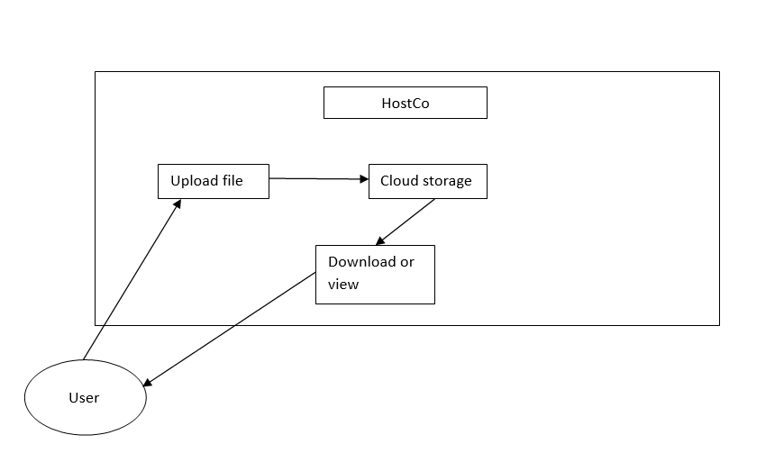

**4.3 Flow-Chart**

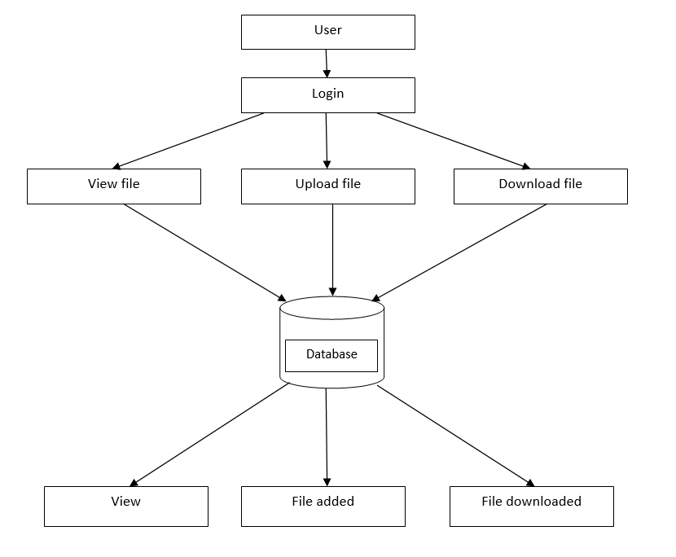

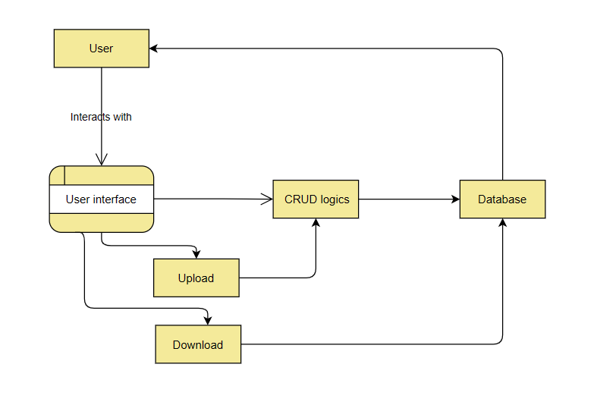**4.4 DFD level 0**

**4.5 ER Diagram**

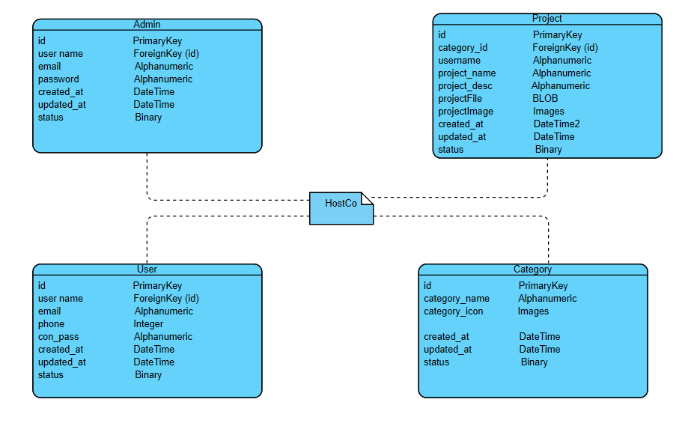

**4.6 Sequence Diagram**

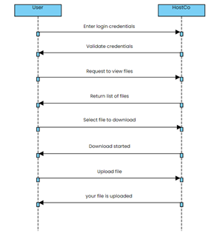

**CHAPTER 5: SYSTEM MODELLING**

**5.1 Activity Diagram**:

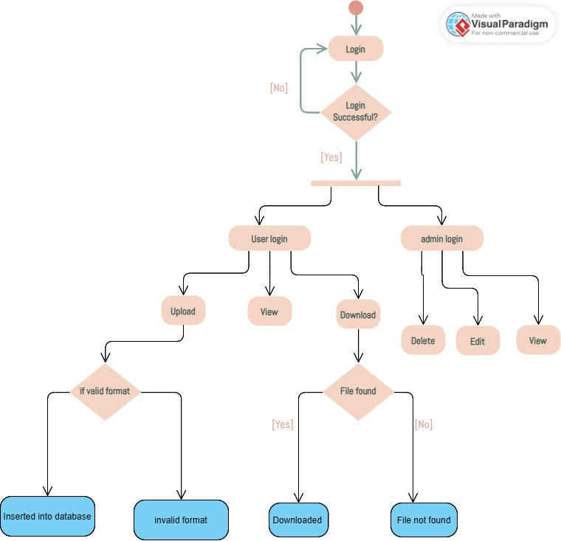

**CHAPTER 6 – CONCLUSION AND FUTURE WORK**

**6.1 Conclusion:**

In conclusion, the development of HostCo, a cloud application, aimed to provide users with seamless data management capabilities. Through the implementation of user roles (customer and admin), users could perform a variety of operations such as account creation, data uploading, updating, deleting, and downloading. Additionally, the admin had access to monitoring features to oversee user activity on the platform. HostCo represents an initial step towards addressing the growing need for efficient cloud-based solutions for data management.

To manage and access the storage problem of individual’s or Business entity, our application HostCo will become a milestone in this field, it provides user secured account for storing and access data at any time, at anywhere without any difficulty.

**6.2 Limitations of the Project**

* **Scalability:** The current implementation might face challenges in scaling to accommodate a large number of users or handling substantial amounts of data.
* **Security:** While efforts were made to ensure data security, the project might lack advanced security features required for handling sensitive or confidential information.
* **User Interface:** The user interface design could be further improved for enhanced user experience and accessibility.
* **Functionality:** Certain advanced features such as real-time collaboration, version control, and advanced search capabilities are not implemented in the current version of HostCo.
* **Testing**: Limited testing scenarios might have overlooked certain edge cases or potential bugs, impacting the overall reliability of the application.
* **Documentation**: Comprehensive documentation, including user guides and technical specifications, might be lacking, which could pose challenges for users and developers.

**6.3 Future Enhancements**

* **Improved Scalability:** Implementing scalable architecture using technologies like microservices or serverless computing to accommodate a growing user base and data volume.
* **Enhanced Security:** Integrating advanced encryption techniques, multi-factor authentication, and regular security audits to fortify the platform against cyber threats.Advanced Functionality: Adding features such as real-time collaboration, versioning, advanced search, and automated backups to enrich user experience and productivity.
* **User Feedback Mechanism:** Incorporating a feedback mechanism to gather user insights and preferences for iterative improvements.
* **Mobile Compatibility:** Developing mobile applications (iOS and Android) or responsive web design to extend accessibility across various devices.
* **Integrations:** Integrating with third-party services such as productivity tools, cloud storage providers, and analytics platforms to enhance interoperability and functionality.

**CHAPTER 7 – BIBLIOGRAPHY & REFERENCES**

**7.1 Reference Books**

* "Cloud Computing: Concepts, Technology & Architecture" by Thomas Erl, Ricardo Puttini, and Zaigham Mahmood.
* "Cloud Application Architectures: Building Applications and Infrastructure in the Cloud" by George Reese.
* "Cloud Computing: Principles and Paradigms" edited by Rajkumar Buyya, James Broberg, and Andrzej M. Goscinski.
* "Cloud Native Java: Designing Resilient Systems with Spring Boot, Spring Cloud, and Cloud Foundry" by Josh Long and Kenny Bastani.
* "Building Microservices: Designing Fine-Grained Systems" by Sam Newman.

**7.2 Other Documentation and References**

**7.2.1 Documentation**

* Cloud Service Providers Documentation: Documentation provided by major cloud service providers like Amazon Web Services (AWS), Microsoft Azure, and Google

Cloud Platform (GCP) can be invaluable for understanding their services, APIs, and best practices.

* Programming Language Documentation: Documentation for programming languages and frameworks commonly used in cloud application development such as Java, Python, Node.js, and Spring Framework can offer guidance on implementing specific functionalities.

**7.2.2 Online References**

* Official Documentation Websites: Refer to the official documentation websites of relevant technologies and frameworks you're using in your project.
* Blogs and Tutorials: Explore blogs and tutorials on cloud application development available on platforms like Medium, Dev.to, and Towards Data Science for practical insights and tips.
* Forums and Community Websites: Participate in forums like Stack Overflow, Reddit (r/cloudcomputing, r/aws, etc.), and specialized community websites for cloud computing discussions, problem-solving, and knowledge sharing.
* YouTube Channels and Webinars: Watch tutorials, webinars, and conference talks by experts in cloud computing available on YouTube channels and other video platforms.

**7.2.3 References for Indian Context**

* Industry Reports: Reports from Indian IT research firms like NASSCOM and research institutions like IITs and IIITs may provide insights into the adoption and trends of cloud computing in India.
* Government Publications: Publications from the Ministry of Electronics and Information Technology (MeitY) and related government bodies might contain information on policies, initiatives, and regulations related to cloud computing in India.
* Conferences and Seminars: Attend conferences, seminars, and workshops on cloud computing organized by industry associations, educational institutions, and technology companies in India for networking and learning opportunities.