**Assignment 1 : Simple SQL Query with a single table with where clause**

**Northwind Database**

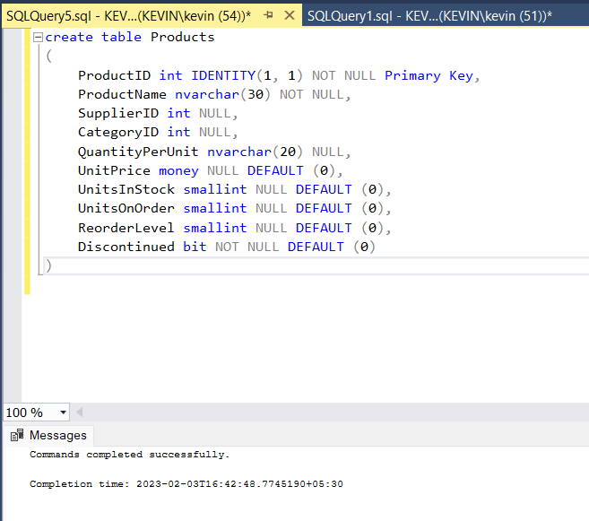

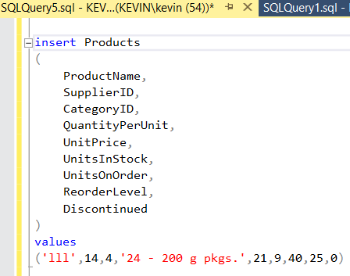

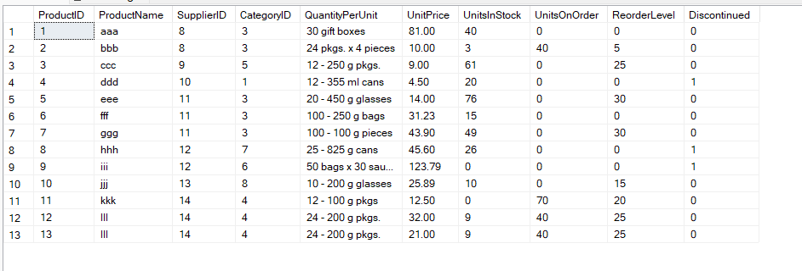

1. Write a query to get a Product list (id, name, unit price) where current products cost

less than $20.

select ProductId,ProductName,UnitPrice from products where UnitPrice<20

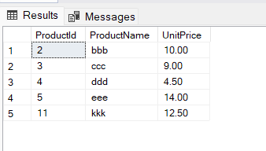

2. Write a query to get Product list (id, name, unit price) where products cost between

$15 and $25

select ProductId , ProductName, UnitPrice from products where UnitPrice >15 AND UnitPrice<25

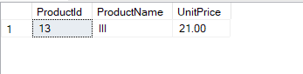

3. Write a query to get Product list (name, unit price) of above average price.

select ProductName, UnitPrice from products where UnitPrice > (select AVG(UnitPrice) from products)

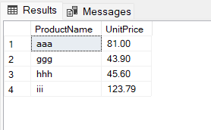

4. Write a query to get Product list (name, unit price) of ten most expensive products

select top 10 ProductName, UnitPrice from products order by UnitPrice desc

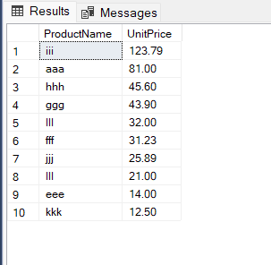

5. Write a query to count current and discontinued products

select count(Discontinued) from products group by Discontinued

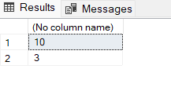

6. Write a query to get Product list (name, units on order , units in stock) of stock is less

than the quantity on order

select productname, unitsonorder,unitsinstock from products where (UnitsInStock<UnitsOnOrder)

