**Assignment – 2**

**Northwind Database**

**Table – Salesman :**

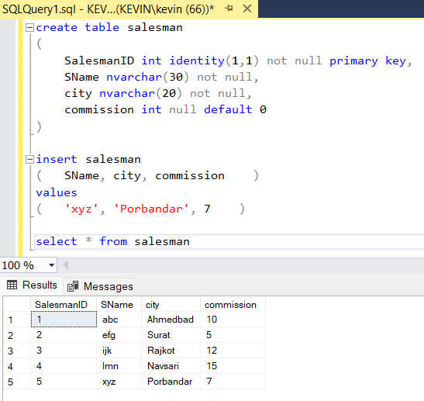

**Table – Customers :**

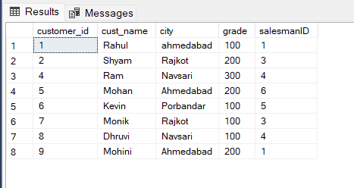

**Table – Orders :**

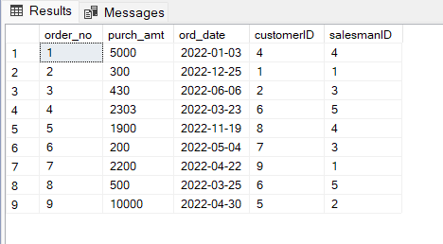

<-- Query-1 -->

select s.SName,c.cust_name,c.city from salesman s inner join customer c

on s.city = c.city

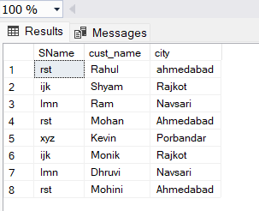

<-- Query-2 -->

select o.order_no,o.purch_amt,c.cust_name, c.city from orders o inner join customer c

on o.customerID = c.customer_id where o.purch_amt between 500 and 2000

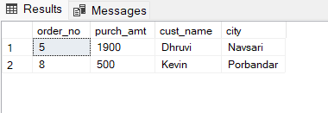

<-- Query-3 -->

select c.cust_name,c.city,s.SName as 'Salesman',s.commission from customer c inner join salesman s

on c.salesmanID = s.SalesmanID

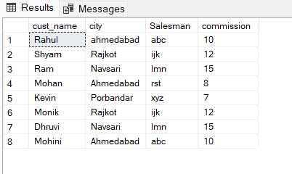

<-- Query-4 -->

select c.cust_name as 'Customer Name', c.city, s.SName as 'Salesman', s.commission from customer c inner join salesman s

on c.salesmanID = s.SalesmanID where s.commission > 12

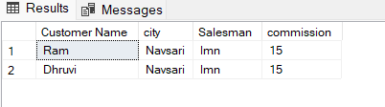

<-- Query-5 -->

select c.cust_name as 'Customer Name', c.city as 'Customer City', s.SName as 'Salesman', s.city as 'Salesman City', s.commission from customer c inner join salesman s

on c.salesmanID = s.SalesmanID where s.commission > 0.12 and c.city != s.city

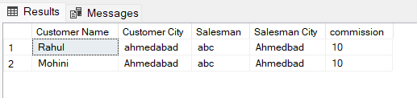

<-- Query-6 -->

select o.order_no, o.ord_date, o.purch_amt, c.cust_name as 'Customer Name', s.SName as 'Salesman', s.commission from orders o inner join customer c

on o.customerID = c.customer_id inner join salesman s on o.salesmanID = s.SalesmanID

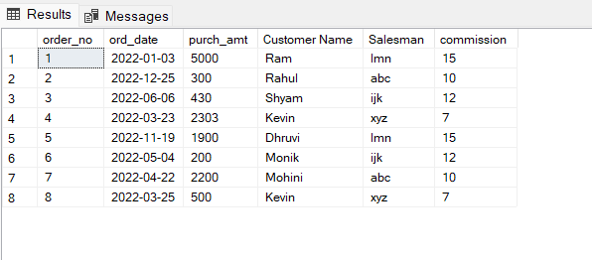

<-- Query-7 -->

select o.order_no, o.ord_date, o.purch_amt, c.cust_name, c.grade, s.SName, s.commission from orders o

inner join customer c on o.customerID = c.customer_id inner join salesman s on o.salesmanId = s.SalesmanId

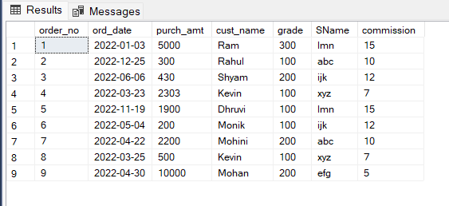

<-- Query-8 -->

select c.cust_name as 'Customer Name', c.city, c.grade, s.SName, s.city from customer c left join salesman s

on c.salesmanID = s.SalesmanID order by c.customer_id asc

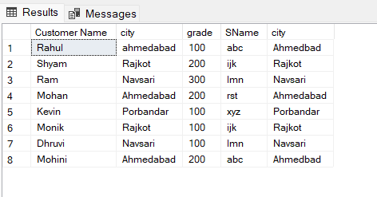

<-- Query-9 -->

select c.cust_name as 'Customer Name', c.city, c.grade, s.SName, s.city from customer c left join salesman s

on c.salesmanID = s.SalesmanID where c.grade < 300 order by c.customer_id asc

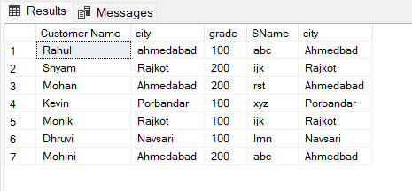

<-- Query-10 -->

select c.cust_name as 'Customer Name', c.city, o.order_no, o.ord_date, o.purch_amt from customer c left outer join orders o

on c.customer_id = o.customerID order by o.ord_date

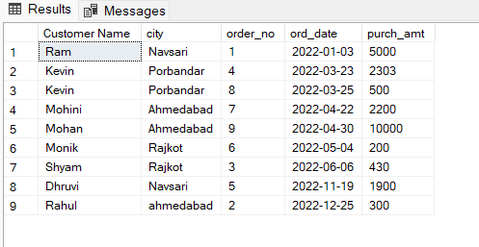

<-- Query-11 -->

select c.cust_name as 'Customer Name', c.city, o.order_no, o.ord_date, o.purch_amt, s.SName as 'Salesman', s.commission from customer c left outer join orders o

on c.customer_id = o.customerID left outer join salesman s on c.salesmanID = s.SalesmanID

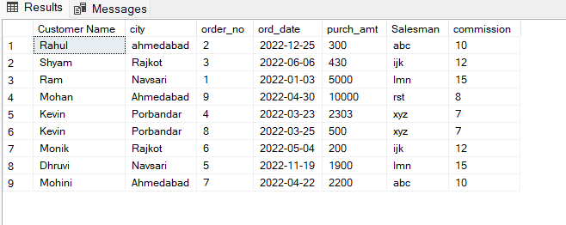

<-- Query-12 -->

select s.SName as 'Salesman' from salesman s left outer join customer c

on s.SalesmanID = c.salesmanID order by c.salesmanID asc

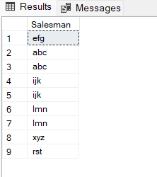

<-- Query-13 -->

select s.SName as 'Salesman', c.cust_name, c.city, c.grade, o.order_no, o.ord_date, o.purch_amt from customer c left outer join orders o

on c.customer_id=o.customerID

left outer join salesman s on c.salesmanID = s.SalesmanID

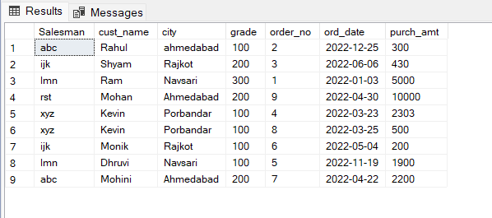

<-- Query-14 -->

select s.SName as 'Salesman' from salesman s left outer join customer c

on s.SalesmanID = c.salesmanID left outer join orders o

on c.customer_id = o.customerID where o.purch_amt >= 2000 and grade is not null

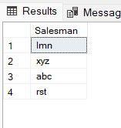

<-- Query-15 -->

select s.SName as 'Salesman' from salesman s left outer join customer c

on s.SalesmanID = c.salesmanID left outer join orders o

on c.customer_id = o.customerID where o.purch_amt >= 2000 and grade is not null

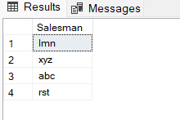

<-- Query-16 -->

select c.cust_name as 'Customer Name', c.city, o.order_no, o.ord_date, o.purch_amt from customer c full outer join orders o

on c.customer_id = o.customerID and c.grade is not null

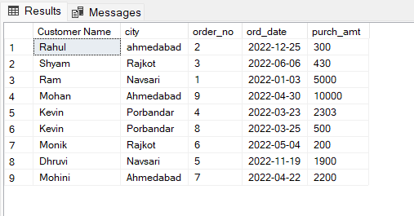

<-- Query-17 -->

select s.SName as 'Salesman', c.cust_name as 'Customer Name' from salesman s cross join customer c

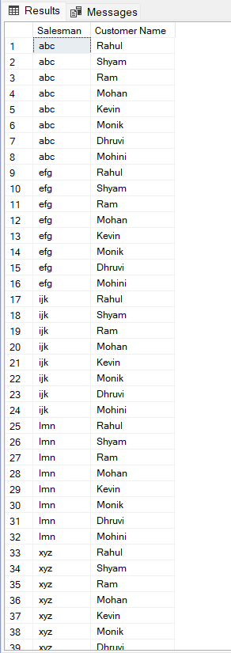

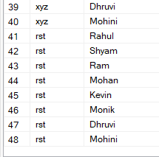

<-- Query-18 -->

select s.SName as 'Salesman', c.cust_name as 'Customer Name' from salesman s cross join customer c

where s.city = c.city

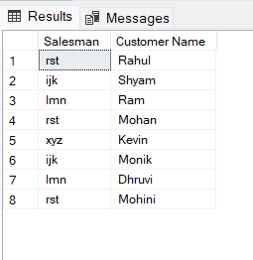

<-- Query-19 -->

select s.SName as 'Salesman', c.cust_name as 'Customer Name(who require grade)' from salesman s cross join customer c

where s.city is not null and c.grade is null

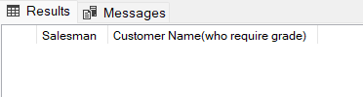

<-- Query-20 -->

select s.SName as 'Salesman', c.cust_name as 'Customer Name' from salesman s cross join customer c

where s.city is not null and s.city != c.city and c.grade is not null

