**Assignment – 3**

**Table – Department**

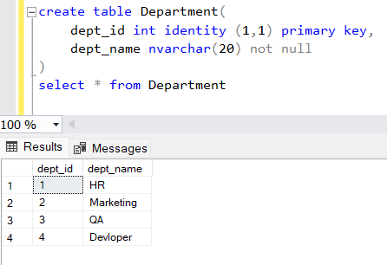

**Table – Employee**

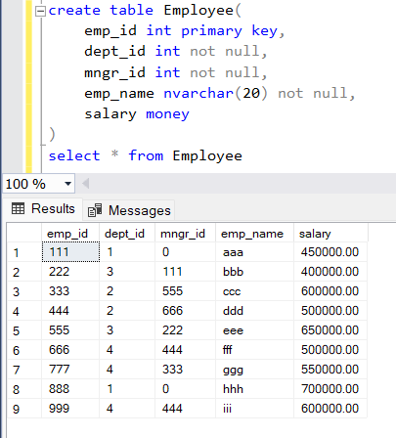

<----- Query-1 ----->

Select emp_name, dept_name, salary from Employee E inner join Department D on E.dept_id = D.dept_id

where salary IN (Select MAX(salary) from Employee group by dept_id)

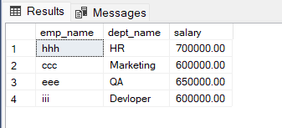

<----- Query-2 ----->

Select E.dept_id, MAX(dept_name) as 'Deparment name' from Employee E

inner join Department D on D.dept_id = E.dept_id

group by E.dept_id having count(*) < 3

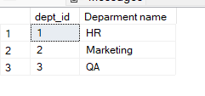

<----- Query-3 ----->

Select E.dept_id, MAX(dept_name) as 'Deparment name', count(*) as employees

from Employee E inner join Department D on D.dept_id = E.dept_id

group by E.dept_id

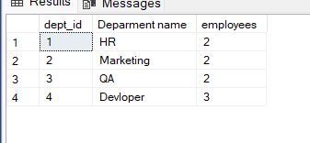

<----- Query-4 ----->

Select E.dept_id, MAX(dept_name) as 'Deparment name', SUM(salary) as 'Total Salary'

from Employee E inner join Department D on D.dept_id = E.dept_id

group by E.dept_id

