**Assignment – 4**

<-------- Query -2 -------->

CREATE procedure EmployeeSalesbyCountry

@country varchar(15)

as

begin

select e.employee_id,e.first_name,e.last_name,sum(od.quantity) as Quantity FROM Orders o

right join "order_details" od

on o.order_id=od.order_id

inner join employees e

on e.employee_id=o.employee_id

where ship_country=@country group by e.employee_id,e.first_name,e.last_name

end

EXECUTE dbo.EmployeeSalesbyCountry 'USA'

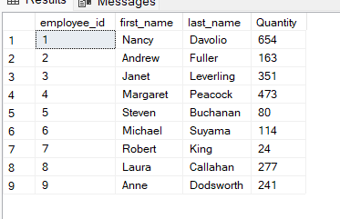

<-------- Query -3 -------->

create procedure SP_Sales_by_Year

@year int

as

begin

select year=@year, count(*) as 'Total Sales' from Orders where YEAR(order_date)=@year

end

execute SP_Sales_by_Year 1997

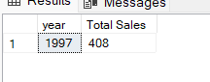

<-------- Query -4 -------->

CREATE procedure SalesByCategory

@categoryName varchar(50)

As

Begin

select @categoryName as Category, count(*) as 'Total Sales' from orders where order_id in

(select order_id from [order_details] where product_id in

(Select product_id from Products where category_id In

(select category_id from Categories where category_name=@categoryName)))

End

execute SalesByCategory 'Condiments'

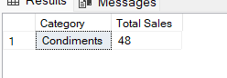

<-------- Query -5 -------->

create procedure SP_Ten_Most_Expensive_Products

as

begin

select top 10

products.product_name as TenMostExpensiveProducts,

products.unit_price

from Products

order by Products.unit_price desc

end

execute SP_Ten_Most_Expensive_Products

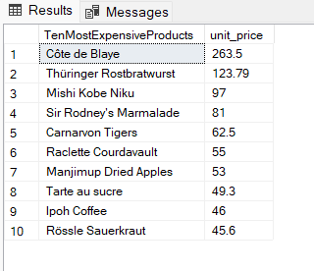

<-------- Query -6 -------->

create procedure spInsert_customer_order_details(@order_id smallint, @product_id smallint,@unit_price real ,@quantity int ,@discount real)

as

begin

insert into order_details values(@order_id,@product_id,@unit_price,@quantity,@discount)

end

execute spInsert_customer_order_details 10250, 44, 50, 40, 0.12

select * from order_details where order_id=10250

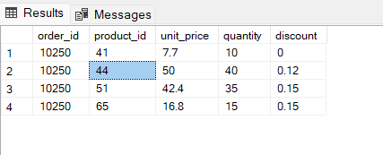

<-------- Query -7 -------->

create procedure SP_Update_Order_Details

@order_id smallint,

@product_id smallint,

@unit_price real ,

@quantity int ,

@discount real

as

begin

update order_details set product_id=@product_id,unit_price=@unit_price,quantity=@quantity,discount=@discount where order_id=@order_id and product_id=@product_id

end

execute SP_Update_Order_Details 10248,42,24.9,6,0.15

select * from order_details where order_id=10248

