1. Create an array of 10 elements and print them using the for each loop.

Code:

**public** **class** ArrayExample {

**public** **static** **void** main(String[] args)

{

**int** arr[]= {10,20,30,40,50,60,70,80,90,100};

System.***out***.println("The array elements are printed using for each loop");

**for**(**int** var:arr)

{

System.***out***.println(var);

}

}

}

Output:

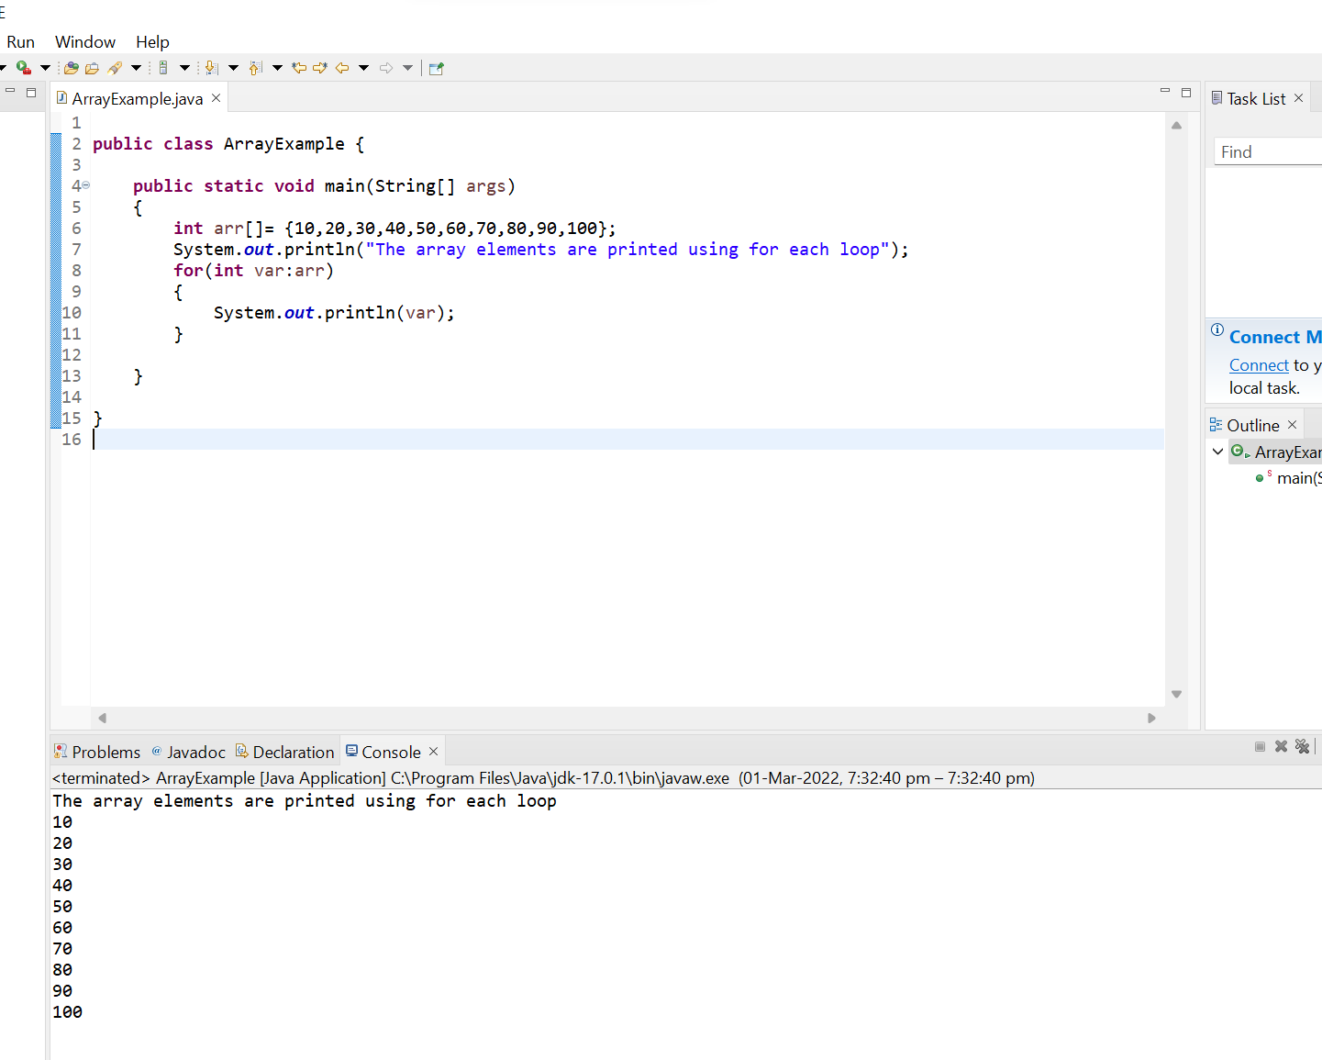

1. Take the number input from the console and add all the positive numbers. (not to consider the negative number if entered)

Code:

**import** java.util.Scanner;

**public** **class** Positive_Number {

**public** **static** **void** main(String[] args)

{

System.***out***.println("Enter the Number of elements :");

Scanner sc =**new** Scanner(System.***in***);

**int** num;

num=sc.nextInt();

**int**[] a= **new** **int**[num];

System.***out***.println("Enter the elements :");

**for** (**int** i = 0; i < num; i++)

{

a[i]=sc.nextInt();

}

**int** sum=0;

**for** (**int** i = 0; i < num; i++)

{

**if**(a[i] >=0)

sum=sum+a[i];

}

System.***out***.println("The sum of positive numbers are " +sum);

}

}

Output:

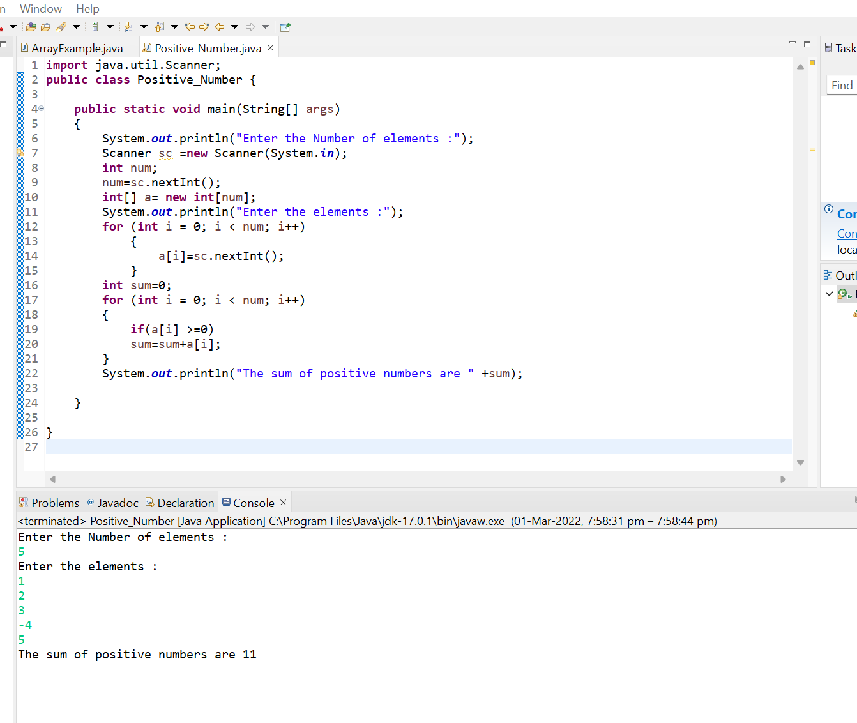

1. Create a labeled break and write a simple logic and execute the program.

Code:

**public** **class** Labeled_Break {

**public** **static** **void** main(String[] args)

{

outerforloop:

**for**(**int** i=1;i<=3;i++)

{

innerforloop:

**for**(**int** j=1;j<=3;j++)

{

**if**(i==2&&j==2)

{

**break** outerforloop;

}

System.***out***.println(i+ " , " +j);

}

}

}

}

Output:

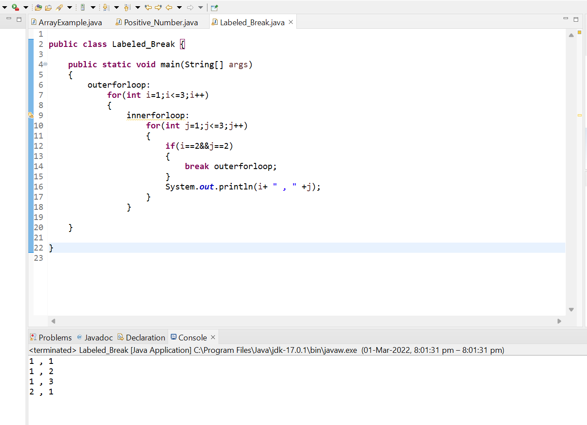

1. Do the addition of around 10 even numbers, but use the continue statement in the logic.

Code:

**public** **class** Continue {

**public** **static** **void** main(String[] args)

{

**int** count=0;

**int** sum=0;

loop1:

**for**(**int** i=1;i<50;i++)

{

**if**(i%2!=0)

{

**continue**;

}

**else** **if**(i%2==0)

{

sum+=i;

count++;

**if**(count==10)

{

**break** loop1;

}

}

}

System.***out***.println("The sum of 10 even numbers is " +sum);

}

Output:

