1. Write a program to reverse the String (use char[] or String built in method)

Code:

**import** java.util.Scanner;

**public** **class** String_Reverse {

**public** **static** **void** main(String[] args)

{

System.***out***.println("Enter a string :");

Scanner sc =**new** Scanner(System.***in***);

String str= sc.nextLine();

**char**[]ch=str.toCharArray();

**for**(**int** i=ch.length-1;i>=0;i--)

{

System.***out***.println(ch[i]);

}

}

}

Output:

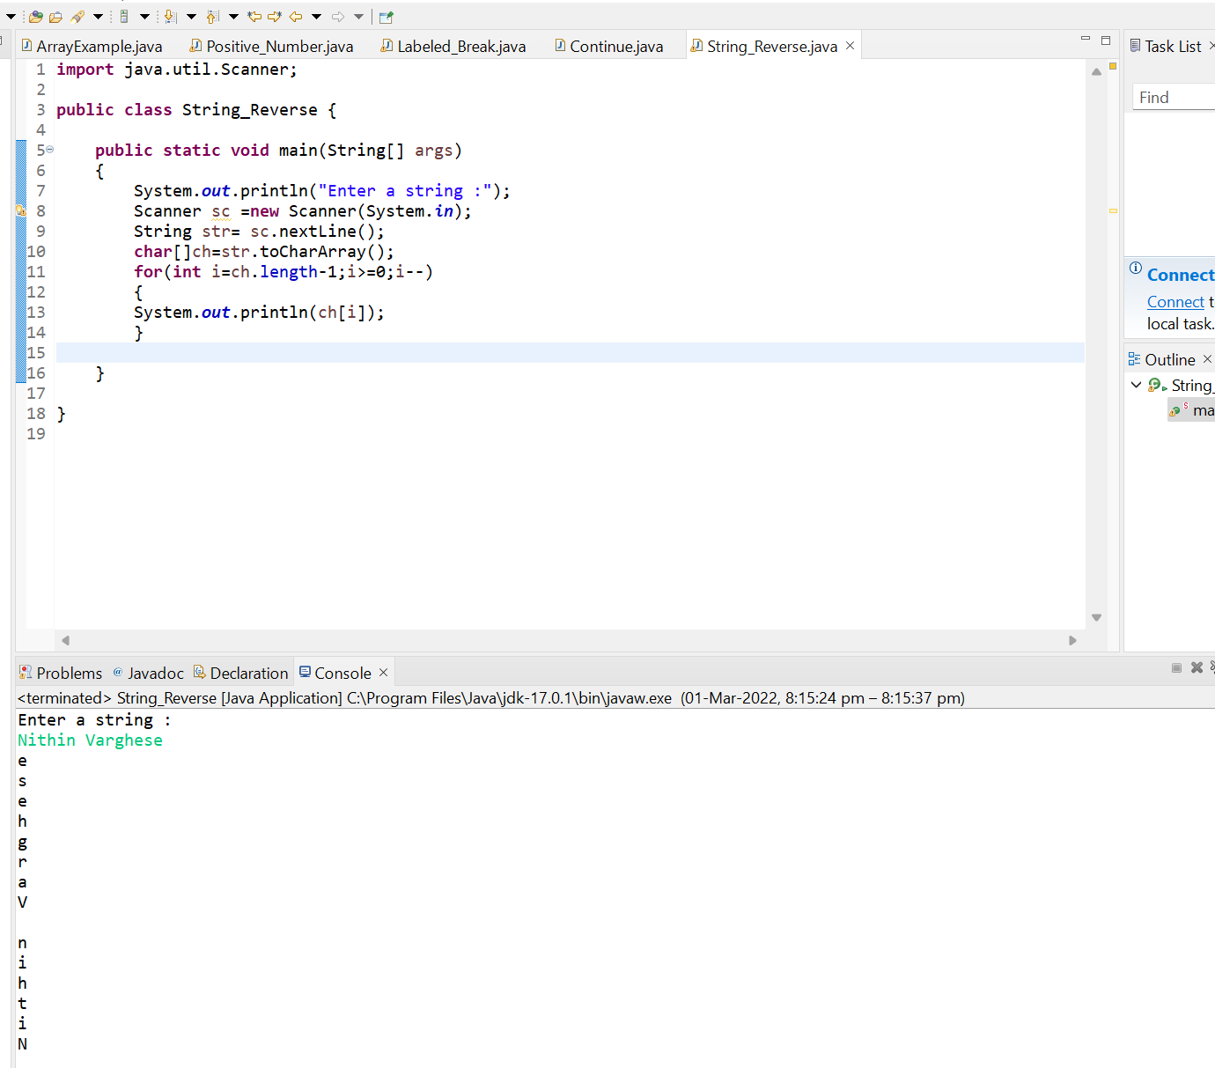

1. Write programs to depict the usage of contains(), length(), replace(), concat(), equals()

Code:

**import** java.util.Scanner;

**public** **class** Cons_Len_Re {

**public** **static** **void** main(String[] args)

{

System.***out***.println("Enter a string :");

Scanner sc =**new** Scanner(System.***in***);

String str= sc.nextLine();

System.***out***.println("The length of this string is " +str.length());

System.***out***.println("Concat: " +str.concat(" pt"));

System.***out***.println("Replacing: " +str.replace(" pt", ""));

System.***out***.println("Contains: " +str.contains("Varghese"));

System.***out***.println("Equality: " +str.equals("Nithin Varghese"));

System.***out***.println("Checking for Equality by ignoring the case :" +str.equalsIgnoreCase("NITHIN Varghese"));

}

}

Output:

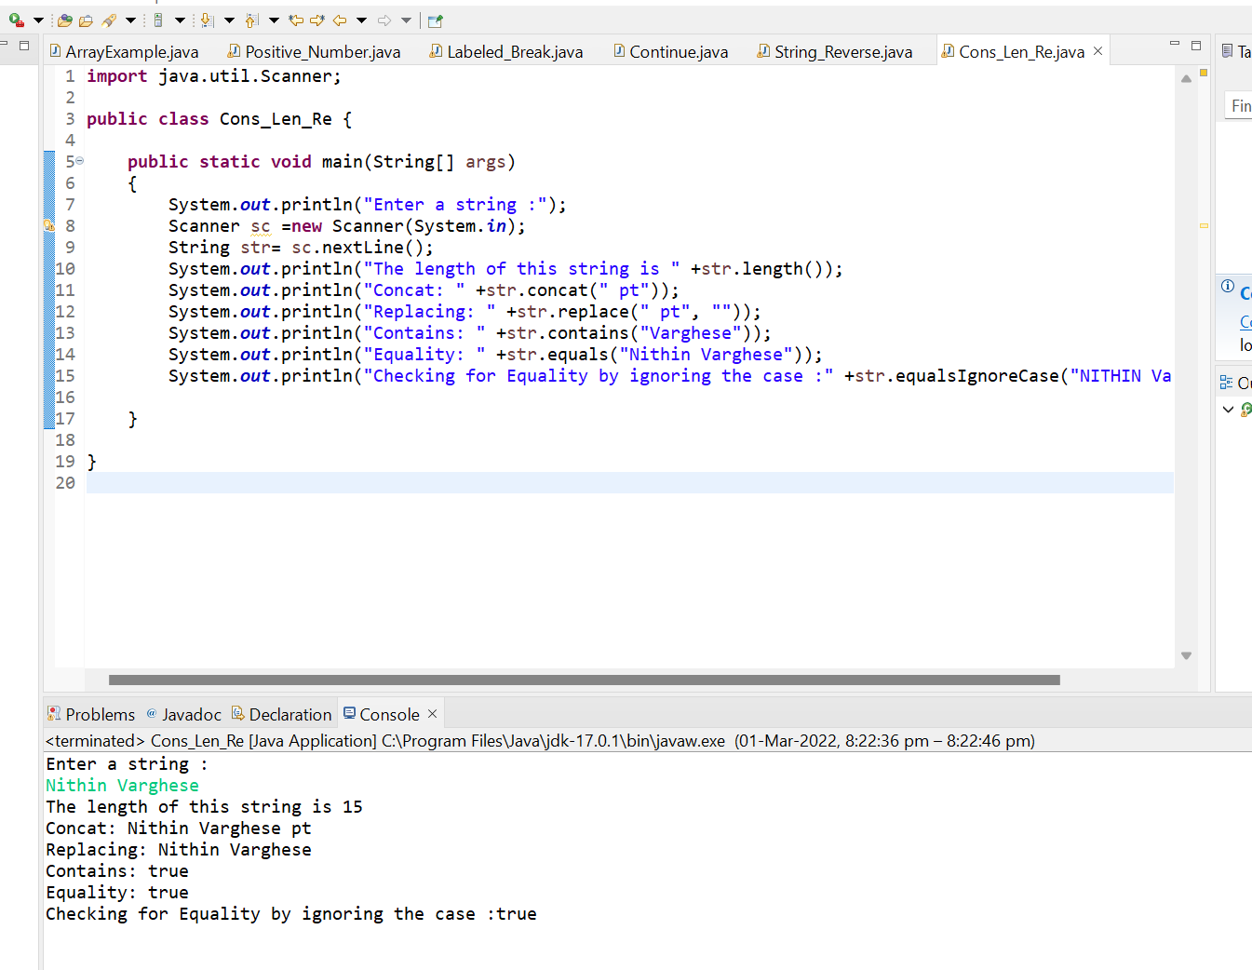

1. Write a customized Exception class for a Banking project

Code:

**public** **class** Bank {

**public** **static** **void** main(String[] args)

{

**try**

{

**int** Debit =1000;

**int** Balance=0;

System.***out***.println(" "+(Debit/Balance));

}

**catch**(ArithmeticException e)

{

System.***out***.println("Arithmetic Exception : Balance is Zero");

}

**finally**

{

System.***out***.println("Insufficient Balance");

}

}

}

Output:

