**SQL USE CASE:**

A XYZ corporation is a organization where they are designing database as per the requirement below cases should be satisfied.

**ER Diagram:**

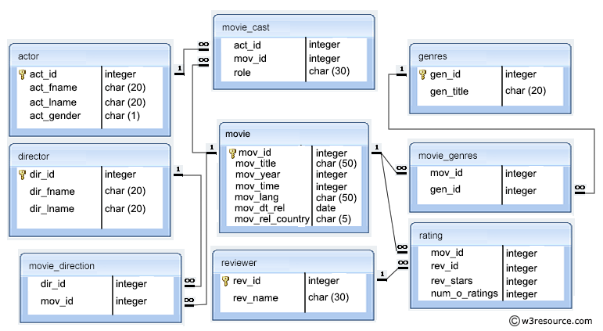

Actor Director

Genres Movie_cast

Movie

Movie_direction Movie_genres

Rating Reviewer

**Section A**

1. Create Database project_movie_data and deploy table data according to ER diagram.

**Code:**

* **create database project_movie_data ;**
* **use project_movie_data ;**
* **create table actor (act_id int not null , act_fname varchar (20) , act_lname varchar (20) , act_gender varchar(4) , primary key ( act_id ));**
* **create table director ( dir_id int not null, dir_fname varchar(20), dir_lname varchar(20), primary key ( dir_id ) );**
* **create table movie ( mov_id int not null, mov_title varchar(50), mov_year int not null, mov_time int not null, mov_lang varchar(50), mov_dt_rel date, mov_rel_country varchar(5), primary key ( mov_id) );**
* **create table reviewer (rev_id int not null, rev_name varchar(30), primary key ( rev_id ));**
* **create table genres ( gen_id int not null, gen_title varchar(20), primary key (gen_id) );**
* **create table movie_cast ( act_id int not null, mov_id int not null, role varchar(20), foreign key ( act_id ) references actor (act_id), foreign key ( mov_id ) references movie ( mov_id) );**
* **create table movie_direction ( dir_id int not null, mov_id int not null, foreign key ( dir_id ) references director ( dir_id ), foreign key ( mov_id) references movie (mov_id) );**
* **create table movie_genres ( mov_id int not null, gen_id int not null, foreign key (mov_id) references movie (mov_id), foreign key (gen_id) references genres (gen_id) );**
* **create table rating ( mov_id int not null, rev_id int not null, rev_stars int not null, num_o_rateing int not null, foreign key (mov_id) references movie ( mov_id ), foreign key (rev_id) references reviewer (rev_id));**

1. Create 9 tables which are presented in ER model and load the data with their foreign key and primary key values.

**Code:**

* **insert into actor (act_id, act_fname, act_lname, act_gender) values**

**(101, ' James ', ' Stewart ', 'M'),**

**(102, ' Deborah ', ' Kerr ', 'F'),**

**(103, ' Peter ', ' OToole ', 'M'),**

**(104, ' Robert ', ' De Niro ', 'M'),**

**(105, ' F. Murray', ' Abraham ', 'M'),**

**(106, ' Harrison ', ' Ford ', 'M'),**

**(107, ' Nicole ', ' Kidman ', 'F'),**

**(108, ' Stephen ', ' Baldwin ', 'M'),**

**(109, ' Jack ', ' Nicholson', 'M'),**

**(110, ' Mark ', ' Wahlberg ', 'M'),**

**(111, ' Woody ', ' Allen ', 'M'),**

**(112, ' Claire ', ' Danes ', 'F'),**

**(113, ' Tim ', ' Robbins ', 'M'),**

**(114, ' Kevin ', ' Spacey ', 'M'),**

**(115, ' Kate ', ' Winslet ', 'F'),**

**(116, ' Robin ', ' Williams ', 'M'),**

**(117, ' Jon ', ' Voight ', 'M'),**

**(118, ' Ewan ', ' McGregor ', 'M'),**

**(119, ' Christian', ' Bale ', 'M'),**

**(120, ' Maggie ', ' Gyllenhaa', 'F'),**

**(121, ' Dev ', ' Patel ', 'M'),**

**(122, ' Sigourney', ' Weaver ', 'F'),**

**(123, ' David ', ' Aston ', 'M'),**

**(124, ' Ali ', ' Astin ', 'F');**

* **select * from actor;**
* **insert into director (dir_id, dir_fname, dir_lname) values**

**(201, ' Alfred ', ' Hitchcock'),**

**(202, ' Jack ', ' Clayton'),**

**(203, ' David ', ' Lean'),**

**(204, ' Michael ', ' Cimino'),**

**(205, ' Milos ', ' Forman'),**

**(206, ' Ridley ', ' Scott'),**

**(207, ' Stanley ', ' Kubrick'),**

**(208, ' Bryan ', ' Singer'),**

**(209, ' Roman ', ' Polanski'),**

**(210, ' Paul ', ' Thomas An'),**

**(211, ' Woody ', ' Allen'),**

**(212, ' Hayao ', ' Miyazaki'),**

**(213, ' Frank ', ' Darabont'),**

**(214, ' Sam ', ' Mendes'),**

**(215, ' James ', ' Cameron'),**

**(216, ' Gus ', ' Van Sant'),**

**(217, ' John ', ' Boorman'),**

**(218, ' Danny ', ' Boyle'),**

**(219, ' Christoph', ' Nolan'),**

**(220, ' Richard ', ' Kelly'),**

**(221, ' Kevin ', ' Spacey'),**

**(222, ' Andrei ', ' Tarkovsky'),**

**(223, ' Peter ', ' Jackson');**

* **select * from director;**
* **insert into genres (gen_id, gen_title) values**

**(1001, ' Action'),**

**(1002, ' Adventure'),**

**(1003, ' Animation'),**

**(1004, ' Biography'),**

**(1005, ' Comedy'),**

**(1006, ' Crime'),**

**(1007, ' Drama'),**

**(1008, ' Horror'),**

**(1009, ' Music'),**

**(1010, ' Mystery'),**

**(1011, ' Romance'),**

**(1012, ' Thriller'),**

**(1013, ' War');**

* **select * from genres;**
* **insert into Movie (mov_id, mov_title, mov_year, mov_time, mov_lang, mov_dt_rel, mov_rel_country) values**

**(901, ' Vertigo ', 1958, 128, ' English ', '1958-08-24', ' UK'),**

**(902, ' The Innocents ', 1961, 100, ' English ', '1962-02-19', ' SW'),**

**(903, ' Lawrence of Arabia ', 1962, 216, ' English ', '1962-12-11', ' UK'),**

**(904, ' The Deer Hunter ', 1978, 183, ' English ', '1979-03-08', ' UK'),**

**(905, ' Amadeus ', 1984, 160, ' English ', '1985-01-07', ' UK'),**

**(906, ' Blade Runner ', 1982, 117, ' English ', '1982-09-09', ' UK'),**

**(907, ' Eyes Wide Shut ', 1999, 159, ' English ', '0000-00-00', ' UK'),**

**(908, ' The Usual Suspects ', 1995, 106, ' English ', '1995-08-25', ' UK'),**

**(909, ' Chinatown ', 1974, 130, ' English ', '1974-08-09', ' UK'),**

**(910, ' Boogie Nights ', 1997, 155, ' English ', '1998-02-16', ' UK'),**

**(911, ' Annie Hall ', 1977, 93, ' English ', '1977-04-20', ' USA'),**

**(912, ' Princess Mononoke ', 1997, 134, ' Japanese ', '2001-10-19', ' UK'),**

**(913, ' The Shawshank Redem', 1994, 142, ' English ', '1995-02-17', ' UK'),**

**(914, ' American Beauty ', 1999, 122, ' English ', '0000-00-00', ' UK'),**

**(915, ' Titanic ', 1997, 194, ' English ', '1998-01-23', ' UK'),**

**(916, ' Good Will Hunting ', 1997, 126, ' English ', '1998-06-03', ' UK'),**

**(917, ' Deliverance ', 1972, 109, ' English ', '1982-10-05', ' UK'),**

**(918, ' Trainspotting ', 1996, 94, ' English ', '1996-02-23', ' UK'),**

**(919, ' The Prestige ', 2006, 130, ' English ', '2006-11-10', ' UK'),**

**(920, ' Donnie Darko ', 2001, 113, ' English ', '0000-00-00', ' UK'),**

**(921, ' Slumdog Millionaire', 2008, 120, ' English ', '2009-01-09', ' UK'),**

**(922, ' Aliens ', 1986, 137, ' English ', '1986-08-29', ' UK'),**

**(923, ' Beyond the Sea ', 2004, 118, ' English ', '2004-11-26', ' UK'),**

**(924, ' Avatar ', 2009, 162, ' English ', '2009-12-17', ' UK'),**

**(925, ' Braveheart ', 1995, 178, ' English ', '1995-09-08', ' UK'),**

**(926, ' Seven Samurai ', 1954, 207, ' Japanese ', '1954-04-26', ' JP'),**

**(927, ' Spirited Away ', 2001, 125, ' Japanese ', '2003-09-12', ' UK'),**

**(928, ' Back to the Future ', 1985, 116, ' English ', '1985-12-04', ' UK');**

* **select * from Movie**
* **insert into movie_cast (act_id, mov_id, role) values**

**(101, 901, ' John Scottie Fergus'),**

**(102, 902, ' Miss Giddens'),**

**(103, 903, ' T.E. Lawrence'),**

**(104, 904, ' Michael'),**

**(105, 905, ' Antonio Salieri'),**

**(106, 906, ' Rick Deckard'),**

**(107, 907, ' Alice Harford'),**

**(108, 908, ' McManus'),**

**(110, 910, ' Eddie Adams'),**

**(111, 911, ' Alvy Singer'),**

**(112, 912, ' San'),**

**(113, 913, ' Andy Dufresne'),**

**(114, 914, ' Lester Burnham'),**

**(115, 915, ' Rose DeWitt Bukater'),**

**(116, 916, ' Sean Maguire'),**

**(117, 917, ' Ed'),**

**(118, 918, ' Renton'),**

**(120, 920, ' Elizabeth Darko'),**

**(121, 921, ' Older Jamal'),**

**(122, 922, ' Ripley'),**

**(114, 923, ' Bobby Darin'),**

**(109, 909, ' J.J. Gittes'),**

**(119, 919, ' Alfred Borden');**

* **select * from movie_cast;**
* **insert into movie_direction (dir_id, mov_id) values**

**(201, 901),**

**(202, 902),**

**(203, 903),**

**(204, 904),**

**(205, 905),**

**(206, 906),**

**(207, 907),**

**(208, 908),**

**(209, 909),**

**(210, 910),**

**(211, 911),**

**(212, 912),**

**(213, 913),**

**(214, 914),**

**(215, 915),**

**(216, 916),**

**(217, 917),**

**(218, 918),**

**(219, 919),**

**(220, 920),**

**(218, 921),**

**(215, 922),**

**(221, 923);**

* **select * from movie_direction;**
* **insert into movie_genres (mov_id, gen_id) values**

**(922, 1001),**

**(917, 1002),**

**(903, 1002),**

**(912, 1003),**

**(911, 1005),**

**(908, 1006),**

**(913, 1006),**

**(926, 1007),**

**(928, 1007),**

**(918, 1007),**

**(921, 1007),**

**(902, 1008),**

**(923, 1009),**

**(907, 1010),**

**(927, 1010),**

**(901, 1010),**

**(914, 1010),**

**(906, 1012),**

**(904, 1013);**

* **select * from movie_genres;**
* **insert into reviewer ( rev_id , rev_name ) values**

**(9001,'Righty Sock'),**

**(9002,'Jack Malvern'),**

**(9003,'Flagrant Baronessa'),**

**(9004,'Alec Shaw'),**

**(9005,''),**

**(9006,'Victor Woeltjen'),**

**(9007,'Simon Wright'),**

**(9008,'Neal Wruck'),**

**(9009,'Paul Monka'),**

**(9010,'Mike Salvati'),**

**(9011,' '),**

**(9012,'Wesley S.Walker'),**

**(9013,'Sasha Goldshtein'),**

**(9014,'Josh Cates'),**

**(9015,'Krug Stillo'),**

**(9016,'Scott LeBrun'),**

**(9017,'Hannah Steele'),**

**(9018,'Vincent Cadena'),**

**(9019,'Brandt Sponseller'),**

**(9020,'Richard Adams');**

* **select * from reviewer;**
* **insert into rating (mov_id, rev_id, rev_stars, num_o_rateing) values**

**(901, 9001, '8', 263575),**

**(902, 9002, '8', 20207),**

**(903, 9003, '8', 202778),**

**(906, 9005, '8', 484746),**

**(924, 9006, '7', 0),**

**(908, 9007, '9', 779489),**

**(909, 9008, '0', 227235),**

**(910, 9009, '3', 195961),**

**(911, 9010, '8', 203875),**

**(912, 9011, '8', 0),**

**(914, 9013, '8', 862618),**

**(916, 9014, '4', 642132),**

**(925, 9015, '8', 81328),**

**(918, 9016, '0', 580301),**

**(920, 9017, '8', 609451),**

**(921, 9018, '8', 667758),**

**(922, 9019, '8', 511613),**

**(923, 9020, '7', 13091);**

1. Write a query in SQL to list the Horror movies?

Code:

* **select mov_title**

**from Movie**

**where mov_id in(**

**select mov_id**

**from movie_genres**

**where gen_id in(**

**select gen_id**

**from genres**

**where gen_title=' Horror'));**

or

* **select mov_title**

**from movie where**

**mov_id=(select mov_id from**

**movie_genres**

**where gen_id in (select**

**gen_id from genres where**

**gen_title=' Horror'));**

**Output:**

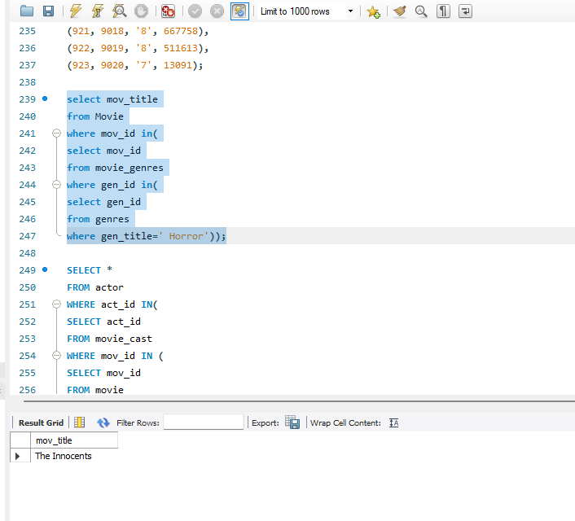

1. Write a query in SQL to find the name of all reviewers who have rated 8 or more stars?

Code:

* **SELECT reviewer.rev_name**

**FROM reviewer, rating**

**WHERE rating.rev_id = reviewer.rev_id**

**AND rating.rev_stars>=8**

**AND reviewer.rev_name IS NOT NULL;**

Or

* **select rev_name**

**from reviewer R, rating RR**

**where R.rev_id = RR.rev_id**

**and rev_stars>=8;**

**Output:**

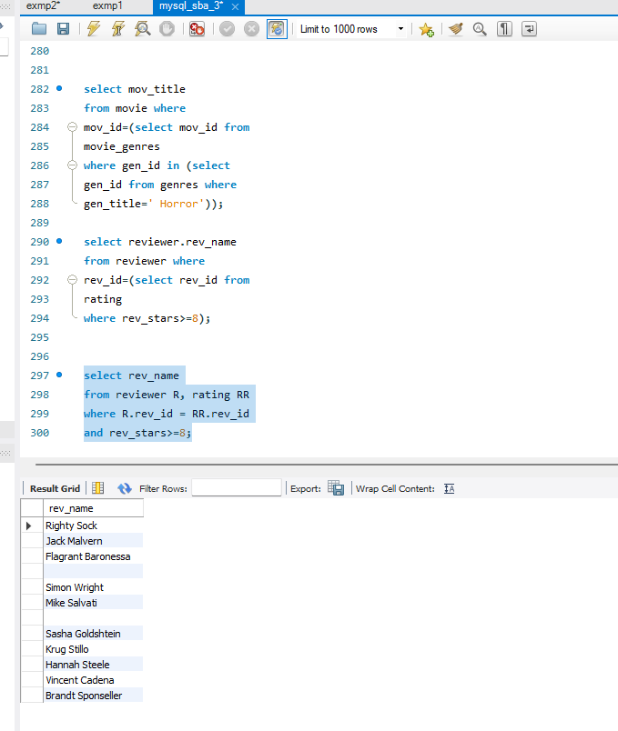

1. Write a query in SQL to list all the information of the actors who played a role in the movie ‘Deliverance’

Code:

* **SELECT \***

**FROM actor**

**WHERE act_id IN(**

**SELECT act_id**

**FROM movie_cast**

**WHERE mov_id IN (**

**SELECT mov_id**

**FROM movie**

**WHERE mov_title=' Deliverance '**

**));**

**Output:**

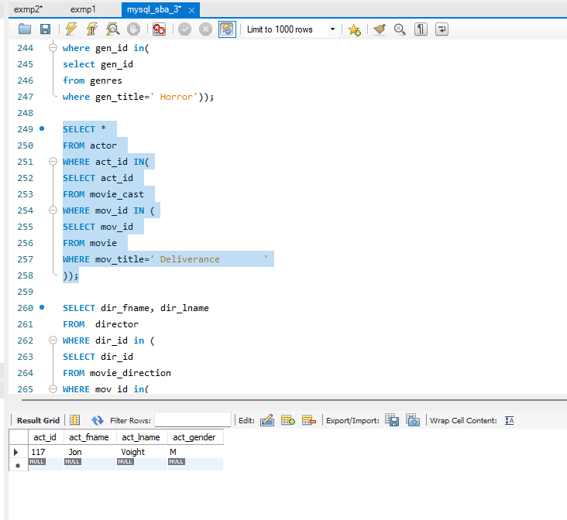

1. Write a query in SQL to find the name of the director (first and last names) who directed a movie that casted a role for ‘Eyes Wide Shut’. (using subquery)

Code:

* **SELECT dir_fname, dir_lname**

**FROM director**

**WHERE dir_id in (**

**SELECT dir_id**

**FROM movie_direction**

**WHERE mov_id in(**

**SELECT mov_id**

**FROM movie_cast WHERE role = ANY (**

**SELECT role**

**FROM movie_cast**

**WHERE mov_id IN (**

**SELECT mov_id**

**FROM movie**

**WHERE mov_title=' Eyes Wide Shut '))));**

**Output:**

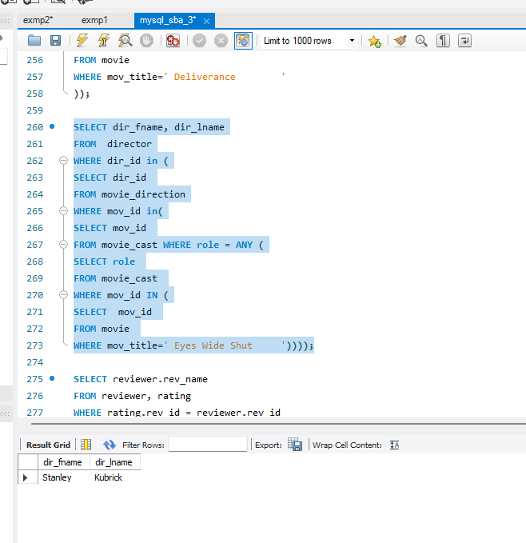

1. Write a query in SQL to find the movie title, year, date of release, director and actor for those movies which reviewer is ‘Neal Wruck’.

Code:

* **SELECT mov_title, mov_year, mov_dt_rel, dir_fname, dir_lname, act_fname, act_lname**

**FROM movie a, movie_direction b, director c, rating d, reviewer e, actor f, movie_cast g**

**WHERE a.mov_id=b.mov_id AND b.dir_id=c.dir_id AND a.mov_id=d.mov_id AND d.rev_id=e.rev_id AND a.mov_id=g.mov_id AND g.act_id=f.act_id AND e.rev_name ="Neal Wruck";**

Output:

