Principle of Computer Organization

Implementation of a Single Cycle CPU simulator

Project due: 30 November, 23:59pm

- Introduction

In this project, you are going to implement a single cycle CPU simulator called MiniCPU using C language. Your MiniCPU will demonstrate some functions of MIPS processors as well as the principle of the datapath and the control signals. MiniCPU should read in a file containing MIPS machine codes (in the format specified below) and simulate what the MIPS processor does cycle-by-cycle. A C file called component.c will be provided to you which implementing each component of the single-cycle datapath, you are required to modify and fill in the body of the functions in this file.

- Specification of the simulator

  - Instructions to be simulated

The 14 instructions listed in Figure 1 in the appendix. Note that you are NOT required to treat situations leading to exception.

  - Registers to be handled

MiniCPU should handle the 32 general purpose registers. At the start of the program, the registers are initialized to be the values specified in minicpu.c

  - Memory usage

- The size of memory of MiniCPU is 64kB (Address 0x0000 to 0xFFFF).
- The system assumes that all program starts at memory location 0x4000.
- All instructions are word-aligned in the memory, i.e. the addresses of all instructions are multiple of 4.
- The simulator (and the MIPS processor itself) treats the memory as one segment. (The division of memory into text, data and stack segments is only done by the compiler/assembler.)
- At the start of the program, all memory are initialized to zero, except those specified in the “-asc” file, as shown in the provided codes.
- The memory is in the following format:
e.g. Store a 32-bit number 0xaabbccdd in memory address 0x0 – 0x3.
 | Mem[0]
Address | 0x0 | 0x1 | 0x2 | 0x3
Content | aa | bb | cc | dd

  - Conditions that the MiniCPU should halt

If one of the following situations is encountered, the global flag Halt is set to 1, and hence the simulation halts.

- An illegal instruction is encountered. Instructions beyond the list of instructions in Figure 1 are illegal.
- Jumping to an address that is not word-aligned (being multiple of 4)
- The address of lw or sw is not word-aligned
- Accessing data or jump to address that is beyond the memory.

  - Format of the input machine code file

MiniCPU takes hexadecimal formatted machine codes, with filename xxx.asc, as input. An example of .asc file is shown below. Code after “#” on any line is treated as comments.

20010000 #addi $1, $0, 0
200200c8 #addi $2, $0, 200
10220003 #beq $1, $2, 3
00000020 #delay slot
20210001 #addi $1, $1, 1
00000020 #no operation

The simulation ends when an illegal instruction, such as 0x00000000, is encountered.

  - Note on branch addressing

The branch offset in MIPS, and hence in MiniCPU, is relative to the next instruction, i.e. (PC+4). For example,
Assembly code

beq $1, $2, label
beq $3, $4, label
label: beq $5, $6, label
Machine codes
4 | 1 | 2 | 0x0001

4 | 3 | 4 | 0x0000

4 | 5 | 6 | 0xffff
Opcode Rs Rt Offset
6 bits 5 bits 5 bits 16 bits

- Resources

  - Files provided

Please download project.zip from ftp://ftp.must.edu.mo/, the following are files after unzip:

minicpu.c minicpu.h component.c minicpuasm.pl incommand
test01.asm test01.asc test02.asm test02.asc

These files contain the main program and the other supporting functions of the simulator. The code should be self-explanatory. You are required to fill in and modify the functions in component.c. You are not allowed to modify minicpu.c and minicpu.h. All your works should be placed in component.c only. You are not allowed to add new files. Otherwise, your program will not be marked.

  - MIPS assembler

A simple assembler minicpuasm.pl is provided for your convenience of testing your MinCPU. The command is:

$minicpuasm.pl filename.asm > filename.asc

where filename.asm is your assembly code file and filename.asc is the output machine code file in hexadecimal format.

- Functions in component.c

Firstly, you are required to complete a function (ALU(…)) in component.c that simulates the operations of an ALU.

void ALU(unsigned A, unsigned B, char ALUControl, unsigned *ALUresult, char *Zero)
{
if(ALUControl==0x0)*ALUresult=A+B; //add
}

- ALU(…)
      - Implement the operations on input parameters A and B according to ALUControl.
      - Output the result to ALUresult.
      - Assign Zero to 1 if the result is zero; otherwise, assign 0.
      - The following table shows the operations of the ALU.
ALUControl | Meaning
000 | Z = A + B
001 | Z = A – B
010 | if A < B, Z = 1; otherwise, Z = 0
011 | if A < B, Z = 1; otherwise, Z = 0 (A and B are unsigned integers)
100 | Z = A AND B
101 | Z = A OR B
110 | Shift B left by 16 bits
111 | Z = NOR(A,B)

Secondly, you are required to fill in 9 functions in component.c. Each function simulates the operations of a section of the datapath. Figure 2 in the appendix shows the datapath and the sections of the datapath you need to simulate.

In minicpu.c, the function Step() is the core function of the MiniCPU. This function invokes the 9 functions that you are required to implement to simulate the signals and data passing between the components of the datapath. Read Step() thoroughly in order to understand the signals and data passing, and implement the 9 functions.

The following shows the specifications of the 9 functions:

- instruction_fetch(…)
- Fetch the instruction addressed by PC from Mem and write it to instruction.
- Return 1 if an invalid instruction is encountered; otherwise, return 0.

int instruction_fetch(unsigned PC, unsigned *Mem, unsigned *instruction)
{
*instruction=Mem[PC>>2];
return 0;
}

- instruction_partition(…)
- Partition instruction into several parts (op, r1, r2, r3, funct, offset, jsec).
- Read line 41 to 47 of minicpu.c for more information.

void instruction_partition(unsigned instruction, unsigned *op, unsigned *r1, unsigned *r2, unsigned *r3, unsigned *funct, unsigned *offset, unsigned *jsec)
{
*op = instruction >> 26;
}

- instruction_decode(…)
- Decode the instruction based on opcode (op).
- Assign appropriate values to the variables (control signals) in the structure controls.
The meanings of the values of the control signals:
For MemRead, MemWrite or RegWrite, the value 1 means that enabled, 0 means that disabled, 2 means “don’t care”.
For RegDst, Jump, Branch, MemtoReg or ALUSrc, the value 0 or 1 indicates the selected path of the multiplexer; 2 means “don’t care”.
The following table shows the meaning of the values of ALUOp.
value (binary) | Meaning
000 | ALU will do addition or “don’t care”
001 | ALU will do subtraction
010 | ALU will do “set less than” operation
011 | ALU will do “set less than unsigned” operation
100 | ALU will do “and” operation
101 | ALU will do “or” operation
110 | ALU will shift left extended_value by 16 bits
111 | The instruction is an R-type instruction

- Return 1 if a halt condition occurs; otherwise, return 0.

int instruction_decode(unsigned op, struct_controls *controls)
{
if(op==0x0){ //R-format
controls->RegWrite = 1;
controls->RegDst = 1;
controls->ALUOp = 7;
}

else return 1; //invalid instruction
return 0;
}

- read_register(…)
- Read the registers addressed by r1 and r2 from Reg, and write the read values to data1 and data2 respectively.

void read_register(unsigned r1, unsigned r2, unsigned *Reg, unsigned *data1, unsigned *data2)
{
*data1 = Reg[r1];
*data2 = Reg[r2];
}

- sign_extend(…)
- Assign the sign-extended value of offset to extended_value.

void sign_extend(unsigned offset, unsigned *extended_value)
{

}

- ALU_operations(…)
- Based on ALUOp and funct, perform ALU operations on data1, and data2 or extended_value.
- Call the function ALU(…) to perform the actual ALU operation.
- Output the result to ALUresult.
- Return 1 if a halt condition occurs; otherwise, return 0.

int ALU_operations(unsigned data1, unsigned data2, unsigned extended_value, unsigned funct, char ALUOp, char ALUSrc, unsigned *ALUresult, char *Zero)
{
switch(ALUOp){
// R-type
case 7:
// funct = 0x20 = 32, add
if (funct==0x20) ALU(data1, data2, 0x0, ALUresult, Zero);
else return 1; //invalid funct
break;
default:
return 1; //invalid ALUop
}
return 0;
}

- rw_memory(…)
- Base on the value of MemWrite or MemRead to determine memory write operation or memory read operation.
- Read the content of the memory location addressed by ALUresult to memdata.
- Write the value of data2 to the memory location addressed by ALUresult.
- Return 1 if a halt condition occurs; otherwise, return 0.

int rw_memory(unsigned ALUresult, unsigned data2, char MemWrite, char MemRead, unsigned *memdata, unsigned *Mem)
{
if (MemRead==1){
*memdata = Mem[ALUresult>>2];
}
return 0;
}

- write_register(…)
- Write the data (ALUresult or memdata) to a register (Reg) addressed by r2 or r3.

void write_register(unsigned r2, unsigned r3, unsigned memdata, unsigned ALUresult, char RegWrite, char RegDst, char MemtoReg, unsigned *Reg)
{
Reg[r2] = memdata;
}

- PC_update(…)
- Update the program counter (PC).

void PC_update(unsigned jsec, unsigned extended_value, char Branch, char Jump, char Zero, unsigned *PC)
{
*PC+=4;
}

The file minicpu.h is the header file which contains the definition of a structure storing the control signals and the prototypes of the above functions. The functions may contain some parameters. Read minicpu.h for more information.

5. Notes

- This project will be compiled and marked using Dev C++. You can download it from the web (http://www.bloodshed.net/dev/devcpp.html) and install it on your computer. Remember you should download and install Dev C++ for C/C++.

- Some instructions may try to write to the register $zero and we assume that they are valid. However, your simulator should always keep the value of $zero 0.

- You should not do any “print” or ”printf()” operation in component.c; otherwise, the operation will disturb the marking process and your marks will be deducted.

- To run the compiled executable:

  - In Windows, open a command prompt.
  - Go to your working directory.
  - Type: your_executable input_asc_file < incommand
for example: minicpu test01.asc <incommand

Where incommand is the downloaded file. The output shows the values of all registers and memory locations, which allows you to check if your simulator can produce the correct result or not.

- To debug your program, check if the values of all registers and memory match the assembly program. The following is a sample output:

cmd:
cont

cmd:
$zero 00000000 $at 00000000 $v0 00000000 $v1 00000000
$a0 00000000 $a1 00000000 $a2 00000000 $a3 00000000
$t0 00000002 $t1 00000003 $t2 00000005 $t3 00000001
$t4 00000002 $t5 00000003 $t6 00000002 $t7 00000000
$s0 00010000 $s1 00000001 $s2 00000001 $s3 00000001
$s4 00000001 $s5 00000000 $s6 00000000 $s7 00000000
$t8 00000000 $t9 00000000 $k0 00000000 $k1 00000000
$gp 0000c000 $sp 0000fffc $fp 00000000 $ra 00000000
$pc 00004034 $stat 00000000 $lo 00000000 $hi 00000000

cmd:
00000 00000002
00004-03ffc 00000000
04000 20080002
04004 20090003
04008 01285020
0400c 01285822
04010 01286024
04014 01286825
04018 ac080000
0401c 8c0e0000
04020 3c100001
04024 0109882a
04028 0109902b
0402c 29130003
04030 2d140003
04034-0fffc 00000000

cmd:
quit

- To submit your work, at the beginning your component.c, type in your English name, e.g.

/*
* Designer: name, student id, email address
*/

Email your component.c to yyliang.fit.must@gmail.com. The subject of your email must be: CO101 Project student_name.

Appendix

Category | Instruction | Example | Meaning | Comments
Arithmetic | add | add $s1,$s2,$s3 | $s1 = $s2 + $s3 | 3 operands; overflow detected
Arithmetic | subtract | sub $s1,$s2,$s3 | $s1 = $s2 - $s3 | 3 operands; overflow detected
Arithmetic | add immediate | addi $s1,$s2,100 | $s1 = $s2 + 100 | + constant; overflow detected
Logic | and | and $s1,$s2,$s3 | $s1 = $s2 & $s3 | 3 operands; logical AND
Logic | or | or $s1,$s2,$s3 | $s1 = $s2 | $s3 | 3 operands; logical OR
Data transfer | load word | lw $s1,100($s2) | $s1 = Memory[$s2 + 100] | word from memory to register
Data transfer | store word | sw $s1,100($s2) | Memory[$s2 + 100] = $s1 | word from register to memory
Data transfer | load upper immediate | lui $s1,100 | $s1 = 100 * 2^16 | loads constant in upper 16 bits
Conditional branch | branch on equal | beq $s1,$s2,25 | if ($s1 == $s2)  goto PC + 4 + 100 | equal test; PC relative branch
Conditional branch | set on less than | slt $s1,$s2,$s3 | if ($s2 < $s3) $s1 = 1  else $s1 =0 | compare less than; two's complement
Conditional branch | set less than immediate | slti $s1,$s2,100 | if ($s2 < 100) $s1 = 1  else $s1 =0 | compare < constant; two's complement
Conditional branch | set less than unsigned | sltu $s1,$s2,$s3 | if ($s2 < $s3) $s1 = 1  else $s1 =0 | compare less than; natural number
Conditional branch | set less than immediate unsigned | sltiu $s1,$s2,100 | if ($s2 < 100) $s1 = 1  else $s1 =0 | compare < constant; natural number
Unconditional branch | Jump | j label | goto label | Jump to target
Figure 1: Instructions to be implemented.

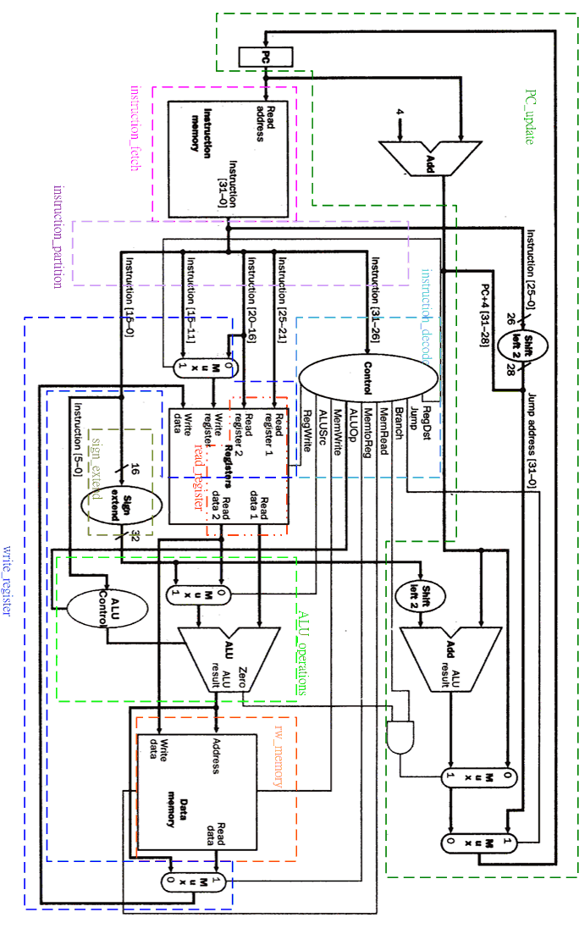
Figure 2: The single-cycle datapath to be implemented.

