en

conf t

hostname SSS-Switch

enable password universe

banner motd #No Unauthorised Access!!!#

no ip domain lookup

line console 0

password universe

login

exit

service password-encryption

ip domain name hospital.net

username admin password universe

crypto key generate rsa

1024

line vty 0 15

login local

transport input ssh

exit

do wr

---------------------------------------------------------

vlan 70

name SSS

exit

int range fa0/1-2

switchport mode trunk

exit

int range fa0/3-24

switchport mode access

switchport access vlan 70

exit

---------------------------------------------------------

vlan 80

vlan 90

vlan 100

vlan 110

vlan 120

vlan 130

int range gig1/0/2-7

switchport mode trunk

exit

do wr

ip routing

router ospf 10

network 192.168.101.128 0.0.0.31 area 0

network 192.168.101.160 0.0.0.31 area 0

network 192.168.101.192 0.0.0.31 area 0

network 192.168.101.224 0.0.0.31 area 0

network 192.168.102.0 0.0.0.31 area 0

network 192.168.102.32 0.0.0.31 area 0

network 192.168.102.96 0.0.0.3 area 0

exit

ip route 0.0.0.0 0.0.0.0 192.168.102.98

(Router)

router ospf 10

network 192.168.102.80 0.0.0.3 area 0

network 192.168.102.84 0.0.0.3 area 0

network 192.168.102.88 0.0.0.3 area 0

network 192.168.102.64 0.0.0.15 area 0

network 195.136.17.4 0.0.0.3 area 0

network 195.136.17.0 0.0.0.3 area 0

exit

ip route 0.0.0.0 0.0.0.0 195.136.17.2

ip route 0.0.0.0 0.0.0.0 195.136.17.6 70(backup with 70 administrative distances)

(ISP)

router ospf 10

network 195.136.17.8 0.0.0.3 area 0

network 195.136.17.0 0.0.0.3 area 0

exit

do wr

(Layer 3 Switch)

int vlan 80

ip address 192.168.101.129 255.255.255.224

ip helper-address 192.168.102.67

exit

int vlan 90

ip address 192.168.101.161 255.255.255.224

ip helper-address 192.168.102.67

exit

int vlan 100

ip address 192.168.101.193 255.255.255.224

ip helper-address 192.168.102.67

exit

int vlan 110

ip address 192.168.101.225 255.255.255.224

ip helper-address 192.168.102.67

exit

int vlan 120

ip address 192.168.102.1 255.255.255.224

ip helper-address 192.168.102.67

exit

int vlan 130

ip address 192.168.102.33 255.255.255.224

ip helper-address 192.168.102.67

Exit

_-------------------------------------------------

(Nat + ACL)

HQ-Router(config-if)#int se0/1/0

HQ-Router(config-if)#ip nat outside

HQ-Router(config-if)#int se0/2/1

HQ-Router(config-if)#ip nat outside

HQ-Router(config-if)#exit

HQ-Router(config)#int range gig0/0-2

HQ-Router(config-if-range)#ip nat inside

HQ-Router(config-if-range)#exit

HQ-Router(config)#do wr

Building configuration...

[OK]

HQ-Router(config)#ip nat inside source list 1 interface se0/2/1 overload

HQ-Router(config)#ip nat inside source list 1 interface se0/1/0 overload

HQ-Router(config)#do wr

Building configuration...

[OK]

HQ-Router(config)#

HQ-Router(config)#

HQ-Router(config)#acc

HQ-Router(config)#access-list 1 permit 192.168.100.0 0.0.0.63

HQ-Router(config)#access-list 1 permit 192.168.100.64 0.0.0.63

HQ-Router(config)#access-list 1 permit 192.168.100.128 0.0.0.63

HQ-Router(config)#access-list 1 permit 192.168.100.192 0.0.0.63

HQ-Router(config)#access-list 1 permit 192.168.101.0 0.0.0.63

HQ-Router(config)#access-list 1 permit 192.168.101.64 0.0.0.63

HQ-Router(config)#do wr

Building configuration...

[OK]

HQ-Router(config)#do show ip nat translation

(VNP Tunel)

HQ-Router(config)#access-list 110 permit ip 192.168.100.0 0.0.0.255 192.168.101.128 0.0.0.255

HQ-Router(config)#access-list 110 permit ip 192.168.101.0 0.0.0.127 192.168.101.128 0.0.0.255

BR-Router(config)#access-list 110 permit ip 192.168.101.128 0.0.0.255 192.168.100.0 0.0.0.255

BR-Router(config)#access-list 110 permit ip 192.168.101.128 0.0.0.255 192.168.101.0 0.0.0.127

(Encrypted)

HQ-Router(config)#crypto is

HQ-Router(config)#crypto isakmp p

HQ-Router(config)#crypto isakmp policy ?

<1-10000> Priority of protection suite

HQ-Router(config)#crypto isakmp policy 10

HQ-Router(config-isakmp)#encryption aes 256?

256

HQ-Router(config-isakmp)#encryption aes 256

HQ-Router(config-isakmp)#authentication ?

pre-share Pre-Shared Key

HQ-Router(config-isakmp)#authentication pre-share

HQ-Router(config-isakmp)#gr

HQ-Router(config-isakmp)#group ?

1 Diffie-Hellman group 1

2 Diffie-Hellman group 2

5 Diffie-Hellman group 5

HQ-Router(config-isakmp)#group 5

HQ-Router(config-isakmp)#

HQ-Router(config-isakmp)#exit

HQ-Router(config)#crypto isakmp key?

key

HQ-Router(config)#crypto isakmp key vpnuniverse address 192.168.102.90

HQ-Router(config)#do wr

Building configuration...

[OK]

HQ-Router(config)#

HQ-Router(config)#crypto is

HQ-Router(config)#crypto isakmp p

HQ-Router(config)#crypto isakmp policy ?

<1-10000> Priority of protection suite

HQ-Router(config)#crypto isakmp policy 10

HQ-Router(config-isakmp)#encryption aes 256?

256

HQ-Router(config-isakmp)#encryption aes 256

HQ-Router(config-isakmp)#authentication ?

pre-share Pre-Shared Key

HQ-Router(config-isakmp)#authentication pre-share

HQ-Router(config-isakmp)#gr

HQ-Router(config-isakmp)#group ?

1 Diffie-Hellman group 1

2 Diffie-Hellman group 2

5 Diffie-Hellman group 5

HQ-Router(config-isakmp)#group 5

HQ-Router(config-isakmp)#

HQ-Router(config-isakmp)#exit

HQ-Router(config)#crypto isakmp key?

key

HQ-Router(config)#crypto isakmp key vpnuniverse address 192.168.102.90

HQ-Router(config)#do wr

Building configuration...

[OK]

HQ-Router(config)#

HQ-Router#

%SYS-5-CONFIG_I: Configured from console by console

HQ-Router#conf t

Enter configuration commands, one per line. End with CNTL/Z.

HQ-Router(config)#

HQ-Router(config)#cry

HQ-Router(config)#crypto ips

HQ-Router(config)#crypto ipsec tr

HQ-Router(config)#crypto ipsec transform-set ?

WORD Transform set tag

HQ-Router(config)#crypto ipsec transform-set VNP-Set esp?

esp-3des esp-aes esp-des esp-md5-hmac esp-sha-hmac

HQ-Router(config)#crypto ipsec transform-set VNP-Set esp-aes

HQ-Router(config)#

HQ-Router#

%SYS-5-CONFIG_I: Configured from console by console

HQ-Router#conf t

Enter configuration commands, one per line. End with CNTL/Z.

HQ-Router(config)#crypto ipsec transform-set VNP-Set esp-aes esp-sha-hmac

HQ-Router(config)#crypto map VNP-MAP 10 ipsec-isakmp

% NOTE: This new crypto map will remain disabled until a peer

and a valid access list have been configured.

HQ-Router(config-crypto-map)#description VNP connects to Branch-Network.

HQ-Router(config-crypto-map)#set peer 192.168.102.90

HQ-Router(config-crypto-map)#set transform-set?

transform-set

HQ-Router(config-crypto-map)#set transform-set VPN-SET

ERROR: transform set with tag VPN-SET does not exist.

HQ-Router(config-crypto-map)#set transform-set VPN-Set

ERROR: transform set with tag VPN-Set does not exist.

HQ-Router(config-crypto-map)#set transform-set VNP-Set

HQ-Router(config-crypto-map)#match address 110

HQ-Router(config-crypto-map)#ex

HQ-Router(config)#HQ-Router(config)#

HQ-Router(config)#interface Serial0/2/0

HQ-Router(config-if)#crypto map VPN-Map

ERROR: Crypto Map with tag VPN-Map does not exist.

HQ-Router(config-if)#crypto map VPN-MAP

ERROR: Crypto Map with tag VPN-MAP does not exist.

HQ-Router(config-if)#crypto map VNN-MAP

ERROR: Crypto Map with tag VNN-MAP does not exist.

HQ-Router(config-if)#crypto map VNN-Map

ERROR: Crypto Map with tag VNN-Map does not exist.

HQ-Router(config-if)#crypto map VNP-Map

ERROR: Crypto Map with tag VNP-Map does not exist.

HQ-Router(config-if)#crypto map VPN-Map

ERROR: Crypto Map with tag VPN-Map does not exist.

HQ-Router(config-if)#crypto map VNP-MAP

*Jan 3 07:16:26.785: %CRYPTO-6-ISAKMP_ON_OFF: ISAKMP is ON

HQ-Router(config-if)#exit

HQ-Router(config)#do wr

do sh crypto ipse sa

(Alternative)

crypto isakmp policy 10

encryption aes 256

authentication pre-share

group 5

exit

crypto isakmp key vpnuniverse address 192.168.102.89

crypto ipsec transform-set VPN-Set esp-aes esp-sha-hmac

crypto map VPN-MAP 10 ipsec-isakmp

description VPN connection to HQ-Hospital

set peer 192.168.102.89

set transform-set VPN-Set

match address 110

exit

interface s0/1/0

crypto map VPN-MAP

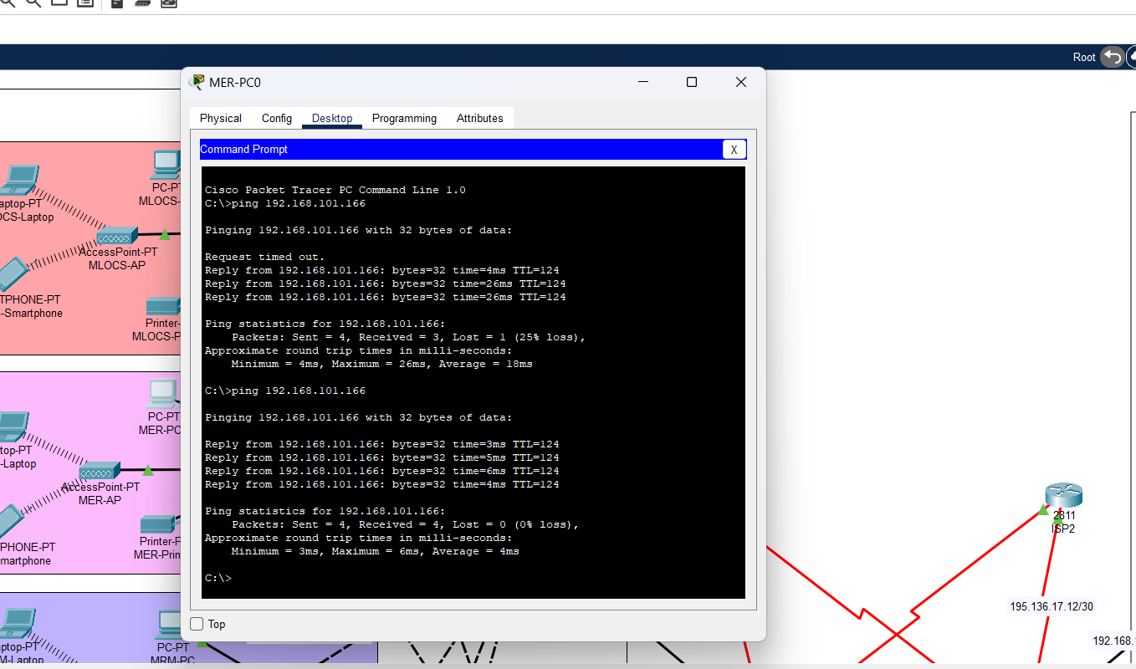

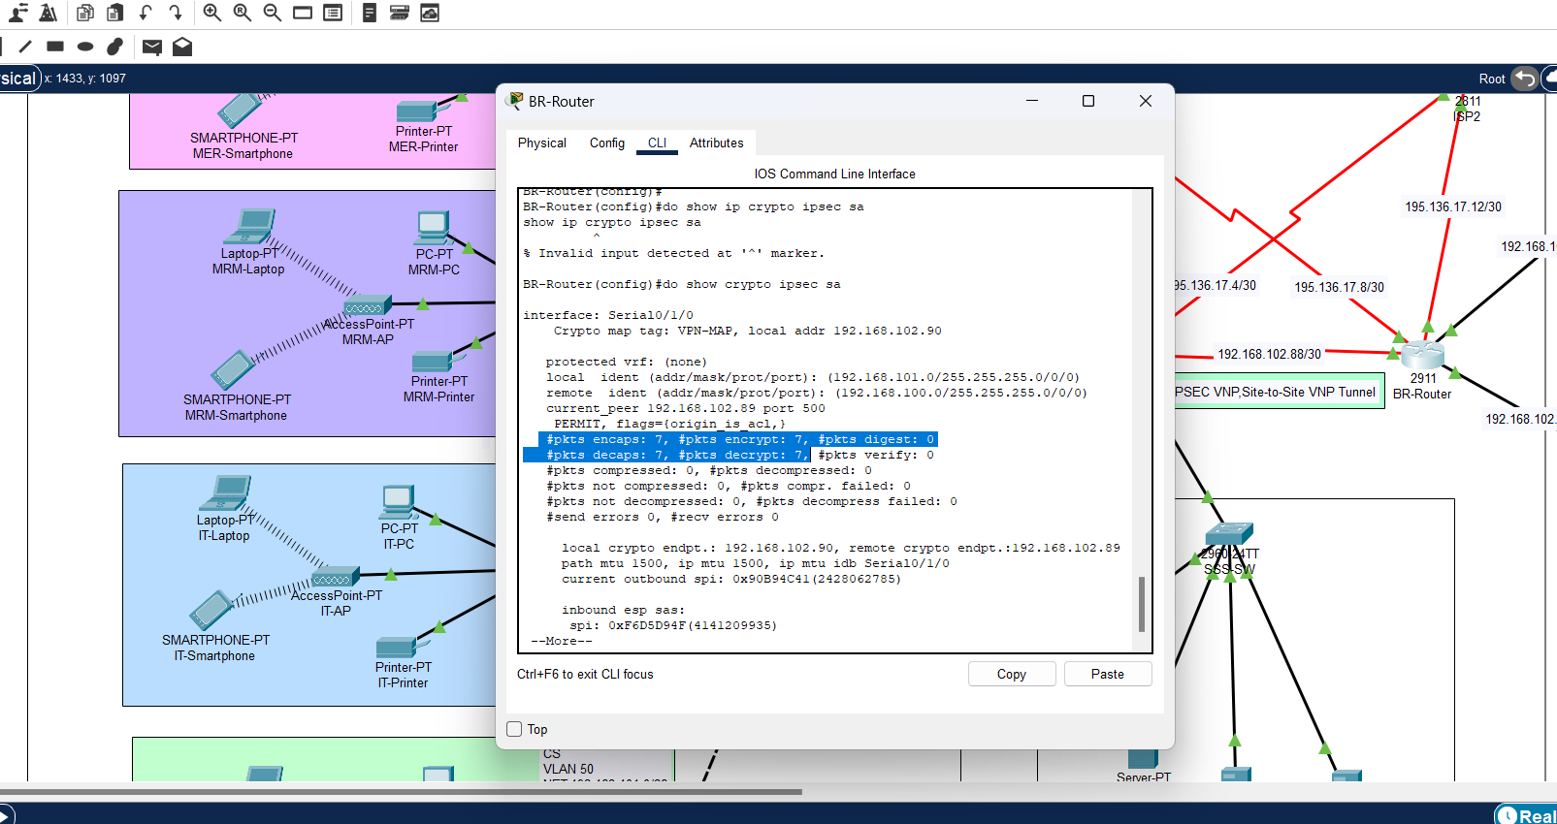

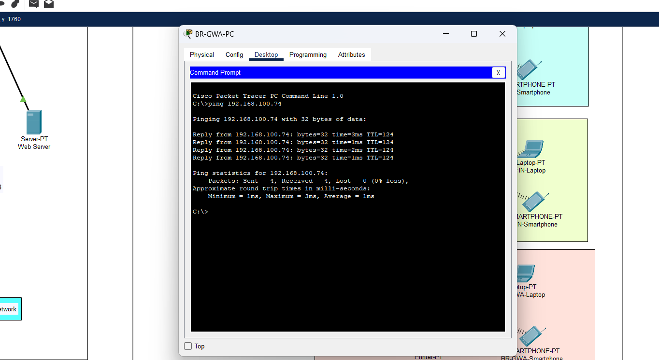

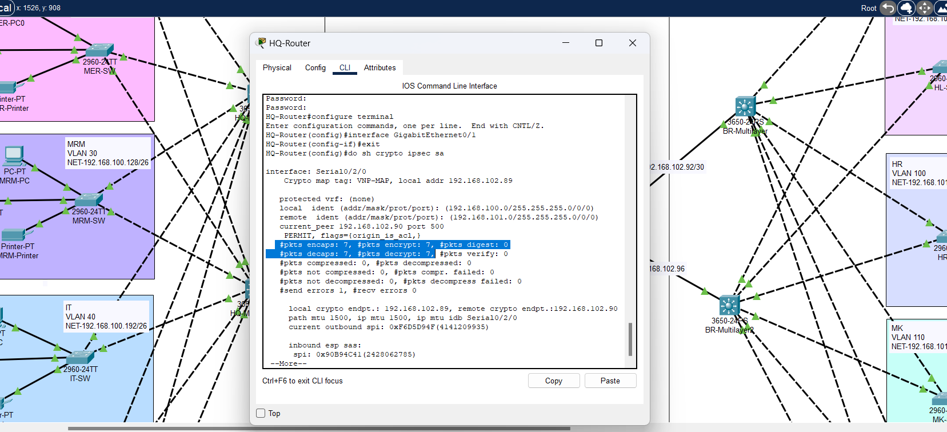

Tham khảo:

<https://itexamanswers.net/19-5-5-packet-tracer-configure-and-verify-a-site-to-site-ipsec-vpn-answers.html>

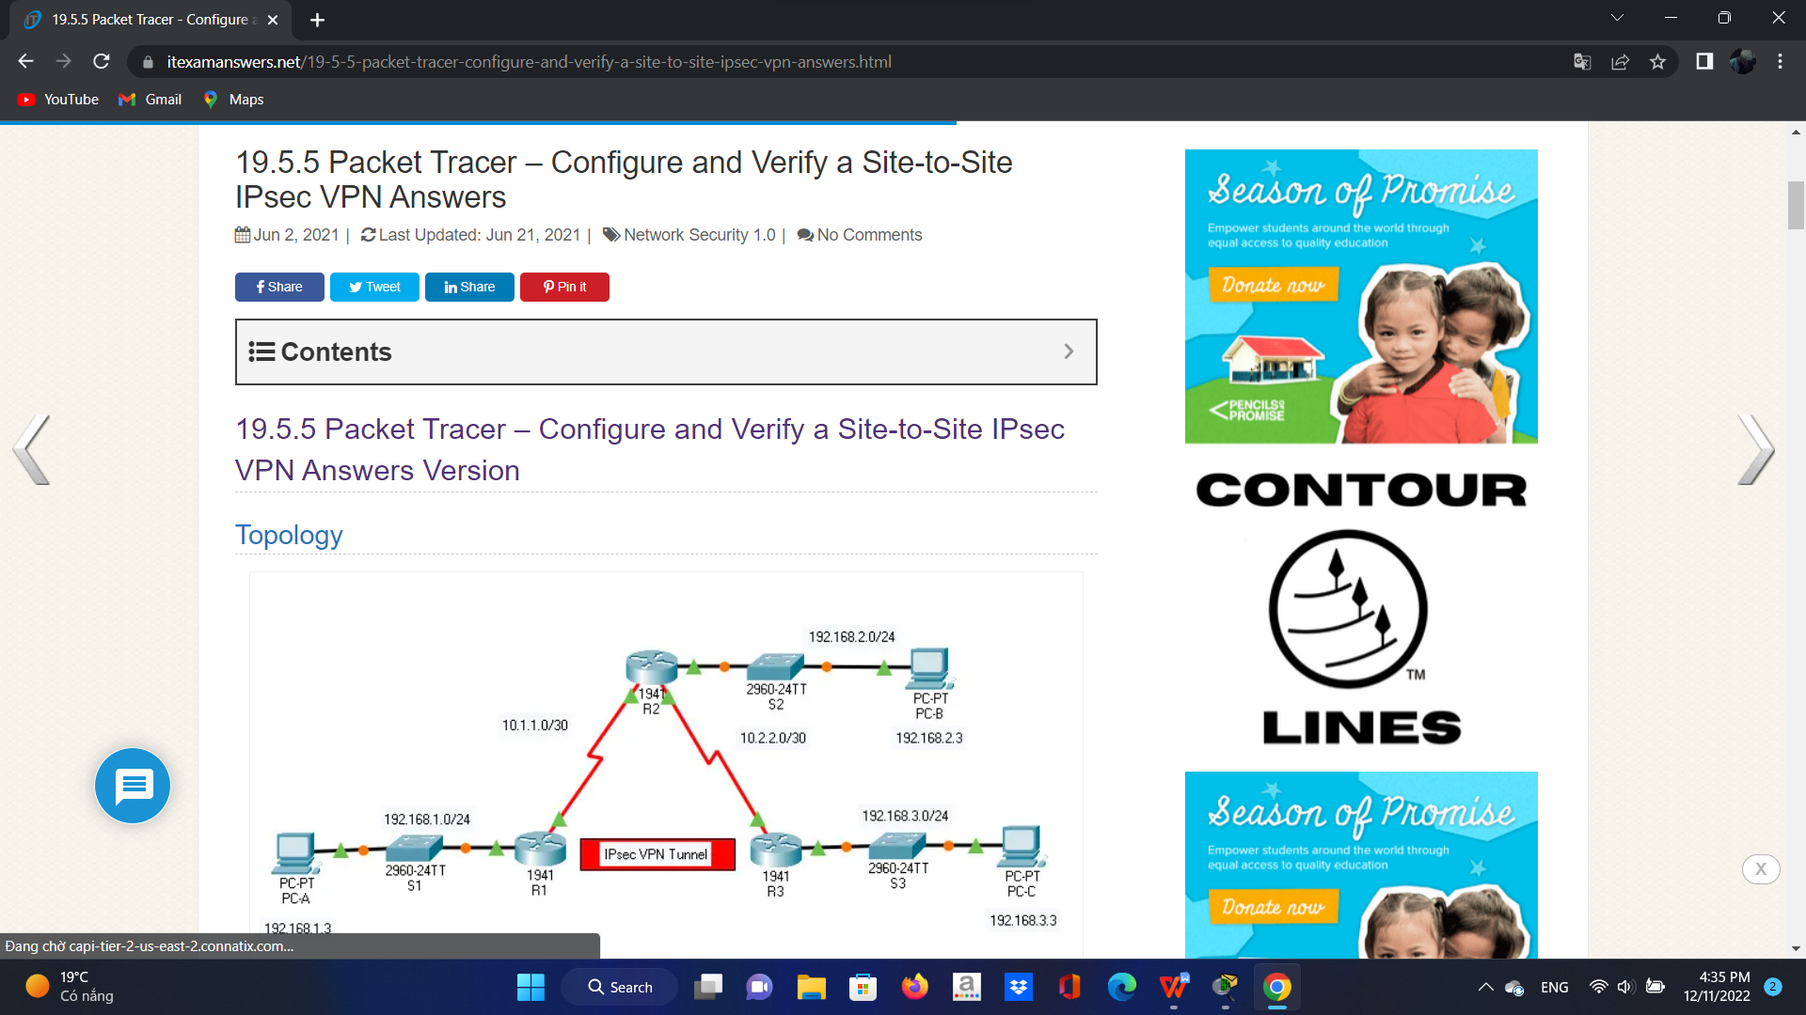

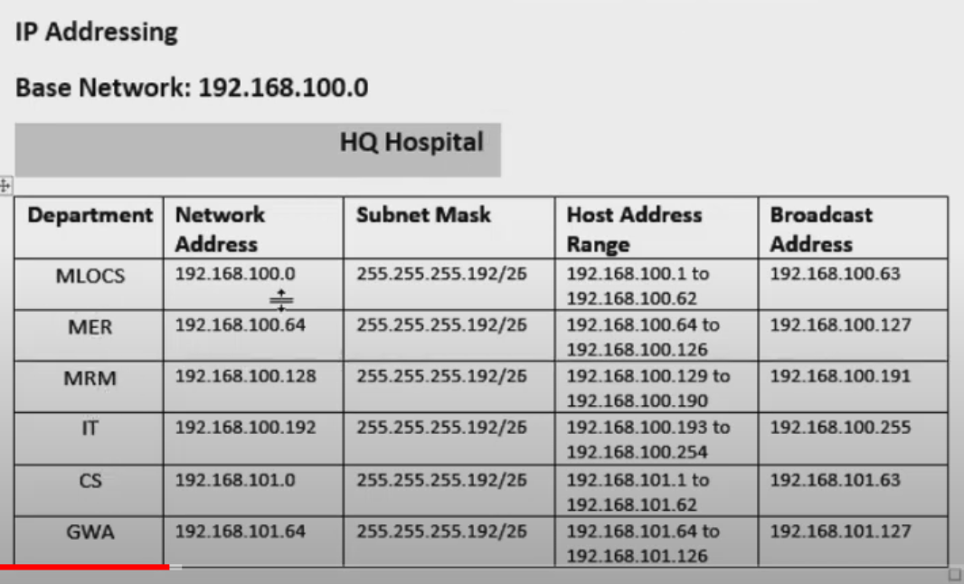

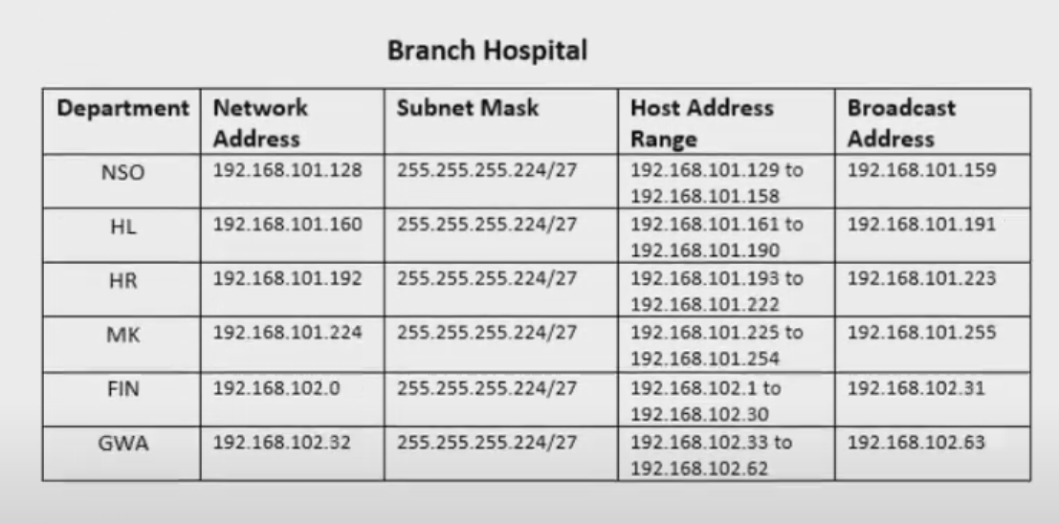

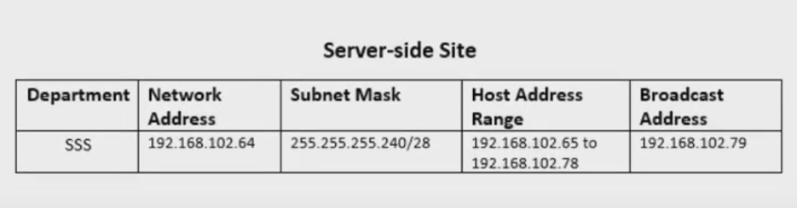

Slash 26 -> 60 users

Slash 27 -> 30 users

Slash 28 -> 10 users

